**Low-voltage operation and high endurance of 5-nm ferroelectric Hf0.5Zr0.5O2 capacitors**   
[Si Joon Kim](http://aip.scitation.org/author/Summerfelt%2C+Scott+R), [Jaidah Mo](http://aip.scitation.org/author/San%2C+Tamer)[han](http://aip.scitation.org/author/Mohan%2C+Jaidah), [Harrison Sej](http://aip.scitation.org/author/Kim%2C+Jiyoung)[oon Kim](http://aip.scitation.org/author/Kim%2C+Harrison+Sejoon), [Jaebeom Lee](http://aip.scitation.org/author/Lee%2C+Jaebeom), [Chadwin D. Young](http://aip.scitation.org/author/Young%2C+Chadwin+D), [Luigi Colombo](http://aip.scitation.org/author/Colombo%2C+Luigi), [Scott R.](http://aip.scitation.org/author/Summerfelt%2C+Scott+R)

[Summerfelt](http://aip.scitation.org/author/Summerfelt%2C+Scott+R)[,](http://aip.scitation.org/author/Kim%2C+Si+Joon) [Tamer San](http://aip.scitation.org/author/San%2C+Tamer)[, an](http://aip.scitation.org/author/Mohan%2C+Jaidah)d [Jiyoung Kim](http://aip.scitation.org/author/Kim%2C+Jiyoung)

Citation: Appl. Phys. Lett.**113**, 182903 (2018); doi: 10.1063/1.5052012 View online: <https://doi.org/10.1063/1.5052012>  
View Table of Contents: <http://aip.scitation.org/toc/apl/113/18>  
Published by the [American Institute of Physics](http://aip.scitation.org/publisher/)

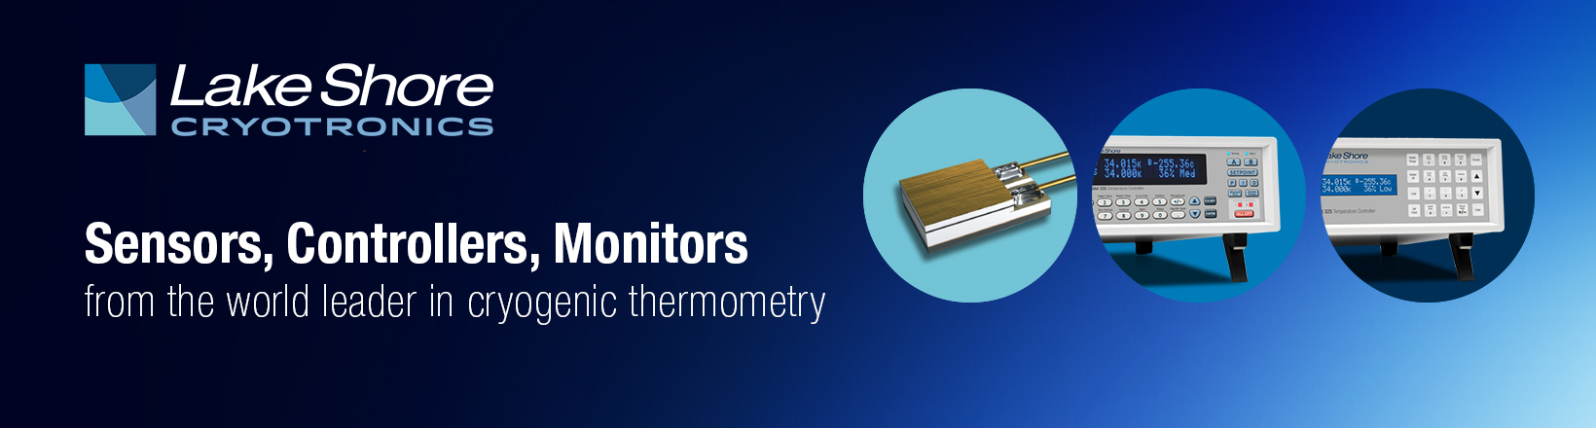

Reuse of AIP Publishing content is subject to the terms at: <a href="https://publishing.aip.org/authors/rights-and-permissions">https://publishing.aip.org/authors/rights-and-permissions</a>. Downloaded to: 146.185.206.101 on 03 November 2018, At: 04:55

APPLIED PHYSICS LETTERS 113, 182903 (2018) 

[Low-voltage operation and high endurance of 5-nm ferroelectric Hf0.5Zr0.5O2](https://doi.org/10.1063/1.5052012)

[capacitors](https://doi.org/10.1063/1.5052012)

Si Joon Kim,1Jaidah Mohan,2Harrison Sejoon Kim,2Jaebeom Lee,2Chadwin D. Young,2 Luigi Colombo,2Scott R. Summerfelt,3Tamer San,3and Jiyoung Kim2,a)   
1Department of Electrical and Electronics Engineering, Kangwon National University, 1 Gangwondaehakgil,

Chuncheon-si, Gangwon-do 24341, South Korea   
2Department of Materials Science and Engineering, The University of Texas at Dallas, 800 West Campbell

Road, Richardson, Texas 75080, USA   
3Texas Instruments, 13121 TI Blvd, Dallas, Texas 75243, USA

(Received 13 August 2018; accepted 6 October 2018; published online 30 October 2018)

In this letter, the ferroelectric (FE) properties of 5-nm-thick Hf0.5Zr0.5O2 (HZO) films deposited by

atomic layer deposition have been investigated. By reducing the HZO film thickness to 5 nm, low-

voltage operation (1.0 V) of the HZO-based capacitor was achieved while maintaining a remnant polarization (Pr) of about 10 lC/cm2(i.e., 2Pr of 20 lC/cm2). Meanwhile, in order to form an ortho-

rhombic phase, which is responsible for FE properties, a rapid thermal annealing process was per-

formed after TiN top electrode deposition. The FE properties were realized after low temperature

annealing (450�C for 1 min), making them compatible with the back-end of the line. In addition,

the low operating voltage and the suppression of an additional monoclinic phase formation by stress-induced crystallization induced a robust endurance (>1010cycles at 1.2 V) of the 5-nm-thick

HZO sample. Published by AIP Publishing. <https://doi.org/10.1063/1.5052012>

Since the discovery of ferroelectricity in HfO2 films,1 interest in non-volatile semiconductor device applications, especially for scaled ferroelectric random access memory (FRAM), has increased significantly. These new ferroelectric (FE) materials offer several notable advantages over the cur-rently commercialized Pb(Zr,Ti)O3 (PZT) material including the appearance of suitable FE properties at the sub-10 nm scale and compatibility with complementary metal oxide semiconductor (CMOS) technology.1–12In addition, it is possible to achieve a low thermal budget process (400�C) that is essential for back-end of line (BEOL) integration through appropriate dopant species selection and capping layer effects, unlike conventional FE materials that require much higher thermal budgets (600�C or higher).4–8Despite these advantages, however, the 10-nm-thick Hf1-xBxO2, where B ¼ Si, Al, Zr, etc, FE films reported so far have a limit in terms of endurance properties (approximate 107–109 cycles) because they require a relatively high operating volt-age (i.e., FE saturation voltage, typically 2.5 V–3.0 V) for sufficiently switching the FE polarization.7–13Recently, it has been reported that the endurance can be improved up to 1010cycles by La doping in the HfO2 or Hf0.5Zr0.5O2 (HZO) thin film.14,15However, high operating voltages (>2.5 V) close to the breakdown are still required to achieve proper

alternately depositing Hf and Zr precursors (a Hf:Zr ratio of 1:1) through an atomic layer deposition (ALD) process, uni-form HZO thin films with FE polarization can be realized more easily in mass-production, whereas other ratios (such as 20%) are difficult to achieve a uniform concentration through-out the film [unevenly distributed supercycle of ALD such as a ratio of 4:1 (to make Hf0.8B0.2O2) can result in a vertically non-uniform concentration profile].17Second, the FE proper-ties of HZO films can be achieved at relatively low process temperature because the crystallization temperature of ZrO2 is generally lower than that of other high-k dielectrics.4–6Here, by selecting Zr as an alloying element, homogenous thin films having satisfactory FE properties can be achieved at low pro-cess temperature (450�C). The following results demonstrate the potential of 5-nm-thick FE HZO films to enable the low-voltage operation (1.0 V) with superior endurance (>1010 cycles at 1.2 V) for next-generation FRAM applications. Furthermore, the variety of physical phenomena connected to ferroelectricity allows a wider range of applications.18–20

|  |  |  |  |  |  |
| --- | --- | --- | --- | --- | --- |
| FE | TiN/HZO/TiN | capacitors | were | fabricated, | as |

depicted in Fig. 1(a), on 100 mm p-type Si wafers with a thermally grown 300-nm-thick SiO2 layer and annealed at 400�C for 60 s in an N2 atmosphere using a rapid thermal annealing (RTA) system. 90-nm-thick TiN bottom and top

FE characteristics. electrodes were deposited at room temperature by radio fre-

In this work, the FE and endurance properties of atomic layer deposited 5-nm-thick Hf0.5Zr0.5O2 (HZO)-based capaci-tors have been investigated. Among the previously reported dopants, Zr is the most promising for two reasons. First, the Zr content for maximum FE polarization can be stable at

|  |
| --- |
| �50% due to its very similar physical and chemical properties to those of Hf, while other dopants are stable at much lower  doping concentrations (<20% for most dopants).1,5,16By |

a)Electronic mail: [jiyoung.kim@utdallas.edu](mailto:jiyoung.kim@utdallas.edu)

quency sputtering, and 5-nm-thick HZO films with a Hf:Zr ratio of 1:1 were deposited by ALD (Cambridge Nanotech Savannah S100) using Hf[N(CH3)2]4, Zr[N(CH3)2]4, and O3 as the Hf-precursor, Zr-precursor, and oxygen source, respectively. A high concentration of O3 (400 g/m3) formed by an O3 generator (OP-250H, Toshiba Mitsubishi Electric Industrial Systems Corporation) was used. The wafer tem-perature was set to 250�C during the HZO deposition, and the growth per supercycle of HfO2 and ZrO2 was about 0.2 nm/supercycle. A conventional photolithography/etching

|  |  |  |
| --- | --- | --- |
| 0003-6951/2018/113(18)/182903/4/$30.00 | 113, 182903-1 | Published by AIP Publishing. |

|  |  |  |
| --- | --- | --- |
| 182903-2 | Kim et al. | Appl. Phys. Lett. 113, 182903 (2018) |

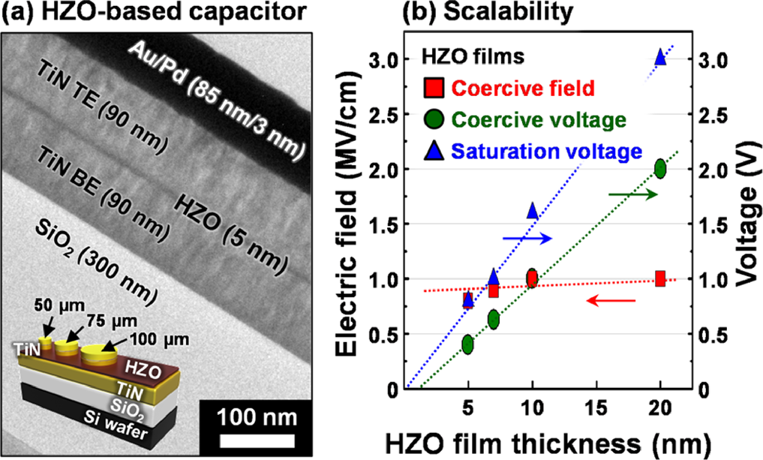

FIG. 1. (a) Cross-sectional TEM image of a 5-nm-thick HZO-based capaci-tor and (b) scalability of operating voltage according to the HZO film thickness.

process was performed using an Au hard mask to form a pre-cise/reproducible area of capacitors with various diameters ranging from 50 to 100 lm. The exact device area after the etching process was estimated by linear extrapolation of the square root of capacitance versus the device diameter and included in the electrical results. Finally, the fabricated 5-nm-thick HZO-based capacitors were annealed again at vari-ous temperatures (450–600�C) for various times (60–180 s) in an N2 atmosphere using a RTA system. For the electrical characterization, the polarization-electric field (P-E) hystere-sis curves were measured at 10 kHz using a semiconductor parameter analyzer (Keithley 4200-SCS). For the pulse write/read measurement, a series of write and read voltage pulses were also applied to the HZO sample using a pulse generator (Agilent 81110A) and an internal resistance of 50 X as a shunt resistor.4   
 Figure 1 shows the cross-sectional transmission electron microscopy (TEM, JEOL JEM-2100F) image of the fabri-cated 5-nm-thick HZO-based capacitor and the scalability of the operating voltage estimated by the linear extrapolation of the coercive voltage and the saturation voltage (Vsat) as a function of the HZO film thickness. The coercive voltage and coercive field (Ec) were extracted from the P-E hystere-sis curves as the average of two points with zero polariza-tion. The Vsat determined when the switching polarization becomes saturated was extracted from the pulse write/read results. The HZO films show that the Ec needed to reverse the polarization is almost constant regardless of the film thickness, unlike the increase in Ec as the thickness of the conventional PZT decreases.5,21This thickness-independent result was similarly reported in previous studies.5,22,23When the film thickness was less than 6 nm, the Ec of the HZO film was even slightly decreased (i.e., completely opposite to that observed in the perovskite FE PZT).22As the HZO film thickness decreases, Vsat also decreases along with the coer-cive voltage. Consequently, by reducing the HZO film thick-ness, it is expected that the low-voltage operation of the HZO-based FRAM devices can be realized without losing the FE behavior. In fact, Ec can decrease with the decreasing film thickness in extremely thin films due to the depolariza-tion field across the FE layer, which can make the operating voltage even lower.21,22Based on these inherent characteris-tics of the HZO films, most of the previous research has

focused on the scaling down to achieve lower operating voltage. However, since the crystallization temperature gen-erally increases as the film thickness decreases, the thin HZO film (<7 nm) requires a relatively high temperature anneal-ing process (600�C or higher) to achieve the appropriate FE properties.22,24This high thermal budget process not only precludes the integration of HZO-based FE circuits in the BEOL to increase the effective memory area and add more functionality but also leads to increased leakage. In addition, as the film thickness decreases, the FE polarization decreases due to the smaller grain size or the dead layer effect at the electrode interface.5,21,22Here, stress-induced crystallization using the room-temperature deposited TiN top electrode was employed to overcome such limitations in the 5-nm-thick HZO film.4The TiN top electrode acts as a tensile stressor on the HZO film during the annealing process to form the non-centrosymmetric orthorhombic phase (o-phase, space group: Pca21) that generates a large FE polarization while maintaining a low thermal budget (<450�C).

Figure 2(a) shows the P-E hysteresis and pulse write/ read results of the 5-nm-thick HZO-based capacitor annealed at 400�C and then at 450�C (second annealing process) after 105wake-up cycles at a field of 2.5 MV/cm. When the 5-nm-thick HZO film is annealed again at high temperature (450�C), the FE switching contribution can be increased, as shown by the ratio of switching polarization to total polariza-tion (i.e., Psw/Ptotal) at 2.5 MV/cm [Fig. 2(b)]. For the 5-nm-thick HZO-based capacitor annealed at 450�C, the extracted remnant polarization (Pr) was approximately 10 lC/cm2 (i.e., 2Pr of about 20 lC/cm2) and saturated when the operat-ing voltage was 1.0 V or higher [Fig. 3(a)]. In addition, this 2Pr remains constant regardless of the second annealing pro-cess conditions (second annealing temperature and time), but the HZO samples annealed again at or above 550�C tend to exhibit relatively high leakage current properties (data not shown). Since the FE switching effect is minimized in the saturation region (>1.0 V), the dielectric constant can also be extracted from the slope of the P-V hysteresis curve in this region (as indicated by the gray scale).5,25The dielectric constant was about 47, which is almost the same value as the previously reported HZO films extracted from the con-ventional small signal capacitance-voltage measurement

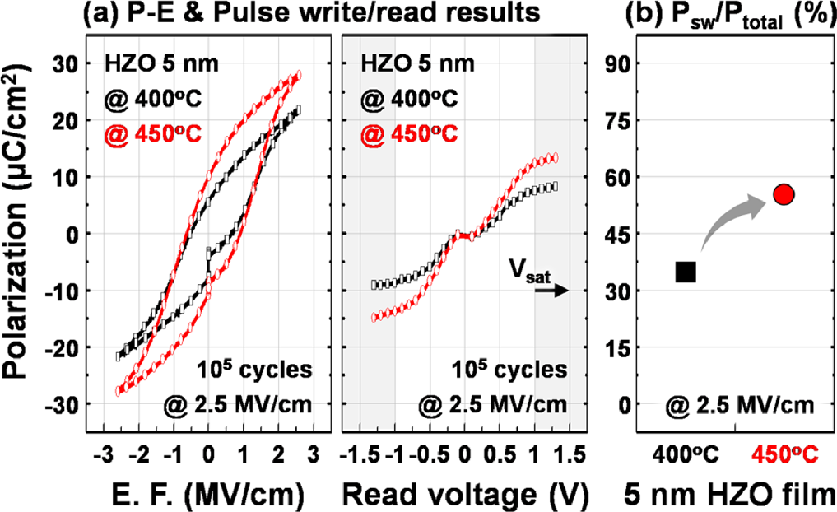

FIG. 2. (a) Polarization-electric field hysteresis curves and pulse write/read results of 5-nm-thick HZO-based capacitors annealed at 400 and 450�C (second annealing process). (b) Ratio of switching polarization to total polarization.

|  |  |  |
| --- | --- | --- |
| 182903-3 | Kim et al. | Appl. Phys. Lett. 113, 182903 (2018) |

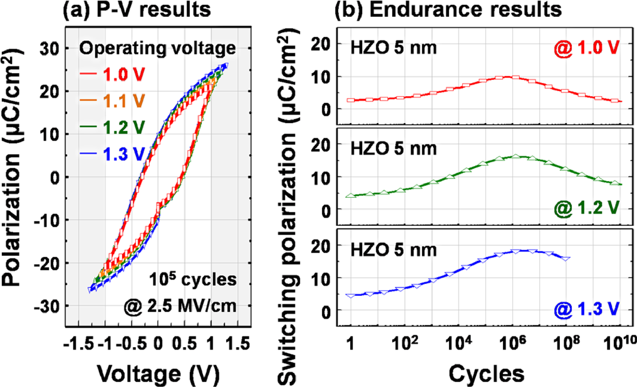

FIG. 3. (a) Polarization-voltage hysteresis curves and (b) endurance results of 5-nm-thick HZO-based capacitors annealed at 450�C measured at various operating voltages.

(50 mV level).4,5Further studies are needed to identify the reason for the relatively high dielectric constant.

An endurance measurement was also carried out using a semiconductor parameter analyzer (Keithley 4200-SCS) as shown in Fig. 3(b). The endurance results of HZO-based capacitors can be divided into three states: wake-up, stabili-zation, and fatigue. Due to the redistribution of existing defects such as oxygen vacancies,4,262Pr increases with the opening of the pinched hysteresis loop (i.e., pristine state) according to the cycles. After wake-up field cycling, 2Pr remains steady and stable. However, as the number of cycles increases, the existing or newly generating defects could result in charge trapping and domain pinning, thereby lead-ing to degradation of the FE properties (i.e., the reduction of 2Pr).9,11,26Since the 5-nm-thick HZO film has a low operat-ing voltage for sufficient switching of the FE polarization, robust endurance properties up to 1010cycles were achieved at a switching voltage of 1.2 V. The number of cycles for the breakdown decreased with increasing switching voltage:�108cycles for 1.3 V. It is to be noted that these endurance levels of the HZO film are superior to those of the previously reported doped HfO2 films despite the fact that films were also scaled down to 5 nm.8–11   
 Figure 4 shows the crystal structure of the 5-nm-thick HZO film annealed at 400�C and then at 450�C (second

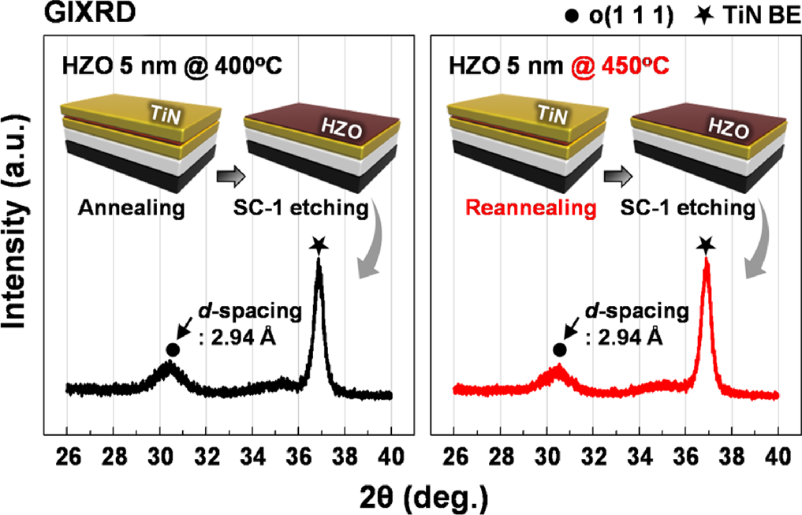

FIG. 4. GIXRD patterns of 5-nm-thick HZO films annealed at 400 and 450�C (second annealing process) taken after chemical removal of the TiN

annealing process), examined using an X-ray diffraction (XRD, Rigaku SmartLab) system via grazing-angle inci-dence XRD (GIXRD) in the 2h range of 26�–40�with an incidence angle of 0.5�after chemical removal of the TiN top electrode using SC-1 (NH4OH þ H2O2). Since it is very chal-lenging to distinguish between the o-phase and the tetragonal phase (space group: P42/nmc) in the GIXRD pattern due to their structural similarities,4–6,16,19the HZO peaks centered at�30.5�are assigned to the non-centrosymmetric o(1 1 1) phase corresponding to the FE behavior shown in Fig. 2. The TiN (1 1 1) peaks from the bottom electrodes centered at 36.7�are also shown.4All HZO films exhibit similar results regardless of the annealing process conditions. Meanwhile, increasing the HZO film thickness or annealing temperature can result in the formation of the monoclinic phase (m-phase, space group: P21/c).4,5Importantly, the m-phase can work as a dead layer in the FE HZO film and thus degrade both the FE and endurance properties.4,9Consequently, the inhibition of m-phase formation during the annealing process is essential to obtain the robust endurance properties of the HZO film. Unlike the previously reported HZO films,6,24the stress-inducing TiN top electrode can suppress the m-phase forma-tion during HZO crystallization,4so m-phase diffraction peaks centered at �28.5�and �31.5�were not observed in this study. The cross-sectional high-resolution TEM and atomic force microscopy (AFM, Veeco 3100) images of the 5-nm-thick HZO sample annealed at 400�C and then at 450�C (second annealing process) are also shown in Fig. 5. All fast Fourier transformation (FFT) patterns of the HZO film match with the o(1 1 1) phase, like the GIXRD result. The inter-atomic distance (�2.94 A˚ ) measured using the reversed FFT image filtered by a mask was consistent with the d-spacing value extracted using Bragg’s law from the GIXRD result. This also reveals that the stress-induced crystallization effectively inhibited the m-phase formation. The relatively small grains with different directions in different areas of the 5-nm-thick HZO film annealed at 400�C were formed [Fig. 5(a)]. Unlike the HZO film of 5 nm thickness annealed at 400�C, the grain size increases significantly in the

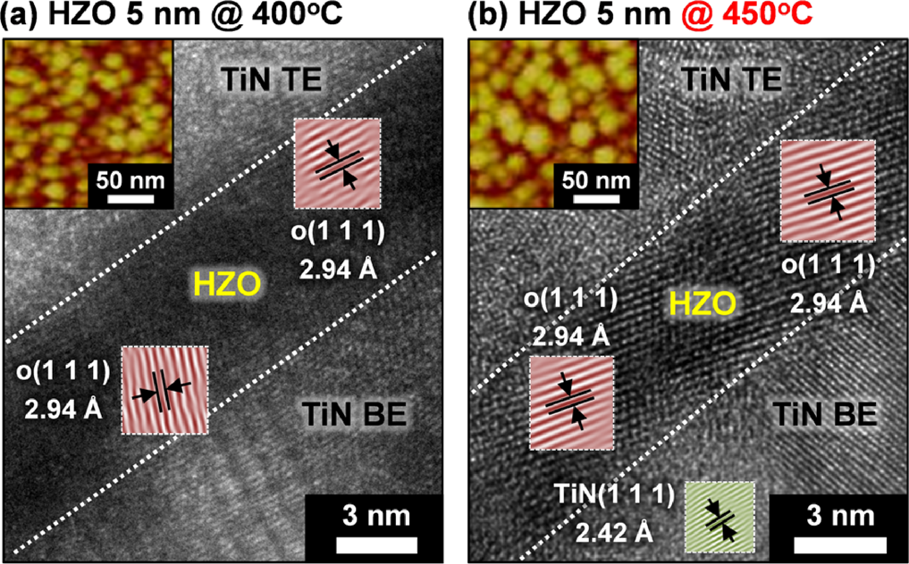

FIG. 5. Cross-sectional HR-TEM images of 5-nm-thick HZO-based capaci-tors annealed at (a) 400�C and (b) 450�C (second annealing process). For better visibility, the reverse FFT images obtained from the filtered FFT images by mask are artificially colored. Top insets show AFM images of 5-nm-thick HZO films annealed at 400 and 450�C (second annealing process),

top electrode. respectively.

|  |  |  |
| --- | --- | --- |
| 182903-4 | Kim et al. | Appl. Phys. Lett. 113, 182903 (2018) |

horizontal direction after second annealing at 450�C [Fig. 5(b)], resulting in a large FE polarization due to the rela-tively easy domain wall motion. The average grain size obtained from the AFM image was approximately 15 nm for the 400�C annealed HZO film and increased to approxi-mately 25 nm after the second annealing at 450�C.

In conclusion, unlike the conventional PZT FE material, the HZO film exhibited almost constant Ec (approximately 1 MV/cm) regardless of the film thickness. Therefore, by reducing the HZO film thickness to 5 nm, low-voltage (1.0 V) was found to be sufficient to saturate the FE polariza-tion, which led to excellent endurance properties over 1010 switching cycles at 1.2 V. The stress-induced crystallization used in this study allows the HZO film to have desirable FE characteristics by forming the o-phase even at a thickness of 5 nm, which is formed at a low temperature (450�C) compat-ible with BEOL integration. In addition, this integration scheme can inhibit the m-phase formation which degrades FE and endurance properties during HZO crystallization. Therefore, we conclude that the low thermal budget 5-nm-thick HZO-based capacitors showing low-voltage operation and high endurance have enormous potential for next-generation FRAM applications. Furthermore, this study advances a variety of applications that require thin FE film thicknesses such as FE tunnel junctions, steep slope devices, and synapse devices.

|  |  |  |  |  |  |  |
| --- | --- | --- | --- | --- | --- | --- |
| This | work | was | financially | supported | by | Texas |

Instruments. The ozone generator used in this work was provided by Toshiba-Mitsubishi-Electric Industrial Systems Corporation (TMEIC).

1T. S. B€oscke, J. M€uller, D. Br€auhaus, U. Schr€oder, and U. B€ottger, [Appl. Phys. Lett.](https://doi.org/10.1063/1.3634052) 99, 102903 (2011).

2J. A. Rodrigues, K. Remack, K. Boku, K. R. Udayakumar, S. Aggarwal, S. R. Summerfelt, F. G. Celii, S. Martin, L. Hall, K. Taylor, T. Moise, H. McAdams, J. McPherson, R. Bailey, G. Fox, and M. Depner, [IEEE Trans. Device Mater. Reliab.](https://doi.org/10.1109/TDMR.2004.837210) 4, 436 (2004).

3H. P. McAdams, R. Acklin, T. Blake, X.-H. Du, J. Eliason, J. Fong, W. F. Kraus, D. Liu, S. Madan, T. Moise, S. Natarajan, N. Qian, Y. Qiu, K. A. Remack, J. Rodriguez, J. Roscher, A. Seshadri, and S. R. Summerfelt, [IEEE J. Solid-State Circuits](https://doi.org/10.1109/JSSC.2004.825241) 39, 667 (2004).

4S. J. Kim, D. Narayan, J.-G. Lee, J. Mohan, J. S. Lee, J. Lee, H. S. Kim, Y.-C. Byun, A. T. Lucero, C. D. Young, S. R. Summerfelt, T. San, L. Colombo, and J. Kim, [Appl. Phys. Lett.](https://doi.org/10.1063/1.4995619) 111, 242901 (2017).

5S. J. Kim, J. Mohan, J. Lee, J. S. Lee, A. T. Lucero, C. D. Young, L. Colombo, and J. Kim, [Appl. Phys. Lett.](https://doi.org/10.1063/1.5026715) 112, 172902 (2018).

6S. Zarubin, E. Suvorova, M. Spiridonov, D. Negrov, A. Chernikova, A. Markeev, and A. Zenkevich, [Appl. Phys. Lett.](https://doi.org/10.1063/1.4966219) 109, 192903 (2016).

7S. J. Kim, D. Narayan, J.-G. Lee, J. Mohan, J. S. Lee, J. Lee, C. D. Young, J. Kim, S. R. Summerfelt, T. San, and L. Colombo, in Proceedings of 9th IEEE International Memory Workshop (IMW) (2017).

8K.-Y. Chen, P.-H. Chen, R.-W. Kao, Y.-X. Lin, and Y.-H. Wu, [IEEE Electron Device Lett.](https://doi.org/10.1109/LED.2017.2771390) 39, 87 (2018).

9M. H. Park, H. J. Kim, Y. J. Kim, W. Jeon, T. Moon, and C. S. Hwang, [Phys. Status Solidi RRL](https://doi.org/10.1002/pssr.201409017) 8, 532 (2014).

10S. Mueller, S. R. Summerfelt, J. M€uller, U. Schroeder, and T. Mikolajick, [IEEE Electron Device Lett.](https://doi.org/10.1109/LED.2012.2204856) 33, 1300 (2012).

11K. Florent, S. Lavizzari, L. D. Piazza, M. Popovici, J. Duan, G. Groesenseken, and J. V. Houdt, [IEEE Trans. Electron Devices](https://doi.org/10.1109/TED.2017.2742549) 64, 4091 (2017).

12S. Mueller, J. M€uller, U. Schroeder, and T. Mikolajick, [IEEE Trans.](https://doi.org/10.1109/TDMR.2012.2216269)  [Device Mater. Reliab.](https://doi.org/10.1109/TDMR.2012.2216269) 13, 93 (2013).

13S. Mueller, J. M€uller, R. Hoffmann, E. Yurchuk, T. Schl€osser, R. Boschke, J. Paul, M. Goldbach, T. Herrmann, A. Zaka, U. Schr€oder, and T. Mikolajick, [IEEE Trans. Electron Devices](https://doi.org/10.1109/TED.2013.2283465) 60, 4199 (2013).

14M. G. Kozodaev, A. G. Chernikova, E. V. Korostylev, M. H. Park, U. Schroeder, C. S. Hwang, and A. M. Markeev, [Appl. Phys. Lett.](https://doi.org/10.1063/1.4999291) 111, 132903 (2017).

15A. G. Chernikova, M. G. Kozodaev, D. V. Negrov, E. V. Korostylev, M. H. Park, U. Schroeder, C. S. Hwang, and A. M. Markeev, [ACS Appl. Mater. Interfaces](https://doi.org/10.1021/acsami.7b15110) 10, 2701 (2017).

16J. M€uller, T. S. B€oscke, U. Schr€oder, S. Mueller, D. Br€auhaus, U. B€ottger, L. Frey, and T. Mikolajick, [Nano Lett.](https://doi.org/10.1021/nl302049k) 12, 4318 (2012).

17K. S. Son, K. Bae, J. W. Kim, J. S. Ha, and J. H. Shim, [J. Vac. Sci.](https://doi.org/10.1116/1.4755921)  [Technol., A](https://doi.org/10.1116/1.4755921) 31, 01A107 (2012).

18M. H. Park, H. J. Kim, Y. J. Kim, T. Moon, K. D. Kim, and C. S. Hwang, [Adv. Energy Mater.](https://doi.org/10.1002/aenm.201400610) 4, 1400610 (2014).

19M. H. Park, H. J. Kim, Y. J. Kim, T. Moon, K. D. Kim, Y. H. Lee, S. D. Hyun, and C. S. Hwang, [Adv. Mater.](https://doi.org/10.1002/adma.201602787) 28, 7956 (2016).

20M. Si, C.-J. Su, C. Jiang, N. J. Conrad, H. Zhou, K. D. Maize, G. Qiu, C.-T. Wu, A. Shakouri, M. A. Alam, and P. D. Ye, [Nat. Nanotechnol.](https://doi.org/10.1038/s41565-017-0010-1) 13, 24 (2018).

21M. Dawber, P. Chandra, P. B. Littlewood, and J. F. Scott, [J. Phys.:](https://doi.org/10.1088/0953-8984/15/24/106)  [Condens. Matter](https://doi.org/10.1088/0953-8984/15/24/106) 15, L393 (2003).

22M. H. Park, H. J. Kim, Y. J. Kim, Y. H. Lee, T. Moon, K. D. Kim, S. D. Hyun, and C. S. Hwang, [Appl. Phys. Lett.](https://doi.org/10.1063/1.4935588) 107, 192907 (2015).

23S. Migita, H. Ota, H. Yamada, K. Shibuya, A. Sawa, and A. Toriumi, [Jpn.](https://doi.org/10.7567/JJAP.57.04FB01)  [J. Appl. Phys.](https://doi.org/10.7567/JJAP.57.04FB01) 57, 04FB01 (2018).

24S. Riedel, P. Polakowski, and J. M€uller, [AIP Adv.](https://doi.org/10.1063/1.4964300) 6, 095123 (2016).

25D. Bolten, U. B€ottger, and R. Waser, [J. Appl. Phys.](https://doi.org/10.1063/1.1535748) 93, 1735 (2003). 26M. M. Pe�sic´, F. P. G. Fengler, L. Larcher, A. Padovani, T. Schenk, E. D. Grimley, X. Sang, J. M. Lebeau, S. Slesazech, U. Schroeder, and T. Mikolajick, [Adv. Funct. Mater.](https://doi.org/10.1002/adfm.201600590) 26, 4601 (2016).