3490 IEEE TRANSACTIONS ON ELECTRON DEVICES, VOL. 61, NO. 10, OCTOBER 2014

Observation and Control of Hot Atom Damage in Ferroelectric Devices

Muhammad Masuduzzaman, *Member, IEEE*, Dhanoop Varghese, *Member, IEEE*, John A. Rodriguez, *Member, IEEE*, Srikanth Krishnan, *Associate Member, IEEE*, and Muhammad Ashraful Alam, *Fellow, IEEE*

***Abstract*—Ferroelectric materials are the most common exam-ple of a Landau structure, defined as a system having an atom/mass moving in a double-well energy landscape. These materials have applications in memories, actuators, low power logic transistors, and so on. For a bipolar ac signal typical in most of the applications, one suspects that the repeated roller coaster shuttling of the moving atoms located microscopically at the domain walls could lead to bond dissociation, suggesting a new channel for defect generation with no classical counterpart. Here, we demonstrate that once the bipolar pulses initiate transfer of atoms between the energy pockets, the transient overshoot away from their equilibrium positions (hot atoms) leads to significant increase in defect generation. We interpret the degradation theoretically and demonstrate a set of soft-switching schemes to control the hot atom damage and to improve the device lifetime dramatically. The damage mechanism should be generic in other Landau structures, such as microelectromechanical systems, nonvolatile memories, and analogous control strategies should improve the lifetime of all such bistable devices.**

***Index***  ***Terms*—Defect**  **generation,**  **ferroelectrics,**  **Landau structure, microelectromechanical**  **system (MEMS), negative capacitance, phase transition materials.**

I. INTRODUCTION   
**A** scaling and performance limits, various alternative device S SILICON-BASED device technology approaches its

technologies based on nanostructured and functional materials

have been suggested as potential replacements. Among these,

the materials involving phase-transitions (e.g., ferroelec-

tric switching, metal–insulator transition, topological transi-

tions, and so on) offer novel routes for information processing

and storage [1]–[4], and suggest techniques to overcome

the fundamental limits of the classical materials and sys-

tems [5], [6]. Many of these phase-transition materials involve

a characteristic energy landscape (either microscopically or

macroscopically) defined by two or more stable energy minima

Manuscript received April 25, 2014; revised July 28, 2014; accepted July 28, 2014. Date of publication September 5, 2014; date of current version September 18, 2014. This work was supported by a research grant from Texas Instruments Inc., Dallas, TX, USA. The review of this paper was arranged by Editor B. Kaczer.

M. Masuduzzaman and M. A. Alam are with the School of Electrical and Computer Engineering, Purdue University, West Lafayette, IN 47907 USA (e-mail: masuduzzaman@ieee.org; alam@purdue.edu).

D. Varghese, J. A. Rodriguez, and S. Krishnan are with Texas Instruments

|  |  |  |  |  |  |  |  |
| --- | --- | --- | --- | --- | --- | --- | --- |
| Inc., | Dallas, | TX | 75243 | USA | (e-mail: | dhanoop@ti.com; | jrz@ti.com; |

s-krishnan1@ti.com).

Color versions of one or more of the figures in this paper are available online at http://ieeexplore.ieee.org.

Digital Object Identifier 10.1109/TED.2014.2347046

(Landau structure), and transition between states occurs in response to an actuation pulse. A typical example is the ferroelectric switching, where the microscopic displacement of the central atom (e.g., Ti/Zr for lead–zirconate–titanate or PZT) between the two stable configurations, leads to the switching polarization hundreds of times larger than that of the classical dielectrics. This large switchable polarization is the basis of commercial and emerging memory technologies such as FeRAM [2], [7], logic devices that would allow sub-60 mV/decade switching [5], [6], and so forth.

|  |  |  |  |  |  |  |
| --- | --- | --- | --- | --- | --- | --- |
| During | the | macroscopic | polarization | switching | of | a |

ferroelectric material, the domain walls move across the sample [8]–[10]. During this process, the atoms located within the domain walls flip from one microscopic state to another. During this microscopic switching, the transitioning atoms within the domain walls overcome an energy barrier and undergo a characteristic roller coaster movement between the pair of energy pockets [Fig. 1(a)]. This suggests a potential of transient overshoot of these atoms away from the ther-modynamically stable energy minima during each switching at ac bias. These localized, energetic (hot) atoms at the domain walls, further assisted by stochastic absorption of lattice phonons, may stretch the bonds beyond the breaking point—leading to defect formation. We coin the term “hot atom damage” to describe the bond dissociation phenomenon associated with the energetic moving atoms in any Landau structure, such as a memory material. The generated defects along with the preexisting defects in the ferroelectric material could self-organize, and/or capture electrons, and assist the traditional fatigue [11], [12], increase leakage, or might lead to dielectric breakdown [13]. This negative reliability aspect of materials with movable atoms under bipolar ac pulse is intuitively plausible, and has long been indirectly reflected in fatigue [14] and erratic dielectric lifetime [13] of ferroelectric memories, or analogous reliability concerns in microelectro-mechanical system (MEMS) devices [15]; however, the very existence of hot atoms (in materials where atoms move as part of switching) as a precursor of new defect formation has never been established, and more importantly—strategies to address the hot atom damage have not been demonstrated. In this paper, we use a series of experiments to conclusively identify hot atom damage in ferroelectric materials and capture its key features in a kinetic model. The model suggests a number of strategies to suppress defect generation; all these approaches are confirmed experimentally.

0018-9383 © 2014 IEEE. Personal use is permitted, but republication/redistribution requires IEEE permission. See http://www.ieee.org/publications_standards/publications/rights/index.html for more information.

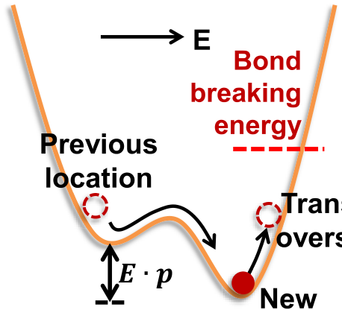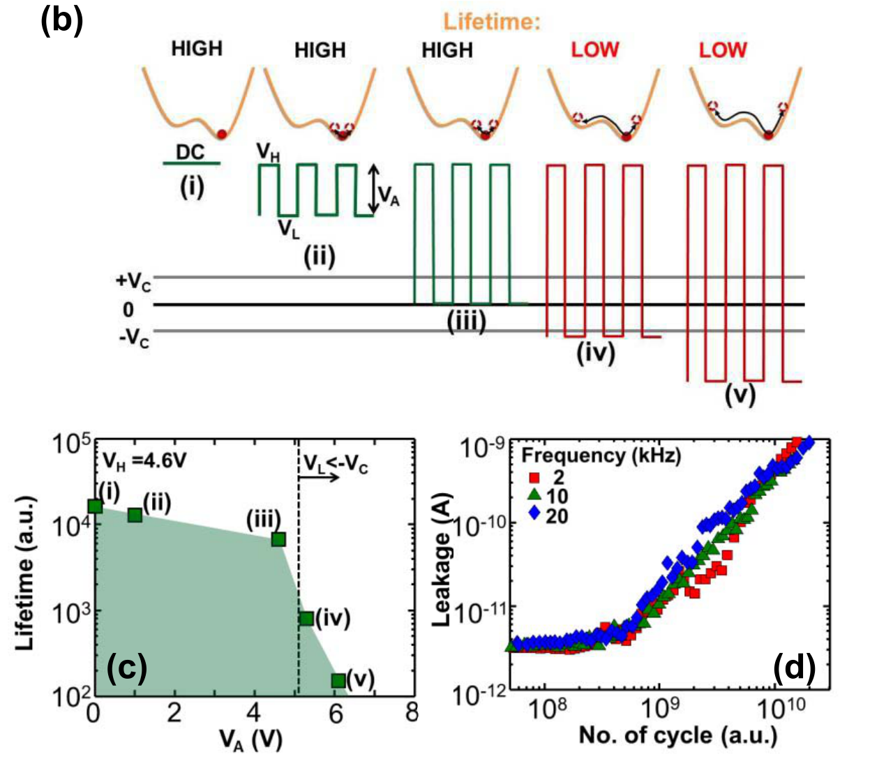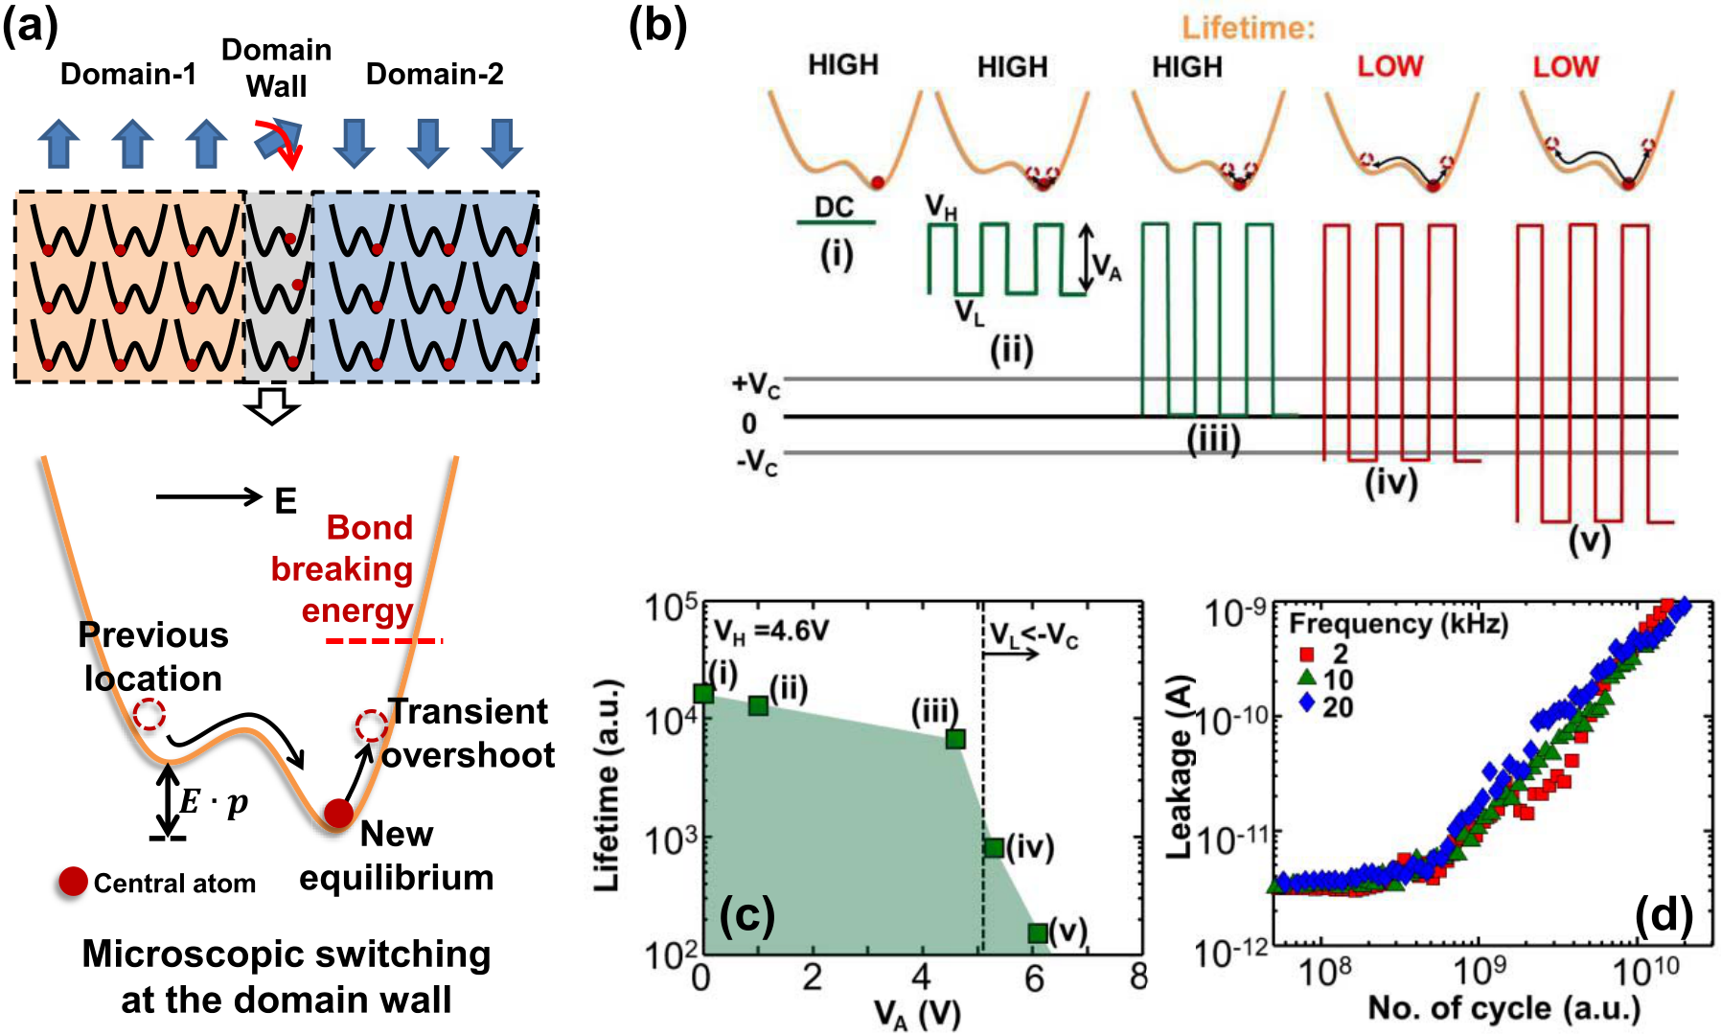

MASUDUZZAMAN *et al.*: OBSERVATION AND CONTROL OF HOT ATOM DAMAGE IN FERROELECTRIC DEVICES 3491

Fig. 1. Experimental evidence of the hot atom damage. (a) Schematic of microscopic switching at the domain walls of a ferroelectric material under a given applied electric field (*E*) (top) and the double-well energy landscape for each microscopic switching (bottom). Microscopic switching from the previous state results in a transient overshoot of the central atom (Ti/Zr for PZT) from the new equilibrium location (hot atom) and makes it susceptible to breaking the associated bond. (b) Different pulses, shown with respect to the coercive voltages (±*Vc*), are used to establish the effect of switching in defect generation. Top row: corresponding energy landscape at *VH* , and the trajectory of the central atoms. (c) Leakage-limited dielectric lifetime is relatively high not only during dc stress, but also during ac stresses if the ac pulses do not lead to switching of atoms between the energy pockets. (d) Leakage current evolution for switching-ac pulses with different frequencies shows that the damage primarily depends, not on the time duration of the ac stress, but on the number of the switching cycles.

II. EXPERIMENTAL EVIDENCE AND CHARACTERISTICS OF HOT ATOM DAMAGE

The following experiments are based on typical polycrys-talline PZT ferroelectric samples (thickness ∼70 nm) with iridium (Ir) bottom and IrO2 top electrodes [16]. First, consider the kinetics of defect generation under a dc stress as a reference point. A dc stress stretches the bond within a single energy pocket, but does not involve periodic oscillations of atoms between the pockets [Fig. 1(b.i)]. Any transient over-shoot occurs only once and dies immediately after the dc bias is applied, and thus the role of hot atoms in defect formation is negligible. Instead, a dc bias increases the bond dissociation probability ( *f )* by reducing the activation energy, *E*′*A*, since

*EA*0 is the activation energy at the relaxed condition, *E*loc is *f* ∼ exp*(*−*E*′*A/kT )* [17], where *E*′*A*= *EA*0− *(pi* × *E*loc*)*,

the local electric field, and *pi* is the polarization of individual bonds (significant for bonds involving the central Ti/Zr atom of PZT lattice), and *kT* reflects the average phonon energy available for (stochastic) bond dissociation. As defects are generated, leakage current through the capacitor increases. The reference lifetime, defined by a leakage current threshold [18] (Appendix A) for the dc stress is shown in Fig. 1(c.i).

To explore the implications of the polarization switching on defect generation, we design [19] a set of pulses with fixed top *(VH)*, but variable bottom (*VL*) levels, as shown

in Fig. 1(b.ii–v). The pulse amplitude (*VA)* is modulated by gradually lowering *VL*. As long as the pulse is non-switching, that is, *VL* is greater than the lower coercive voltage (−*VC)*, the atoms are confined within a single energy pocket [Fig. 1(b.ii and iii)]. The transient overshoot (the hot atom phenomenon) is minimum and the defect generation is dictated by *VH*. As a result, the lifetime is reduced only slightly from that of the dc stress [Fig. 1(c.i–iii)]. However, once *VL* crosses the lower coercive voltage (i.e., a switching pulse is applied), the Ti/Zr atoms at the domain walls are forced to switch to the neighboring energy pockets and is heated significantly by the transient overshoot. Because of the repeated domain wall motion, the defect generation increases dramatically across the entire volume of the ferroelectric, and is reflected in sharply reduced lifetime [Fig. 1(c.iv and v)]. This explicit threshold of leakage-limited lifetime related to the coercive voltage implies that the polarization switching generates defects and reduces the lifetime during the switching ac stress. Note that, since phonon energy is relatively small, the probability that a specific bond would break in any given cycle, especially at low fields, is small. However, the number of atoms undergoing the transition is so large (of the order of 1*/a*3 *l*, where *al* is the lattice constant) that a finite number of defects are generated in each cycle; these defects accumulate over time that leads to increased leakage through the sample [18], [20].

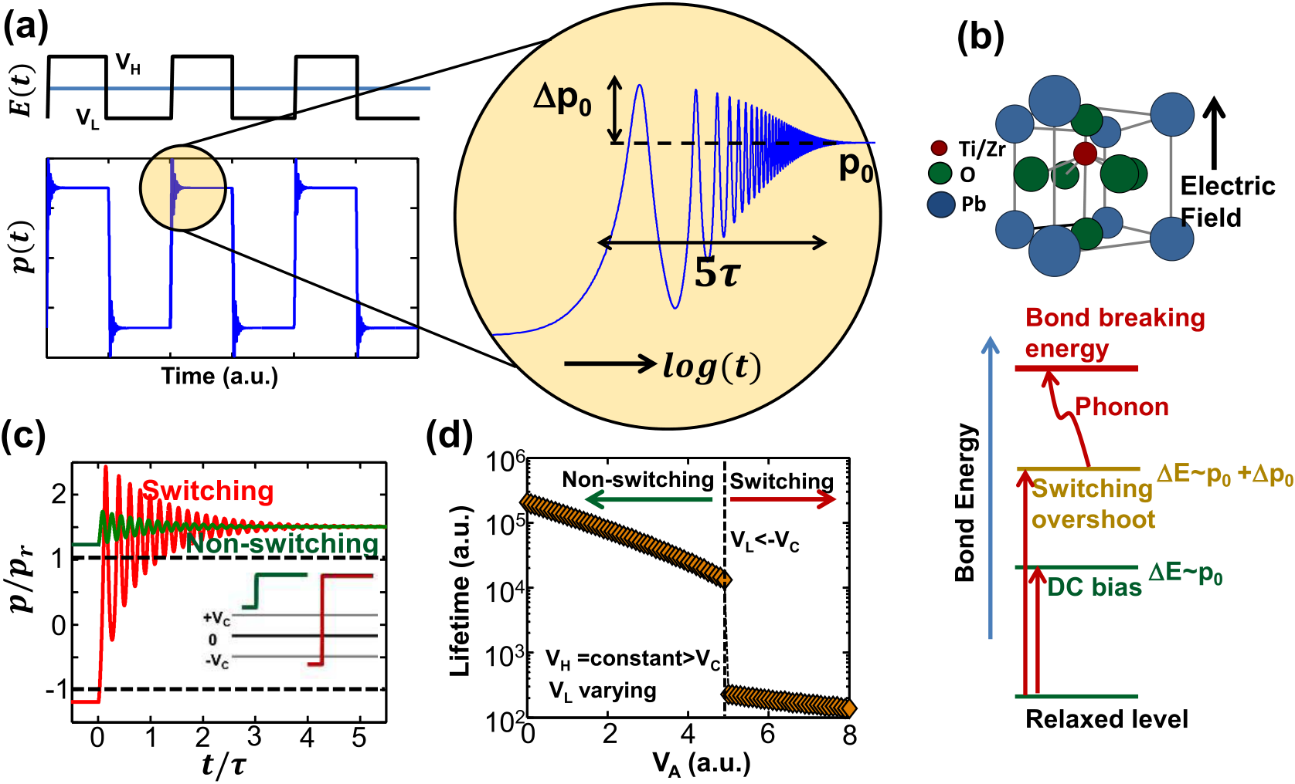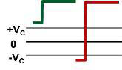

3492 IEEE TRANSACTIONS ON ELECTRON DEVICES, VOL. 61, NO. 10, OCTOBER 2014

Fig. 2. Physical model for the hot atom damage. (a) Polarization dynamics is shown for an applied ac pulse. For every switching event, there is an associated overshoot in polarization (*�p*0, with time constant *τ*) giving more energy to the associated bonds. (b) Contribution of different bias components to the total bond energy is shown schematically. The dc bias increases the bond energy to some extent, which is further enhanced by an ac pulse overshoot. The rest of the energy is taken from the lattice phonons to reach the bond-breaking energy. As shown in (c), the overshoot is much higher for a switching pulse (red) than a nonswitching pulse (green). *p/pr* = ±1 (horizontal lines: two equilibrium polarization states at zero bias), where *pr* is the remnant polarization. (d) Calculated lifetime for different ac pulses with varying *VL* and fixed *VH* (*>Vc)* shows a significant reduction in lifetime (more than an order of magnitude), for *VL <* −*Vc*, that is, when the nonswitching pulses change to switching pulses [Fig. 1(b)].

For further verification of the switching-induced damage, periodically. The corresponding equation of motion is given we apply a switching pulse train with very narrow pulse-width by

(∼500 ns), so that any effect caused by the dc stress compo-nent is suppressed (Appendix B). The evolution of the leakage current (a measure of cumulative defect generation) shows very little dependence on frequency, and it depends almost exclusively on the number of the switching pulses [Fig. 1(d)], confirming the essential role of the switching in creating hot atom damage. Also, because switching occurs throughout the volume of the ferroelectric material, hot atom damage is a bulk phenomenon. This is evidenced from the increased leakage current (see Appendix C for supporting experiments). As an aside, note that for the purpose of acceleration, the stress voltages used in these experiments [Fig. 1c] were increased significantly above the 1.5 V nominal operation for these PZT thin films. At nominal operation defect generation is reduced and robust endurance has been demonstrated [21].

III. THEORETICAL MODEL

The physical origin of this switching-assisted hot atom damage within the bulk region can be phenomenologically described by the Landau theory of oscillator in an double-well energy landscape [22], coupled to an elementary ther-mochemical model of bond dissociation and defect generation [17]. For a dc applied field, the local microscopic polarization *pi* for the Ti/Zr atom is a constant depending on the field. But for an ac electric field, as the domain walls move back and forth, the local Ti/Zr atoms, and hence *pi(t)*, oscillates

*M d*2 *pi dt*2 + *� dpi dt*− *F(pi)* = *E(t)*  (1)

where *M* and *�* are the inertial and damping coefficients, respectively, which depend on the intrinsic material properties and extrinsic circuit elements (Appendix D), *E(t)* is the external applied field, and *F(pi)* is the field term related to the total system energy *U*, as *F(pi)* = −*dU/dpi*, where *U* = *a/*2*p*2 coefficients for the ferroelectric, and *k* is the first-neighbor *i*+ *b/*4*p*4 *i*+ *k*∇ *pi*. Here *a*, *b* are the Landau

coupling constant for switching [22].

Equation (1) can be solved to find *pi(t)* for any arbitrary applied pulse *E(t)*, for example, the square pulse, as in Fig. 2(a). As the pulse switches from *VH* to *VL* or vice versa, there is a microscopic polarization overshoot associated with the transition, as expected. The overshoot (*�p*0*)* decays expo-nentially to the final polarization level *p*0, with a characteristic stored energy within the bond, and greater susceptibility time constant of *τ* ∼ 2*M*/*�*. A higher *�p*0 implies increased to phonon-assisted bond dissociation [Fig. 2(b)]. Since the lifetime (∼1/ *f* ) depends exponentially on *EA*, it reduces dramatically when the transient overshoot *�p*0 becomes comparable with *p*0. As shown in Fig. 2(c), the overshoot*�p*0 is considerably higher for a switching pulse (*VL <* −*VC)* compared with a nonswitching pulse (*VL >* −*V C)*, for same *VH*. The corresponding change of lifetime as a function of pulse amplitude (*VA)*, as summarized in Fig. 2(d), offers

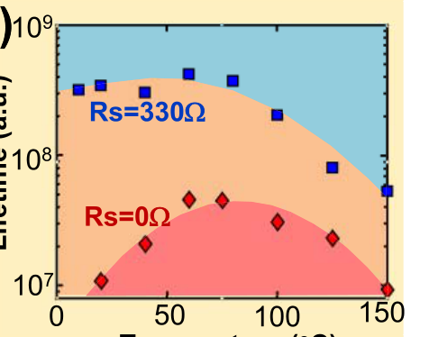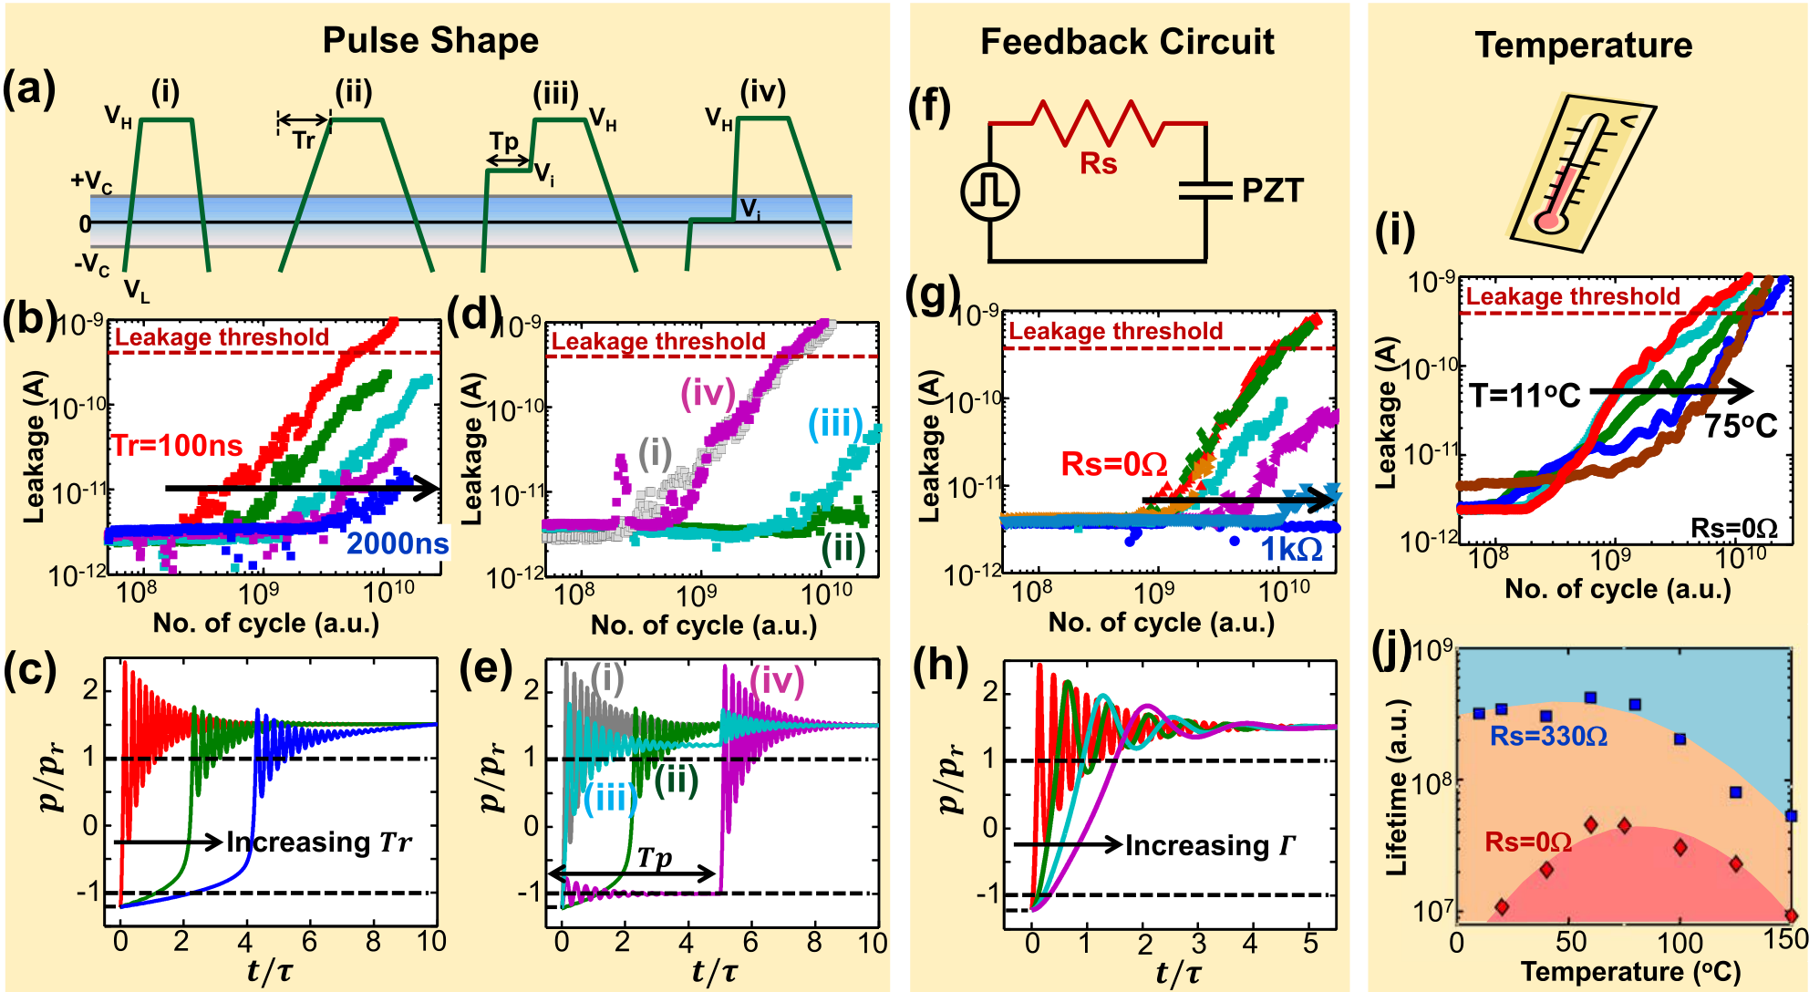

MASUDUZZAMAN *et al.*: OBSERVATION AND CONTROL OF HOT ATOM DAMAGE IN FERROELECTRIC DEVICES 3493

Fig. 3. overshoot. (b) Experimentally observed lifetime (defined by the number of cycles required to reach the leakage threshold) are shown to increase by an Control of the hot atom damage. (a) Various pulse-shapes (i–iv) with different types of transitions (*VL* → *VH*) are used to control the polarization

order of magnitude simply by increasing the transition time, *Tr*. (c) Corresponding simulation shows diminishing polarization overshoot for increased *Tr*. (d) Experimental leakage current evolution are shown for the four different shapes of input pulses as in (a.i–iv). As explained by the simulation in (e), case (ii) and (iii) have lower overshoots, whereas cases (i) and (iv) have higher overshoots. (f) Resistance connected in series modulates the switching transient, and thereby effectively increases *�*. As verified experimentally in (g), the lifetime increases with the increasing magnitude of the series resistance. With the increase of *�*, the decrease of the polarization overshoot is shown in (h) from the simulation. (i) As *�* increases at higher temperature, the lifetime is also shown to increase with temperature in the experiments. (j) However, beyond a critical temperature, there is a turnaround in lifetime as observed experimentally owing to the increasing likelihood of bond dissociation by phonon absorption.

a consistent explanation of the experiments in Fig. 1(c). Note that the model here has been used to *interpret* the

kinetic energy to the environment, with a reduced polarization overshoot and less hot atom damage. The two-step transition

|  |  |  |  |  |  |  |  |  |
| --- | --- | --- | --- | --- | --- | --- | --- | --- |
| experimental findings in a consistent way. To develop a | [Fig. | 3(a.iii | and | iv)]—a | variant | of | the | soft-switching |

predictive model, one must characterize the parameters [as used in (1)] using the first principle calculations.

IV. CONTROL OF HOT ATOM DAMAGE

As hot atom damage appears fundamental to double-well energy landscape, and given the necessity of ac switching in most ferroelectric devices, one wonders if it could be suppressed by innovative switching. Remarkably, (1) suggests several solutions, and in the following discussion, we consider three variants of soft-switching schemes based on pulse shap-ing, extrinsic dissipation by a series resistance, and enhanced local damping through higher temperature.

scheme, offers a similar improvement in lifetime [Fig. 3(d)], provided that the intermediate voltage step level (*Vi)* is above *VC* (case iii). In this case, the switching overshoot is initiated after the first *VL* to *Vi* transition [Fig. 3(e)], but can dissipate the excess energy at a lower voltage plateau (*Vi)* com-pared with the final voltage level, *VH*. Technologically, these soft-switching schemes offer opportunities for optimization between speed (performance) and lifetime of a ferroelectric device.

*B. Series Passive Elements*

A soft switching can also be induced by remote dissipation

|  |  |
| --- | --- |
| *A. Pulse Shaping* | of the excess energy. For example, a resistance (*RS)* connected in series with the ferroelectric device [Fig. 3(f)] offers a neg- |

Since the damage occurs because of switching, the pulses can be shaped particularly to minimize the transient over-shoot of the hot atoms. First, the effect of increased transi-tion time, as shown in Fig. 3(a.i and ii), is experimentally reflected in the increased number of pulses sustained by the ferroelectric capacitor [Fig. 3(b)] before the leakage current (proportional to defects generated) becomes significant. The theoretical simulation [Fig. 3(c)] shows that a slower tran-sition allows the moving atom more time to dissipate its

ative feedback of *I RS/T*OX to the applied field, *E* (1). Since the current *I* ∝ *A*OX*(d P/dt)*, where *P* is the macroscopic average of *pi*, the addition of *RS* will effectively increase the damping coefficient *�* by an amount *�R* = *ηRS A*OX*/T*OX, where *A*OX, *T*OX are the area and thickness of the ferroelectric, respectively, and *η* is the efficiency of switching at the domain

walls (Appendix D). Fig. 3(g) confirms experimentally that the

number of cycles sustained increases greatly with increasing

*RS*. The corresponding simulation [Fig. 3(h)] shows how *�p*0

3494 IEEE TRANSACTIONS ON ELECTRON DEVICES, VOL. 61, NO. 10, OCTOBER 2014

decreases with the increase of the net damping coefficient, explaining the increase of lifetime with the series resistance.

*C. Temperature Control*

Finally, with increasing temperature, the damping coeffi-cient (*�)* increases significantly because the atoms interact more frequently with the lattice, and thus have reduced overshoot during switching. This increases the number of cycles sustained by the PZT with temperature, as verified in our experiments [Fig. 3(i)]. Beyond a critical temperature (*T*∗∼ 75 C), this negative temperature activation switches increasing phonon energy at higher temperature, and the pos-sign, [Fig. 3(j), *RS* = 0]. The turnaround in lifetime reflects sibility of bond dissociation following absorption of relatively few phonons. The negative temperature activation disappears with increasing *RS*, because the weak temperature dependence of *�R* reduces the temperature sensitivity of the total damping coefficient *�* + *�R*. The disappearance of negative activation for *T < T*∗for *RS* = 330 *�* is experimentally confirmed [Fig. 3(j)].

Although the aforementioned schemes may require addi-tional circuit elements or may reduce the switching speed to some extent, these provide opportunities for tradeoff between reliability and performance or circuit complexity. Moreover, these experiments further confirm the hot atom hypothesis which suggests that if we can somehow slow down the transition of the switching atom, the defect generation would be reduced as well. The solution strategies proposed (pulse shaping, series resistor, higher temperature, etc.) all reduce this transition rate by different physical phenomena, and therefore they all successfully reduce defect generation and improve lifetime.

V. CONCLUSION

In general, ac switching may damage a ferroelectric material in different ways: 1) bulk defects may be generated through mechanisms such as hot atom damage; 2) charging of defects may occur due to electron/hole injection from the contacts; and 3) heating, stress, or gas accumulation may lead to delam-

of experiments, and interpreted the phenomenon as a conse-quence of shuttling of the hot atoms within a bistable energy landscape. Guided by the theory, we have also demonstrated a set of soft-switching schemes to reduce the hot atom damage and increase the lifetime dramatically. We find it not surprising that similar schemes (e.g., pulse-shaping [26] and series resis-tance [15]) have been effective in reducing damage due to hard-landing in micro- and nanoelectromechanical switches, because, after all, MEMS is also governed by analogous bistable energy landscape (a Landau structure). The generality of the formulation thus suggests future exploration of such hot atom damage, as well as the control mechanisms, in all bistable phase transition processes, such as MEMS, ferroic materials (multiferroics, ferromagnetics, and so on), resistive RAM and other nonvolatile memories and devices.

APPENDIX A

To measure the defects generated in the PZT dielectric after any arbitrary stress, we use a small sense voltage (typically 0.5 V) to measure the leakage current through the oxide. Because the leakage of a 70 nm thick oxide primarily depends on the defects within the oxide [18], [20], the current increases as new defects are created within the sample. The experimental setup used for applying any arbitrary stress pattern and simul-taneously sensing the leakage is shown in Fig. 4(a). The setup has a very low noise level and capable of measuring current as low as few tens of *f A*, as required for such measurements. For the switching experiments, we apply a specific pulse pattern, and interrupt it periodically for very short duration to measure the leakage current at the sense voltage [Fig. 4(b)]. This measure-stress-measure (MSM) method is a standard procedure for damage measurement for any arbitrary stress. As the defects are generated owing to the stress, the leakage current increases as a function of time, as shown in Fig. 4(c). A threshold level of leakage current is used to define the leakage-limited lifetime. It is very important to use a low sense voltage in the MSM measurements, because the high background leakage current at the stress voltage (dc) makes it difficult to monitor any incremental increase in leakage due to the defect

ination of contacts [11], [12], [23], and so on. The relative generation.

importance of these mechanisms depends on stress versus

|  |  |
| --- | --- |
| coercive voltages, Schottky barrier heights at the contacts, piezoelectric and thermal responses of the capacitor, and so | APPENDIX B |

forth. In this paper, we have demonstrated through multiple independent experiments that, in PZT materials, the switching causes bulk defect generation which increases leakage cur-rent, and eventually reduces leakage-limited dielectric lifetime. Because ferroelectric switching would always involve transi-tion of atoms between wells separated by an energy barrier, we believe that the hot atom damage should, in principle, occur, in varying degrees of importance, in all ferroelectric materials, such as, PZT, SBT, PVDF, doped HfO2 [23]–[25], and so on. The methodology presented in this paper (e.g., test patterns, ramp rates, and so on) can be used to quantify the hot atom damage in various materials.

Finally, to summarize, we have identified the hot atom damage during ferroelectric switching through a broad range

For a ferroelectric switching experiment, the top and the bot-tom levels of the applied pulse (*VH* and *VL)* should encompass both the coercive levels (i.e., *VH > VC* and *VL <* −*VC)* to ensure complete switching in every cycle. For example, during normal operation, the nominal operating voltage for switching of the PZT is *VH* = 1*.*5 V and *VL* = −1*.*5 V (here *VC* = 0*.*5 V). However, to accelerate the defect generation so that the lifetime falls within the measurement time limit (*<*105s), either or both of the pulse levels should be increased to some stress voltage. In our case, we only increased *VH* to the stress level (∼4*.*6 V), whereas *VL* is kept at a nominal voltage of 1*.*5 V [Fig. 5(a)], so that we only have one control variable for the voltage acceleration measurement. We also note that the device is a two terminal symmetric capacitor [16], and

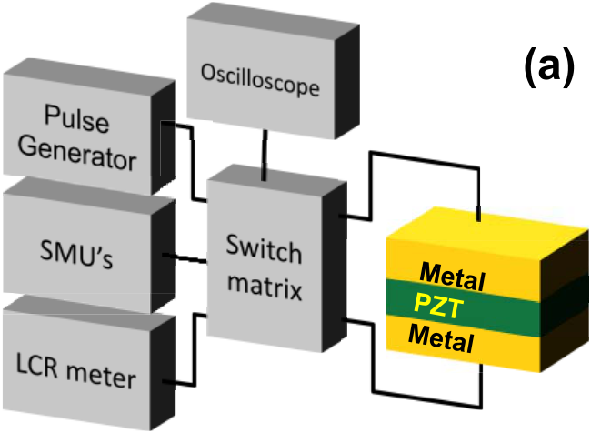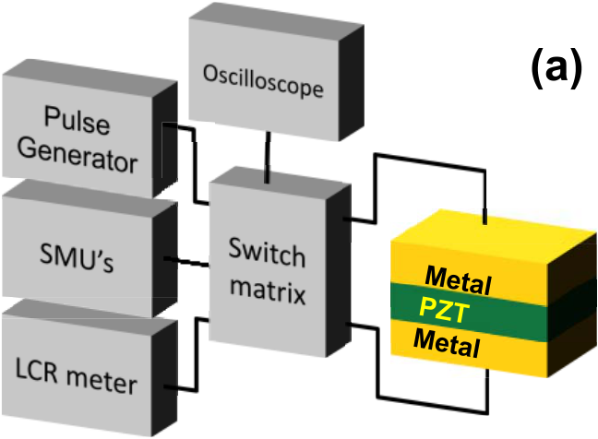

MASUDUZZAMAN *et al.*: OBSERVATION AND CONTROL OF HOT ATOM DAMAGE IN FERROELECTRIC DEVICES 3495

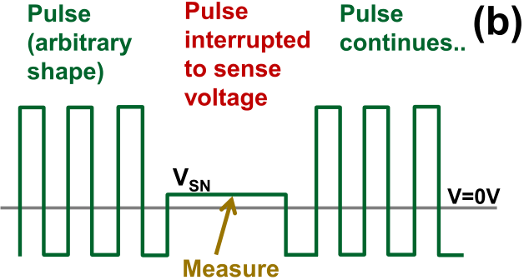



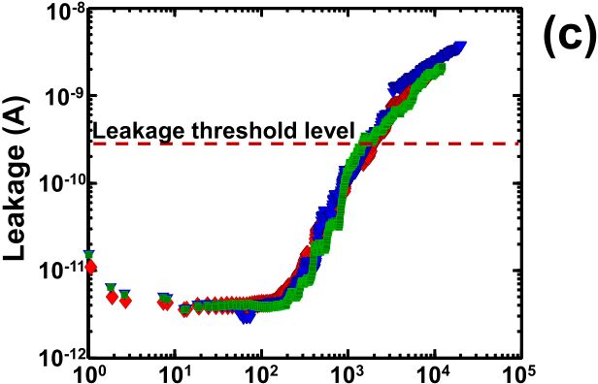



Fig. 4. Experimental setup for measuring leakage evolution as a function of stress. (a) Measurement setup consisting of different instruments connected by the programmable switch matrix to the sample. (b) Typical applied pulse

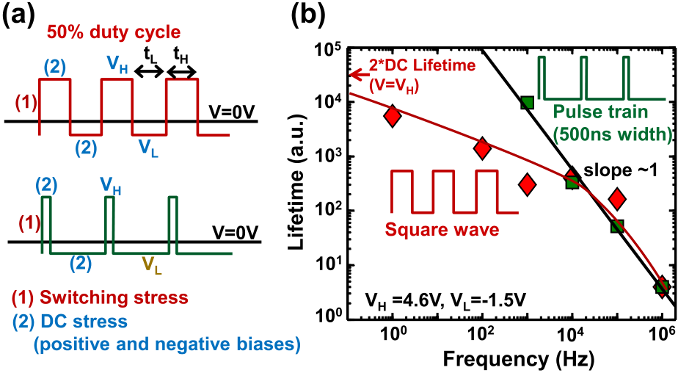

Fig. 5. Effects of square wave and pulse train on the lifetime. (a) Square wave (50% duty cycle), and a pulse train are shown along with the stress components. At low frequencies, the square wave also contains the dc stress component. On the other hand, the pulse train is appropriate for all frequencies for a switching stress. (b) Lifetime at different frequencies shows the deviation for the square wave case because of the additional dc stress. The lines are drawn as guides to eyes.

*tH* = 500 ns, and frequency = 10 kHz, even after 10 000 s of stressing, the effective dc stress time, *T*+ Thus, although *VH* is at the stress level, the narrow pulse *S*  = 50 s only.

train ensures that the dc stressing is negligible. Note that a pulse with 50% duty cycle could not avoid such dc stressing. Fig. 5(b) shows that for the pulse train, the lifetime is inversely proportional to frequency, as can be expected ideally when the damage depends on the applied number of cycles (*Cy)* for a switching stress. However, for a square pulse at low frequencies, we find that the lifetime does not scale linearly with frequency. This is because *T*+   
*S*becomes significant at low frequencies, and the damage is dominated by the dc stress. Thus, a square wave is not suitable, and the pulse train should be used as the input signal for the switching stress experiments.

|  |  |
| --- | --- |
| sequence for an MSM measurement. A pulse with the desired shape is periodically interrupted at the sense voltage to measure the damage using the leakage current. (c) Leakage current evolution (shown for three different | APPENDIX C |

samples) as a function of stress time at the sense voltage indicates creation of defects within the oxide. A threshold in leakage current (horizontal dashed line) has been used to define the leakage-limited dielectric lifetime.

therefore, the lifetime is identical irrespective of the particular symmetrical choice of *VH* or *VL* for the voltage acceleration.

Now, besides pulse levels, the duty cycle is also an impor-tant consideration for the following reason: a pulse exerts two different types of stresses—the switching stress during each transition and the dc stresses at the positive and the negative bias plateaus. The effective stress duration for the switching frequency*)*, and for dc stress as the time *T*+ stress is measured as the number of cycle (*Cy* = time ×

[Fig. 5(a)]. Because the damage modes could be very different *T*−*S*= *tL* × *Cy*, for positive and negative biases, respectively *S*= *tH* × *Cy*, and

in these two stress conditions and we need to examine only the effect of *switching stress*, we must avoid dc stressing in both positive and negative biases. As mentioned, the dc stressing at the negative bias is already avoided by keeping

damage is negligible within our measurement time window). *VL* at the nominal level (i.e., *VL* = −1*.*5 V, where the

However, to avoid the dc stressing at the positive bias, while still maintaining *VH* at a stress level, we use a narrow pulse train (a very low and fixed value of *tH)*. For example, with

During ferroelectric switching, as the domain wall pro-gresses, microscopic switching is expected in every functional unit cell across the bulk of the oxide, and the hot atom damage should occur stochastically over the volume of the ferroelectric film (bulk phenomenon). Besides the increased leakage current, this bulk characteristics is also reflected in capacitance measurements. Fig. 6(a) shows that after a dc (or a nonswitching ac) stress, there is no significant degra-dation of capacitance. However, after a switching ac stress for a similar duration, there is substantial capacitance degradation, indicating a significant bulk damage caused by the switching polarization.

The lifetime distribution for dc and switching stress also offers an alternate way to verify this bulk damage phenomenon, as follows. Previously, we have shown that, at dc stress, the leakage current path primarily consists of the grain boundaries (GBs) for a polycrystalline PZT, which have large number of preexisting defects [27]. On the other hand, at switching-ac stress, the microscopic switching mainly occurs at the grains and switching is inefficient at the GBs owing to the defective cells. Therefore, new defects are primarily generated at the grain regions. As a result, the stress-generated leakage path should consist of the gain regions. Because the grain regions have much less preexisting defect density



3496 IEEE TRANSACTIONS ON ELECTRON DEVICES, VOL. 61, NO. 10, OCTOBER 2014

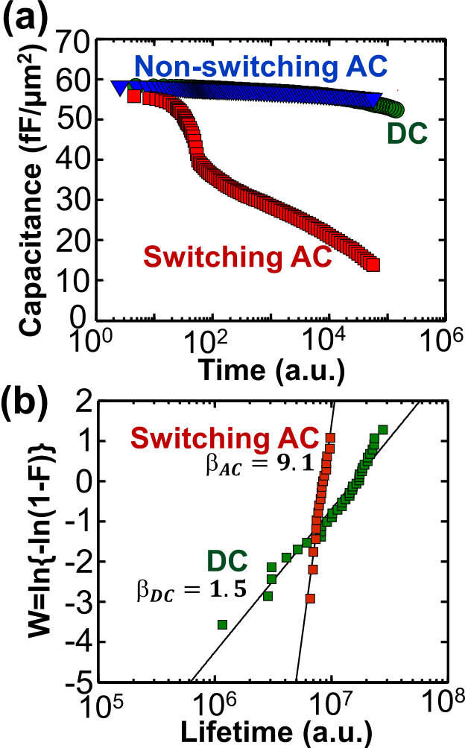

Fig. 6. Bulk characteristics of hot atom damage. (a) Bulk capacitance reduces significantly following a switching-ac stress (unlike a dc or a nonswitching-ac stress). (b) Cumulative failure fraction (*F*) for 35 samples with dc stress and 18 samples with switching-ac stress shows much higher *β*ac in a Weibull plot. Unlike the dc stress, the leakage path at switching-ac stress occurs within the grain region, and therefore a steeper distribution (*β*ac *> β*dc ) is expected and observed.

than the GB regions, one would expect from the classical percolation-based dielectric breakdown theory [28]–[30] that the lifetime distribution at ac stress should be much sharper than that of the dc stress (because more defects are required to cause a breakdown through a grain). This is indeed observed

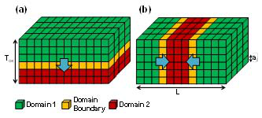

Fig. 7. Active cells for switching transients reside at the domain boundaries. Two simple scenario of domain wall movements are shown in (a) and (b). When an external bias is applied, the size of domain-1 (green) increases at the expense of domain-2 (red). The polarization flipping happens at domain walls (yellow), and thus the cells at the domain walls represent the potential active cells for switching damage. The ratio of the domain wall cells to the total number of cells can be calculated as *al/*¯*L D*. The average distance between domain walls,¯*L D* is found by total distance perpendicular to the domain walls, divided by the number of domain walls crossing the distance [i.e., cases (a) and (b), respectively]. ¯*L D*  = *T*OX*/*1 and ¯*L D*  = *L/*2 for the above two hypothetical

surface charge density as *QS* = *P* · ˆ*n* (C/m2*)*, where *N*TOT is the total number of unit cells in the materials, and ˆ*n* is a unit vector perpendicular to the oxide surface. For simplicity, we will avoid the vector notation by assuming that the applied electric field has the same direction parallel to that of the domains, and the adjacent domains have 180° orientation. Thus, the series current can be expressed as *I* = *A*OX ×*d/dt(QS)* = *A*OX × *d/dt(P)* = *A*OX × 1*/N*TOT   
Now, since only the cells at the domain boundaries are active at�*(d/dt pi)*. a time, *d/dt pi* = 0 for all the cells inside the domains (Fig. 7). Also if the total number of cells at the domain boundaries at a given time is *N*DW, then one can write�*(d/dt pi)* ∼identical time dynamics. Thus, one can estimate *I* as

|  |  |  |  |  |
| --- | --- | --- | --- | --- |
| (*β*ac ≫ *β*dc*)* in our experiments [Fig. 6(b)]. An important caveat related to the previous discussion is that | *I* ∼ *A*OX | � *N*DW | � *d dt pi* ≡ *A*OX × *η d dt pi.* | (3) |
| the percolation theory for lifetime distribution should apply |
| only if the capacitor lifetime is associated with a dielectric |
| Equation (2) can thus be simplified as | | |
| breakdown. Although our leakage-based capacitor lifetime |
| involves a high threshold level (at least two orders higher | *M d*2 *pi dt*2 + *(�* + *�R)dpi dt*− *F(pi)* = *E* | | | (4) |
| than the initial leakage current), and we see small jumps |
| in current transients [Fig. 4(c)] with a time exponent larger |

than unity (possibly indicating postbreakdown transient [31]), one must confirm the occurrence of dielectric breakdown at the threshold current level through experiments, such as the area dependence of the capacitor lifetime. The exact nature of dielectric breakdown owing to hot atom damage will be

where *�R* ≡ *ηRS A*OX*/T*OX. As shown in Fig. 7, *η* can be estimated as *η* ∼ *N*DW*/N*TOT ∼ *al/*¯*L D*, where *al* is the lattice parameter, and¯*L D* is the average distance between two con-

secutive domain walls. Thus, the series resistance effectively

increases the damping coefficient of the polarization dynamics

discussed in a future publication. at the domain walls.

Similarly, one can show that the presence of a series

APPENDIX D   
 The presence of a series resistor (*RS)* with a ferroelectric capacitor will modify the polarization dynamics (1) as   
 *M d*2 *pi dt*2 + *� dpi dt*− *F(pi)* = *E* − *I RS/T*OX (2)

where *I* is the total current through the circuit, and *T*OX is the thickness of the oxide. The macroscopic polarization of the material *P*, defined as *P* = 1*/N*TOT� *pi*, is related to the

inductor (*LS)* effectively increases the coefficient *M* in (1) by *ML* increases the coefficient of = *ηLS A*OX*/T*OX, and a series capacitance (*CS) pi*  (*a*, as found within the term F*(pi)* as −F*(pi)* = *api* + *bp*3 the center hump of the double-well potential landscape) by *i*+ · · · , characterizing

*aC* = *η(*1*/CS)A*OX*/T*OX. In summary, the series *RS* and *LS* increase the damping and the inertial coefficients of the switching dynamics, respectively, and *CS* flattens the potential landscape for the switching.

MASUDUZZAMAN *et al.*: OBSERVATION AND CONTROL OF HOT ATOM DAMAGE IN FERROELECTRIC DEVICES 3497

ACKNOWLEDGMENT   
 The authors would like to thank Birck Nanotechnology Center at Purdue University for experimental facilities.

[24] H. N. Al-Shareef, D. Dimos, T. J. Boyle, W. L. Warren, and B. A. Tuttle,“Qualitative model for the fatigue-free behavior of SrBi2Ta2O9,” *Appl. Phys. Lett.*, vol. 68, no. 5, pp. 690–692, 1996.

[25] T. S. Böscke, J. Müller, D. Bräuhaus, U. Schröder, and U. Böttger,

|  |  |
| --- | --- |
| REFERENCES | “Ferroelectricity in hafnium oxide thin films,” *Appl. Phys. Lett.*, vol. 99, no. 10, p. 102903, 2011.  [26] D. A. Czaplewski *et al.*, “A soft-landing waveform for actuation of a |

[1] G. Catalan, J. Seidel, R. Ramesh, and J. F. Scott, “Domain wall nanoelectronics,” *Rev. Modern Phys.*, vol. 84, no. 1, p. 119, 2012.

[2] C. H. Ahn *et al.*, “Local, nonvolatile electronic writing of epitax-ial Pb(Zr0*.*52Ti0*.*48)O3/SrRuO3 heterostructures,” *Science*, vol. 276, no. 5315, pp. 1100–1103, 1997.

[3] R. Ramesh and N. A. Spaldin, “Multiferroics: Progress and prospects in thin films,” *Nature Mater.*, vol. 6, no. 1, pp. 21–29, 2007.

[4] H. Takagi and H. Y. Hwang, “An emergent change of phase for electronics,” *Science*, vol. 327, no. 5973, pp. 1601–1602, 2010.

[5] S. Salahuddin and S. Datta, “Use of negative capacitance to provide voltage amplification for low power nanoscale devices,” *Nano Lett.*, vol. 8, no. 2, pp. 405–410, 2008.

[6] A. I. Khan *et al.*, “Experimental evidence of ferroelectric negative capacitance in nanoscale heterostructures,” *Appl. Phys. Lett.*, vol. 99, no. 11, p. 113501, 2011.

[7] J. F. Scott, *Ferroelectric Memories*. Berlin, Germany: Springer-Verlag, 2000.

[8] M. Dawber, K. M. Rabe, and J. F. Scott, “Physics of thin-film ferro-electric oxides,” *Rev. Modern Phys.*, vol. 77, no. 4, p. 1083, 2005.

[9] E. Fatuzzo, “Theoretical considerations on the switching transient in ferroelectrics,” *Phys. Rev.*, vol. 127, no. 6, pp. 1999–2005, 1962.

[10] V. Gopalan and T. E. Mitchell, “Wall velocities, switching times, and the stabilization mechanism of 180° domains in congruent LiTaO3 crystals,”*J. Appl. Phys.*, vol. 83, no. 2, pp. 941–954, 1998.

[11] M. Dawber and J. F. Scott, “A model for fatigue in ferroelectric

single-pole single-throw ohmic RF MEMS switch,” *J. Microelectromech. Syst.*, vol. 15, no. 6, pp. 1586–1594, 2006.

[27] M. Masuduzzaman *et al.*, “The origin of broad distribution of breakdown times in polycrystalline thin film dielectrics,” *Appl. Phys. Lett.*, vol. 101, no. 15, p. 153511, 2012.

[28] E. Y. Wu, J. Sune, and W. Lai, “On the Weibull shape factor of intrinsic breakdown of dielectric films and its accurate experimen-tal determination. Part II: Experimental results and the effects of stress conditions,” *IEEE Trans. Electron Devices*, vol. 49, no. 12, pp. 2141–2150, Dec. 2002.

[29] M. A. Alam, B. E. Weir, and P. J. Silverman, “A study of soft and hard breakdown—Part II: Principles of area, thickness, and voltage scaling,”*IEEE Trans. Electron Devices*, vol. 49, no. 2, pp. 239–246, Feb. 2002.

[30] M. A. Alam, B. E. Weir, P. J. Silverman, Y. Ma, and D. Hwang,“The statistical distribution of percolation resistance as a probe into the mechanics of ultra-thin oxide breakdown,” in *Proc. Int. Electron Devices Meeting*, Dec. 2000, pp. 529–532.

[31] M. A. Alam and R. K. Smith, “A phenomenological theory of correlated multiple soft-breakdown events in ultra-thin gate dielectrics,” in *Proc.*

*41st Annu. IEEE Int. Rel. Phys. Symp.*, Apr. 2003, pp. 406–411.

|  |  |  |  |  |  |
| --- | --- | --- | --- | --- | --- |
| perovskite thin films,” *Appl. Phys. Lett.*, vol. 76, no. 8, pp. 1060–1062, |  | **Muhammad** | **Masuduzzaman** | | (SM’09–M’13) |
| 2000. |
| received the Ph.D. degree from Purdue University, | | | |
| [12] A. K. Tagantsev, I. Stolichnov, E. L. Colla, and N. Setter, “Polarization | West Lafayette, IN, USA, in 2012. His current | | | |
| fatigue in ferroelectric films: Basic experimental findings, phenomeno- | research interests include design, performance and | | | |
| logical scenarios, and microscopic features,” *J. Appl. Phys.*, vol. 90, | reliability of novel electronic devices, transistors, | | | |
| no. 3, pp. 1387–1402, 2001. | microelectromechanical | | systems, and nonvolatile | |
| [13] J. F. Scott, B. M. Melnick, L. D. McMillan, and C. A. Paz de Araujo, | memories. | | | |
| “Dielectric breakdown in high-*ε* films for ULSI DRAMs,” *Integr.* |
| *Ferroelectr., Int. J.*, vol. 3, no. 3, pp. 225–243, 1993. |
| [14] W. Pan, C.-F. Yue, and O. Tosyali, “Fatigue of ferroelectric polarization |
| and the electric field induced strain in lead lanthanum zirconate titanate |

ceramics,” *J. Amer. Ceram. Soc.*, vol. 75, no. 6, pp. 1534–1540, 1992.

[15] A. Jain, P. R. Nair, and M. A. Alam, “Strategies for dynamic soft-  
landing in capacitive microelectromechanical switches,” *Appl. Phys.*   
*Lett.*, vol. 98, no. 23, p. 234104, 2011.

|  |  |  |  |
| --- | --- | --- | --- |
| [16] J. A. Rodriguez *et al.*, “Reliability properties of low-voltage ferroelectric |  | **Dhanoop Varghese** | (M’10) received the Ph.D. |
| capacitors and memory arrays,” *IEEE Trans. Device Mater. Rel.*, vol. 4, |
| degree in electrical engineering from Purdue Univer- | |
| no. 3, pp. 436–449, Sep. 2004. |
| sity, West Lafayette, IN, USA, in 2009. He has been | |
| [17] J. W. McPherson and H. C. Mogul, “Underlying physics of the ther- |
| with Texas Instruments Inc., Dallas, TX, USA, since | |
| mochemical *E* model in describing low-field time-dependent dielec- | 2009. His current research interests include semi- | |
| tric breakdown in SiO2 thin films,” *J. Appl. Phys.*, vol. 84, no. 3, pp. 1513–1523, 1998. | conductor device physics, and simulation, modeling, | |
| and characterization of various transistor degradation | |
| [18] M. A. Alam, “SILC as a measure of trap generation and predictor of | mechanisms. | |
| T*BD* in ultrathin oxides,” *IEEE Trans. Electron Devices*, vol. 49, no. 2, pp. 226–231, Feb. 2002. |
| [19] M. Masuduzzaman and M. Alam, “Hot atom damage (HAD) limited |

TDDB lifetime of ferroelectric memories,” in *Proc. IEEE Int. Electron*   
*Devices Meeting (IEDM)*, Dec. 2013, pp. 21.4.1–21.4.4.

[20] J. Q. Yang, M. Masuduzzman, J. F. Kang, and M. A. Alam,

|  |  |  |
| --- | --- | --- |
| “SILC-based reassignment of trapping and trap generation regimes of |  | **John A. Rodriguez** (M’94) received the Ph.D. |
| positive bias temperature instability,” in *Proc. IEEE Int. Rel. Phys. Symp.* |
| *(IRPS)*, Apr. 2011, pp. 3A-3.1–3A-3.6. |
| degree in electrical engineering from Rice University |
| [21] J. Rodriguez *et al.*, “Reliability of ferroelectric random access memory |
| in Houston, Texas. He is a Distinguished Member |
| embedded within 130 nm CMOS,” in *Proc. IEEE Int. Rel. Phys. Symp.* |
| of Technical Staff at Texas Instruments in Dallas, |
| *(IRPS)*, May 2010, pp. 750–758. |
| TX, where he researches the reliability physics of |
| [22] D. Ricinschi, C. Harnagea, C. Papusoi, L. Mitoseriu, V. Tura, and |
| ferroelectric memory. |
| M. Okuyama, “Analysis of ferroelectric switching in finite media as a |
| Landau-type phase transition,” *J. Phys., Condens. Matter*, vol. 10, no. 7, |
| pp. 477–492, 1998. |
| [23] D. Zhao *et al.*, “Polarization fatigue of organic ferroelectric capacitors,” |
| *Sci. Rep.*, vol. 4, p. 1, May 2014. |

|  |  |  |  |  |  |  |
| --- | --- | --- | --- | --- | --- | --- |
| 3498 | **Srikanth Krishnan** | (S’86–M’87–A’92) received | | | IEEE TRANSACTIONS ON ELECTRON DEVICES, VOL. 61, NO. 10, OCTOBER 2014 | |
|  |  | **Muhammad Ashraful Alam** (M’96–SM’01–F’06) received the Ph.D. degree from Purdue Univer-sity, West Lafayette, IN, USA, in 1995. His cur-rent research interests include the reliability and performance of emerging electronic devices, such as microelectromechanical systems, biosensors, and solar cells. |
| the Ph.D. degree in engineering | | science | from |
| Pennsylvania State University, State College, PA, | | | |
| USA, in 1992, and the M.B.A. degree from Southern | | | |
| Methodist University, University Park, TX, USA. | | | |
| He is currently the Device Reliability Manager with | | | |
| Texas Instruments Inc., Dallas, TX, USA, where he | | | |
| is responsible for component reliability of CMOS | | | |
| technology nodes. | | | |