1300 IEEE ELECTRON DEVICE LETTERS, VOL. 33, NO. 9, SEPTEMBER 2012

Ten-Nanometer Ferroelectric Si:HfO2 Films for

Next-Generation FRAM Capacitors

Stefan Mueller, Scott R. Summerfelt, *Member, IEEE*, Johannes Müller, *Student Member, IEEE*,

Uwe Schroeder, *Member, IEEE*, and Thomas Mikolajick, *Senior Member, IEEE*

***Abstract*—Ferroelectric properties of Si-doped HfO2 thin films (10 nm) have been investigated. The focus of this letter is to evaluate the potential applicability of these thin films for future 3-D ferroelectric random access memory capacitors. Polariza-tion switching was tested at elevated temperatures up to 185*◦*C and showed no severe degradation. Domain switching dynam-ics were electrically characterized with pulse-switching tests and were not in accordance with Kolmogorov–Avrami-type switching. Nucleation-limited switching is proposed to be applicable for these new types of ferroelectric thin films. Furthermore, same-state and opposite-state retention tests were performed at 125*◦*C up to 20 h. It was found that samples that had previously been annealed at 800*◦*C showed improved retention of the written state as well as of the opposite state. In addition, fatigue measurements were carried out, and no degradation occurred for 106programming and erase cycles at 3 V.**

***Index Terms*—Doped HfO2, ferroelectric HfO2, ferroelec-tric thin films, ferroelectric random access memory (FRAM), nucleation-limited switching (NLS).**

I. INTRODUCTION

**T** represents a memory concept which combines fast access HE FERROELECTRIC random access memory (FRAM)

times in the range of nanoseconds with nonvolatile data storage.

The permanent storage of states is achieved by using a ferro-

electric capacitor in a memory cell which is similar to a 1T–1C

architecture of traditional dynamic random access memories.

The most common material used as ferroelectric insulator to

date is Pb[Zr*x*Ti1*−x*]O3 (PZT) which has been scaled down to the 130-nm technology node [1].

In order to reduce the size of an elementary FRAM cell even

further, a transition from planar capacitors to 3-D stack capac-

itors seems inevitable [2]. However, due to their architecture,

Manuscript received March 19, 2012; accepted June 12, 2012. Date of publication July 24, 2012; date of current version August 21, 2012. This work was supported in part within the scope of technology development by the EFRE fund of the European Community, by the Free State of Saxony (Project HEIKO), and by a grant from Texas Instruments. The review of this letter was arranged by Editor M. Östling.

S. Mueller and U. Schroeder are with NaMLab gGmbH, 01187 Dresden, Germany (e-mail: stefan.mueller@namlab.com).

S. R. Summerfelt is with Texas Instruments, Dallas, TX 75243 USA.

J. Müller is with Fraunhofer CNT, 01099 Dresden, Germany.

T. Mikolajick is with NaMLab gGmbH, 01187 Dresden, Germany, and also with the Institute of Semiconductors and Microsystems, Technische Universität Dresden, 01187 Dresden, Germany.

Color versions of one or more of the figures in this letter are available online at http://ieeexplore.ieee.org.

Digital Object Identifier 10.1109/LED.2012.2204856

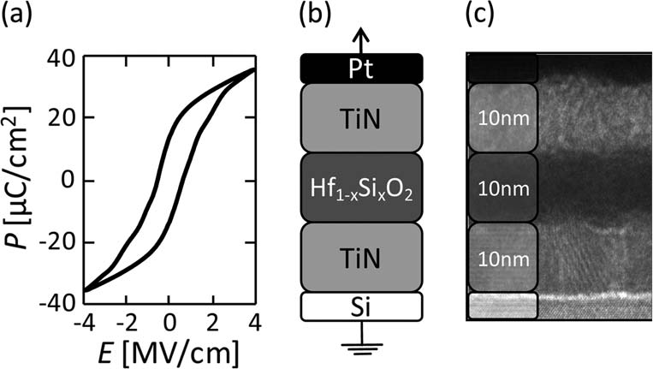

Fig. 1. sponse to an applied rectangular voltage signal. A remanent polarization of (a) *P−E* characteristics resulting from the integrated current re-

approximately 15 *µ*C/cm2and a coercive field of 1 MV/cm can be extracted. (b) Schematic of the stack. (c) TEM micrograph of the MIM stack which shows the polycrystalline nature of the silicon-substituted HfO2.

these different types of capacitors essentially require a reduc-tion of the ferroelectric layer thickness. As previous studies have shown [3], this represents a major obstacle for traditional ferroelectric materials since the ferroelectric properties degrade or even vanish for small film thicknesses.

On the other hand, there are certain dielectrics, like STO, which possess paraelectric properties as bulk materials but become ferroelectric under certain conditions like mechanical confinement or doping [4], [5]. Only recently, these properties have been discovered for doped HfO2 [6]–[10]. Incorporation of substituting elements like silicon, zirconium, yttrium, or alu-minum as well as mechanical confinement using TiN electrodes can stabilize a ferroelectric phase in hafnium oxide.

II. EXPERIMENTS

In order to characterize polarization switching of the substi-tuted hafnium oxide, metal–insulator-metal (MIM) capacitors (104*µ*m2) were manufactured on highly doped silicon sub-strates. TiN bottom and top electrodes of 10-nm thickness were deposited by pulsed chemical vapor deposition at 450*◦*C, and the 10-nm ferroelectric Si:HfO2 was formed by atomic layer deposition at 350*◦*C. The precursor gases tetrakisethylmethy-laminohafnium and tetrakisdimethylaminosilane were used in a 16 : 1 pulsing ratio effectively achieving 3.8 mol% of incorpo-rated SiO2. Rapid thermal annealing was carried out at 650*◦*C in nitrogen environment. Evaporated platinum dots served as contact for electrical characterization. Characteristics of the MIM stack are shown in Fig. 1.

The hysteretic charge–voltage relationship was characterized by polarization measurements. Therefore, a triangular voltage

0741-3106/$31.00 © 2012 IEEE

MUELLER *et al.*: TEN-NANOMETER FERROELECTRIC Si:HfO2 FILMS FOR NEXT-GENERATION FRAM CAPACITORS 1301

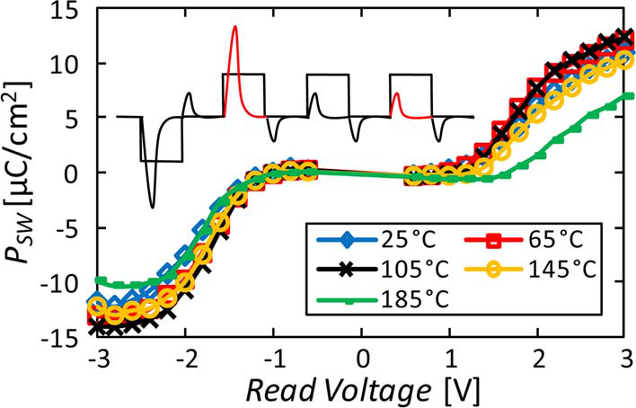

Fig. 2. Switched polarization extracted from pulse-switching tests for sym-metric WRITE and READ voltages at elevating temperatures. Significant tem-perature degradation only occurs at 185*◦*C. The inset shows a schematic of the applied pulse train (10-*µ*s pulses with 1-s delay time) and (red) the extracted current responses used for calculating the switched polarization.

signal was applied to the capacitor, and the resulting current response was integrated with respect to the voltage using a vir-tual ground amplifier. The resulting *P−E* hysteresis is shown in Fig. 1(a).

Furthermore, by using the shunt technique, pulse switching at elevated temperature and same-state and opposite-state reten-tion tests as well as fatigue measurements have been performed within our studies.

III. RESULTS AND DISCUSSION

In order to analyze the switching characteristics of the thin-film ferroelectric, standard pulse-switching tests were carried out. Four voltage pulses were applied to the MIM capacitor, whereas only the first pulse was of opposite polarity. By sub-tracting the current response of the second and the fourth pulses, it is possible to extract the real ferroelectric switching current. Delay times of 1 s between all of the pulses reduce potential errors due to relaxation. These tests were performed for various symmetric voltage amplitudes and at different temperatures

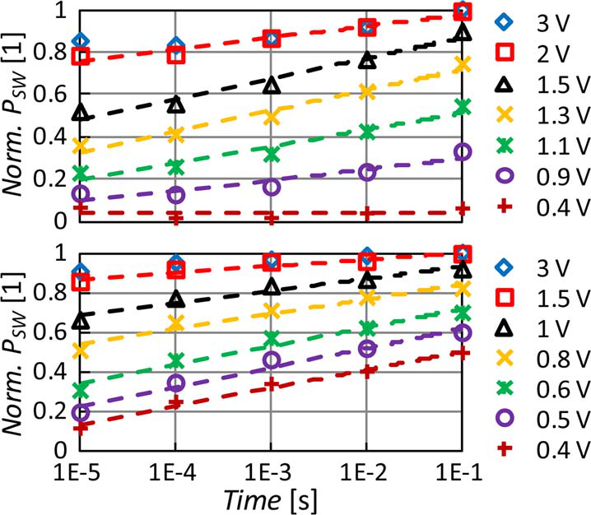

Fig. 3. Normalized switched polarization versus WRITE pulsewidth for (top) negative and (bottom) positive WRITE amplitudes. The linear relationship between pulsewidth and switched charge indicates that switching is nucleation limited and not governed by the speed of domain wall motion. Polarity depen-dence of switching speed reflects imprint characteristics as observed previously. The normalization was performed with respect to *P*SW obtained for 3 V at 0.1-s pulsewidth.

We observed a logarithmic dependence of switched polar-ization and WRITE pulsewidth for voltages close to the co-ercive voltage. This behavior is not in accordance with the traditional Kolmogorov–Avrami switching which would pre-dict an exponential dependence between switched polariza-tion and pulsewidth [11]–[13]. A similar behavior has already been observed for polycrystalline Pb(Zr*,* Ti)O3 thin films with 135-nm thickness [14], and a nucleation-limited switching (NLS) model had been derived. This model neglects the kinetics of domain coalescence and is mainly based on nucleation statistics represented by a partially defined distribution function *g*(*z*) [15]. As already mentioned, a consistent data set could be achieved for pulsewidths between 10 *µ*s and 100 ms. Within this range, a logarithmic fit led to a good interpolation of the acquired data and indicated that the thin-film switching dynam-

(Fig. 2). ics are in accordance to the previously defined NLS model.

Slightly asymmetric switching behavior indicates imprint most likely caused by the electrode interfaces. The small in-crease of switched polarization from 25*◦*C to 105*◦*C can be assigned to initial poling of the sample. During our studies, this was observed to be an intrinsic property for many of the Si:HfO2 compositions. The switching behavior was stable up to 145*◦*C. At 185*◦*C, degradation of *P*SW was clearly visible. Based on a more detailed temperature-dependent study of the switching characteristics, a Curie temperature of approximately 400*◦*C was linearly extrapolated based on remanent polariza-tion values in the range between 150*◦*C and 205*◦*C.

Furthermore, switching dynamics of the ferroelectric thin films were investigated using the same pulse scheme as de-scribed before. In addition, the WRITE pulsewidths (first and third pulses) were varied from 10 *µ*s to 100 ms. Since the *RC* delay of the measurement setup was in the range of microsec-onds, no pulses shorter than 10 *µ*s had been applied. The READ pulses (second and fourth pulses) had a constant amplitude and width of *±*3 V and 10 *µ*s, respectively. Switching dynamics are reported in terms of normalized switched polarization versus WRITE pulsewidth (Fig. 3).

The fact that the thin-film layers are only 10 nm in thickness further supports the hypothesis that the switching dynamics are dominated by the statistical distribution of nucleation times rather than by domain coalescence.

In order to test the retention characteristics of ferroelec-tric thin films, same-state and opposite-state retention tests at elevated temperatures are commonly used [16]. For these measurements, the samples are poled in one of the two possible ferroelectric states and then put into an oven for a certain bake time. In our studies, a bake temperature of 125*◦*C was used, and the polarization measurements were performed at room temperature. For the first retention tests, the same samples as described in Section II had been used. However, these samples showed strong degradation of the opposite-state polarization, i.e., significant imprint [Fig. 4(a)].

For another retention test, samples with larger amounts of incorporated silicon (5.3 mol% SiO2, pulsing ratio 10 : 1, and 10 nm thickness) were annealed at 800*◦*C in order to achieve larger *Pr* values and were characterized as described before. These samples showed significantly improved retention char-acteristics, particularly with respect to opposite-state retention

1302 IEEE ELECTRON DEVICE LETTERS, VOL. 33, NO. 9, SEPTEMBER 2012

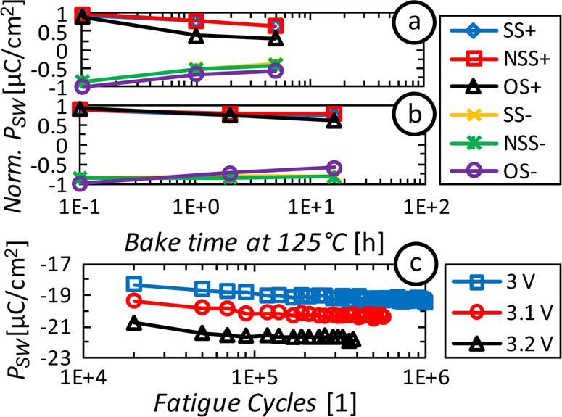

Fig. 4. Same-state and opposite-state retention tests performed at 125*◦*C bake times. Sample (a) shows severe degradation of the opposite state, whereas sample (b) has significantly improved retention characteristics and only small degradation of the opposite state up to 20 h of bake time. (c) Endurance tests show a sharp breakdown at voltages above 3 V.

[Fig. 4(b)]. Moreover, endurance measurements were carried out by exposing the samples to 106bipolar voltage cycles of different amplitude. Sharp breakdown characteristics can be observed for voltages above 3 V. The increase of switched polarization with cycling can again be attributed to the incre-mental poling of the sample.

Compared to state-of-the-art PZT-based FRAM capacitors, which can achieve up to 1014endurance cycles, same-state and opposite-state retentions up to 103h, and stable operation in the range of *−*40*◦*C to 125*◦*C [17], the presented data are not sufficient to claim Si:HfO2 as a replacement of PZT yet. Nevertheless, the exceptional scalability as well as the CMOS compatibility of HfO2-based ferroelectrics should stimulate more extensive research regarding HfO2-based ferroelectrics.

IV. CONCLUSION

We have investigated polarization switching in 10-nm-thick Si:HfO2 thin films, and stable switching behavior could be observed up to 145*◦*C. For pulsewidths between 10 *µ*s and 100 ms, measurements indicate that the switching dynamics are mainly governed by nucleation times and their statistical dis-tribution. Furthermore, retention characteristics of those films were tested by same-state and opposite-state retention tests. Our investigations showed that processing and annealing con-ditions of the ferroelectric thin films can significantly influence retention characteristics. Further studies will elaborate on this even further (to be published). Endurance was measured for 106 switching cycles and did not degrade for voltages up to 3 V. In summary, because of the very small layer thickness and due to the fact that HfO2 films can be deposited into high-aspect-ratio geometries, the authors see great potential for Si:HfO2 to enable the development of next-generation 3-D FRAM capacitors. However, future studies will have to verify the stability of the ferroelectric phase for vertical capacitor geometries.

ACKNOWLEDGMENT

The authors would like to thank M. Reinicke for metal-insulator-metal-capacitor processing and M. Mildner for TEM micrographs.

REFERENCES

[1] S. R. Summerfelt, T. S. Moise, K. R. Udayakumar, K. Boku, K. Remack, J. Rodriguez, J. Gertas, H. McAdams, S. Madan, J. Eliason, J. Groat, D. Kim, P. Staubs, M. Depner, and R. Bailey, “High-density 8 Mb 1T–1C ferroelectric random access memory embedded within a low-power 130 nm logic process,” in *Proc. 16th IEEE Int. Symp. Appl. Ferroelect.*, Nara, Japan, 2007, pp. 9–10.

[2] K. Kim and S. Lee, “Integration of lead zirconium titanate thin films for high density ferroelectric random access memory,” *J. Appl. Phys.*, vol. 100, no. 5, pp. 051604-1–051604-11, Sep. 2006.

[3] K. Kim and G. Koh, “The prospect on semiconductor memory in nano era,” in *Proc. 7th Int. Conf. Solid State Integr. Circuits Technol.*, 2004, pp. 662–667.

[4] J. H. Haeni, P. Irvin, W. Chang, R. Uecker, P. Reiche, Y. L. Li, S. Choudhury, W. Tian, M. E. Hawley, B. Craigo, A. K. Tagantsev, X. Q. Pan, S. K. Streiffer, L. Q. Chen, S. W. Kirchoefer, J. Levy, and D. G. Schlom, “Room-temperature ferroelectricity in strained SrTiO3,”*Nature*, vol. 430, pp. 758–761, 2004.

[5] T. Mitsui and W. B. Westphal, “Dielectric and X-ray studies of Ca*x*Ba1*−x*TiO3 and Ca*x*Sr1*−x*TiO3,” *Phys. Rev.*, vol. 124, no. 5, pp. 1354–1359, Dec. 1961.

[6] T. S. Böscke, St. Teichert, D. Brauhaus, J. Muller, U. Schroder, U. Bottger, and T. Mikolajick, “Phase transitions in ferroelectric silicon doped hafnium oxide,” *Appl. Phys. Lett.*, vol. 99, no. 11, pp. 112904-1–112904-3, Sep. 2011.

[7] T. S. Böscke, J. Müller, D. Bräuhaus, U. Schröder, and U. Böttger, “Ferro-electricity in hafnium oxide thin films,” *Appl. Phys. Lett.*, vol. 99, no. 10, pp. 102903-1–102903-3, Sep. 2011.

[8] J. Müller, T. S. Boscke, D. Brauhaus, U. Schroder, U. Bottger, J. Sundqvist, P. Kucher, T. Mikolajick, and L. Frey, “Ferroelectric Zr0*.*5Hf0*.*5O2 thin films for nonvolatile memory applications,” *Appl. Phys. Lett.*, vol. 99, no. 11, pp. 112901-1–112901-3, Sep. 2011.

[9] J. Müller, U. Schroder, T. S. Boscke, I. Muller, U. Bottger, L. Wilde, J. Sundqvist, M. Lemberger, P. Kucher, T. Mikolajick, and L. Frey, “Fer-roelectricity in yttrium-doped hafnium oxide,” *J. Appl. Phys.*, vol. 110, no. 11, pp. 114113-1–114113-5, Dec. 2011.

[10] S. Mueller, J. Mueller, A. Singh, S. Riedel, J. Sundqvist, U. Schroeder, and T. Mikolajick, “Incipient ferroelectricity in Al-doped HfO2 thin films,”*Adv. Funct. Mater.*, vol. 12, no. 11, pp. 2412–2417, Jun. 2012.

[11] A. N. Kolmogorov, “On the statistical theory of metal crystallization [in Russian],” *Izv. Akad. Nauk SSSR Ser. Mat.*, vol. 1, pp. 355–359, 1937.

[12] M. Avrami, “Kinetics of phase change. II transformation-time relations for random distribution of nuclei,” *J. Chem. Phys.*, vol. 8, no. 2, pp. 212–224, 1940.

[13] H. Orihara, S. Hashimoto, and Y. Ishibashi, “A theory of D–E hysteresis loop based on the Avrami model,” *J. Phys. Soc. Jpn.*, vol. 63, no. 3, pp. 1031–1035, 1994.

[14] A. K. Tagantsev, I. Stolichnov, and N. Setter, “Non-Kolmogorov–Avrami switching kinetics in ferroelectric thin films,” *Phys. Rev. B*, vol. 66, no. 21, pp. 214109-1–214109-6, Dec. 2002.

[15] I. Stolichnov, A. K. Tagantsev, E. Colla, and N. Setter, “Physical model of retention and temperature-dependent polarization reversal in ferro-electric films,” *J. Appl. Phys.*, vol. 98, no. 8, pp. 084106-1–084106-7, Oct. 2005.

[16] S. Kim, J. Koo, S. Shin, and Y. Park, “Improvement of retention loss in Pb(Zr*,* Ti)O3 capacitors using Ir/SrRuO3 top electrodes,” *Appl. Phys. Lett.*, vol. 87, no. 21, pp. 212910-1–212910-3, Nov. 2005.

[17] J. Rodriguez, K. Remack, J. Gertas, L. Wang, C. Zhou, K. Boku, J. Rodriguez-Latorre, K. R. Udayakumar, S. Summerfelt, T. Moise, D. Kim, J. Groat, J. Eliason, M. Depner, and F. Chu, “Reliability of ferroelectric random access memory embedded within 130 nm CMOS,”in *Proc. IEEE IRPS*, pp. 750–758.