**Ferroelectric and piezoelectric properties of Hf1-xZrxO2 and pure ZrO2 films**

[S. Starschich](http://aip.scitation.org/author/Starschich%2C+S), [T. Schenk](http://aip.scitation.org/author/Schenk%2C+T), [U. Schroeder](http://aip.scitation.org/author/Schroeder%2C+U), and [U. Boettger](http://aip.scitation.org/author/Boettger%2C+U)

Citation: Appl. Phys. Lett.**110**, 182905 (2017); doi: 10.1063/1.4983031 View online: <http://dx.doi.org/10.1063/1.4983031>  
View Table of Contents: <http://aip.scitation.org/toc/apl/110/18>  
Published by the [American Institute of Physics](http://aip.scitation.org/publisher/)



APPLIED PHYSICS LETTERS 110, 182905 (2017) 

[Ferroelectric and piezoelectric properties of Hf1-xZrxO2 and pure ZrO2 films](http://dx.doi.org/10.1063/1.4983031)

S. Starschich,1T. Schenk,2U. Schroeder,2and U. Boettger1   
1Institut f€ur Werkstoffe der Elektrotechnik 2, RWTH Aachen University, Sommerfeldstraße 24, D-52074 Aachen, Germany   
2NaMLab gGmbH/TU Dresden, Noethnitzer Str. 64, 01187 Dresden, Germany

(Received 7 March 2017; accepted 22 April 2017; published online 2 May 2017)

Ferroelectric and piezoelectric properties of Hf1-xZrxO2 (HZO) and pure ZrO2 films with a layer thickness of up to 390 nm prepared by chemical solution deposition (CSD) are investigated. The piezoelectric properties are measured using a double-beam laser interferometer (DBLI) and piezoresponse force microscopy. It is shown that for 100 nm thick films, the maximum remanent polarization is found for pure ZrO2 and reduces for the increasing hafnium content. A stable rema-nent polarization of 8 lC/cm2is observed for ZrO2 film thicknesses between 195 and 390 nm. A piezoelectric coefficient of 10 pm/V is extracted from unipolar DBLI measurements. The observed thickness limitation for atomic layer deposition deposited HZO based ferroelectrics can be overcome by the CSD deposition technique presented in this work. Thick ZrO2 films are promising candidates for energy related applications such as pyroelectric and piezoelectric energy harvesting and electrocaloric cooling as well as for microelectromechanical systems. Published by AIP Publishing. [<http://dx.doi.org/10.1063/1.4983031>]

The recently found class of unconventional ferroelec-trics based on hafnium and zirconium oxide is a promising candidate for future high density, low power, and nonvolatile memory applications.1–3Apart from memory applications, Park et al. also discussed about energy-related applications such as pyroelectric energy harvesting, electrocaloric cool-ing, and electrostatic energy storage.4–6The ferroelectric phase in the hafnia- and zirconia based ferroelectrics is attributed to the non-centrosymmetric orthorhombic phase with a Pca21 space group.1,7–9   
 Since the discovery of hafnia based ferroelectrics in 2011 by Boescke et al.,1ferroelectricity for atomic layer deposition (ALD) and PVD prepared layers have been stud-ied for several dopants (Y,10,11Gd,12Al,13Sr,14La,15N, Sc, and Ge16). A wealth of further dopants was shown to induce ferroelectricity in hafnium oxide prepared by chemical solu-tion deposition (CSD).17Furthermore, a mixture of hafnium and zirconium oxide (HZO) does also stabilize the ferroelec-tric phase.18,19HZO shows a significantly larger compound window where ferroelectricity appears compared to the doped HfO2.18Until now, for the ALD prepared HZO samples, the maximum layer thickness has been 50 nm, which was shown by Riedel et al.20Alumina interlayers artificially confined the grainsize of HZO to retain the ferroelectricity at this, com-pared to previous publications, relatively large thickness. Piezoresponse force microscopy (PFM) measurements were performed by several groups, revealing the ferroelectric nature of the hafnia and zirconia based ferroelectrics.8,21,22 Displacement measurements with a double-beam laser inter-ferometer (DBLI) were realized for very thin silicon doped hafnia1and HZO2films and for thicker yttrium doped haf-nium oxide prepared by CSD.23   
 In this work, we demonstrate ferroelectric pure ZrO2 films with a thickness of up to of 390 nm deposited by the means of CSD. Such thick layers are highly interesting for piezoelectric devices and for the energy related topics

mentioned above. Specifically, for electrocaloric cooling, thicker films are essential as discussed by Park et al. and Hoffmann et al.6,24Here, pure ZrO2 is of special interest due to its simple layer preparation and due to the fact that no doping or compound adjustment is necessary. The hafnia and zirconia based ferroelectric films shown until now are not promising for applications in piezoelectric devices, which on the one hand is due to the small film thickness1,2 and on the other hand due to their relatively low piezoelec-tric coefficient.23Using relatively thick ZrO2 films with a significantly higher piezoelectric coefficient, these draw-backs can be overcome.

The devices were fabricated by chemical solution depo-sition. The precursor solution was prepared by dissolving the desired amount of hafnium 2,4-pentandionate and zirconium 2,4-pentadionate in propionic acid and propionic acid anhy-drite (5:3) at 140�C for 6 h. The prepared solution was spin coated on a 1 cm2substrate covered with a 100 nm platinum bottom electrode with a (111) orientation. After each spin coating, a heating step was performed at 215�C for 5 min. The desired film thickness was achieved by repeating the spin coating step. The final crystallization step was realized by the rapid thermal processing step at 800�C for 90 s in an argon/ oxygen atmosphere (1:1). For the layers thicker than 100 nm, it was necessary to perform an intermediate crystallization step after each 100 nm; otherwise, the layers would crack dur-ing a final anneal. The patterned 50 nm thick square shaped platinum top electrodes were deposited by a negative lift-of process at room temperature. The polarization (P-V) meas-urements were carried out using an aixACCT Systems TF Analyzer 2000 at 1 kHz on a device area of 2.5 � 10�5cm2. The displacement measurements were performed with an aixACCT Systems aixDBLI double beam laser interferometer (DBLI) with the fast measurement method as described by Gerber et al.25at a frequency of 1 kHz, which is significantly lower than the resonance frequency of the thin film. A device

|  |  |  |
| --- | --- | --- |
| 0003-6951/2017/110(18)/182905/5/$30.00 | 110, 182905-1 | Published by AIP Publishing. |

|  |  |  |
| --- | --- | --- |
| 182905-2 | Starschich et al. | Appl. Phys. Lett. 110, 182905 (2017) |

area of 4 � 10�4cm2is used. A larger electrode area would have been preferable due to the electrode size effect observed by Gerber et al.26However, the higher probability of a dielec-tric breakdown during electrical field cycling did not allow the use of larger capacitors. By using a double beam laser interferometer, the contribution of the bending substrate should be negligible.27For further information concerning the DBLI measurement technique for ferroelectric thin films, the interested reader is referred to the literature.25,27–29To ensure pronounced ferroelectric properties, a necessary initial wake-up of 1000 cycles at 1 kHz was performed on each device if not mentioned otherwise. The wake-up effect describes an increase in the remanent polarization during field cycling and is observed in hafnium oxide for different dop-ants,12,14,30as well as for different deposition techniques11,23,31 and for the Hf1-xZrxO2 system.32The PFM measurements of the vertical AC deflection signal were carried out with a Veeco Dimension 3100 atomic force microscope with an SR844 lock-in amplifier by Stanford Research Systems and an A33220 pulse generator by Agilent Technologies. Solid Pt tips of type 25Pt200B-H by Rocky Mountain Nanotechnology were used to supply a sinusoidal excitation field of 0.026 MV/ cm to the exposed ZrO2. Hysteresis curves were recorded by bias voltage pulse with stepwise increasing and decreasing amplitude following a triangular envelope. The bias pulses were separated by steps of zero voltage to record both in field and remanent response during the bias voltage sweep. This common approach of recording PFM loops has been referred to as “pulse DC mode” by Hong et al.33   
 Figure 1(a) shows the hysteresis curves for 100 nm thick HZO films with varying hafnium contents. The maximum remanent polarization of 12 lC cm�2can be found for pure ZrO2. With the increasing hafnium content, the remanent polarization decreases and a paraelectric behavior can be found for 50% hafnium oxide. This strongly differs from the results by Mueller et al. who showed a maximum remanent polarization at the 50% HfO2 content for 9.2 nm thin films.18 For even thinner films of 6 nm, Polakowski and Mueller found that pure hafnium oxide becomes ferroelectric, whereas the ferroelectricity vanishes with the increasing layer thickness.34Kim et al. showed that with the increasing layer thickness for Hf0.5Zr0.5O2, the remanent polarization disappears.35They were able to prevent the reduction of the remanent polarization by using very thin Al2O3 interlayers, thus interrupting the grain growth. Furthermore, Kim et al. confirmed ferroelectricity for pure hafnium oxide for smaller grain sizes induced by a lower deposition temperature.36 Therefore, the grain size seems to play a crucial role in the stabilization of the ferroelectric phase in HZO. In the publi-cation by Materlik et al.9a surface energy model is used to explain how a window for a stable ferroelectric orthorhom-bic phase can occur between the tetragonal phase as the sta-ble phase for the lowest grain size and the monoclinic bulk phase. With the impact of surface energy, the ferroelectric concentration window is anticipated to move toward zirconia for higher thicknesses. This is exactly what our experimental results show and what can be used to overcome the thickness limitation (SEM figures of ZrO2 confirming the columnar growth of the grains and the grain size distribution can be found in the [supplementary material](ftp://ftp.aip.org/epaps/appl_phys_lett/E-APPLAB-110-018719), S1 and S2). A

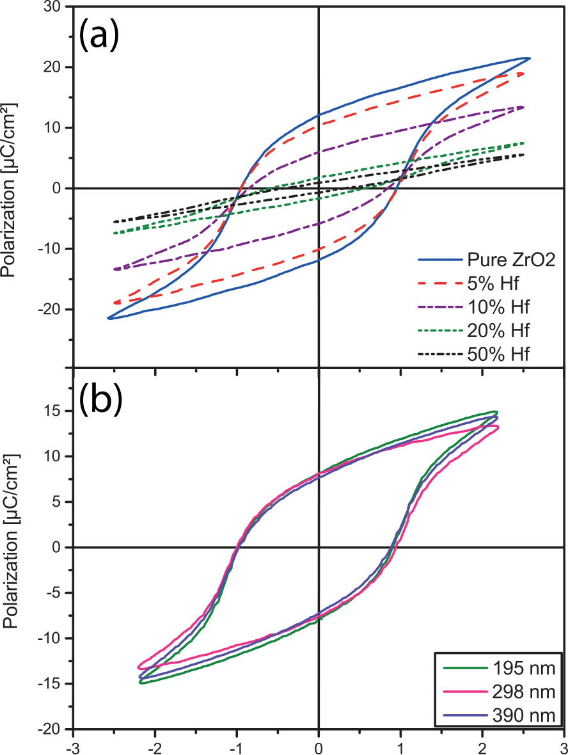



FIG. 1. (a) Ferroelectric hysteresis curves for 100 nm thick ZrO2 with vary-ing hafnium contents. (b) Ferroelectric hysteresis curves for 195 nm to 390 nm thick ZrO2 layers. A wake-up treatment of 1000 cycles at 1 kHz was applied to all devices before recording the hysteresis curves.

comparison of CSD and ALD prepared samples with differ-ent thicknesses was done in a previous work for yttrium doped hafnium oxide.37For those films, no significant differ-ence in the doping concentration window to ALD films was found. Therefore, it seems obvious that there are differences between the stabilization mechanisms of the ferroelectric phase for yttrium doped HfO2 and the HZO system.

Figure 1(b) shows the ferroelectric hysteresis curves for pure ZrO2 with a thickness of up to 390 nm. In contrast to ALD deposited layers, ferroelectricity is found for significantly thicker films without further reduction in the remanent polari-zation above 195 nm. Figure 2 shows the ferroelectric P(V) response (a), the corresponding current (b), and displacement (c) curves for a 100 nm ZrO2 film. A constricted hysteresis is found initially, which is also indicated by the two double peaks in the transient current response.38Interestingly, the displace-ment curve show the normal “butterfly” behavior (Figure 2(c)) as it is expected for ferroelectrics and not for antiferroelectric materials. This shows that the constriction is not correlated with antiferroelectricity but rather results from a field (cycling) induced phase transition from a paraelectric tetragonal/cubic to the ferroelectric orthorhombic Pca21 phase, as also reported elsewhere9,18,39,40(The GI-XRD (grazing incidence x-ray dif-fractions) pattern of a 100 nm thick ZrO2 film confirming the initial high symmetric cubic phase can be found in the [supple-mentary material](ftp://ftp.aip.org/epaps/appl_phys_lett/E-APPLAB-110-018719), S3). After 1000 cycles, the two current peaks are merged together, as described also for strontium doped haf-nium oxide.41Such a wake-up behavior was found by several

|  |  |  |
| --- | --- | --- |
| 182905-3 | Starschich et al. | Appl. Phys. Lett. 110, 182905 (2017) |

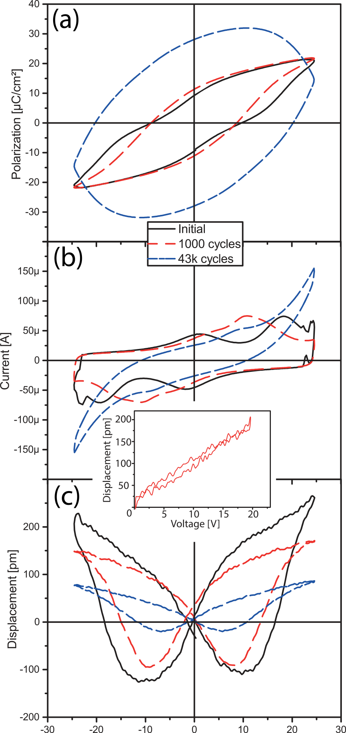

to the piezoelectric response found for yttrium doped HfO2 in a previous work.23With further cycling accompanied by a wake-up, the piezoelectric response is reduced. This is probably cor-related with the cycling induced phase transition which takes place during wake up as mentioned before. An increase in the piezoelectric coefficient around phase transition regions where different phases compete was also shown for perovskite based ferroelectrics.45,46Therefore, by controlling the initial phase and the phase transition during wake-up, the piezoelectric response can be further increased. The inset in Figure 2 shows a DBLI measurement with a unipolar signal, whereby a piezo-electric coefficient of 10pm/V can be extracted.

Figure 3 shows the piezoelectric activity that can be probed on a nanoscale via PFM. The solid metal tips were initially chosen to ensure that the high displacement currents can be provided to achieve the desired sinusoidal excitation field required for the lock-in technique. However, the pads started peeling off when the bias sweep was performed, which might be due to the high absolute amplitude of the piezoresponse compared to a film with a thickness of just around 10 nm. To get an idea of the local manifestation of the piezoelectric properties, the measurements had to be per-formed on the bare oxide. As it was argued, for example, by Balke et al.,47,48artifacts can give rise to hysteretic loops, and it is hard to argue with PFM alone that the measure loops are dominated by the piezoelectric response itself. Capacitor measurements are preferable to achieve this goal. However, the remanent loop shown here is nicely saturated and fairly symmetric and exhibits a phase jump of exactly 180�. This is in line with the theory of a ferroelectric response but cannot be taken for granted on bare oxide as pointed out before.47,48 Figure 4 shows the results for the initial ferroelectric hysteresis and the corresponding current curves (a) and the DBLI (b) results of the 390 nm ZrO2 film. As shown in Figure 2, for the 100 nm thick layer and also for the 390 nm thick layer, the highest piezoelectric response is given for the initial curve. Further cycling does lead to a stronger wake-up and therefore to a reduction in the piezoelectric response (data not shown here).

In summary, we have demonstrated ferroelectric ZrO2

|  |  |
| --- | --- |
|  | with a layer thickness of up to 390 nm, deposited by chemi-cal solution deposition (CSD). Compared to previous results, |

FIG. 2. Ferroelectric P(V)-loops (a) with the corresponding current (b) and

displacement (c) curves for a 100 nm ZrO2 layer after different numbers of cycles. For the initial measurement, an average of 50 measurements is used to achieve a smooth displacement curve. The cycling in this case is per-formed by triangle voltage sweeps in contrast to the standard wake-up with rectangle pulses. The inset shows an unipolar DBLI measurement with 50 averages at a prepoled film, revealing a piezoelectric coefficient of 10 pm/V.

groups and is attributed to a cycling induced phase transition due to redistribution of oxygen vacancies.17,30,41–44Further field cycling leads to a strong increase in the leakage currents, and almost no switching current peaks are visible after 43k cycles. The strong increase in the leakage current is most prob-ably related to defects caused by generation of oxygen vacan-cies during cycling as described by Pe�sic´ et al.44The displacement curve displays that even after 43k cycles, the film is still ferroelectric, which is indicated by the clear butterfly curve in Figure 2(c). Worth noting is the strong piezoelectric response for the initial cycles. It is significantly larger compared

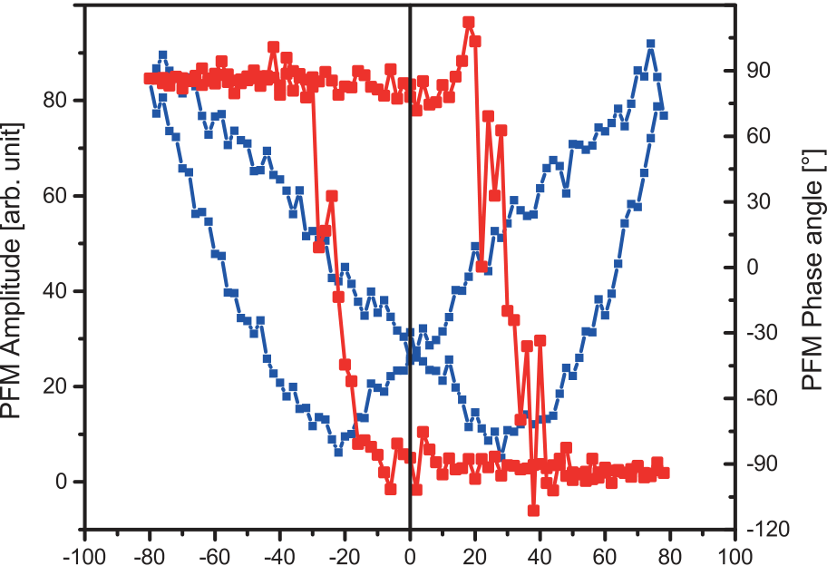



FIG. 3. PFM results directly measured on the 390 nm thick ZrO2 oxide, showing the remanent loop.

|  |  |  |
| --- | --- | --- |
| 182905-4 | Starschich et al. | Appl. Phys. Lett. 110, 182905 (2017) |

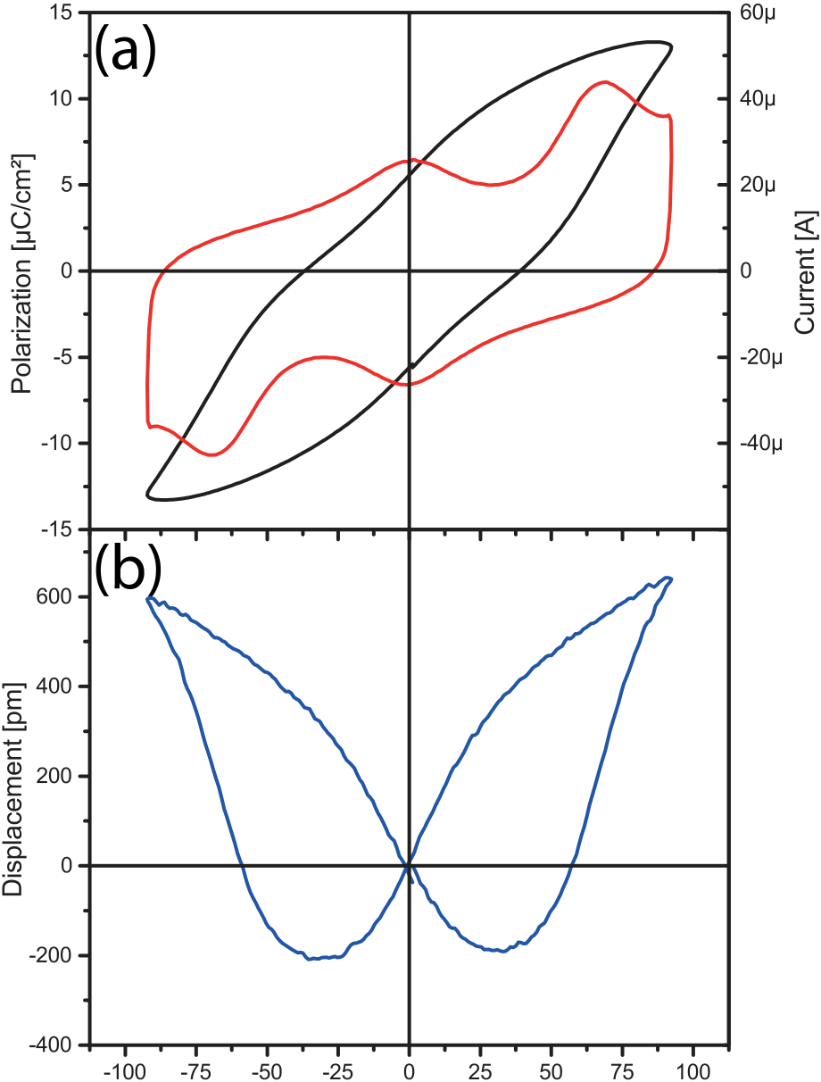



FIG. 4. (a) Initial hysteresis curve and the corresponding current curve of the 390 nm thick ZrO2 film. (b) Initial displacement curve for the 390 nm thick ZrO2 layer.

this significantly extends the thickness range for Hf1-xZrxO2 based ferroelectrics. It was shown that for thicker films, the maximum remanent polarization of the HZO compounds is found for pure ZrO2, which confirms the grain size depen-dence of the HZO system reported earlier for ALD prepared films. PFM and DBLI measurements revealed the piezoelec-tric nature of the given films with a piezoelectric coefficient of 10 pm/V. Therefore, pure ZrO2 is a promising candidate for future lead free piezoelectric devices and for pyroelectric energy related applications due to its easy and cost efficient preparation.

See [supplementary material](ftp://ftp.aip.org/epaps/appl_phys_lett/E-APPLAB-110-018719) for the SEM figures and the XRD pattern of ZrO2.

This work was funded by German Research Foundation (Deutsche Forschungsgemeinschaft) within the scope of the project “Inferox” (Project No. BO 1629/10-2).

1T. S. Boescke, J. Mueller, D. Braeuhaus, U. Schroeder, and U. Boettger, [Appl. Phys. Lett.](http://dx.doi.org/10.1063/1.3634052) 99, 102903 (2011).

2J. Mueller, T. S. Boescke, D. Braeuhaus, U. Schroeder, U. Boettger, J. Sundqvist, P. Kuecher, T. Mikolajick, and L. Frey, [Appl. Phys. Lett.](http://dx.doi.org/10.1063/1.3636417) 99, 112901 (2011).

3J. M€uller, P. Polakowski, J. Paul, S. Riedel, R. Hoffmann, M. Drescher, S. Slesazeck, S. M€uller, H. Mulaosmanovic, U. Schr€oder, T. Mikolajick, S. Flachowsky, E. Erben, E. Smith, R. Binder, D. Triyoso, J. Metzger, and S. Kolodinsi, [ECS Trans.](http://dx.doi.org/10.1149/06903.0085ecst) 69, 85 (2015).

4M. Hyuk Park, H. Joon Kim, Y. Jin Kim, W. Jeon, T. Moon, and C. Seong Hwang, [Phys. Status Solidi RRL](http://dx.doi.org/10.1002/pssr.201409017) 8, 532–535 (2014).

5M. H. Park, H. J. Kim, Y. J. Kim, T. Moon, K. D. Kim, and C. S. Hwang, [Adv. Energy Mater.](http://dx.doi.org/10.1002/aenm.201400610) 4, 1400610 (2014).

6M. H. Park, H. J. Kim, Y. J. Kim, T. Moon, K. D. Kim, and C. S. Hwang, [Nano Energy](http://dx.doi.org/10.1016/j.nanoen.2014.09.025) 12, 131–140 (2015).

7X. Sang, E. D. Grimley, T. Schenk, U. Schroeder, and J. M. LeBeau, [Appl. Phys. Lett.](http://dx.doi.org/10.1063/1.4919135) 106, 162905 (2015).

8D. Martin, J. Mueller, T. Schenk, T. M. Arruda, A. Kumar, E. Strelcov, E. Yurchuk, S. Mueller, D. Pohl, U. Schroeder, S. V. Kalinin, and T. Mikolajick, [Adv. Mater.](http://dx.doi.org/10.1002/adma.201403115) 26, 8198 (2014).

9R. Materlik, C. K€unneth, and A. Kersch, [J. Appl. Phys.](http://dx.doi.org/10.1063/1.4916707) 117, 134109 (2015).

10J. Mueller, U. Schroeder, T. S. Boescke, I. Mueller, U. Boettger, L. Wilde, J. Sundqvist, M. Lemberger, P. Kuecher, T. Mikolajick, and L. Frey, [J. Appl. Phys.](http://dx.doi.org/10.1063/1.3667205) 110, 114113 (2011).

11T. Olsen, U. Schroeder, S. Mueller, A. Krause, D. Martin, A. Singh, J.

Mueller, M. Geidel, and T. Mikolajick, [Appl. Phys. Lett.](http://dx.doi.org/10.1063/1.4747209) 101, 82905 (2012). 12S. Mueller, C. Adelmann, A. Singh, S. Van Elshocht, U. Schroeder, and T. Mikolajick, [ECS J. Solid State Sci. Technol.](http://dx.doi.org/10.1149/2.002301jss) 1, N123 (2012).

13S. Mueller, J. Mueller, A. Singh, S. Riedel, J. Sundqvist, U. Schroeder, and T. Mikolajick, [Adv. Funct. Mater.](http://dx.doi.org/10.1002/adfm.201103119) 22, 2412 (2012).

14T. Schenk, S. Mueller, U. Schroeder, R. Materlik, A. Kersch, M. Popovici, C. Adelmann, S. Van Elshocht, and T. Mikolajick, in ESSDERC (2013). 15J. Muller, T. Boscke, S. Muller, E. Yurchuk, P. Polakowski, J. Paul, D. Martin, T. Schenk, K. Khullar, A. Kersch, W. Weinreich, S. Riedel, K. Seidel, A. Kumar, T. Arruda, S. Kalinin, T. Schlosser, R. Boschke, R. van Bentum, U. Schroder, and T. Mikolajick, in 2013 IEEE International Electron Devices Meeting (IEDM) (2013), p. 10.8.1.

16L. Xu, S. Shibayama, K. Izukashi, T. Nishimura, T. Yajima, S. Migita, and A. Toriumi, in IEDM (2016).

17S. Starschich and U. Boettger, [J. Mater. Chem. C](http://dx.doi.org/10.1039/C6TC04807B) 5, 333 (2017).

18J. Mueller, T. S. Boescke, U. Schroeder, S. Mueller, D. Braeuhaus, U. Boettger, L. Frey, and T. Mikolajick, [Nano Lett.](http://dx.doi.org/10.1021/nl302049k) 12, 4318 (2012).

19H. J. Kim, M. H. Park, Y. J. Kim, Y. H. Lee, T. Moon, K. D. Kim, S. D. Hyuna, and C. S. Hwang, [Nanoscale](http://dx.doi.org/10.1039/C5NR05339K) 8, 1383 (2016).

20S. Riedel, P. Polakowski, and J. M€uller, [AIP Adv.](http://dx.doi.org/10.1063/1.4964300) 6, 095123 (2016). 21S. Shibayama, L. Xu, S. Migita, and A. Toriumi, in 2016 IEEE Symposium on VLSI Technology (2016).

22A. Chernikova, M. Kozodaev, A. Markeev, D. Negrov, M. Spiridonov, S. Zarubin, O. Bak, P. Buraohain, H. Lu, E. Suvorova, A. Gruverman, and A. Zenkevich, [ACS Appl. Mater. Interfaces](http://dx.doi.org/10.1021/acsami.5b11653) 8, 7232 (2016).

23S. Starschich, D. Griesche, T. Schneller, R. Waser, and U. Boettger, [Appl.](http://dx.doi.org/10.1063/1.4879283)  [Phys. Lett.](http://dx.doi.org/10.1063/1.4879283) 104, 202903 (2014).

24M. Hoffmann, U. Schroeder, C. K€unneth, A. Kersch, S. Starschich, U. B€ottger, and T. Mikolajick, [Nano Energy](http://dx.doi.org/10.1016/j.nanoen.2015.10.005) 18, 154–164 (2015).

25P. Gerber, A. Roelofs, O. Lohse, C. Kugeler, S. Tiedke, U. Boettger, and R. Waser, [Rev. Sci. Instrum.](http://dx.doi.org/10.1063/1.1544415) 74, 2613 (2003).

26P. Gerber, A. Roelofs, C. Kugeler, U. Boettger, R. Waser, and K. Prume, [J. Appl. Phys.](http://dx.doi.org/10.1063/1.1775306) 96, 2800 (2004).

27A. Kholkin, C. Wutchrich, D. Taylor, and N. Setter, [Rev. Sci. Instrum.](http://dx.doi.org/10.1063/1.1147000) 67, 1935 (1996).

28A. Kholkin, A. Seifert, and N. Setter, [Appl. Phys. Lett.](http://dx.doi.org/10.1063/1.121608) 72, 3374 (1998). 29A. L. Kholkin, M. L. Calzada, P. Ramos, J. Mendiola, and N. Setter, [Appl.](http://dx.doi.org/10.1063/1.117220)  [Phys. Lett.](http://dx.doi.org/10.1063/1.117220) 69, 3602 (1996).

30D. Zhou, J. Xu, Q. Li, Y. Guan, F. Cao, X. Dong, J. Mueller, T. Schenk, and U. Schroeder, [Appl. Phys. Lett.](http://dx.doi.org/10.1063/1.4829064) 103, 192904 (2013).

31T. Shimizu, K. Katayama, T. Kiguchi, A. Akama, T. J. Konno, O. Sakata, and H. Funakubo, [Sci. Rep.](http://dx.doi.org/10.1038/srep32931) 6, 32931 (2016).

32M. H. Park, H. J. Kim, Y. J. Kim, Y. H. Lee, T. Moon, K. D. Kim, S. D. Hyun, F. Fengler, U. Schroeder, and C. S. Hwang, [ACS Appl. Mater. Interfaces](http://dx.doi.org/10.1021/acsami.6b03586) 8(24), 15466 (2016).

33S. Hong, J. Woo, H. Shin, J. U. Jeon, Y. E. Pak, E. L. Colla, N. Setter, E. Kim, and K. No, [J. Appl. Phys.](http://dx.doi.org/10.1063/1.1331654) 89, 1377 (2001).

34P. Polakowski and J. Muller, [Appl. Phys. Lett.](http://dx.doi.org/10.1063/1.4922272) 106, 232905 (2015). 35H. J. Kim, M. H. Park, Y. J. Kim, Y. H. Lee, W. Jeon, T. Gwon, T. Moon, K. Do Kim, and C. S. Hwang, [Appl. Phys. Lett.](http://dx.doi.org/10.1063/1.4902072) 105, 192903 (2014).

36K. D. Kim, M. H. Park, H. J. Kim, Y. J. Kim, T. Moon, Y. H. Lee, and S. D. Hyun, [J. Mater. Chem. C](http://dx.doi.org/10.1039/C6TC02003H) 4, 6864–6872 (2016).

37S. Starschich, D. Griesche, T. Schneller, and U. B€ottger, [ECS J. Solid](http://dx.doi.org/10.1149/2.0061512jss)  [State Sci. Technol.](http://dx.doi.org/10.1149/2.0061512jss) 4, P419 (2015).

38T. Schenk, E. Yurchuk, S. Mueller, U. Schroeder, S. Starschich, U. Bottger, and T. Mikolajick, [Appl. Phys. Rev.](http://dx.doi.org/10.1063/1.4902396) 1, 041103 (2014).

39M. H. Park, H. J. Kim, Y. J. Kim, Y. H. Lee, T. Moon, K. D. Kim, S. D. Hyun, and C. S. Hwang, [Appl. Phys. Lett.](http://dx.doi.org/10.1063/1.4935588) 107, 192907 (2015).

40S. E. Reyes-Lillo, K. F. Garrity, and K. M. Rabe, [Phys. Rev. B: Condens.](http://dx.doi.org/10.1103/PhysRevB.90.140103)  [Matter](http://dx.doi.org/10.1103/PhysRevB.90.140103) 90, 140103 (2014).

41T. Schenk, U. Schroeder, M. Pe�sic, M. Popovici, Y. V. Pershin, and T. Mikolajick, [ACS Appl. Mater. Interfaces](http://dx.doi.org/10.1021/am504837r) 6, 19744 (2014).

|  |  |  |
| --- | --- | --- |
| 182905-5 | Starschich et al. | Appl. Phys. Lett. 110, 182905 (2017) |

42E. D. Grimley, T. Schenk, X. Sang, M. Pe�sic´, U. Schroeder, T. Mikolajick, and J. M. LeBeau, [Adv. Electron. Mater.](http://dx.doi.org/10.1002/aelm.201600173) 2, 1600173 (2016).

43S. Starschich, S. Menzel, and U. B€ottger, [Appl. Phys. Lett.](http://dx.doi.org/10.1063/1.4940370) 108, 032903 (2016).

44M. Pe�sic, F. P. G. Fengler, L. Larcher, A. Padovani, T. Schenk, E. D. Grimley, X. Sang, J. M. LeBeau, S. Slesazeck, U. Schroeder, and T. Mikolajick, [Adv. Funct. Mater.](http://dx.doi.org/10.1002/adfm.201600590) 26, 4601 (2016).

45M. Budimir, D. Damjanovic, and N. Setter, [J. Appl. Phys.](http://dx.doi.org/10.1063/1.1625080) 94, 6753 (2003). 46V. Kovacova, N. Vaxelaire, G. Le Rhun, P. Gergaud, T. Schmitz-Kempen,

and E. Defay, [Phys. Rev. B](http://dx.doi.org/10.1103/PhysRevB.90.140101) 90, 140101 (2014).

47N. Balke, P. Maksymovych, S. Jesse, A. Herklotz, A. Tselev, C. B. Eom,

I. I. Kravchenko, P. Yu, and S. V. Kalinin, [ACS Nano](http://dx.doi.org/10.1021/acsnano.5b02227) 9, 6484 (2015). 48N. Balke, S. Jesse, Q. Li, P. Maksymovych, M. B. Okatan, E. Strelcov, A.

Tselev, and S. V. Kalinin, [J. Appl. Phys.](http://dx.doi.org/10.1063/1.4927811) 118, 72013 (2015).