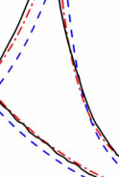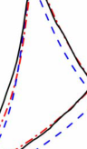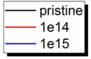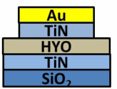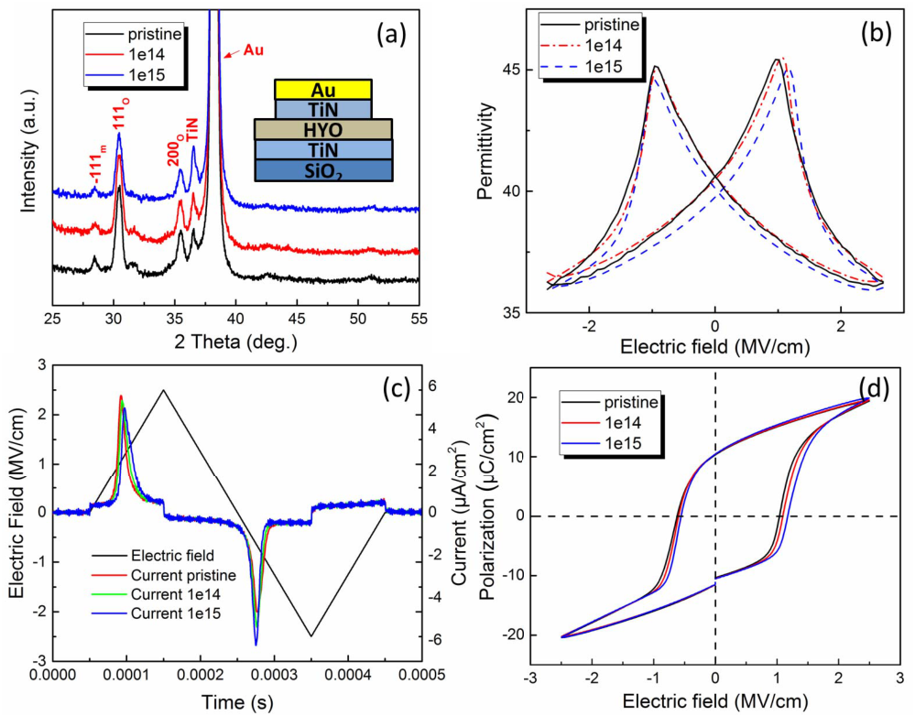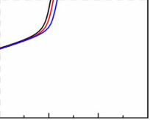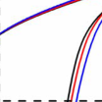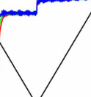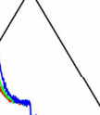

IEEE ELECTRON DEVICE LETTERS, VOL. 39, NO. 6, JUNE 2018 823



Proton Radiation Effects on Y-Doped HfO2-Based Ferroelectric Memory

Yan Wang, Fei Huang, Yuan Hu, Rongrong Cao, Tuo Shi, Qi Liu, Member, IEEE,

Lei Bi, and Ming Liu, Fellow, IEEE

***Abstract— In this letter, ferroelectric memory perfor-***  
***mance of TiN/Y-doped-HfO2 (HYO)/TiN capacitors is inves-***  
***tigated under proton radiation with 3-MeV energy and***   
***different fluence (5e13, 1e14, 5e14, and 1e15 ions/cm2).***   
***X-ray diffraction patterns confirm that the orthorhombic***   
***phase Pbc21 of HYO film has no obvious change after proton***   
***radiation. Electrical characterization results demonstrate***   
***slight variations of the permittivity and ferroelectric hys-***  
***teresis loop after proton radiation. The remanent polariza-***  
***tion (2Pr) of the capacitor decreases with increasing proton***   
***fluence. But the decreasing trend of 2Pr is suppressed***   
***under high electric fields. Furthermore, the 2Pr degradation***   
***with cycling is abated by proton radiation. These results***   
***show that the HYO-based ferroelectric memory is highly***   
***resistive to proton radiation, which is potentially useful for***   
***space applications.***

***Index Terms— HfO2, ferroelectric memory, radiation,***   
***proton.***

I. INTRODUCTION   
**B** ory has already been used for space exploration [1]–[3].

ECAUSE of high radiation tolerance, ferroelectric mem-

In ferroelectric memory based on traditional materials such

as PZT and SBT [4], [5], it is difficult to improve the

storage density and capacity due to the material scaling problem and poor CMOS compatibility. Recently the emerging

HfO2-based ferroelectric memory is expected to solve these problems [6]–[10], in which CMOS friendly HfO2 film of 10 nm scale is used as ferroelectric layer. It makes the

Manuscript received April 13, 2018; revised April 25, 2018; accepted April 26, 2018. Date of publication April 30, 2018; date of current version May 22, 2018. This work was supported in part by the National High Technology Research Development Program under Grant 2017YFB0405600 and Grant 2016YFA0201803, in part by the National Natural Science Foundation of China under Grant 61521064, Grant 61732020, Grant 61474136, Grant 61574166, Grant 61522408, Grant 61475031, and Grant 51522204, and in part by the Austrian-Chinese Cooperative R&D Projects under Grant 172511KYSB20150006. The review of this letter was arranged by Editor M. Tabib-Azar. (Yan Wang and Fei Huang are co-first authors and contributed equally to this work.) (Corresponding authors: Qi Liu; Lei Bi.)   
 Y. Wang, Y. Hu, R. Cao, T. Shi, Q. Liu, and M. Liu are with the Key Laboratory of Microelectronics Device & Integrated Technology, Institute of Microelectronics of Chinese Academy of Sciences, Beijing 100029, China, and also with the University of Chinese Academy of Sciences, Beijing 100049, China (e-mail : liuqi@ime.ac.cn).

F. Huang and L. Bi are with the National Engineering Research Center of Electromagnetic Radiation Control Materials, University of Electronic Science and Technology of China, Chengdu 610054, China (e-mail: bilei@uestc.edu.cn).

Color versions of one or more of the figures in this letter are available online at http://ieeexplore.ieee.org.

Digital Object Identifier 10.1109/LED.2018.2831784

Fig. 1. (a) The XRD spectrums (b) *ε*r–E curves (c) E/I-t curves and (d) hysteresis loops of the pristine devices, and devices after the proton radiation with the fluence of 1e14 and 1e15 ions/cm2. The inset of (a) is the device structure of TiN/HYO/TiN.

ideal ferroelectric memory of high density, mass storage and radiation resistance possible. To explore the applications in radiation environment, study of the radiation effects on HfO2-based ferroelectric memory is necessary.

In our previous report, Y-doped HfO2-based (HYO) ferroelectric memory is found to be extremely resistant to *γ* ray radiation [11]. Another important kind of radiation source is charged particles, with different radiation effects from *γ* ray [12]. Proton is one of the most common charged particle in the universe, accounting for about 90% in cosmic rays. The average integral proton flux range from 1e4/cm2to 1e9/cm2per day with different energy in low earth orbit [13]. In this work, the proton radiation effects of HYO based ferroelectric memory is investigated. The ferroelectric material and memory performance including permittivity, hysteresis loop, remanent polarization and polarization degradation with cycling are researched systematically. Possible mechanisms of the proton radiation effects are proposed.

II. EXPERIMENTS

The device is consisted of TiN/HYO/TiN/Au stacked layers with the thickness of 120/20/30/150 nm from bottom to top, as shown in the inset of Fig. 1(a). Y doped HfO2 is used as the ferroelectric layer, with the Y concentration of 3.8 mol%.

0741-3106 © 2018 IEEE. Personal use is permitted, but republication/redistribution requires IEEE permission. See http://www.ieee.org/publications_standards/publications/rights/index.html for more information.

824 IEEE ELECTRON DEVICE LETTERS, VOL. 39, NO. 6, JUNE 2018



The fabrication and basic performance of this device have been reported in our previous work [9], [11]. Protons with energy of 3 MeV are adopted as the radiation source in this research. 2×1.7 MV tandem electrostatic accelerator of Peking University is used to provide the proton beam. Devices are in open circuit state during radiation, and the angle between the proton beam and sample surface normal is about 7°. The proton fluence are 5e13, 1e14, 5e14 and 1e15 ions/cm2, and the corresponding exposure time are 20min, 40min, 200min, 400min, respectively. The crystal structure of the HYO films is analyzed by an X-ray diffractometer (XRD, XRD-7000, SHIMADZU). The permittivity–electric field (*ε*r–E) curves are measured by Agilent B1500A semiconductor device analyzer. The AC bias frequency is 50 kHz and the amplitude is 30 mV. For polarization measurements, the B1530A waveform generator fast measurement unit module is used to generate triangular and trapezoidal electrical pulses and monitor the switching current. Hysteresis loops and remanent polarization are draw based on the electrical pulses and current curve. It is noted that all irradiated electrical results of devices are measured after proton radiation.

III. RESULTS AND DISCUSSION

In HfO2-based ferroelectric device, the orthorhombic phase Pbc21 of HfO2 is believed as the origin of the ferroelectricity [6]–[10]. To investigate the proton effects on the orthorhombic phase, XRD of the same HYO film sample are tested three times: the pristine, 1e14 and 1e15 states (radiated after proton beam with the fluence of 1e14 and 1e15 ions/cm2*)*.

As shown in Fig. 1(a), the (111)o diffraction peaks from the orthorhombic phase is observed at 30.27°. The peak positions and half peak widths are not significantly altered, and no diffraction peaks from other phases emerge. The very similar XRD patterns indicate no obvious phase change induced by proton radiation. The permittivity of the pris-tine, 1e14 and 1e15 states are also investigated and shown in Fig. 1(b). The *ε*r–E curves do not display any distor-tion or asymmetry, which is much robust than PZT based devices against the proton radiation [4]. Only slight variations are shown after proton radiation. For three states, the permit-tivity at 0 MV/cm are 40.6, 40.5 and 39.7, respectively. A very small decrement of permittivity about −2.2 % is observed after the 1e15 ions/cm2proton fluence.

To investigate the polarization of capacitor, a triangular electrical pulse is enforced on the capacitor, with the elec-tric field loop 0→2.5→0→−2.5→0 MV/cm. Electric field and current of the capacitors are monitored meanwhile, and recorded in Fig. 1(c). Hysteresis loops are drawn based on the current curves, and shown in Fig. 1(d). The asymmetry of the positive and negative coercive fields may be attributed to the different fabrication process of the top and bottom electrodes. There is no distortion shown in all hysteresis loops under different proton fluence. Up to fluence of 1e15 ions/cm2, the polarization value remains almost the same as the pristine state. The positive coercive fields of the three states are 1.04, 1.09 and 1.17 MV/cm. The negative coercive fields are −0.62,−0.59, and −0.56 MV/cm respectively. A slight “imprint”

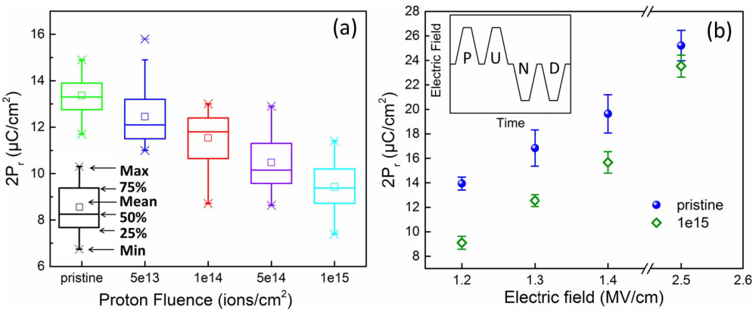

Fig. 2. (a) Statistical 2Pr values of pristine, 5e13, 1e14, 5e14, and 1e15 ions/cm2proton fluence. The inset shows the percentile of the box charts. (b) Statistical 2Pr values of pristine sample and after 1e15 ions/cm2proton fluence radiation under different electric field. The inset is the PUND mode wave used to test 2Pr values.

effect is shown, which is similar to the coercive field shift after gamma ray radiation in our previous report [11]. Proton radiation will induce electron-hole pairs, oxygen vacancies and subsequent charge trapping [15], [16], leading to built-in field and ferroelectric domain pinning [10], [14]. The built-in field change the voltage imposed on ferroelectric domains, causing voltage shift. Comparing the permittivity and ferroelectric hysteresis variations after radiation, the perfor-mance of HYO devices is more stable than other ferroelectric memory [4], [14].

To further investigate the proton radiation effects on the memory storage window, the remanent polarization values of 5 groups (35 devices for each group) are tested under the electric field of 1.3 MV/cm after different proton fluence. 2Pr values are tested using the positive-up-negative-down (PUND) mode, as shown in the inset of Fig. 2(b). The PUND is consisted of four trapezoidal waves with the time of 2200 ns. The rising time, keeping time, falling time are all 150 ns, and delaying time is 100 ns. The statistical box charts of 2Pr values are summarized in Fig. 2(a). 2Pr values distribution is represented by the shape of the box chart, and the percentile is shown in the inset. As the proton fluence increases from pristine to 1e15 ions/cm2, 2Pr values decrease from 13.4 to 9.4 *μ*C/cm2gradually. The phenomenon is related to the fer-roelectric domain pinning induced by proton radiation, which decrease the reversible domain [10], [14]. More ferroelectric domain pinning are formed with increasing the proton fluence, resulting in a further reduction in the 2Pr values, as shown in Fig. 2(a). The difference of 2Pr before and after radiation is lower under high electric fields, as shown in Fig. 2(b). After proton radiation with the fluence of 1e15 ions/cm2, the 2Pr values decrease by 34%, 25% and 20%, for the electric field of 1.2, 1.3, and 1.4 MV/cm respectively. But under the electric field of 2.5 MV/cm, which is the field used in Fig. 1, the variation is only 6%. Therefore, although the memory window is decreased by proton radiation, the influence is little under the electrical field of 2.5 MV/cm, which is commonly used in read/write cycles.

The endurance of HYO ferroelectric memory devices has been investigated in our previous reports [9], [11], where cycling endurance over 4e7 cycles is achieved. The deteriora-tion induced by cycling is more obvious under lower electrical

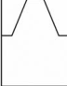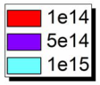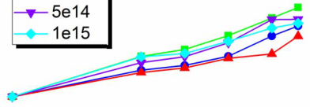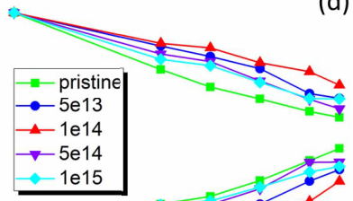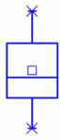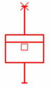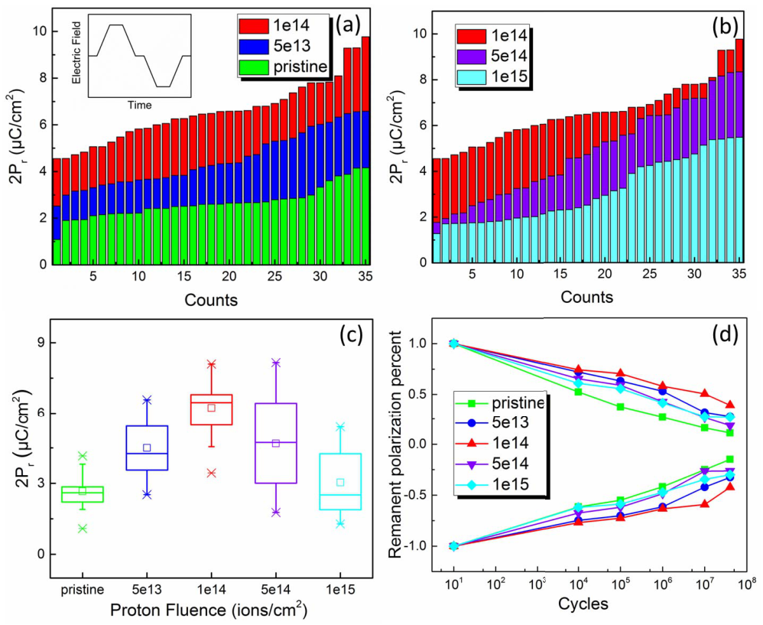

WANG et al.: PROTON RADIATION EFFECTS ON Y-DOPED HfO2-BASED FERROELECTRIC MEMORY 825



TABLE I   
COMPARISON OF THE PERFORMANCE PARAMETERS BEFORE AND AFTER PROTON RADIATION





|  |  |  |  |
| --- | --- | --- | --- |
|  |  |  |  |
|  |

is related to the oxygen vacancies diffusion induced by   
cycling. Based on the reference [10], the oxygen vacancies   
diffusion probably cause the phase transformation from non-  
ferroelectric to ferroelectric in the HfO2-based capacitors,   
which increases the volume fraction taking part in polarization   
switching process. The effect suppresses the 2Pr degrada-  
tion. Combining the decreased initial 2Pr induced by proton   
radiation, the condition of 1e14 ions/cm2shows the largest   
remanent polarization after 4e7 cycles. To clearly understand   
the mechanism of the suppressed fatigue, further research is   
needed in future.

The electrical characterization results of the pristine and   
radiated devices are summarized in Table I. There are   
very slight variations in permittivity, coercive field, and   
2Pr under the electrical field of 2.5 MV/cm. The cycling   
induced 2Pr deterioration (fatigue) is suppressed in radiated   
devices, improving the endurance performance. In general,

Fig. 3. The remanent polarization after 4e7 cycling in the (a) pristine devices and devices after 5e13, 1e14, ions/cm2proton fluence, the inset is the measure wave for endurance (b) devices after 1e14, 5e14, and 1e15 ions/cm2proton fluence. (c) The statistical box chart of the remanent polarization after 4e7 cycling. (d) The endurance characteristic of the device after different proton fluence.

fields [9], [11]. To investigate the proton effects of endurance, a relatively small electrical field of 1.3 MV/cm is used in the endurance test. In this experiment, 5 groups (35 devices for each group) of devices are tested. One group is pristine, and other 4 groups are radiated by protons with fluence of 5e13, 1e14, 5e14 and 1e15 ions/cm2, respectively. Then all the devices are cycled up to 4e7 times with the electrical field of 1.3 MV/cm. The measure wave for endurance is inserted in Fig. 3(a), one cycle time is 1100 ns (rising time, keeping time, falling time are all 150 ns, and delaying time is 100 ns). After 4e7 cycles, remanent polarizations are tested using the PUND mode and shown in Fig. 3(a) and (b). The overall changes are shown for the whole group. Statistical box charts of the remanent polarization after cycling are summarized in Fig. 3(c). For the pristine devices, 80 % reduction of the 2Pr is observed after 4e7 cycles due to fatigue. Cycling induced defects and subsequent domain pinning decrease reversible domain, leading to 2Pr decrease [9]. Interestingly, this fatigue process is suppressed in radiated devices. For proton flu-ence of 1e14 ions/cm2, the minimum fatigue and the largest remanent polarization is reached, with 45% reduction of 2Pr after 4e7 cycles, much lower than the pristine devices. The normalized remanent polarization results of different cycling with various fluence are shown in Fig. 3(d). The mechanism of the suppressed fatigue is still unclear, a tentative explanation

no obvious deterioration is induced by proton radiation in HYO-based ferroelectric memory up to a proton radiation fluence of 1e15 ions/cm2.

IV. CONCLUSION

In this letter, the proton radiation effects on HYO-based fer-roelectric memory are investigated. Under a cycling electrical field of 2.5 MV/cm, very slight variations are shown in per-mittivity, coercive field, and polarization up to proton fluence of 1e15 ions/cm2. Cycling fatigue is suppressed in radiated devices up to 1e14 ions/cm2, which promote the endurance characteristics. These results indicate that the HYO-based ferroelectric memory is highly resistive to proton radiation. Combining our previous research on *γ* ray total dose radiation, HYO-based ferroelectric memory proves high resistance to radiation environments, which shows a promising potential for space applications.

REFERENCES

[1] S. Gerardin and A. Paccagnella, “Present and future non-volatile mem-ories for space,” *IEEE Trans. Nucl. Sci.*, vol. 57, no. 6, pp. 3016–3039, Dec. 2010, doi: [10.1109/TNS.2010.2084101](http://dx.doi.org/10.1109/TNS.2010.2084101).

[2] S. C. Philpy, D. A. Kamp, A. D. DeVilbiss, A. F. Isacson, and G. F. Derbenwick, “Ferroelectric memory technology for aerospace applications,” in *Proc. IEEE Aerosp. Conf.*, Aug. 2000, pp. 377–383, doi: [10.1109/AERO.2000.878511](http://dx.doi.org/10.1109/AERO.2000.878511).

[3] R. Sayyah, T. C. Macleod, and F. D. HO, “Radiation-hardened

|  |  |  |  |  |  |  |  |  |  |  |  |
| --- | --- | --- | --- | --- | --- | --- | --- | --- | --- | --- | --- |
| electronics | and | ferroelectric | | memory | | for | space | flight | | systems,” | |
| *Ferroelectrics*, | | vol. | 413, | no. | 1, | pp. | 170–175, | | Jun. | | 2011, |
| doi: [10.1080/00150193.2011.554145](http://dx.doi.org/10.1080/00150193.2011.554145). | | | | | |

[4] Y. Bastani, A. Y. Cortés-Peña, A. D. Wilson, S. Gerardin, M. Bagatin, A. Paccagnella, and N. Bassiri-Gharb, “Effects of high energy X ray and proton irradiation on lead zirconate titanate thin films’ dielectric and piezoelectric response,” *Appl. Phys. Lett.*, vol. 102, no. 19, p. 192906, May 2013, doi: [10.1063/1.4805045](http://dx.doi.org/10.1063/1.4805045).

826 IEEE ELECTRON DEVICE LETTERS, VOL. 39, NO. 6, JUNE 2018



|  |  |  |  |  |  |  |  |  |  |  |  |  |
| --- | --- | --- | --- | --- | --- | --- | --- | --- | --- | --- | --- | --- |
| [5] D. Wu, A. D. Li, H. Q. Ling, T. Yu, Z. G. Liu, and N. B. Ming, | [11] F. | Huang, | Y. | Wang, | X. | Liang, | J. | Qin, | Y. | Zhang, | X. | Yuan, |

“*γ* -ray irradiation effect on hysteresis symmetry and data retention of Pt/SrBi2Ta2O9/Pt thin-film capacitors,” *Appl. Phys. A, Solids Surf.*, vol. 73, pp. 255–257, Aug. 2001, doi: [10.1007/s003390100905](http://dx.doi.org/10.1007/s003390100905).

[6] T. S. Böscke, J. Müller, D. Bräuhaus, U. Schröder, and U. Böttger,“Ferroelectricity in hafnium oxide thin films,” *Appl. Phys. Lett.*, vol. 99, no. 10, p. 102903, Sep. 2011, doi: [10.1063/1.3634052](http://dx.doi.org/10.1063/1.3634052).

[7] J. Müller, T. S. Böscke, U. Schröder, S. Mueller, D. Bräuhaus, U. Böttger, L. Frey, and T. Mikolajick, “Ferroelectricity in simple binary ZrO[2 and HfO2](http://dx.doi.org/10.1021/nl302049k),” *Nano Lett.*, vol. 12, pp. 4318–4323, Jul. 2012, doi: [10.1021/nl302049k](http://dx.doi.org/10.1021/nl302049k).

[8] M. H. Park, Y. H. Lee, H. J. Kim, Y. J. Kim, T. Moon, K. D. Kim, J. Müller, A. Kersch, U. Schroeder, T. Mikolajick, and C. S. Hwang,“Ferroelectricity and antiferroelectricity of doped thin HfO2-based films,” *Adv. Mater.*, vol. 27, no. 11, pp. 1811–1831, Mar. 2015, doi: [10.1002/adma.201404531](http://dx.doi.org/10.1002/adma.201404531).

[9] F. Huang, X. Chen, X. Liang, J. Qin, Y. Zhang, T. Huang, Z. Wang, B. Peng, P. Zhou, H. Lu, L. Zhang, L. Deng, M. Liu, Q. Liu, H. Tian, and L. Bi, “Fatigue mechanism of yttrium-doped hafnium oxide ferroelectric thin films fabricated by pulsed laser deposition,”*Phys. Chem. Chem. Phys.*, vol. 19, no. 5, pp. 3486–3497, Jan. 2017, doi: [10.1039/c6cp07501k](http://dx.doi.org/10.1039/c6cp07501k).

Z. Wang, B. Peng, L. Deng, Q. Liu, L. Bi, and M. Liu, “HfO2-based highly stable radiation-immune ferroelectric memory,” *IEEE Electron Device Lett.*, vol. 38, no. 3, pp. 330–333, Mar. 2017, doi: [10.1109/LED.2017.2653848](http://dx.doi.org/10.1109/LED.2017.2653848).

[12] J. R. Srour and J. M. McGarrity, “Radiation effects on microelectronics in space,” *Proc. IEEE*, vol. 76, no. 11, pp. 1443–1469, Nov. 1988, doi: [10.1109/5.90114](http://dx.doi.org/10.1109/5.90114).

[13] E. G. Stassinopoulos and J. P. Raymond, “The space radiation envi-ronment for electronics,” *Proc. IEEE*, vol. 76, no. 11, pp. 1423–1442, Nov. 1988, doi: [10.1109/5.90113](http://dx.doi.org/10.1109/5.90113).

[14] M. Zanata, N. Wrachien, and A. Cester, “Ionizing radiation effect on ferroelectric nonvolatile memories and its dependence on the irradiation temperature,” *IEEE Trans. Nucl. Sci.*, vol. 55, no. 6, pp. 3237–3244, Dec. 2008, doi: [10.1109/TNS.2008.2006052](http://dx.doi.org/10.1109/TNS.2008.2006052).

[15] S. L. Weeden-Wright, W. G. Bennett, N. C. Hooten, E. X. Zhang, M. W. McCurdy, M. P. King, R. A. Weller, M. H. Mendenhall, M. L. Alles, D. Linten, M. Jurczak, R. Degraeve, A. Fantini, R. A. Reed, D. M. Fleetwood, and R. D. Schrimpf, “TID and dis- placement damage resilience of 1T1R HfO2/Hf resistive memories,” *IEEE Trans. Nucl. Sci.*, vol. 61, no. 6, pp. 2972–2978, Dec. 2014, doi: [10.1109/TNS.2014.2362538](http://dx.doi.org/10.1109/TNS.2014.2362538).

|  |  |  |  |  |  |  |  |  |  |  |  |  |
| --- | --- | --- | --- | --- | --- | --- | --- | --- | --- | --- | --- | --- |
| [10] M. Peši´c, F. P. G. Fengler, L. Larcher, A. Padovani, T. Schenk, | [16] B. | Butcher, | X. | He, | M. | Huang, | Y. | Wang, | Q. | Liu, | H. | Lv, |

E. D. Grimley, X. Sang, J. M. LeBeau, S. Slesazeck, U. Schroeder, and T. Mikolajick, “Physical mechanisms behind the field-cycling behavior of HfO2-based ferroelectric capacitors,” *Adv. Funct. Mater.*, vol. 26, pp. 4601–4612, Jun. 2016, doi: [10.1002/adfm.201600590](http://dx.doi.org/10.1002/adfm.201600590).

M. Liu, and W. Wang, “Proton-based total-dose irradiation effects

on Cu/HfO2:Cu/Pt ReRAM devices,” *Nanotechnology*, vol. 21,

no. 47, p. 475206, Oct. 2010, doi: [10.1088/0957-4484/21/47/](http://dx.doi.org/10.1088/0957-4484/21/47/475206)

[475206](http://dx.doi.org/10.1088/0957-4484/21/47/475206).