**A synoptic view of the stock status of the twenty Northeast groundfish stocks in 2015**

*Last update: September 21, 2015*

**Summary**

The following synopsis is derived from the 2015 groundfish stock assessment reports.

* Stock status did not change for 15 of the 20 stocks, worsened for two stocks, improved for one stock, and became more uncertain for two stocks (Table 1).
* The number of stocks with retrospective adjustments applied increased from the last assessment from 2 to 7 (Table 2). The previous Georges Bank cod assessment did apply a retrospective adjustment, however, the assessment model was not approved at the 2015 Updates so it has been excluded from these counts.
* While the number of overfished stocks and stocks experiencing overfishing has generally decreased since 2007 (Figure 1), the magnitude of overfishing or depletion for several stocks has worsened considerably (Figures 2 and 3; Gulf of Maine cod, Southern New England/Mid-Atlantic yellowtail flounder, witch flounder and Cape Cod/Gulf of Maine yellowtail flounder).
  + Of those Northeast groundfish stocks for which stock status can be determined, the majority remain below their biomass targets (69%; Figures 1 and 3).
* Recent NEFSC survey biomass indices for both the spring and fall surveys are below the long term means.
  + For the majority of stocks the average of the most recent five years are below the time series means (Table 3, Figures 4 and 5)
* Estimates of overall (aggregate) groundfish minimum swept area biomass are at, or near, all-time highs (Figures 6 and 7)
  + However, the current stock diversity of the overall groundfish biomass is less than that seen in the 1960s and 1970s.
    - Current groundfish biomass is dominated by only a few stocks: For example the combined biomass of the Georges Bank haddock, Gulf of Maine haddock, and redfish stocks currently make up more than 80% of the overall groundfish biomass (Figure 8).
* Relative condition factor for the twenty groundfish stocks are generally near the time series averages (1992 to present; Table 4).

Table 1: Synopsis of stock status suggested by preliminary results (subject to change during review).

|  |  |  |  |  |
| --- | --- | --- | --- | --- |
| ***Stock*** | ***Last Assessment*** | ***Status Change* Since Last Assessment*** | ***Overfishing Occurring?*** | ***Overfished?*** |
| **Gulf of Maine Cod** | **2014** | ***Same*** | ***Yes*** | ***Yes*** |
| **Georges Bank Cod** | **2012** | ***More uncertain*** | ***Unknown*** | ***Yes*** |
| **Georges Bank Haddock** | **2012** | ***Same*** | ***No*** | ***No*** |
| **Gulf of Maine Haddock** | **2014** | ***Same*** | ***No*** | ***No*** |
| **Cape Cod/Gulf of Maine Yellowtail Flounder** | **2012** | ***Same*** | ***Yes*** | ***Yes*** |
| **Southern New England/Mid-Atlantic Yellowtail Flounder** | **2012** | ***Worse*** | ***Yes*** | ***Yes*** |
| **Georges Bank Winter Flounder** | **2014** | ***Worse*** | ***Yes*** | ***Yes*** |
| **Southern New England/Mid-Atlantic Winter Flounder** | **2011** | ***Same*** | ***No*** | ***Yes*** |
| **American Plaice** | **2012** | ***Same*** | ***No*** | ***No*** |
| **Witch Flounder** | **2012** | ***Same*** | ***Yes*** | ***Yes*** |
| **Acadian Redfish** | **2012** | ***Same*** | ***No*** | ***No*** |
| **White Hake** | **2013** | ***Same*** | ***No*** | ***No*** |
| **Pollock** | **2014** | ***Same*** | ***No*** | ***No*** |
| **Wolffish** | **2012** | ***Same*** | ***No*** | ***Yes*** |
| **Atlantic Halibut** | **2012** | ***More uncertain*** | ***Unknown*** | ***Yes*** |
| **Gulf of Maine/Georges Bank Windowpane** | **2012** | ***Better*** | ***No*** | ***Yes*** |
| **Southern New England/Mid-Atlantic Windowpane** | **2012** | ***Same*** | ***No*** | ***No*** |
| **Ocean Pout** | **2012** | ***Same*** | ***No*** | ***Yes*** |
| **Gulf of Maine Winter Flounder** | **2014** | ***Same*** | ***No*** | ***Unknown*** |
| **Georges Bank Yellowtail Flounder** | **2014** | ***Same*** | ***Unknown*** | ***Unknown*** |

*Status change relates only to changes in status relating to overfishing or overfished.

Table 2. Comparison of biomass and fishing mortality rate Mohn’s rho values by stock between previous assessment and the 2015 updates. The biomass and fishing mortality rate point estimates and rho adjusted values are provided for the 2015 update assessments. The total number of stocks using rho adjusted values in the last assessment and the 2015 assessments, along with the type of rho adjustment used in the 2015 assessment (NAA=numbers at age, SSB=spawning stock biomass applied to all ages), are also provided. Only age-based and length-based stocks that could exhibit retrospective patterns are included in this table. *Note: Because the Georges Bank cod assessment was rejected at the 2015 OA Update it has been excluded from this table.*



Table 3. Mean z-score of the NEFSC spring and fall bottom trawl surveys over the last five years for the twenty Northeast Multispecies Fishery Management Plan (groundfish) stocks. Where values are null, the survey season is uninformative as an index of abundance and not used in the stock assessment.



Table 4. Average relative condition factor of fish captured in the NEFSC bottom trawl survey by stock over the last five years. The spring survey includes the years 2011 to 2015 and the fall survey 2010 to 2014. The relative condition factor (observed weight/predicted weight) is calculated from a season-specific time series (1992-present) length-weight relationship. The time series begins in 1992 when collection of individual fish weights began on NEFSC bottom trawl surveys.



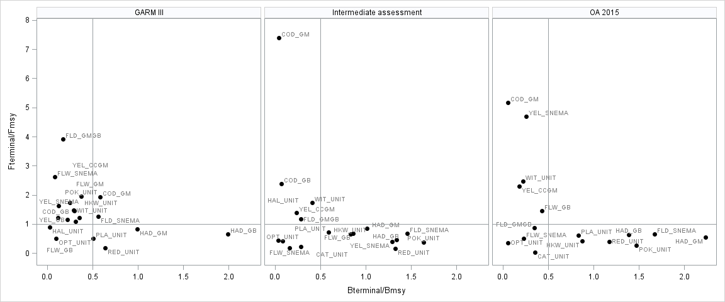

Figure 1. Status of the Northeast Multispecies Fishery Management Plan (groundfish) stocks in 2007 (GARM III) and 2014 (OA 2015) with respect to the FMSY and BMSY proxies. The ‘Intermediate assessment’ represents the last stock assessment conducted prior to the OA 2015 assessment (year varies by stock). Stocks on which overfishing is occurring are those where the Fterminal/FMSY-proxy ratio is greater than 1 and overfished stocks are those where the Bterminal/BMSY-proxy ratio is less than 0.5. *Notes: (1) the GARM III assessments did not include wolfish; (2) for the intermediate assessments stock status could not be determined for Gulf of Maine winter flounder (OA 2014) or Georges Bank yellowtail (TRAC 2015); and, (3) based on the OA 2015 assessments stock status could not be determined for Atlantic halibut, Gulf of Maine winter flounder and Georges Bank yellowtail flounder. In the OA 2015 assessment, the stock status for Georges Bank cod remained overfished and overfishing is occurring; however, since the assessment was rejected, ratios of terminal conditions to reference points cannot be determined. Species codes: COD-Atlantic cod, HAD-haddock, POL-pollock, RED-redfish, WHK-white hake, OPT-ocean pout, CAT-wolffish, PLA-American plaice, FLW-winter flounder, YEL-yellowtail flounder, WIT-witch flounder, FLD-windowpane flounder, HAL-Atlantic halibut.*

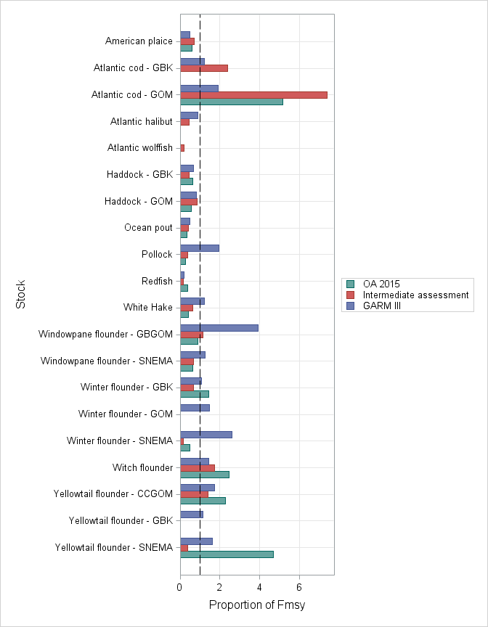

Figure 2. Changes in the ratio of fishing mortality to FMSY proxy from 2007 (GARM III) to 2014 (OA 2015) for the twenty Northeast Multispecies Fishery Management Plan (groundfish) stocks. The results from the assessment prior to the OA 2015 assessment are shown for each stock to provide an ‘Intermediate’ value. Stocks on which overfishing is occurring are those where the Fterminal/FMSY-proxy ratio is greater than 1. *Notes: (1) the GARM III assessments did not include wolfish; (2) stock status in the ‘Intermediate’ assessment could not be determined for Gulf of Maine winter flounder or Georges Bank yellowtail flounder; and, (3) based on the OA 2015 assessments stock status could not be determined for Atlantic halibut, Gulf of Maine winter flounder and Georges Bank yellowtail flounder. In the OA 2015 assessment, the stock status for Georges Bank cod remained overfished and overfishing is occurring; however, since the assessment was rejected, ratios of terminal conditions to reference points cannot be determined.*

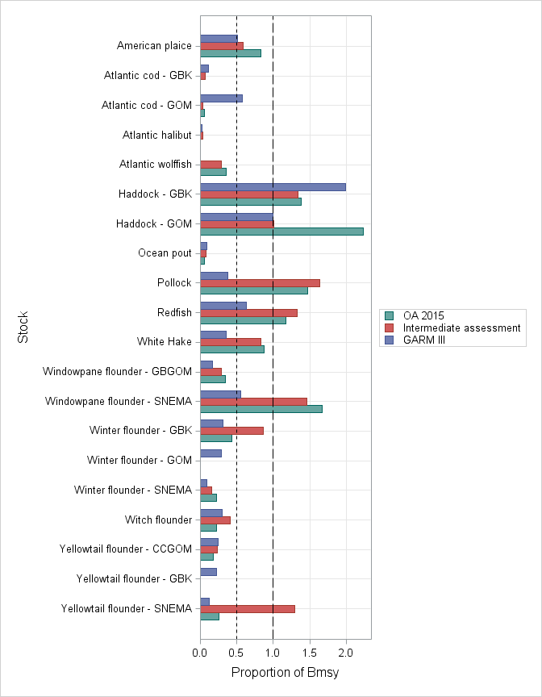

Figure 3. Changes in the ratio of stock biomass to BMSY proxy from 2007 (GARM III) to 2014 (OA 2015) for the twenty Northeast Multispecies Fishery Management Plan (groundfish) stocks. The results from the assessment prior to the OA 2015 assessment are shown for each stock to provide an ‘Intermediate’ value. Stocks that are overfished stocks are those where the Bterminal/BMSY-proxy ratio is less than 0.5. *Notes: (1) the GARM III assessments did not include wolfish; (2) stock status in the ‘Intermediate’ assessment could not be determined for Gulf of Maine winter flounder or Georges Bank yellowtail flounder; and, (3) based on the OA 2015 assessments stock status could not be determined for Atlantic halibut, Gulf of Maine winter flounder and Georges Bank yellowtail flounder. In the OA 2015 assessment, the stock status for Georges Bank cod remained overfished and overfishing is occurring; however, since the assessment was rejected, ratios of terminal conditions to reference points cannot be determined.*

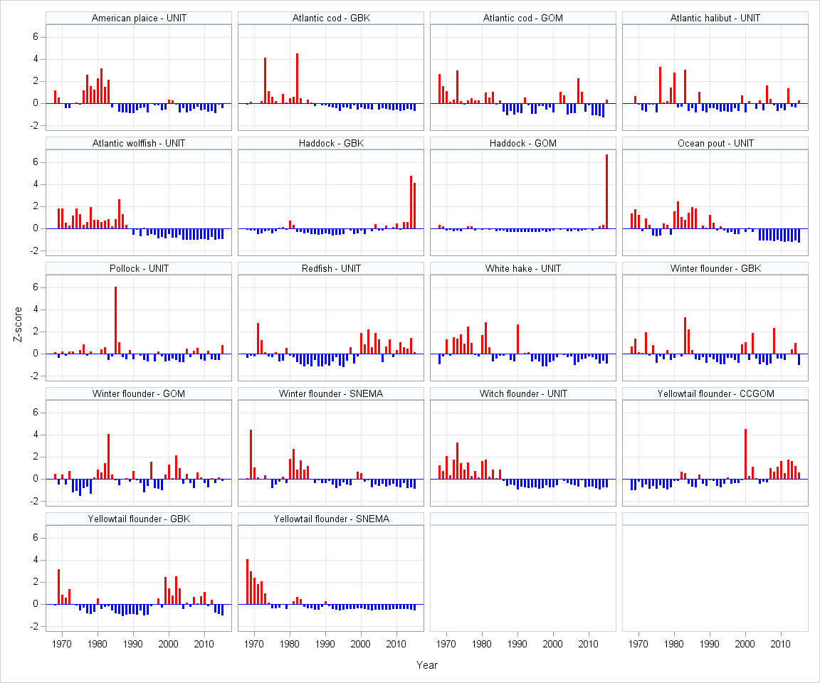

Figure 4. NEFSC spring bottom trawl survey index standardized anomalies (Z-score) for the Northeast Multispecies Fishery Management Plan (groundfish) stocks from 1968 to 2015. *Note that both the Georges Bank/Gulf of Maine and Southern New England/Mid-Atlantic windowpane flounder stocks are not included since the spring survey is uninformative as an index of abundance and not used in the stock assessment.*

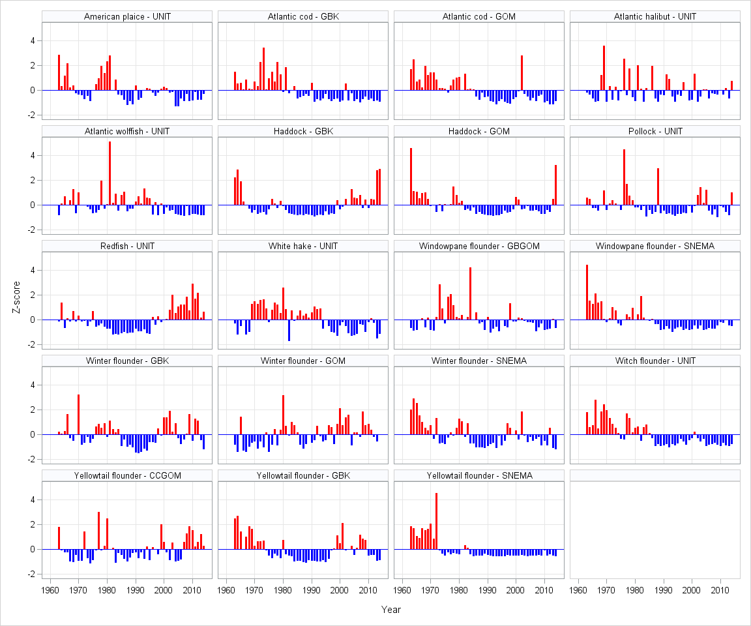

Figure 5. NEFSC fall bottom trawl survey index standardized anomalies (Z-score) for the Northeast Multispecies Fishery Management Plan (groundfish) stocks from 1963 to 2014. *Note that ocean pout is not included since the fall survey is uninformative as an index of abundance and not used in the stock assessment.*

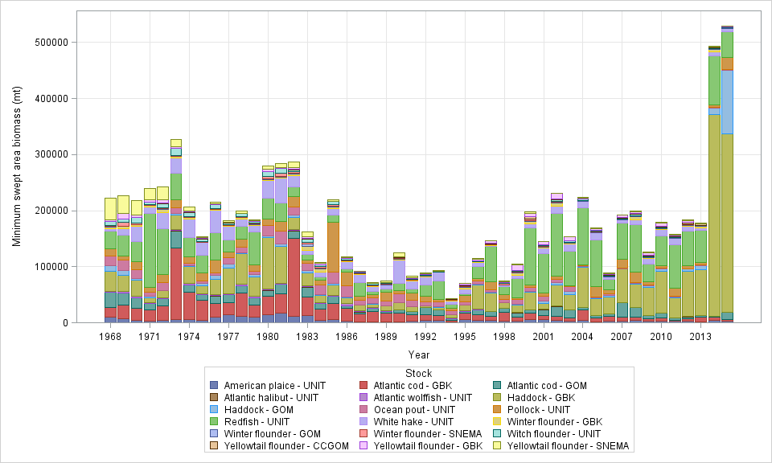

Figure 6. NEFSC spring bottom trawl survey minimum swept area biomass (mt) for the Northeast Multispecies Fishery Management Plan (groundfish) stocks from 1968 to 2015, by stock. Minimum swept area estimates assume a trawl swept area of 0.0112 nm2 (0.0384 km2) based on the wing spread of the trawl net. *Note that both the Georges Bank/Gulf of Maine and Southern New England/Mid-Atlantic windowpane flounder stocks are not included since the spring survey is uninformative as an index of abundance and not used in the stock assessment.*

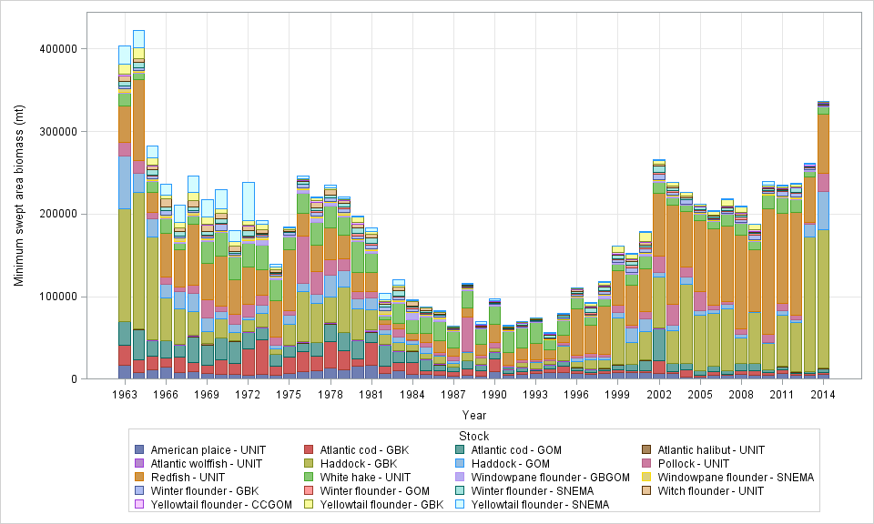

Figure 7. NEFSC fall bottom trawl survey minimum swept area biomass (mt) for for the Northeast Multispecies Fishery Management Plan (groundfish) stocks from 1963 to 2014, by stock. Minimum swept area estimates assume a trawl swept area of 0.0112 nm2 (0.0384 km2) based on the wing spread of the trawl net. *Note that ocean pout is not included since the fall survey is uninformative as an index of abundance and not used in the stock assessment.*

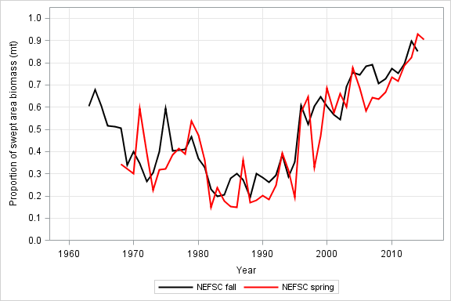

Figure 8. Proportion of the total groundfish swept minimum swept area biomass contributed by Georges Bank and Gulf of Maine haddock and Redfish based on the NEFSC spring and fall bottom trawl surveys.