**Checkbox**

Two to five short sentences describing this component’s:

Checkboxes are form components that let users select one or multiple options from a list. They also allow users to uncheck an option, which is helpful if a user changes their mind. Checkboxes commonly have instructions on how to use them, all options are visible, and users can easily change their selection making checkboxes very understandable and user friendly.   
**Usage and Function:**

* **Value of component:**

**Component in HTML/CSS and PrimeNG**

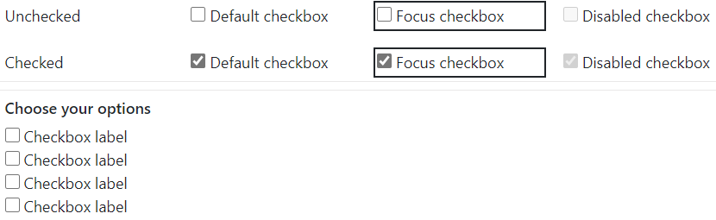

**{Code blocks for use}**

**When to use**

* Secondary use cases if applicable:

A single checkbox could be used as a toggle to switch on (checked) and off (unchecked) an option, or select between a yes or no option.

* Problems this component is used to solve:

When you present more than one options without limitation to number of choices a user can select

**When not to use**

* Instances when using this component should be avoided:

when a user is restricted to only one choice among several options presented, use a radio instead

* Purposes this component should not be used for:

**(Drawer title) Accessibility for Checkbox**

Details about accessibility implementation

* The checkboxes should be wrapped in a group labeled by heading level element –
* A Checkbox or Checkbox group with relevant additional descriptive static text can include the element attribute or property aria-describedby, set to the ID of the element containing the description
* One way of presenting checkboxes is to enclose the options within a list element, each div element contained by a ul element. This will announce to screen reader users that a list of options exists and how many to expect.
* Clicking either the label or checkbox should activate the checkbox, when hovered over the checkbox or label, a border should appear, and the cursor should change to a pointer.
* The <label> element of a checkbox connect explanatory text with each checkbox and allows the user a larger target area for selecting an option, this is especially helpful for users on mobile devices.

**State Attribute**

* False: [aria-checked="false"]
* True: [aria-checked="true"]

This is attributes are useful in customized element. Not needed in the semantic HTML because it is built in.

Example:

<span

role="checkbox"

id="checkbox"

aria-checked="false"

tabindex="0"

aria-labelledby="chk"></span>

<label id="chk">Sample checkbox</label>

**(Drawer title) Best practices for {component name}**

* Mobile considerations
* Additional best use information that would make the user experience more efficient/enjoyable
  + Labels should be descriptive and short
  + Checkbox options should begin with a capital letter
  + Be sure to list options in either alphabetical or most-frequent to least-frequent order
* Patterns that use this component (listed links)
  + Pattern 1
  + Pattern 2
  + etc