BRICKS

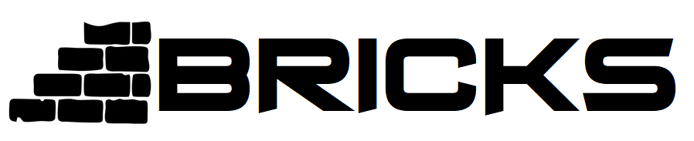

Own a piece of vetted properties with BRICKS

**Invest in real estate with as little as R5000 through BRICKS.**

Own a piece of vetted properties with BRICKS

accessible, transparent, and hassle-free.