|  |
| --- |
| PGIS – University of Peradeniy |
| Web Programming Assignment |
| M.Sc. in Computer Science (2012/2013) |
|  |
| **Ananda** |
| **6/28/2014** |

|  |
| --- |
| **Name : SMAP Subasigha**  **Re No : PGIS/SC/M.Sc/CSC/11/43** |
|  |

Table of Contents

Introduction 2

Database design 3

Application design 4

Functionality the system provides 4

1. Exam coordinator 5

2. Visiting Lecturer (Teacher) 7

3. Students 9

Installation & User logins 12

Technology used 15

Further improvements 16

# Introduction

The intended users of the system are prospective postgraduate students and visiting lecturers of the postgraduate institute. Prospective postgraduate students should register for a course by sending an application for an examination. A sample application is given at the end this document. The application has three main sections:

1. Personal information section
2. Educational and Professional qualification section
3. Details of the Intended course section.

Assume that postgraduate studies will be offered in five subjects: Computer Science, Mathematics, Statistics, Chemistry and Physics. For each subject a programme coordinator is assigned to manage students who are applying for examinations. Also prospective students could apply for multiple courses.

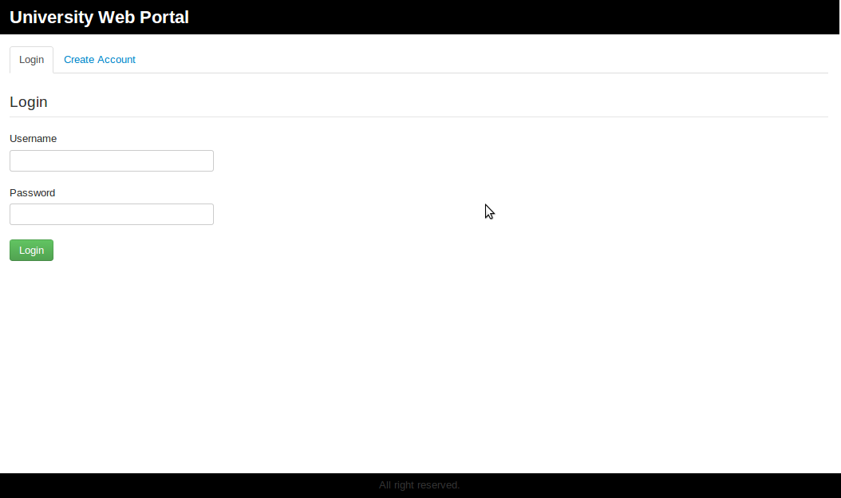

Figure 1: System home page

# Database design

This development of the web application uses MySQL as the database used to persist the data collected from the users that belongs to following three categories

1. Postgraduate student
2. Visiting Lecturer(teacher)
3. Course coordinator

As show below 9 tables have been used to store and manage the information captured form above three user categories.

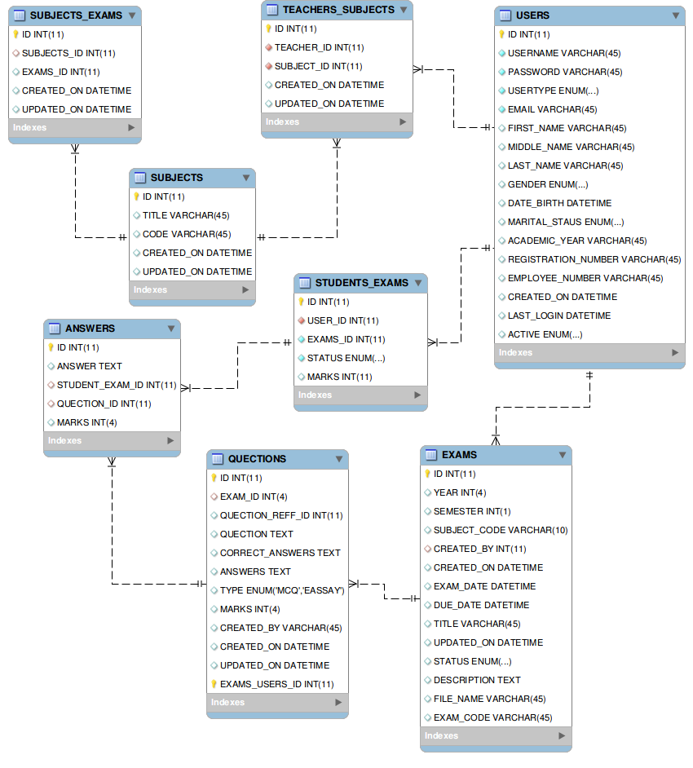

Figure 2: System DB design

### Application design

### Functionality the system provides

1. The system provides access to three types of users
   1. Prospective postgraduate student.
   2. A programme coordinator
   3. Visiting lecturer
2. The Student and teacher can create new account to access the system. According to there user type. System captures different user specific information according to the requirements. Program coordinator has a free define account and he can mange any user (from student and teacher types) with his login.
3. For each user, the system provides the following functionalities.

### 1. Exam coordinator

The exam coordinator can do the following actions,

1. Views and search the list of active teachers how have registered with the system.

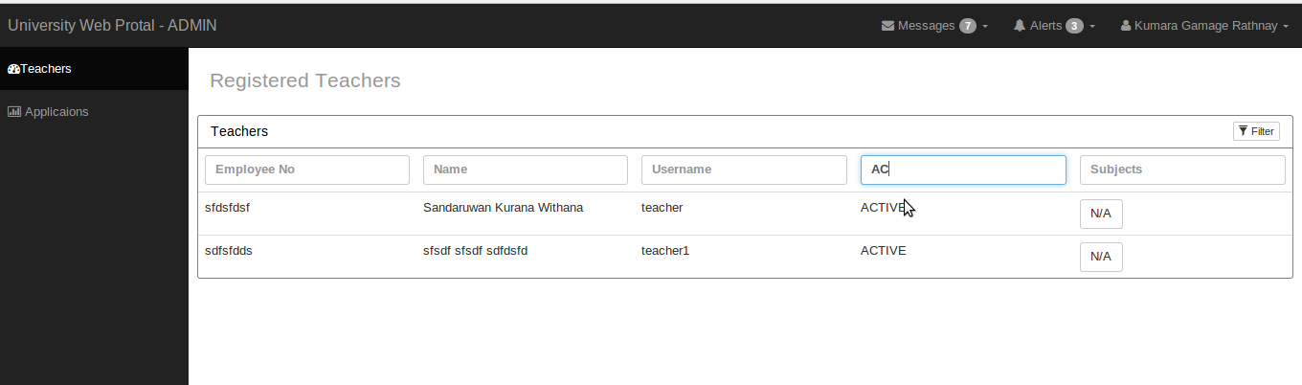

Figure 3: Teacher assign screen for subjects.

1. Assign subject to each teacher. One teacher may be assigned for one or more subjects. Teachers only can place exams for these assigned subjects.

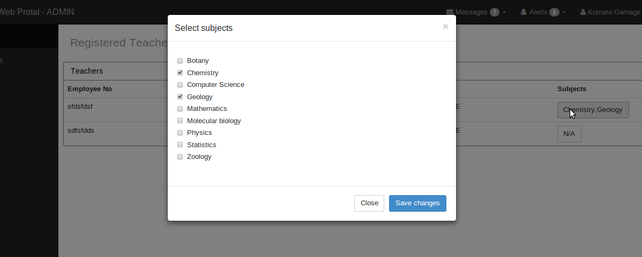

Figure 4: Subject selection.

1. Views the list of all the student subscription for the exam.
2. Accept or reject each use subscription. Students only can take the exam if coordinator accepts the student subscription.

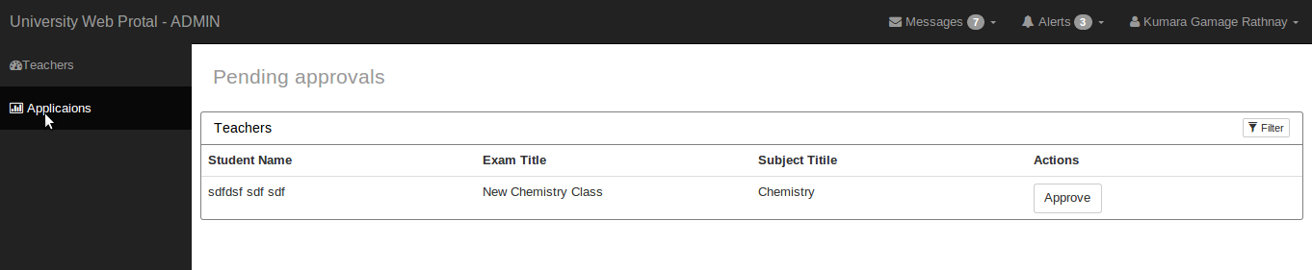

Figure 5: Approving student subscription.

### 2. Visiting Lecturer (Teacher)

After the system coordinator assigned subject for each teacher they will able to place exams. System provides following actions to teachers:

1. Create new exam by selecting subject and due date.

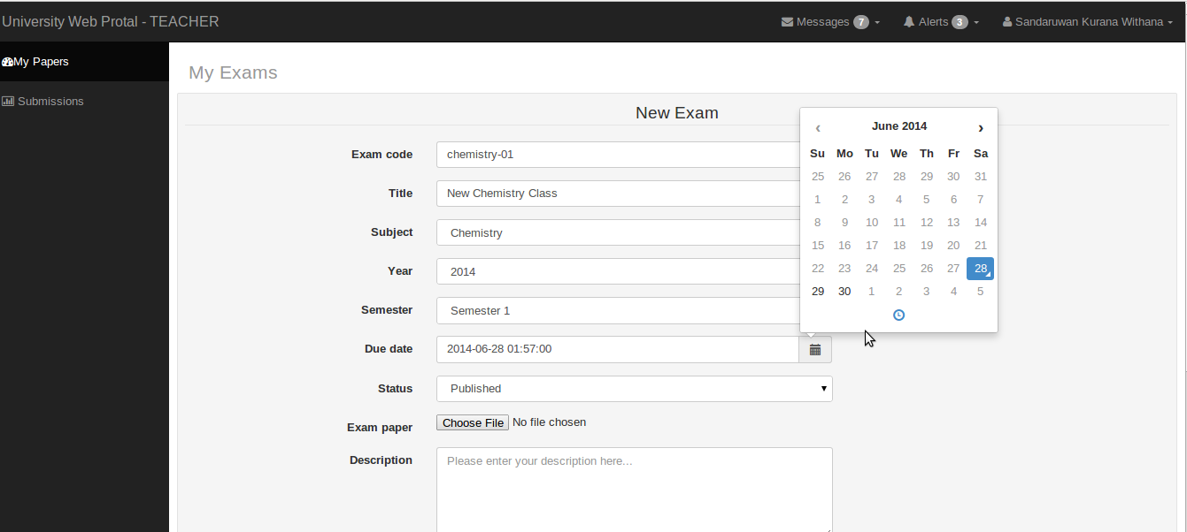

Figure 6: New exam form.

1. Edit the created exam.
2. Upload the exam paper in ”.csv” format. With the “.csv” format teacher can specify the possible answerers for MCQ questions. Each possible answerer should be separated with semicolon (“;”). Then system is smart enough to generate exam paper for students.

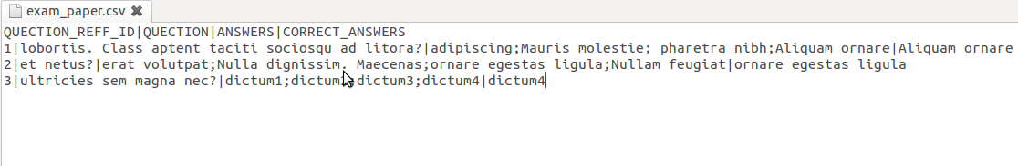

Figure 7: CSV file.

1. View and search the list of students have submitted their answers.
2. View and search the list of exam teacher created.

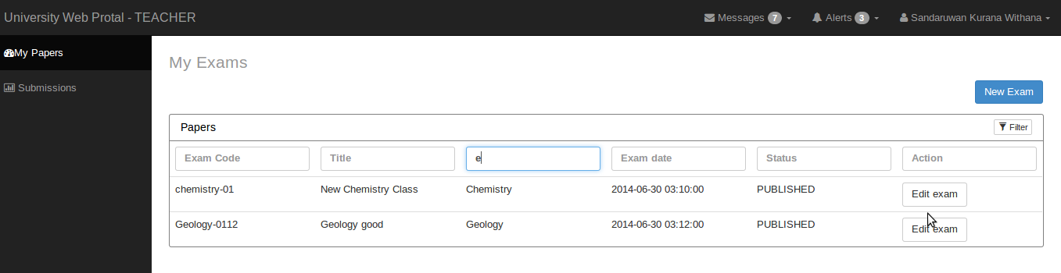

Figure 8: Teacher created exams.

1. See the student marks by click on “paper mark” button.

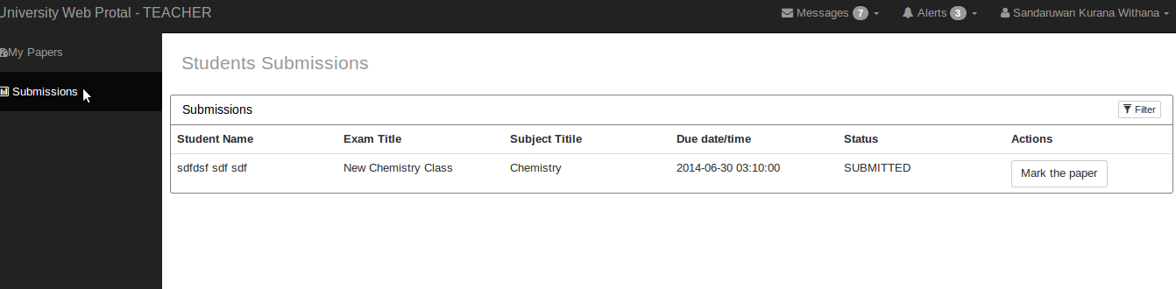

Figure 9: Just after student submit their answers.

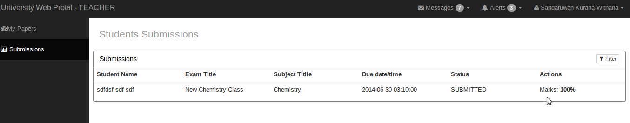

Figure 10: When click on Mark the paper button

### 3. Students

As a student he can do the following actions.

1. View and search the list available exams which users can be subscribed. When student subscribed for the exam until coordinator accept it student can not takes the exams. After coordinator accepts the subscription he can see that specific exam under his my exam section.

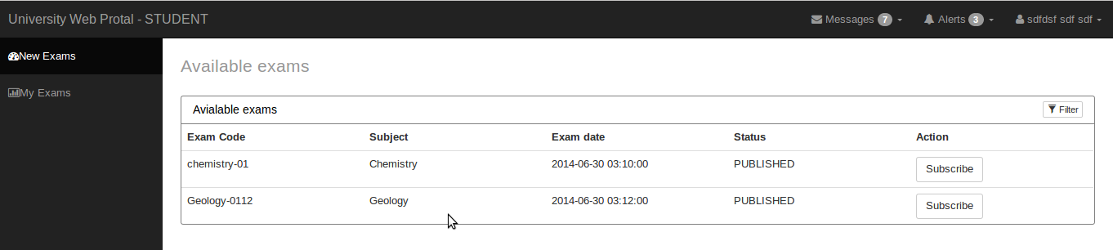

Figure 11: When just after teacher created a new exam student view.

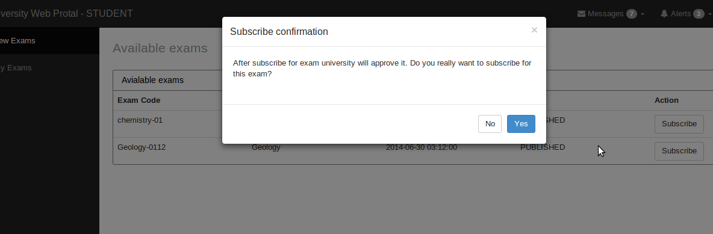

Figure 12: Exam subscription confirmation.

1. In the same time students able to view and search the list of exam which he has subscribed.

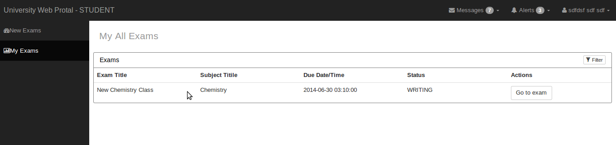

Figure 13: After the coordinator approves student subscription it is ready to go to the exam.

1. Submit the answerers for MCQ questions by click on “Go to exam”. Students can submit a paper until due date or teacher set the submission status as mark.

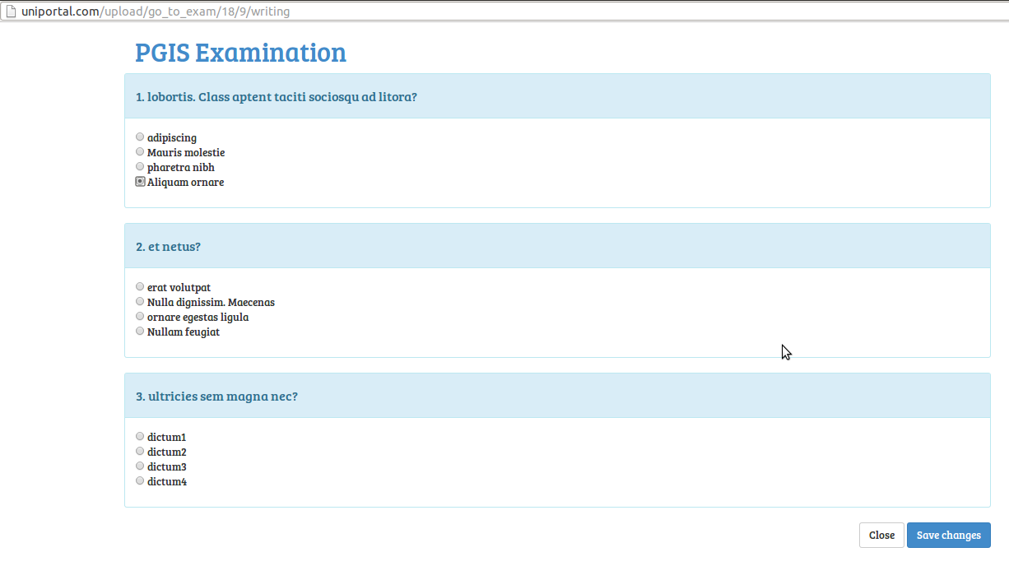

Figure 14: Exam paper generated from the CSV content for student.

### Installation & User logins

### Installation

Please do the following steps setup the application.

* Enalble mod_rewrite - on a linux machine please issue following instructions
  + $ sudo a2enmod rewrite
  + $ sudo /etc.init.d/apache2 restart
  + $ sudo vim /etc/apache2/sites-available
* Update the followings
  + Options Indexs FollowSymlinks Multiviews
  + AllowOverride None
  + Order allow,deny
  + allow from all

to

* + Options Indexs FollowSymlinks Multiviews
  + AllowOverride all
  + Order allow,deny
  + allow from all
* Extract attached file to **/var/www/** in a linux machine or **htdocs/** folder  in Windows machine if you are using Xampp
* Please find the **uniprotal.sql** script that holds all the database tables required for the application, execute it by creating a new database called **uniprotal** inside MySQL
* Please provide following file permission to **application/codebase/assets/** folder
  + **chmod -R 777 files/tmp/**
* Locate the following two config files and update the following parameters
  + **application/config/config.php**
    - $config['base_url']
  + **application/config/database.php**
    - hostname
    - user
    - password
    - database

### Login

Username & password pairs for the user's that belongs to the main categories of the users.

* Student
  + Username: student
  + Password: 12345
* Teacher
  + Username: teacher
  + Password: 12345
* Coordinator
  + Username: instructor
  + Password: passsword

# Technology used

1. Codeigniter as a php framework.

Codeigniter is a php framework that helped to layout the system architecture nicely.

1. Jquery as javascrpt framework.

Jquery used for some front end operations make easy. eg: form validation.

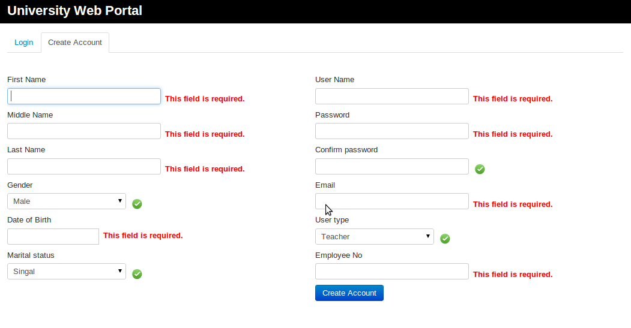

Figure 15: Validation done with Jquery.

1. GIT as versioning controlling package.

Because of this is an individual project GIT did not paly a major role but help to backup the code in the cloud for any emergency.

# Further improvements

1. When students ask for a exam’s subscription it can display as number of pending message with message icon as already place with UI(top left). With the current implementation this displays as a hard corded value.

2. Update the each user view base on real time interaction without page refresh.

3. Give the possibility of question base marking system because of different question may carry the different number of marks.

4. Current system provides functionality of adding Lectures and Students. So it is possible to improve the system for having more system coordinators.

5. Provide a functionality to add essay type questions.