Bitget Hack : On-Chain Forensic Report
Sep 24-26, 2026 • $387.5M • Backend spoof, no keys • Free-tools investigation • Filed BITGET + Binance
Investigator alias: Henoch • Timezone: WAT (UTC+1, Nigeria) / UTC • Status: submitted, 48h review pending, no payout claimed • Sources: public explorers only • Contact: okumagbeenoch4@gmail.com
Disclaimer: public XRPSCAN / TronGrid / Ethplorer freekey / Blockscout / zcashexplorer / trace.bgblockchain.xyz only. No private keys touched. Amounts native (XRP/ETH/ZEC/TRX/USDT); USD approximate Sep 25-26 spot, never filing basis. Attribution DPRK-consistent per Bitget CEO + Elliptic overlap note, same-operator unproven.

1. Executive summary
- Detected 18:31 UTC Sep 24 2026. Backend wallet compromise → spoofed tx data → own signing process. Hot+warm drained, cold safe, self-custodial Bitget Wallet unaffected. $351.6M → $387.5M (added ZEC+TRON). Mandiant/SlowMist, $464M protection fund, withdrawals plan 04:00 UTC Sep 26.
- Primary sinks (Bitget official): EVM 0x770b10b273fc44fe9197d6bf20f145c2e98463ee, XRP rwNhefsz1UQEusxhCvHip3RANinWi4CTck (102.9M in), ZEC t1WgMdtND8NF7NDUuYmq8MpMj1NTCXkMDVG (37,828 in), TRON TBWNguTTgezw9dVorX441C6nDrZpRxYwKD.
- EVM bulk → ~68k ETH (swap wallet 0x7c96, consolidation 0xA6dD, 10k parks 0xD2C2 / 0x600c dormant). Frozen only Exploiter 8 ~$318k (0xe07b… / 0x9acc…, 170 ETH remains unfreezable).
- XRP: consolidator drained to 4×20M + 22.9M splits. Big 4 dormant (82.97M) TRACE-ready. 4th 20M rDRV… active → r4HFF… → rKcDF… 370k → rU7dx… (729k→13k live) → rNnMCi… → Binance Tag 470475839.
- CEX breakthrough: rNnMCi68fuqVCk9nFPjat8mnzCzQGLRzfS (Binance-activated rfQ9Ec…) → rNxp4h8apvRis6mJf9Sh8C6iRxfrDWN7AV verified Binance Require Tag 470475839. 194,629 XRP in 25 sends through 00:55:51Z Sep 26 + 35,333 XRP in 7 sends to 01:53Z = ~229,962 XRP (~$352k). Filed Binance fraud + BITGET LazarusBounty FREEZE (alias Henoch). Live at filing: rNnMCi… 474-5,153, rU7dx… 13k-33k still feeding. • Contact: okumagbeenoch4@gmail.com
- TRON→ETH bridge: TTe3o6… → UsdtOFT TFG4… (LayerZero EID 30101 Ethereum) 367,355 USDT tx 5f754814… → 0x0193aca55a772f5873b11af64a03f33fe7e5b7a4 receive 0x01f393… → 136 ETH peel 0xdc7ff7… to 0xDbD0… hub (0 bal, mixed). Feeder 0x7cf6… 987 ETH out. TRACE filed.
- ZEC 18,911.62 transparent (37,828 in / 18,916 out), 5.1 test t→z shielded, bulk transparent. THORChain offline → shield only exit. TRACE + watch.
- Bybit Feb 2025 $1.46B context: primary 0x4766… dust now, FBI I-022625-PSA 51 addrs, ZachXBT 920+, Elliptic 11k, THORChain $5.4B, $48.4M recovered + $30.5M frozen Aug 2026 (D.C. suit). jUSDT V2 hunt #4214/#4220/#4222 dropped (no Bybit-size inflows). Remaining EV: refund wallets, OTC/Huione→Xinbi Sep 9 OFAC cluster, eXch 8TB log-match via counsel.

2. Timeline (UTC)
Time | Event
Sep 24 18:31 | Detection, hot+warm unauthorized transfers
Sep 24 19:01-23:43 | XRP consolidator funded (2.24M) → 4×20M + 22.9M splits; EVM 10k peels from 0x770b…; TRON peels; ZEC 37,828 in
Sep 24-25 | EVM stables→~68k ETH via 0x7c96; TRON 1.01M TRX→342k USDT via UniversalRouter → 367k UsdtOFT bridge EID 30101; ZEC 5.1 test→shielded
Sep 25 05:00 | Circle+Tether freeze Exploiter 8 ~$318k
Sep 25 12:36 | Public XRP peels (@era_0k/@0xJingg)
Sep 25 22:34-26 01:53 | rNnMCi… → Binance Tag 470475839, 25+7 sends, 194k→229k XRP; rU7dx… 729k→13k
Sep 26 04:00 | Withdrawal plan due (Bitget)

3. Methodology (free only)
- XRPSCAN API: /api/v1/account/{r…}, /…/transactions?limit=25, /tx/{hash}. Drops/1M. ParentName verified (Bitget/Binance). Ground truth: Sequence/PreviousTxnID/ledger_index + tesSUCCESS. Dust filter: rwLCaBL… 10 XRP, Gwei, sun.
- TronGrid: /v1/accounts/{T…}, /…/transactions/trc20, factory TKWJdr…/events?event_name=PairCreated&min_block_timestamp=1740268800000&max_block_timestamp=1741651200000. jUSDT TXJgMdj… = CErc20Delegator ($87M USDT), not worthless.
- Ethplorer freekey /getAddressInfo + /getAddressTransactions (Etherscan 403 workaround) + Blockscout txlist. zcashexplorer, trace.bgblockchain.xyz/api/holdings (499 addrs). X Latest+Replies manual exact-address.
- No paid (AgentKey 88% used, Nansen Solana-only skipped). EVM hex→Tron Base58 via local script. No invented hashes; truncated display expanded before filing (leading-zero 0x0193… fix).

4. EVM : 20k parks dormant TRACE
Primary 0x770b10b273fc44fe9197d6bf20f145c2e98463ee fanned 10000 each Sep 24. Zero outbound since, dust only. ETH unfreezable → CEX watch.
Park | Balance live | Peel tx | Time
0xD2C2f029eFF5caCc686F24377CfdDcfc82d9F899 | 10000.004730540008, tokens [] | 0xf5ae8db20a36d4e05bfebdc71e261a2e1879ddb5a6ab645b98811be6aeefedd3 | 1790280791
0x600cfeDc6Bd65Fa79B604dC44964f419e45784b2 | 10000.0007 | 0x32df608e29e71b2f20dbf276dabf929df55ed1c806cfe9f49ecec123ac1d13d5 | 1790281151

Dust inbound ignore: 0xfab8501482db701401cb2966bad36cb080ad8e4a / 0xdbbd8e5af2080a7b0c95a5f0ce78438ffef1f41e / 0x31313131319e316b59e5e75f385f4e1afeeb5d8c8. Feeder 0x7cf6465cdffb584f74941e8c1fdaed6388de45da 987 ETH out to 0xDbD0… hub (0 bal). Frozen Exploiter 8: 0xe07bd590e1198666230932bad5db3dbbe21e7d57 (170.46 ETH remains, stables frozen) + 0x9acc843479784924e5ad90b982e4d2a73f95b046 residual.

5. XRP dormant (82,976,677 TRACE)
Split | Balance | Peel tx | Time / Seq
r6NcwN3dR5ciyBv9XsLyMNc9Kg2FBCs7Y | 22976677 | AEC36EF74D80C5016E6C9A86FFE2C2E8D64E5C3890C6E4DAD21692E883010F57 | 2026-09-24T23:43:41Z / 107214202
r3UGfDM4ZyFSCzKH7TQEjgago9QoUJagtJ | 20000000 | 8F4376382000AE0D1C2FEA19565F9DE1004BAABE2AB521F66398FE10989537DE | 22:03:41Z
rH7oMFKBgdK99TPQctFVzddD7srRzyCqZn | 20000000 | 515E708732DCE6EAE44D482967D9FF661DE471242EC38D3B48858388B7D14D73 | 22:04:42Z
rwSjBrtxBC75TqZ5YvJ1TGfaRpQvVNsAKw | 20000000 | 31845DF307FE79EC4BB0086ADC8D6DA0A82C640F37CE6456989B7E17ED39B9D7 | 22:06:01Z

All parent rwNhefsz1UQEusxhCvHip3RANinWi4CTck (Bitget parent rGDreBvnHrX1get7na3J4oowN19ny4GzFn, 3.09 left, contained). Each only peel + 10 XRP dust from rwLCaBLPKcE55pjgmEicUYTtXHr8VawD9Z, ownerCount 0, zero outbound. Native unfreezable → TRACE for CEX/Bridgers intercept.

6. Active hub → Binance Tag 470475839 (FREEZE filed)
Chain: rwNhef… → rDRV9nLg8xbLsafKZnhNgWuE1TiSLE95hs 20M (emptied to 22.8, disperser, failed 340k UNFUNDED 916381BC…) → r4HFFpv8h7ZHotdJXsSku6Evj1MUEeukXp (1.0 left) → rKcDFVGCxqexNaZVF84k2AF2iRtHZs9FFB (169 left, 370k via 442D4219…) → rU7dx6W4YUaKMk5exCgEC8e9j7gY39UnDF live 33,909→13,039 (729k peak, memo OUT:… batch IDs, PreviousTxn B7522121…/CDD26FEE…) → rNnMCi68fuqVCk9nFPjat8mnzCzQGLRzfS live 5,153→474 (Binance-activated rfQ9EcLkU6WnNmkS3EwUkFeXeN47Rk8Cvi) → rNxp4h8apvRis6mJf9Sh8C6iRxfrDWN7AV verified Binance Require Tag 470475839 (206,119 live).
25 sends 22:34:11Z Sep 25-00:55:51Z Sep 26 totaling 194,629 XRP (hashes: 292576BB 23811, 9D4F57AB 3098, 5A4510EC 3185, B20B4FAE 4297, 3C3F84B6 2925, 2703B890 2353, 17F95D85 2057, 8E9EBA63 4940, 4754292E 3737, 9F1CBFB4 2509, D7E0C349 3756, 39C3A540 16397, 914389A5 12836, 41A0AAD8 2498, 4F983301 25975, 16AC2C70 11871, 73DFC90B 2459, 91F848F8 3191, 7B4D2FA1 4424, 6301D39E 3029, 253654D7 2629, plus feed 66120B79 10300 rU7dx→rNnMCi with OUT memo, reverse 4961018B 1698 cycling, Bridgers C9D101BD 9294 XRP rBcrN…→rM27yz… memo ETH 0x42fe… still in SWFT). +7 sends 01:48-01:53Z totaling 35,333 XRP (63355BC2 2340, C5DCE9BA 3342, 8C4C35DE 3538, D70171D4 2136, 254E13D3 9966, E0BC7883 3107, 708081B6 10904) → running ~229,962 XRP (~$352k). Filed Binance fraud + BITGET LazarusBounty FREEZE (alias Henoch). Two-way Binance hot wallets inbound (rDAE53… 7,829, rhWj9… 9,016) prove CEX nesting. • Contact: okumagbeenoch4@gmail.com
Full 32 hashes in Appendix B. Attachments 01-21 + live updates 01b/02b/17b/20/21 (5-image limit: 02b, 21, 01b, 20, 17b; rest in zip Bitget-Binance-Tag470475839-evidence.zip 8.98 MB). Bounty: 5% frozen ≈ $15k+ (Bitget), paid after confirmation, 48h review. Tag still receiving at filing; supplement on new sends.

7. TRON→ETH bridge TRACE
- TCaNww3hT7BQCUWsNzuYk4yK7XoXyPkV64 4,820 USDT remainder (30k in 52258618… from TKDqp…, 25k out b06ab9be… to TTe3o6…). Primary TBWN… 0.39 TRX empty.
- TQqgNg13s2DjvXhW1ky4v6TsR8wZGvb7Y4 = UniversalRouter. Attacker TTe3o6… pushed 1,012,400 TRX in, got 342,355 USDT back tx 0439aca45ddc464618547e997e35b350d3bc051818bb3a2811bb6aa04e4b3607.
- TTe3o6YqiRuUX9bRky5iTzR9LSAokYtRB3 → UsdtOFT TFG4wBaDQ8sHWWP1ACeSGnoNR6RRzevLPt (USDT TR7NH…, LayerZero) 367,355.864045 USDT tx 5f7548142927d2337004e9485ad692e7de6b83d1c0c8e514642284565c747dc4 (revert 25a21f9e…), method c7c7f5b3, EID 30101 Ethereum, recipient 0x0193aca55a772f5873b11af64a03f33fe7e5b7a4 (42-char leading-zero fix), amount 0x55881da3ed.
- Receive 0x01f393d2f9100144e6a845a4c316190cf65931fdbccd52424c02ba2670193fdb → 136 ETH peel 0xdc7ff7221b5e110062529f8d1a4c80c278bd11fb54d88e8f50fa4299c489e147 to 0xDbD0… hub (0 bal, mixed via Uniswap V4/Universal). No freeze TRON side; EVM CEX watch.

8. ZEC watch
t1WgMdtND8NF7NDUuYmq8MpMj1NTCXkMDVG 18911.62233872 / 37828.34697744 in / 18916.72463872 out. 5.1 test t→z shielded, bulk transparent. THORChain offline → shield only exit. TRACE + watch z→t.

9. Bounty + evidence
- LazarusBounty BITGET: Fund Binance, Dest rNxp4… Tag 470475839, Amount 166026→194629→229962 (supplements), Token XRP, Related Tx full hashes, Alias Henoch, Description recovery-directed, Attachments 5/25 PNGs (URL bar, Tag, Binance name, UTC). 48h review. • Contact: okumagbeenoch4@gmail.com
- Binance Report Fraud: Report Type fraud/illicit deposit, URLs (XRPSCAN ×4 + trace dashboard), Channels on-chain OSINT, Contact 149-char UID/dep/snd/up string, Brief 601→full expanded (no …), Supporting 10/20 (02b,21,01b,20,17b top 5).
- PII redacted here (email/wallet 0xcea…). Do not edit addresses for spellcheck. Re-pull balances before submit (36-min drift observed 01:05→01:41Z).

10. Bybit context + legal bundle
- Feb 21 2025 $1.46B Safe UI spoof. Primary 0x47666Fab8bd0Ac7003bce3f5C3585383F09486E2 dust now (0.2 ETH + spam). FBI I-022625-PSA 51 addrs (0xa4b2… incl). ZachXBT 920+, Elliptic 11k. THORChain $5.4B, 440k ETH→12.8k BTC via Wasabi/mixers→Tron USDT→Huione/Xinbi (Sep 9 OFAC Xinbi cluster, XinbiPay/NewPay). $48.4M recovered + $30.5M frozen Aug 2026 (D.C. suit). LazarusBounty 10%, $2.2M paid Mar 2025.
- jUSDT V2 hunt closed: #4214 TD5yie… pre-hack scam, #4220 TXVoy… (GoldToken 2023), #4222 TB8EPv… counterfeit + gas. Zero jUSDT 0xea09… in 24 pools. Wrong filter (loop pairs jUSDT, V1/V1.5/V3 untested).
- eXch 8TB seized Apr 30 2025 (>$200M Bybit flow) + Cryptomixer 12TB Nov 2025. Logs not public; route fresh residuals via Bybit/BKA/D.C. discovery. Refund-address topology + OTC reuse + Bitget overlap note (Elliptic Sep 25 infra overlap, AFX $24M, same-operator unproven).

Appendix A : full wallets
EVM 0x770b10b273fc44fe9197d6bf20f145c2e98463ee; 0x7c96279ec1e888aa56b9b836e0db26ca48573e1c; 0xd2c2f029eff5cacc686f24377cfddcfc82d9f899; 0x600cfedc6bd65fa79b604dc44964f419e45784b2; 0x469ac1406de92f82c0563477240a3627057425dc; 0xa6dd3f218b65e32ccc37be30f74884133c655545; 0xe410a2e5710ee787bcaa63f52A3943ff71F0d946; 0xe07bd590e1198666230932bad5db3dbbe21e7d57; 0x9acc843479784924e5ad90b982e4d2a73f95b046; 0x0193aca55a772f5873b11af64a03f33fe7e5b7a4; 0xdbd0f5ebada6632dde7d47713ea200a7c2ff91eb; 0x7cf6465cdffb584f74941e8c1fdaed6388de45da; 0x42feCf4832E56Ccfe2009187242A440A842bF762. XRP rwNhefsz1UQEusxhCvHip3RANinWi4CTck; r6NcwN3dR5ciyBv9XsLyMNc9Kg2FBCs7Y; r3UGfDM4ZyFSCzKH7TQEjgago9QoUJagtJ; rH7oMFKBgdK99TPQctFVzddD7srRzyCqZn; rwSjBrtxBC75TqZ5YvJ1TGfaRpQvVNsAKw; rDRV9nLg8xbLsafKZnhNgWuE1TiSLE95hs; rPfoxaxh2naH6kQSe3FZNXEC3pFgF5xwMR; r4HFFpv8h7ZHotdJXsSku6Evj1MUEeukXp; rKcDFVGCxqexNaZVF84k2AF2iRtHZs9FFB; rU7dx6W4YUaKMk5exCgEC8e9j7gY39UnDF; rNnMCi68fuqVCk9nFPjat8mnzCzQGLRzfS; rNxp4h8apvRis6mJf9Sh8C6iRxfrDWN7AV; rBcrNwytuY9RN9purWgW5mPwp2pQagm95E; rM27yzkCw6WA3T4g1sPaeC1kpxHUhuxRWn; rNnMCi chain + rU7dx chain as §6. TRON TBWNguTTgezw9dVorX441C6nDrZpRxYwKD; TTe3o6YqiRuUX9bRky5iTzR9LSAokYtRB3; TCaNww3hT7BQCUWsNzuYk4yK7XoXyPkV64; TQqgNg13s2DjvXhW1ky4v6TsR8wZGvb7Y4; TFG4wBaDQ8sHWWP1ACeSGnoNR6RRzevLPt; TKDqpHWruHoseYJhVJF9rz1gmsFM3N7sEr. ZEC t1WgMdtND8NF7NDUuYmq8MpMj1NTCXkMDVG. Contracts USDT TR7NHqjeKQxGTCi8q8ZY4pL8otSzgjLj6t; jUSDT TXJgMdjVX5dKiQaUi9QobwNxtSQaFqccvd; Bybit 0x47666Fab8bd0Ac7003bce3f5C3585383F09486E2; 0xA4B2Fd68593B6F34E51cB9eDB66E71c1B4Ab449e; cold 0x1Db92e2EeBC8E0c075a02BeA49a2935bCd2dFcF4.

Appendix B : full tx hashes (Bitget filing set)
TRON 5f7548142927d2337004e9485ad692e7de6b83d1c0c8e514642284565c747dc4; 25a21f9e42cac4835d08053197e75a64f46946756b365bb9e261b3ec5a9f8f83; 0439aca45ddc464618547e997e35b350d3bc051818bb3a2811bb6aa04e4b3607; 5225861877e80ea9c394ea4def077ee81ff3ab91c8ae385d53a7edd0c39fa709; b06ab9be787c59307116e9066847a9d77f9d9b98e244ddd937d64e49c197ce51. ETH 0x01f393d2f9100144e6a845a4c316190cf65931fdbccd52424c02ba2670193fdb; 0xdc7ff7221b5e110062529f8d1a4c80c278bd11fb54d88e8f50fa4299c489e147; 0xf5ae8db20a36d4e05bfebdc71e261a2e1879ddb5a6ab645b98811be6aeefedd3; 0x32df608e29e71b2f20dbf276dabf929df55ed1c806cfe9f49ecec123ac1d13d5. XRP AEC36EF74D80C5016E6C9A86FFE2C2E8D64E5C3890C6E4DAD21692E883010F57; 8F4376382000AE0D1C2FEA19565F9DE1004BAABE2AB521F66398FE10989537DE; 515E708732DCE6EAE44D482967D9FF661DE471242EC38D3B48858388B7D14D73; 31845DF307FE79EC4BB0086ADC8D6DA0A82C640F37CE6456989B7E17ED39B9D7; 6650BF9DEECEA293B329015F79C0F21FEACA35686F4CA277F18EBCAC7EEE0F22; AAD51D4FF197A3256024FE7E49E408B5C22D937495DC7F448221DEC55BADB7DF; DEB15CB11998A6A69C0269E3407F4949EA24C06DA1C27D8446ADC75BB94D55F6; 8D0DB45FC797DBC6AE727475684214758FBB7373B0778E2D9981698BA413F97E; 442D4219E414D601EE55F9E6F5A2D0B454CDBBA60147D247229BDECF2D3E84DF; D351A9F153C9525F6824A6A75D0FCD539CFE6783131B7020601ED18389C4CE8C; 79959A8E41BDA3BCBEB43BC32719E77A5E711D66BE4BC1951B7973BB1A447B65; D3B2D3A8F3F7C047E7738242859659CD4022F5806BCB94425D6637234A313DAF; A027BDB47B5283BCDEC8809A7ADD3163746D54CAD8728A408895CA7B7BAE3D38; C9D101BDBD7DFE4DFE75BA09D633EFD135D4B951CEA0DE64CB90D14F130843CB; 916381BCF01ACD90A8D876E42FEAD09C45C42DF082FC5278564331EDDC51DDCB; 292576BBEC35979EED8CC135A48B0DB36EF1988267A6F6A3076D7A15F6B57515; 9D4F57ABCD16940A65C02C8FB388E9217A59CE105FBE6E09C5FF0EF17BB93C47; 5A4510EC3A66A76A856C2426082C5818213FDC16919DC330099799759D2FD4EC; B20B4FAEE4308E0163318A35DABF8ECA02F11717FAFCDBAABDD1982FE579F868; 3C3F84B6DB09C83C0C0569B9FA2E2EC48A2DCDFD39F4E797A837E406EF34967F; 2703B890CB12E81284AE3337498666F9A72C6F374B7941816D48EA77EC86EAB9; 17F95D8575B2D4D172117EB547D7EDB606569F98CB4765F57A52CD26C66D23A3; 8E9EBA63F90DC71A8B473F2653F805CAA184D42F85C9555A64309C616B4FB302; 4754292E4C4ACEFDB686A2729AAD79CCC17878A1ACB6DE1D6707B38178086960; 9F1CBFB465218F7429A2401A907552D70A88C82A005808CE67D4710751EB5DA7; D7E0C3494DA832F6FE731A4CF587CB4893B717C6CDAA0EA16C1426929A536B1C; 39C3A54048F8C124D2AB0A8B44383F609FD01DBF141173BB8369A578FB9956CE; 914389A599B08297DE33EE501B45805B29F0A558EACE91A3275192C737B40DB8; 41A0AAD87E85017D49533333F48A7DA4F1ED61491BB6049DE27440F9B68BEB72; 4F983301EB1FB914AB25654756FF2CB9DD57A563CCF3F8548CC3DDA743664D6A; 16AC2C705E64B1432AF575E966128FEF3B5417CA672C30511B0EE5F7585DCF96; 73DFC90B5D20D7B3D98C21E8412C7C5CD0302176AF77B731FE8C699C310F2FC9; 91F848F8324D1A06B21474068F2AAC659FA2260C411E1D39095DB3E8F433BA29; 7B4D2FA10F4243459E77E4A3C749D4F75C2640C042354522938E745C77021B8C; 6301D39E19700892D23397A5D176B00E41F8CF1D2D2B51924576DA4071AD4A58; 253654D7B3F796C932511EF27EE70BA241D52569EFD23C2B804539D60DB33829; 66120B79245AFF3B2DEC997A81941531C3453543B81AE721F356460297E8B8CD; 4961018B35380F8A97D44E5E50CA4986D5376E39A0FA09D2AAAA5DE44A1F1726.

Appendix C : evidence + queries
- Files 01-21 + 01b/02b/17b/20 (25 PNGs) + zip Bitget-Binance-Tag470475839-evidence.zip 8.98 MB. Top-5 upload: 02b, 21, 01b, 20, 17b. Missing pre-rename: none (253654D7 captured). Duplicate removed (10-…-DUPLICATE).
- Queries: XRPSCAN /api/v1/account/{r}, TRONGRID /v1/accounts/{T} + factory events above, Ethplorer freekey, Blockscout txlist, zcashexplorer, trace API. X manual exact-address Latest+Replies. Rate-limit backoff 2 min (Tronscan 1015, TronGrid transport, Etherscan 403).
- Status Sep 26 02:52 WAT (01:52 UTC): filed BITGET + Binance, 48h pending. rNnMCi… 474, rU7dx… 33,432, r6NcwN… dormant, ZEC 18,911, TRON gas-only, EVM parks dormant. Supplement on new Tag sends; monitor rU7dx… 148k outflow + ZEC bulk shield + parks first outbound.

Appendix D : evidence images (embedded)

01 rNnMCi hub balance
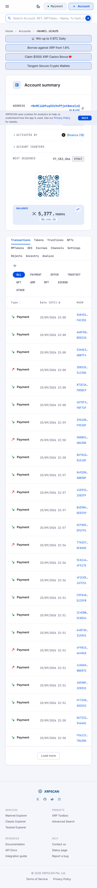

01b rNnMCi 5153 live 01:05-01:07Z
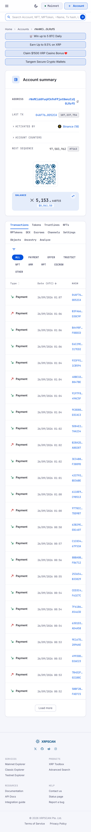

02 Binance destination name + Require Tag
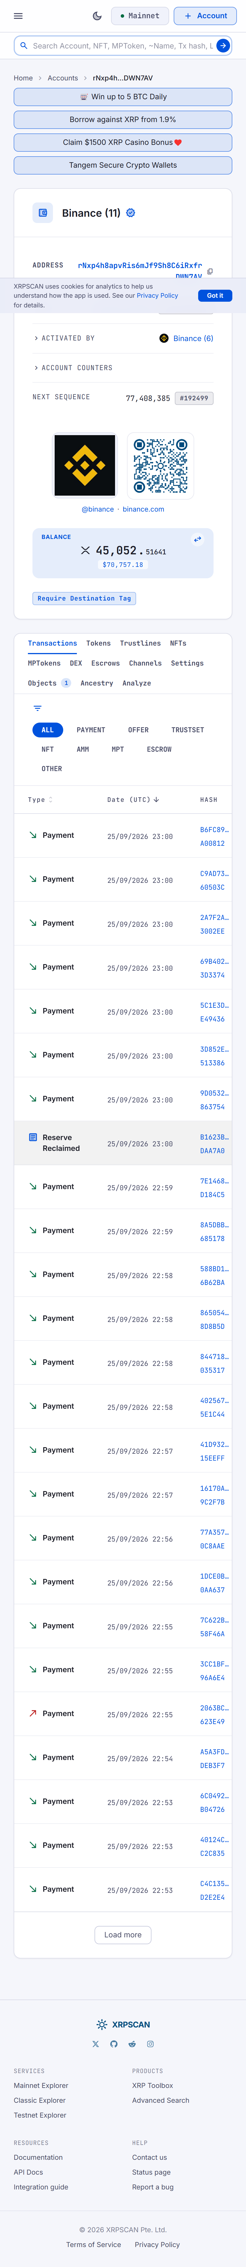

02b Binance 206119 live 01:13Z
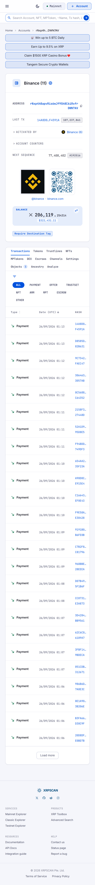

03 rU7dx hub (stale 729k, history)
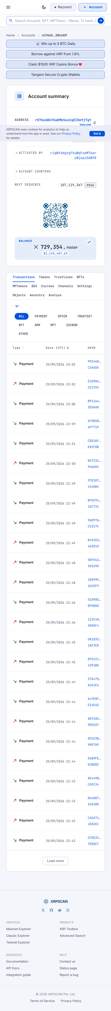

20 rU7dx 13039 live
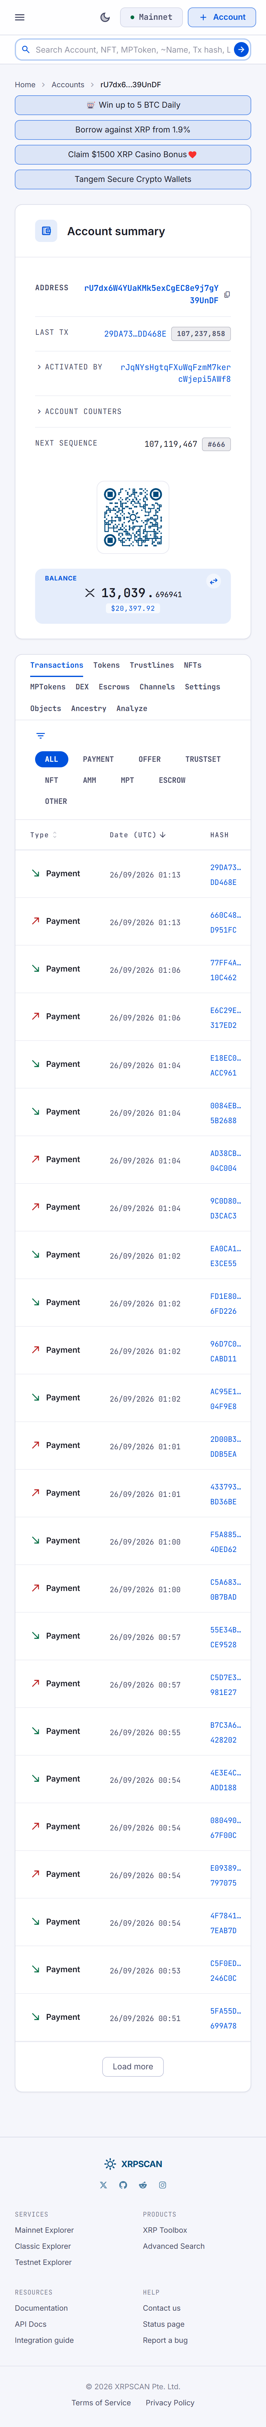

04 3737 XRP 22:41:00Z
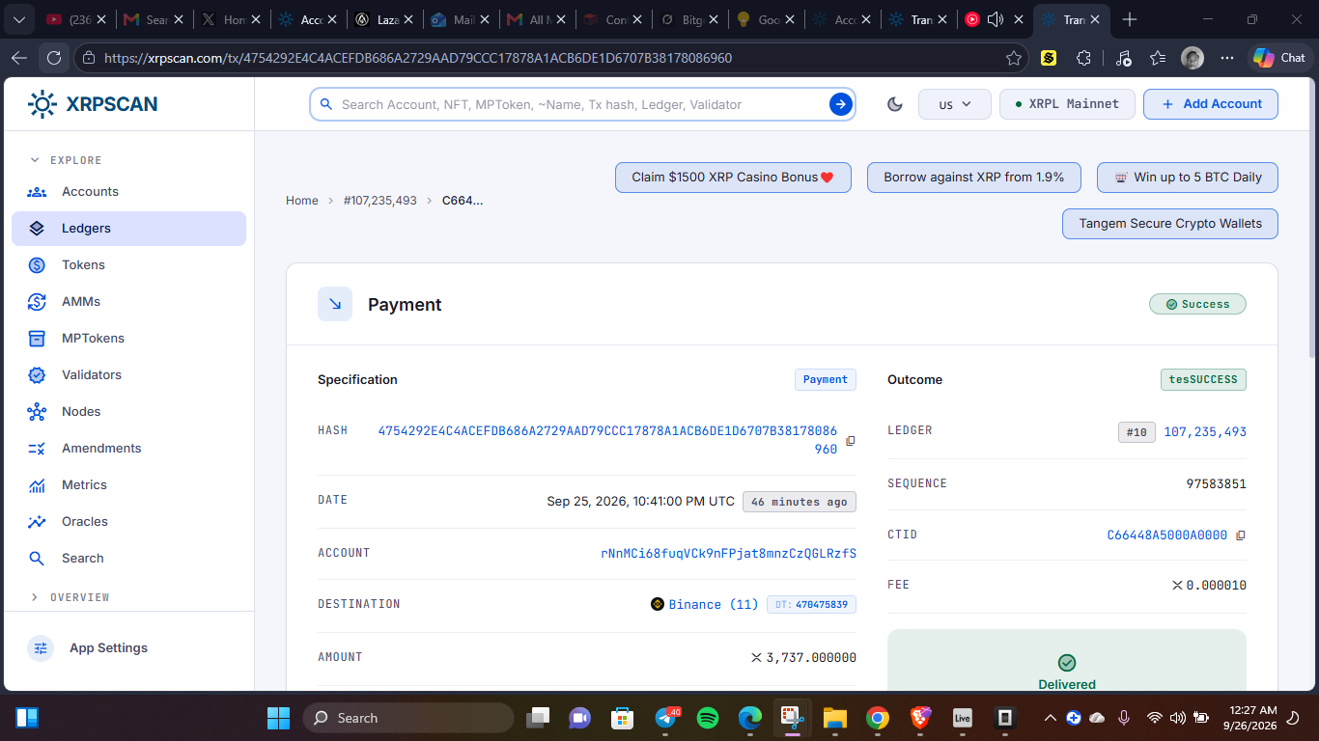

04 2509 XRP 22:41:22Z
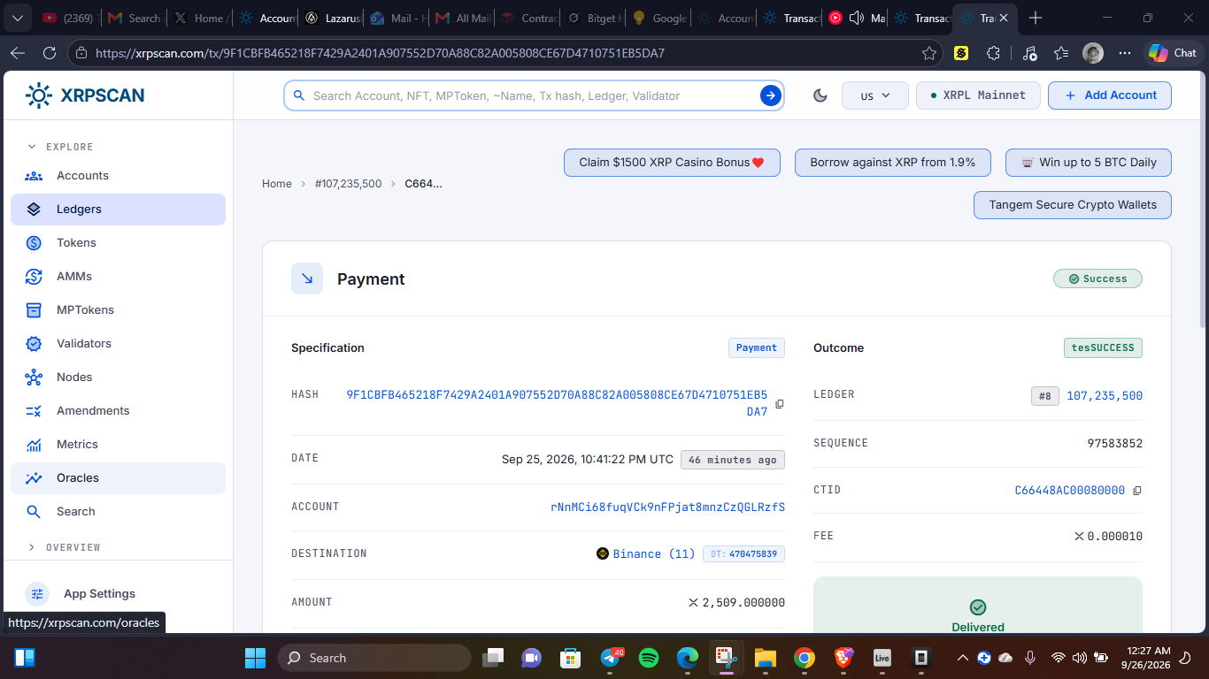

05 23811 XRP
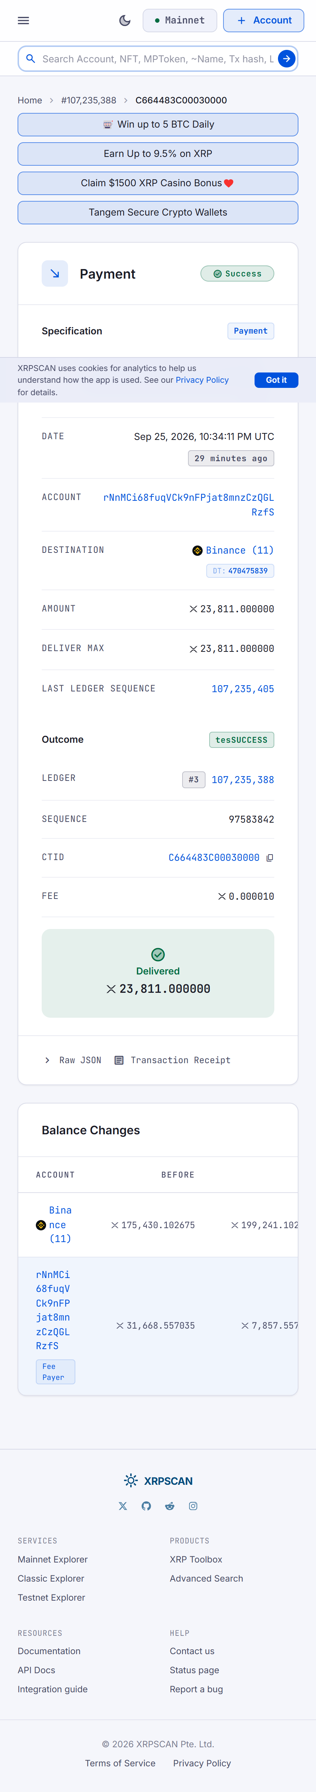

06 3098 XRP
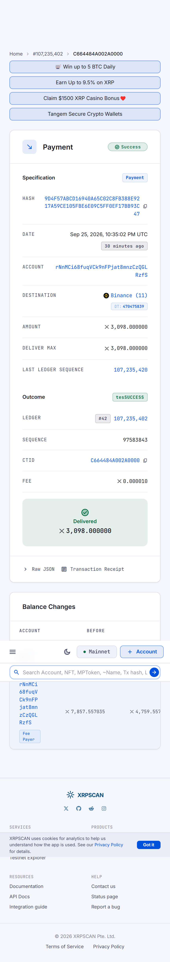

07 3185 XRP
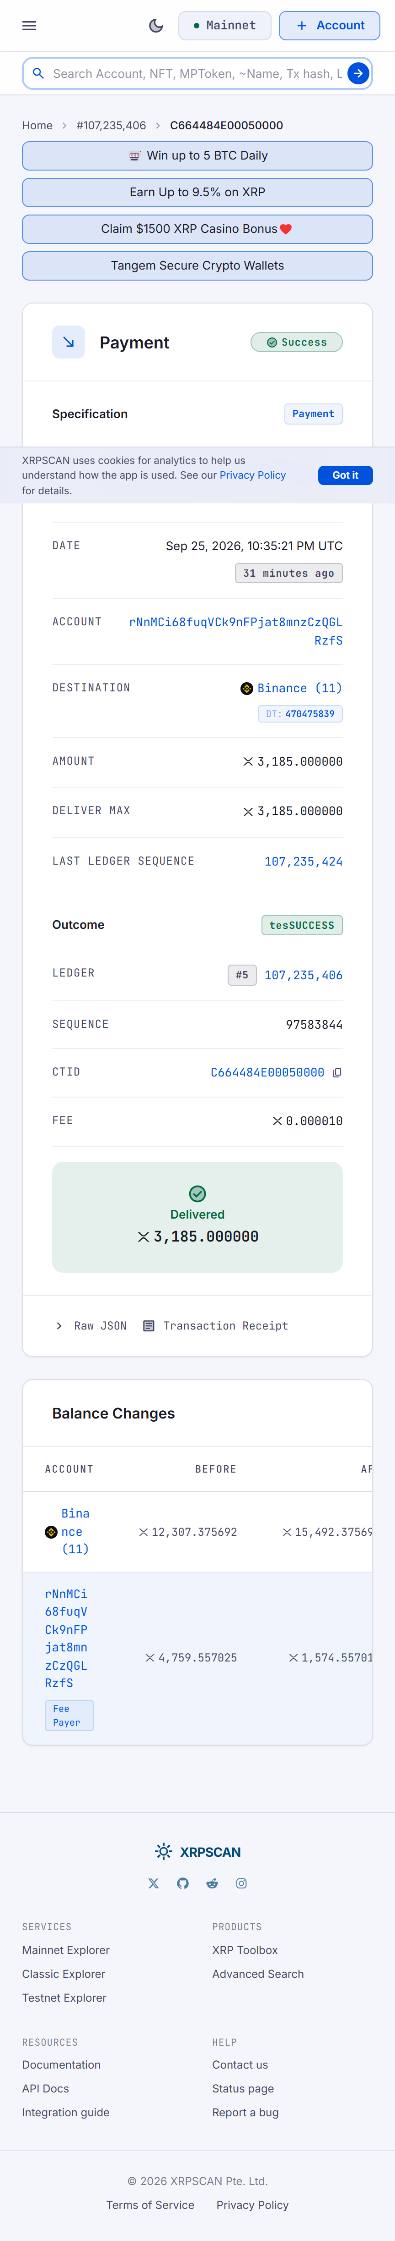

08 4297 XRP
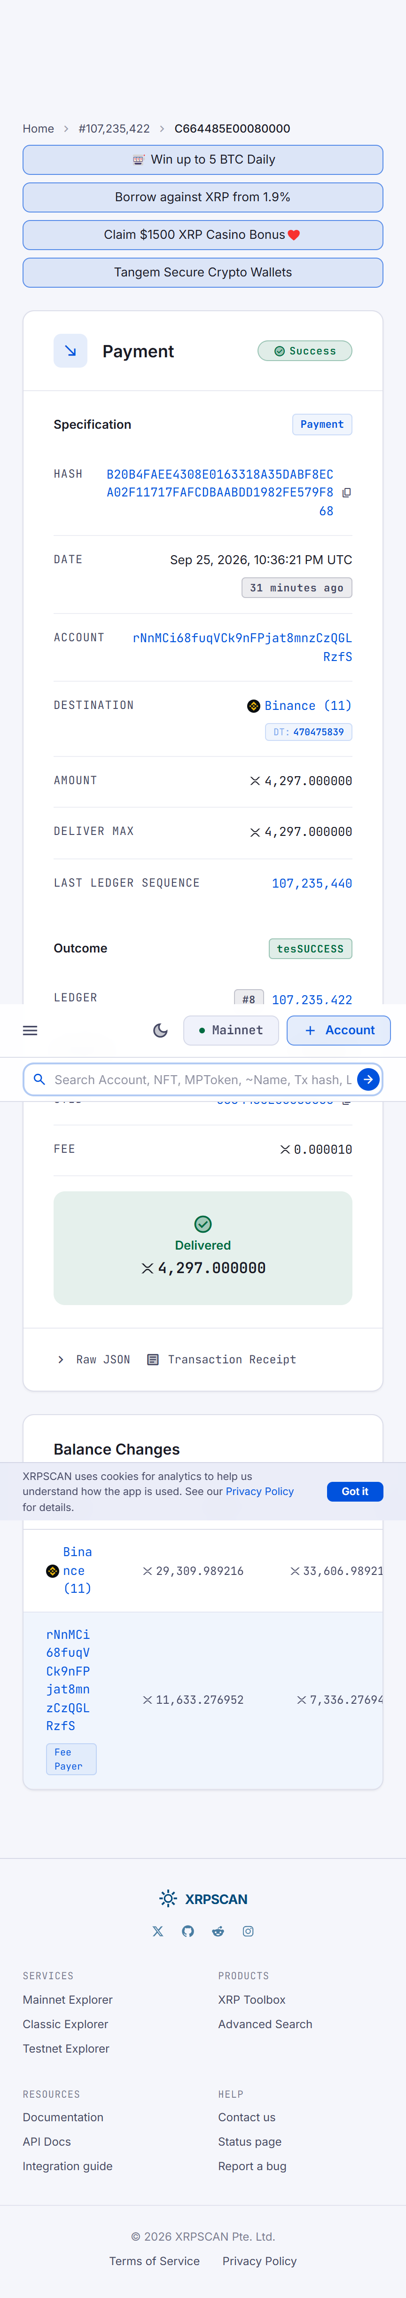

09 2925 XRP
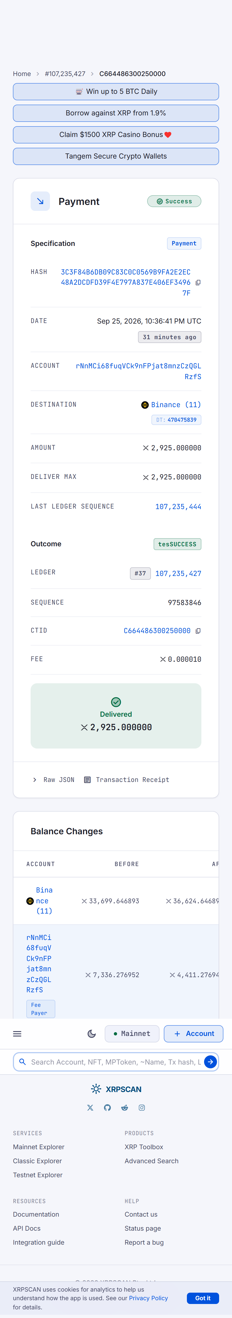

10 2353 XRP
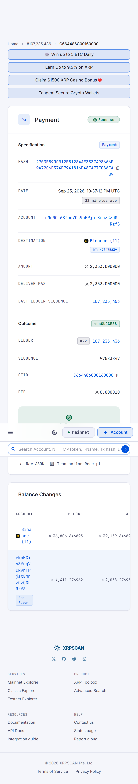

11 2057 XRP
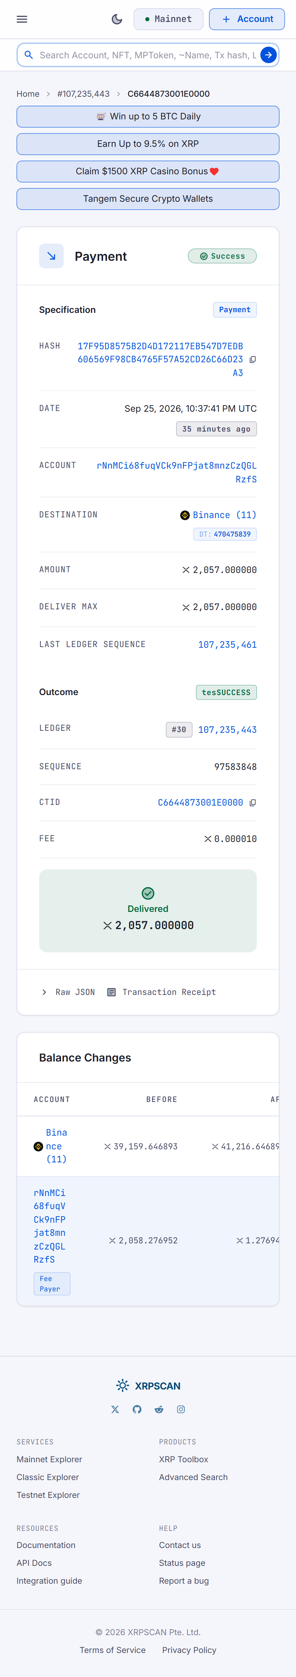

12 4940 XRP sample with balance changes
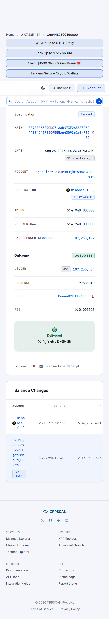

13 3756 XRP
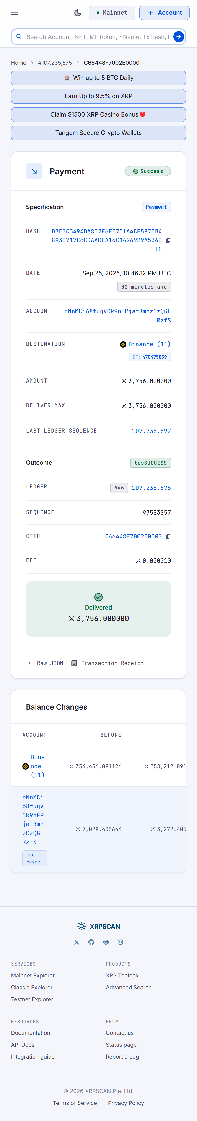

14 16397 XRP
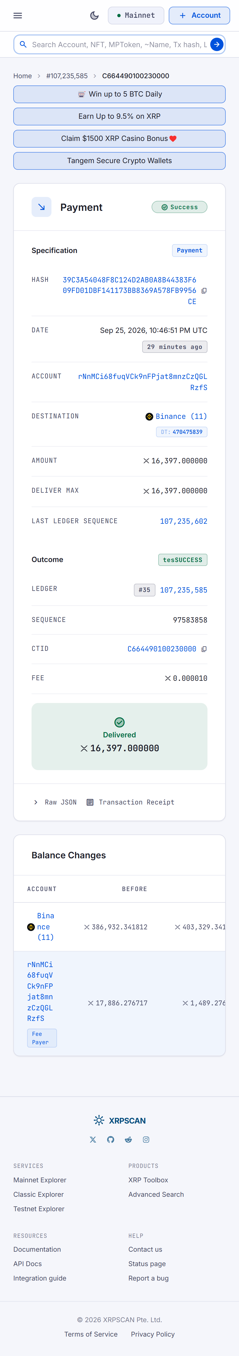

15 12836 XRP
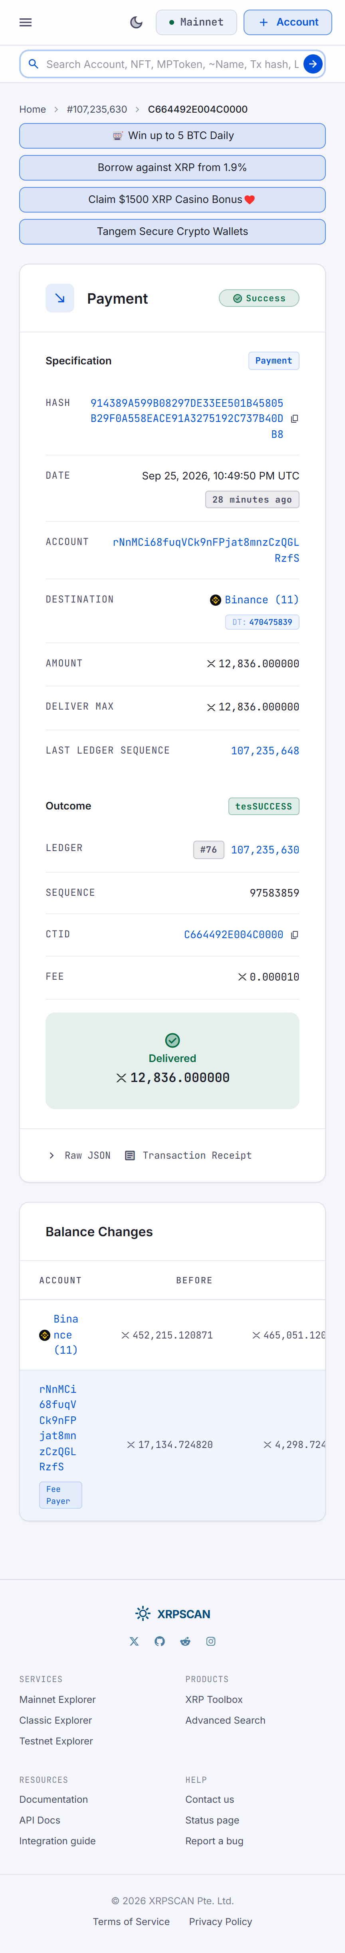

16 2498 XRP
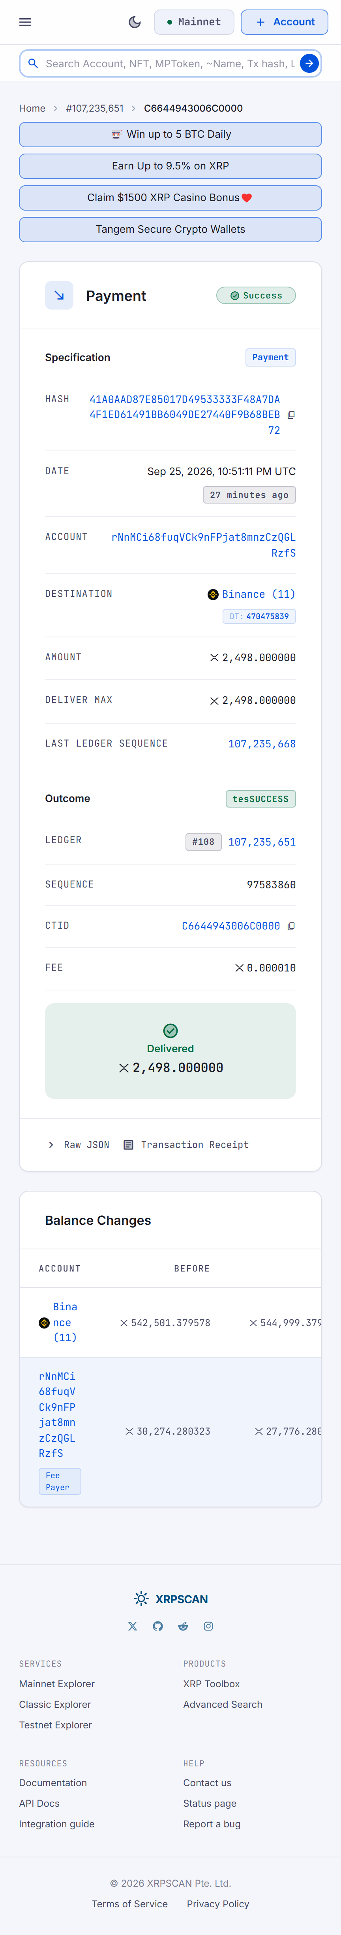

17 25975 XRP largest
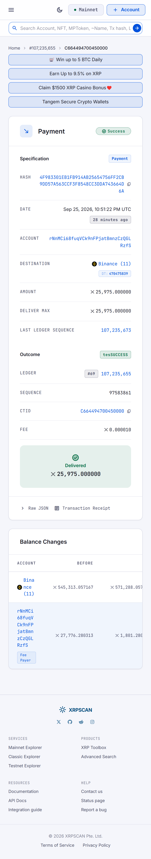

17b 25975 FRESH duplicate
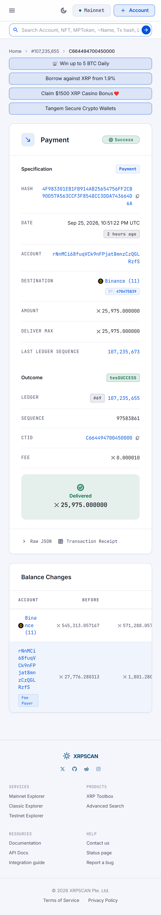

18 rU7dx->rNnMCi 10300 feed with OUT memo
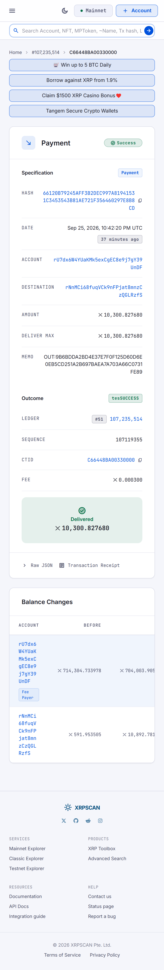

19 Bridgers 9294 XRP memo ETH 0x42fe
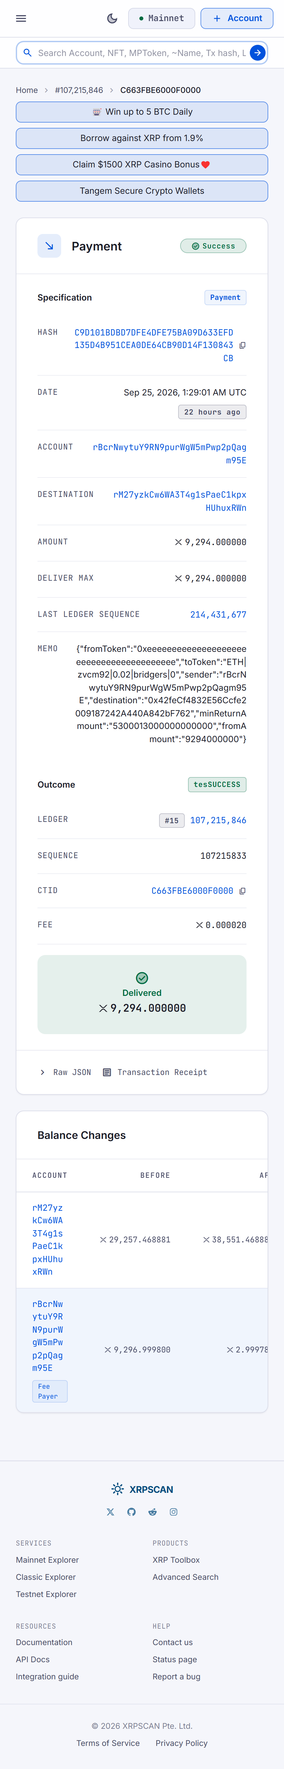

21 2629 XRP newest 00:55:51Z
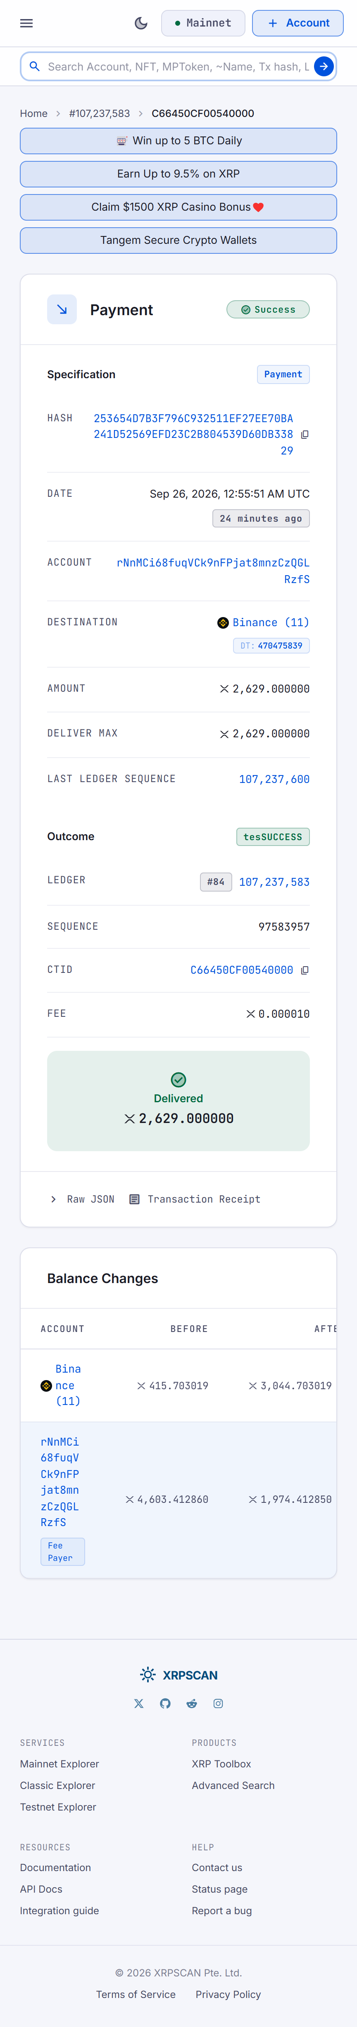

Update : Sep 26 10:53 AM WAT (09:53 UTC)

Binance Tag 470475839 : filed, supplemented
Total 194,629 XRP in 25 sends through 00:55:51Z Sep 26 + 7 sends 01:48-01:53Z totaling 35,333 XRP (63355BC2 2340, C5DCE9BA 3342, 8C4C35DE 3538, D70171D4 2136, 254E13D3 9966, E0BC7883 3107, 708081B6 10904) → running 229,962 XRP (~$352k). Hub rNnMCi68fuqVCk9nFPjat8mnzCzQGLRzfS 5,153→474→2,038→5,153 cycling (Binance-activated rfQ9Ec…), feeder rU7dx6W4YUaKMk5exCgEC8e9j7gY39UnDF 729,354→33,909→13,039→33,432 live (memo OUT:… batch IDs). Filed Binance fraud + BITGET LazarusBounty FREEZE (Henoch, okumagbeenoch4@gmail.com). 48h review pending.

Tag 6415484 + Bithumb batch : filed
rDWxjaZ5iQZMD6xuetA49G28MP7Yp6vYiM → rBuZfn1m4tA6znziHsRp9AyC1M3qg6rgbF Tag 6415484 14,835 XRP in 8 sends 09:03:31Z-09:41:10Z (871B099E 941, 06B464FF 2803, 9B218B5B 466, CAAFBE6F 1900, 83D2E076 476, 691DB20E 2854, 0D926FF9 4887, 636F00E3 508; SourceTag 1741383633 = wallet-service fingerprint shared since early 2025, clusters via feeder+dest tag trio). Router rBuZfn… 35,895,287 live → Bithumb rDxfhNRgCDNDckm45zT5ayhKDC4Ljm7UoP DT 1082757429 (corrected from 1002757429) 37,970 XRP batch D8C54CB7… 09:16:22Z mixed. Tag router-side NOT Bithumb UID (Bithumb UIDs 100xxxxxx). Filed LazarusBounty + Bithumb support (batch hold + downstream UID). Direct attacker $10k, batch $58k mixed.

Dormant break overnight
r3UGfDM4ZyFSCzKH7TQEjgago9QoUJagtJ 20M→55 (emptied 06:53-08:40Z to 8 downstreams: rfFqZ…, r4HFF…, r3ZqSC…, r9czFy…, rQHvBv…, rEZ5C…, rfQeWM…, rftXZm…; failed UNFUNDED 134k/165k/175k racing). rH7oMFKBgdK99TPQctFVzddD7srRzyCqZn 20M→14,437,257 (5.56M out, incl 127,437 to r3ZqSC…). r3ZqSCQ1MdYUc498XDW3gsumeN4PPJawAR 254,927 left (768k in, 100k×5 out to rGP5…/r4duMq…/rpnu…/r3n8sb…/rU7dx…). rGP5LBfA7aBB6Pfh8CsVVCfiMffTdT6Esp 1,352,968 accumulating (100k from r3ZqSC… + 13.8k rB4Vn… + others). r6NcwN… 22,976,677 + rwSjB… 20M still dormant.

Unchanged
ZEC t1WgMdt… 18,911.62 transparent; TRON gas-only (TCaNww 4,820 remainder); EVM 10k parks 0xD2C2…/0x600c… dormant; primary 0x770b… 0.008 ETH dust; Bybit 0x4766… dust; jUSDT V2 hunt closed.

Publishing note
Medium v2 reconciled totals + appendix published from this file. PII: Henoch / okumagbeenoch4@gmail.com on filing lines only. Evidence 01-24 + CROP + zip retained in Downloads. Bounty: ~$19-21k on $380-420k frozen if acted on; $6.4M upside on 82M dormant if CEX next. No payout claimed.

Upload order - file these first (5-image limit per report)
Filing 1 - Binance Tag 470475839 (BITGET + Binance fraud portal): upload in this exact order: 1) 02b-rNxp4-206119-live.png 2) 21-253654D7-Binance-2629.png 3) 01b-rNnMCi-5153-live.png 4) 20-rU7dx-13039-live.png 5) 17b-4F983301-Binance-25975-FRESH.png. Rest (05-19, 04x2, 18) via Related Tx URLs + zip.
Filing 2 - Tag 6415484 + Bithumb batch (LazarusBounty + Bithumb support): upload in this exact order: 1) 24-D8C54CB7-Bithumb-37970.png 2) 23-rBuZfn-35895287-live-CROP.png 3) 22-rDWxja-966-live-CROP.png 4) 06B464FF send shot (in 01-21 set, re-capture if needed) 5) CAAFBE6F send shot. Rest via Related Tx URLs.
Use CROP versions for account pages (address + balance + activity in one screen). Tx pages upload full (hash + date + tag + outcome visible). -CROP files: 22-rDWxja-966-live-CROP.png, 23-rBuZfn-35895287-live-CROP.png.

24 Bithumb batch 37970 DT 1082757429
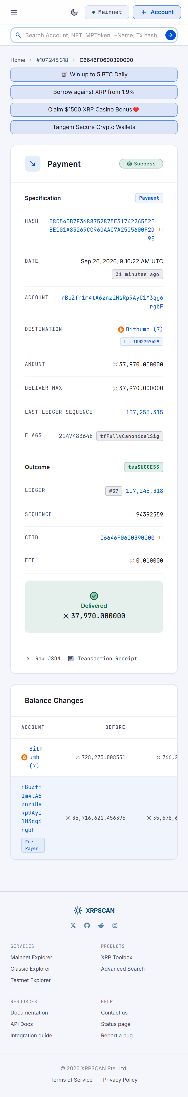

22 CROP rDWxja 966 account summary
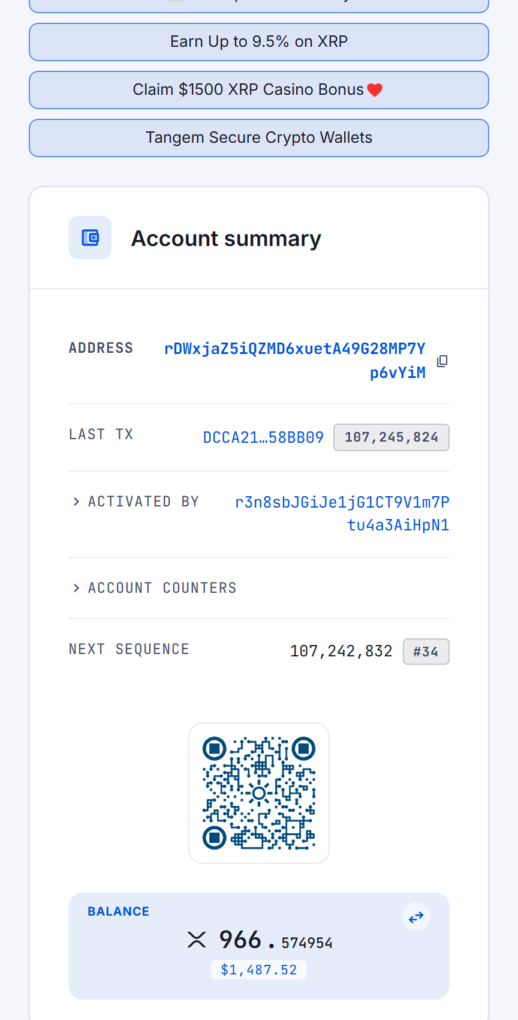

23 CROP rBuZfn 35.89M account summary
