**Types of web applications**

**What is web application?**

An application is collection of programs or resources. These resources accessed using internet.

1. Browser (Thin Client)
2. Http Server/Web Server
3. Static web application
4. Dynamic web application

**Static web application**

Static web application is called of static resources.

1. HTML pages
2. Images
3. Audio files
4. Video files

**Example: Tutorials**

**Dynamic web applications**

Dynamic web application consist of,

1. Static resources
2. Dynamic resources (Backend Programs)

Example: online reservation, online shopping, online banking,..

**HTML**

HTML stands for Hyper Text Markup Language.

HTML is not a programming language, it is a markup language.

HTML is used for developing web page. Page consist of information which shared on internet.

HTML is used for developing frontend for web application.

HTML is used in web application development for presenting data or information.

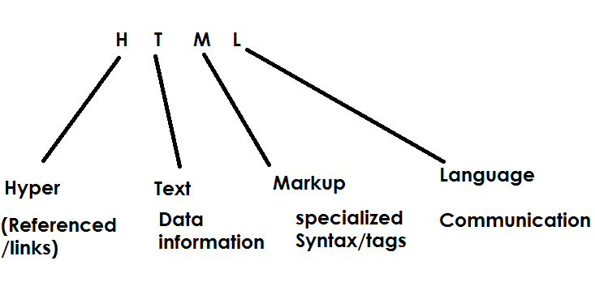

HTML is developed by Tim Berners-Lee in the year 1991.

Versions of HTML

HTML 1.0 🡪 1994

HTML 2.0 🡪 1995

HTML 3.0 🡪 1997

HTML 4.0 🡪 1998

HTML 4.1 🡪 1999

HTML 5.0 🡪 2014

HTML 5.1 🡪 2016

HTML 5.2 🡪 2017

HTML is interpreted language. HTML tags are interpreted and executed by HTML interpreter/Parsers exists within Browser.

No need to install any software to work with HTML.

Browser is software responsible in execution of HTML page/web page.

**Advantage of HTML**

1. **Easy to understand and develop web pages**
2. **HTML is case in-sensitive language (upper case and lowercase both are same)**
3. **HTML is easy to maintain**

**Disadvantage HTML**

1. **Need to write lots of code**

Every html file is having extension .html or .htm

HTML is web technology.

**Who uses HTML?**

1. Web Developer
   1. Front End Developer
   2. Back End Developer
2. Web Designer (UI/UX)
3. Full Stack Web Developers

**Programming Langauges:**

C,C++,Java

**Web Technologies:**

**Frontend:** HTML,CSS,JavaScript,BootStrap, JQuery, AngularJS,ReactJS

**Backend:** Servlets, JSP, Spring Boot and Micro Services

**Database : Oracle**

**Structure of HTML Page**