**Q: What is Web Page, Web Application and Web Site?**

Web page or HTML page used to present data or information to client (OR) Web page is a front end which is used to communicate with back end.

Web Application is a collection of web resources,

1. Static resources 🡪 html, images, audio, videos, …
2. Dynamic resource server side programs (servlets,jsp,….)

Web site is place where web application is deployed or placed.

HTML is a markup language and it is collection of tags.

**What is tag?**

HTML present data/information using a special syntax called tag.

Tag is similar to keywords/reserved words in other language.

Tag is represented within angular brackets <tag-name>

Browser does not shows any error, if invalid tag or syntax in defining tag.

These tags are two types.

1. Paired tags
2. Unpaired tag

Paired tags are having beginning and end

Example: <h1> </h1>

Unpaired tags are having only beginning

Example: <br>

HTML tags are parsed or rendered by HTML parser provided by browser.

**Structure of HTML page**

HTML page/document is divided into three sections.

1. Document Version
2. Head
3. Body

**<!DOCTYPE>**

<!DOCTYPE> is also called document type definition.

<!DOCTYPE> is used to define HTML version used to prepare HTML document.

Syntax of HTML5

<!DOCTYPE html>

This syntax tells the browser this document is prepared using HTML5 Version.

This tag is appeared top of the web page

This tag is used by browser.

**<html>…</html>**

**<html> is root tag of** every webpage or web document

All other tags or elements are placed within <html> tag.

<html lang=”en-US”>

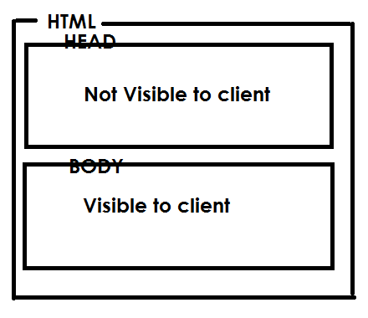

**<HEAD>…</HEAD>**

<head> tag is used to define meta data

<head> is called global scope/section.

Whenever webpage is loaded within browser, browser executes head section.

<head> is not displayed client.

The following are sub tags used within <head> tag.

* + - 1. Title
      2. Style
      3. Base
      4. Script
      5. Meta
      6. link

codewithsatishgupta