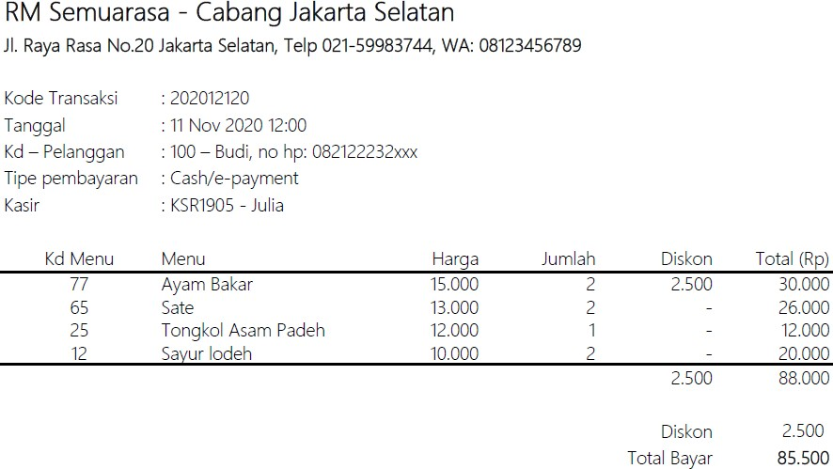

.LEGEND:  
“TEKS” = Primary key

[“TEKS”] = Foreign Key

UNF

Transaction(KotaCabang,AlamatCabang ,TelpCabang ,WaCabang,TransactionID , Tanggal, UserID ,UserName, UserPhone, TipePembayaran , StaffCode, StaffName {MenuID, MenuName, Price , Quantity , Diskon,Total}TotalBayar)

1NF

TransactionHeader(KotaCabang,AlamatCabang ,TelpCabang ,WaCabang,TransactionID , Tanggal, UserID ,UserName, UserPhone, TipePembayaran , StaffCode, StaffName)

TransactionDetail(TransactionID,MenuID,MenuName,Price, Quantity, Diskon )

2NF

TransactionHeader(KotaCabang,AlamatCabang ,TelpCabang ,WaCabang,TransactionID , Tanggal, UserID ,UserName, UserPhone, TipePembayaran , StaffCode, StaffName)

TransactionDetail([TransactionID],[MenuID], Quantity, Diskon )

Menu(MenuID,MenuName,MenuPrice)

3NF

TransactionHeader([IDCabang],TransactionID , Tanggal, [UserID] , [IdPaymentType] , [StaffCode])

Cabang(IDCabang ,KotaCabang, AlamatCabang, TelpCabang ,WaCabang, EmailCabang)

User(UserID,UserName,UserPhone,UserGender ,UserAddress , UserEmail, UserWa)

Payment(IDPaymentType,PaymentName)

Staff(StaffCode,Staffname , StaffPhone, [PositionID])

Position (PositionID,PositionName)

TransactionDetail([TransactionID],[MenuID], Quantity, Diskon )

Menu(MenuID,MenuName,MenuPrice,MenuKategori,JumlahPorsi,Daerah,[GambarID])

Gambar(IDGambar,LinkGambar)

**ERD**

