TD02 : PYHON GIT LINUX

Part 1 - Review the starter
Commande « src/main.py”
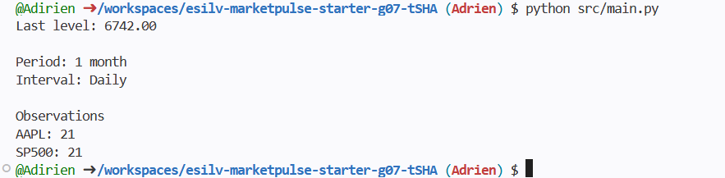

Commande “python src/main.py”
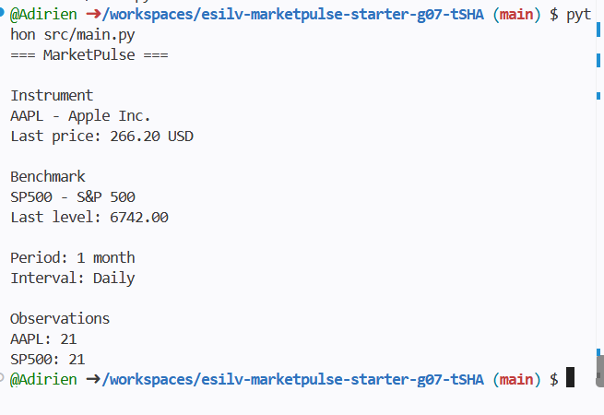

- Which function reads JSON?
“load_instruments()” reads the JSON file containing information about the instruments.
- Which function reads CSV?
“load_prices()” reads the CSV file containing the price data.
- Which function selects one ticker?
“filter_prices()” selects the price data corresponding to a specific ticker.
- Which function coordinates execution?
“main()” coordinates the execution of the program. Main calls the other functions and displays the final results.
- Where are the input files stored?
The input files are stored in the data/ directory and in data/sample/ for the sample data.

Part 2 - Understand JSON and dictionaries
Commande « cat data/sample/instruments.json »
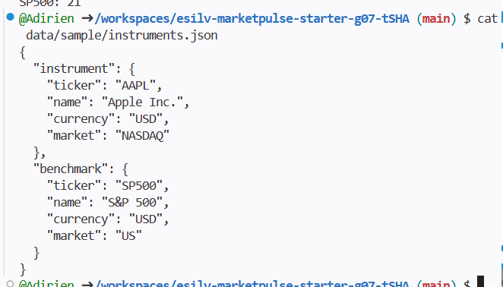

Add « print(type(instruments))
print(instruments.keys()) »

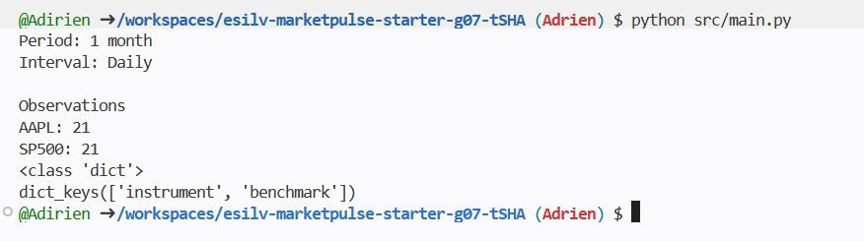

Add:
instrument = instruments["instrument"]
benchmark = instruments["benchmark"]

print(instrument["ticker"])
print(instrument["name"])
print(instrument["currency"])

print(benchmark["ticker"])
print(benchmark["name"])
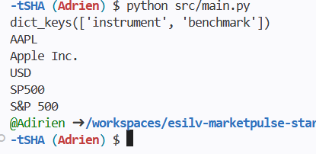

Part 3 - Understand CSV and lists of dictionaries
Command “head data/sample/prices.csv”
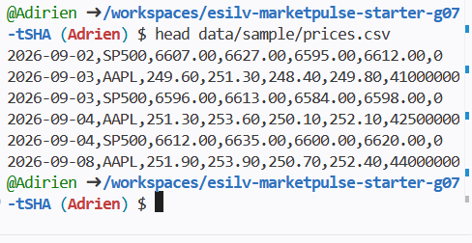

Command:
prices = load_prices()

print(type(prices))
print(type(prices[0]))
print(prices[0])
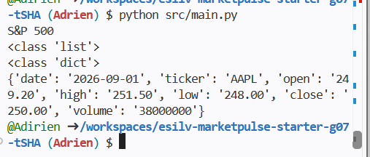

CSV values are text
Add :
print(prices[0]["close"])
print(type(prices[0]["close"]))
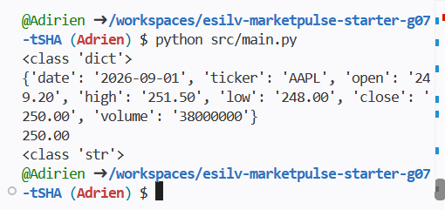

Part 4 - Filter instrument and benchmark rows

Commande:
print(len(instrument_prices))
print(len(benchmark_prices))
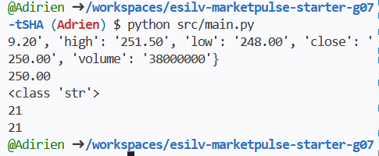

Part 5 - Create first and last close helpers

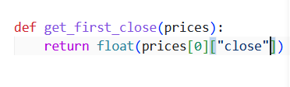
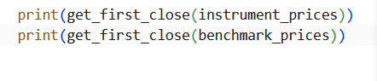
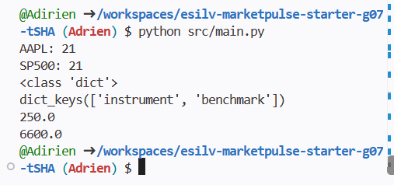

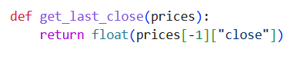
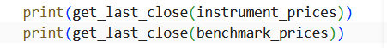
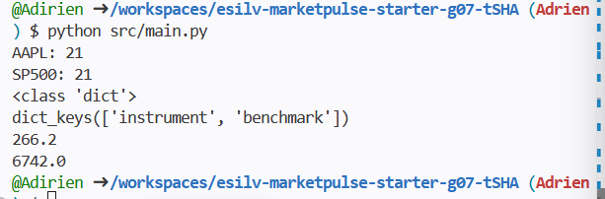

Part 6 - Build one reusable market summary

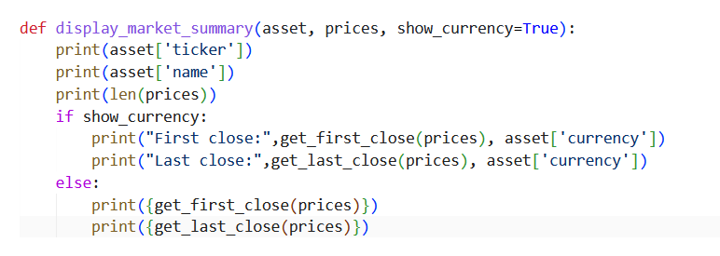
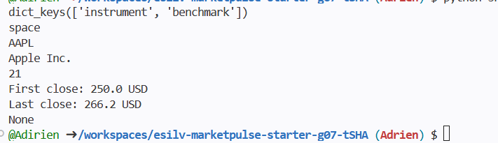

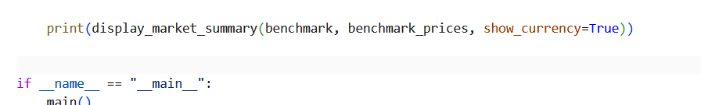

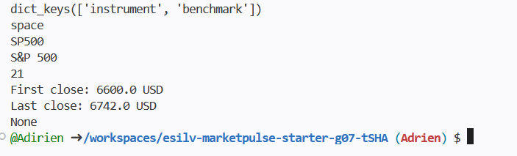

Part 7 - Keep main() readable

Part 8 - Validate the final output
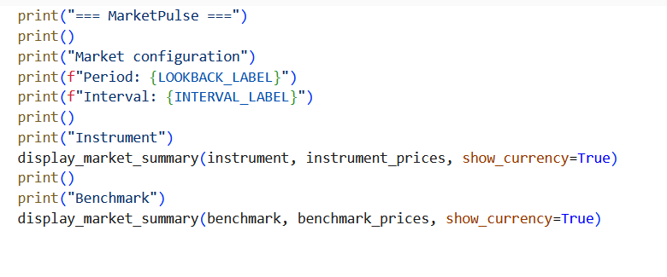
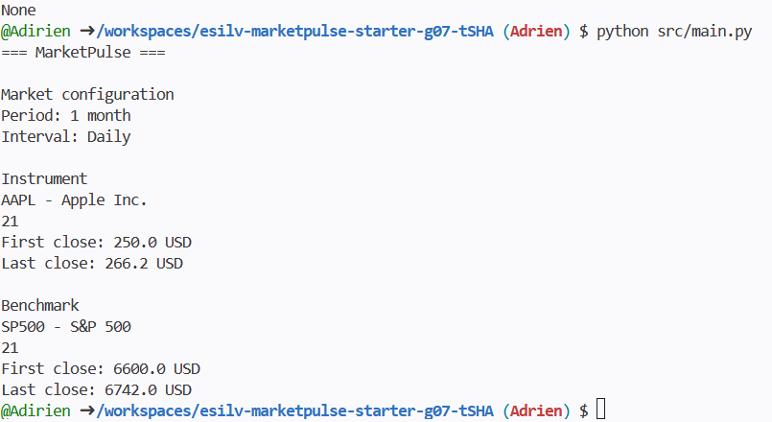

Part 9 - Python concepts recap
Part 10 - CORE handoff to TD03

Optional 1 - First and last date
