TD3

Part 1 – Understand the local Git model

Part 2 – Verify Git identity
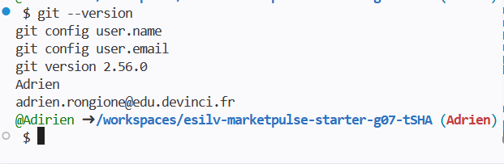

Part 3 – Inspect the real TD02 changes
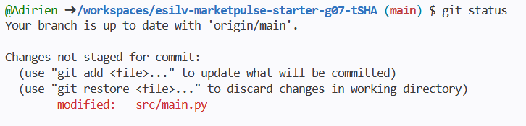
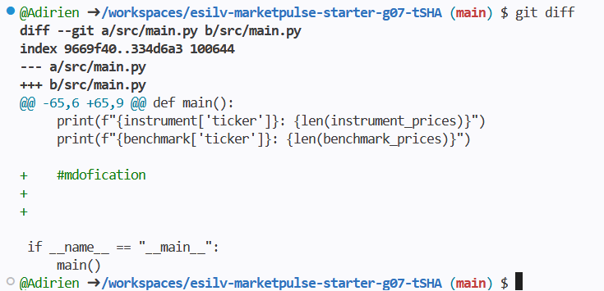

Part 4 – Understand git status and git diff
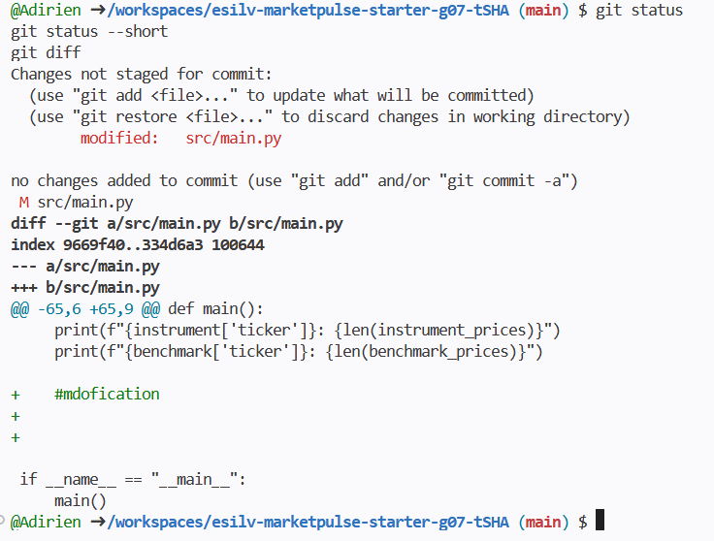

Part 5 – Stage the intended change
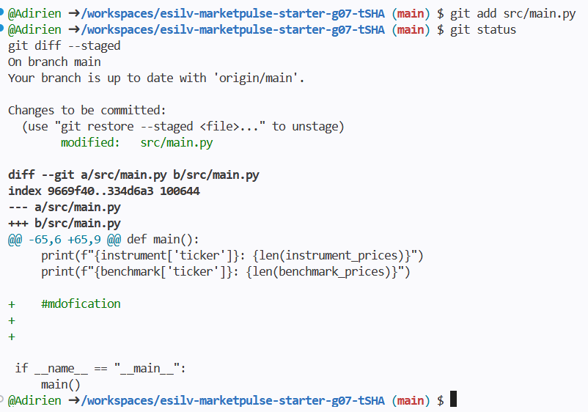
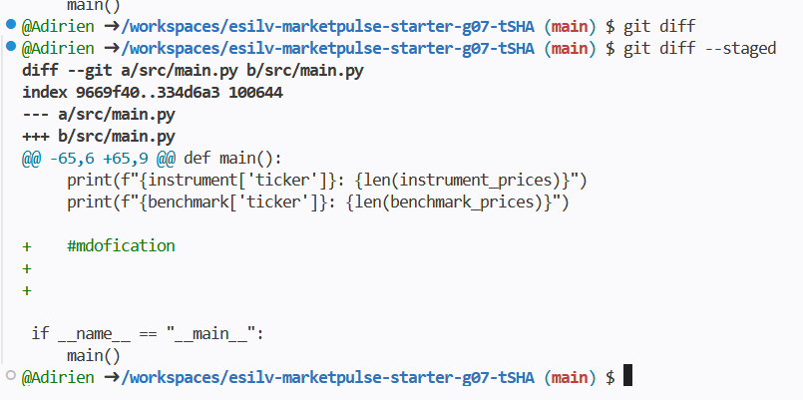

Part 6 – Create the first meaningful commit
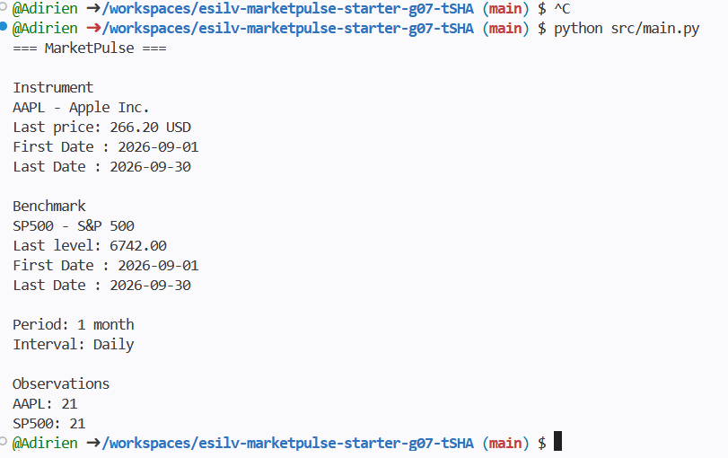
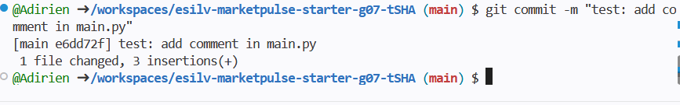

Part 7 – Read the local history
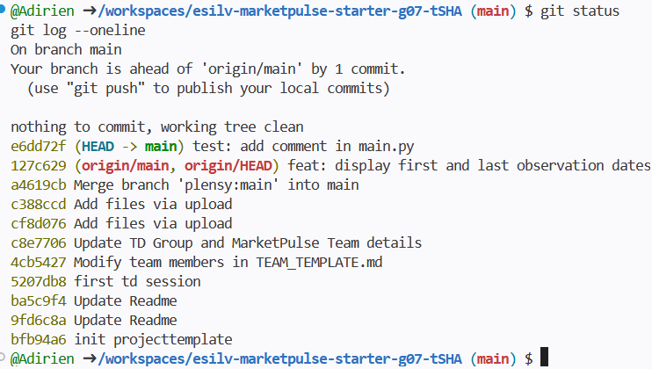
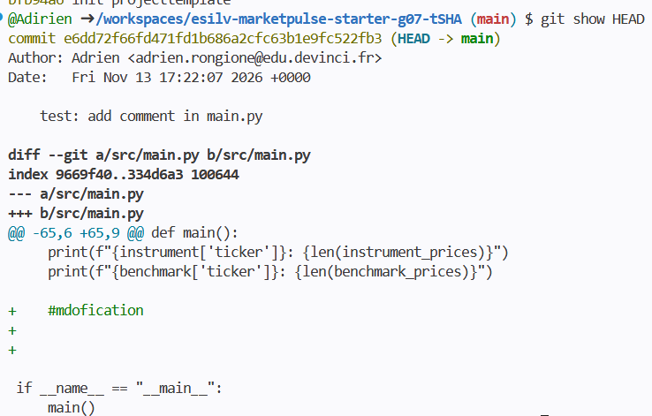

Part 8 – Commit quality and traceability

Part 9 – Local vs remote Git

Part 10 – CORE validation


