TD4

Part 2 – Inspect the current branch
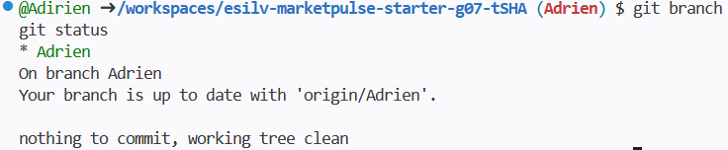

Part 3 – Create a feature branch
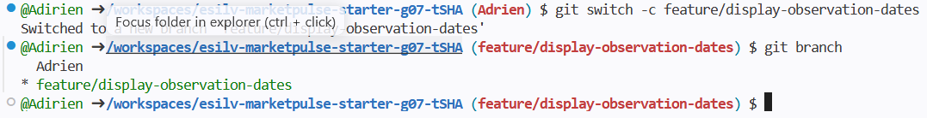

Part 4 – Implement the small feature
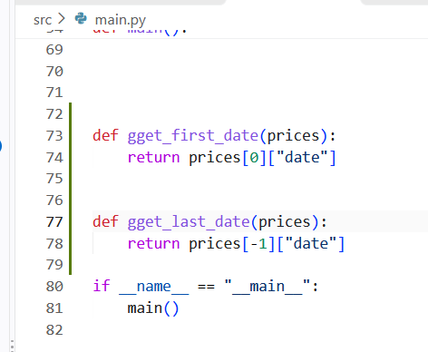
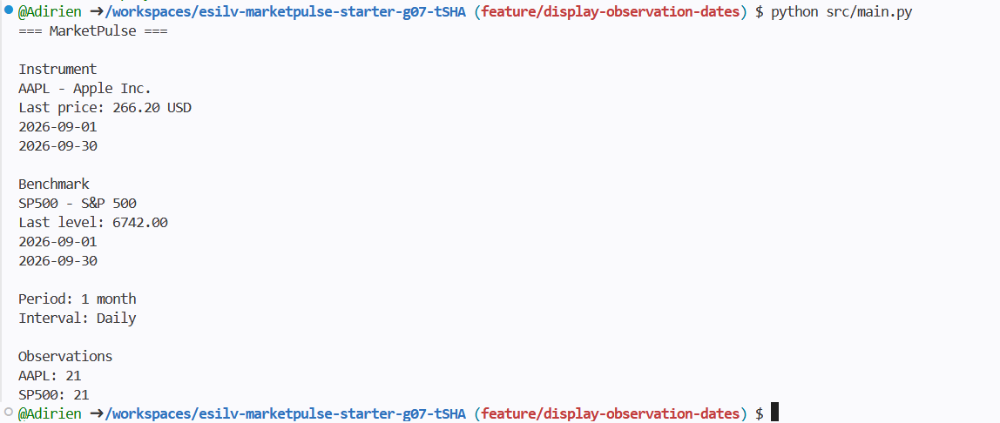

Part 5 – Inspect and commit the branch change
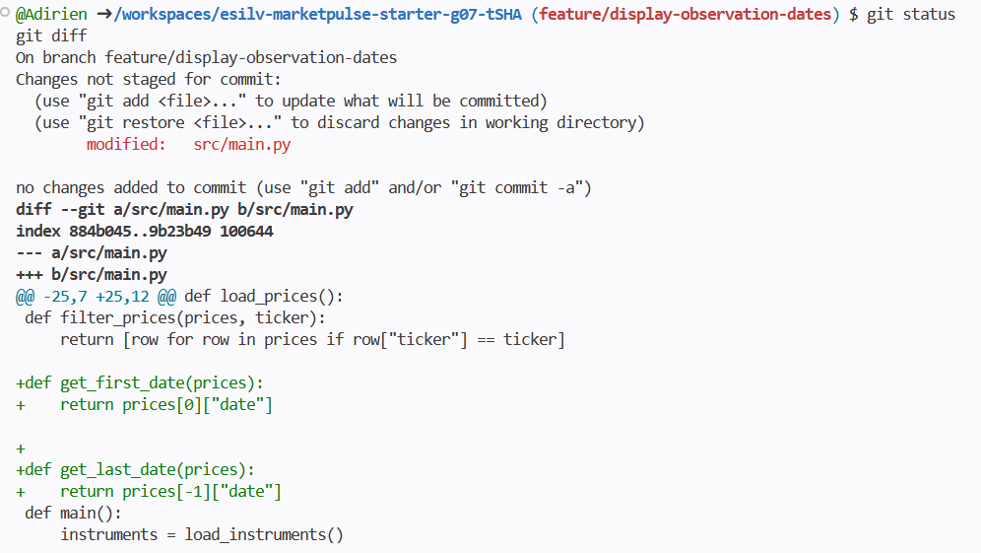
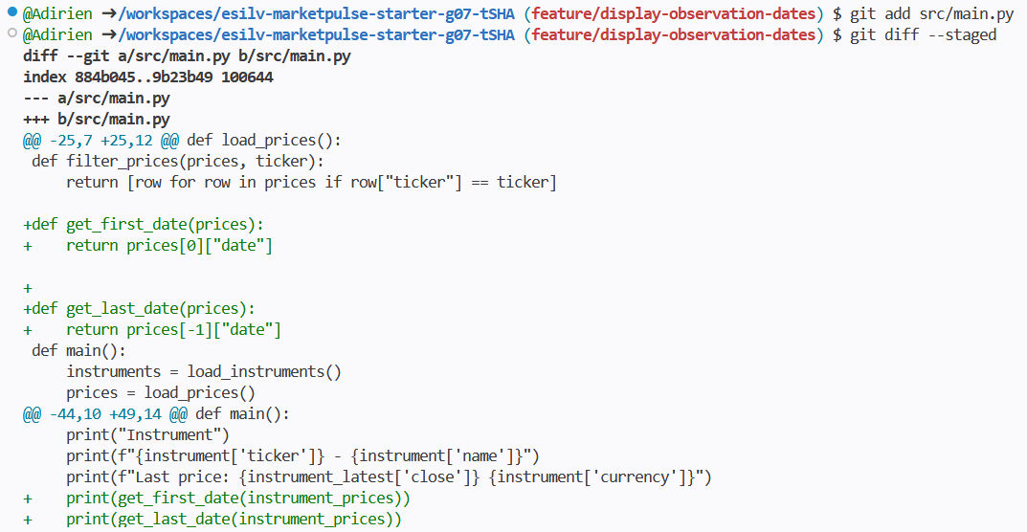
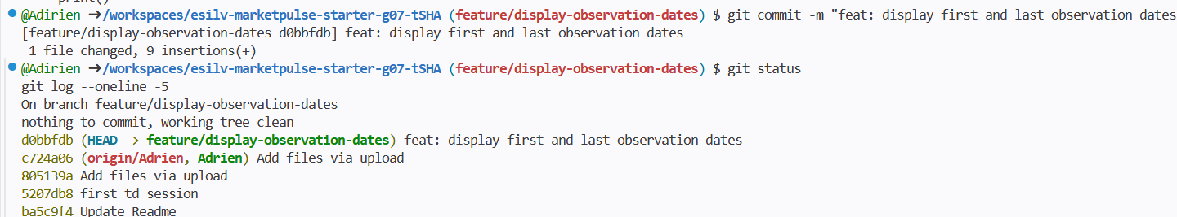

Part 6 – Compare feature branch and main
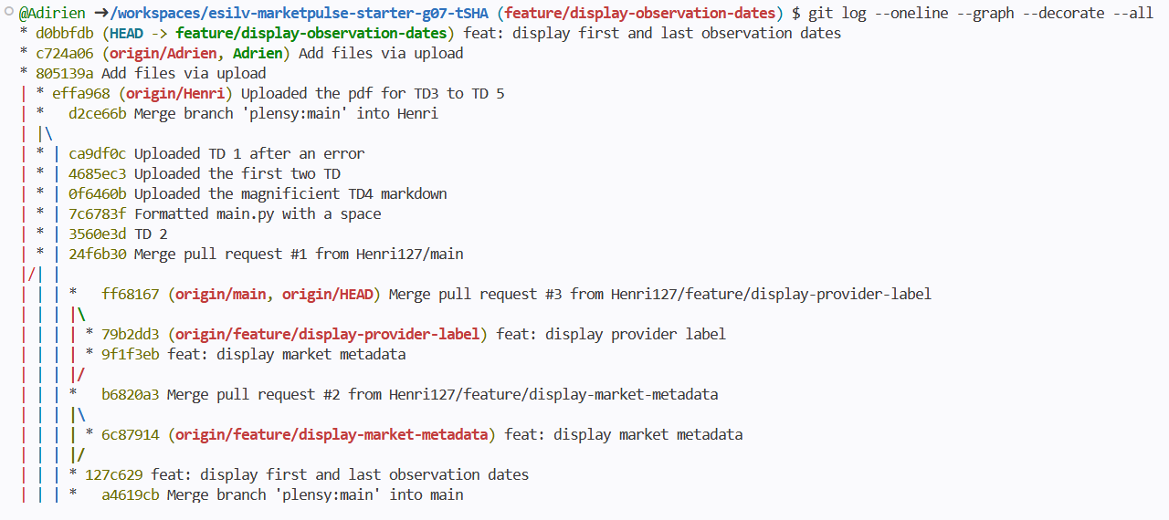
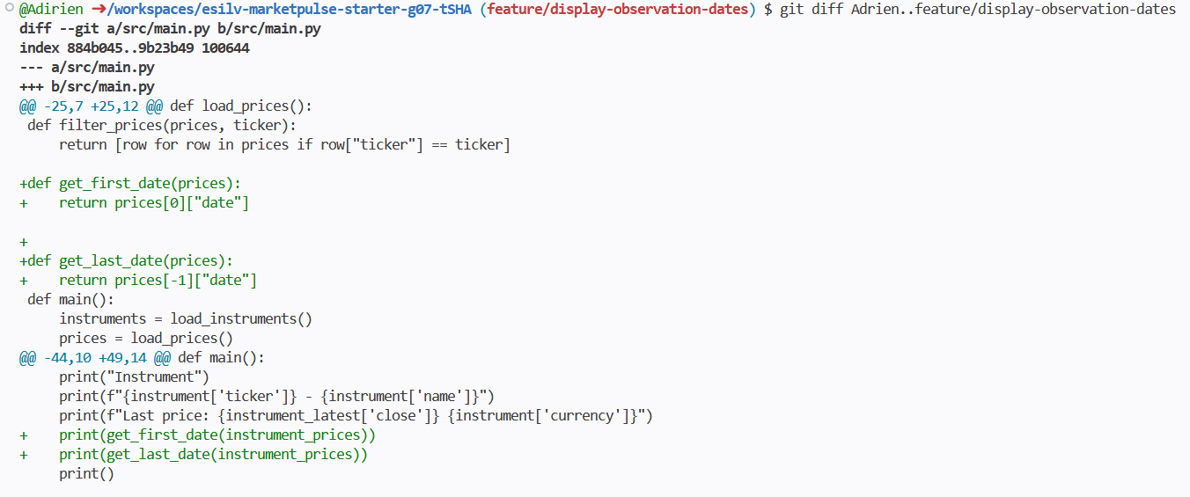

Part 7 – Merge the feature into main
Vous aviez dit de ne pas merge la branch dans le main mais de la merge into sa branche
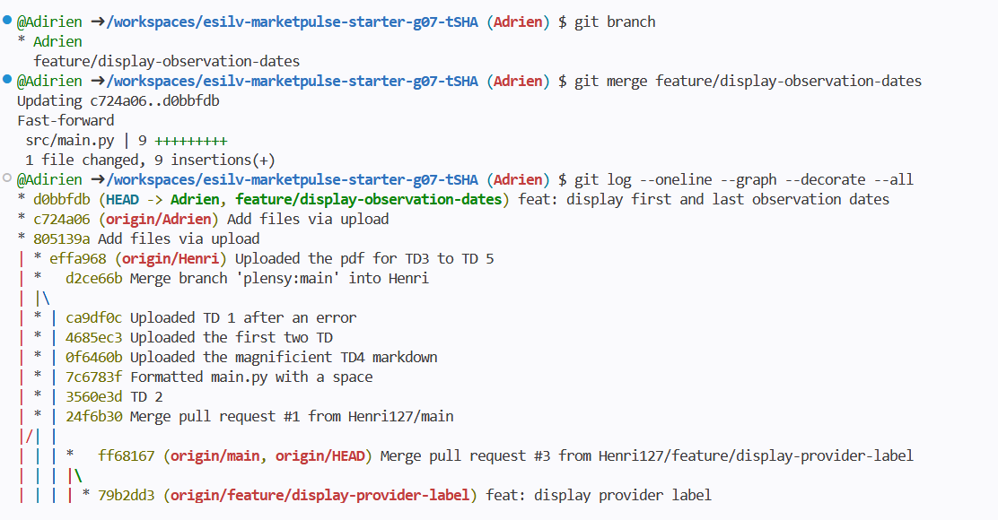
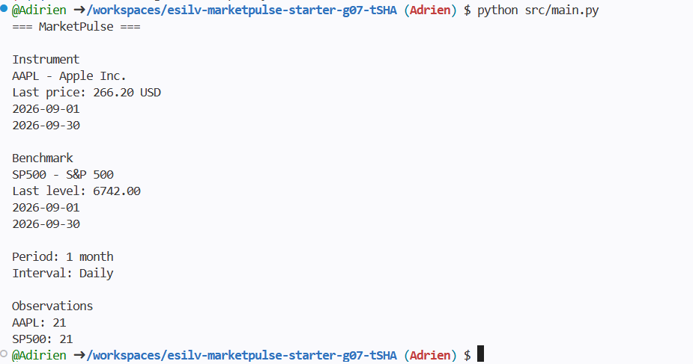

Part 8 – Capture Checkpoint A branch evidence, then clean the branch
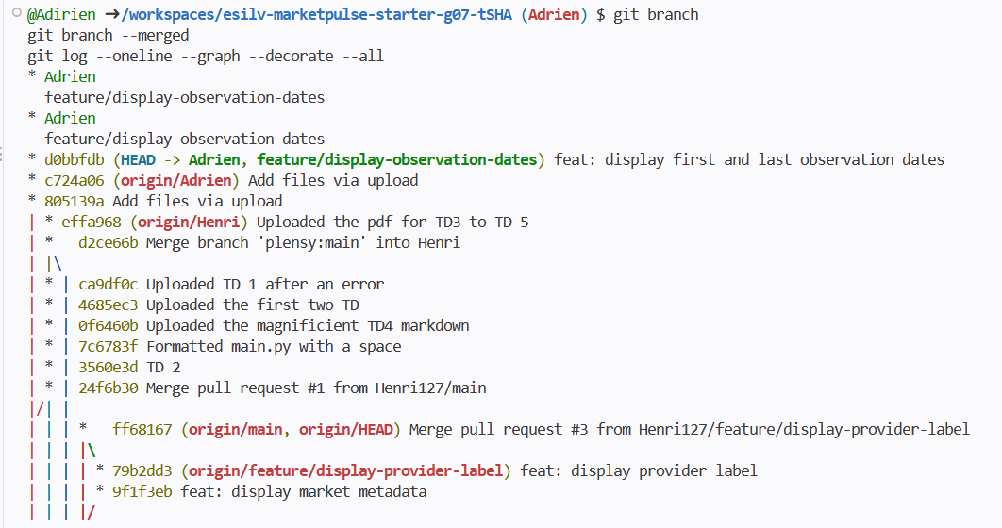
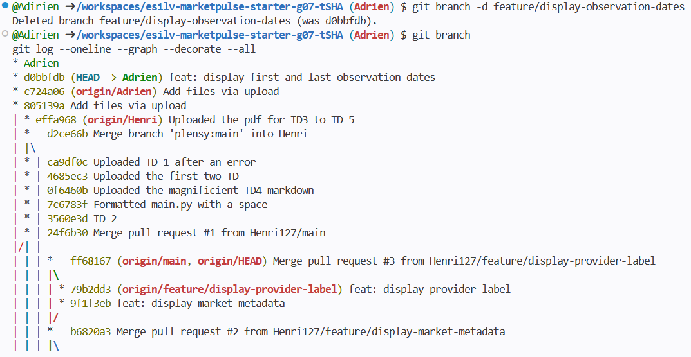

Part 9 – Understand merge conflicts

Part 10 – CORE validation
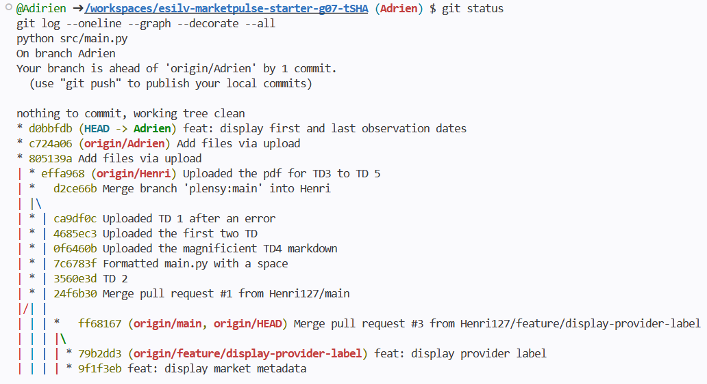

TD5
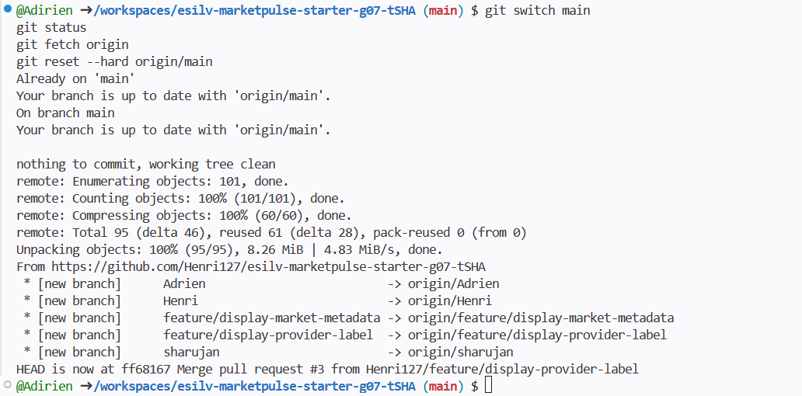
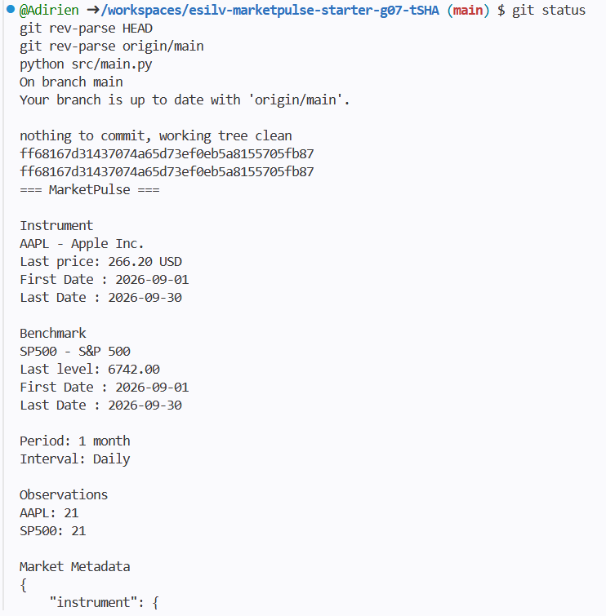

Part 3 – Create the feature branch
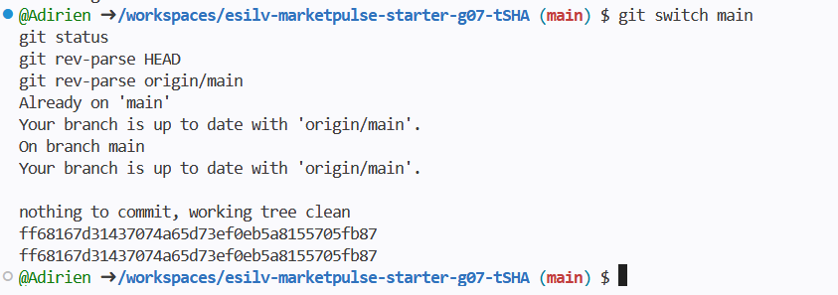
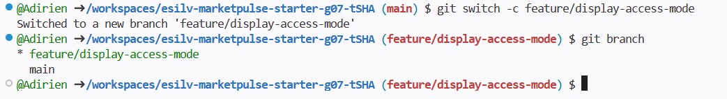

Part 4 – Implement and validate the change
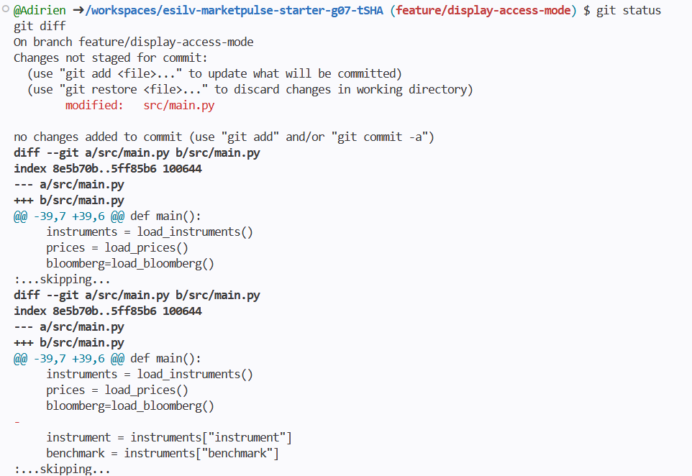
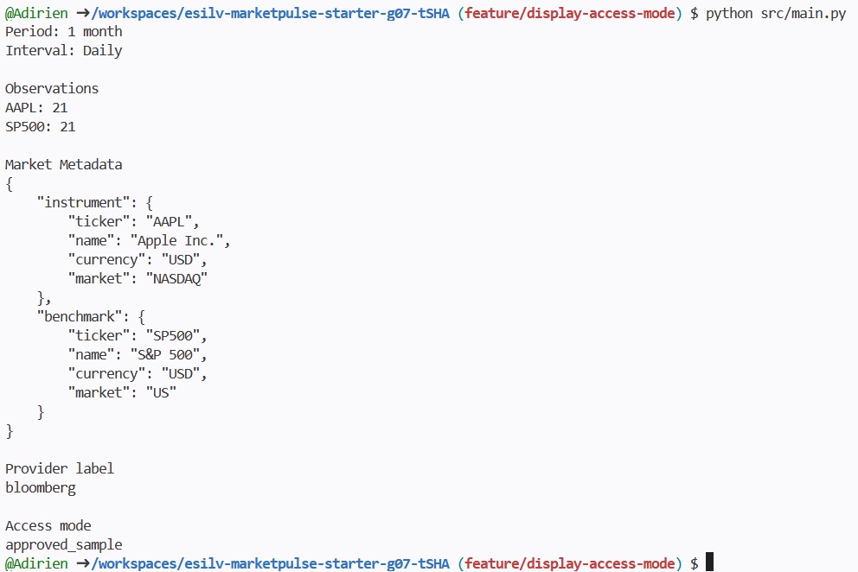

Part 5 – Commit the feature
f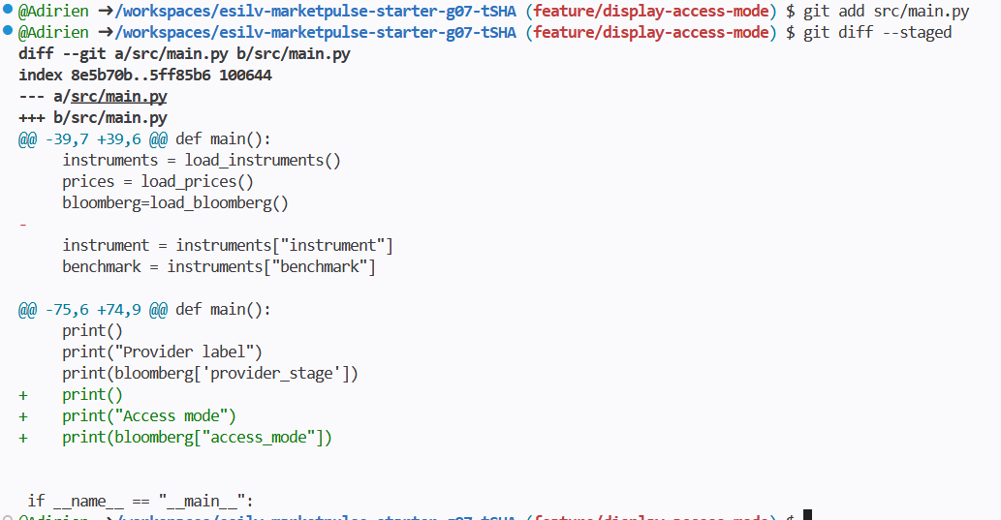
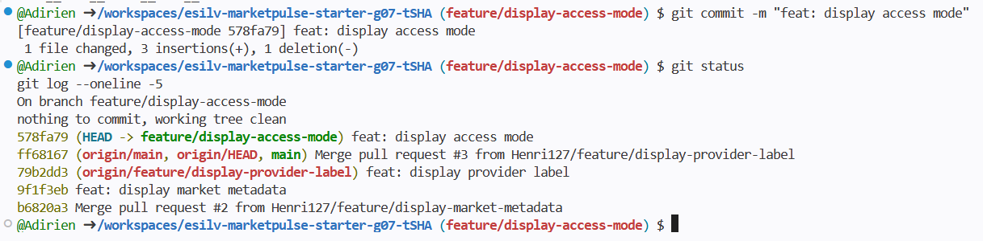

Part 6 – Push the branch
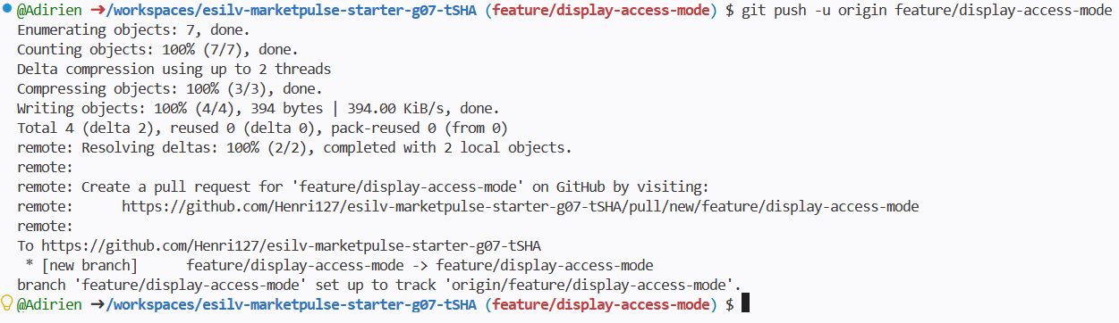

TD6
It is on github.

