TD02
Python · Git · Linux

Part 1 – Review the starter
Commande : src/main.py
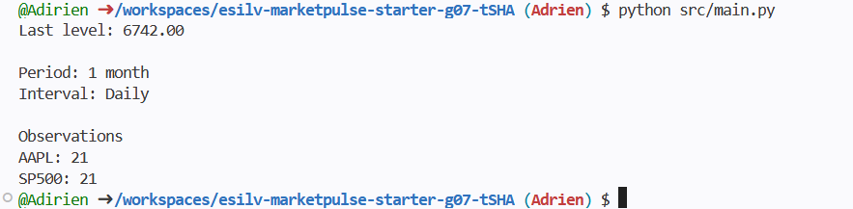
Commande : python src/main.py
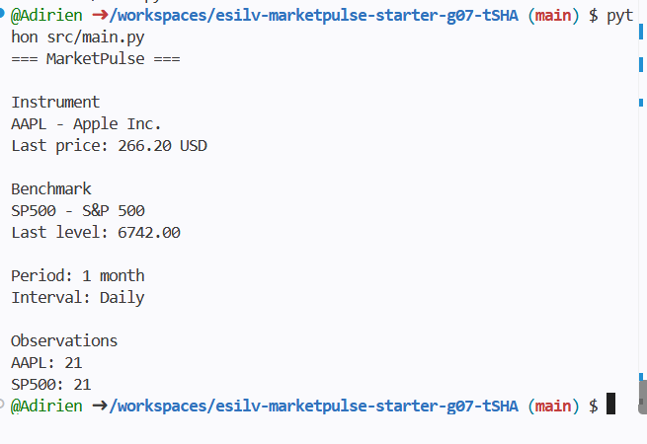
1. Which function reads JSON?
"load_instruments()" reads the JSON file containing information about the instruments.
2. Which function reads CSV?
"load_prices()" reads the CSV file containing the price data.
3. Which function selects one ticker?
"filter_prices()" selects the price data corresponding to a specific ticker.
4. Which function coordinates execution?
"main()" coordinates the execution of the program. Main calls the other functions and displays the final results.
5. Where are the input files stored?
The input files are stored in the data/ directory and in data/sample/ for the sample data.

Part 2 – Understand JSON and dictionaries
Commande : cat data/sample/instruments.json
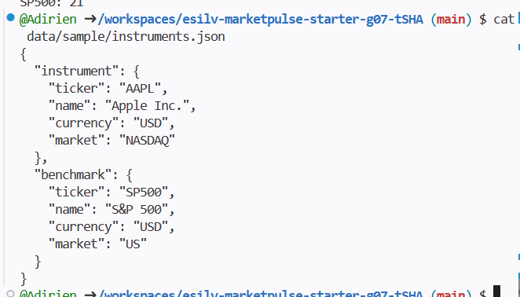
Add :
print(type(instruments))
print(instruments.keys())
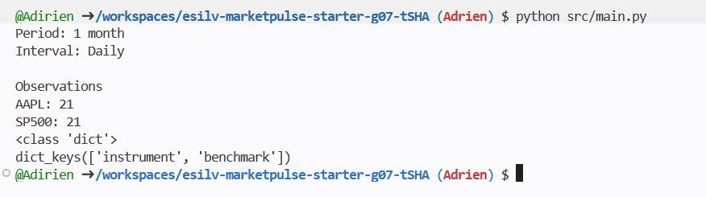
Add :
instrument = instruments["instrument"]
benchmark = instruments["benchmark"]
print(instrument["ticker"])
print(instrument["name"])
print(instrument["currency"])
print(benchmark["ticker"])
print(benchmark["name"])
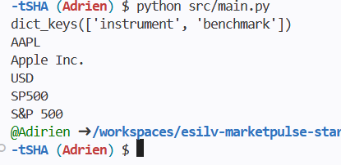

Part 3 – Understand CSV and lists of dictionaries
Commande : head data/sample/prices.csv
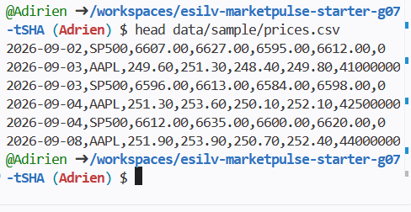
Command :
prices = load_prices()
print(type(prices))
print(type(prices[0]))
print(prices[0])
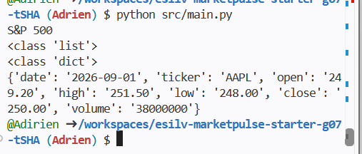

CSV values are text
Add :
print(prices[0]["close"])
print(type(prices[0]["close"]))
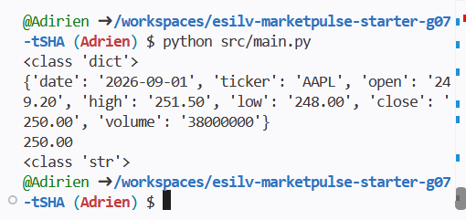

Part 4 – Filter instrument and benchmark rows
Command :
print(len(instrument_prices))
print(len(benchmark_prices))
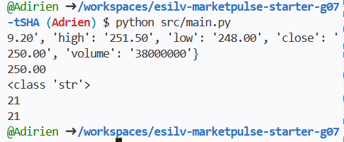

Part 5 – Create first and last close helpers
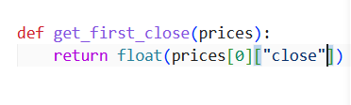
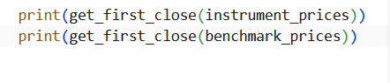
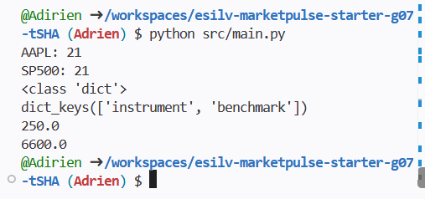
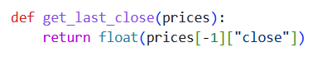
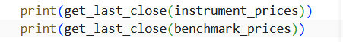
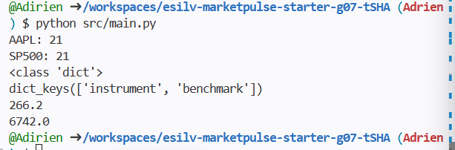

Part 6 – Build one reusable market summary
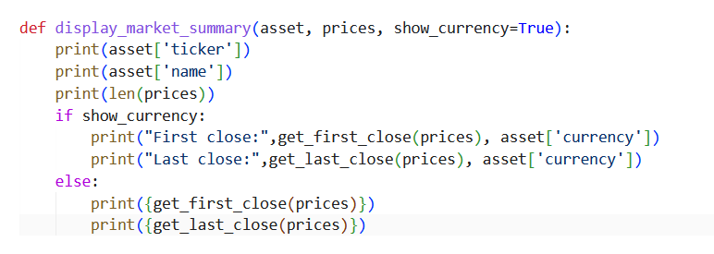
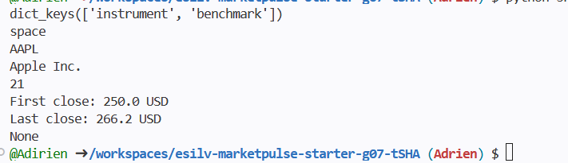
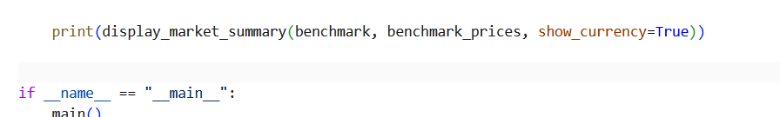
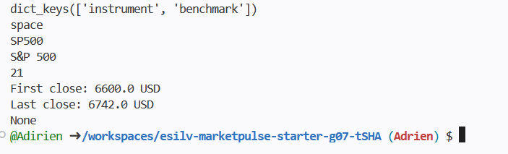

Part 7 – Keep main() readable

Part 8 – Validate the final output
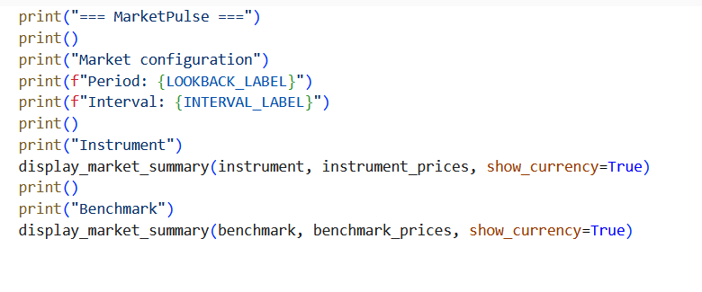
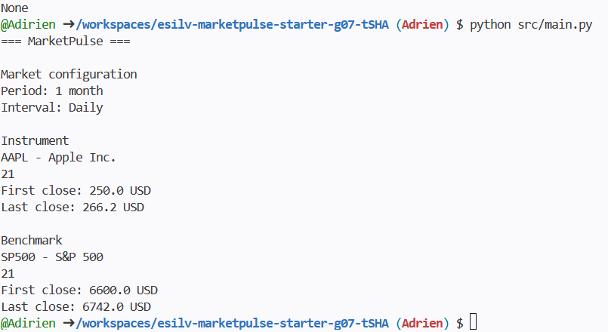

Part 9 – Python concepts recap

Part 10 – CORE handoff to TD03

Optional 1 – First and last date
