TDO1
Python · Git · Linux

Part 5
Commande : ls -la
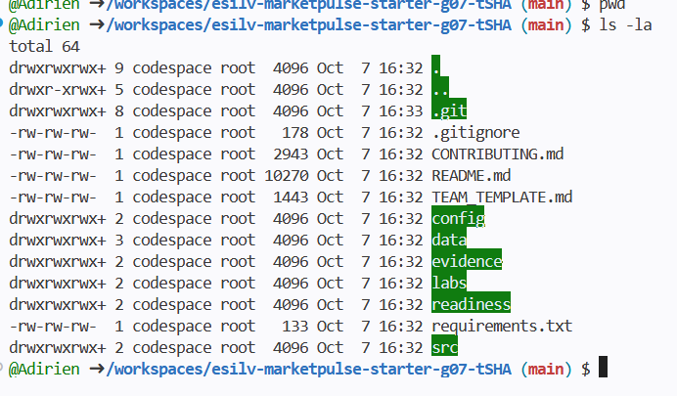
Commande : cd data pwd ls cd sample pwd ls
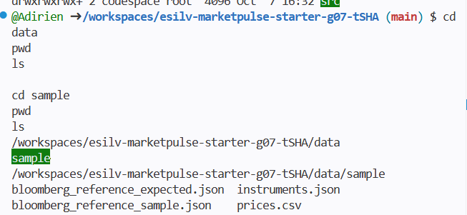
Commande : cd ../.. pwd
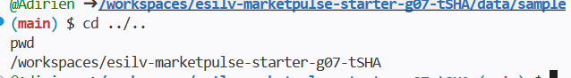

Part 6
Commande : cat data/sample/instruments.json
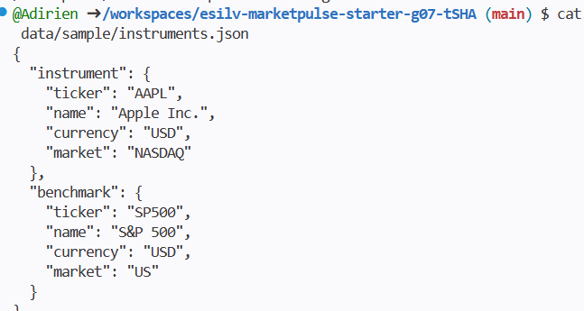
1. What is the instrument?
The instrument is Apple.
2. What is the benchmark?
The benchmark is SP500.
3. Where are their names and tickers stored?
They are stored in the "data/sample/instruments.json".

6.2 CSV observations
Commande : head data/sample/prices.csv
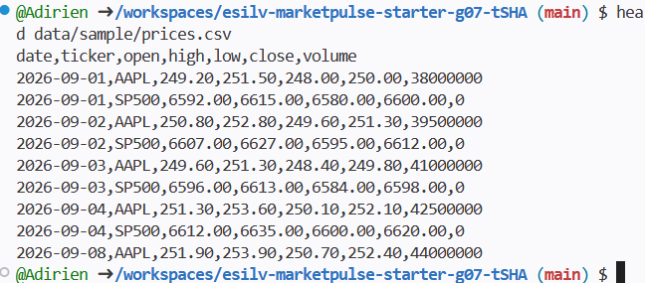
Commande : grep AAPL data/sample/prices.csv grep SP500 data/sample/prices.csv
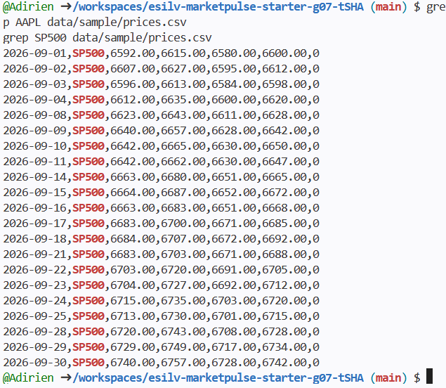

Part 7 – Verify the runtime

7.1 Check Python
Commande : python --version
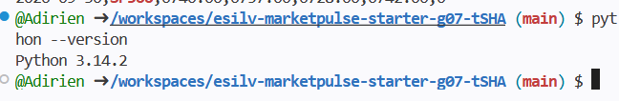

7.2 Check Git
Commande : git --version
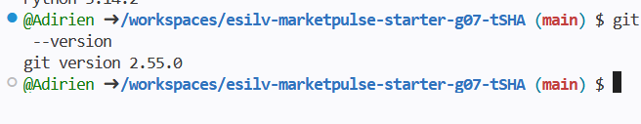

7.3 Run MarketPulse
Commande : python src/main.py
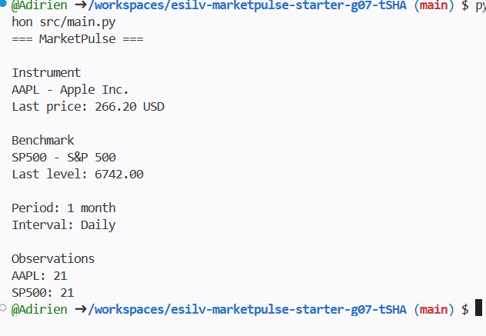

Part 8 – CORE validation
OPTIONAL

Optional 1 – Count observations
Commande : grep -c AAPL data/sample/prices.csv grep -c SP500 data/sample/prices.csv
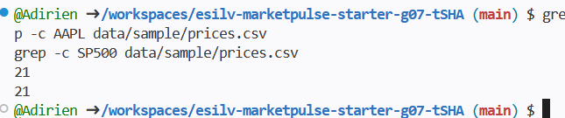
Why is having two aligned series useful for future comparison work?
When they are aligned, their observations are on the same date. It is useful because we can compare their performance, correlation...

Optional 2 – Explore Linux output
Commande : ls -lh head -n 5 data/sample/prices.csv tail -n 5 data/sample/prices.csv
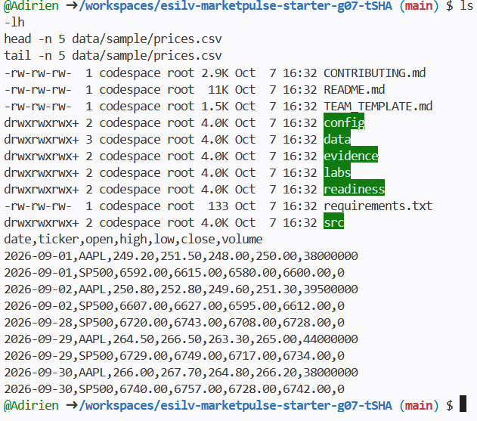
Explain what changes between these commands.
The command "ls -lh" lists the files and folders in the current directory and gives information about the files themselves like the file size and modification date.
Command "head -n 5 data/sample/prices.csv" displays the first five lines of the prices.csv. Allowing us to check the beginning of the dataset.
Command "tail -n 5 data/sample/prices.csv" displays the last five lines of the file, allowing us to check the end of the dataset.
"ls -lh" gives information about the files themselves, while "head..." and "tail..." allow us to inspect the content of a specific file.

Optional 3 – Count and search repository files
Commande : find . -type f grep -R "AAPL" .
