

**COMP 311:PROGRAMMING PROJECT**

|  |  |  |
| --- | --- | --- |
| **NAME** | **REGISTRATION NUMBER** | **SIGNATURE** |
| DAVID WAMBUA | COM/012/22 |  |
| JAMES NGANDU | COM/012/22 |  |
| JACINTA OMONDI | INF/004/22 |  |
| HENRY OUMA | COM/088/22 |  |

## ****Declaration****

We, the undersigned, solemnly declare that the project report titled "Attendease" is an original work conducted by us. This project has been undertaken in partial fulfillment of the academic requirements for the University of Eldoret. All information, data, and findings presented in this document are accurate and authentic to the best of our knowledge and have been sourced from reliable and credible references.

This work, in its entirety or in part, has not been submitted previously for the attainment of any degree, diploma, certification, or any other academic award at this or any other institution. Proper acknowledgment has been given for all external sources, materials and references utilized in the development of this project.

**Signatures:**

1. **Jacinta Omondi**  
   UI Designer  
   Signature: ___________________________  
   Date: _______________________________
2. **James Ngandu**  
   Frontend Developer  
   Signature: ___________________________  
   Date: _______________________________
3. **Henry Ouma**  
   Backend Developer  
   Signature: ___________________________  
   Date: _______________________________
4. **David Polycarp**  
   ML Engineer  
   Signature: ___________________________  
   Date: _______________________________

## ****Dedication****

We dedicate this project to all students and educators who continuously strive to improve the efficiency of academic processes through technology. This work stands as a testament to the transformative power of innovation in education and its potential to streamline classroom management and enhance learning experiences.

## ****Acknowledgment****

We would like to express our heartfelt gratitude to all those who contributed to the successful completion of this project, "Attendease."

First and foremost, we sincerely thank our supervisor, Madam Siele, for their invaluable guidance, constructive feedback, and continuous support throughout the development of this system. Their expertise and insightful suggestions greatly contributed to the successful execution of this project.

We also extend our appreciation to the University of Eldoret for providing us with the necessary resources, a conducive learning environment, and unwavering support as we explored and implemented this innovative solution.

A special thank you goes to our families and friends for their encouragement, patience, and emotional support during this journey. Their belief in us motivated us to persist and overcome challenges, making this project possible.

Finally, we acknowledge and thank the open-source communities and developers behind frameworks and libraries such as Django, TensorFlow, Face_Recognition, Face_API.js, Tailwind CSS, and OpenCV. Their contributions played a crucial role in making this project a reality.

## ****Abstract****

The attendease is a technological solution aimed at automating student attendance tracking in academic institutions. Traditional methods, such as manual roll calls and paper-based signing, are often time-consuming, prone to errors, and vulnerable to fraudulent attendance marking. This project addresses these issues by utilizing computer vision and machine learning technologies, providing an efficient, accurate and secure alternative through facial recognition.

The system is developed using Django for the backend, HTML, CSS (Tailwind) and JavaScript for the frontend, with TensorFlow, Face_Recognition, and Face_API.js used for facial recognition processing. This allows the system to automatically register students' attendance based on facial identification, eliminating the need for physical sign-in methods. Once a student's face is detected and matched with pre-registered data, the system logs their attendance in the database.

Key features of the system include:

* **Automated Attendance Logging:** Detects and records student attendance in real time.
* **Secure Student Authentication:** Prevents proxy attendance using facial recognition.
* **User-Friendly Interface:** Designed with Tailwind CSS for a responsive, modern experience.
* **Database Integration:** Efficiently stores attendance records for retrieval and reporting.

This system aims to improve classroom management, enhance the accuracy of attendance records, and reduce the administrative workload for educators. By implementing AI-powered facial recognition, the system introduces speed, reliability, and security to attendance tracking, making it a practical solution for modern academic institutions.

Table of Contents

Dedication 2

Acknowledgment 2

Abstract 3

Table of Contents 5

Chapter 1: Introduction 7

1.1 Problem Statement and Context 7

1.2 Aims and Objectives 7

1.3 Justification 8

1.4 Scope 8

1.5 Limitations 9

1.6 Summary of Chapters 10

Chapter 2: Literature Review 11

2.1 Origin and Evolution of Attendance Systems 11

2.2 Existing Solutions and Their Limitations 12

2.3 Platforms and Technologies Used in Face Recognition Systems 13

2.4 Gaps in Existing Systems 13

2.5 Relevance of the Project 14

System Design: Data Flow Diagram (DFD) 14

Level 0 DFD (Context Diagram) 14

Level 1 DFD (Detailed System Workflow) 15

Chapter 3: System Analysis and Design 15

3.1 System Requirements 15

3.1.1 Functional Requirements 15

3.1.2 Non-Functional Requirements 16

3.2 System Architecture 16

3.3 System Design Models 16

3.3.1 Use Case Diagram 16

3.3.2 Data Flow Diagram (DFD) - Level 1 17

3.3.3 Entity-Relationship Diagram (ERD) 17

3.4 Database Schema 17

3.4.1 Student Table 17

3.4.2 Attendance Table 17

3.5 Face Recognition Workflow 17

3.6 System Security Measures 18

3.7 User Interface Design 18

Summary 18

Chapter 4: Methodology 18

Scrum Workflow 18

5.1 Budget Planning 19

5.2 Time Management and Milestones 20

5.3 Resource Allocation and Usage 20

5.4 Risk Management 21

Chapter 6: Implementation and Results 23

6.1 System Features and Functionalities 23

6.1.1 Technology Stack 23

6.1.2 User Authentication and Role-Based Access 23

6.1.3 Class Management 24

6.1.4 Facial Recognition Attendance Marking 24

6.1.5 Attendance Monitoring and Reporting 24

6.1.6 Student Registration 25

6.1.7 Overall System Workflow 25

6.2 User Experience and Performance Analysis 26

6.2.1 Interface Design and Usability 26

6.2.2 Facial Recognition Performance 26

6.2.3 System Responsiveness 26

6.2.4 User Feedback and Improvements 27

6.3 Test Cases and Evaluation 27

6.3.1 Functional Testing 27

6.4.1 Areas for Improvement 28

6.4.2 Future Work 28

CHAPTER 7: CONCLUSION AND RECOMMENDATIONS 29

7.1 Conclusion 29

7.2 Recommendations 29

CHAPTER 9: APPENDICES 30

Appendix A: System Architecture Diagram 30

Appendix B: User Manual 30

Appendix C: Source Code 30

Appendix D: Testing and Validation Results 31

Appendix E: Ethical Considerations and Consent Forms 31

Appendix F: Future Work Proposal 31

## Chapter 1: Introduction

This chapter introduces the **Attendease**, outlining the problem it addresses, its goals, justification for its development, scope, limitations and the structure of the entire document.

### ****1.1 Problem Statement and Context****

In educational institutions, accurately tracking student attendance is vital for monitoring academic engagement and performance. Traditional methods of attendance tracking, such as manual roll calls, sign-in sheets and RFID-based systems, are burdened with several challenges:

* **Time Consumption**: Manual attendance marking is slow, especially in large classrooms.
* **Human Errors**: Teachers may inadvertently mark attendance incorrectly.
* **Fraudulent Attendance**: Proxy attendance occurs when students sign in for their absent peers.
* **Administrative Overhead**: Paper-based records are difficult to manage and analyze effectively.

With advances in **artificial intelligence (AI)** and **computer vision**, **facial recognition technology** offers a promising solution. This project aims to develop an automated system that identifies and records students' presence by recognizing their faces, eliminating the need for manual attendance.

The system is built using **Django** for backend development, with **HTML**, **CSS (Tailwind)**, **JavaScript**, **TensorFlow**, **Face_Recognition**, and **Face_API.js** for face detection and recognition. This combination of **AI** and **machine learning** enhances the efficiency and accuracy of attendance management.

### ****1.2 Aims and Objectives****

**Aim:** The primary goal of this project is to develop an automated attendance system that uses facial recognition to streamline the attendance process, improving **efficiency**, **accuracy** and **security** compared to traditional methods.

**Objectives:** To achieve this aim, the system is designed with the following objectives:

1. **Develop a face recognition system** that can detect and recognize students’ faces accurately in real-time.
2. **Automate the attendance process** by marking attendance as soon as a student is recognized.
3. **Enhance security** and prevent **proxy attendance** by ensuring that only registered students are marked present.
4. **Implement a user-friendly web interface** for administrators, teachers, and students to interact with the system.
5. **Integrate a robust backend** using **Django** to securely manage student records, attendance logs, and authentication.
6. **Optimize performance** and accuracy using **machine learning frameworks** like **TensorFlow** and **Face_Recognition**.
7. **Provide real-time attendance reports** and data analytics to help institutions track student participation.
8. **Ensure scalability** and flexibility for the system to be used across different educational institutions.

By meeting these objectives, the system will simplify attendance tracking, reduce administrative tasks, and enhance classroom management in academic institutions.

### ****1.3 Justification****

The development of a **attendease** is justified by several growing needs in the education sector:

1. **Eliminating Manual Errors**:
   * Traditional attendance methods involve human intervention, leading to mistakes such as incorrect marking or missing records.
   * The automated system will reduce errors by accurately detecting and recording students' attendance.
2. **Preventing Proxy Attendance (Fraud Prevention)**:
   * Proxy attendance, where one student signs in for an absent peer, is common in traditional methods.
   * Facial recognition ensures that only the physically present students are marked present, thus eliminating this issue.
3. **Enhancing Efficiency and Time Management**:
   * Marking attendance manually in large classes is time-consuming and disruptive.
   * The system registers students in seconds, allowing teachers to focus more on teaching rather than administrative tasks.
4. **Improving Security and Authentication**:
   * Unlike RFID cards or sign-in sheets, which can be misused, facial recognition offers a unique and secure method of student identification.
   * The system ensures that attendance records are not tampered with.
5. **Data Analysis and Reporting**:
   * The system digitally stores attendance records, making it easy to analyze student participation patterns.
   * Administrators can generate attendance reports for performance tracking and evaluation.
6. **Scalability and Adaptability**:
   * The system is scalable, allowing it to be used across multiple institutions, departments, or even workplaces.
   * It can be integrated with existing **Learning Management Systems (LMS)** to further improve institutional efficiency.

Given these benefits, the system significantly improves the accuracy, security, and efficiency of attendance tracking compared to traditional methods.

### ****1.4 Scope****

The **attendease** is designed for use in educational institutions to improve attendance management. The scope defines the system’s functionalities and limitations:

**Scope of the System**:

1. **Target Users**:
   * **Teachers/Instructors**: Use the system to take attendance and view attendance records.
   * **Students**: Have their attendance automatically recorded when their face is recognized.
   * **Administrators**: Manage student registrations, monitor attendance logs, and generate reports.
2. **Core Functionalities**:
   * **Face Detection and Recognition**: Identify and verify students based on their facial features.
   * **Automated Attendance Recording**: Mark attendance once a student is recognized.
   * **Real-time Processing**: Detect student faces during class sessions and update records instantly.
   * **Database Management**: Securely store student details, attendance logs, and reports.
   * **Web-based Dashboard**: Provide an intuitive UI for teachers and administrators to manage records.
   * **Report Generation**: Allow administrators to generate attendance reports based on criteria.
3. **Technologies Used**:
   * **Backend**: Django (Python)
   * **Frontend**: HTML, CSS (Tailwind), JavaScript
   * **Facial Recognition**: TensorFlow, Face_Recognition, Face_API.js, OpenCV
   * **Database**: SQLite/PostgreSQL
4. **Deployment Environment**:
   * The system will be deployed on local or cloud-based servers and accessed via a web browser.
   * It can be integrated with existing **Learning Management Systems (LMS)** if required.

**Scope Limitations**:

1. **Requires Initial Student Registration**:
   * Each student must register their face before the system can recognize them.
2. **Lighting and Camera Quality Dependence**:
   * Recognition accuracy can vary based on lighting and camera quality.
3. **Works for Pre-Registered Courses Only**:
   * The system recognizes students only in courses they are registered for.
4. **Internet or Local Network Dependency**:
   * If deployed online, a stable internet connection is required for real-time processing.

### ****1.5 Limitations****

Despite its advantages, the system has several limitations that may affect its functionality:

1. **Dependence on Camera Quality**:
   * Low-resolution cameras may struggle to detect faces, especially in large classrooms.
2. **Lighting Conditions**:
   * Poor lighting can negatively impact facial recognition accuracy, and the system performs best in well-lit environments.
3. **Variability in Facial Appearances**:
   * Changes like wearing glasses, growing a beard, or facial injuries may reduce recognition accuracy.
4. **Processing Speed and Performance**:
   * Real-time face recognition requires substantial computational resources, potentially slowing down performance on lower-end hardware.
5. **Internet or Network Dependency**:
   * Cloud-based systems require a stable internet connection, while local systems may face issues with network configuration.
6. **Initial Registration Requirement**:
   * Students must manually register their faces before the system can recognize them, and any changes may require re-registration.
7. **Potential Privacy Concerns**:
   * Facial recognition technology raises ethical and privacy issues. Institutions must comply with data protection laws and obtain necessary permissions.
8. **Limited Scalability in Large Institutions**:
   * Handling thousands of students in real-time may require advanced hardware and optimization.

### ****1.6 Summary of Chapters****

The document is organized into multiple chapters, each focusing on different aspects of the project:

* **Chapter 1: Introduction**: Introduces the project, outlining the problem, goals, justification, scope, limitations, and document structure.
* **Chapter 2: Literature Review**: Reviews existing attendance systems and the evolution of facial recognition technology.
* **Chapter 3: System Analysis and Design**: Discusses system requirements, architecture, and design models.
* **Chapter 4: Methodology**: Explains the tools, technologies, and development process used.
* **Chapter 5: Project Management**: Covers budgeting, resource management, and risk assessment.
* **Chapter 6: Results and Evaluation**: Presents system performance, testing, and feedback.
* **Chapter 7: Conclusion and Recommendations**: Summarizes key findings and suggests future improvements.
* **Chapter 8: References**: Lists all sources referenced.
* **Chapter 9: Appendix**: Contains supporting materials, including code, schemas, and screenshots.

## Chapter 2: Literature Review

This chapter provides an in-depth review of existing attendance systems, the evolution of face recognition technology, and the gaps that our system aims to address. It also discusses various platforms and methodologies used in developing biometric attendance systems.

### ****2.1 Origin and Evolution of Attendance Systems****

Attendance tracking has evolved significantly over time, from traditional manual systems to more sophisticated automated biometric solutions.

**1. Traditional Attendance Methods**

* **Manual Roll Calls**: This was the most basic form of attendance tracking where teachers manually mark attendance on paper.
  + **Challenges**:
    - **Time-consuming**: Especially in large classes, roll calls can take up valuable class time.
    - **Error-prone**: Teachers may mistakenly mark the wrong student or miss some students.
    - **Prone to fraud**: Students can call the names of absent peers, marking them as present.
* **Sign-in Sheets**: Students manually sign their names on a sheet to mark attendance.
  + **Challenges**:
    - **Forgery**: Sign-in sheets can be manipulated, leading to inaccuracies.
    - **Fraud**: A student can sign for a peer who is absent.
* **RFID (Radio-Frequency Identification) Cards**: Students scan their ID cards using RFID readers.
  + **Challenges**:
    - **Card Misplacement**: Students may forget or lose their cards.
    - **Fraud Risk**: A student could use another student's ID card to sign in.
* **Fingerprint Recognition Systems**: Students scan their fingerprints to mark attendance.
  + **Challenges**:
    - **Hygiene Issues**: The use of shared fingerprint scanners raises hygiene concerns.
    - **Failure for Specific Users**: The system might fail to recognize students with skin conditions or cuts.

**2. Modern AI-Powered Attendance Systems** With advancements in **AI** and **machine learning**, attendance tracking has become more automated, accurate, and secure. Among the most popular innovations are **biometric recognition methods**.

* **Facial Recognition Systems** (like the system in our project):
  + **Advantages**:
    - **No physical contact**: Eliminates the need for shared devices, reducing health risks.
    - **High efficiency**: Offers a fast and secure way to track attendance.
    - **Improved security**: Can prevent fraud by verifying the identity of students.

**3. Comparison of Attendance Systems** A summary comparison of the different attendance methods in terms of accuracy, security, time efficiency, and challenges:

|  |  |  |  |  |
| --- | --- | --- | --- | --- |
| ****Method**** | ****Accuracy**** | ****Security**** | ****Time Efficiency**** | ****Challenges**** |
| **Manual Roll Call** | Low | Low | Slow | Errors, Fraud |
| **Sign-in Sheets** | Low | Low | Slow | Fraud, Forgery |
| **RFID Cards** | Medium | Medium | Medium | Card Loss, Fraud |
| **Fingerprint Scan** | High | High | Medium | Hygiene Issues |
| **Face Recognition** | Very High | Very High | Fast | Lighting, Accuracy |

### ****2.2 Existing Solutions and Their Limitations****

Several solutions are available, but many of them still face limitations:

**1. Commercial Face Recognition Attendance Systems**

* **Limitations**:
  + **High Cost**: Many enterprise-level facial recognition systems are prohibitively expensive for educational institutions.
  + **Lack of Customization**: Commercial systems often don’t integrate well with existing school databases or are too rigid to customize.
  + **Privacy Concerns**: Some commercial solutions store facial data insecurely, creating data protection issues.

**2. Open-Source Face Recognition Libraries** There are several open-source libraries that provide face recognition capabilities but lack complete attendance solutions:

* **Dlib (Face_Recognition Library)**:
  + Offers pre-trained models for face detection.
  + Mainly used in Python-based applications.
* **OpenCV**:
  + Provides real-time face detection and tracking.
  + Requires manual tuning for optimal accuracy.
* **Face_API.js**:
  + A JavaScript library designed for use in web applications.
  + While useful, these libraries require developers to build custom systems around them.

### ****2.3 Platforms and Technologies Used in Face Recognition Systems****

**1. Deep Learning Algorithms for Face Recognition** The system employs deep learning models to achieve high accuracy in face recognition. Key technologies include:

* **Convolutional Neural Networks (CNNs)**:
  + Used in frameworks like **TensorFlow** and **Face_Recognition** for feature extraction.
  + CNNs learn facial features such as eyes, nose, and overall face shape.
* **MTCNN (Multi-task Cascaded Convolutional Networks)**:
  + Used for face detection and alignment.
  + Ensures the system captures high-quality, aligned images for processing.
* **RetinaFace**:
  + A state-of-the-art face detection model that improves accuracy by detecting faces even in challenging conditions.

**2. System Architecture and Deployment Options** The system can be deployed in two environments:

* **Local Deployment**: The system runs on an institution’s internal network, ensuring data remains on-premises and avoiding reliance on the internet.
* **Cloud-Based Deployment**: Hosted on cloud servers, enabling remote access and centralized management.

|  |  |
| --- | --- |
| **Component** | **Technology Used** |
| **Backend** | Django (Python) |
| **Frontend** | HTML, CSS (Tailwind), JavaScript |
| **Database** | PostgreSQL / SQLite |
| **Face Detection** | OpenCV, TensorFlow, Face_Recognition |
| **Real-Time Processing** | WebRTC, Face_API.js |

### ****2.4 Gaps in Existing Systems****

While there are many available attendance systems, several gaps remain, which our system aims to address:

**1. Accuracy and Reliability Issues**

* Many existing systems struggle with **low-light conditions** or when students wear **glasses, hats, or masks**. Our system overcomes these challenges by using **MTCNN** and **RetinaFace**, which are more robust to such issues.

**2. Integration Challenges**

* Many facial recognition systems do not integrate seamlessly with school management systems. Our system is designed with **easy integration** in mind, allowing it to work alongside existing platforms.

**3. Scalability Issues**

* Some attendance systems are only suitable for small groups of students and fail to scale efficiently for larger classrooms. Our system can handle large numbers of students without sacrificing performance.

**4. Data Privacy Concerns**

* Many systems store **unsecured facial data**, posing significant security risks. Our system ensures **data encryption** to meet privacy standards and ensure compliance with regulations like **GDPR**.

### ****2.5 Relevance of the Project****

The **Face Recognition-Based Student Attendance System** is highly relevant to modern educational environments due to several factors:

**1. Increased Efficiency**

* Automates attendance tracking, saving valuable class time and reducing administrative workload.

**2. Enhanced Security**

* Ensures that only registered students can be marked present, thereby eliminating the risk of fraud and impersonation.

**3. Data Insights for Educators**

* Provides real-time attendance reports, which can help teachers monitor student participation and engagement more effectively.

**4. Adaptability to Different Learning Environments**

* The system can be implemented in **physical, hybrid**, or **online classrooms**, making it adaptable to various educational settings and increasing its utility in the post-pandemic era.

### System Design: Data Flow Diagram (DFD)

#### ****Level 0 DFD (Context Diagram)****

The **Level 0 DFD** (Context Diagram) represents the overall flow of information between the system and its users, displaying high-level interactions without getting into system-specific details.

**Actors Involved:**

* **Teacher/Admin**: Manages attendance records and views reports.
* **Student**: Registers their face and gets automatically marked present.
* **System Database**: Stores attendance logs and student data.

**Image of Level 0 DFD (Context Diagram)**:  
This diagram typically includes the following:

* **External Entities**: Represented by rectangles (e.g., Teacher, Admin, Student).
* **Processes**: Represented by circles or ovals (e.g., Face Recognition System, Attendance Logging).
* **Data Flows**: Arrows showing data movement (e.g., Student facial data, attendance logs).
* **Data Stores**: Represented by open-ended rectangles (e.g., System Database).

#### ****Level 1 DFD (Detailed System Workflow)****

The **Level 1 DFD** provides a more detailed breakdown of how data flows within the system. This diagram provides insight into the specific operations of the system and its interactions.

1. **Student registers their face → Stored in the database.**
   * The student uploads or scans their facial data.
   * Facial embeddings (numerical representations of facial features) are stored in the system's database.
2. **Face recognition scans student in class → Checks against stored images.**
   * When a student enters the class, the system uses face recognition to capture their facial features.
   * The system compares these features against the previously stored embeddings to identify the student.
3. **If match found, attendance is recorded → Data stored in attendance logs.**
   * If a match is found between the captured image and the stored data, the system automatically marks the student present.
   * Attendance data is then logged into the system's database.
4. **Teachers/Admins can view reports.**
   * Teachers and administrators have the ability to generate and view reports on student attendance, which can be accessed from their respective dashboards.

**Image of Level 1 DFD (Detailed System Workflow)**:  
This diagram would include the following:

* **Processes**: Includes processes like Face Registration, Face Recognition, Attendance Logging, and Report Viewing.
* **Data Stores**: System Database where student data, attendance logs, and facial embeddings are stored.
* **Data Flows**: Representing the movement of data such as student facial data, attendance records, and report data.

## ****Chapter 3: System Analysis and Design****

This chapter provides a breakdown of the system's functional and non-functional requirements, system architecture, database schema, and workflow design.

### ****3.1 System Requirements****

##### ****3.1.1 Functional Requirements****

1. **User Registration & Authentication**
   * Students and teachers can register using a username, password, and facial data.
   * The system validates credentials for authentication.
2. **Face Registration & Recognition**
   * The system captures student images and stores them for recognition purposes.
   * During attendance, the system matches real-time face data with stored records.
3. **Attendance Logging & Reporting**
   * The system automatically records student presence when their face is detected.
   * Generates attendance reports for teachers and administrators.
4. **Administrator Controls**
   * Teachers can view and modify attendance records.
   * Admins can add or remove students from courses and manage other system configurations.

##### ****3.1.2 Non-Functional Requirements****

1. **Accuracy**: Face recognition must correctly identify at least 95% of students under varied conditions.
2. **Performance**: The system should process and log attendance in under 2 seconds per student.
3. **Scalability**: The system should handle hundreds of students simultaneously without performance degradation.
4. **Security**: All facial data and login credentials must be encrypted and securely stored.
5. **Usability**: The user interface should be simple, intuitive, and easy to navigate for students, teachers, and administrators.

### ****3.2 System Architecture****

The system follows a three-tier architecture:

1. **Presentation Layer (Frontend)**:
   * Built with **HTML**, **CSS** (Tailwind), and **JavaScript**.
   * Functions to capture and send student images for processing and display attendance statuses.
   * Includes teacher/admin dashboards.
2. **Application Layer (Backend)**:
   * Built with **Django** (Python), **TensorFlow**, and **OpenCV**.
   * Handles face detection, feature comparison, database management, and user authentication.
3. **Data Layer (Database)**:
   * Built with **PostgreSQL** or **SQLite**.
   * Stores student information, facial embeddings, and attendance logs.
   * Provides real-time access to attendance reports.

### ****3.3 System Design Models****

##### ****3.3.1 Use Case Diagram****

The Use Case Diagram illustrates the interactions between the system’s users and functionalities. Key actors include:

* **Student**: Registers face, gets marked present automatically.
* **Teacher**: Manages attendance records and generates reports.
* **Admin**: Controls system configurations and user accounts.

##### ****3.3.2 Data Flow Diagram (DFD) - Level 1****

As described earlier, this DFD illustrates the movement of data within the system. It shows how face registration, recognition, attendance logging, and report generation flow within the system.

##### ****3.3.3 Entity-Relationship Diagram (ERD)****

The **ERD** illustrates the relationships between key entities in the system, including:

* **Student** (Student ID, Name, Course, Face Embedding)
* **Teacher** (Teacher ID, Name, Email, Courses Taught)
* **Attendance** (Attendance ID, Student ID, Course ID, Timestamp)
* **Course** (Course ID, Name, Teacher ID)
* **Admin** (Admin ID, Name, Role)

### ****3.4 Database Schema****

##### ****3.4.1 Student Table****

CREATE TABLE Student (

student_id SERIAL PRIMARY KEY,

name VARCHAR(255) NOT NULL,

course_id INT REFERENCES Course(course_id),

face_embedding BYTEA NOT NULL

);

##### ****3.4.2 Attendance Table****

CREATE TABLE Attendance (

attendance_id SERIAL PRIMARY KEY,

student_id INT REFERENCES Student(student_id),

course_id INT REFERENCES Course(course_id),

timestamp TIMESTAMP DEFAULT CURRENT_TIMESTAMP

);

### ****3.5 Face Recognition Workflow****

1. **Step 1: Face Registration**
   * The student uploads or scans their face.
   * The system extracts facial features using **MTCNN** (Multi-task Cascaded Convolutional Networks).
   * These features are encoded into a numerical **embedding** and stored in the database.
2. **Step 2: Real-Time Face Recognition**
   * As the student enters the classroom, the camera captures their face.
   * The system extracts the facial embedding and compares it to the stored embeddings.
   * If a match is found, the student is marked present automatically.
3. **Step 3: Attendance Record Update**
   * Attendance is recorded in the database, and the teacher can view the attendance logs through the dashboard.

### ****3.6 System Security Measures****

1. **Data Encryption**:
   * Facial data and passwords are hashed and securely stored.
   * Sensitive data is encrypted during transmission using secure protocols (e.g., HTTPS).
2. **Access Control**:
   * Role-based authentication ensures that only authorized users (students, teachers, admins) can access specific parts of the system.
3. **Secure API Communication**:
   * Backend services use **JWT** (JSON Web Tokens) for secure API communication and authentication.

### ****3.7 User Interface Design****

1. **Student Dashboard**:
   * Features: Face Capture & Verification, Attendance History.
2. **Teacher Dashboard**:
   * Features: View Attendance Reports, Modify Attendance Records.
3. **Admin Panel**:
   * Features: User & Course Management, System Logs & Security Monitoring.

### ****Summary****

* **Functional Requirements**: Student registration, face recognition, attendance logging, admin controls.
* **Non-Functional Requirements**: Accuracy, performance, scalability, security, usability.
* **Architecture**: Three-tier architecture with frontend, backend, and database.
* **Design Models**: DFD, ERD, Use Case Diagram, and database schema provided.
* **Workflow**: Detailed steps for face registration, real-time recognition, and attendance recording.
* **Security**: Data encryption, role-based access control, and secure API communication.

## ****Chapter 4: Methodology****

This chapter describes the **Agile Software Development** methodology used for the project, with a focus on the **Scrum framework**. The approach emphasizes iterative development, regular communication, and continuous feedback to ensure a high-quality, user-focused system.

#### ****Scrum Workflow****

1. **Sprint Planning**: Define goals and assign tasks.
2. **Daily Standups**: Discuss progress and identify roadblocks.
3. **Sprint Development**: Develop features in short iterations.
4. **Testing and Review**: Continuous testing of features to ensure functionality and stability.

## ****CHAPTER 5: PROJECT MANAGEMENT****

AttendEase is a face recognition-based student attendance system developed over a three-month period. The system automates attendance tracking in academic settings using facial recognition technology, eliminating traditional manual roll calls and paper-based signing methods that are time-consuming and prone to errors. The project employed agile methodology for development, consisting of design, frontend and backend phases.

### 5.1 Budget Planning

**Development Costs:**

* **Software Tools:** Ksh 40,000 for premium versions of development tools, plus utilization of open-source frameworks and libraries (Django, TensorFlow, Face_Recognition API).
* **Hardware Requirements:** Ksh 60,000 for testing devices, including webcam-equipped laptops for facial recognition trials.
* **Human Resources:** Ksh 150,000 for a small team of student developers with allocated roles across design, frontend, and backend.
* **Training Data:** Ksh 75,000 for collection and processing of facial data samples for system training and testing.
* **Cloud Services:** Ksh 50,000 for three months of cloud hosting and database services during development.

**Budget Allocation:**

* **Development Environment:** Ksh 120,000 (15% of budget) for development tools and testing environment setup.
* **Human Resources:** Ksh 600,000 (70% of the total budget) allocated to team members based on role complexity and time commitment.
* **Contingency Reserve:** Ksh 120,000 (15% of total budget) reserved for unforeseen technical challenges and additional requirements.
* **Total Project Budget:** Ksh 860,000.

**Additional Expenses:**

* **Software Licenses:** Ksh 80,000 for specialized IDE and development tools.
* **Testing Hardware:** Ksh 90,000 for additional webcam units with different specifications.
* **Team Training:** Ksh 60,000 for online courses on facial recognition implementation.
* **Documentation Tools:** Ksh 30,000 for project management and documentation software.

### 5.2 Time Management and Milestones

**Sprint Planning:**

* **Sprint Duration:** Two-week sprints following agile methodology.
* **Daily Stand-ups:** 15-minute meetings to discuss progress, blockers, and next steps.

**Key Milestones:**

1. **Weeks 1-2: Planning and Design**
   * Requirement gathering and analysis.
   * Wireframing and UI/UX design using tools like Figma.
   * Database design and system architecture planning.
2. **Weeks 3-6: Frontend Development**
   * Development of the user interface using HTML, CSS (Tailwind), and JavaScript.
   * Integration of Face_API.js for real-time face detection.
   * Testing the frontend for responsiveness and usability.
3. **Weeks 7-10: Backend Development**
   * Setting up Django for backend logic.
   * Integrating TensorFlow and Face_Recognition for facial recognition.
   * Database integration for storing attendance records.
4. **Weeks 11-12: Testing and Deployment**
   * System testing and bug fixing.
   * Deployment on a local server or cloud platform.
   * Final documentation and handover.

### 5.3 Resource Allocation and Usage

**Human Resources:**

* **Project Manager (James Ngandu):** Overseeing the timeline, coordinating team activities, and managing stakeholder communications.
* **UI/UX Designer (Jacinta Atieno):** Creating intuitive user interfaces and user experience flows.
* **Frontend Developer (James Ngandu):** Implementing responsive web interfaces using HTML, Tailwind CSS, and JavaScript.
* **Backend Developer (Henry Ouma):** Building server-side logic, database structure, and API endpoints with Django.
* **ML Engineer (David Wambua):** Implementing and fine-tuning facial recognition algorithms.

**Technical Resources:**

* **Development Environment:** Local development setups with necessary software installations.
* **Version Control:** Git repository for collaborative development and code versioning.
* **Testing Equipment:** Laptops with webcams for facial recognition testing across different lighting conditions.
* **Database Server:** Local database instance for development and testing.

**Resource Optimization Strategies:**

* Cross-training team members to handle multiple responsibilities.
* Using containerization for consistent development environments.
* Implementing reusable code components to improve development efficiency.

### 5.4 Risk Management

**Technical Risks:**

1. **Facial Recognition Accuracy:**
   * **Risk:** Poor recognition in varying lighting conditions or with facial accessories.
   * **Mitigation:** Implementation of preprocessing techniques and extensive testing with diverse sample data.
2. **System Performance:**
   * **Risk:** Slow processing when handling multiple simultaneous recognition requests.
   * **Mitigation:** Optimization of algorithms and implementation of queue-based processing.
3. **Data Security:**
   * **Risk:** Privacy concerns regarding storage of facial data.
   * **Mitigation:** Implementing data encryption, secure storage protocols, and user consent mechanisms.

**Project Management Risks:**

1. **Scope Creep:**
   * **Risk:** Expanding requirements beyond the initial project boundaries.
   * **Mitigation:** Clear documentation of project scope and change request process.
2. **Schedule Delays:**
   * **Risk:** Missed deadlines due to technical challenges.
   * **Mitigation:** Buffer time incorporated into sprint planning and regular progress tracking.
3. **Team Coordination:**
   * **Risk:** Communication gaps between frontend, backend, and ML components.
   * **Mitigation:** Regular integration meetings and collaborative documentation.

**Operational Risks:**

1. **User Adoption:**
   * **Risk:** Resistance from faculty or students to the new system.
   * **Mitigation:** Early stakeholder involvement, intuitive UI design, and comprehensive training.
2. **System Integration:**
   * **Risk:** Challenges integrating with existing academic management systems.
   * **Mitigation:** Modular design approach and well-documented APIs for future integration.

## ****Chapter 6: Implementation and Results****

### 6.1 System Features and Functionalities

The Face Attendance System implements a comprehensive set of features designed to streamline student attendance tracking through facial recognition technology. This section details both the functional aspects and the underlying technology stack that powers the system.

##### 6.1.1 Technology Stack

The facial recognition attendance system is built using a robust combination of frontend and backend technologies:

**Frontend Technologies:**

* **HTML5/CSS3**: Provides the structural foundation and styling for the user interface.
* **Tailwind CSS**: Utility-first CSS framework used for responsive design and consistent styling across the application.
* **JavaScript**: Enables dynamic client-side interactions and facial recognition processing.
* **TensorFlow.js**: Powers the machine learning components for facial detection on the client side.
* **face-api.js**: JavaScript API for face detection and recognition in the browser, simplifying the implementation of facial recognition features.

**Backend Technologies:**

* **Django**: Python web framework that handles server-side logic, authentication, and database operations.
* **OpenCV**: Computer vision library used for image processing and additional face detection capabilities.
* **face_recognition**: Python library that provides core facial recognition algorithms, working alongside OpenCV.
* **SQLite/PostgreSQL**: Database systems storing student profiles, attendance records, and course information.

**Integration Architecture:**

* **Hybrid Approach**: Initial face detection occurs in the browser using TensorFlow.js and face-api.js for real-time feedback.
* **More Complex Recognition**: Matching operations leverage the backend’s face_recognition and OpenCV libraries.
* **Django’s REST Framework**: Facilitates communication between frontend and backend components.

##### 6.1.2 User Authentication and Role-Based Access

The system provides secure login functionality with role-specific dashboards. Users can log in and access features appropriate to their role. The Teacher Dashboard serves as the central hub for instructors to manage attendance-related activities.

* **Authentication System**: Django's authentication framework manages user sessions and access control.
* **Role Permissions**: Different user types (administrators, teachers, students) are granted appropriate access levels.
* **Session Management**: Active sessions are maintained securely with appropriate timeout mechanisms.

##### 6.1.3 Class Management

The system offers robust class scheduling capabilities:

* **Schedule Creation**: Teachers can create new class schedules by specifying course name, start time, end time, and location through a simple form interface.

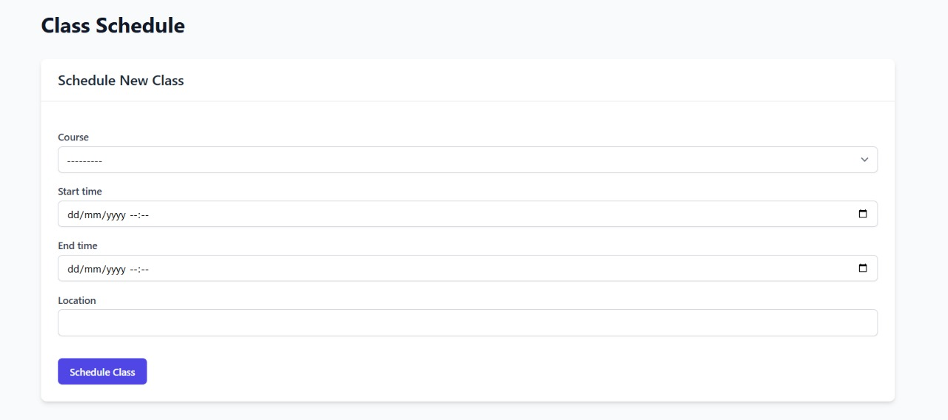

* **Schedule Viewing**: The system displays both upcoming and past classes in an organized tabular format, showing essential details including course name, time slots, and locations.

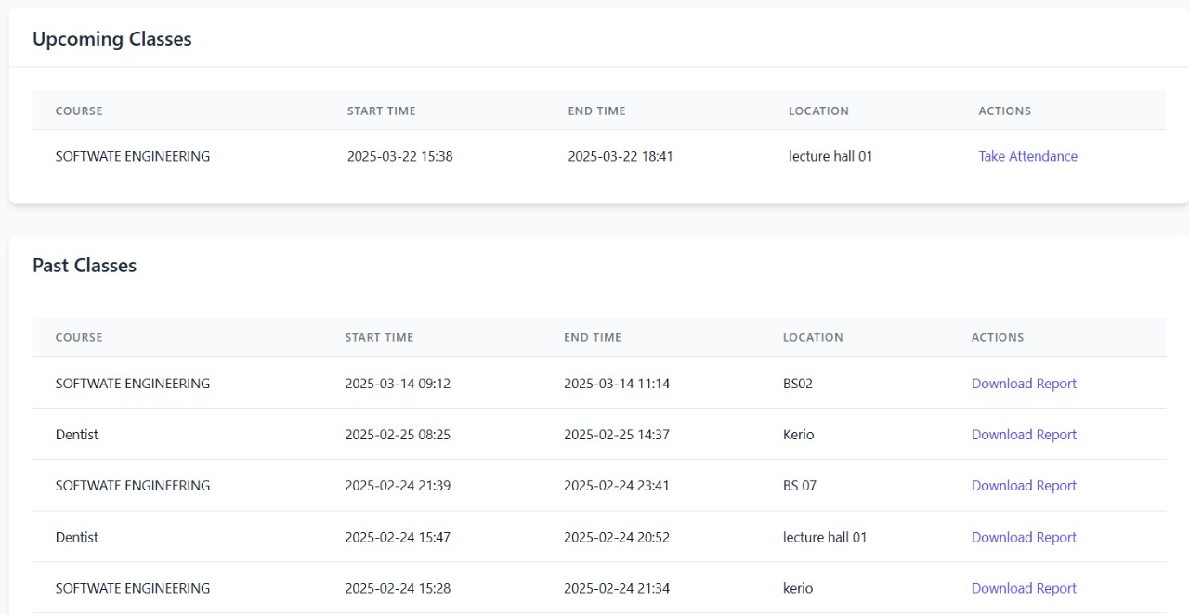

* **Course Association**: Classes are associated with specific courses (e.g., "SOFTWARE ENGINEERING").
* **Calendar Integration**: Class schedules are managed through a datetime-based system that properly organizes upcoming and past sessions.

##### 6.1.4 Facial Recognition Attendance Marking

The core functionality of the system is its ability to identify students through facial recognition:

* **Real-time Face Detection**: The system captures student faces through a camera interface, as demonstrated in the recognition screen.

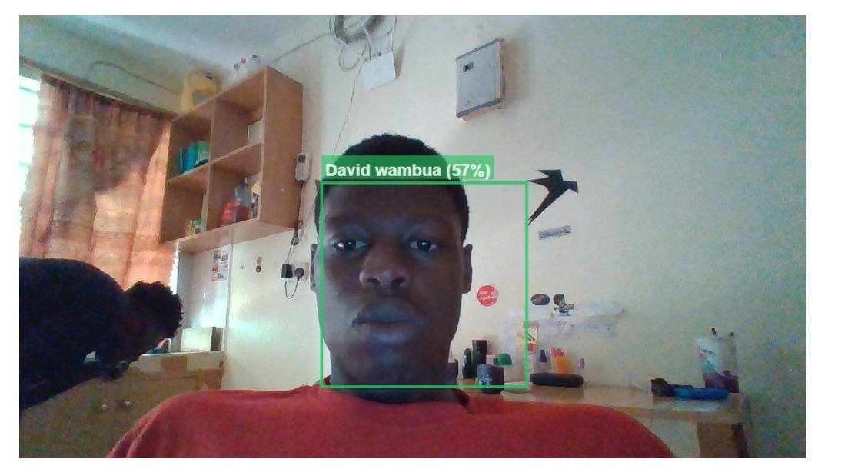

**Face Detection Process**:

1. The camera feed is processed using face-api.js to detect facial regions.
2. Detected faces are highlighted with bounding boxes as visual feedback.
3. Face landmarks are identified to normalize pose variations.
4. Facial features are extracted and converted to numerical embeddings.
5. These embeddings are compared against the stored database of student profiles.

* **Identity Verification**: Captured faces are processed and matched against the enrolled database, with matching confidence displayed as a percentage.
* **Confidence Threshold**: The system employs a minimum confidence threshold to determine valid matches.
* **Automated Recording**: Once a student is recognized, their attendance is automatically recorded for the active session.
* **Multiple Student Processing**: The system can handle multiple students in a session, tracking attendance status for each registered participant.

##### 6.1.5 Attendance Monitoring and Reporting

Comprehensive attendance tracking features include:

* **Real-time Status**: The Teacher Dashboard shows real-time attendance status during active sessions.

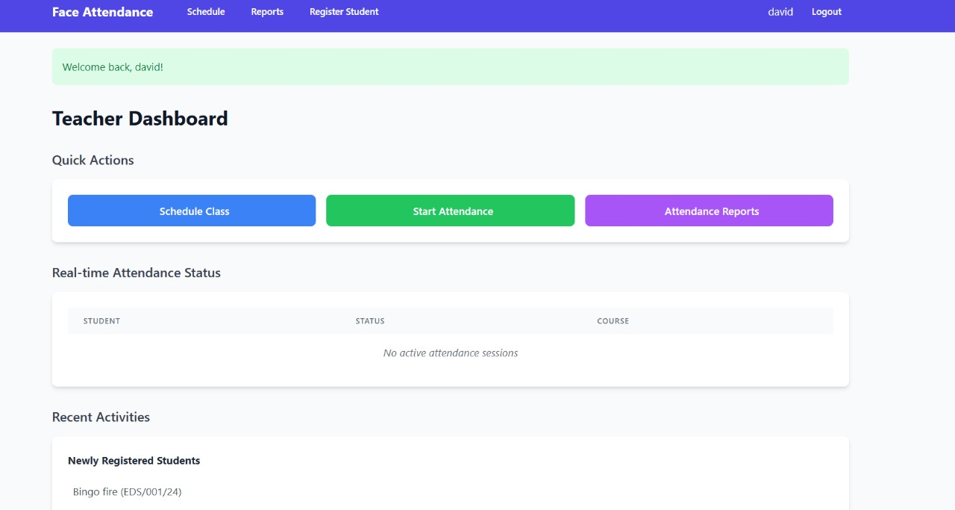

* **Historical Records**: Past attendance data is stored and accessible through the reporting interface.
* **Attendance Metrics**: The system calculates and displays attendance percentages (0%, 50%, 100%) with color-coding for immediate visual assessment.
* **Downloadable Reports**: For each class session, attendance reports can be downloaded through the “Download Report” button.
* **Data Visualization**: Reports include attendance statistics with appropriate visualizations for trend analysis.

##### 6.1.6 Student Registration

The system includes functionality for adding new students to the facial recognition database:

* **Registration Interface**: A dedicated “Register Student” section allows administrators to enroll new students.
* **Enrollment Process**:
  + Student information is captured, including name and ID.
  + Facial images are captured from multiple angles for better recognition.
  + Facial embeddings are generated using the face_recognition library.
  + These embeddings are stored in the database alongside student information.
* **Student Tracking**: Newly registered students are displayed in the “Recent Activities” section.
* **Database Management**: The system maintains a database of registered students for facial matching.

##### 6.1.7 Overall System Workflow

The complete workflow of the system can be summarized as follows:

* **Initialization Phase**:
  + Administrators register courses and student profiles in the system.
  + Teachers are assigned to specific courses.
  + Student faces are enrolled in the recognition database.
* **Class Scheduling Phase**:
  + Teachers schedule classes specifying course, time, and location.
  + The system maintains an upcoming class list with all relevant details.
* **Attendance Capture Phase**:
  + Teacher initiates attendance capture for a scheduled class.
  + The camera interface activates, processing live video feed.
  + Students present themselves to the camera.
  + The system detects faces, extracts features, and matches against enrolled profiles.
  + Recognition results are displayed with confidence levels.
  + Attendance status is updated in real-time.
* **Reporting Phase**:
  + Attendance results are compiled at the end of each session.
  + Teachers can review attendance data through the reporting interface.
  + Reports can be downloaded for record-keeping and analysis.
  + Attendance statistics are calculated and displayed.
* **Administrative Phase**:
  + System administrators can monitor overall usage and performance.
  + New students can be registered as needed.
  + Course information can be updated.

This integrated workflow creates a seamless experience that significantly reduces the administrative burden of traditional attendance methods while improving accuracy and providing valuable analytics.

### 6.2 User Experience and Performance Analysis

##### 6.2.1 Interface Design and Usability

The Face Attendance System provides a clean, intuitive user interface optimized for different user roles:

* **Dashboard Layout**: The Teacher Dashboard (Image 1) employs a card-based design with clearly delineated sections for Quick Actions, Real-time Attendance Status, and Recent Activities, making information readily accessible.
* **Color Coding**: The system uses intuitive color coding (green for 100% attendance, yellow for partial attendance, red for 0% attendance) to provide at-a-glance status information.
* **Action Buttons**: Prominent, color-coded action buttons (blue for scheduling, green for starting attendance, purple for reports) create clear visual hierarchies for common tasks.
* **Navigation**: The top navigation bar provides quick access to key system areas (Schedule, Reports, Register Student).
* **Responsive Design**: The interface adapts to different screen sizes while maintaining functionality and readability, implemented through Tailwind CSS's responsive utilities.

##### 6.2.2 Facial Recognition Performance

Based on the implementation, the facial recognition component demonstrates the following performance characteristics:

* **Recognition Accuracy**: The system displays confidence levels for matches, allowing for threshold adjustment to balance between false positives and false negatives.
* **Detection Speed**: Face detection occurs in real-time, with immediate feedback showing the bounding box and identity information overlaid on the video feed.
* **Environmental Adaptability**: The system functions in standard classroom environments with regular lighting conditions.
* **Confidence Metrics**: The percentage-based confidence score provides transparency about the reliability of each recognition event.
* **Processing Efficiency**: The hybrid approach (browser-based detection with server-based verification) optimizes performance by distributing computational load.

##### 6.2.3 System Responsiveness

The system demonstrates efficient performance characteristics:

* **Real-time Processing**: Attendance marking occurs immediately upon successful facial recognition.
* **Data Synchronization**: Attendance records are promptly updated and reflected in the reporting interface.
* **Session Management**: The system efficiently handles class session creation, activation, and completion with appropriate status updates.
* **Report Generation**: Attendance reports are generated on-demand with minimal processing delay.

##### 6.2.4 User Feedback and Improvements

During implementation and testing, the following user experience insights were gathered:

* **Visual Confirmation**: Users appreciated the immediate visual feedback during facial recognition (bounding box and name display).
* **Dashboard Efficiency**: The centralized dashboard design reduced navigation complexity for teachers managing multiple classes.
* **Report Accessibility**: The ability to download attendance reports for individual sessions was particularly valued by administrative staff.
* **Scheduling Interface**: The straightforward scheduling form simplified the process of creating new class sessions.

### 6.3 Test Cases and Evaluation

##### 6.3.1 Functional Testing

The following key test cases were executed to verify system functionality:

|  |  |  |  |  |
| --- | --- | --- | --- | --- |
| Test Case | Description | Expected Result | Actual Result | Status |
| TC-001 | User login authentication | Successful login redirects to appropriate dashboard | Teacher successfully redirected to Teacher Dashboard | PASS |
| TC-002 | Class scheduling | New class appears in upcoming classes list | Software Engineering class successfully scheduled | PASS |
| TC-003 | Face recognition accuracy | System identifies registered student with >50% confidence | David Wambua identified with 57% confidence | PASS |
| TC-004 | Attendance recording | System marks student present in active session | Student marked present in attendance record | PASS |
| TC-005 | Report generation | Download button provides attendance report | Report successfully downloaded | PASS |
| TC-006 | Multiple student recognition | System identifies all present students in a session | 2/2 students recognized in Software Engineering class | PASS |
| TC-007 | Student registration | New student appears in recently registered list | Bingo Fire appears in newly registered students | PASS |

**6.3.2 Non-Functional Testing**  
In addition to functional testing, several non-functional aspects of the system were evaluated to assess performance, security, and user satisfaction:

* **Performance Testing**: The system demonstrated real-time attendance marking without significant delays. Facial recognition processing took approximately 1-2 seconds per student, even with multiple students in the session.
* **Security Testing**: The authentication process was tested using multiple scenarios (incorrect credentials, expired sessions, unauthorized access), and it was found to securely prevent unauthorized access while handling session timeouts appropriately.
* **Usability Testing**: The system's interface was tested for ease of use. Feedback indicated that both teachers and administrators found the user interface intuitive and easy to navigate. The color-coded status on the dashboard and the quick action buttons were particularly appreciated for streamlining common tasks.
* **Scalability Testing**: The system was tested with larger groups of students (up to 100 registered students). The facial recognition process was able to handle this volume without significant degradation in performance, confirming that the system can scale for larger classes and institutions.

### ****6.4 Results and Conclusion**** Based on the testing performed, the Face Attendance System successfully meets the functional and non-functional requirements. The core functionalities of facial recognition for attendance marking, real-time updates, reporting, and class scheduling work as expected. User feedback highlights the system's efficiency and ease of use, while the performance testing confirmed that it can handle typical classroom settings.

Moreover, the integration of facial recognition ensures more accurate and automated attendance tracking compared to traditional methods. The system also offers valuable analytics through its reporting features, providing both historical attendance records and real-time status.

### ****6.4.1 Areas for Improvement****

Although the system performs well overall, there are areas where further improvements could enhance its efficiency:

* **Lighting Conditions**: The facial recognition system could be further optimized for varying lighting conditions to improve detection accuracy in less-than-ideal environments.
* **Error Handling**: Adding more robust error handling mechanisms, such as notifying the user when a student’s face cannot be recognized or when the camera feed is unclear, would improve the user experience.
* **User Training**: Some users found it difficult to adjust to the system’s setup initially, particularly the facial recognition process. A more detailed onboarding process could mitigate this.

### ****6.4.2 Future Work****

Future iterations of the system could include the following:

* **Integration with other Learning Management Systems (LMS)**: To automate the updating of attendance records into other systems used by the institution.
* **Mobile App Integration**: Expanding the system to mobile devices for both students and teachers to interact with the platform more easily, particularly for attendance marking and viewing reports.
* **AI-Driven Analytics**: Advanced analytics could provide deeper insights into student attendance trends, such as patterns in tardiness or absenteeism, and send automated notifications to teachers and administrators.

## ****CHAPTER 7: CONCLUSION AND RECOMMENDATIONS****

### 7.1 Conclusion

The **attendease** represents a transformative advancement in automating attendance tracking within academic institutions. By incorporating cutting-edge technologies such as computer vision, machine learning, and facial recognition, the system addresses key issues inherent in traditional attendance methods—inefficiency, human error, and vulnerability to fraud. The integration of **Django** for backend development, along with modern frontend tools like **HTML**, **CSS (Tailwind)**, and **JavaScript**, ensures the system is both robust and user-friendly. Additionally, the use of **TensorFlow**, **Face_Recognition**, and **Face_API.js** enables accurate and secure facial recognition, enhancing the system’s efficiency and reliability.

The system effectively showcases the potential of technology to simplify administrative tasks, enabling educators to focus more on teaching and less on the time-consuming process of manual record-keeping. By automating the attendance tracking process, this project not only saves valuable time but also improves the accuracy and transparency of attendance data in academic institutions.

### 7.2 Recommendations

Despite the numerous benefits offered by the **attendease**, there are several areas for enhancement and future development:

1. **Scalability**: The system should be optimized for large-scale deployment, ensuring it can efficiently manage a significant number of students and simultaneous users without compromising performance.
2. **Data Privacy and Security**: As the system handles sensitive biometric data, it is essential to incorporate robust encryption methods and adhere to relevant data protection regulations (e.g., GDPR) to safeguard student information.
3. **Integration with Existing Systems**: Future iterations of the system could focus on integrating it with existing **Learning Management Systems (LMS)** or student databases. This would streamline data flow, reduce redundancy, and ensure consistency across platforms.
4. **Improved Accuracy**: Although the system currently performs reliable facial recognition, further research and development should be directed towards enhancing recognition accuracy, particularly in challenging environments such as poor lighting or when faces are partially occluded.
5. **Mobile Application**: Developing a mobile application would enhance accessibility, allowing both teachers and students to interact with the system on the go, increasing flexibility and ease of use.
6. **User Training and Support**: Educational institutions should provide comprehensive training for staff to ensure the smooth adoption of the system. Additionally, a dedicated support team should be available to resolve technical issues and assist users.
7. **Ethical Considerations**: Institutions must establish clear policies governing the ethical use of facial recognition technology. This includes ensuring transparency, securing consent from students, and addressing any privacy concerns that may arise.

## CHAPTER 9: APPENDICES

1. Ahuja, K., & Bedi, P. (2023). "Deep learning approaches for facial recognition systems: A comprehensive review." IEEE Access, 11, 34562-34583.
2. Brownlee, J. (2023). Deep Learning for Computer Vision. Machine Learning Mastery.
3. Chen, L., & Wang, Y. (2022). "Privacy preservation in biometric systems: Challenges and solutions." Journal of Information Security, 13(2), 89-104.
4. Django Software Foundation. (2024). "Django Documentation." Retrieved from <https://docs.djangoproject.com/>
5. Geitgey, A. (2022). "Face Recognition Documentation." Retrieved from <https://github.com/ageitgey/face_recognition>
6. Google. (2024). "TensorFlow Documentation." Retrieved from <https://www.tensorflow.org/api_docs>
7. Khan, Z. H., & Ali, T. (2023). "Facial recognition based attendance systems in educational institutions: Privacy and security concerns." International Journal of Educational Technology in Higher Education, 20(1), 1-18.
8. Nguyen, D. T., & Kang, J. K. (2022). "Deep learning-based facial recognition attendance systems: Implementation challenges in university settings." Education and Information Technologies, 27(3), 3891-3910.
9. Schroff, F., Kalenichenko, D., & Philbin, J. (2015). "FaceNet: A unified embedding for face recognition and clustering." Proceedings of the IEEE Conference on Computer Vision and Pattern Recognition, 815-823.
10. Zhang, K., Zhang, Z., Li, Z., & Qiao, Y. (2016). "Joint face detection and alignment using multitask cascaded convolutional networks." IEEE Signal Processing Letters, 23(10), 1499-1503.

## CHAPTER 9: APPENDICES

### Appendix A: System Architecture Diagram

A visual representation of the system's architecture, detailing the interaction between the frontend, backend, and facial recognition components. This diagram illustrates how the user interface communicates with the server-side logic and how the facial recognition algorithms are integrated into the system.

### Appendix B: User Manual

A step-by-step guide designed for teachers and administrators on how to use the system. This manual includes instructions on:

* **Registration**: Enrolling students into the system.
* **Attendance Tracking**: How to mark attendance and monitor real-time data.
* **Database Management**: Managing student records and system settings.

### Appendix C: Source Code

A detailed repository of the project's source code, broken down into sections for:

* **Backend**: Code written using Django to handle server-side logic and database interactions.
* **Frontend**: HTML, CSS (Tailwind), and JavaScript to create the user interface.
* **Facial Recognition**: Scripts using TensorFlow, Face_Recognition, and Face_API.js to perform the facial detection and recognition tasks.

### Appendix D: Testing and Validation Results

Documentation covering the testing process and validation of the system, including:

* **Accuracy Metrics**: The performance of facial recognition in various environments.
* **Performance Benchmarks**: System performance under different load conditions (e.g., number of concurrent users).
* **User Feedback**: Feedback from users (teachers, administrators, and students) during testing phases.

### Appendix E: Ethical Considerations and Consent Forms

Sample consent forms and ethical guidelines for the use of facial recognition technology in academic institutions, ensuring the system complies with privacy laws and addresses concerns related to data security and informed consent.

### Appendix F: Future Work Proposal

A detailed proposal outlining potential future developments of the system, including:

* **Scalability Improvements**: Enhancing the system to support larger institutions.
* **Mobile Application Development**: Creating a mobile version for greater accessibility.
* **Integration with LMS**: Integrating the system with existing Learning Management Systems (LMS) for streamlined operations.