Getting Started with the REST API
Learn how to use the GitHub REST API

About the GitHub REST API
- Quickstart for GitHub REST API
- REST reference documentation
- About GitHub's APIs

Making a Request
- Install and import octokit in order to use the Octokit.js library used in the JavaScript examples.
  - Octokit.js README
- To make a request using JavaScript, you can use Octokit.js. For more information, see "Scripting with the REST API and JavaScript" (Write a Script using the Octokit.js SDK to interact with the REST API)

// Create an instance of Octokit.
const octokit = new Octokit({})

// use the request method to make re quests. Pass HTTP method and path as the first argument:
await octokit.request("GET /octocat", {});

Path Parameters
When you make a request with Octokit.js, all parameters, including path parameters, are passed in an object as the second argument to the request method.
For example, to get issues from the octocat/Spoon-Knife repository, specify owner as octocat, and repo as Spoon-Knife.
await octokit.request("GET /repos/{owner}/{repo}/issues", {
owner: "octocat",
repo: "Spoon-Knife"
});

- "Using the response" section

Using query parameters
- Control what data is returned for a request.
  - A query parameter may let you specify how many items are returned when the response is paginated.
- per_page, sort, direction
- When you make a request with Octokit.js, all parameters, including query parameters, are passed in an object as the second argument to the request method.
await octokit.request("GET /repos/{owner}/{repo}/issues", {
owner: "octocat",
repo: "Spoon-Knife",
per_page: 2,
sort: "updated",
direction: "asc",
})

Using the response
- Headers that start with X- or x- are custom to GitHub.
  - x-ratelimit-remaining tells you how many requests you can make in a time period.
try {
const result = await octokit.request("GET /repos/{owner}/{repo}/issues", {
owner: "octocat",
repo: "Spoon-Knife",
per_page: 2,
});

console.log(`Success! Status: ${result.status}. Rate limit remaining: ${result.headers["x-ratelimit- remaining"]}`)

} catch (error) {
console.log(`Error! Status: ${error.status}. Rate limit remaining: ${error.headers["x-ratelimit- remaining"]}. Message: ${error.response.data.message}`)
}

About the response body
- The response body is typically in JSON format.
- Unlike GraphQL API where you specify what information you want, the REST API typically returns more information than needed.
You can parse the response to pull out specific pieces of information.
// Example to get the title and author ID of each issue:

try {
const result = await octokit.request("GET /repos/{owner}/{repo}/issues", {
owner: "octocat",
repo: "Spoon-Knife",
per_page: 2,
});

const titleAndAuthor = result.data.map(issue => {title: issue.title, authorID: issue.user.id});

console.log(titleAndAuthor);

} catch (error) {
console.log(`Error! Status: ${error.status}. Message: ${error.response.data.message}`);
}

Next Steps
- REST reference documentation.

Summary from Personal Experience
- Siddhant Varma (12 May 2022), GitHub Search API: An Introduction With Examples, https://stateful.com/blog/github-search-api
- https://docs.github.com/en/rest/search/search?apiVersion=2022-11-28#constructing-a-search-query
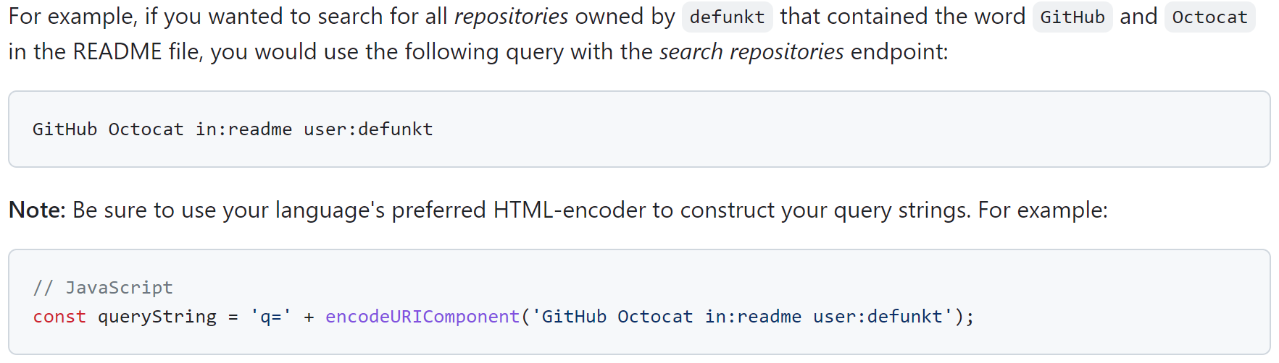
You cannot use queries that:
  - are longer than 256 characters (not including operators or qualifiers).
  - Have more than five AND, OR, or NOT operators.
- https://docs.github.com/en/rest/search/search?apiVersion=2022-11-28#search-users
  - For example, if you're looking for a list of popular users, you might try this query:
q=tom+repos:%3E42+followers:%3E1000
Results are restricted to users with more than 42 repositories, and over 1,000 followers.
  - Parameters for "Search Users":
    - accept
application/vnd.github+json
    - q the query string
    - sort
followers repositories joined
    - order
desc asc
    - per_page
default of 30. max of 100.
- https://docs.github.com/en/search-github/searching-on-github/searching-users#search-by-account-name-full-name-or-public-email
  - 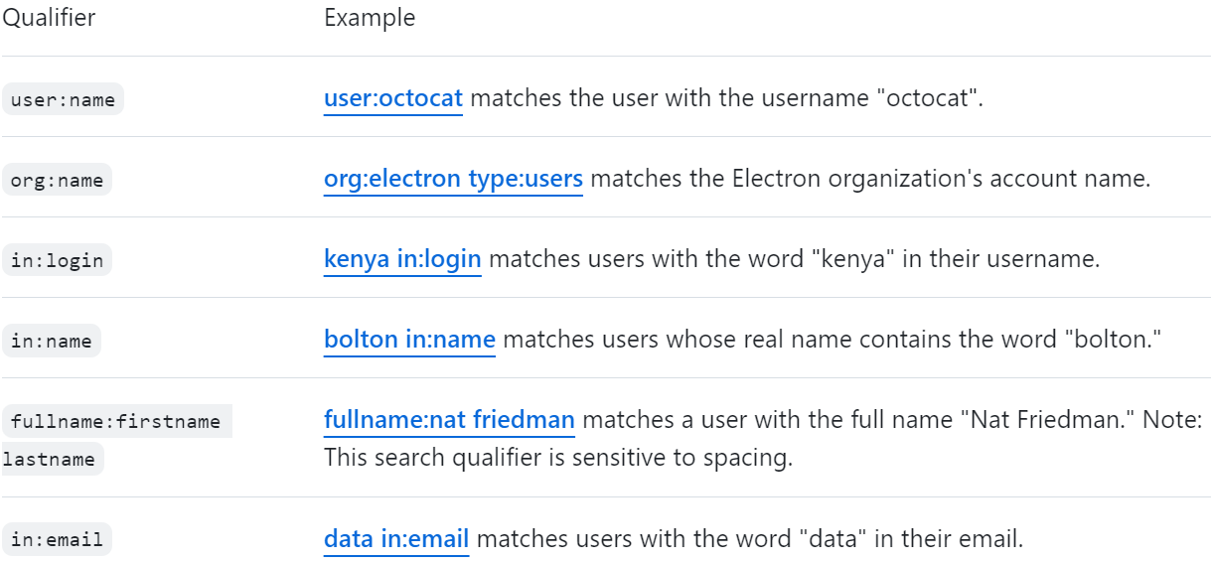
- https://github.com/layne74/Vcs-react-app/blob/main/vcs-app-proxy-server.js
Headers:
- "Accept" : "application/vnd.github+json"
- "X-GitHub-Api-Version" : "2022-11-28"
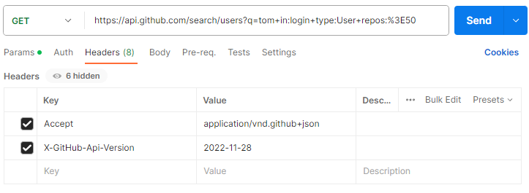
// The Code Snippet for JavaScript Fetch (from PostMan):
var myHeaders = new Headers();
myHeaders.append("Accept", "application/vnd.github+json");
myHeaders.append("X-GitHub-Api-Version", "2022-11-28");

var requestOptions = {
method: 'GET',
headers: myHeaders,
redirect: 'follow'
};

fetch("https://api.github.com/search/users?q=tom+in:login+type:User+repos:%3E50", requestOptions)
.then(response => response.text())
.then(result => console.log(result))
.catch(error => console.log('error', error));

// The code for NodeJS Axios (from PostMan):
const axios = require('axios');

let config = {
method: 'get',
maxBodyLength: Infinity,
url: 'https://api.github.com/search/users?q=tom+in:login+type:User+repos:%3E50',
headers: {
'Accept': 'application/vnd.github+json',
'X-GitHub-Api-Version': '2022-11-28'
}
};

axios.request(config)
.then((response) => {
console.log(JSON.stringify(response.data));
})
.catch((error) => {
console.log(error);
});
// The API Endpoints according to https://api.github.com:
{
current_user_url: "https://api.github.com/user",
current_user_authorizations_html_url: "https://github.com/settings/connections/applications{/client_id}",
authorizations_url: "https://api.github.com/authorizations",
code_search_url: "https://api.github.com/search/code?q={query}{&page,per_page,sort,order}",
commit_search_url: "https://api.github.com/search/commits?q={query}{&page,per_page,sort,order}",
emails_url: "https://api.github.com/user/emails",
emojis_url: "https://api.github.com/emojis",
events_url: "https://api.github.com/events",
feeds_url: "https://api.github.com/feeds",
followers_url: "https://api.github.com/user/followers",
following_url: "https://api.github.com/user/following{/target}",
gists_url: "https://api.github.com/gists{/gist_id}",
hub_url: "https://api.github.com/hub",
issue_search_url: "https://api.github.com/search/issues?q={query}{&page,per_page,sort,order}",
issues_url: "https://api.github.com/issues",
keys_url: "https://api.github.com/user/keys",
label_search_url: "https://api.github.com/search/labels?q={query}&repository_id={repository_id}{&page,per_page}",
notifications_url: "https://api.github.com/notifications",
organization_url: "https://api.github.com/orgs/{org}",
organization_repositories_url: "https://api.github.com/orgs/{org}/repos{?type,page,per_page,sort}",
organization_teams_url: "https://api.github.com/orgs/{org}/teams",
public_gists_url: "https://api.github.com/gists/public",
rate_limit_url: "https://api.github.com/rate_limit",
repository_url: "https://api.github.com/repos/{owner}/{repo}",
repository_search_url: "https://api.github.com/search/repositories?q={query}{&page,per_page,sort,order}",
current_user_repositories_url: "https://api.github.com/user/repos{?type,page,per_page,sort}",
starred_url: "https://api.github.com/user/starred{/owner}{/repo}",
starred_gists_url: "https://api.github.com/gists/starred",
topic_search_url: "https://api.github.com/search/topics?q={query}{&page,per_page}",
user_url: "https://api.github.com/users/{user}",
user_organizations_url: "https://api.github.com/user/orgs",
user_repositories_url: "https://api.github.com/users/{user}/repos{?type,page,per_page,sort}",
user_search_url: "https://api.github.com/search/users?q={query}{&page,per_page,sort,order}"
}

YouTube Tutorials:
Build GitHub Search User App Using ReactJS | Use GitHub API to build Search User with React pt. 1.
- Tadnology
- 13 April 2022
Use GitHub API to Build Search User App with React Part 2
- Tadnology
- 22 April 2022

- assets folder:
Place for static images.
- react-router-dom:
We need our app to navigate from the Home Page to the User Profile Page.
  - <BrowserRouter> Manipulate the URL in the Browser.
- In this project, we are going to focus on:
  - user_search_url
  - user_repositories_url
  - user_url

I must Investigate:
https://api.github.com/users/HenriBranken/repos
- https://api.github.com/repos/HenriBranken/AboutHenri
Creation Date: data.created_at
  - https://api.github.com/repos/HenriBranken/AboutHenri/commits
Last Commit Date: data[0].commit.author.date E.g. "2023-03-15T15:08:00Z"
Last 5 Commits' Description: data[index].commit.message E.g. "Updated the profile..."
  - https://api.github.com/repos/HenriBranken/AboutHenri/git/commits

