
An Explainable Case-Based Reasoning System for AICS
Assistance Decision Support in Davao City
A Thesis Presented to the
Faculty of the
Computer Studies Cluster
Ateneo de Davao University
In Partial Fulfillment
of the Requirements for the Degree
Bachelor of Science in Computer Science
By
Henri James Dillo
Alexzander Rojan Payot
Rygan Carl Rocamora
ATENEO DE DAVAO UNIVERSITY
SCHOOL OF ARTS AND SCIENCES
COMPUTER STUDIES CLUSTER
November 2026

Chapter 1: Introduction
1.1 Background of the Study
Social protection programs play an important role in reducing poverty and supporting vulnerable individuals in the Philippines, particularly those facing financial difficulties, disasters, and other crises. The Department of Social Welfare and Development (DSWD) implements several assistance programs, including the Assistance to Individuals in Crisis Situation (AICS), which serves individuals and families facing crisis situations as determined by the assessment of social workers (DSWD, 2024). Its schedule of assistance covers six types: transportation, medical, burial, educational, food, and cash assistance (Department of Social Welfare and Development Policy Development and Planning Bureau [DSWD PDPB], 2022, pp. 16–17). In recent years, demand for AICS services has increased significantly. According to the Philippine News Agency (2025), more than six million Filipinos received assistance from January to November 2024, and the number rose to more than 8.2 million over the same months of 2025 (Philippine News Agency, 2026). These figures highlight the growing reliance on government support during crises.
In Davao City, AICS is delivered by the Crisis Intervention Section (CIS) of DSWD Field Office XI, which serves about 250 clients a day on average (DSWD PDPB, 2022, p. 39). In the crisis intervention offices covered by the Department's 2022 process evaluation, clients are generally served by queuing number under a daily quota, with priority lanes for persons with disabilities, senior citizens, and pregnant clients (DSWD PDPB, 2022). At Field Office XI, clients do not fill out the General Intake Sheet (GIS) themselves; CIS staff complete it for them, and the client is only asked to check the details before signing. Program staff explained that this practice was adopted after an earlier incident in which fixers or scammers tried to sell the GIS to clients (DSWD PDPB, 2022, p. 39). The social worker then interviews and assesses the client. This assessment, together with the documents the client presents, is the main basis for the amount of assistance that the social worker recommends (DSWD PDPB, 2022, p. 51). The central decision in each case is therefore not the order in which clients are served, but whether the client is eligible and how much assistance the client should receive.
The AICS guidelines set a minimum and a maximum amount for each type of assistance. Under the schedule in force at the time of the Department's 2022 process evaluation, burial assistance ranged from ₱5,000 to ₱25,000, while cash assistance for other needs ranged from ₱1,000 to ₱10,000 (DSWD PDPB, 2022, pp. 16–17, 26). That schedule also allowed a social worker to recommend more than the maximum if the case was justified in a Social Case Study Report (DSWD PDPB, 2022, p. 17). In that schedule, the widest range belonged to the most common type of assistance. In the evaluation's survey, 363 of the 473 respondents (76.74%) had received medical assistance (DSWD PDPB, 2022, p. 30), and for hospital bills and other medical expenses the range ran from ₱1,000 to ₱150,000 (DSWD PDPB, 2022, p. 16). The guidelines have since been amended, but their structure has not changed: each type of assistance still has a minimum and a maximum. The range is not where the amount starts, however. The schedule ties the amount to the documented cost of the need, and for out-patient medicines and laboratory procedures it gives no peso minimum at all, only “Actual amount/cost” (DSWD PDPB, 2022, p. 17). Release also depends on the funds the office has left, since both outright cash and guarantee letters are released “depending on the availability of funds” (DSWD PDPB, 2022, p. 17), and the evaluation found that “the amount of assistance received by the respondents differs depending on the form of assistance and availability of funds in the region” (DSWD PDPB, 2022, p. 40). The form matters in Davao City in particular. Region XI was the only region in the evaluation where guarantee letters outnumbered cash, 73 to 29, and its clients received an average of ₱18,449.30 by guarantee letter against ₱5,218.14 in cash (DSWD PDPB, 2022, p. 40). The documented cost therefore sets the upper bound of an amount, and the guidelines set the cap. What no document determines is how much of the remaining need DSWD covers, after what other sources have already paid, given the household's circumstances and the funds available. The Department's own process evaluation explains that “because there is no standard amount of assistance for different types of AICS, the professional skills of social workers come in during this step” (DSWD PDPB, 2022, p. 51). The same evaluation found that the amount also depended on the time of year and the funds available, with smaller amounts given at the start of the year than toward the end, and that repeat clients noticed the amounts they received were not consistent (DSWD PDPB, 2022, p. 51). It concluded that “information on how the amount is objectively determined is lacking, resulting into varying expectations from the clients” (DSWD PDPB, 2022, p. 52).
The Department's first recommendation in the same report is to base the amount of assistance on the actual needs of the client, formulated “by citing specific criteria or concrete indicators of their vulnerability” (DSWD PDPB, 2022, p. 70). The gap addressed by this study is therefore not one proposed by the researchers; it is documented by DSWD itself. It was also confirmed locally. During a presentation of this study to the Crisis Intervention Section of DSWD Field Office XI on 23 September 2026, staff explained that social workers usually do not follow the amount asked for by the applicant. The amount granted is a separate judgment made by the social worker. An officer of the Regional Information and Communications Technology Management Service who reviewed the study's case sheets on 13 October 2026 described how that judgment is bounded. It starts from the documented cost of the need, less what PhilHealth, the local government, or a health maintenance organization has already paid, stays within the cap for that type of assistance, and is limited by what remains of the office's monthly fund allocation. The officer also noted that the decision includes the form of assistance, not only a peso figure.
Several computational methods have been used to support decisions in social welfare, particularly in identifying and targeting vulnerable individuals. Machine learning models have been used to target humanitarian aid (Aiken et al., 2022) and to predict household poverty in the Philippines (Onsay & Baltar, 2026). These approaches, however, produce a score or a predicted label, and the reasoning behind the result is not always visible to the people who must act on it. A study of social workers using an algorithmic decision support tool in child welfare found that their reliance on the tool was shaped by contextual information the model did not capture and by their beliefs about what the tool could and could not do compared with their own judgment (Kawakami, Sivaraman, Cheng, et al., 2022). More broadly, as public bodies adopt algorithmic systems in delivering public services, these systems raise serious questions of accountability (Busuioc, 2021). The AICS setting adds a further problem. A model trained to predict the amount would learn from past amounts, but because there is no standard amount, those past amounts are themselves judgments, not correct answers. A predicted figure would present past judgment as if it were a rule, while hiding the cases it came from.
Case-based reasoning (CBR) offers a different approach. Instead of learning a rule, a CBR system solves a new problem by drawing on the experience of similar past problems, and it has been used to support decisions in settings where general guidelines do not transfer well to individual cases (Granviken et al., 2024). This fits situations where there are no written rules but many recorded past decisions, which is the situation of the AICS amount. A CBR system can also be read directly, because the retrieved cases are the output itself rather than a score needing a separate account, an approach known as explanation by example (Kenny & Keane, 2021). Whether examples actually help the person reading them is a separate question, and Section 2.2 returns to it. A social worker assessing a new applicant can see the past clients most like the current one and what each received, and can judge whether those cases are truly comparable.
This study therefore develops an explainable case-based reasoning system for AICS in Davao City. Given a new applicant's intake information, the system retrieves the most similar cases from a base of past assistance records and shows what each received. It does not decide, rank, or recommend an amount; the social worker keeps full authority over the decision. This approach only makes sense if similar past cases actually received different amounts, and that cannot be checked here. DSWD does not publish how much amounts vary within a type, and the records used in this study are generated, with amounts set by a written rule that the researchers defined. The study therefore tests whether retrieval recovers a pattern in generated data, not whether it reproduces actual AICS decisions.
1.2 Statement of the Problem
The AICS guidelines of DSWD set a minimum and a maximum amount for each type of assistance, and state only that the amount should be based on the actual or augmentation need and the documents presented, considering the available funds of the program (DSWD, 2022a, p. 16). They give no method for deciding how much of that need DSWD covers once the documented cost and the cap are known. At DSWD Field Office XI in Davao City, this is left to the professional assessment of the social worker. The gap is widest where decisions are most frequent: medical assistance is the most common type, and under the schedule in force at the time of the Department's 2022 evaluation, its range for hospital bills ran from ₱1,000 to ₱150,000 (DSWD PDPB, 2022, p. 16). The Department's own evaluation found that the basis of the amount is not clear to clients, and it recommended that the amount be set using specific criteria or concrete indicators of vulnerability (DSWD PDPB, 2022). Every past decision is recorded in the intake and release records, yet a social worker assessing a new case has no organized way to see how similar past cases were settled. Existing computational approaches in social welfare mostly produce a score or a prediction, which hides the reasoning and treats past judgments as if they were rules. At the same time, it is not yet known how much the amounts in Davao City actually vary among applicants whose recorded circumstances are alike. To address these gaps, this research seeks to answer the following questions:
- When a relationship between the intake fields and the share of the documented cost that the assistance covers, or the amount itself where there is no documented cost, is present in the case base, how closely do the retrieved cases match the amount of a held-out case, for each type of assistance, and how does that change as the strength of the relationship falls to none?
- Does the weight search recover the fields that carry that relationship, and does it retrieve closer matches than equal weights on the same held-out cases?
1.3 Objectives of the Study
The main objective of this research is to develop an Explainable Case-Based Reasoning System for AICS Assistance Decision Support in Davao City that retrieves the past cases most similar to a new applicant and shows what each received, in order to support the social workers of DSWD Field Office XI in deciding the amount of assistance. The study also seeks to accomplish the following measurable objectives:
- To determine the retrieval error of the system through leave-one-out evaluation for each type of assistance and at each of the four strengths of the relationship described in Section 1.5, measured in pesos as the difference between the amount the retrieved cases indicate for the held-out case and its actual recorded amount, as defined in Section 3.2.2, and to measure the same error on the forty test cases, where it must improve on a baseline that assigns the typical share or amount for that purpose of assistance to every case by the margin set out in Section 1.5.
- To determine whether learned weights reduce the retrieval error compared with equal weights, using a paired statistical test, the Wilcoxon signed-rank test, on the same held-out cases, reporting the difference in pesos alongside the test so that a difference too small to matter in practice is not presented as a result, and reporting whether the search recovered the fields that carry the planted relationship.
1.4 Significance of the Study
The study contributes to Explainable Artificial Intelligence (XAI) and Decision Support Systems by applying explanation by example to a public welfare setting. Instead of scoring applicants and explaining the score afterward, the system shows whole past cases that a social worker can check against their own experience. It also writes down a complete set of rules for comparing welfare intake records that mix numbers, tick boxes and categories, covering how shared absences, missing fields and money fields are handled, and it tests those rules for the ways an evaluation of this kind can leak. Whether weights learned from data beat equal weights is examined on a case base built with a known structure, so the result shows whether the weight search finds that structure rather than settling the question for real records. Because the amounts follow a written rule, the study knows exactly which fields carry the pattern, so it can check directly whether retrieval and the weight search find them.
The study responds directly to the Department's own recommendation that the amount of assistance be based on specific criteria or concrete indicators of vulnerability, and to its finding that the basis of the amount is not clear to clients (DSWD PDPB, 2022). The study does not set a standard amount, which remains a policy decision of DSWD. However, it offers a way to see how amounts have been settled for similar cases, which could inform the Department if it develops such criteria.
In terms of stakeholders, the Crisis Intervention Section of DSWD Field Office XI stands to benefit from a method that, applied to its own records, would bring its past decisions to the point of assessment. Social workers will be able to compare a new case with similar past cases, which supports consistency and gives them concrete examples to refer to when explaining an amount to a client. Applicants in Davao City could benefit from amount decisions that are more consistent and easier to explain, once the method has been tested on real records, addressing the varying expectations that the Department's evaluation found among clients. Future researchers may use this study as a reference for applying case-based reasoning to government records. The researchers have also committed to return to the Crisis Intervention Section to share the findings with the office that took part in the study.
Furthermore, this research aligns with the United Nations Sustainable Development Goals (SDGs). It supports Goal 1 (No Poverty) by supporting the delivery of social protection to people in crisis. It contributes to Goal 10 (Reduced Inequalities) by making it easier to check whether similar cases are treated alike. Finally, it supports Goal 16 (Peace, Justice, and Strong Institutions) by making the basis of assistance decisions more visible, which encourages transparent and accountable decision-making within public institutions.
1.5 Scope and Limitations
The scope of this study centers on the design, development, and evaluation of an explainable case-based reasoning system for the AICS program of DSWD Field Office XI in Davao City. The study uses a constructed dataset rather than live client records. It is built in two parts. The case base is a set of records generated from the structure of the General Intake Sheet, covering the structured fields of Sections I to VIII and the record of assistance provided, namely the type, purpose, amount, and fund source. A further forty cases, printed as case sheets and reviewed by DSWD staff, are held out of the case base as test cases. No amount in either part was set by a social worker. Every amount comes from a written rule defined by the researchers and described in Section 3.2.1. The rule starts from the share of the documented cost that DSWD's own published Region XI figures show was covered for each purpose of assistance (DSWD PDPB, 2022, pp. 41–42), moves that share up or down according to the household's recorded circumstances, and adds random noise. The starting shares are published figures. How the household moves the share, and how much noise is added, are the researchers' own choices. The study therefore tests whether retrieval recovers a pattern in generated data, not whether it reproduces actual AICS decisions. The documented costs are generated from ranges the researchers set for each type and purpose to resemble real costs, and are checked against figures DSWD has already published, as the next paragraph sets out. The finished dataset will be submitted to DSWD for review, and the study will report what their written reply says rather than assuming what it will contain. The number of cases of each type is set deliberately rather than following the mix DSWD reports, so that every type holds enough cases for retrieval to mean anything, and both the generated mix and the reported mix are given with the results. No client record, de-identified or otherwise, is used at any point.
The checks against published figures work as follows. Tables 29 and 31 to 34 of the Department's 2022 process evaluation give the average cost of the need and the average amount received side by side (DSWD PDPB, 2022, pp. 41–42). For medical assistance the evaluation also states the amount received as a proportion of the cost of the need, from 72% for medicines to 19.2% for dialysis and chemotherapy across all regions (DSWD PDPB, 2022, p. 41), which supports setting the amount as a share of the cost rather than as a peso figure. Two checks follow from these tables, and both are fixed before any data are generated. The first is on the costs, which the researchers generate. If the average generated cost for a type, or for a purpose within medical assistance, differs from the published average cost by more than twenty per cent of the published figure, the cost range for it is adjusted once, and the study says so. The second is on the shares. The rule starts each share from the published Region XI figure for its purpose: 20.7% for hospital bills, 80.5% for medicines, 29.0% for burial, and 61.1% for educational assistance, measured against tuition (DSWD PDPB, 2022, pp. 41–42). Agreement with the published shares is therefore expected by construction, and it is not evidence that the generated amounts are realistic. The generated share for each type and purpose is still computed in the same way as the published one, as the average amount received divided by the average cost, and compared with it, as a check that the household adjustment and the noise have not moved the average away from where the rule started. The shares are never adjusted after the data are generated. For food assistance and cash relief, which are generated without a documented cost, the rule starts from the published Region XI average amounts received, ₱3,857.14 and ₱4,400.00 (DSWD PDPB, 2022, p. 42), and the generated averages are compared with them in the same way. The published figures do not cover every purpose. Transportation has no Region XI row. Its only figure is the overall row of Table 34, which comes from Central Office and National Capital Region respondents alone. Assistive devices have no Region XI row in Table 30, which also prints no cost. For these two purposes the rule uses an assumption of the researchers, stated in Section 3.2.1, and neither can be checked. The published costs are also the costs that survey respondents reported, which may include what other payers met, so applying a published share to the balance still owed, and comparing the two, is approximate. The generated and the published figures are reported side by side in Chapter 4.
A research request for an extract of closed AICS records was filed and approved as DRN XI-FO-PPD-PDPS-A-COMM-26-08-28354-S. The data sharing agreement required for its release was raised to an institutional agreement between Ateneo de Davao University and DSWD, and could not be completed within the period of this study. The alternative of a constructed dataset reviewed by DSWD was suggested by an officer of the Regional Information and Communications Technology Management Service, and was approved by the adviser and the thesis coordinator in October 2026.
The system measures similarity between cases using a distance measure that handles numeric, categorical, ordered and multi-select fields together. Two weighting schemes are compared: equal weights as the baseline, and weights learned from the data. The system is evaluated through leave-one-out testing, in which each applicant is held out in turn together with all of their assistance events, and the outcome of each held-out case is compared with the outcomes of its most similar cases. Results are reported separately for each type of assistance, since the same amount can be near the minimum for one type and near the maximum for another. The study covers only the part of the AICS process where the amount of assistance is decided.
Whether amounts actually vary among applicants whose records are alike cannot be checked in this study. The Department's 2022 process evaluation reports the average cost of the need and the average amount received in Region XI for most types of assistance, and the monthly field office reports give client counts and totals, but none of them publishes the spread of amounts inside a type. The amounts in this study's dataset are set by the researchers' rule, so any spread in them is a choice rather than a finding. The study rests on the assumption that similar cases did receive different amounts, and that assumption is stated here rather than tested. A wide spread would not by itself show inconsistency in any case, since it may reflect genuinely different needs. The forty test cases include four pairs that are the same case presented twice, identical on every field, and four near pairs that differ in one field. Under the rule, identical cases receive identical amounts by construction, so the identical pairs now only confirm that the generator behaves as specified and no longer measure anything about a person. The near pairs show what the one field that differs does to the amount under the rule. That is a check on the rule, not evidence about what moves a real decision.
Regarding limitations, this research is designed as a decision support tool. It is not intended to automate the approval or rejection of assistance, nor to compute or recommend an amount. The system only shows similar past cases and what they received, while the decision-making authority remains fully with the professional social worker.
No amount in the dataset was set by a social worker. Every amount comes from the researchers' rule, so a retrieved case illustrates that rule rather than recording a decision that was really made. The system shows precedent, not prescription, and what counts as precedent here is narrower than it would be with real records. Retrieval error measures agreement with the recorded amount, not correctness: Section 1.1 notes that amounts are judgments rather than correct answers, so a small error means the system found cases settled in a similar way, not that the amount was right. The 2022 evaluation also found that the amount depended on the time of year and the funds available (DSWD PDPB, 2022, p. 51), which real records would show but which a constructed case base cannot carry.
The requested amount is not recorded as a data field in DSWD's system, so the study cannot test whether the granted amount follows what the applicant asked for. During the 23 September 2026 presentation, staff of the Crisis Intervention Section stated that social workers usually do not follow the applicant's figure. This is staff testimony, not something the study can measure.
The findings of this study are descriptive, not causal. The case base is built on the structure of the General Intake Sheet used by DSWD Field Office XI, so the results may not apply to offices that record different fields. The system is also not tested with the social workers it is meant for. No social worker uses the prototype or rates the retrieved cases, so this study does not establish whether they would find the cases relevant or the system usable.
The most important limitation is the dataset itself. The case base is constructed, so the error figures reported in Chapter 4 measure whether the retrieval method recovers a relationship that is known to be present. They do not estimate how the method would perform on live DSWD records, and they move with how much noise is added and how varied the generated applicants are. The relationship is also the researchers' own. Its starting shares are published, but how the household moves the share is a choice the researchers made, so a good result shows that retrieval can find a pattern of this kind in intake fields, not that DSWD decides amounts this way. Running the same evaluation on an extract of real records that includes the granted amount and the structured fields of Sections I to VIII, once the data sharing agreement is completed at institutional pace, is the first recommendation of this study.
The study states in advance what would count as failure, and fixes the terms of the test before any amounts are generated, so that no choice made later can turn a failure into a pass. The test is run on the forty test cases, with amounts from the main condition of the rule, in which the household accounts for half of the spread in the share (Section 3.2.1). Five cases are retrieved from the case base for each. For a type that carries a documented cost, the shares of the cost that the five cases received are combined by taking the median, and that median share is multiplied by the test case's own documented cost. For food assistance and cash relief, which carry no documented cost, the five amounts are combined by taking the median directly. The error is the absolute difference in pesos between that figure and the test case's amount. The comparison is pooled across types, because forty cases hold too few of any single type. The four transportation cases are left out of the test and reported separately, since under the rule their amount is always the ticket cost and there is nothing for retrieval to find. The baseline is the median share of the same purpose of assistance in the case base multiplied by the same documented cost, or the median amount of that purpose for food assistance and cash relief. The baseline is set by purpose rather than by type because the published shares differ widely between purposes within one type: within medical assistance they run from 20.7% for hospital bills to 80.5% for medicines. A retrieval that did no more than match the purpose would beat a baseline set by type without finding anything about the household. Retrieval must reduce the mean absolute error by at least twenty per cent against that baseline. If it does not, the study reports that the method does not work on this data rather than presenting a smaller improvement as a success. The way the retrieved cases are combined for types that carry a documented cost was settled before any evaluation had been run, so no result influenced the choice. Elsewhere the number of retrieved cases is reported over a range, but for this test it is fixed at five in advance.
Because the spread of amounts inside each type is not published anywhere, and because requesting it from DSWD could not be completed within the period of this study, the spread in the dataset is set by the researchers. The rule is run at four strengths, in which the household accounts for none, a quarter, a half, and three quarters of the spread in the share, with the total spread held the same, and the evaluation is repeated at each, so that a reader can see how much the figures depend on that choice. The setting at one half was chosen in advance as the main condition. The setting at none is the control described in Section 3.1. Whether the spread looks right is also put to DSWD as one of the four review questions in Section 3.2.1, and is answered by their judgment rather than by a statistic.
The system does not handle actual financial transactions or the distribution of aid, nor does it connect with biometric or banking systems for identity verification. The study does not extend to post-assistance monitoring or case management.
Chapter 2: Review of Related Works
2.1 Decision Making in Social Welfare
2.1.1 Social Welfare Assistance in the Philippines
Social protection in the Philippines rests on the 1987 Constitution, which directs the State to promote a just and dynamic social order and to free the people from poverty through policies that provide adequate social services (Republic of the Philippines, 1987, art. II, sec. 9). The DSWD describes itself as the leader in social protection, and it implements the AICS program to aid individuals and families who need help with medical, burial, food, transportation, educational, and other needs (DSWD, 2022a, p. 1). Where Memorandum Circular No. 15 speaks of funeral assistance, this manuscript uses burial, the term used in the Department's process evaluation. The legal bases of the AICS guidelines include Executive Order No. 221, series of 2003, which mandates the DSWD to implement crisis intervention (DSWD, 2022a, p. 2). Besides financial assistance, the program may also give material assistance, psychosocial support, and referrals to other services (DSWD, 2022a, pp. 5–8).
The current AICS guidelines trace back to DSWD Memorandum Circular (MC) No. 15, series of 2022, which replaced MC No. 11, series of 2019 (DSWD, 2022a, p. 1). MC No. 15 defines a crisis situation as a time when a person experiences a breakdown or disruption in their usual daily activities or family functioning, which keeps them from performing their social roles and may lead them into worse life situations (DSWD, 2022a, p. 4). It defines the GIS as the form that social workers use to record the basic information of the beneficiary and the authorized representative, the problem presented, the assessment, and the recommended assistance (DSWD, 2022a, p. 4), and it requires the GIS for all clients (DSWD, 2022a, p. 9). MC No. 15 was later amended by MC No. 16, series of 2022, which became the Revised Guidelines on the Implementation of AICS (DSWD, 2022b), and DSWD's list of AICS issuances shows further circulars, including MC No. 06 and MC No. 17, series of 2023, and MC No. 04 and MC No. 30, series of 2024 (DSWD, n.d.).
Each AICS case involves three decisions. During the interview and assessment, the social worker determines whether the client is eligible, what type of assistance fits the client's actual need, and, if financial assistance is given, the amount to recommend for approval (DSWD, 2022a, p. 16). The guidelines are detailed on the first two decisions. They list the documents required for each type of assistance and set how often each type may be availed (DSWD, 2022a, pp. 9–13, 21–22). On the amount, however, they state only that it should be based on the actual or augmentation need and the documents presented, considering the available funds of the program (DSWD, 2022a, p. 16).
The amount itself is bounded by a range for each type of assistance. The process evaluation, which used MC No. 11, series of 2019, as its main reference, reported a minimum and a maximum amount for each type of assistance (DSWD PDPB, 2022, pp. 16–17, 26). The later circulars carry their own rate tables. The 2019 schedule and MC No. 15 both allowed the social worker to recommend more than the maximum when the case was justified in a Social Case Study Report or case summary (DSWD PDPB, 2022, p. 17; DSWD, 2022a, p. 23). What has not changed is the form of the rule. Both set a floor and a ceiling for each type of assistance, and MC No. 15 leaves the amount within them to the social worker's assessment of the client's actual need, the documents presented, and the available funds of the program (DSWD, 2022a, p. 16). In Davao City, AICS is delivered by the CIS of DSWD Field Office XI, which serves about 250 clients a day on average (DSWD PDPB, 2022, p. 39).
2.1.2 How Assistance Decisions Are Made
Decisions in social welfare assistance rest on judgment as well as on written rules. Written guidelines can set who may receive assistance and what documents are needed, but they may not say how the circumstances of a particular client should be weighed. Lipsky (1980/2010) described the frontline workers who apply such rules as street-level bureaucrats, who in effect make policy when the rules run out. Eiró and Lotta (2024) argue that this theory was built mainly on cases from rich countries and misses what happens in developing countries, where deep inequality changes the relationship between the worker and the citizen. Their argument is built on social assistance work in Brazil.
What frontline workers weigh is often not the case alone. In a review of 39 empirical studies of child welfare workers' decisions about neglect, Gibbs et al. (2025) found that decisions were driven less by the case itself than by the worker's situation. Heavy caseloads and stress pushed cases further down the list of cases to act on, workers set a lower bar for acting when support services were actually available, and problems that were harder to evidence received less attention. Experienced and newly qualified workers also used different thresholds. Studies of child welfare workers who use algorithmic tools also show that decisions draw on more than the record. Kawakami, Sivaraman, Cheng, et al. (2022) studied how workers at a child welfare agency make screening decisions with the help of an algorithmic decision support tool, and found that the workers' reliance on the tool was guided by their knowledge of contextual information about each case that the tool's model did not capture. In a related study, call screeners and supervisors doubted that administrative data could capture what drives a case (Kawakami, Sivaraman, Stapleton, et al., 2022, p. 464). Together, these studies suggest that both the worker's knowledge of the case and the worker's own situation shape the result.
When a decision rests on many factors and no written rule says how to combine them, part of the result depends on the judgment of the person making it, and decisions on similar cases may differ between workers or over time. Several studies have measured this directly. Bergmark and Stranz (2025) ran three vignette surveys in Sweden, in the mid-1990s, the mid-2000s, and 2018, in which 1,337 social assistance caseworkers each judged the same six invented applicant cases and said whether to grant help and how much money to give. Generosity fell over the 25 years, and the differences between caseworkers judging the identical case grew larger over time, despite national and local efforts to standardize decisions. Garcia-Gomez et al. (2025) studied about 400,000 Dutch disability insurance applications from 2006 to 2017 and found that assessors bent a supposedly rule-driven award formula in ways that favored lower-wage applicants. In their data, 46.2% of low-wage applicants near a threshold had their disability degree raised by an assessor, compared with 32.5% of high-wage applicants, and simulating a different assessor changed the outcome. Kunz et al. (2026) had forty psychiatrists independently assess 55 real disability claimants in a social security setting, giving 280 ratings in total. Agreement was poor to fair, with intraclass correlation coefficients of 0.26 to 0.46, and for claimants with identical scores on the functional limitation form, judgments of remaining work capacity ranged from 5% to 100%.
Belle et al. (2024) give a way to name this problem. In six randomized experiments with 2,647 doctors, they found that experts were swayed by framing, loss aversion, the pull of the status quo, and in-group favoritism, and that experts judging identical scenarios were widely scattered, with answers spread across the whole 0 to 100 scale. Their work separates two kinds of error in public sector decisions. Bias is when decision-makers all lean the same wrong way, while noise is when professionals disagree with each other on the same case. The findings of Bergmark and Stranz (2025), Garcia-Gomez et al. (2025), and Kunz et al. (2026) describe noise in this sense: the same case can receive a different answer depending on who decides it.
The Department's 2022 process evaluation of AICS describes this situation in the program. It observed that, because there is no single standard figure for each type of assistance, this step relies on the professional judgment of social workers (DSWD PDPB, 2022, p. 51). The same evaluation found that the amount also depended on the time of year and the funds available, with smaller amounts at the start of the year than toward the end, and that repeat clients noticed the amounts they received were not consistent (DSWD PDPB, 2022, p. 51). It concluded that “information on how the amount is objectively determined is lacking, resulting into varying expectations from the clients” (DSWD PDPB, 2022, p. 52).
The variation that DSWD reports in AICS amounts looks more like noise than bias, although it has not been measured. Several of the studies above come from Sweden and the Netherlands, and Eiró and Lotta (2024) caution that frontline theory built on rich-country cases misses what happens in developing countries, so these findings need local testing rather than direct use. The search for this review found DSWD's own documents and grey literature, but no peer-reviewed Philippine study of how AICS amounts are decided. The international literature documents discretion and variation in welfare decisions, and the Department's own evaluation reports the same symptom in AICS, but how the amount is actually chosen has not been studied.
Taken together, these sources show that the amount of assistance, a decision made in every case that receives financial assistance, is also the decision with the least written guidance. Social workers decide it through professional judgment within wide ranges, and the only record of how that judgment has been used is the set of past cases kept in the intake and release records. The problem in AICS is therefore one of making past decisions visible and comparable. Approaches to supporting decisions of this kind are reviewed in the next section.
2.2 Decision Support in Social Welfare
This section reviews four approaches to supporting decisions in social welfare: machine learning, case-based reasoning, fuzzy logic, and explanation by example. It ends with the research gaps that remain.
2.2.1 Machine Learning Approaches
Most computational work on welfare decisions has used prediction. In these studies, a model is trained on past records and then gives a score or a label for each new person. Five such studies are reviewed here.
Aiken et al. (2022) used machine learning on mobile phone data to identify the poorest people for a cash transfer program in Togo. Compared with the geographic targeting options that the government considered, the approach reduced errors of exclusion by 4% to 21%. Compared with a comprehensive social registry, which Togo does not have, it increased errors of exclusion by 9% to 35%. In other words, the score did better than a rough alternative but worse than detailed information about each household. Romeo and Frontoni (2022) proposed a hierarchical gradient boosting model that classified the COVID-19 vaccination priority of about 17,000 patients from electronic health records, and the authors report that the model was built into a clinical decision support system that was supporting general practitioners in Italy in assigning vaccination priorities. In the Philippines, Onsay and Baltar (2026) combined probit regression with machine learning to predict household poverty in the poorest region of Luzon, and found that the lack of electricity, Internet, and cell phone access was linked to higher poverty rates.
Two further studies show the same approach in targeting and its limits. Wobcke and Mariyah (2023) applied machine learning to Indonesia's proxy means test, the formula used to decide which households count as poor enough for assistance. Using data from 2016 to 2019 to predict household spending in 2020 in three districts, they found that XGBoost reduced inclusion and exclusion errors by roughly 4.5% to 13.9% compared with ridge regression. Dietrich et al. (2024) studied how prediction models decide who receives cash transfers in poorer countries, using real data from Tanzania and Malawi. They showed that when the training data carries bias, whether wrong labels or proxy-means-test weights that shift over time, the real harm to people is much larger than the usual accuracy numbers suggest, and some groups are hurt more than others. A score can therefore look accurate while hiding the harm done by errors in the data it learned from.
These studies share a common form. Each learns a link between inputs and an outcome that is treated as correct, such as measured poverty status or clinical priority, and each returns a score or a class for a new case. The output tells the user where a case falls, but not which past cases the result came from or how similar those cases were. For the AICS amount, this form also meets a deeper problem. Because there is no standard amount, past amounts are themselves judgments rather than correct answers, so a model trained to predict them would present past judgment as if it were a rule.
2.2.2 Case-Based Reasoning
CBR solves a new problem by finding a similar past problem and reusing what was done in it. The standard description of this process comes from Aamodt and Plaza (1994), who described it as a cycle of four steps: retrieve the most similar past case or cases, reuse the information in them to solve the new problem, revise the proposed solution if needed, and retain the new experience so that it can be used in the future. This formulation is still in use: a recent review by Yan and Cheng (2024) treats this four-step cycle as the basic framework of CBR research. Later work has extended it. Finnie and Sun (2003), for example, called Aamodt and Plaza's cycle the R4 model and proposed an R5 model that adds a first step, repartition, in which the case base is built by partitioning the possible world of problems and solutions. A case usually holds a description of a problem and the solution that was applied to it.
CBR belongs to a group of methods known as instance-based or lazy learning. In the classic review by Wettschereck et al. (1997), a method such as the k-nearest neighbor classifier is described as one that simply stores all past examples and puts off all work until a new case needs to be handled, at which point it compares the new case with the stored ones. This is different from methods such as gradient boosting, which fit a model to the data in advance and no longer need the individual records to make a prediction. Because a lazy method keeps the records, every result it gives can be traced back to specific past cases. That review also found that the performance of such methods depends heavily on how the distance between cases is defined, which is discussed later in this subsection.
CBR has been used most in health care. Granviken et al. (2024) developed a CBR application to support physiotherapists in managing common musculoskeletal pain disorders, a setting where treatment guidelines and systematic reviews transfer poorly to individual patients. The application draws on the experience of similar past patients to guide decisions for a new patient. An earlier assessment by Montani (2008) noted that although CBR had been proposed for medical decision support since the 1980s, its success in medicine had been limited, and “almost no research product has been fully tested and commercialized” (p. 275). A more recent scoping review suggests that this picture has not changed much. Noll et al. (2022) found that only about 24% of the clinical CBR systems they reviewed had been validated by experts, and concluded that CBR can be a useful way to support clinical decision-making but needs further research before it can be used in clinical routine.
Applications in public services are fewer. Chala et al. (2024) applied CBR to decision making in humanitarian response, where their system uses earlier emergency situations to support decisions about assistance. They proposed describing cases with an ontology, so that similarity could take into account the meaning of concepts and the relations between them, and reported a 5% improvement in classification compared with the classical representation of cases as lists of parameters.
Retrieval depends on how the distance between two cases is measured. Many case records mix two kinds of fields. Some are numbers, such as income and expenses. Others are categories, such as a type of service, a person's sector, or the tick-boxes on a form. A plain distance such as the straight-line distance works only on numbers, since categories cannot be subtracted from one another.
The standard way to compare such records comes from Gower (1971), who proposed a general coefficient of similarity for records that mix these kinds of fields. The coefficient compares two records one field at a time and then takes the average. For a numeric field, the score is one minus the absolute difference divided by the range of that field, so two equal values score one and two values at opposite ends of the range score zero. For a category, the score is one if the two records match and zero if they do not. A field that is missing in either record is left out of the average for that pair. Section 3.2.2 separates three cases that look alike on a form: a field that does not apply to the client, a question that was asked and answered no, and a value that was never recorded. Only the third is missing in this sense. Gower's coefficient as published covers numeric and categorical fields, and Section 3.2.2 adds rules for the ordered and multi-select fields that the General Intake Sheet also contains. The distance between two cases is then one minus their similarity. Each field may also be given a weight that controls how much it counts in the average. The coefficient is still widely used on mixed data. Liu et al. (2024), for example, built on it to group records from a health survey that mixed numbers and categories. They noted that the standard coefficient can be dominated by categorical fields, and their modified version, which adds feature-importance weights, performed better than the baseline methods in their simulation tests.
Gower (1971) also set a rule for yes-or-no fields. He reserved the term dichotomous for characters “that are either present or absent and whose absence in both of a pair of individuals is not taken as a match” (p. 858). A field where both records lack the feature is therefore left out of the comparison for that pair instead of being counted as a similarity. A yes-or-no field treated as an ordinary category would instead count a shared “no” as a match.
The simplest choice is to give every field the same weight. This treats each field as equally important and needs no tuning. The alternative is to learn the weights from data. In a classic review, Wettschereck et al. (1997) compared several weighting methods for nearest neighbor methods and found that methods which set weights using feedback on how well retrieval performed needed less preprocessing, handled interacting features better, and generally needed less training data than other methods. They also found that giving fields continuous weights tended to work better than simply keeping or dropping fields when some fields were useful but less important than others. Kenny and Keane (2021) showed that the weights used in retrieval change which past cases are shown as explanations, and compared several methods for setting them. Learning weights for case similarity is still an active research topic. Cheng and Yan (2023), for example, proposed a deep neural network that learns weighted similarity between cases, with the aim of making case retrieval more accurate. Granviken et al. (2024) also show how field weights can support comparison in individual professional assessments. Their weights reflect prognostic importance and treatment considerations. Learned weights are not always better, however. With small groups of cases, weights fitted to the data can follow noise.
Range scaling has one more property that matters for money. It treats a difference in pesos the same way wherever it occurs in the range. A gap from ₱3,000 to ₱6,000 counts the same as a gap from ₱60,000 to ₱63,000, even though the first is a doubling and the second is a change of 5%. For a household, the first gap may mean a very different situation, while the second may not. One way of handling this is log transformation, which replaces each value with its logarithm so that equal ratios become equal gaps. Under it, ₱3,000 to ₱6,000 counts the same as ₱60,000 to ₱120,000. It is widely used for skewed data such as income, but Feng et al. (2014) caution that it does not always reduce the spread of data and that results on transformed values may not carry over to the original values, so it must be applied carefully. It also cannot be applied directly to a value of zero. A second way, based on fuzzy sets, is discussed in Section 2.2.3.
Overall, these studies show that CBR is used where many past decisions are recorded but general rules fit individual cases poorly. They also show that most CBR work has been in health care, that evidence from public welfare is limited, and that in medicine, CBR systems are still rarely validated or used in clinical routine. Gower's coefficient offers a standard way to compare records that mix numbers and categories, and the literature on weighting and scaling shows that the choices made inside it affect which cases are retrieved.
These studies relate to AICS in different ways. Chala et al. (2024) give the closest contextual example, since their system supports decisions about assistance in response to crisis needs. Their work does not establish that the same approach works on individual government intake records, however, and their comparison uses ontological relations rather than Gower's coefficient. Granviken et al. (2024) show the need to support a professional decision when general guidance is insufficient for an individual case, but their clinical results are not evidence of effectiveness in public welfare, and their field weights show the role of field importance rather than evidence that learned weights outperform equal weights in welfare decisions. The situation of the AICS amount, where many past decisions are recorded but general rules fit individual cases poorly, matches the settings where CBR has been used. For this study, this means CBR is a reasonable way to present precedent, but whether the retrieved cases are useful must be tested with the data and with social workers rather than assumed.
In this study, a case is one AICS assistance event: the intake information recorded for an applicant together with the assistance that was provided. The intake information from the GIS is the problem description, and the type and amount of assistance given is the solution. Only the retrieve step is automated. The reuse and revise steps stay with the social worker, who decides whether the retrieved cases apply and what amount to recommend. The retain step happens as new cases are closed and added to the records. This is a narrow use of CBR, and it is chosen on purpose, since the system is meant to show precedent and not to produce an answer.
Gower's rule for yes-or-no fields matters for the AICS data, because the General Intake Sheet has several lists where every box that applies is ticked. Section III asks which crises the family experienced in the past three months and says “check all that apply”: hospitalization, death of a family member, catastrophic event, disablement, and loss of livelihood. Section IV lists the available support systems: family, relatives, friends, employer, and church or community organization. Section V lists the external resources tapped by the family: PhilHealth, health card, guarantee letter from other agencies, and the MSS, senior citizen, and person with disability (PWD) discounts. Section VII lists the vulnerability and risk factors. Section V also has its own “Not Applicable” box, so on that section a blank and a ticked “Not Applicable” are not the same thing, and preprocessing must decide how to treat each. Since each box applies to only some clients, most of them are likely to be unticked on both sides for most pairs of cases. Whether shared absences count as similarity is therefore a real design decision, and both sides can be defended. Leaving them out keeps a long list of rarely ticked boxes from making all cases look alike. Counting them treats a shared “no” as real information, which it clearly is for a field such as having no available support system. Chapter 3 will settle which rule this study uses.
For this reason, the study treats equal weights as the baseline and keeps learned weights only if they reduce retrieval error on held-out cases under the standard of evidence set out in Section 3.2.4, while the prototype shown to social workers runs on equal weights for the reason given in Section 3.1. Log transformation is likewise tested against the plain range-scaled distance, on a separately generated set rather than on the case base the results are reported from, and kept only if it reduces retrieval error there by the same standard. The weighting of fields and the scaling of money fields are therefore treated in this study as questions to test, not settings to assume.
2.2.3 Fuzzy Logic
Fuzzy logic starts from the fuzzy set theory that Zadeh (1965) introduced. In ordinary set theory, an object either belongs to a set or does not. Zadeh noted that many classes of objects met in practice have no precisely defined criteria of membership, and proposed the fuzzy set, a class in which each object has a grade of membership between zero and one, given by a membership function. This allows a quantity such as income to belong partly to a class such as low income, instead of falling on one side of a single sharp cut-off. In a review of fuzzy logic in decision support, Wu and Xu (2021) organized the field into five parts: the basics of fuzzy logic systems, evaluation and prediction methods, decision support algorithms, group decision making, and applications. They concluded that fuzzy logic is suited to intelligent decision making when information is uncertain or expressed in words rather than precise numbers.
The same idea has been applied to welfare. Handastya and Betti (2023) argued that splitting people into poor and not poor with a single cut-off throws away information, because deprivation is a matter of degree. Their “double fuzzy set” approach lets a household belong to a poverty dimension partially, and lets one indicator count toward more than one dimension, and they applied it to Tunisian household consumption data from 2015. Sanjaya et al. (2025) applied the fuzzy-TOPSIS method to decide which households in Sumur Bandung district, Indonesia, should receive social assistance, using eligibility criteria and real applicant data from April 2024. They reported more objective and consistent selections than the manual method it replaced.
Fuzzy membership can also be used to compare two values. Instead of scaling a difference in a straight line, as range scaling does, a membership function sets how similar two values are for any size of difference. This allows similarity to fall off in any chosen shape, but someone must choose that shape and its break points. Kusumadewi et al. (2024) did this inside a CBR system. They replaced the ordinary similarity calculation with a fuzzy one built on Graded Mean Integration Representation, so that each attribute contributes by degree rather than by a hard number, and checked it against expert judgment using the Intuitionistic Fuzzy Weighted Arithmetic Mean. Across 15 test scenarios, the expert-agreement check reached 93.33% accuracy, and the fuzzy method returned fewer but tighter sets of similar cases than the standard additive method at thresholds from 0.2 to 0.8. Zheng et al. (2025) also used fuzzy sets to select past cases, in public health treatment. They extended case information into probabilistic hesitant fuzzy sets with uncertainty, used interval evidential reasoning to assess similarity, and then selected the most appropriate historical cases to generate treatment recommendations. Their model was validated on a COVID-19 therapy case study.
These studies relate to the present study in different ways. Kusumadewi et al. (2024) are the closest on the method side, since they place fuzzy membership inside the similarity function of a CBR system and compare it with the plain additive approach. Handastya and Betti (2023) are the closest on the money side, since they treat deprivation as a matter of degree rather than a cut-off. Sanjaya et al. (2025) show a fuzzy method in use in a local social assistance program in Southeast Asia, a setting close to AICS. No paper found for this review applies fuzzy membership to money fields inside Gower's coefficient, which is the specific option this study considers. In this study, fuzzy membership is the second option considered for scaling money fields, alongside the log transformation described in Section 2.2.2. The study does not commit to either method. Both will be tested against the plain range-scaled distance on a separately generated set, and a method will be kept only if it reduces retrieval error there under the standard of evidence set out in Section 3.2.4.
2.2.4 Explanation by Example
XAI studies how the results of AI systems can be understood by the people who use them. One common approach explains a model after it has produced a score, for example by showing which features pushed the score up or down. Rudin (2019) made an influential argument that for high-stakes decisions, such after-the-fact explanations of black-box models can be misleading, since the explanation is a separate approximation of what the model does, and recommended using models that can be understood as they are. Case-based explanation takes a different path. Schoenborn et al. (2021) noted that experts often rely on their stored experience when making decisions, yet most XAI methods cannot explain a result through specific past experiences because they do not keep them. Explainable CBR can, since the cases are kept and can be shown.
This approach is known as explanation by example. Kenny and Keane (2021) studied it in systems where a black-box model is paired with a case-based reasoner, so that a result can be explained by showing the most similar past cases, and they compared methods for weighting features when finding those cases. User studies of this approach give a mixed picture. Kenny et al. (2021) found that explanations by example made people judge a system's wrong answers as less incorrect, but did not raise their trust, and that trust fell as error rates increased from 3% upward. This means similar-looking cases can make a wrong result seem more reasonable than it is.
An early framework by Sørmo et al. (2005) argued that what counts as a good explanation in a CBR system depends on the goals of its users and designers, and proposed that these goals be taken into account when deciding how a system should explain itself. The user goals described by Sørmo et al. (2005) have a direct welfare counterpart in the design study of Kawakami, Sivaraman, Stapleton, et al. (2022), where workers wanted to understand the tool while bringing their own knowledge of the case into the decision.
In public services, explanation is tied to accountability. Busuioc (2021) examined how the use of algorithmic systems by public bodies raises questions of accountability and mapped the limits these systems place on it. Grimmelikhuijsen (2023) tested how people react to algorithmic government decisions, such as visa refusals and suspected welfare fraud, and found that explaining the reason for a decision mattered much more for its perceived trustworthiness than making the algorithm visible. Studies of social workers show what this looks like in practice. In the child welfare study discussed in Section 2.1.2, Kawakami, Sivaraman, Cheng, et al. (2022) also found that workers' reliance on the tool was shaped by their beliefs about what the tool could and could not do compared with their own judgment, and by their awareness of mismatches between what the algorithm predicted and what they were actually trying to decide.
The design study by Kawakami, Sivaraman, Stapleton, et al. (2022) also raises an objection to the use of similar cases. The researchers worked with 12 call screeners and supervisors who use an algorithmic decision support tool for child maltreatment screening. Across two site visits, they held design interviews built around 10 design concepts for how such a tool could work. The workers wanted ways to understand the tool's risk score and to bring in their own knowledge of the case, and their conversations surfaced concerns about inference based on similar historical cases. One supervisor rejected the idea of similar cases outright: “Why do I care what's similar? It's not this case. I don't care if your neighbor's case is kind of like yours – it doesn't relate to what's going on at your house... I'm not dealing with your neighbor” (Kawakami, Sivaraman, Stapleton, et al., 2022, p. 464). Workers also doubted that administrative data could capture what drives a case. As one participant put it, “it's just a lot of other variables going on that decide whether or not this child is going to be placed” (p. 464). The researchers added that decision-makers “might fall into the trap of believing similar cases always lead to similar future outcomes, causing biases to become even further entrenched in their decision processes” (p. 464).
Overall, the literature shows that case-based explanation fits settings where decisions rest on experience and must be justified to others, and that it avoids explaining a score after the fact. It also shows two limits. Examples can make weak results look reasonable, and social workers may question the basis of similarity itself.
In this study there is no separate model to explain, since the retrieved cases are the output itself. The same risk still applies, however: a retrieved case that only looks similar can lend false support to an amount. The users of the system are social workers, and their goal is to judge whether past cases are comparable to the one in front of them. The concerns of the workers studied by Kawakami, Sivaraman, Stapleton, et al. (2022) are relevant here, because both their setting and AICS involve frontline judgments informed by administrative records, and those concerns are a reason not to assume that examples are useful.
The system in this study never predicts an amount and never shows one as a recommendation. It retrieves past cases and shows what each received, and the question of what this client should receive stays with the social worker. The study does use the recorded amounts, but only to test whether retrieval finds genuinely comparable cases; this is a check on the retrieval, not a prediction offered to any user.
The objection raised by Kawakami, Sivaraman, Stapleton, et al. (2022) is serious, and it applies to this study in part. The workers in that study make screening decisions on reports of possible child maltreatment, where the question is what is happening to a particular child in a particular household. The AICS amount is a different kind of decision. It is a peso figure bounded above by the documented cost of the need, where there is one, and by the guideline ceiling, with no written rule for how much of that cost the assistance should meet, made for about 250 clients a day at Field Office XI (DSWD PDPB, 2022, p. 39), and the Department's own evaluation found that repeat clients noticed the amounts they received were not consistent (DSWD PDPB, 2022, p. 51). In that setting, seeing how similar past cases were settled is a way to check consistency, not a substitute for knowing the client. The design also differs from the tool those workers used. The system gives no score and no recommendation. It shows the retrieved cases and what each received, and nothing else. Neither point removes the objection. The system still compares clients using administrative fields from the intake sheet, which miss what the social worker learns in the interview, and past amounts may carry past inconsistency or bias forward. For this reason, the study does not assume that the retrieved cases are relevant. Whether social workers find them relevant is not tested in this study, so the objection remains open, and Section 1.5 states it as a limitation rather than setting it aside.
2.2.5 Research Gaps
The first gap is between keeping a decision and being able to consult it when another decision is made. The intake and release records preserve past AICS decisions, but they do not give a social worker assessing a new client an organized way to see how similar cases were settled. The records serve as an administrative archive rather than a reference at the point of assessment. The prediction studies reviewed above return a score or a class, while Chala et al. (2024) and Granviken et al. (2024) show uses of case comparison in different settings. None of the reviewed studies designs and tests a method for consulting welfare precedent while an assessment is being made. This study designs such a method, writes down every rule it uses, and checks that the software follows those rules. Testing the method on a real case archive that records the granted amount alongside the intake fields is left as the first recommendation of the study.
The second gap concerns what a prediction allows the user to see and what it treats as an answer. Aiken et al. (2022), Romeo and Frontoni (2022), and Onsay and Baltar (2026) return a score or a class rather than the past cases behind the result. For the AICS amount, the problem goes beyond a lack of explanation. As the DSWD process evaluation makes clear, there is no standard amount for an individual case, so past granted amounts record professional judgments rather than correct answers (DSWD PDPB, 2022). A model trained to reproduce those amounts would risk presenting earlier judgments as rules.
The third gap is the limited evidence that case comparison will work on the records available in this setting. Much of the CBR work reviewed here is clinical, and Noll et al. (2022) found that only about 24% of the systems in their review had been validated by experts. The closest public service example, Chala et al. (2024), tested fifty case representations developed from humanitarian response scenarios and open sources. This is a small basis for drawing conclusions about a government archive of individual welfare cases. The workers in Kawakami, Sivaraman, Stapleton, et al. (2022) also questioned whether administrative data could capture the circumstances that drive a case. It therefore remains uncertain whether the structured fields of the GIS are enough to identify cases that social workers consider genuinely comparable. This study does not settle this question. Its amounts are generated by a rule the researchers wrote, so it can show only whether retrieval finds a pattern known to be carried by the structured fields, not whether those fields carry what social workers actually weigh. Whether social workers find the retrieved cases relevant is not tested here.
This study responds to these gaps in three ways. It makes a case base searchable by similarity and shows the decisions recorded in the retrieved cases. It retrieves the cases and shows what each received, while leaving the decision on the current amount with the social worker. Finally, it measures retrieval on a case base whose amounts follow a known, written rule, and against a control in which the household plays no part in the amount. Agreement on an amount alone cannot establish that two clients have the same needs, so whether social workers find the retrieved cases relevant remains open.
2.3 Theoretical Framework
The study draws on three related ideas: using past cases as experience, measuring how similar those cases are, and explaining a result through the cases themselves. Together, they describe how the system brings earlier decisions to the social worker without deciding the amount for a new client.
2.3.1 Case-Based Reasoning Theoretical Framework
The CBR framework follows the retrieve, reuse, revise, and retain cycle described by Aamodt and Plaza (1994). Retrieve finds earlier cases that resemble the current problem. Reuse draws on the information in those cases, revise checks and adjusts the proposed solution, and retain keeps the new experience for future use. Figure 2.1 shows how this cycle applies to the AICS study.
Only retrieve is automated in this study. The system compares the new intake information with the cases in the case base and presents the most similar ones with their recorded amounts. Reuse takes place when the social worker considers what was done in those cases. Revise stays with the social worker, who checks whether the comparison fits what is known about the client and makes the amount decision through professional assessment. The system does not produce an amount for the worker to accept or revise.
Retain occurs as new cases are closed and added to the records, making their decisions available for later comparison. The cycle describes how experience can accumulate; it does not mean that the research prototype is connected to a live government case management system. A recorded amount remains evidence of a past decision, not a rule for the next case.
Figure 2.1 Case-Based Reasoning Theoretical Framework
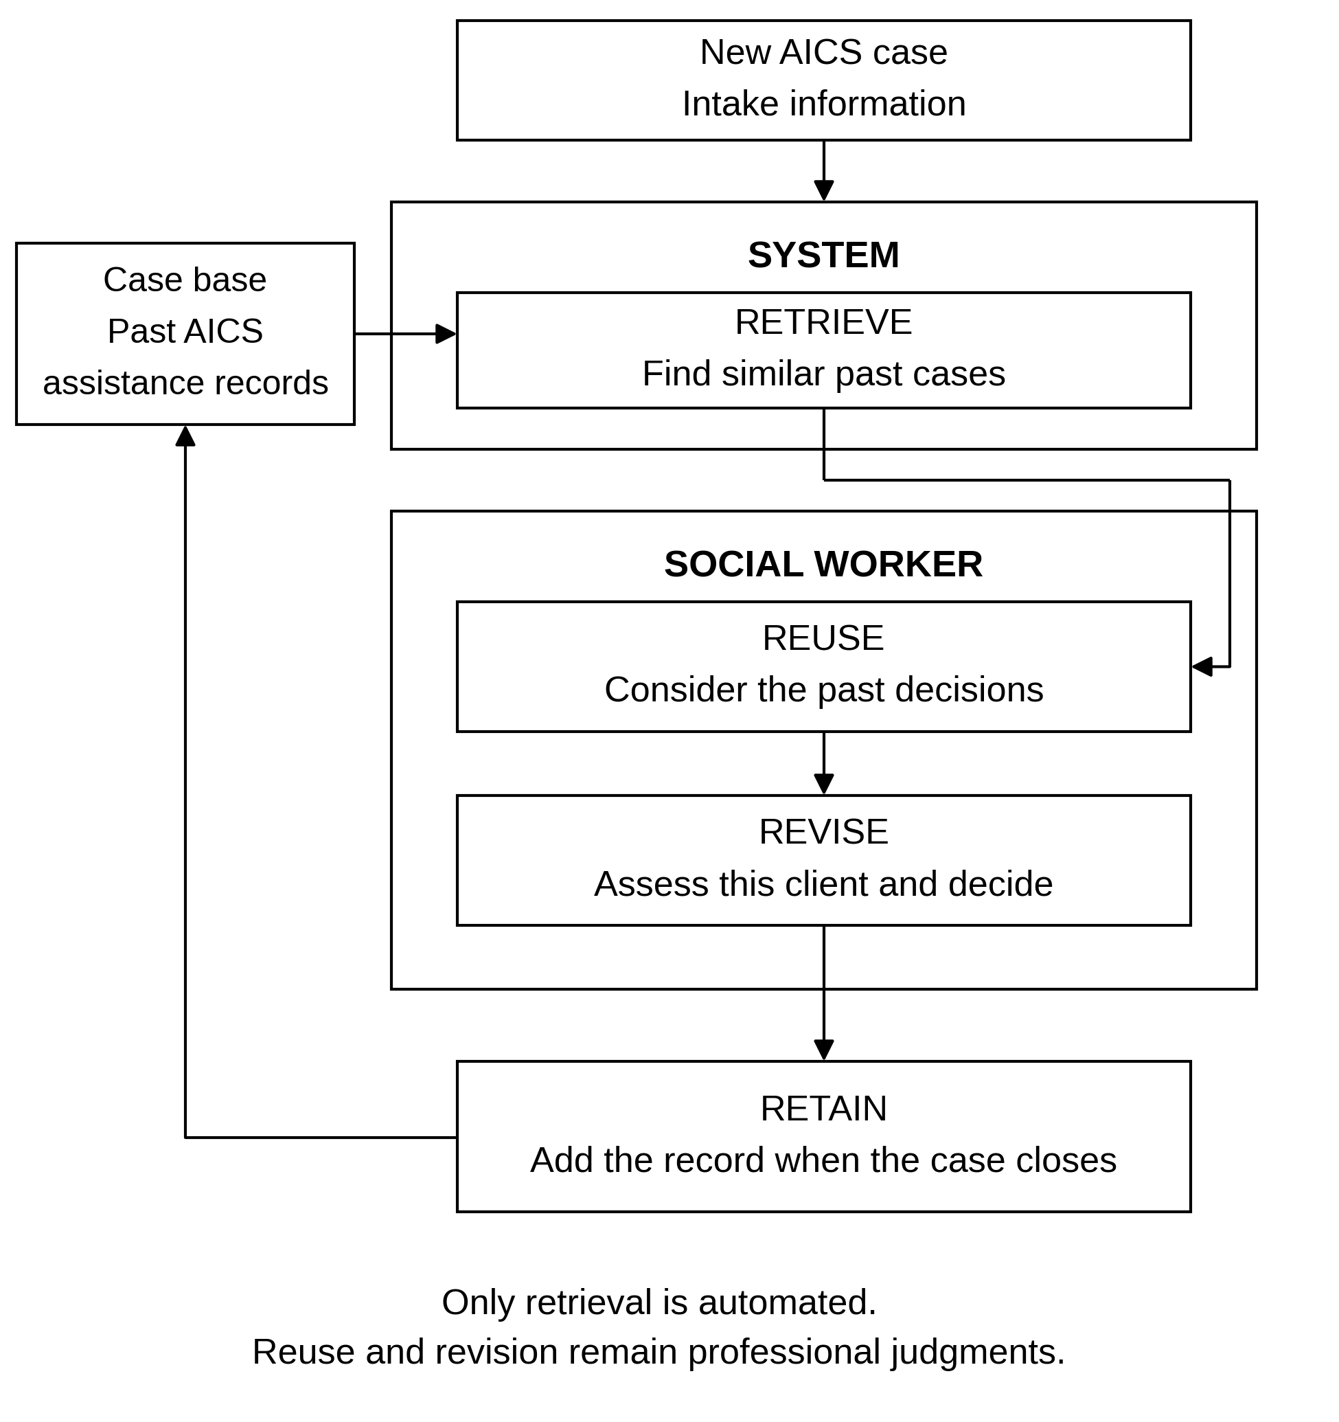
Note. Researchers' diagram of the study's use of the cycle described by Aamodt and Plaza (1994).
2.3.2 Similarity Measure Theoretical Framework
The similarity framework uses Gower's (1971) coefficient to compare numeric and categorical intake fields within the same calculation. Let i be the new case, j a past case, and k one of the fields used for comparison. The field score s(i, j, k) describes their similarity on that field. For a numeric field, the score is calculated as follows:
s(i, j, k) = 1 − |xᵢₖ − xⱼₖ| / Rₖ
Rₖ = maximum value of field k − minimum value of field k
Here, xᵢₖ and xⱼₖ are the two recorded values, and Rₖ is the range used for that field. Equal values give a score of one, while values at opposite ends of the range give zero. For a categorical field, matching categories score one and different categories score zero. If either record is missing a value, that field is left out of the comparison for that pair.
The overall score is a weighted average of the field scores that can be compared. In the following expression, wₖ is the nonnegative weight of field k, and δ(i, j, k) is one when that field is included for the pair and zero when it is excluded:
S(i, j) = [Σₖ wₖ δ(i, j, k) s(i, j, k)] / [Σₖ wₖ δ(i, j, k)]
The sums run over the comparison fields. A larger weight gives a field more influence on which cases are retrieved. Equal weights provide the baseline, and learned weights are tested against it. Distance is then one minus similarity:
D(i, j) = 1 − S(i, j)
A smaller distance means that the two records are more similar on the included fields. The granted amount is kept as the recorded outcome, not used as an intake field for matching a new client. As shown in Figure 2.2, the same comparison is carried out across past records to retrieve the closest cases.
The calculation also has limits that preprocessing must handle. A numeric field with a zero range cannot be used in the range formula, and a pair with no comparable fields of positive weight has no defined overall score. A value outside the reference range also needs a stated rule so that its field score does not fall below zero. Chapter 3 will state these rules together with the treatment of shared absences in tick-box fields and the tests of money scaling described in Section 2.2. Figure 2.2 shows the basic comparison and leaves those choices open.
Figure 2.2 Similarity Measure Theoretical Framework
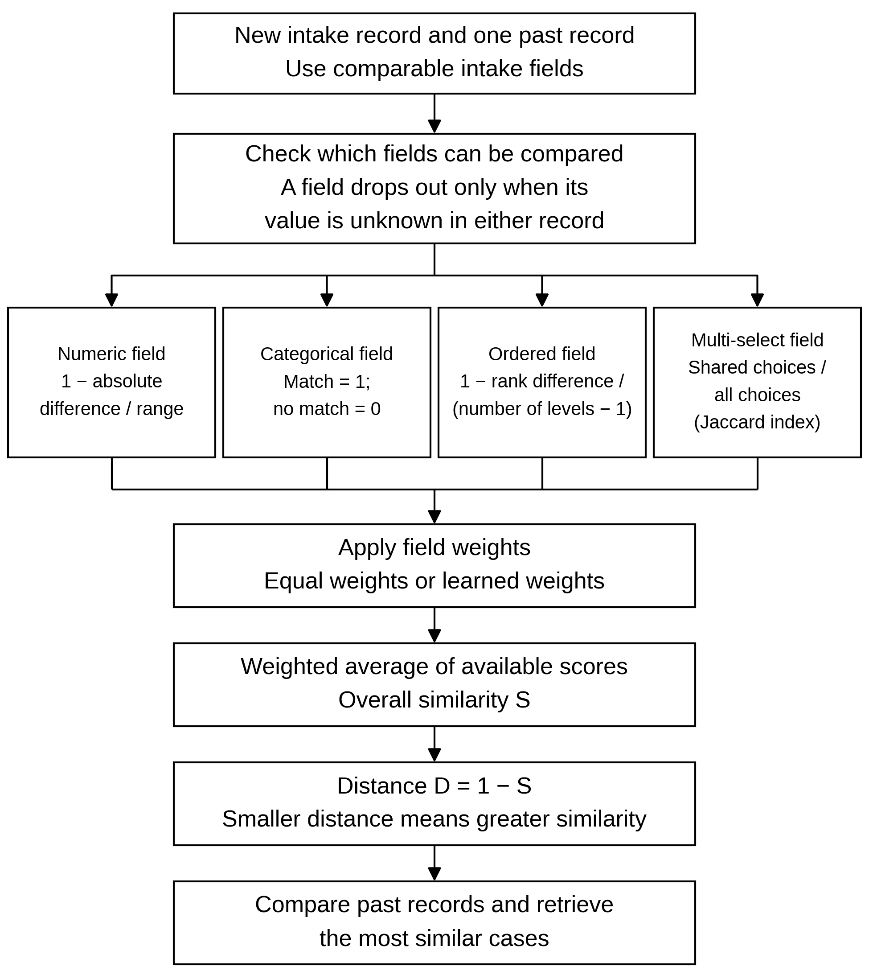
Note. Researchers' diagram based on Gower (1971); the figure shows the baseline comparison before the alternatives described in Section 2.2 are tested.
2.3.3 Explanation by Example Theoretical Framework
Explanation by example makes the past cases available for the user to inspect. Kenny and Keane (2021) studied this approach in twin systems, where a case-based reasoner explains the output of a separate black-box model. The present study uses the examples differently. There is no predicted amount to explain after the fact, because the retrieved cases are the system's output. Figure 2.3 shows how these cases support the social worker's assessment.
The explanation consists of the intake information in the retrieved cases and the amounts each client received. The social worker can compare that information with the current client and decide which similarities matter. This follows the view of Sørmo et al. (2005) that the value of an explanation depends on what its user needs to understand. For AICS, that need is to examine the basis for comparing cases, not to justify a figure already chosen by the system.
Making a case visible does not make it relevant. The concern raised by Kawakami, Sivaraman, Stapleton, et al. (2022) still applies when two records look alike but leave out important circumstances. The social worker therefore considers the examples together with the interview and supporting documents, and may find that none is useful. The framework keeps that judgment with the worker. Whether the examples help a worker assess a case is a question for testing with users, which this study does not carry out.
Figure 2.3 Explanation by Example Theoretical Framework
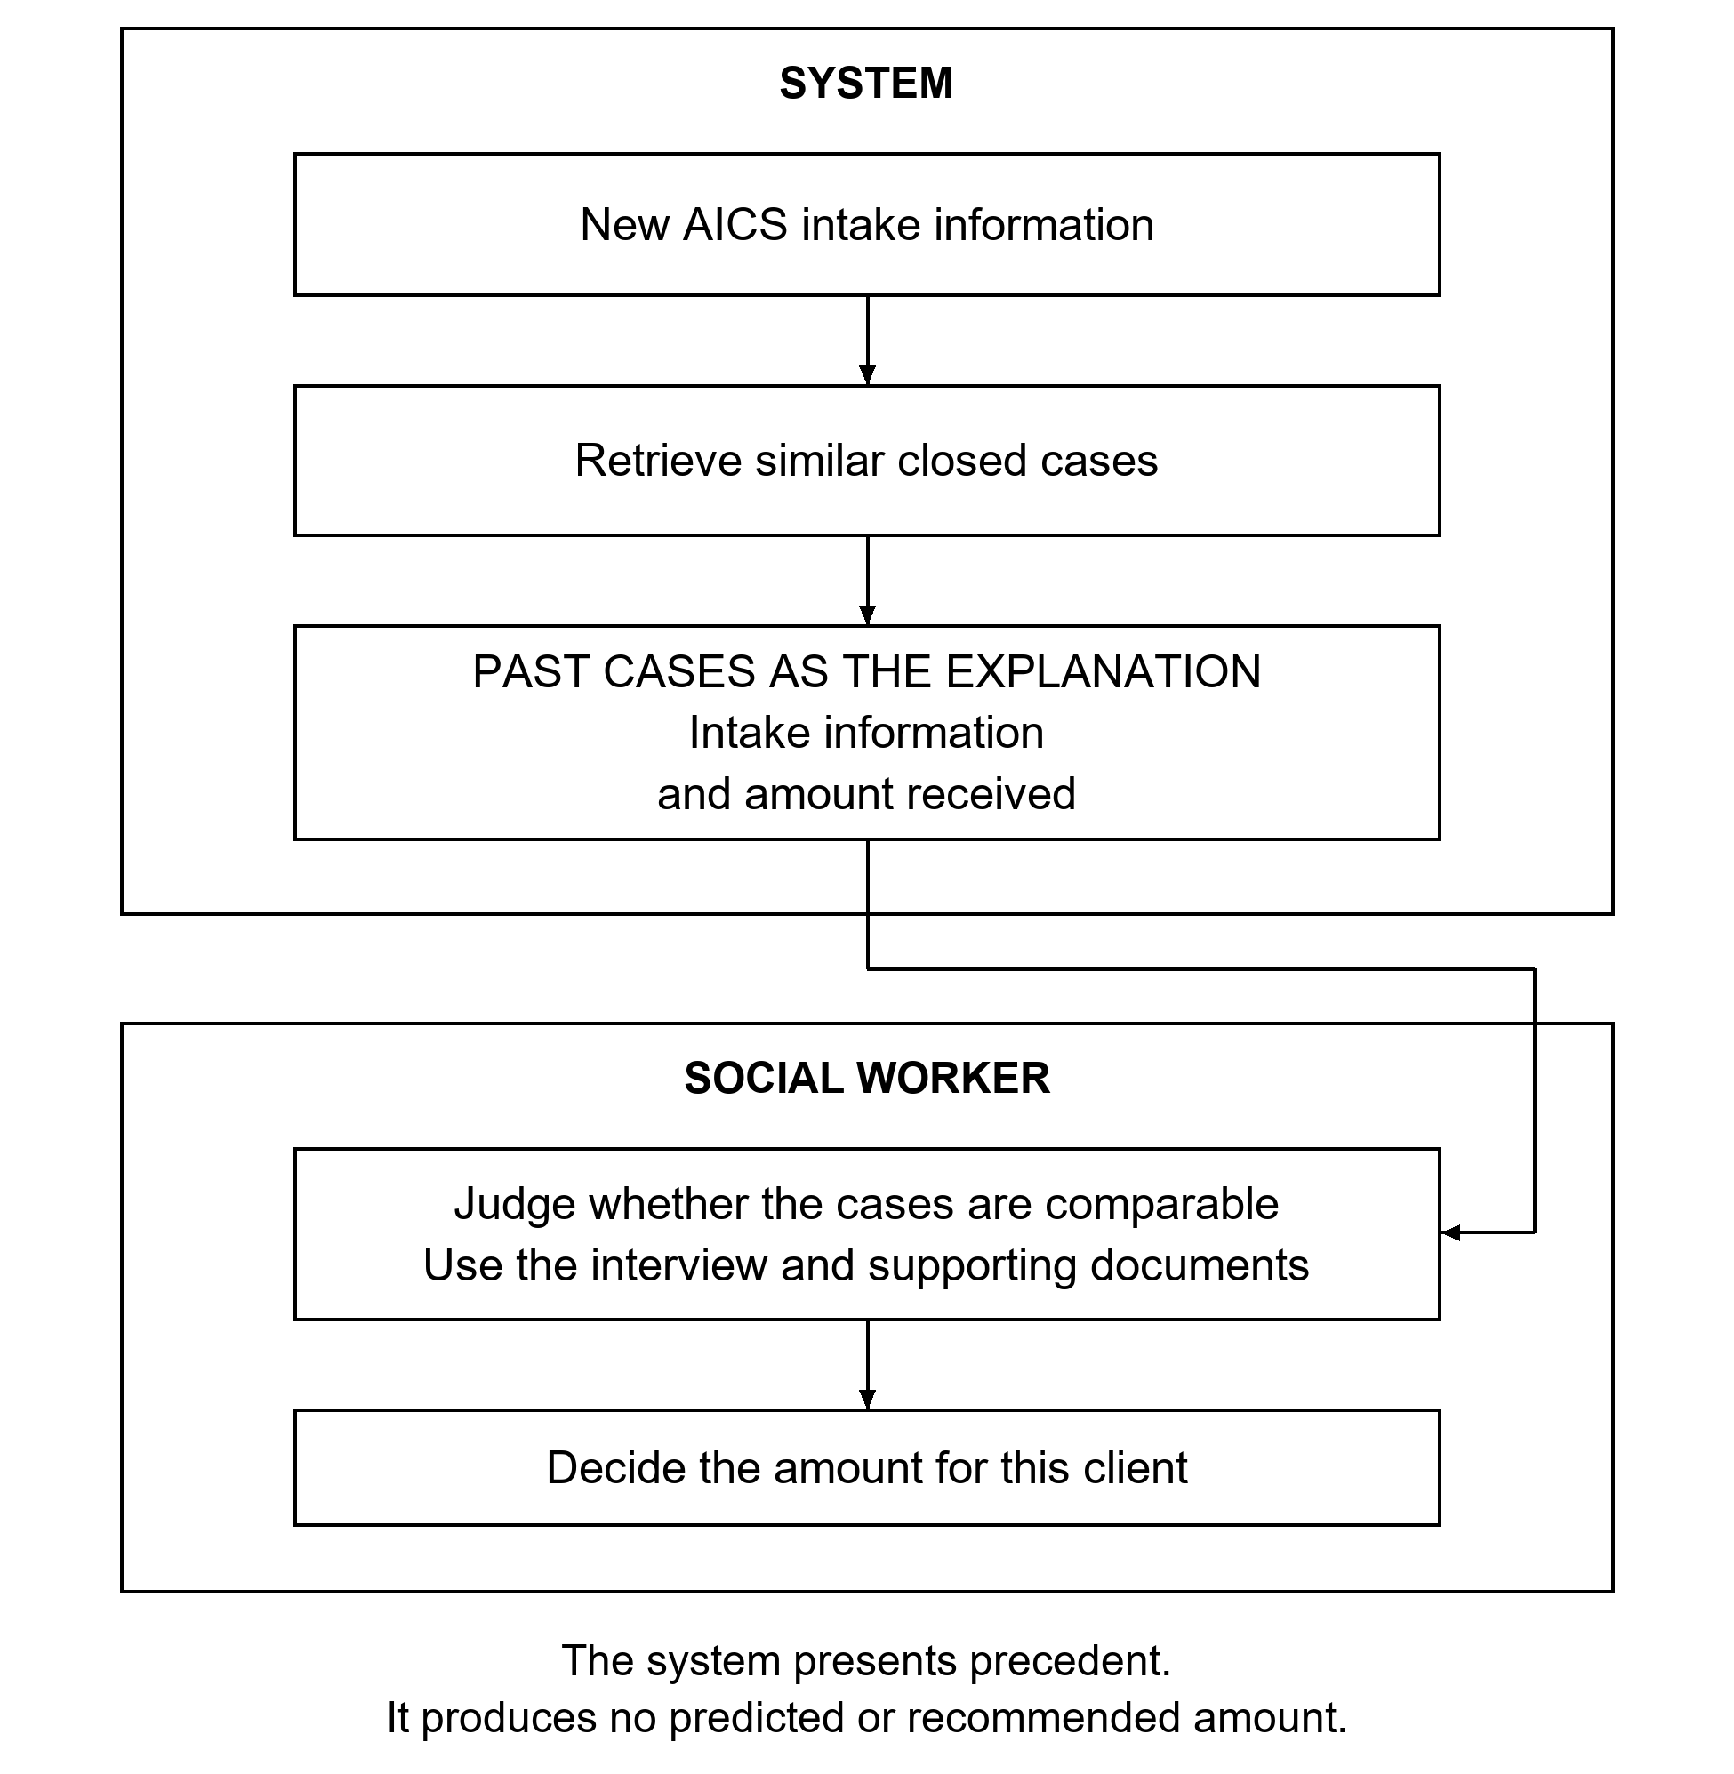
Note. Researchers' diagram informed by Sørmo et al. (2005) and Kenny and Keane (2021), showing the study's use of examples as the output itself.
Chapter 3: Methodology
This chapter has four sections. Section 3.1 presents the conceptual framework of the study, Section 3.2 sets out the methodology, Section 3.3 presents the operational framework of the prototype, and Section 3.4 sets out the ethical considerations. Section 3.2 covers the case study, the mathematical assumptions built into the similarity measure, the problem and model description, and the experimental setup, which names the baselines, the evaluation metrics, and the computing environment.
3.1 Conceptual Framework
The conceptual framework of this study illustrates how the system brings past AICS decisions to the social worker when a new applicant is assessed. It follows the retrieve step of the case-based reasoning cycle described in Section 2.3, compares cases using Gower's (1971) coefficient, and uses the retrieved cases themselves as the explanation. The process begins with the Case Base. Each case in it is one AICS assistance event. Its intake information from Sections I to VIII of the General Intake Sheet (GIS) describes the client's situation, and its record of assistance provided states the type, purpose, amount, and fund source of the assistance the client received. The granted amount is kept as the recorded outcome of each case and is not used as a field for matching.
Before cases can be compared, the intake fields pass through Data Preparation. This stage has four parts. Field Selection chooses the intake fields that will be used for comparison. Missing Value Handling sets how blank fields are treated, since Gower's coefficient leaves out a field that is missing in either record. Money Field Scaling puts each money field on a scale so that a difference in pesos can be compared within that field. Category Encoding records the categorical and tick-box fields in a form that can be checked for a match. The specific rules for each part, including the treatment of shared absences in tick-box fields, are stated in later sections of this chapter. The scaling of money fields is also tested rather than assumed. As described in Section 2.2, log transformation and fuzzy membership are compared with the plain range-scaled distance on a separately generated set, and a method is kept only if it reduces retrieval error there under the standard of evidence set out in Section 3.2.4.
When a client applies, the social worker records the client's answers as the New Applicant Intake. These are the same GIS fields held in the case base, and they are prepared by the same rules, so that the new case and each past case can be compared field by field. The new case has no granted amount yet, since that is the decision still to be made.
The prepared intake information then goes to Similarity Comparison. Here the new case is compared with every case in the case base using Gower's (1971) coefficient. For each pair of records, the coefficient compares the fields that both records have, takes a weighted average of the results, and turns that average into a distance, as set out in Section 2.3. A smaller distance means that the past case is more similar to the new applicant on the fields compared.
The comparison leads to Case Retrieval. The system returns the past cases with the smallest distances. Each retrieved case is shown with its intake information and with what the client received, namely the type, purpose, and amount of assistance, together with the documented cost of the need where there is one. The system does not combine these amounts into a single figure. The retrieved cases are the whole output of the system, and they are also its explanation, since the social worker can see which past cases were found and how each was settled.
The retrieved cases then pass to the social worker for the Amount Decision. The social worker examines them alongside the interview and the documents presented, judges whether any of them are truly comparable to the current client, and decides the amount through professional assessment. The social worker may also find that none of the retrieved cases applies. This follows Section 2.3, where only the retrieve step is automated, and the reuse and revise steps stay with the social worker.
Separate from this flow is the Weighting Evaluation, shown off to the side in Figure 3.1. This evaluation settles how much each field counts in the Similarity Comparison. It is carried out on the case base before the system is used, and it is not a step in the running system. Equal weights, which give every field the same importance, are the baseline. Weights learned from the case base are tested against them by leave-one-out. In this test each applicant is held out in turn, together with every assistance event belonging to that applicant, so that a case is never matched against another record of the same household. The closest cases are retrieved from the remaining records. For a type that carries a documented cost, the median share of the cost that those cases received is applied to the held-out case's own cost; for food assistance and cash relief, their amounts are used directly. The difference in pesos between the resulting figure and the actual recorded amount of the held-out case is recorded as the retrieval error, separately for each assistance type. Both weight settings are tested on the same held-out cases, and a paired statistical test, the Wilcoxon signed-rank test, checks whether the difference between them is real, under the standard of evidence set out in Section 3.2.4, reported alongside the difference in pesos so that a difference too small to matter in practice is not presented as a result. The same evaluation is run a second time on a control version of the case base, in which each amount depends only on the published starting share for its purpose and on random noise, and the household fields play no part. That control confirms no result; it checks only that the evaluation code does not leak the answer, since a method that does better there than the baseline set by purpose, described in Section 3.2.4, is reading something it should not. The only result of this evaluation is the set of field weights. It is a one-time comparison, not a training loop, and no model is fitted to produce amounts. The prototype runs on equal weights, because weights learned from a case base whose amounts were built from a known pattern would carry that pattern into the system itself, rather than leaving it as a finding about the method.
Ultimately, the framework culminates in a set of the closest past cases, each shown with what the client received, which the social worker examines alongside the interview and the documents presented before deciding the amount. The system produces no score and no recommendation. Only the retrieve step is automated, and the decision stays with the social worker.
Figure 3.1 Conceptual framework
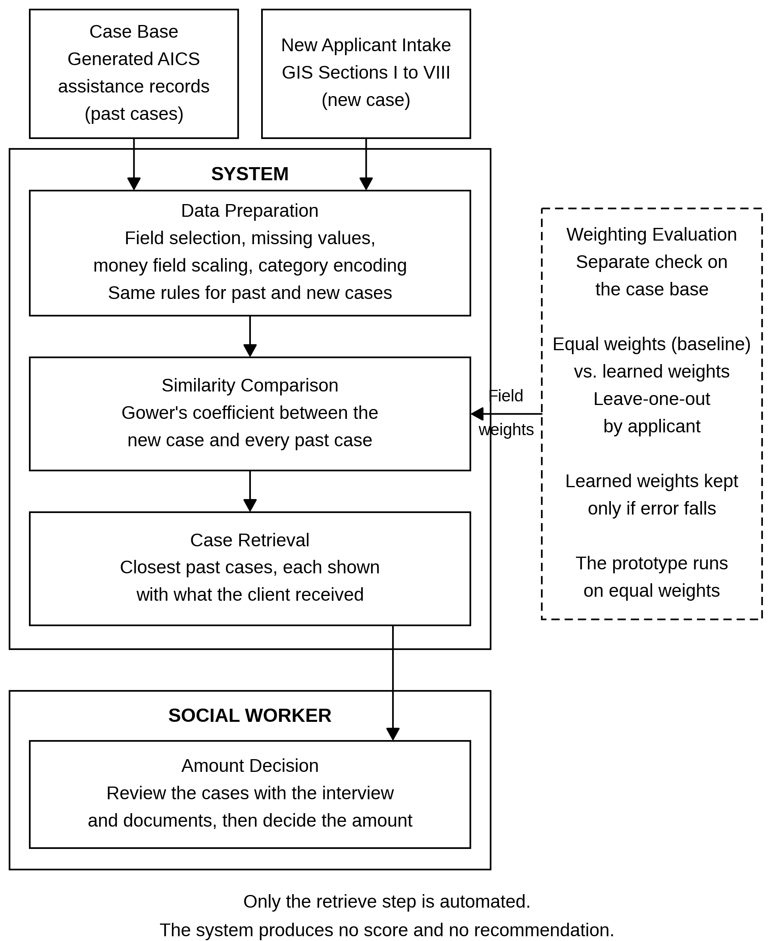
Note. Researchers' diagram of the study's conceptual framework; the weighting evaluation is a separate check on the case base and is not part of the running system.
3.2 Methodology
3.2.1 Case Study
The case study is set in the Crisis Intervention Section (CIS) of DSWD Field Office XI, which delivers AICS in Davao City and serves about 250 clients a day on average (DSWD PDPB, 2022, p. 39). In each case, the social worker interviews and assesses the client and decides whether the client is eligible, what type of assistance fits the client's need, and, if financial assistance is given, the amount to recommend for approval (DSWD, 2022a, p. 16). The guidelines give detailed rules for the first two decisions, but for the amount they set a minimum and a maximum for each type of assistance, and for out-patient medicines and laboratory procedures the minimum is given as the actual cost rather than a peso figure (DSWD PDPB, 2022, p. 17). What no rule settles is how much of the documented cost the assistance should meet. The Department's own evaluation found that this step relies on the professional judgment of social workers, and that repeat clients noticed the amounts they received were not consistent (DSWD PDPB, 2022, p. 51). The amount is therefore the decision with the least written guidance, and it is the decision this study is designed to support. Sections 1.1 and 2.1 describe this setting in more detail.
The study does not use records released by DSWD. A formal request for an extract of closed AICS records was filed with the Policy Development and Planning Section (PDPS), supported by the Research Request Form (GF-003), the Research Brief (GF-004), the Data Privacy Notice and Consent Form (GF-014), and the research instrument. The request was reviewed by the Regional Information and Communications Technology Management Service (RICTMS) and approved under DRN XI-FO-PPD-PDPS-A-COMM-26-08-28354-S, and on 23 September 2026 the researchers presented the study to the process owner, the Crisis Intervention Section, which gave its go-signal for release. The data sharing agreement required before any records could be handed over was then raised by the DSWD Legal Office from an arrangement between the RICTMS and the researchers to an institutional agreement between Ateneo de Davao University and DSWD. That brought in the signature of the University President, a board resolution authorizing it, and review by both institutions, and it could not be completed within the period of this study.
An officer of the RICTMS proposed an alternative: the researchers build a dataset, DSWD reviews it, and DSWD issues a written statement of what it found. The adviser and the thesis coordinator approved this course in October 2026. The research request and the agreement remain open, and running this study's evaluation on an extract of real records that includes the granted amount and the structured fields of Sections I to VIII is the first recommendation in Chapter 5.
The dataset is built in two parts. The case base supplies the volume of cases the method needs, and a set of forty test cases, held out of the case base, supplies the queries for the failure test. The amounts in both parts are set by a written rule, described below. The generated costs and shares are checked against figures DSWD has published, and the spread of amounts within each type is a stated choice of the researchers, both as explained in Section 1.5. No individual client record is used in any part.
The case base holds about 1,000 assistance events across roughly 850 applicants, generated from the structure of the General Intake Sheet and covering the same period the extract would have covered, August 2025 to August 2026. One record is one assistance event rather than one applicant, since an applicant can return for assistance more than once, and each visit is a separate precedent: an applicant who received medical assistance on one visit and burial assistance on a later one is two precedents rather than one. Every record therefore carries both an applicant identifier and an event identifier, and the evaluation holds out applicants rather than events, as Section 3.2.2 sets out. Fields are generated in an order that respects the dependencies between them, so that income follows from employment, pension income appears with the senior citizen sector, disability type holds the value “not applicable” unless the person with a disability sector is ticked, and a burial case always records a death in the family. A separate script checks the file against these rules and reports any record that breaks one. The intake records pass with no violations, and the check is run again once the amounts are added, since some of its rules concern the amounts. The number of cases of each assistance type is set deliberately, with a floor per type, rather than following the mix DSWD reports, because at this size the reported mix would leave the least common type with too few cases to retrieve from. Both the generated mix and the reported mix are given with the results.
The forty test cases are drawn from the same generator and held out of the case base. Each is printed on one page in the order of the General Intake Sheet, with its documented cost, the funds available, and, for medical and burial requests, the diagnosis or cause of death. The pages were first prepared as a packet for a social worker of the Crisis Intervention Section to answer, and DSWD staff reviewed it. Answers could not be gathered within the period of this study, so the amounts for these cases come from the same rule as the case base. Four pairs among the forty cases are the same case presented twice, identical on every field including which fields are blank, and four more are near pairs that differ in one field each: whether a member is unable to work, support from relatives, savings, and whether the client sought other income. Under the rule, the identical pairs receive identical amounts by construction, so they now serve only to confirm that the generator behaves as specified. The near pairs show what the one changed field does to the amount under the rule, before noise is added, which is a check on the rule rather than evidence about what moves a real decision. If a practising social worker is able to answer the eight near-pair pages, the study reports, for each pair, whether their two amounts move in the same direction as the rule's. Eight answers from one person are a check on the direction of the rule, not a measure of practice. The rule is fixed before any such answers are seen, and a pair that moves the other way is reported, not corrected.
The amounts in both parts of the dataset are set by a written rule, kept in the generator's code and given here in full. For a type that carries a documented cost, the amount is a share of that cost, found in three steps. The rule starts from a base share for the purpose of assistance, taken from DSWD's own published Region XI figures as the average amount received divided by the average cost: 20.7% for hospital bills, 80.5% for medicines, 29.0% for burial, covering both funeral expenses and cadaver transfer, and 61.1% for educational assistance, measured against tuition (DSWD PDPB, 2022, pp. 41–42). Two purposes have no Region XI figure, so their base shares are the researchers' assumptions. Assistive devices borrow the dialysis and chemotherapy share of 35.6%, the published medical row closest to them in cost, since Table 30 prints no cost and no Region XI row. Transportation is set at 100% of the ticket cost, since the guidelines set it at the actual cost (DSWD PDPB, 2022, p. 16). The base share is then moved up or down by a score built from the household's recorded circumstances. The score adds points for conditions that point to greater need, namely no emergency fund, no savings, no insurance, a member needing special care, a member unable to work, unstable employment, each crisis ticked in Section III, the sub-categories of no regular income and 4Ps beneficiary, and no member in employment. It takes points away for resources already in hand, namely PhilHealth, a health card, a guarantee letter from another agency, each discount availed, each support system available, and the two self-help efforts in Section VI. It also adds points for a lower total income in the past six months, entered in bands rather than as a straight line or a logarithm. The band edges are taken from the poverty and food thresholds for Davao Region published by the Philippine Statistics Authority (Philippine Statistics Authority Regional Statistical Services Office XI [PSA RSSO XI], 2024). For a family of five, the poverty threshold is ₱157,607 a year and the food threshold is ₱110,323 a year. Halved to cover six months, they give three bands: below ₱55,162, which is below the food threshold; ₱55,162 to ₱78,803, which is between the two thresholds; and ₱78,804 and above, which is at or above the poverty threshold. Income is recorded in whole pesos, so no value can fall between these edges and the exact halved figures of ₱55,161.50 and ₱78,803.50. These fields follow the kinds of indicators that the Department's own recommendation names, which are needs, vulnerability, the money situation, and shocks to health, income, and spending (DSWD PDPB, 2022, p. 70), but which fields count and how many points each carries are the researchers' choices, not published figures. Only the income band edges come from a published source. Finally, random noise is added. The amount is the resulting share multiplied by the documented cost, which is taken as the balance the client still owes after what other payers have met, as a billing statement shows it, following the reasoning set out in Section 1.1. The share is not allowed to exceed one, since a grant cannot be larger than the cost presented. Food assistance and cash relief for other needs carry no documented cost, so for those two types the rule starts instead from the published Region XI average amounts received, ₱3,857.14 and ₱4,400.00 (DSWD PDPB, 2022, p. 42), and moves the amount itself in the same way. Transportation receives no household adjustment and no noise, since its amount is always the ticket cost, so its results are reported separately.
The income bands rest on four assumptions, stated together here. First, the intake sheet records no household size, so the family of five used for the published family thresholds is assumed for every household. Second, six months of household income is compared with half of the published annual threshold. Third, the thresholds are for 2023, and they are applied to records dated August 2025 to August 2026. Fourth, the thresholds are for Davao Region as a whole rather than for Davao City, and the cost of living in the city may differ from the rest of the region. On the forty test cases, 26 fall below the food threshold, 7 fall between the two thresholds, and 7 are at or above the poverty threshold, so the income term separates only about a third of them. The generator is not changed to even out the bands, since the Department's evaluation found that the average income of AICS clients was below the poverty threshold (DSWD PDPB, 2022, p. 40), and the split in the case base is reported with the results.
The schedule of assistance is then applied. The minimum for each type always applies. The maximum applies to burial and medical assistance. It is not applied to educational and food assistance, because DSWD's own Region XI averages for those two, ₱7,142.86 and ₱3,857.14, are already above their schedule maximums (DSWD PDPB, 2022, pp. 17, 42), and the schedule allows a higher amount when the case is justified (DSWD PDPB, 2022, p. 17). Amounts are rounded to the nearest ₱50. The total spread of the share is held the same at every setting, and the noise decides how much of it the household explains. The rule is run at four settings, in which the household accounts for none, a quarter, a half, and three quarters of that spread. The setting at one half is the main condition, chosen before anything is run. The setting at none is the control described in Section 3.1. There the amount depends only on the base share for its purpose and on noise, so the household fields carry no part of it, although the purpose still does. The noise for each case is drawn from a seed computed from the case's own field values rather than from its position in the file, so two identical case sheets always receive the same amount, and the seed of the whole generator, 20261014, is recorded. Five matching fields are given no part in the rule on purpose, namely client type, walk-in or referral, service setting, disability type, and occupation, and several other matching fields, including monthly family expenses, are not used either, so the weight search has fields that it should learn to ignore. The rule uses only fields that Table 3.1 marks as used for comparing cases, so the pattern can in principle be recovered by retrieval. Of the money fields, only total income in the past six months is used. Combined family income and the income sources are not used, because they are kept as context, and monthly family expenses are not used, because high expenses can mean either a struggling household or a comfortable one. The retrieval code never sees the rule. It sees only the amount recorded with each past case.
The case sheets also show three things the distance does not compare: the documented cost, the funds available, which is the same ₱250,000 on every sheet, and the diagnosis or cause of death. They also show the other fields kept as context only. The rule does not use the funds figure or the diagnosis. A social worker answering a sheet could draw on them, which is one more reason that near-pair answers, if any are gathered, are a check on direction only.
The finished case base is submitted to DSWD for review, with four questions: whether the field values and ranges look like real AICS records, whether the mix of assistance types matches their caseload, whether the spread of amounts within each type looks right, and whether any combination of fields appears that never occurs in practice. The study reports what their written reply says, rather than assuming what it will contain. If no reply is received before the manuscript is final, the study says so.
The variables follow the structure of the intake sheet: the header fields that describe the case, Sections I to VIII that describe the household's situation, and the record of assistance provided on page 2. Table 3.1 lists the variable groups and how each is used. The requested amount is not stored as a data field in DSWD's system and is not generated here.
Table 3.1 Variable groups from the General Intake Sheet
Group (GIS location) | Variables | Type | Use
Case profile (header) | Client type, service setting, walk-in or referral, purpose of assistance written at intake, mode of assistance | Categorical | Used for comparing cases, except mode of assistance, which is settled after the assessment and is shown as context only
Diagnosis line (header) | Diagnosis or cause of death | Text | Shown as context only and never used for matching, since it is free text
I. Income and financial resources | Occupation, number of employed and seasonal members, combined family income, insurance coverage, savings | Categorical, numeric, yes/no | Used for comparing cases, except combined family income, which is shown as context only
II. Budget and expenses | Monthly family expenses, availability of an emergency fund | Numeric, yes/no | Used for comparing cases
III. Severity of the crisis | Duration of illness, crisis in the past three months, type of crisis experienced | Ordered, yes/no, tick-box list | Used for comparing cases
IV. Availability of support systems | Family, relatives, friends, employer, church or community organization | Tick-box list | Used for comparing cases
V. External resources tapped | PhilHealth, health card, guarantee letters from other agencies, MSS, senior citizen, and PWD discounts | Tick-box list | Used for comparing cases
VI. Self-help and client efforts | Sought employment or other income, reached out to other agencies | Yes/no | Used for comparing cases
VII. Vulnerability and risk factors | Elderly, child, PWD, or pregnant member; member unable to work; unstable employment | Tick-box list | Used for comparing cases
VIII. Client sector | Target sector and sub-category, disability type, income sources, total income in the past six months | Multi-select, numeric | Used for comparing cases, except the income sources, which are shown as context only
Supporting documents | Documented cost of the need, as the balance owed after other payers (billing statement, prescription, quotation, or contract) | Numeric | Shown as context only and never used for matching; sets the upper bound and the scale of the amount, and is not generated for food assistance or cash relief
Case sheet only | Funds available | Numeric | Printed on the forty test case sheets only, as the same ₱250,000 on every sheet; not part of the case base and never used for matching
IX and X (free text) | Problem Presented, Social Worker's Assessment | Text | Excluded as narrative fields
Page 2 (decision record) | Assistance granted, purpose of assistance, amount granted, fund source | Categorical, numeric | Recorded outcome, shown with each retrieved case and never used for matching

The fields on page 2 record what was approved after the assessment: the assistance granted, the purpose of assistance, the amount granted, and the fund source. They are kept as the recorded outcome of each case. They are shown with every retrieved case, so that the social worker can see how that case was settled, but they are never used as matching fields, since they describe the decision rather than the applicant's situation at intake and are not known when a new applicant is assessed. Sections IX and X, the Problem Presented and the Social Worker's Assessment, are excluded because they are narrative fields. The identifying block of the form, which holds the client and beneficiary names, is not generated at all.
The type of assistance is also recorded on page 2. Even so, the study uses the assistance type to group cases: a case is compared only with past cases of the same type, and the results are reported per assistance type. The reason is that the type of assistance is settled before the amount is. A social worker assessing a new client already knows whether the request is for burial, medical, or another type of assistance, so comparing only within that type matches how the system would be used. In real records the type granted can differ from the type the client sought, and a study of such records would have to assume that one stands for the other. In the constructed dataset the two are the same by construction, so the question does not arise here, and it is left to the study on real records recommended in Chapter 5.
Each event also carries the documented cost of the need, except food assistance and cash relief, which are generated without one. This is not one of the sections of the intake sheet. It comes from the documents a client presents, such as a hospital billing statement, a prescription, a laboratory quotation, or a funeral contract. The guidelines tie the amount to this cost: for out-patient medicines and laboratory procedures, the schedule gives no peso minimum and reads “Actual amount/cost” instead (DSWD PDPB, 2022, p. 17). The documented cost therefore sets the upper bound of what an event can receive, and the guideline maximum for its type and purpose sets the cap for burial and medical assistance, as stated above. In the case base the cost is generated with each event and no amount is allowed to exceed it, and the cost is printed on each test case sheet, since a social worker would not set an amount without it. It is shown with every retrieved case but is kept out of the distance, as Table 3.1 shows. What the study compares is the household's circumstances, which Sections I to VIII record; the cost sets the band within which the amount is decided rather than describing the household. Part of what other sources have already paid is also on the form, since Section V records whether the family tapped PhilHealth, a health card, or a guarantee letter from another agency, but the amounts those sources paid are not recorded separately, since they are already netted out of the documented cost.
The case study therefore covers one city and one field office, Davao City under DSWD Field Office XI, and the amount decision only, with eligibility and the type of assistance taken as already settled. It compares cases only on the structured fields of the intake sheet. Of the documents a client presents, it carries only the documented cost of the need, as context, and it carries nothing of what a social worker learns in the interview.
Several limits follow from building the dataset rather than receiving it. The first is that the case base describes the structure of the intake sheet, not the population it records. A real record set would contain only people who reached a DSWD office and were assessed, and would leave out those who could not travel, lacked documents, or did not know of the program. A generated set does not even have that much claim on the population, and nothing measured on the case base should be read as describing applicants in Davao City.
The second is that the pattern of blank fields is ours. In real records, completeness depends on the assessing social worker and on how busy the office was, so blanks are unlikely to be missing at random. Here the rate at which fields are left unknown is a parameter the generator was given, and the three kinds of blank described in Section 3.2.2 are written into the file by construction rather than observed. Because Gower's coefficient leaves out a field that is unknown in either record, blanks are never filled in, and the proportion of unknown entries per field, together with the number of fields actually compared for each retrieved pair, is reported with the results.
The third is that the service channels, onsite, through the Malasakit Center, and offsite, are generated in proportions we chose, so any difference between them in these data is a property of the generator. The fourth concerns repeat applicants, and here the constructed dataset is stronger than an extract would have been. In a de-identified extract repeat applicants cannot be linked, so a held-out case could be matched against an earlier record of the same household, which is effectively a match against itself. Here every event carries an applicant identifier, and the evaluation holds out all of an applicant's events together, so that cannot happen. The share of applicants who return for another visit is an assumed setting of the generator, not an observed figure.
The fifth is that real amounts move with the time of year and the funds available, as the Department's 2022 evaluation found. Both outright cash and guarantee letters are released “depending on the availability of funds” (DSWD PDPB, 2022, p. 17), and the officer of the RICTMS who reviewed the case sheets explained that each office works within a monthly fund allocation, so what a case can receive depends on what remains of that allocation when it is decided. Nothing on the intake sheet records what remains, so the study cannot model it, and a constructed case base cannot carry it. Section 1.5 states how the study approaches the question of variation instead. Taken together, these limits mean that the figures reported in Chapter 4 describe how the retrieval method behaves on a dataset whose structure is known, and are not estimates of how it would behave on DSWD records.
Because the dataset is generated rather than delivered, there is no cleaning step to describe. The generator, the amount rule, the consistency checker, and the file of figures taken from DSWD publications are kept under version control with a fixed random seed recorded, so that the exact dataset used in this study can be reproduced. Every figure in the generator that did not come from a DSWD source is marked as an assumption in the code.
3.2.2 Mathematical Assumptions
The similarity measure used in this study is Gower's (1971) coefficient, as set out in Section 2.3.2. That section also noted that the coefficient leaves several choices open. This subsection states how the study settles each of them. Each rule is a decision made before the data are examined, and each is given with its reason. The subsection then shows how these choices, taken together, control bias.
3.2.2.1 Rules for the Similarity Measure
The first rule concerns what a blank means. A field with no ticked or written answer can mean three different things, and each is treated differently. A field that does not apply to the client holds the value “not applicable”, for example disability type for a client who is not a person with a disability, or duration of illness for a request that has nothing to do with illness. This is a recorded value, and two records that both carry it match on that field, since neither client has what the field asks about. A box that was not ticked holds the value No, because the question was asked and the answer was no. A cell that is empty is unknown, because no answer was recorded. Only this third kind is treated as missing in the sense of Section 2.3.2: the field is left out of the comparison for that pair, and the remaining fields carry the similarity. An unknown value is never filled in, since an imputed value would put a guess into the distance.
The second rule concerns shared absences in the tick-box lists. The General Intake Sheet has four check-all-that-apply lists, and they are not all the same kind of field. In the list of crises the family experienced in Section III, and in the list of vulnerability and risk factors in Section VII, a box that is No in both records is dropped from the comparison for that pair. This follows Gower's (1971) rule for dichotomous characters, whose absence in both members of a pair is not taken as a match. Not having had a death in the family is the ordinary state rather than a shared trait, and counting such absences would make unrelated cases look alike simply because neither family went through the same event.
In Section IV, which lists the available support systems, and in Section V, which lists the external resources tapped by the family, a box that is No in both records counts as a match. Two clients who both have no employer and no church or community support genuinely share a condition that bears on their need, so the absence carries information. Section V also has its own Not Applicable box, which the form provides for a client who has none of the listed resources. If nothing at all is ticked in Section V, not even Not Applicable, the section is treated as unanswered for that record, and every box in it is left out of the comparison. If Not Applicable is ticked, every resource in the section is recorded as absent, and those absences count as matches under the rule for this section.
The third rule concerns the yes/no questions that stand on their own rather than as part of a list. These are insurance coverage and savings in Section I, the emergency fund in Section II, whether the family had a crisis in the past three months in Section III, and the two self-help items in Section VI, seeking employment or other income and reaching out to other agencies. Each is compared as a plain categorical field, scoring one when the two records give the same answer and zero when they differ, so two records that both answer No match. The shared-absence rule for Section III applies only to the list of crises, not to the separate question of whether a crisis happened. Having no savings or no emergency fund is a real condition of the household, like the absences in Sections IV and V, so it is counted.
The fourth rule concerns fields that are not simple categories. Target sector, sub-category, and disability type are multi-select fields, since the printed form does not say that only one choice may be ticked, and a client can be, for example, both a senior citizen and a person with a disability. The value of each such field is therefore a set of choices, and two sets are compared with the Jaccard index: the number of choices the two records share, divided by the number of choices that appear in either. A record for which the field does not apply holds the empty set, and two empty sets score one, which keeps the rule for “not applicable” given above. The Jaccard index already lies between zero and one, so it enters Gower's coefficient without change. A plain match-or-no-match rule would score a client who is a senior citizen against one who is both a senior citizen and a person with a disability as zero, while the Jaccard index scores them one half. If only one choice is ever recorded, the Jaccard index gives the same result as a plain match, so the rule holds either way.
Duration of illness is an ordered field. Its three levels, recently diagnosed, three months to a year, and chronic or lifelong, have a natural order, and recently diagnosed is closer to three months to a year than to chronic. Two treatments are tested. The first treats the field as plain categorical, scoring one for the same level and zero otherwise. The second uses the normalized rank given in Section 3.2.3, which gives partial credit to neighboring levels. In both, “not applicable” is a value of its own: two records that both carry it match, and it scores zero against any of the three levels. The treatment is chosen in the same way as the scaling of money fields, described in the tenth rule.
The fifth rule concerns the money fields. The form records money in ten fields: combined family income in Section I, monthly family expenses in Section II, and in Section VIII seven income sources and the total income in the past six months. Most of these describe the same thing. Under equal weights every field counts once, so if all ten were compared, money would take about ten of roughly forty-five shares in the similarity, and two cases would be judged mostly on income whatever else differed between them. That share would come from how many lines the form prints for income, not from any decision about how much income should count. Only two money fields are therefore used for comparing cases: the total income in the past six months, which is the one figure that covers all sources, and monthly family expenses, which measures something different from income. Combined family income and the seven income sources are kept as context. They are shown to the social worker with each retrieved case but are left out of the distance, as Table 3.1 shows.
The sixth rule concerns constant fields. A field whose value is the same for every record in the case base of an assistance type cannot tell two cases of that type apart, so it is removed for that type before any comparison is made. For example, if a death in the family is ticked for every burial case, that box is removed from the burial case base. For a numeric field this rule also prevents a range of zero, which the range formula would otherwise have to divide by.
The seventh rule concerns values outside the reference range. A new applicant may have a value that falls outside the range seen in the case base, which would make the numeric field score fall below zero. The field score is therefore clamped at zero:
s(i, j, k) = max(0, 1 − |xᵢₖ − xⱼₖ| / Rₖ)
With this rule, every field score lies between zero and one, so the overall similarity also stays between zero and one and the distance keeps its meaning.
The eighth rule concerns where the ranges come from. The range Rₖ of each numeric field, and the break points used if fuzzy membership is kept, are computed within the assistance type, since the case base for a query holds only records of that type. This keeps each field score spread over its full range rather than compressed by values from other types. They are also computed only from the records that the current step is allowed to see. When an applicant is held out, the ranges are taken from the remaining records, so that no record helps set the scale on which it is later measured, and while the weights for a fold are being fitted, the records of that fold are left out of the ranges as well.
The ninth rule concerns pairs with nothing to compare. If no field of positive weight can be compared for a pair, for example because every such field is unknown in one of the two records, the similarity for that pair is undefined. That past case is excluded from retrieval for that query rather than being given an invented score, and the number of times this happens is reported.
The tenth rule concerns the scaling of money fields and how it is chosen. Plain range scaling is the baseline. Log transformation uses log(x + 1) rather than log(x), because a recorded amount such as income can be zero, and the logarithm of zero is undefined. The range of the transformed values is then used in the same range formula. Fuzzy membership needs break points that set where one level of a money field gives way to the next. These break points are the lower quartile, the median, and the upper quartile of that field, taken from the data rather than chosen by intuition, and they are computed as stated in the eighth rule. The scaling is not chosen on the case base. Trying the three options on the case base, keeping the best, and then reporting results on the same records would make the reported error look better than it is, since the option kept would be the one that happened to suit those records. Instead, a separate set is generated in the same way as the case base but with a different random seed, and the three options are compared on that set with equal weights. Plain range scaling is kept unless a transformation reduces retrieval error on that set under the standard of evidence set out in Section 3.2.4. The rule that generates the amounts uses total income in the past six months in bands, as Section 3.2.1 states, and none of the three options has exactly that shape. Of the three, fuzzy membership is the closest in kind, since it also treats a money field in levels, but its break points come from the data rather than from the band edges, and the study reports how far apart the two sets of edges lie. On the forty test cases, pooled across types, the upper quartile of six-month income, ₱75,500, is 4.2% below the poverty edge of ₱78,803.50, and the median, ₱49,200, is 10.8% below the food edge of ₱55,161.50. The break points actually used are computed within each assistance type on the separate set, and their distance from the band edges is reported with the results. The comparison therefore tests whether the distance's money scaling recovers a banded shape in generated data, not whether one scaling is better for real AICS records. The two treatments of duration of illness are compared on the same set in the same way, and the plain categorical treatment is kept unless the normalized rank does better by the same standard. The chosen options are then fixed, and every result is reported on the case base.
The eleventh rule sets out how weights are learned and tested, as one procedure. One set of weights is learned for the whole case base rather than a separate set for each assistance type. A separate set would be preferable in principle, since a field such as the duration of illness may matter for a medical request and not for an educational one, but it cannot be estimated at this size. There are thirty-nine matching fields, and the three smallest types hold eighty events each, of which a fit sees about sixty-four, so a per-type search would be fitting thirty-nine numbers to fewer than two examples apiece and would describe those particular records rather than anything general. Fitted across all types, a fit sees about eight hundred of the 1,000 events, or roughly twenty events per weight. Learning per-type weights on a larger case base is recorded in Chapter 5 as future work. The case bases themselves stay separate, so a medical case is still only ever compared with other medical cases; only the weights are shared. The applicants are divided at random into five folds, with every assistance event of an applicant placed in the same fold. For each fold p in turn, the weights are fitted on the other four folds only. The weight search looks for the weights that give the lowest leave-one-out retrieval error among the applicants of those four folds, holding out one applicant at a time and retrieving from the rest of the four folds, so that the records of fold p play no part in the fit. The weights found are then used for the applicants of fold p. Each of these applicants is held out in turn, together with all of its events, and its closest cases are retrieved from every other record of the same assistance type, that is, from the four folds used for fitting and from the other applicants of fold p. This is the same pool of past cases used when equal weights are tested, so the two settings differ only in their weights. Because every applicant belongs to exactly one fold, every applicant receives one retrieval error under learned weights and one under equal weights, taken as the mean error over that applicant's events when there is more than one, computed for the same held-out applicant against the same pool, and this is what makes the comparison between the two a paired test. The search minimizes the same quantity the study reports. For each held-out case, five past cases are retrieved. For a type that carries a documented cost, the median of their shares of the cost is multiplied by the held-out case's own documented cost; for food assistance and cash relief, the median of their amounts is used directly. The error is the absolute difference in pesos between that figure and the recorded amount of the held-out case. Applying the neighbors' shares to the held-out case's own cost keeps the error about whether retrieval found households that were treated alike, rather than about differences in cost, which the distance does not see by design. This way of combining the retrieved cases was settled before any evaluation was run. Because the weights are shared, errors from different assistance types are averaged together, and a peso error does not mean the same thing in every type: a burial error can be more than twice the largest possible cash error, so an average of raw pesos would tune the weights mostly to the types with the largest amounts. Each error is therefore divided by the width of the range of amounts that the guidelines allow for that case, the maximum minus the minimum, before the errors are averaged. For medical assistance the range depends on the purpose. The guidelines allow ₱1,000 to ₱150,000 for hospital bills and other medical expenses, but only up to ₱10,000 for out-patient medicines and for out-patient laboratory procedures (DSWD PDPB, 2022, pp. 16–17). A medical case is therefore scaled by the range for its own purpose rather than by one range for the whole type, since otherwise the same averaging problem would return inside medical assistance. Where the schedule gives only a maximum, as it does for medicines and laboratory procedures, that maximum is used as the width. The purpose appears on the form twice, and the two are different fields. The purpose written in the header at intake is one of the matching fields, as Table 3.1 shows, while the purpose recorded on page 2 beside the amount and fund source is part of the outcome and stays out of the distance. In the constructed dataset the two purposes are the same by design, so the bracket is unambiguous here; with real records the page-2 purpose would govern, since it is the one printed beside the amount. The quantity minimized is the mean of these scaled errors, and it is reported alongside the mean error in pesos for each assistance type. The median is used to combine the retrieved shares or amounts because a single distant neighbor would pull an average a long way while leaving the middle value alone. Fixing the search objective to a reported measure matters: a search told to minimize one quantity while the study reports another would be tuned for something that never appears in the results. The search uses five retrieved cases, and the results reported for other numbers of retrieved cases use the same weights, so they show how sensitive the figures are to that number rather than being tuned separately.
The last rule concerns the order of these choices. The scaling of money fields and the weighting of fields are settled in sequence rather than as a full grid of combinations. The scaling, and the treatment of duration of illness, are chosen first, on the separate set and with equal weights, as stated in the tenth rule. They are then held fixed while equal weights are compared with learned weights on the case base, as stated in the eleventh rule. Each stage settles one choice, and the second stage does not reopen the first.
3.2.2.2 How the Model Controls Bias
Taken together, these rules control bias in the retrieval, but they do not make it neutral, and the limits are stated here. Equal weights are the baseline. They give no field more importance than any other field, but they do not give every topic the same importance. Under equal weights, each field the form prints counts once, so the layout of the General Intake Sheet decides how much each topic counts. The fifth rule removes the largest case of this, the ten money fields. The same effect remains on a smaller scale in the list of crises in Section III and the list of vulnerability and risk factors in Section VII, where one topic is spread over several boxes, although the second rule softens it, since a box that is No in both records drops out of the comparison. The remaining effect is stated rather than corrected, because any correction would be a set of weights chosen by the researchers, which is what the equal-weight baseline exists to avoid.
The granted amount is kept as the recorded outcome of each case and is never used as a matching field, so the amount cannot steer which cases are found. The leave-one-out evaluation holds out each applicant together with every assistance event of that applicant, so a case is never matched against another record of the same household. Every event in the case base carries the identifier of its applicant, so this is done exactly rather than estimated. Results are reported per assistance type, so that burial and cash amounts are never compared on the same peso scale.
The remaining rules keep the evaluation from leaking information. The ranges and the fuzzy break points are computed without the held-out applicant, and without fold p while the weights for that fold are fitted, so that no record helps set the scale on which it is judged. The weights are never fitted on the applicants they are tested on. The scaling of money fields and the treatment of duration of illness are chosen on a separately generated set, so that the reported error is not flattered by a choice made on the same records. The shared-absence rule is set per section of the General Intake Sheet with a stated reason rather than for convenience, so that the treatment of each tick-box list follows what an absence means in that list.
The amounts in the case base are set by the researchers' rule, as stated in Section 3.2.1, and no step of the retrieval or of the weight search can see that rule. Its starting shares come from DSWD's published figures, but the household part of it is the researchers' choice, so whatever bias that choice contains is carried by the case base. These choices do not remove that bias, but they keep the measure itself from adding bias of its own.
3.2.3 Problem and Model Description
The problem can be stated formally. Let the case base C be the set of assistance events of the same assistance type as the applicant, and let N be the number of such events. A separate case base is therefore used for each assistance type, following the grouping explained in Section 3.2.1. Each event j is described by K comparison fields, the fields of Sections I to VIII of the General Intake Sheet that Table 3.1 marks as used for comparing cases, with one value xⱼₖ for each field k. Each event also carries the identifier of its applicant and a recorded outcome made up of the type, purpose, amount, and fund source of assistance. Given a new applicant i described on the same K fields, the task is to return the m cases with the smallest distance to i, each shown with its recorded outcome. The letter m is used for the number of retrieved cases so that k keeps its meaning from Section 2.3.2 as the index of a field.
The parameters of the study are as follows. The case base holds about 1,000 assistance events across roughly 850 applicants, since one applicant can receive more than one assistance event. The events cover six assistance types. The number of events of each type is set deliberately rather than following the mix of types in DSWD's caseload, so that every type holds enough cases for retrieval to mean anything, as stated in Section 1.5. The number of retrieved cases m is reported over a range of values rather than fixed at a single value, since the right number of examples for a social worker to review is not known in advance. The one exception is the failure test set out in Section 1.5, where m is fixed at five in advance.
For each field k, the field score s(i, j, k) depends on the type of the field, following the rules in Section 3.2.2:
s(i, j, k) = max(0, 1 − |xᵢₖ − xⱼₖ| / Rₖ) if field k is numeric
s(i, j, k) = 1 if xᵢₖ = xⱼₖ, and 0 otherwise if field k is categorical or yes/no
s(i, j, k) = 1 − |r(xᵢₖ) − r(xⱼₖ)| / (L − 1) if field k is ordered and the normalized rank is kept
s(i, j, k) = |Aᵢₖ ∩ Aⱼₖ| / |Aᵢₖ ∪ Aⱼₖ|, and 1 if both sets are empty if field k is multi-select
Here Rₖ is the range of field k, computed as stated in Section 3.2.2. For the ordered field, r(x) is the position of level x in the order, from 1 for recently diagnosed to L for chronic or lifelong, and L is the number of levels, which is three. The value “not applicable” has no position in this order: two records that both carry it score one, and it scores zero against any of the three levels. If the plain categorical treatment is kept instead, the ordered field is scored by the categorical formula. For a multi-select field, Aᵢₖ and Aⱼₖ are the sets of choices ticked in the two records. For a money field, the numeric formula is applied either to plain values or to the values after the transformation log(x + 1), depending on which scaling option is kept, with Rₖ then the range of the transformed values. If fuzzy membership is kept instead, the field score for that field is given by its membership function, which also lies between zero and one. Each box in a tick-box list is a yes/no field.
The inclusion indicator δ(i, j, k) is one when field k can be compared for the pair and zero when it cannot. It is zero in three cases: when field k is unknown in either record; when field k is a box in the list of crises in Section III or in Section VII that is No in both records; and when field k belongs to Section V and that section was left unanswered in either record. A value of “not applicable” or No is a recorded answer, not a missing one, so it does not by itself make δ zero. The overall similarity is the weighted average of the field scores that can be compared, where wₖ is the nonnegative weight of field k:
S(i, j) = [Σₖ wₖ δ(i, j, k) s(i, j, k)] / [Σₖ wₖ δ(i, j, k)]
S(i, j) is defined only when the denominator is greater than zero. When it is zero, record j is excluded from retrieval for applicant i, as stated in Section 3.2.2. The distance between the two records is then one minus their similarity:
D(i, j) = 1 − S(i, j)
The system computes D(i, j) between the new applicant and every event in the case base and returns the m events with the smallest distance.
It is equally important to state what the model does not do. The system does not fit a function from intake fields to an amount. The dataset does contain one, the written rule of Section 3.2.1, which sets the share of the documented cost from the purpose and the household fields, or the amount itself for food assistance and cash relief. The two are kept apart on purpose. The retrieval code has no access to the rule, only to the amount recorded with each past case, so it cannot return the rule's figure for a new applicant. What the evaluation asks is whether retrieval, knowing nothing of the rule, finds past cases that were treated alike, judged by their shares of the documented cost or, where there is no documented cost, by their amounts, and whether the weight search gives the most weight to the fields the rule uses. The system produces no score and no ranking of applicants against one another; the only ordering it makes is of past cases by their distance to one new applicant. It also has no objective function over the retrieval step. Retrieval is a computation, not a search for an optimum: once the fields, the scaling, and the weights are set, the distances and the retrieved cases are fully determined.
The one genuine optimization problem in the study is the choice of field weights. Let C₁ to C₅ be the events of the five folds of applicants described in Section 3.2.2, and let E(w; A) be the leave-one-out retrieval error on a set of events A with the weight vector w, which holds one weight wₖ for each field and is shared across all assistance types for the reason given in Section 3.2.2. E(w; A) is the mean, over the held-out cases, of the absolute peso difference between the figure indicated by the five retrieved cases and the recorded amount of the held-out case, with each difference divided by the width of the range that applies to that case, as stated in Section 3.2.2. That figure is the median of their shares of the documented cost multiplied by the held-out case's own cost, or the median of their amounts for food assistance and cash relief. In E(w; A), each applicant in A is held out in turn and its closest cases are retrieved from the rest of A. Because the weights are shared, C here denotes the events of all assistance types together, while each held-out case is still compared only with events of its own type. For each fold p, the weights are found by solving:
w⁽ᵖ⁾ = arg min over w of E(w; C \ Cₚ)
subject to wₖ ≥ 0 for every field k, and Σₖ wₖ = K
Here C \ Cₚ is the case base without fold p. The weights w⁽ᵖ⁾ are then used only for the applicants of fold p, whose closest cases are retrieved from the whole case base less the held-out applicant, as stated in the eleventh rule of Section 3.2.2. Because S(i, j) does not change when every weight is multiplied by the same positive number, the weights are fixed to sum to K, which also makes the equal-weight setting the point where every weight equals one. The equal-weight setting is the baseline this optimization must beat. Learned weights are reported as better only if they give a lower retrieval error than equal weights for the same held-out applicants under the standard of evidence set out in Section 3.2.4, and the prototype runs on equal weights in either case, as stated in Section 3.1. Since the fields used by the rule are known, the study also reports whether the largest learned weights fall on those fields, which is the check named in the second research question. How the retrieval error is measured is set out in the eleventh rule of Section 3.2.2.
3.2.4 Experimental Setup
3.2.4.1 Baselines
Three baselines are used, and each answers a different question. The first is the baseline for the retrieval error. For a type that carries a documented cost, it gives every case the median share of the same purpose of assistance in the case base, multiplied by the case's own documented cost. For food assistance and cash relief, it gives every case the median amount of that purpose. It is set by purpose rather than by type for the reason given in Section 1.5: within medical assistance the starting shares run from 20.7% for hospital bills to 80.5% for medicines, so a baseline set by type would be beaten by any retrieval that only matched the purpose. Retrieval must reduce the mean absolute error against this baseline by at least twenty per cent, as Section 1.5 sets out. The second is equal weights, which the weight search must beat, as stated in Section 3.2.3. The third is the control setting of the rule, in which the household plays no part in the amount. It is not a baseline that retrieval must beat. It checks that the evaluation does not leak: on the control, retrieval should do no better than the first baseline, since the purpose is the only part of the amount that the intake fields carry there.
3.2.4.2 Evaluation Metrics
The quality of the results is measured in four ways. The first is the retrieval error, the mean absolute difference in pesos between the figure indicated by the five retrieved cases and the recorded amount, reported for each assistance type and at each of the four settings of the rule, together with the scaled error that the weight search minimizes, as defined in Section 3.2.2. The second is the reduction in that error against the baseline set by purpose, given as a percentage, which is what the failure test in Section 1.5 is judged on. The third compares learned weights with equal weights. The two settings give one error each for the same held-out applicant, and the Wilcoxon signed-rank test checks whether the difference between these paired errors is larger than chance would give. It is used rather than a paired t-test because errors in pesos are not expected to follow a normal distribution. The difference is reported in pesos alongside the test, so that a difference too small to matter in practice is not presented as a result. The fourth is whether the weight search found the fields the rule uses: the share of the total learned weight that falls on those fields, and how many of the fields given no part in the rule receive one of the largest weights.
Every comparison in this study between a baseline and a challenger uses one standard of evidence: plain range scaling against log transformation and fuzzy membership, the plain categorical treatment of duration of illness against the normalized rank, and equal weights against learned weights. The challenger is kept, or reported as better, only if it passes two tests, both fixed before anything is compared. First, it must lower the mean retrieval error by more than the noise floor. To find it, the baseline and the challenger are both run on thirty sets generated in the same way as the set being compared, each under a different random seed, and the difference between their mean retrieval errors is recorded for each set. The noise floor is the standard deviation of that difference across the thirty sets, so it measures how much the gap between the two methods moves when nothing but the seed changes. The improvement compared with the noise floor is the mean of those thirty differences. Second, the Wilcoxon signed-rank test must reject at the 0.05 level, divided by the number of challengers compared against the same baseline, which is two for the scaling of money fields and one for the other comparisons. The errors in this test are paired by held-out applicant: on the case base for the weights, and on the separate set for the scaling of money fields and the treatment of duration of illness. The first test asks whether the improvement survives the data being generated again, and the second asks whether it holds across the individual cases. If two challengers both pass, the one with the lower error is kept. If none passes, the baseline is kept, and that is reported as the result.
Two measures often reported for optimization methods, the optimality gap and the convergence rate, apply here only to the weight search, since retrieval itself has no objective to optimize, as Section 3.2.3 explains. Because the rule is known, the study can compute a reference point that would not exist with real records: the error under weights that give an equal weight to each field the rule uses and no weight to the others. The gap between the error under learned weights and the error under that reference is reported as the nearest equivalent of an optimality gap. It is not a true optimality gap, since the reference is not proven to be the best possible setting. For convergence, the value of the search objective is recorded after each round of the search, so that a reader can see when it stopped improving.
Computational performance is measured in three ways: the time taken to retrieve the closest cases for one new applicant from the full case base, the memory used by the prototype's backend with the case base loaded, and the time taken by the full evaluation, including the weight search across the five folds. Each time is the median over repeated runs on the machine described below.
3.2.4.3 Environment and Reproducibility
All experiments are run on one machine: 12th Gen Intel Core i7-12700H, 15.63 GiB of RAM, and Windows 11 Home Single Language 10.0.26200, with Python 3.12.10. The libraries used and their exact versions are React 19.3.0 and Vite 7.3.6 (Node.js 24.19.0), with Python packages annotated-doc 0.0.5; annotated-types 0.8.0; anyio 4.15.1; certifi 2026.7.22; click 8.5.0; colorama 0.4.6; fastapi 0.141.1; h11 0.16.0; httpcore 1.0.9; httpx 0.28.1; idna 3.20; iniconfig 2.3.0; numpy 2.5.3; packaging 26.3; pandas 2.3.3; pluggy 1.6.0; pydantic 2.13.5; pydantic_core 2.46.5; Pygments 2.21.0; pytest 9.1.1; python-dateutil 2.9.0.post0; pytz 2026.4; six 1.17.0; starlette 1.7.0; typing-inspection 0.4.4; typing_extensions 4.16.0; tzdata 2026.4; uvicorn 0.53.0, and the same list is kept in the requirements file of the repository. The prototype's backend uses FastAPI and its frontend uses React, as Section 3.3 describes.
The code is kept under version control at https://github.com/HenriDillo/aics-case-based-retrieval. The repository holds the generator, the amount rule with its recorded seed, the consistency checker, the file of figures taken from DSWD publications, the retrieval code, and the evaluation code, so that the exact dataset and every reported figure can be produced again. Its README gives the steps to install the code and a minimal working example: one command that generates a small case base with a fixed seed, and one that retrieves the five closest cases for a sample applicant and prints them with what each received.
3.3 Operational Framework
Operational Framework
The operational framework illustrates the practical, step-by-step execution of the system from the perspective of the DSWD frontline personnel. The workflow initiates when a Social Worker opens the system and encodes the intake information of a new applicant in the Intake Encoding Layer. The worker enters the answers recorded in Sections I to VIII of the General Intake Sheet through a React frontend. This is the only point in the workflow where information is entered, and it is done by the social worker.
The encoded information is sent to the Backend Processing Layer, where a FastAPI backend receives it. The backend prepares the new intake information using the same rules applied to the case base, covering field selection, missing values, money field scaling, and category encoding, so that the new case can be compared field by field with the past cases.
The past cases are held in the In-Memory Case Base Layer. When the backend starts, it loads the case base once from a CSV file and keeps it in memory while it runs. This arrangement suits the data. The dataset is fixed and read only, since the case base is prepared in advance and the prototype does not add or change records. Every search also compares the new case against every record, so the whole case base is needed each time. Keeping it in memory means that it is read from the file once rather than at every search.
The backend then carries out the work of the Similarity Retrieval Layer. It computes the distance between the new case and every record in the case base, using equal weights, as stated in Section 3.1, and returns the closest past cases. The weighting evaluation described in Section 3.1 is a separate study on the case base and does not configure this prototype. Each returned case includes its intake information, the type, purpose, and amount of assistance it received, and its documented cost where there is one. The backend returns only these cases. It does not compute a score or suggest an amount.
The prototype has a limited scope. It runs on one machine. It is not connected to DSWD's live case system, and it does not write new cases back to the case base. The retain step of the cycle described in Section 2.3 is therefore not carried out by the prototype, and the case base stays the same throughout the study.
Ultimately, the framework culminates in the Amount Decision Layer, where the Social Worker reviews each retrieved case and its granted amount alongside the interview and the documents presented, and decides the amount of assistance. The worker may use the retrieved cases, set them aside, or find that none of them applies. Only the retrieve step is automated, and the amount remains the social worker's decision.
Figure 3.2 Operational framework
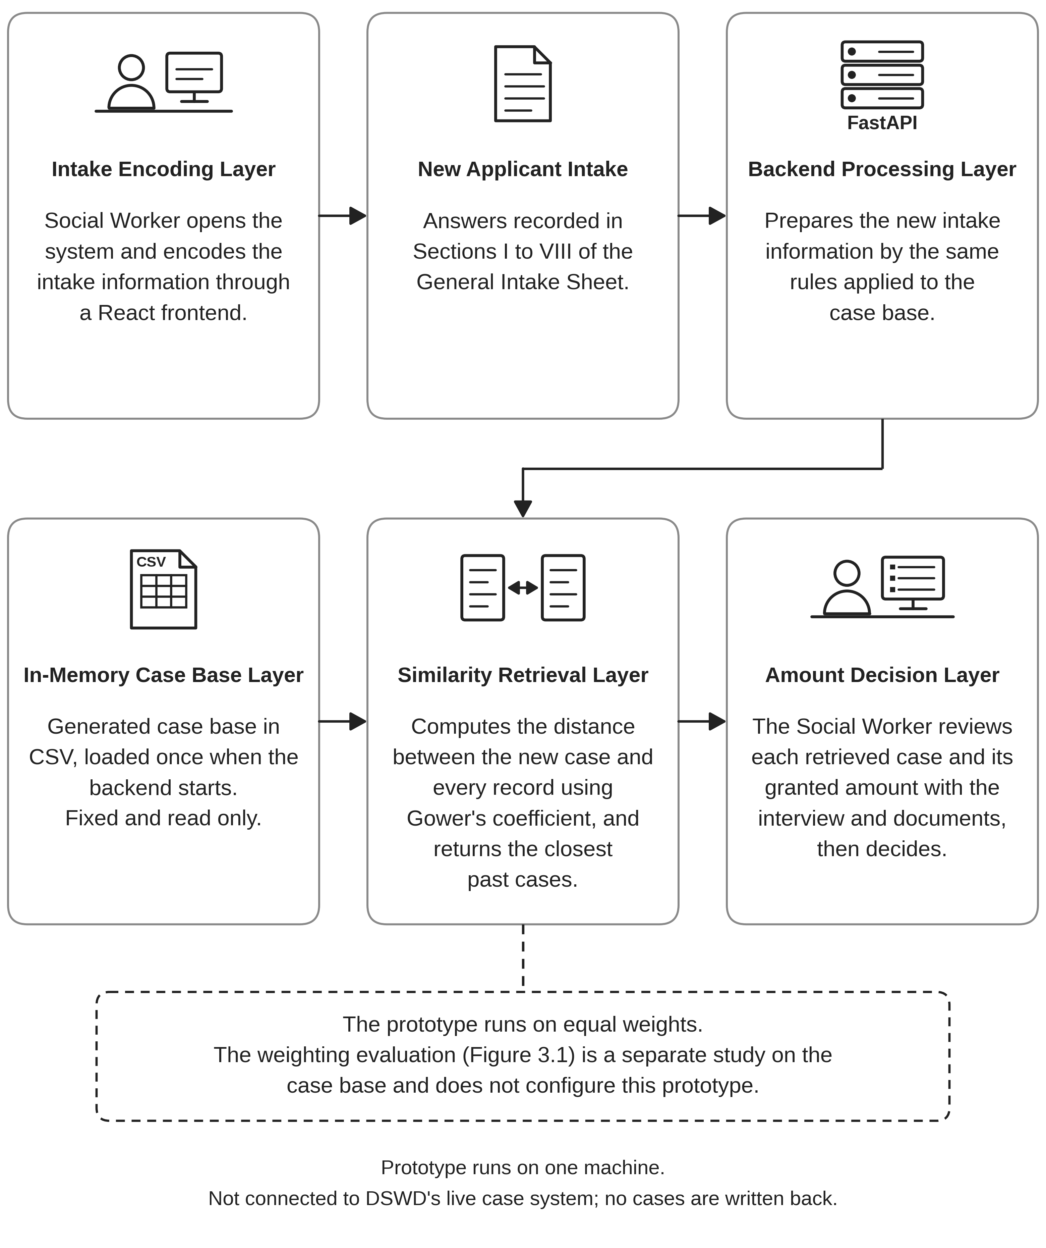
Note. Researchers' diagram of the prototype workflow; the prototype runs on one machine and is not connected to DSWD's live case system.
3.4 Ethical Considerations
This study uses no DSWD client records. Every case in the case base and among the test cases is generated by the researchers from the structure of the General Intake Sheet, and no record, de-identified or otherwise, was received from DSWD, as Section 3.2.1 explains. No real applicant appears in the dataset. The forty test cases are prepared records, so no real applicant's assistance decision depends on anything in this study, and the prototype is not connected to DSWD's live case system.
If a social worker answers any of the case sheets, as Section 3.2.1 allows for the eight near-pair pages, they are a human participant, and the study treats them as such. Taking part is voluntary. A social worker may decline, or may stop at any point without giving a reason, and declining or stopping does not affect their work. Before answering, each participant is told that the cases are prepared rather than real, that there is no right answer, and that they may say a sheet does not give enough information to decide. The packet does not say in advance which pages are paired, and the design of the packet is explained to each participant once the answers are returned.
No individual answer is attributed to anyone. The study does not record which social worker gave which answer, and written reasons, where they are quoted, are not linked to a person. Results are reported only as totals and patterns, such as how many near pairs moved in the same direction as the rule. Because at most one or two social workers are expected to take part, the report does not name them or give their position, so that an answer cannot be traced to a person through the report. If more than one social worker takes part, the study reports how many did, and not who.
References
Aamodt, A., & Plaza, E. (1994). Case-based reasoning: Foundational issues, methodological variations, and system approaches. AI Communications, 7(1), 39–59. https://doi.org/10.3233/AIC-1994-7104
Aiken, E., Bellue, S., Karlan, D., Udry, C., & Blumenstock, J. E. (2022). Machine learning and phone data can improve targeting of humanitarian aid. Nature, 603(7903), 864–870. https://doi.org/10.1038/s41586-022-04484-9
Belle, N., Cantarelli, P., & Wang, S. Y. (2024). The management of bias and noise in public sector decision-making: Experimental evidence from healthcare. Public Management Review, 26(11), 3246–3269. https://doi.org/10.1080/14719037.2024.2322159
Bergmark, Å., & Stranz, H. (2025). A safety net for all? Vignette-based assessments of Swedish social assistance over three decades. Journal of Social Policy, 54(3), 829–846. https://doi.org/10.1017/S0047279422000988
Busuioc, M. (2021). Accountable artificial intelligence: Holding algorithms to account. Public Administration Review, 81(5), 825–836. https://doi.org/10.1111/puar.13293
Chala, O., Bilova, T., Dyomina, V., Pobizhenko, I., & Domina, T. (2024). Ontologically supported case-based reasoning for decision making in humanitarian response processes. In Proceedings of the Modern Data Science Technologies Workshop (MoDaST-2024) (CEUR Workshop Proceedings, Vol. 3723, pp. 365–382). CEUR-WS.org. https://ceur-ws.org/Vol-3723/paper20.pdf
Cheng, Z., & Yan, A. (2023). A case weighted similarity deep measurement method based on a self-attention Siamese neural network. Industrial Artificial Intelligence, 1, Article 2. https://doi.org/10.1007/s44244-022-00002-y
Department of Social Welfare and Development. (n.d.). Knowledge resource corner [List of AICS issuances]. Retrieved September 24, 2026, from https://aics.dswd.gov.ph/knowledge-resource-corner
Department of Social Welfare and Development. (2022a). Memorandum Circular No. 15, series of 2022: Updated guidelines for the implementation of the Assistance to Individuals in Crisis Situation program.
Department of Social Welfare and Development. (2022b). Memorandum Circular No. 16, series of 2022: Revised guidelines on the implementation of the Assistance to Individuals in Crisis Situation.
Department of Social Welfare and Development. (2024, October 7). DSWD continues giving ‘ayuda’ through various programs like AICS, AKAP. https://pia.gov.ph/press-release/dswd-continues-giving-ayuda-through-various-programs-like-aics-akap/
Department of Social Welfare and Development Policy Development and Planning Bureau. (2022). Process evaluation of the Assistance to Individuals in Crisis Situation (AICS). Research and Evaluation Division, Department of Social Welfare and Development.
Dietrich, S., Malerba, D., & Gassmann, F. (2024). Predicting social assistance beneficiaries: On the social welfare damage of data biases. Data & Policy, 6, Article e3. https://doi.org/10.1017/dap.2023.38
Eiró, F., & Lotta, G. (2024). On the frontline of global inequalities: A decolonial approach to the study of street-level bureaucracies. Journal of Public Administration Research and Theory, 34(1), 67–79. https://doi.org/10.1093/jopart/muad019
Feng, C., Wang, H., Lu, N., Chen, T., He, H., Lu, Y., & Tu, X. M. (2014). Log-transformation and its implications for data analysis. Shanghai Archives of Psychiatry, 26(2), 105–109. https://doi.org/10.3969/j.issn.1002-0829.2014.02.009
Finnie, G., & Sun, Z. (2003). R5 model for case-based reasoning. Knowledge-Based Systems, 16(1), 59–65. https://doi.org/10.1016/S0950-7051(02)00053-9
Garcia-Gomez, P., Koning, P., O'Donnell, O., & Riumalló-Herl, C. (2025). Selective exercise of discretion in disability insurance awards. Journal of Policy Analysis and Management, 44(3), 816–835. https://doi.org/10.1002/pam.22560
Gibbs, J., Coughlan, B., Morgan, T., Mikushnica, A., Phippard, S., Crozier-Roche, F., Drayak, T., Graham, D., Smith, J., & Duschinsky, R. (2025). Which factors in a child welfare worker's environment influence their decision-making about neglect? A systematic narrative literature review. Trauma, Violence, & Abuse. Advance online publication. https://doi.org/10.1177/15248380251320987
Gower, J. C. (1971). A general coefficient of similarity and some of its properties. Biometrics, 27(4), 857–871. https://doi.org/10.2307/2528823
Granviken, F., Vasseljen, O., Bach, K., Jaiswal, A., & Meisingset, I. (2024). Decision support for managing common musculoskeletal pain disorders: Development of a case-based reasoning application. JMIR Formative Research, 8, e44805. https://doi.org/10.2196/44805
Grimmelikhuijsen, S. (2023). Explaining why the computer says no: Algorithmic transparency affects the perceived trustworthiness of automated decision-making. Public Administration Review, 83(2), 241–262. https://doi.org/10.1111/puar.13483
Handastya, N., & Betti, G. (2023). The “double fuzzy set” approach to multidimensional poverty measurement: With a focus on the health dimension. Social Indicators Research, 166(1), 201–217. https://doi.org/10.1007/s11205-023-03065-1
Kawakami, A., Sivaraman, V., Cheng, H.-F., Stapleton, L., Cheng, Y., Qing, D., Perer, A., Wu, Z. S., Zhu, H., & Holstein, K. (2022). Improving human-AI partnerships in child welfare: Understanding worker practices, challenges, and desires for algorithmic decision support. In Proceedings of the 2022 CHI Conference on Human Factors in Computing Systems (pp. 1–18). Association for Computing Machinery. https://doi.org/10.1145/3491102.3517439
Kawakami, A., Sivaraman, V., Stapleton, L., Cheng, H.-F., Perer, A., Wu, Z. S., Zhu, H., & Holstein, K. (2022). "Why do I care what's similar?" Probing challenges in AI-assisted child welfare decision-making through worker-AI interface design concepts. In DIS '22: Proceedings of the 2022 ACM Designing Interactive Systems Conference (pp. 454–469). Association for Computing Machinery. https://doi.org/10.1145/3532106.3533556
Kenny, E. M., Ford, C., Quinn, M., & Keane, M. T. (2021). Explaining black-box classifiers using post-hoc explanations-by-example: The effect of explanations and error-rates in XAI user studies. Artificial Intelligence, 294, 103459. https://doi.org/10.1016/j.artint.2021.103459
Kenny, E. M., & Keane, M. T. (2021). Explaining deep learning using examples: Optimal feature weighting methods for twin systems using post-hoc, explanation-by-example in XAI. Knowledge-Based Systems, 233, 107530. https://doi.org/10.1016/j.knosys.2021.107530
Kunz, R., Giezendanner, S., von Allmen, D. Y., Jeger, J., Eichhorn, M., Hoffmann-Richter, U., Fischer, K., & de Boer, W. (2026). The reproducibility of structured functional assessments in a social security setting: A pre-specified explanatory analysis of the RELY-studies. Frontiers in Psychiatry, 16, Article 1643221. https://doi.org/10.3389/fpsyt.2025.1643221
Kusumadewi, S., Wahyuningsih, H., & Wahyuni, E. G. (2024). Graded mean integration representation and intuitionistic fuzzy weighted arithmetic mean for similarity measures in case-based reasoning. International Journal of Fuzzy Systems, 26(6), 1802–1826. https://doi.org/10.1007/s40815-024-01704-4
Lipsky, M. (2010). Street-level bureaucracy: Dilemmas of the individual in public services (30th anniversary expanded ed.). Russell Sage Foundation. (Original work published 1980)
Liu, P., Yuan, H., Ning, Y., Chakraborty, B., Liu, N., & Peres, M. A. (2024). A modified and weighted Gower distance-based clustering analysis for mixed type data: A simulation and empirical analyses. BMC Medical Research Methodology, 24, Article 305. https://doi.org/10.1186/s12874-024-02427-8
Montani, S. (2008). Exploring new roles for case-based reasoning in heterogeneous AI systems for medical decision support. Applied Intelligence, 28(3), 275–285. https://doi.org/10.1007/s10489-007-0046-2
Noll, R., Schaaf, J., & Storf, H. (2022). The use of computer-assisted case-based reasoning to support clinical decision-making: A scoping review. In M. T. Keane & N. Wiratunga (Eds.), Case-based reasoning research and development: ICCBR 2022 (Lecture Notes in Computer Science, Vol. 13405, pp. 395–409). Springer. https://doi.org/10.1007/978-3-031-14923-8_26
Onsay, E. A., & Baltar, K. C. (2026). A machine learning approach in predicting poverty in the poorest region of Luzon, Philippines. International Journal of Population Studies, 12(2), 23–46. https://doi.org/10.36922/ijps.4879
Philippine News Agency. (2025, January 6). Over 6M Filipinos in crisis assisted by DSWD in 2024. https://www.pna.gov.ph/articles/1241118
Philippine News Agency. (2026, January 5). DSWD serves over 8M Filipinos in crisis in 2025. https://www.pna.gov.ph/articles/1266212
Philippine Statistics Authority Regional Statistical Services Office XI. (2024, October 25). 2023 poverty statistics of Davao Region (Special Release No. SR-24RSSO11-0030). https://rsso11.psa.gov.ph/content/2023-poverty-statistics-davao-region
Republic of the Philippines. (1987). The Constitution of the Republic of the Philippines. https://www.officialgazette.gov.ph/constitutions/1987-constitution/
Romeo, L., & Frontoni, E. (2022). A unified hierarchical XGBoost model for classifying priorities for COVID-19 vaccination campaign. Pattern Recognition, 121, 108197. https://doi.org/10.1016/j.patcog.2021.108197
Rudin, C. (2019). Stop explaining black box machine learning models for high stakes decisions and use interpretable models instead. Nature Machine Intelligence, 1(5), 206–215. https://doi.org/10.1038/s42256-019-0048-x
Sanjaya, R., Fatihah, I. C., & Abdul Rahman, T. K. (2025). Determining social assistance recipients using fuzzy-TOPSIS method in Sumur Bandung district Indonesia. Indonesian Journal of Electrical Engineering and Computer Science, 40(1), 366–378. https://doi.org/10.11591/IJEECS.V40.I1.PP366-378
Schoenborn, J. M., Weber, R. O., Aha, D. W., Cassens, J., & Althoff, K.-D. (2021). Explainable case-based reasoning: A survey. In Proceedings of the Explainable Agency in Artificial Intelligence Workshop at the 35th AAAI Conference on Artificial Intelligence. AAAI.
Sørmo, F., Cassens, J., & Aamodt, A. (2005). Explanation in case-based reasoning: Perspectives and goals. Artificial Intelligence Review, 24(2), 109–143. https://doi.org/10.1007/s10462-005-4607-7
Wettschereck, D., Aha, D. W., & Mohri, T. (1997). A review and empirical evaluation of feature weighting methods for a class of lazy learning algorithms. Artificial Intelligence Review, 11, 273–314. https://doi.org/10.1023/A:1006593614256
Wobcke, W., & Mariyah, S. (2023). Machine learning and data augmentation in the proxy means test for poverty targeting. Statistical Journal of the IAOS, 39(4), 961–977. https://doi.org/10.3233/SJI-230033
Wu, H., & Xu, Z. (2021). Fuzzy logic in decision support: Methods, applications and future trends. International Journal of Computers Communications & Control, 16(1), Article 4044. https://doi.org/10.15837/ijccc.2021.1.4044
Yan, A., & Cheng, Z. (2024). A review of the development and future challenges of case-based reasoning. Applied Sciences, 14(16), Article 7130. https://doi.org/10.3390/app14167130
Zadeh, L. A. (1965). Fuzzy sets. Information and Control, 8(3), 338–353. https://doi.org/10.1016/S0019-9958(65)90241-X
Zheng, J., Wang, Y. M., & Zhang, K. (2025). A decision-making model with similarity measurement for case selection in public health treatment. International Journal of Machine Learning and Cybernetics, 16(1), 337–360. https://doi.org/10.1007/s13042-024-02217-0

