Exercício SNMPv1
Joice Alves Marek; Henrique Krausburg Corrêa
1.
Comando: snmpget -v 1 -c public localhost sysName
sem instancia retorna: Error in packet. - Reaseon: (noSuchName) – não existe o nome da variável na MIB (necessário informar instância)
Comando: snmpget -v 1 -c public localhost sysName.0
Retorno: SNMPv2-MIB::sysName.0 = STRING: labredes – Retornou o nome da máquina em uma variável tipo STRING

2.
- snmpget -v 1 -c public localhost sysLocation.0
SNMPv2-MIB::sysLocation.0 = STRING: Laboratorio 301
- snmpget -v 1 -c public localhost ifNumber.0
IF-MIB::ifNumber.0 = INTEGER: 3
- snmpget -v 1 -c public localhost ifDescr.1 ifDescr.2
IF-MIB::ifDescr.1 = STRING: lo
IF-MIB::ifDescr.2 = STRING: Realtek Semiconductor Co., Ltd.
- snmpget -v 1 -c public localhost ipInReceives.0
IP-MIB::ipInReceives.0 = Counter32: 3214

3.
Comando: snmpgetnext -v 1 -c public localhost ip
Resposta: IP-MIB::ipForwarding.0 = INTEGER: notForwarding(2)
Comando: snmpgetnext -v 1 -c public localhost ipForwarding.0
Resposta: IP-MIB::ipDefaultTTL.0 = INTEGER: 64
Comando: snmpgetnext -v 1 -c public localhost ipDefaultTTL.0
Resposta: IP-MIB::ipInReceives.0 = Counter32: 3232
Comando: snmpgetnext -v 1 -c public localhost ipInReceives.0
Resposta: IP-MIB::ipInHdrErrors.0 = Counter32: 0
Comando: snmpgetnext -v 1 -c public localhost ipInHdrErrors.0
Resposta: IP-MIB::ipInAddrErrors.0 = Counter32: 1
4.
Comando: snmpget -v 1 -c public localhost ifTable
Resposta: Error in packet Reason: (noSuchName) – Este erro é retornado porque o objeto não é um nodo folha.
5.
- snmpget -v 1 -c public localhost ifPhysAddress.2
IF-MIB::ifPhysAddress.2 = STRING: a4:1f:72:f5:90:59
- snmpget -v 1 -c public localhost icmpInEchos.0 icmpInEchoReps.0 icmpOutEchos.0 icmpOutEchoReps.0
IP-MIB::icmpInEchos.0 = Counter32: 0
IP-MIB::icmpInEchoReps.0 = Counter32: 0
IP-MIB::icmpOutEchos.0 = Counter32: 0
IP-MIB::icmpOutEchoReps.0 = Counter32: 0
- snmpget -v 1 -c public localhost snmpInGetNexts.0
SNMPv2-MIB::snmpInGetNexts.0 = Counter32: 11
- snmpset -v 1 -c private localhost sysLocation.0 = “LabRedes”
SNMPV2-MIB::sysLocation.0 = STRING: LabRedes

6.
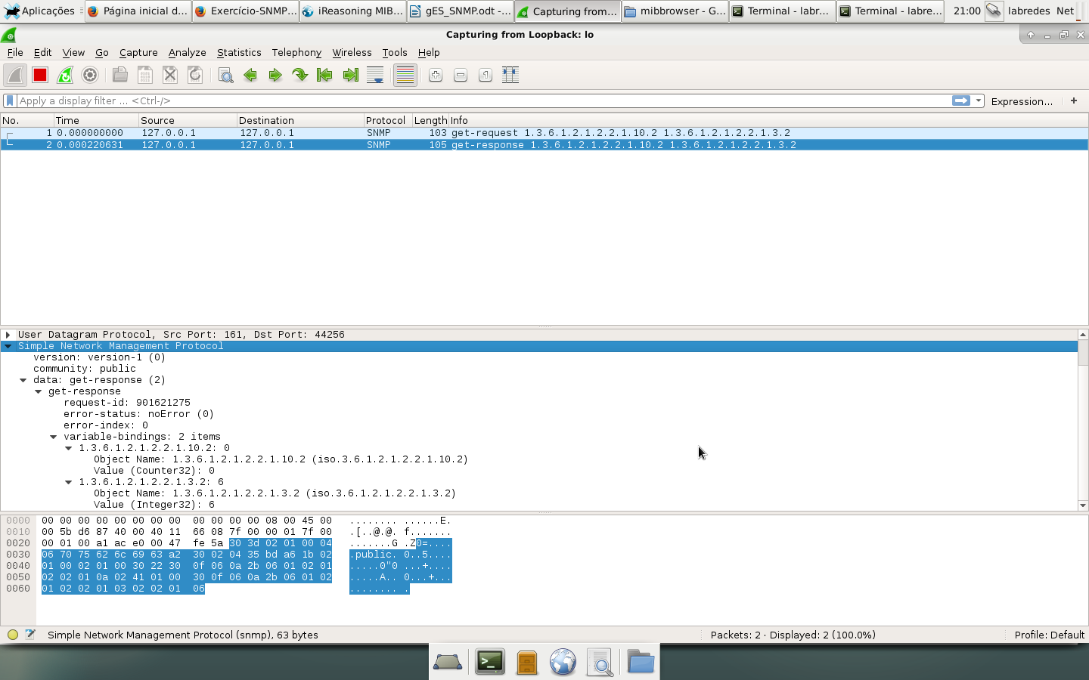

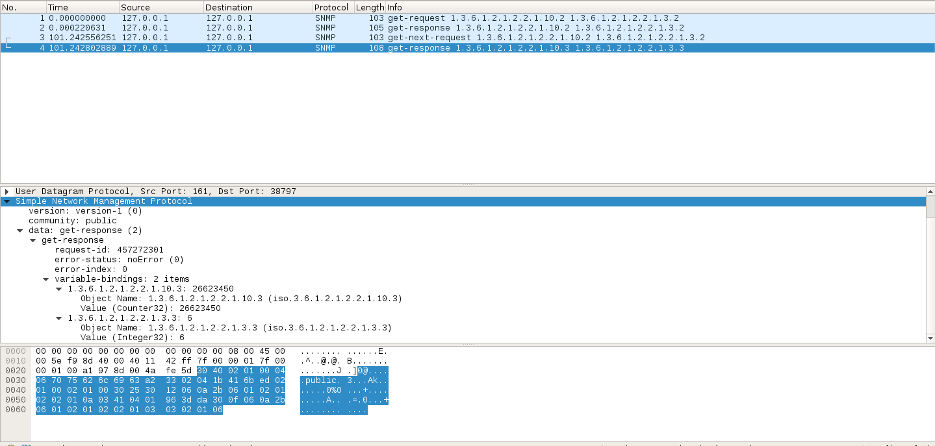

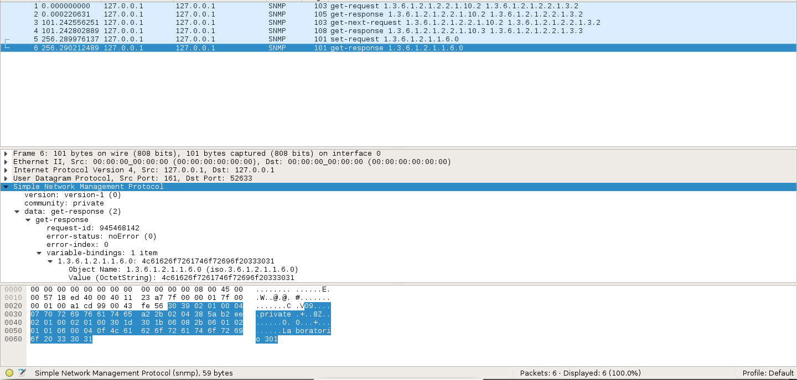

7.
a)

b)

c)

d)

