**Microprocessor Lab**

Laboratory Activity No. 2

**Arduino and Tinkercad Interface**

|  |
| --- |
|  |

Score

*Submitted by:*

**Chiong Maya, Henrich Bryan R.**

**<Sat 1:00-7:00> / <CpE 0412-2>**

*Date Submitted*

**30-09-23**

*Submitted to:*

**Engr. Maria Rizette H. Sayo**

I. Objectives

This laboratory activity aims to implement the principles and techniques of hardware programming using Arduino through:

- creating an Arduino programming and circuit diagram.

II. Method/s

- Perform a task problem given in the presentation.

- Write a code and perform an Arduino circuit diagram of a ring counter that display

eight (8)LEDs starting from left.

III. Results

**TinkerCad**

**Exercise 1: Write a code that does a ring counter display for eight (8) LEDs starting from left.**

Figure No.1 Ring Counter Display Circuit Diagram

**Components Used**

1. 8 LEDs
2. Resistor
3. Breadboard

**CODE:**

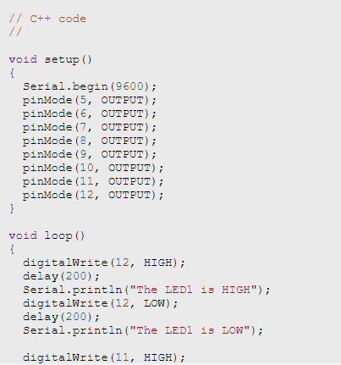

IV. Conclusion

To conclude this Laboratory activity, It begins by initializing the serial communication interface at a baud rate of 9600, ensuring efficient communication with external devices. Following this, the code configures eight specific pins as output pins, signifying their intended use for controlling external device presumably LEDs.

Within loop function, an LED is activated, creating an ON state, which is followed by pause or delay of 200 millisecns. Then a message is dispatched to the serial monitor, affirming the illuminated status of the LED. The LED is then deactivated, shifting it to an OFF state with 200 delay also. Moreover, ring counters contribute to clock synchronization in synchronous digital systems by producing clock signals with precise timing relationships. In essence, the significance of ring counters lies in their adaptability and utility across a spectrum of digital circuit and system tasks, making them a foundational component in modern electronics design.

**References**

1. techZeero. (2020, February 23). *Controlling Multiple LEDs With Arduino Uno - 6 Steps*. TechZeero. https://techzeero.com/arduino-tutorials/controlling-multiple-leds-with-arduino/

*<This is in a separate page>*