OpenSpace Backend Workflow and Upload Guide
PSB OpenSpace Capture Dashboard
This guide explains how the React frontend, Node.js API, SQLite database and private OpenSpace integration work together. The upload scenario is the main example because it touches every backend layer. The central rule is simple: React calls the PSB backend, the backend validates and stores data, and only server-side code communicates with OpenSpace.
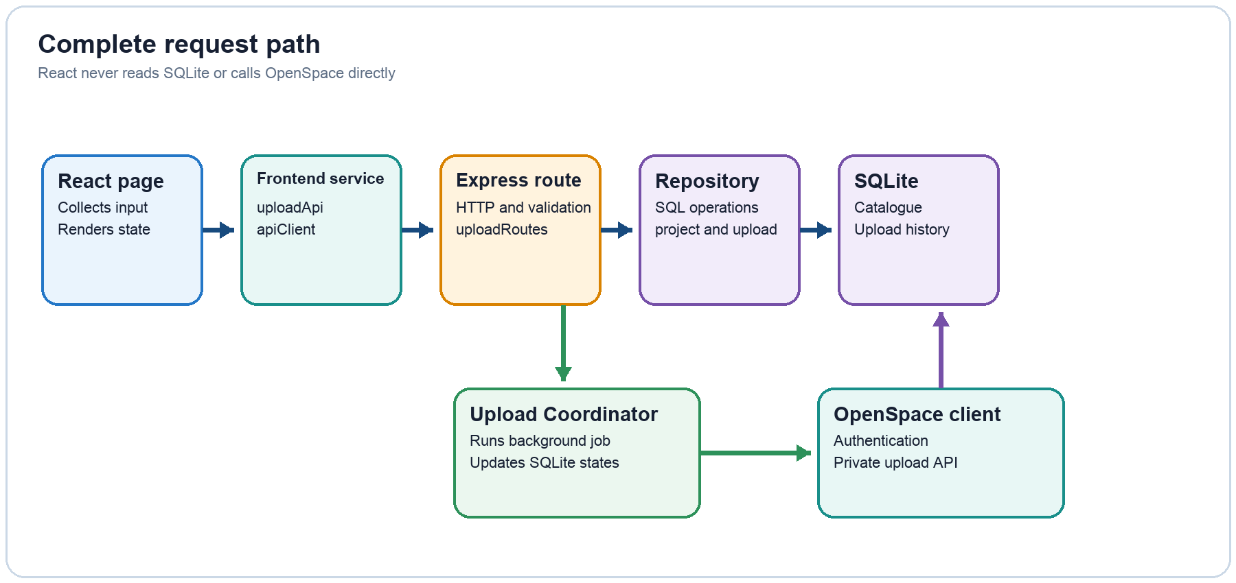

Main rule
Frontend pages never use SQLite or OpenSpace credentials directly. They call functions in the frontend service layer. Express routes receive those requests, repositories own SQL, and the Upload Coordinator owns long-running remote work.

How the backend starts
Starting the API creates the shared objects once. Every later request reuses these objects instead of opening a new database or rebuilding the integration client.
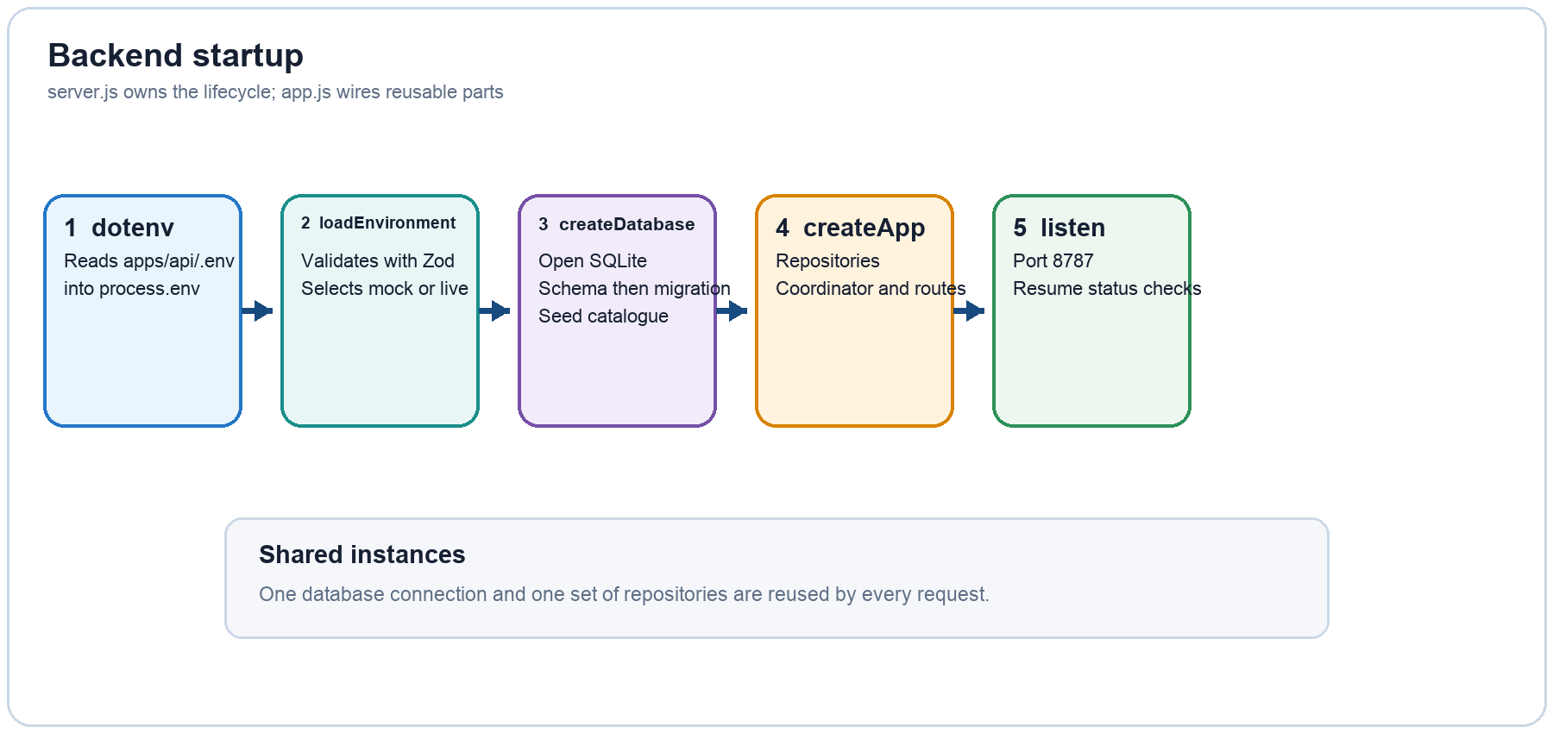
- server.js: entry point that loads configuration, creates SQLite and starts port 8787
- connection.js: opens SQLite, applies schema.js, runs migrations.js and then seed.js
- app.js: constructs repositories and the coordinator, mounts routers and provides the final error handler
- Shutdown: SIGINT or SIGTERM closes the HTTP server and SQLite connection cleanly

Backend file map
Use this map to decide which file should contain a change. Each layer has one clear responsibility.
Layer | Main files | Responsibility
Configuration | config/environment.js | Validate .env values and expose normalized runtime settings.
Database | database/schema.js  database/migrations.js  database/seed.js | Create tables, upgrade older local databases and maintain the approved PSB catalogue.
Repositories | projectRepository.js  uploadRepository.js | Run parameterized SQL and map SQLite rows into API objects.
HTTP routes | projectRoutes.js  dashboardRoutes.js  uploadRoutes.js | Receive requests, validate input, select status codes and delegate work.
Upload engine | services/uploadCoordinator.js | Control background upload, cancellation, retry and processing polling.
OpenSpace | openspace/client.js  openspace/urlId.js | Authenticate and execute the private capture-upload requests.
Composition | app.js  server.js | Create dependencies, mount routes and own application startup and shutdown.

Upload scenario from browser to backend
When a user submits the New Upload form, the API first receives the file safely and creates a durable local record. Remote OpenSpace work begins only after that record exists.
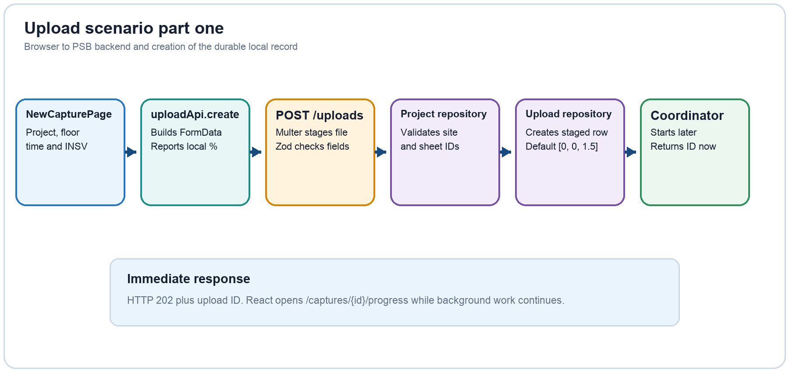
- Frontend: uploadApi.create calls uploadForm in apiClient.js using FormData and XMLHttpRequest
- File intake: uploadRoutes.js uses Multer to accept one .insv file into data/uploads
- Validation: Zod checks form fields and projectRepository confirms the site and sheet combination
- Persistence: uploadRepository creates a staged SQLite row with the documented default start position
- Response: the route returns HTTP 202 and an upload ID without waiting for OpenSpace processing

Upload scenario from backend to OpenSpace
The Upload Coordinator continues in the background. In mock mode it simulates the same status sequence; in live mode it delegates private API requests to client.js.
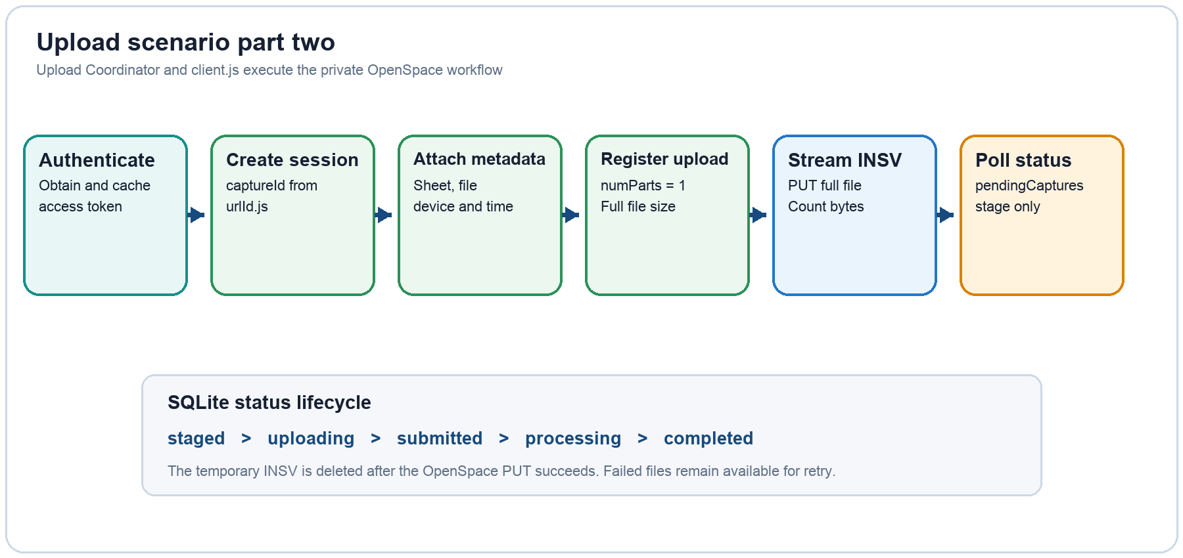
- Credentials: client.js reads them from the backend environment; they are never returned to React
- Identifiers: urlId.js creates URL-safe random capture and upload identifiers
- Single-part upload: registerUpload sets numParts to one and uploadFile streams the complete INSV
- Processing: layout2 is used only for the documented pendingCaptures status check
- Cleanup: the staged local file is removed after the OpenSpace PUT succeeds

How dashboard history and dropdowns load
Read-only pages follow the same round trip: page, frontend service, Express route, repository and SQLite. Results return through the same layers before React renders them.
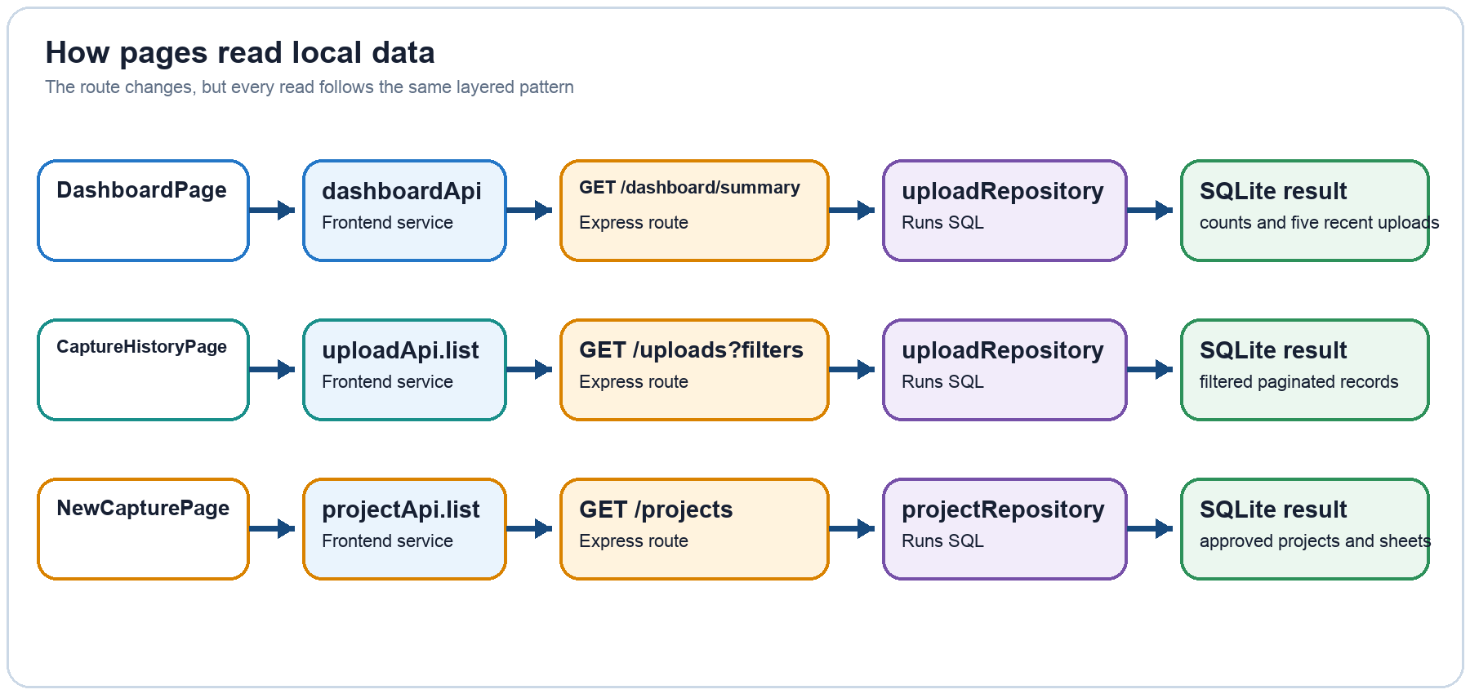
- Dashboard: getDashboardSummary calculates total, in-progress, completed and failed counts locally
- History: uploadRepository.list supports search, status, project, date and pagination filters
- Dropdowns: projectRepository.list returns approved local projects with their configured sheets
- No project-list API: PSB staff add OpenSpace site and sheet IDs to the local catalogue

How progress retry and cancellation work
Two file transfers and one remote processing stage are different. The application shows only the information that is actually available at each stage.
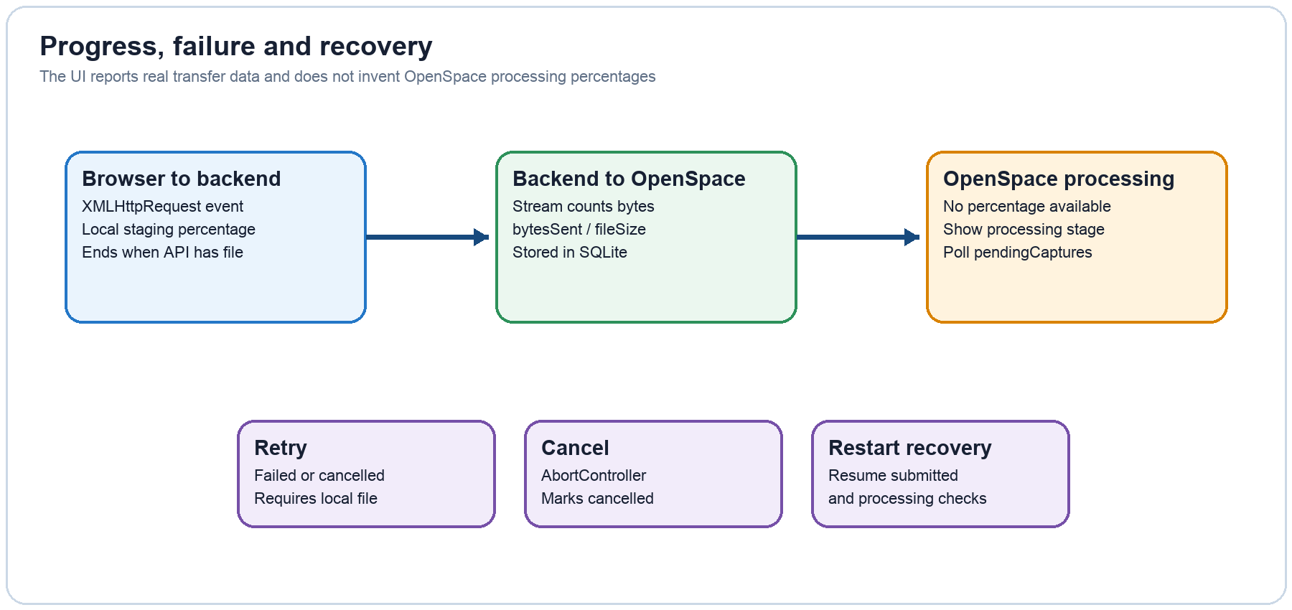
- Local percentage: XMLHttpRequest measures browser-to-backend staging progress
- OpenSpace percentage: the streaming transform counts backend-to-OpenSpace bytes
- Processing stage: no processing percentage is available, so the UI displays a state only
- Progress page: polls GET /api/uploads/{id} and reads the latest SQLite record
- Failure safety: errors are stored for display; retry requires the original local file

Environment dependencies and developer checklist

How environment files work
.env.example documents every supported setting and is safe to commit because its secret fields are blank. Each backend developer creates a private apps/api/.env file. dotenv loads that file into process.env, and loadEnvironment validates the values before the server starts. Live credentials must remain server-side and must never be placed in React, screenshots, logs or GitHub.

What replaces requirements.txt
requirements.txt belongs to Python projects. This project uses Node.js, so dependencies are described by package.json files. The root package.json also defines npm workspaces and shared commands. package-lock.json records the exact resolved versions so every teammate installs the same dependency tree with npm install.
Developer task | Frontend call | Backend path
Show dashboard | dashboardApi.getSummary | dashboardRoutes > uploadRepository > SQLite
Show history | uploadApi.list | uploadRoutes > uploadRepository > SQLite
Load dropdowns | projectApi.list | projectRoutes > projectRepository > SQLite
Submit INSV | uploadApi.create | uploadRoutes > repositories > Upload Coordinator
Show progress | uploadApi.get | uploadRoutes > uploadRepository > SQLite
Retry or cancel | uploadApi.retry / cancel | uploadRoutes > Upload Coordinator > uploadRepository

Run locally
1 nvm use
2 npm install
3 npm run dev
4 Frontend: localhost:5173 Backend health: localhost:8787/api/health

