PSB UNIVERSITY PROJECT
OpenSpace Robot Capture, IoT and AI Platform
Project Proposal
Prepared for | Lecturer, project team, school management and AWS collaborators
Prepared by | Henrick and the PSB OpenSpace project team
Version | Draft 1.1 — architecture and Insta360 X5 update
Date | 23 August 2026
Project period | August 2026 to July 2027

Proposal status. This document presents the proposed project scope, phased implementation and expected outputs for team and stakeholder discussion. Technical details may be refined through prototypes and consultation with AWS, OpenSpace and the selected hardware providers.

Executive summary
This proposal presents the OpenSpace university project as a robot-based platform that combines 360-degree site capture, IoT sensing, data visualisation, machine learning and a later AI assistant. AWS services will provide the main cloud foundation for the IoT and AI workstream, while the student team will remain responsible for implementation, testing and documentation.
The implementation is divided into three phases, and each phase will end with a visible and testable output for the management team. Phase 1 will demonstrate end-to-end connectivity from Raspberry Pi sensors to an AWS-hosted frontend dashboard. Phase 2 will introduce a clearly defined machine-learning task and display the resulting analysis in the same frontend. Phase 3 will explore edge AI and generative AI, including AWS IoT Greengrass, Amazon Bedrock and Amazon Bedrock AgentCore where these services fit the agreed use case.
A connected camera workstream will use the confirmed Insta360 X5 8K 360 camera with replaceable lenses. Official Insta360 documentation shows a normal phone workflow through Bluetooth-assisted discovery and the camera's 5 GHz Wi-Fi, while the official desktop Camera SDK lists X5 support for USB control, capture and file download. This makes a Raspberry Pi bridge a realistic prototype direction, but SDK access terms, Raspberry Pi compatibility, sustained transfer and panorama processing still require validation.
Main proposal. Build the AWS IoT–AI platform in three demonstrable phases while continuing a parallel technical-discovery workstream for the robot-mounted 360° camera. Connect the two workstreams later through shared project, mission, time and location identifiers.

1. Project background and rationale
Construction, facility and research environments can produce several forms of site information, including visual records, robot status and environmental measurements. These data sources are often viewed separately, which makes it harder to understand what was observed, where it was collected and how conditions changed over time. The proposed project will investigate whether a robot-mounted platform and one web application can organise these records into a clearer project workflow.
The robot platform is expected to carry an Insta360 X5 8K 360 camera and a Raspberry Pi connected to selected IoT sensors. Users should be able to organise work by project and floor plan, review robot missions, view sensor information and manage capture sessions through one web application. The current proposal separates confirmed X5 capabilities from the integration work that still needs prototyping. Machine learning will be used to analyse a defined sensor-data problem, while a later AI assistant may help users explore validated project information using natural-language questions.
The school’s collaboration with AWS provides a supported cloud pathway for the IoT and AI parts of the pilot. AWS IoT services can connect the Raspberry Pi to cloud data stores, an API layer can supply the web application, SageMaker AI can support model training or deployment, and Greengrass and Bedrock services can be evaluated for the final edge and generative AI phase. A phased approach allows the team to demonstrate progress while keeping the project suitable for student development and evaluation.

2. Aim and objectives
Project aim.
To develop and evaluate a student-built robot platform that can collect site information, visualise IoT data, integrate an Insta360 X5 capture workflow, apply machine learning to selected sensor problems, and later provide an AI-assisted way to explore validated project information.
The project objectives are to:
- establish a secure end-to-end data path from Raspberry Pi sensors through AWS IoT Core to cloud storage and a web dashboard;
- produce a visible management demonstration at the end of every phase;
- define and evaluate a meaningful machine-learning problem using data collected by the project;
- evaluate whether a locally trained model can be packaged, stored, hosted or deployed using SageMaker AI and/or AWS IoT Greengrass;
- develop an AI assistant only after the underlying data, permissions and use cases are sufficiently clear;
- continue technical investigation of camera control, file transfer, panorama processing and 360-degree viewing;
- maintain traceability across projects, robot missions, sensor records, captures, model versions and frontend outputs.

3. Project scope and boundaries
Area | Currently in scope | Boundary or point to confirm
Robot and IoT | Raspberry Pi, selected sensors, device status, timestamped readings and secure cloud connectivity. | Final sensor package, sampling rate, robot interfaces and on-site networking remain to be confirmed.
AWS cloud platform | IoT Core, S3, API Gateway, Lambda, authentication, metadata storage and Amplify hosting. The live telemetry database is still to be selected. | Final region, account structure, telemetry store, service limits, sponsorship and governance will be agreed with AWS and the school.
Machine learning | Problem definition, data preparation, student-developed baseline/model, evaluation and frontend display. | Exact use case and success measures depend on the sensors and available representative data.
Edge and generative AI | Greengrass-based edge experiments and a narrow Bedrock/AgentCore assistant prototype. | These are Phase 3 items, not Phase 1 requirements; the design must be justified by a real use case.
360° capture | Confirmed Insta360 X5 camera; project/floor-plan workflow; capture records; USB/Wi-Fi transfer investigation; S3 storage and viewer research. | SDK access terms, Raspberry Pi validation, automated upload, panorama processing and OpenSpace platform access remain to be confirmed.
Frontend | A web application for phase outputs, project context, sensor visualisation, ML results and later assistant access. | Final capture controls and 360° viewer behaviour depend on the camera integration findings.

4. Proposed solution overview
The proposed solution uses the Raspberry Pi as the robot-side gateway. It reads selected sensors and publishes small structured messages to AWS IoT Core. A live telemetry database will be selected with AWS; Amazon S3 will store raw datasets, floor plans, model artefacts and, if approved, large X5 media files. The X5 should not send large files through IoT Core. Instead, a robot-side bridge can request time-limited upload permission from the backend and transfer files directly to S3. API Gateway, Lambda, authentication and metadata storage provide the remaining backend functions used by the Amplify-hosted web application. Later phases add machine-learning output and an AI assistant without changing the identifiers established in Phase 1.

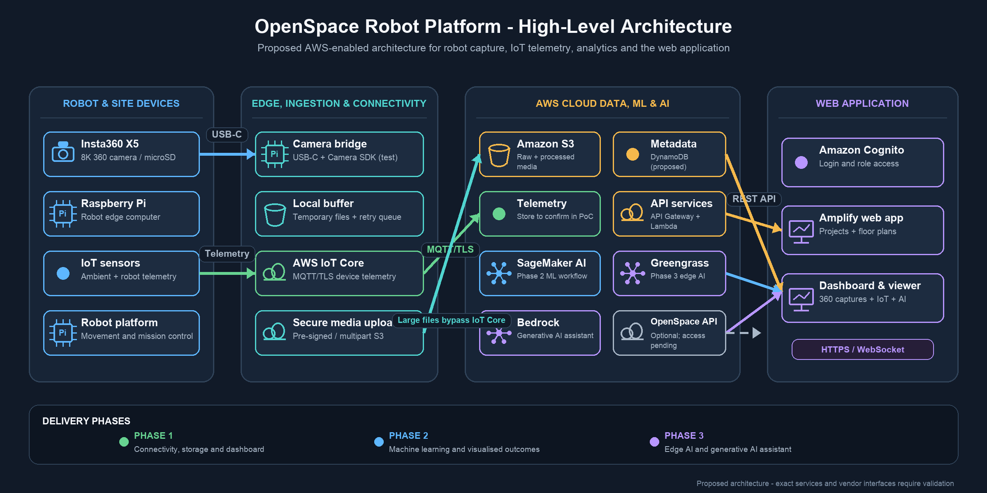
Figure 1. Proposed high-level architecture for the OpenSpace robot platform, Insta360 X5, AWS IoT/AI services and web application. Exact services and vendor interfaces remain subject to AWS, OpenSpace and Insta360 validation.
Important separation. Sensor telemetry and ML results can proceed through the AWS pathway even while the camera integration is unresolved. Large camera files should have their own validated transfer and storage design rather than being assumed to follow the sensor-message pathway.

5. Phase 1 — End-to-end connectivity and visualisation
Purpose. Phase 1 will prove that physical sensors can send trustworthy data from a Raspberry Pi to AWS and that authorised users can view the result in a web application. This phase creates the foundation for all later analysis.

5.1 Proposed AWS pathway
Component | Proposed role in Phase 1
Raspberry Pi and sensors | Read the selected measurements, apply timestamps and device identifiers, buffer short interruptions, and publish structured telemetry.
AWS IoT Core | Authenticate the device, receive MQTT messages and route selected fields through IoT rules.
Live telemetry database | Store recent time-series measurements. Selection is pending AWS confirmation; DynamoDB is a simple PoC option, while Timestream options depend on account access and cost.
Amazon S3 | Store raw/archived datasets, floor plans, model artefacts and approved camera files. S3 is object storage, not the complete application backend.
Amazon API Gateway + AWS Lambda | Provide a controlled API for the frontend when direct access is not appropriate.
AWS Amplify | Host and deploy the frontend web application and support an iterative student development workflow.

5.2 Detailed tasks
- Confirm the first sensor set and document the unit, range, accuracy, sample rate, calibration method and research question for each sensor.
- Prepare the Raspberry Pi environment and create a repeatable sensor-reading program with timestamps, device health and error flags.
- Register each test device in AWS IoT Core and apply a unique identity, certificate and least-privilege IoT policy.
- Define MQTT topics and a versioned JSON message schema that includes project, robot, device, sensor, value, unit, timestamp and quality fields.
- Configure rules to route time-series data to the selected telemetry database and selected raw or batch data to S3; do not assume access to Timestream for LiveAnalytics until AWS confirms it.
- Create the first API responses for latest readings, historical ranges, device status and data-quality information.
- Develop the Phase 1 dashboard with device cards, latest values, time-series charts, filters, freshness indicators and clear error states.
- Add logging, budget alerts, access control and a small test checklist for connectivity loss, invalid values and duplicate messages.
- Prepare a short management demonstration using real or controlled sensor readings.

5.3 Phase 1 demonstration and acceptance
- At least one Raspberry Pi publishes data securely to AWS IoT Core.
- The selected readings are stored and can be queried from the agreed cloud data stores.
- The frontend displays recent and historical values with the correct units and timestamps.
- A disconnected or delayed device is shown clearly rather than appearing healthy.
- The team can demonstrate the complete path from physical reading to dashboard output and explain each component.
- The design, schema, configuration and test evidence are documented so another team member can reproduce the prototype.

6. Phase 2 — Machine learning and analysed outcomes
Purpose. Phase 2 will use the collected data to answer one clearly defined problem, such as anomaly detection, environmental classification, forecasting or condition/risk indication. The phase should demonstrate learning and evaluation, not only the use of an automated tool.

6.1 Proposed model-development approach
The team should begin with a transparent baseline and a student-developed training workflow. This helps the awarded or AI-focused team members show their own understanding of data preparation, feature selection, model choice and evaluation. SageMaker AI can then be used as a managed environment for training, comparison, deployment or hosting where it adds value. AWS documentation also allows teams to bring their own training scripts or externally trained models, so the choice is not limited to a fully ready-made model.
Option | Educational value | Proposed use
Locally developed model | Makes preprocessing, algorithm choice, training and evaluation visible to the student team. | Preferred starting point when it can meet the agreed technical and assessment criteria.
SageMaker AI training | Provides managed training resources while still allowing the team to supply its own script, data and model design. | Use for repeatable experiments, comparison and managed compute after the baseline is understood.
Bring an external model to SageMaker AI | Allows a model trained outside SageMaker AI to be packaged and hosted using AWS services. | Evaluate if the student model performs well but needs a managed inference pathway.
SageMaker Canvas or built-in approaches | Can speed up exploration and provide comparison results. | Use as a benchmark or fallback

6.2 Detailed tasks
- Agree on one ML problem, target user, expected action and measurable success criteria before selecting a model.
- Create a versioned dataset from Phase 1 data while keeping raw, cleaned and labelled data separate.
- Document missing-value treatment, outlier handling, calibration corrections and feature engineering.
- Create train, validation and test splits that avoid leakage between related missions or time periods.
- Implement a simple non-ML or statistical baseline before training more complex models.
- Train and compare candidate models locally and/or in SageMaker AI, recording settings, versions and costs.
- Evaluate accuracy and practical errors, including false alarms and behaviour under missing or noisy sensor data.
- Store approved model artefacts and result files with model version, timestamp, prediction and confidence information.
- Expose approved analysis through the API and display it in the frontend without presenting predictions as confirmed facts.
- Prepare a management demonstration that compares source data, baseline and model output.

6.3 Phase 2 demonstration and acceptance
- The team can explain the selected ML problem and why the available data is suitable.
- A reproducible baseline and at least one trained model are evaluated using agreed measures.
- The frontend displays a model outcome together with its source period, model version and confidence or limitation.
- The team documents whether the model was trained locally, in SageMaker AI or through a combined approach.
- A fallback to SageMaker AI is available if the local training route cannot meet the required performance or schedule.

7. Phase 3 — Edge AI and generative AI
Purpose. Phase 3 will explore more advanced intelligence after the data pipeline and ML results are reliable. This phase will be the combination of a physical robot, sensing, edge processing and an AI-assisted user experience. The exact technical definition and assessment criteria should be agreed before implementation.

7.1 Edge AI with AWS IoT Greengrass
AWS IoT Greengrass can provide local compute, messaging and ML inference capabilities on a supported edge device. AWS documentation indicates that Greengrass can use models trained in SageMaker AI or custom pre-trained models stored in Amazon S3. This creates a possible path for running selected inference closer to the robot when latency, connectivity or offline operation makes cloud-only inference unsuitable.
- Confirm whether the chosen Raspberry Pi or robot computer meets the storage, operating-system and performance requirements for Greengrass and the selected model.
- Package the approved model, runtime and inference code as versioned components.
- Compare cloud and edge inference for latency, resource use, reliability and output consistency.
- Define safe local behaviour during lost connectivity and prevent an ML output from directly controlling unsafe robot actions.
- Send only required results or summaries back to the cloud and record model/component versions.

7.2 Generative AI assistant
The first assistant should be narrow and evidence-based. Possible questions include summarising sensor trends, explaining a model result, locating a project session, or identifying missing data. Amazon Bedrock can provide access to a foundation model. A controlled Lambda-based workflow may be enough for the first prototype. Amazon Bedrock AgentCore and a framework such as Strands Agents can be evaluated later if the project requires managed tools, identity, memory, monitoring or multi-step agent behaviour.
- Define approved assistant questions and explicitly list questions that are out of scope.
- Create read-only tools for validated project data, sensor summaries and approved model results.
- Require responses to identify the underlying project, time range, dataset or model result when possible.
- Add guardrails for unavailable data, low confidence, prompt injection, privacy and unsafe robot-control requests.
- Create a test set of expected answers, incorrect-answer examples and human-review criteria.
- Compare a simple Bedrock-and-Lambda prototype with an AgentCore-based approach only if the added complexity is justified.

7.3 Phase 3 demonstration and acceptance
- A validated model runs on the selected edge device, or the team produces documented evidence explaining why cloud inference is more suitable.
- The assistant answers a small approved set of questions using project data and clearly reports when evidence is unavailable.
- The team can show the separation between measured data, model predictions and generative explanations.
- No assistant response or model output is allowed to bypass robot safety controls or human approval.

8. Insta360 X5 capture and backend workstream
The camera model is now confirmed as the Insta360 X5 8K 360 camera with replaceable lenses. This removes one uncertainty, but it does not by itself confirm how the camera will be controlled from the robot or how its files will become a navigable web experience. Official capabilities, proposed integration and remaining dependencies are separated below.

8.1 Confirmed camera capabilities
- The selected camera is the Insta360 X5, which records 8K 360 video and uses replaceable lenses.
- The X5 records 360 video in INSV format and photos in INSP/JPEG-compatible workflows on a UHS-I V30-or-higher microSD card.
- The camera provides 5 GHz Wi-Fi, Bluetooth Low Energy 5.2 and USB-C 3.0 connectivity.
- Insta360's desktop Camera SDK lists X5 support for USB connection, parameter control, photo/video capture and file download, including Linux ARM64 builds.
- Insta360's Media SDK can stitch and export X5 media, but documented Linux support is x86-64 and the newer SDK requires a discrete GPU; processing on the Raspberry Pi must not be assumed.

8.2 Normal phone connection and transfer workflow
- Turn on the X5 and enable Wi-Fi and Bluetooth on the phone.
- Open the Insta360 app and select the camera. Bluetooth helps the app discover the camera, while the media connection uses the X5's 5 GHz Wi-Fi.
- Approve the first connection on the X5 touchscreen.
- Use the app to control recording and browse the camera album.
- Download footage into the Insta360 app or export processed media to the phone's local album.
- To upload through a normal website, the user selects the exported local file in the web application.
- Because the camera's Wi-Fi is used for camera transfer rather than Internet access, the phone may need cellular data or may need to reconnect to normal Wi-Fi before uploading.
- This phone workflow is useful for manual testing, but it does not provide the unattended robot workflow required for the final platform.
Current finding. The X5 has an official USB Camera SDK route that is more suitable for robot integration than relying on the consumer phone app. However, the team must still test the SDK on the selected Raspberry Pi, confirm access/licensing, and decide where stitching and panorama export will run.

8.3 Proposed robot-to-website workflow
The most suitable technical direction is a robot-side bridge rather than direct browser-to-camera communication. This is a proposed architecture, not yet a confirmed implementation.
- Connect the X5 to the Raspberry Pi through USB-C and select Android mode, as required by the desktop Camera SDK.
- Run a small bridge service on the Pi to discover the camera, start or stop recording, read status and download newly captured files into a local staging folder.
- Create a capture manifest containing project ID, floor ID, mission ID, camera ID, timestamps, file names, sizes and checksums.
- Request a short-lived pre-signed upload URL from the project's API and upload large files directly to a private S3 bucket. Use multipart upload for large videos.
- Store project and capture metadata separately, for example in DynamoDB, while S3 stores the actual files.
- Run stitching/export on a supported workstation or approved cloud processing service if it cannot run reliably on the Pi.
- Store the processed panorama in S3 and let authorised users access it through the web application using controlled URLs.
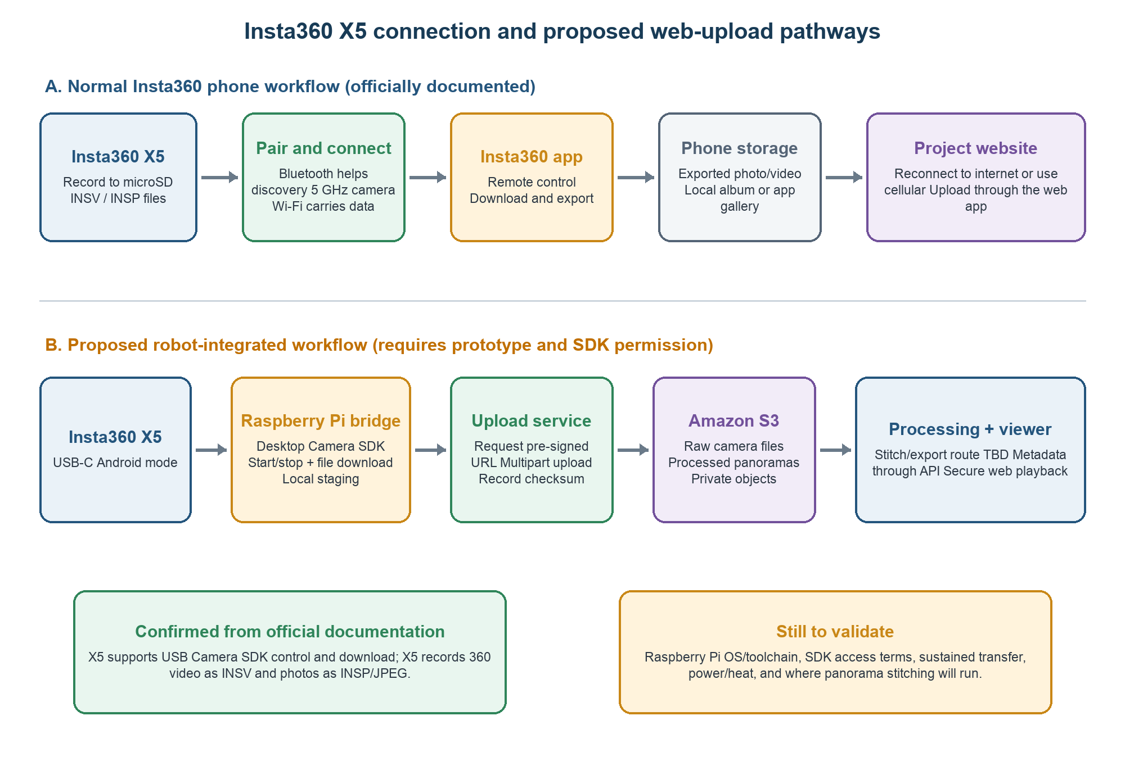
Figure 2. Official phone workflow and proposed robot-integrated X5-to-S3 workflow. Orange items require validation.

8.4 Backend and storage decision
Amazon S3 can store the X5's INSV, INSP, JPEG and exported video files. It is general-purpose object storage and is not limited to IoT data. However, S3 is only one backend service. A complete application backend also needs authentication, API/business logic, metadata storage, permissions, processing and monitoring.
Three integration positions should be discussed:
- Independent AWS backend — the team controls the X5 through a robot-side bridge, stores media in S3, keeps metadata in DynamoDB, and exposes approved functions through API Gateway and Lambda. This is technically feasible in principle and should be the main prototype path.
- OpenSpace-hosted integration — OpenSpace stores/processes captures and the PSB frontend consumes an approved OpenSpace API. This should only be selected if OpenSpace provides the required product access, raw/processed-media endpoints and control permissions.
- Hybrid integration — AWS stores IoT data and project metadata while OpenSpace processes or hosts 360 captures. The frontend links both sources using shared project, mission, time and location identifiers.
Current evidence does not confirm that OpenSpace will provide its complete enterprise backend. OpenSpace publicly documents a paid Usage API for organisation-level reporting, but that is not evidence of an API for camera control, raw media upload, panorama processing or viewer delivery. The project should therefore request the provider documentation and keep the independent AWS route available.

8.5 Required feasibility tests
- Confirm the Raspberry Pi model, operating system and CPU architecture, then obtain the correct X5 Camera SDK package and usage permission.
- Test USB detection, Android mode, start/stop recording, file listing, file download and recovery after disconnect or power loss.
- Measure transfer speed, CPU/RAM use, camera temperature, Pi power demand and storage required for a representative mission.
- Collect sample INSV and INSP files and confirm whether the required panorama output can be created on a supported x86-64/GPU workstation or approved cloud worker.
- Test pre-signed and multipart S3 uploads, checksums, retry behaviour, duplicate prevention and incomplete-upload cleanup.
- Confirm whether OpenSpace will provide any project-specific API, processing or viewer access before committing to an OpenSpace-hosted or hybrid backend.

9. Frontend application across the three phases
The frontend should remain one web application rather than separate demonstration products. Each phase will add a small set of pages or modules to a shared project structure. This approach reduces duplicated UI work and gives management a consistent place to view progress.
Page or module | Phase 1 | Phase 2 | Phase 3 / camera workstream
Dashboard | Device status, latest readings, freshness and basic alerts. | Analysed outcomes and model status. | Assistant entry point and edge status where approved.
Projects / Sites | Project and device context. | Dataset and experiment links. | Capture sessions and approved assistant scope.
IoT Data | Live/history charts and filters. | Measured-versus-predicted view. | Edge/cloud comparison and explanations.
ML Results | Placeholder and data readiness. | Predictions, confidence, model version and evaluation summary. | Edge deployment status and assistant tools.
360° Capture | X5 capability test, manual file upload and capture metadata structure. | Sensor/capture alignment by shared time, mission and location identifiers. | Robot-side X5 control, automated S3 upload and 360° viewer only after feasibility validation.
Administration | Device registry, schema versions and access roles. | Model/dataset versions. | Assistant permissions, audit and guardrail settings.

10. Data and integration principles
Shared identifiers. Project, floor, mission, robot, device, sensor, capture and model identifiers should be stable across local files, AWS resources and frontend API responses.
Time and location. All systems should use an agreed time-zone and timestamp format. Approximate locations must include a confidence or quality indicator.
Data layers. Raw measurements, cleaned datasets, model outputs and generative explanations must remain distinguishable.
Versioning. Schemas, datasets, processing scripts, models, Greengrass components and frontend API contracts should be versioned.
Local-first compatibility. The data model should allow early testing with local files while keeping a clear mapping to the AWS-hosted implementation.
API boundaries. The frontend should access data through a defined service layer instead of embedding storage credentials or service-specific logic in page components.
Camera-file separation. Raw X5 files, exported/stitched panoramas, thumbnails and capture metadata should use separate object prefixes and lifecycle rules. File content belongs in S3; searchable project and capture metadata belongs in the selected metadata database.

11. Security, ethics and responsible AI
- Use a unique device identity and least-privilege permissions for each Raspberry Pi or robot gateway.
- Protect IoT communication using the AWS-supported authentication and TLS approach; do not store private device keys in the frontend repository.
- Separate student development, demonstration and any later deployment environment where practical.
- Limit access to project, sensor, camera and model data according to school and site requirements.
- Do not present model output as a confirmed safety or engineering decision without validation and human review.
- Test the AI assistant for unsupported claims, data leakage, harmful instructions and prompt injection.
- Keep an audit trail of model versions, assistant tools and important configuration changes.
- Agree retention and deletion rules before collecting real on-site images or potentially sensitive environmental data.

12. Collaboration, governance and ownership
The school–AWS collaboration creates an opportunity for architecture review, technical mentoring and possible support with service selection. However, student ownership of implementation and learning outcomes should remain clear. The following responsibilities are proposed for discussion rather than assigned as final roles.
Group | Proposed responsibility
Programme leader — Dr. Julia | Coordinate the pilot, align school and AWS discussions, confirm academic expectations and approve phase reviews.
AWS collaborators | Review architecture and security, advise on service selection, provide technical guidance and clarify available support or sponsorship.
Frontend / IT team | Maintain information architecture, shared components, API integration, dashboards, capture workflow and user testing.
IoT / hardware team | Select and integrate sensors, prepare Raspberry Pi devices, validate readings and support robot-side deployment.
Data / ML / AI team | Define the ML problem, prepare data, train/evaluate models, explore Greengrass and implement the approved assistant prototype.
Whole project team | Document decisions, review phase outputs, test integrations, manage risks and prepare management demonstrations.

13. Provisional schedule and management demonstrations
The proposed project period is August 2026 to July 2027. In-house development is planned from August 2026 to February 2027, followed by on-site deployment and improvement from February to July 2027. The exact phase boundaries will be confirmed through technical scoping and team task allocation.
Period | Main focus | Visible output for review
Aug–Sep 2026 | Requirements, AWS account/governance setup, sensor selection, schemas and Phase 1 prototype. | First Raspberry Pi reading received in AWS and shown in a simple frontend.
Oct–Nov 2026 | Complete Phase 1 reliability, API and dashboard; continue camera technical discovery. | End-to-end IoT dashboard demonstration and Phase 1 technical note.
Nov 2026–Jan 2027 | Phase 2 dataset preparation, model baseline, training and evaluation. | ML outcome displayed in the frontend with evaluation evidence.
Jan–Feb 2027 | Phase 3 prototype, edge feasibility and narrow AI-assistant use case; deployment preparation. | Edge/cloud comparison and controlled assistant demonstration.
Feb–Jul 2027 | On-site deployment, data collection, reliability testing, refinement and final evaluation. | Site-trial evidence, refined models/dashboard, final report and demonstration.

14. Main risks and responses
Risk | Possible effect | Proposed response
X5 SDK access, Raspberry Pi compatibility or processing route is unavailable | Automated camera control, transfer or panorama viewing cannot be completed as proposed. | Test the official USB Camera SDK early; keep manual phone/USB transfer as an MVP fallback; validate processing separately on supported hardware.
Insufficient sensor data | The ML phase cannot produce a meaningful validated model. | Choose a narrow task, collect controlled data early, use a baseline and treat prediction claims conservatively.
Ready-made ML reduces student learning evidence | The work may not satisfy assessment or award requirements. | Start with student-developed preprocessing and a local baseline; use SageMaker AI as a platform, comparison or fallback.
AWS design becomes too complex | The team spends time on infrastructure rather than demonstrating outcomes. | Keep each phase small, use managed services only when their purpose is clear, and review architecture with AWS.
Unexpected cost or resource sprawl | Testing may exceed the project budget or leave unused resources running. | Use budgets, alerts, tagging, scheduled cleanup and phase-specific resource reviews.
Security or privacy gap | Device credentials, images or site data could be exposed. | Apply least privilege, separate credentials from code, review data governance and test before on-site deployment.
Team integration mismatch | Frontend, IoT and AI outputs use incompatible structures. | Agree shared identifiers, schemas, API contracts and component ownership before parallel implementation.

15. Immediate next steps
- Confirm the proposal and phase outputs with the lecturer, project members and AWS technical contacts.
- Nominate provisional owners for Phase 1 device setup, IoT Core, data storage, API and frontend dashboard tasks.
- Select the first two or three sensors and write their data dictionary and message schema.
- Agree the AWS account, region, identity, budget and environment structure before creating resources.
- Complete a one-device proof of connectivity and record the setup as a repeatable guide.
- Confirm the first ML research question early so Phase 1 collects useful data rather than arbitrary data.
- Obtain the Insta360 X5 Camera SDK package/permission, sample media and licensing terms; run the USB-to-Raspberry-Pi feasibility tests before finalising capture architecture.
- Update the wireframe to show the Phase 1 dashboard and the separation between confirmed IoT functions and provisional 360° functions.
- Schedule formal end-of-phase demonstrations and define the evidence required for each review.

16. Questions for the AWS technical-scoping discussion
- Is the proposed IoT Core → selected telemetry database/S3 → API Gateway/Lambda → Amplify pathway suitable for a small student pilot?
- Which AWS Region and account/environment structure should the school use for development and on-site trials?
- What reference architecture, sample code, workshops or technical mentoring can AWS provide?
- Which security controls should be mandatory before a Raspberry Pi is connected outside the laboratory?
- Which live telemetry store should be used, considering that Timestream for LiveAnalytics is closed to new customers unless the sponsoring payer account already has access?
- What is the most suitable SageMaker AI path for a student-developed model and for hosting a model trained outside AWS?
- What Raspberry Pi or edge-device limitations should be considered before adopting Greengrass and local inference?
- For the Phase 3 assistant, when is a simple Bedrock invocation preferable to AgentCore?
- What credits, sponsorship, sandbox accounts, service quotas and support channels are available to the pilot?
- Can AWS review the proposed X5 → Raspberry Pi bridge → pre-signed S3 upload → processing → web-viewer pathway, including large-file transfer, metadata, security and cost?

17. Conclusion
The AWS collaboration gives the OpenSpace project a clearer and more achievable path for its IoT and AI platform. Dividing the work into three phases allows the project team to demonstrate progress regularly: first a working sensor-to-dashboard pathway, then an evaluated ML outcome, and finally a carefully controlled edge and generative AI prototype. This phased method also protects the educational value of the project because each stage requires the team to explain, test and document what it has built.
The Insta360 X5 is now confirmed as the project's robot-mounted camera. Official USB SDK support provides a credible direction for control and file download through a Raspberry Pi bridge, while Amazon S3 can store raw and processed media. The remaining work is to validate the SDK on the chosen Pi, confirm software access and licensing, select a stitching/export environment and clarify whether OpenSpace will provide any backend or viewer services. Shared project, mission, time and location identifiers will allow the camera, IoT and AI workstreams to remain connected whichever backend option is approved.
This proposal is intended to guide project planning and stakeholder discussion. Its technical details should be refined after AWS review, the Insta360 X5 feasibility prototype, confirmation of the telemetry database and receipt of any OpenSpace provider documentation.

References
[1] AWS, “AWS IoT Core — Amazon Timestream integration.” Official documentation
[2] AWS, “AWS IoT security.” Official documentation
[3] AWS, “Amazon SageMaker AI model training.” Official documentation
[4] AWS, “Machine learning components in AWS IoT Greengrass.” Official documentation
[5] AWS, “Amazon Bedrock AgentCore.” Official documentation
[6] AWS, “Amazon S3: uploading objects.” Official documentation
[7] AWS, “Download and upload objects with pre-signed URLs.” Official documentation
[8] AWS, “Timestream for LiveAnalytics availability change.” Official documentation
[9] Insta360, “Insta360 X5 product specifications.” Official product page
[10] Insta360, “Connect X5 to the Insta360 app.” Official manual
[11] Insta360, “X5 file transfer.” Official manual
[12] Insta360Develop, “Desktop Camera SDK and Media SDK overview.” Official developer documentation
[13] OpenSpace, “Usage API.” Official Help Center

