OPENSPACE PROJECT
Capture Upload and
AWS Integration
Visual Process and Architecture Brief
A diagram-led explanation of the local MVP, OpenSpace private API workflow, secure credential handling, S3 research archive, ML data preparation and future AWS deployment.

Prepared for the OpenSpace technical discussion | 1 September 2026

System flow
From camera file to the final OpenSpace viewer
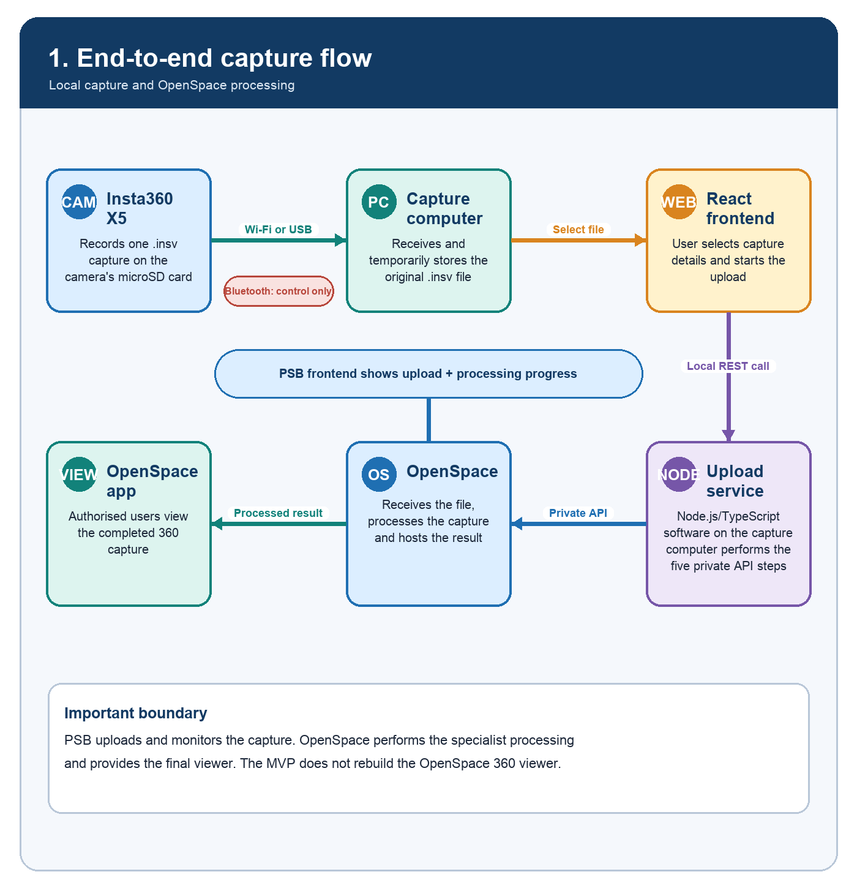
Explanation. The camera creates an INSV file. The capture computer stores it temporarily, and the local Node.js service performs the OpenSpace private API workflow while React displays progress.
Implementation note. The upload service streams an existing file; it is not a live camera stream. OpenSpace remains responsible for processing and final viewing.
Source: OpenSpace Capture Upload API - Private Integration (supplied to the PSB project team).

Local-first MVP
The first implementation uses a local React app and computer-based upload service
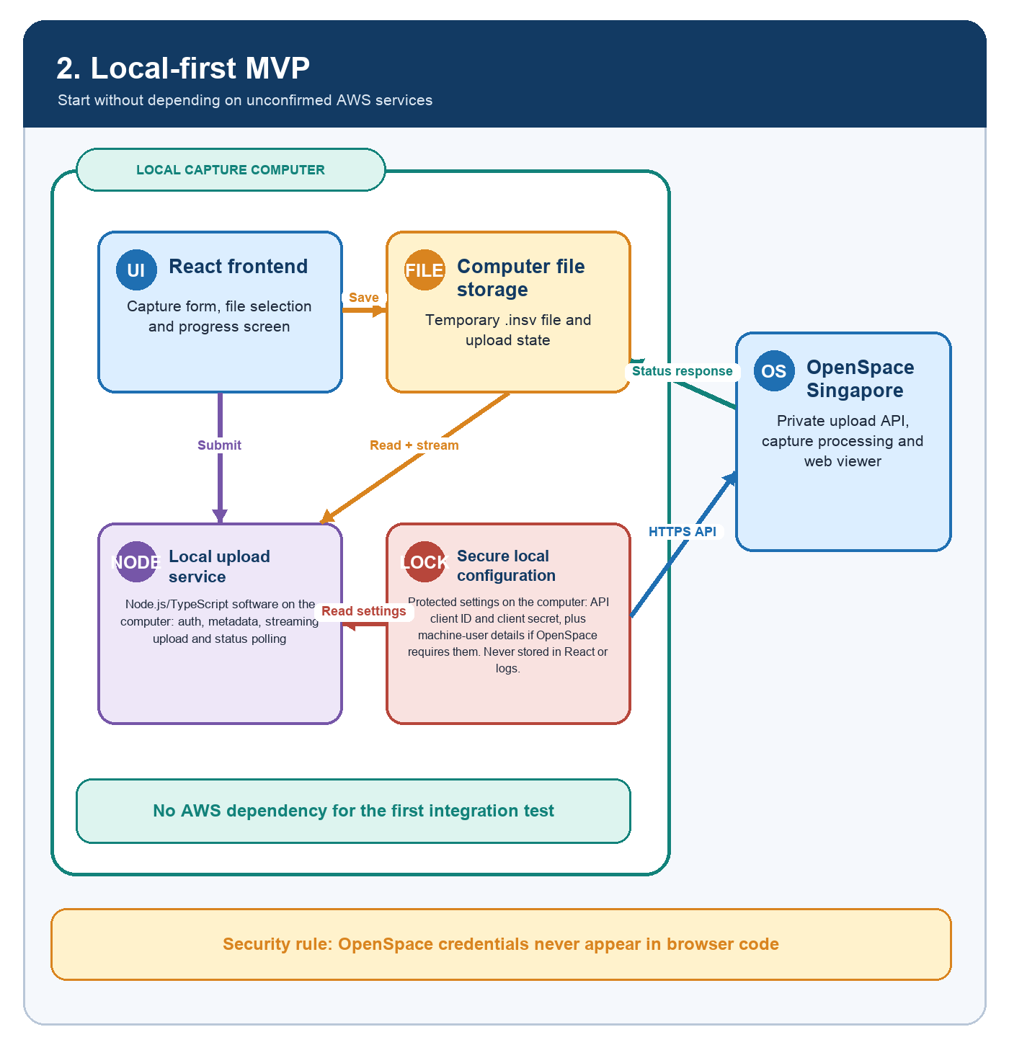
Explanation. React provides the user interface. A separate Node.js/TypeScript service on the same computer protects credentials, reads the file and calls OpenSpace.
Implementation note. The 1Password item appears to contain an API client ID and client secret. OpenSpace should confirm the token flow, required scopes and whether a separate machine-user identity is also required. Credentials must never be embedded in React browser code.
Source: OpenSpace Capture Upload API - Private Integration (supplied to the PSB project team).

Five API steps
The exact workflow described in the supplied private integration document
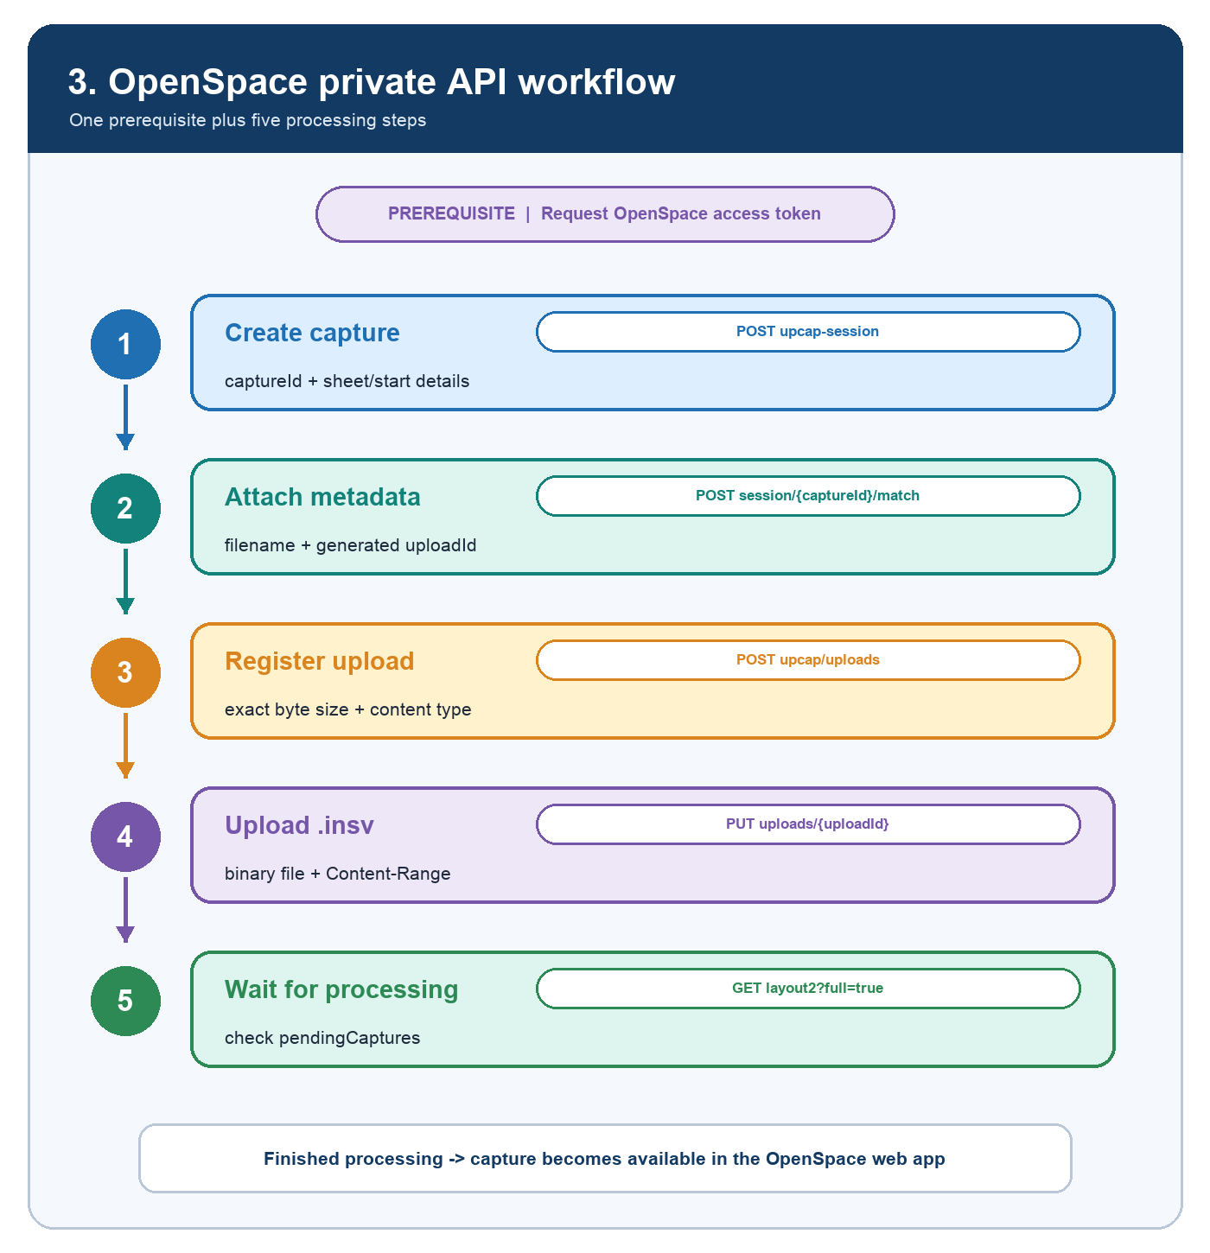
Explanation. After obtaining an access token, the uploader creates the capture, attaches metadata, registers the file, uploads the binary and monitors processing.
Implementation note. Each capture should have a local job record so failed steps can be diagnosed and retried without confusing the user.
Source: OpenSpace Capture Upload API - Private Integration (supplied to the PSB project team).

Progress and status
What users can see in the PSB frontend
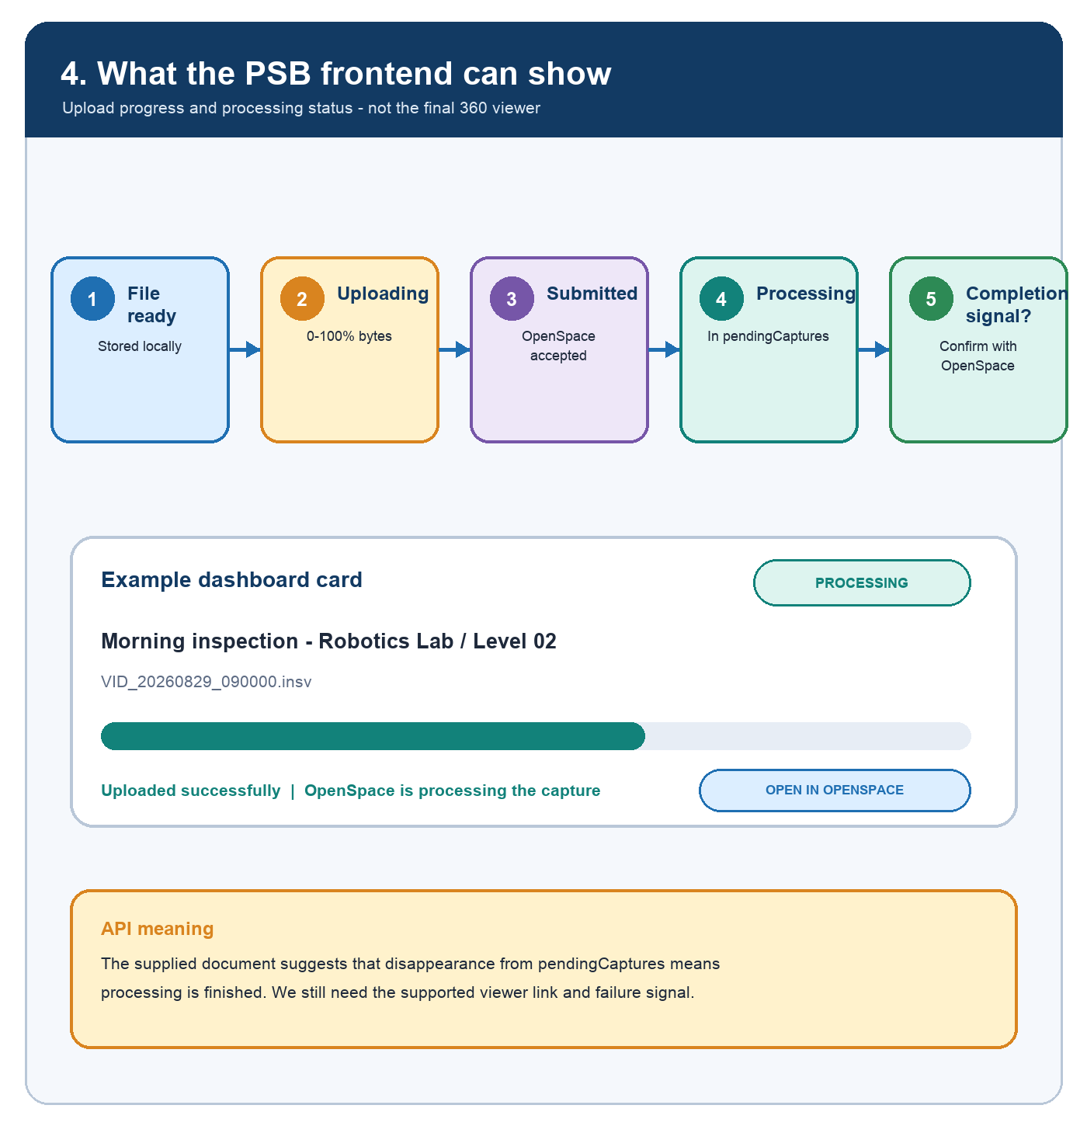
Explanation. The PSB dashboard can show local file readiness, byte-upload progress, submission and OpenSpace processing status. The completed visual is opened in OpenSpace.
Implementation note. The team should confirm the supported success and failure signals, and how the frontend obtains the final OpenSpace capture/viewer link or identifier.
Source: OpenSpace Capture Upload API - Private Integration (supplied to the PSB project team).

Future AWS architecture
The combined capture, IoT, ML and AI dashboard after approval
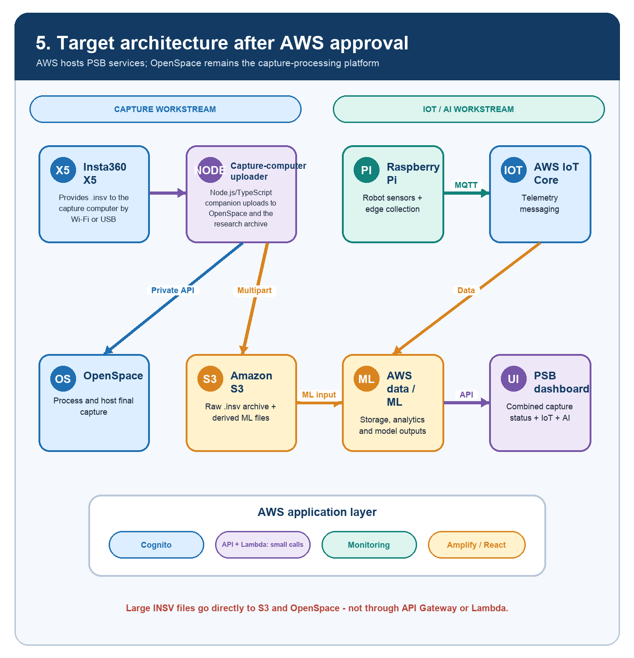
Explanation. The capture-computer uploader sends the same source file to two independent destinations: OpenSpace for specialist processing and Amazon S3 for the PSB research archive.
Implementation note. API Gateway and Lambda handle only small control, token, metadata and status requests. Large INSV bytes should go directly to OpenSpace and S3 using resumable or multipart upload.
AWS references: S3 Uploading Objects; S3 Multipart Upload; S3 Presigned URLs.

Research archive and ML
Preparing capture files and IoT telemetry for machine learning
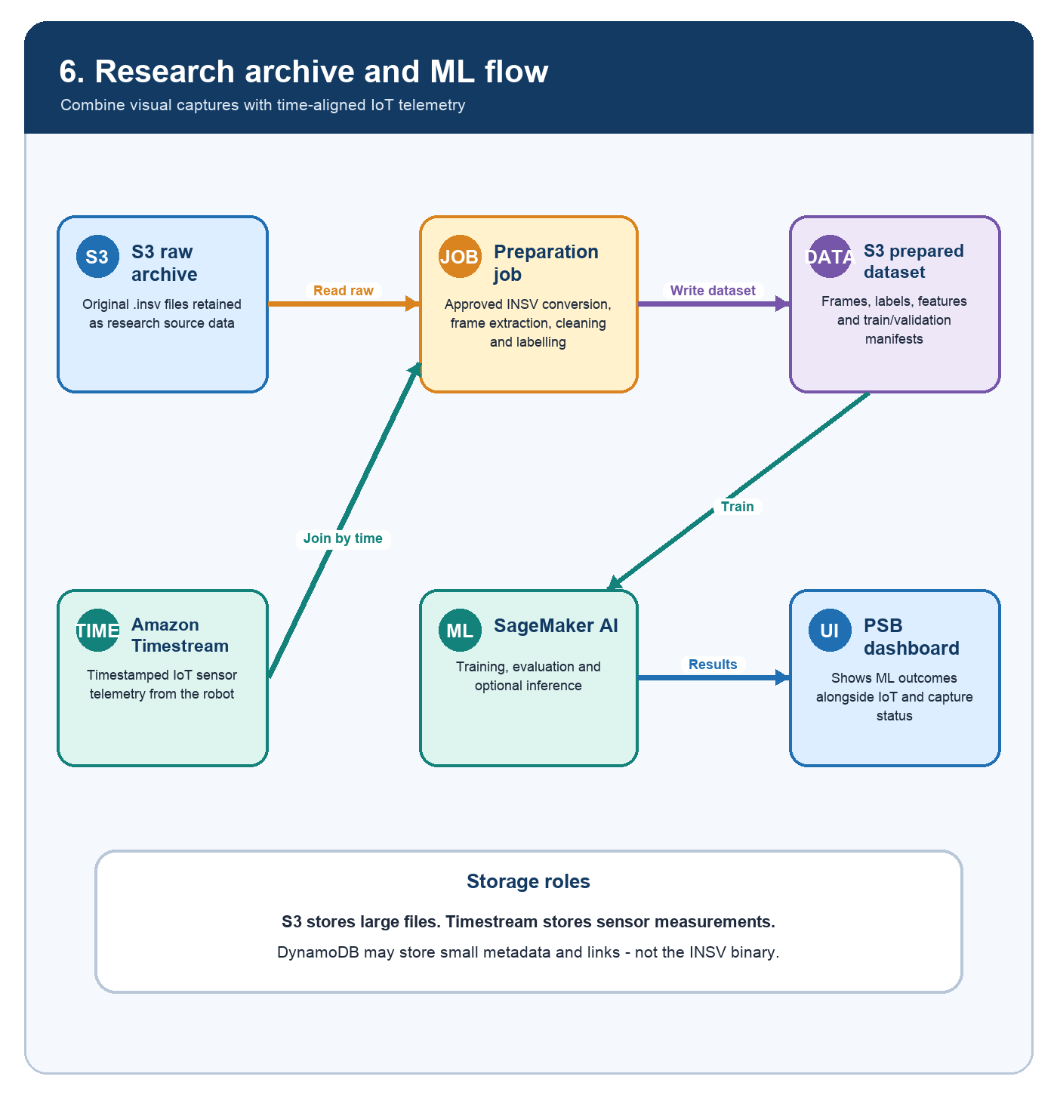
Explanation. Amazon S3 can store the original INSV and derived frames, labels and model outputs. Timestream is suitable for time-series sensor readings, while DynamoDB may hold identifiers and object links.
Implementation note. The raw INSV may require an approved conversion or frame-extraction step before ML. Capture and sensor records should share timestamps, project, floor and robot identifiers.
AWS references: DynamoDB large-item guidance; SageMaker training data from S3; Amazon Timestream.

Migration plan
Move from local proof of concept to the AWS pilot without changing the user journey
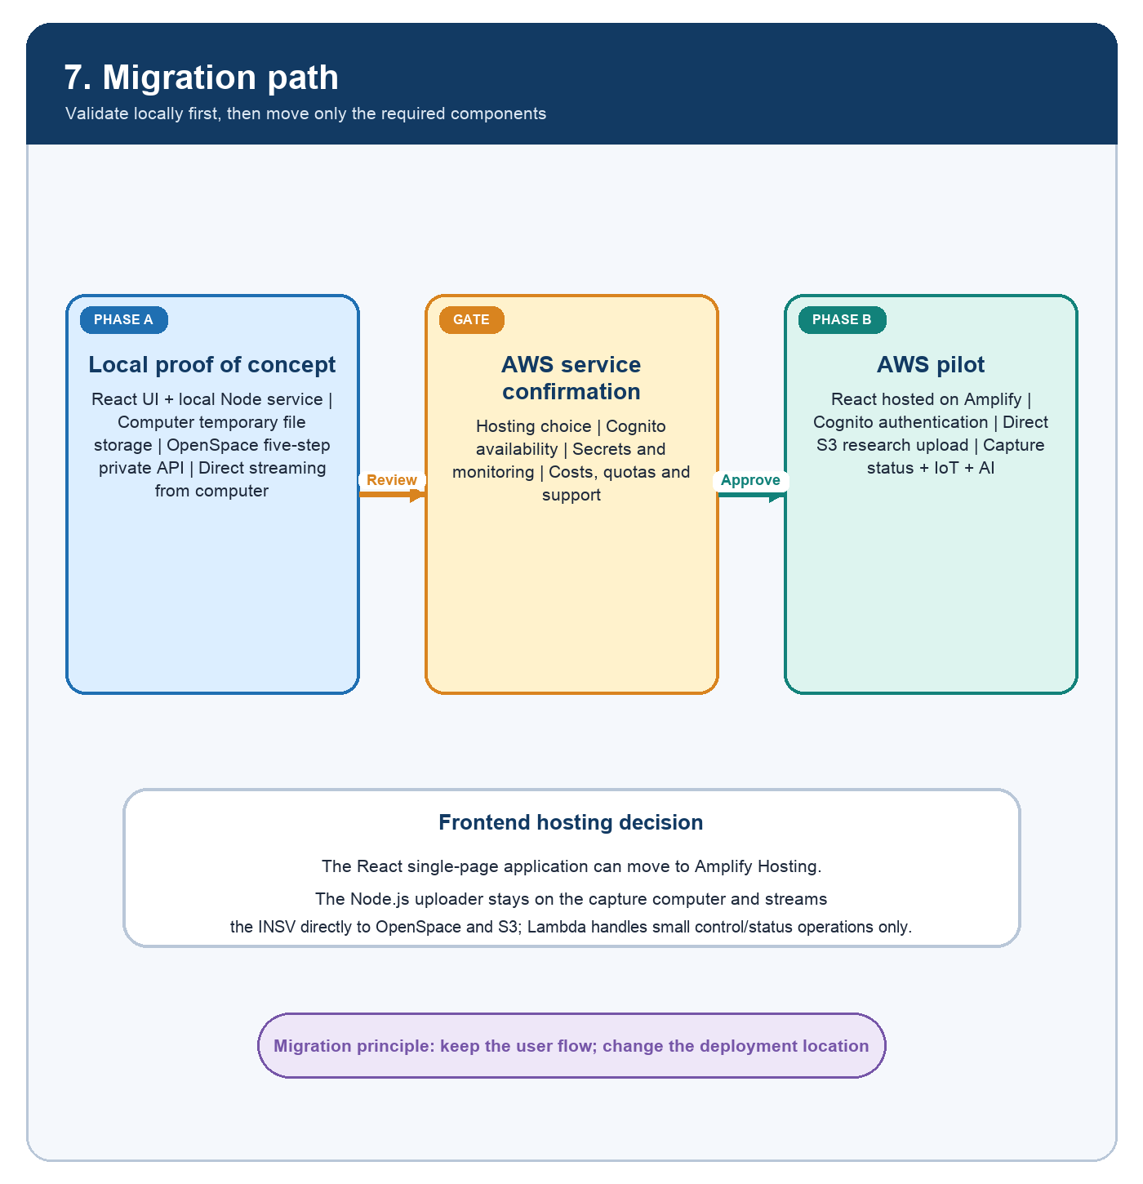
Explanation. After approval, React can move to Amplify Hosting and Cognito can provide PSB authentication. The capture-computer uploader can remain local and upload directly to both clouds.
Implementation note. A hosted web page still needs an approved secure connection to the local uploader: secure localhost, a desktop companion, or browser-direct upload if supported.
Architecture proposal: AWS services and the local-companion pattern remain subject to technical confirmation.

Local secret management
How authorised integration developers run Node.js without copying secrets into the project
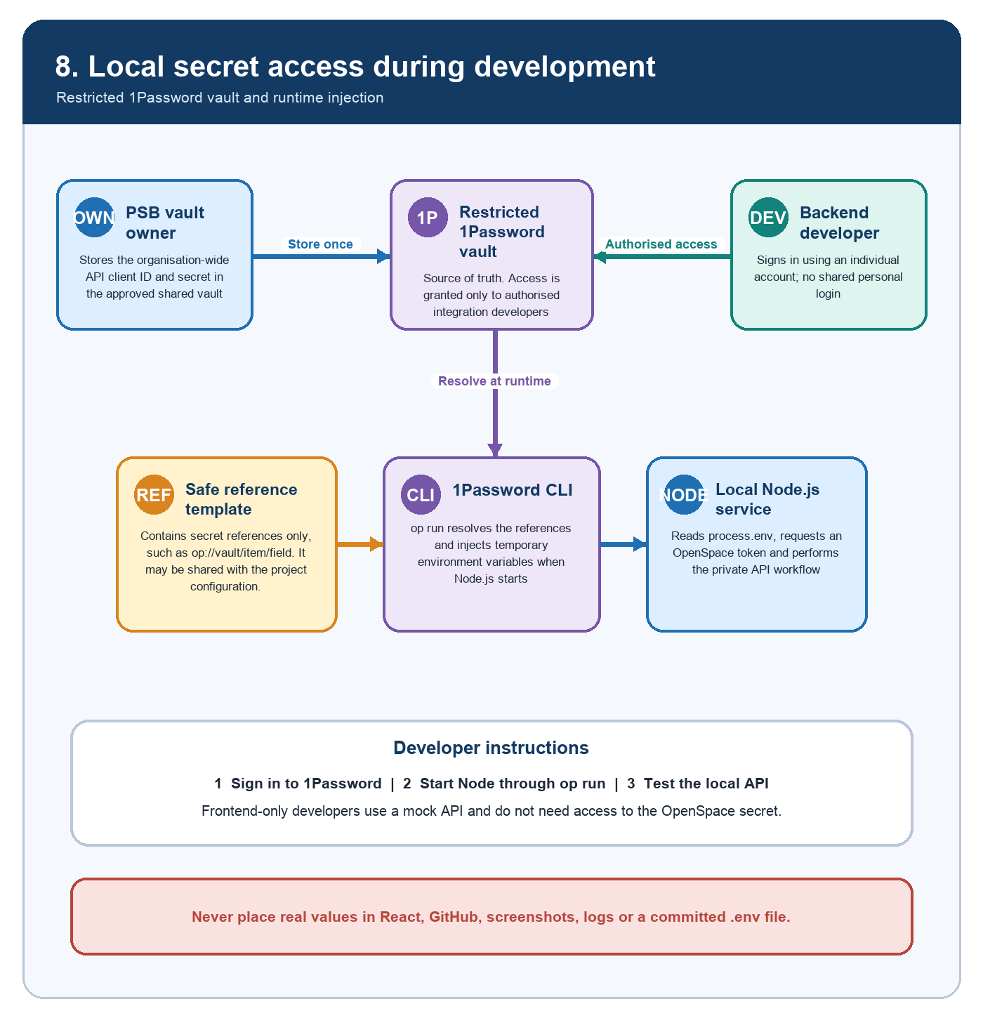
Explanation. For the local MVP, the approved 1Password vault remains the source of truth. An authorised developer signs in personally, and the 1Password CLI injects the API client ID and secret into the Node.js process only while it is running.
Implementation note. Use a secret-reference template and start Node.js through op run. Grant vault access only to backend/integration developers; frontend-only developers should use a mock local API. Do not use temporary share links as the long-term team source of truth.
Reference: 1Password Developer Documentation - Load secrets into scripts.

AWS secret management
How the same Node.js integration retrieves credentials after AWS approval
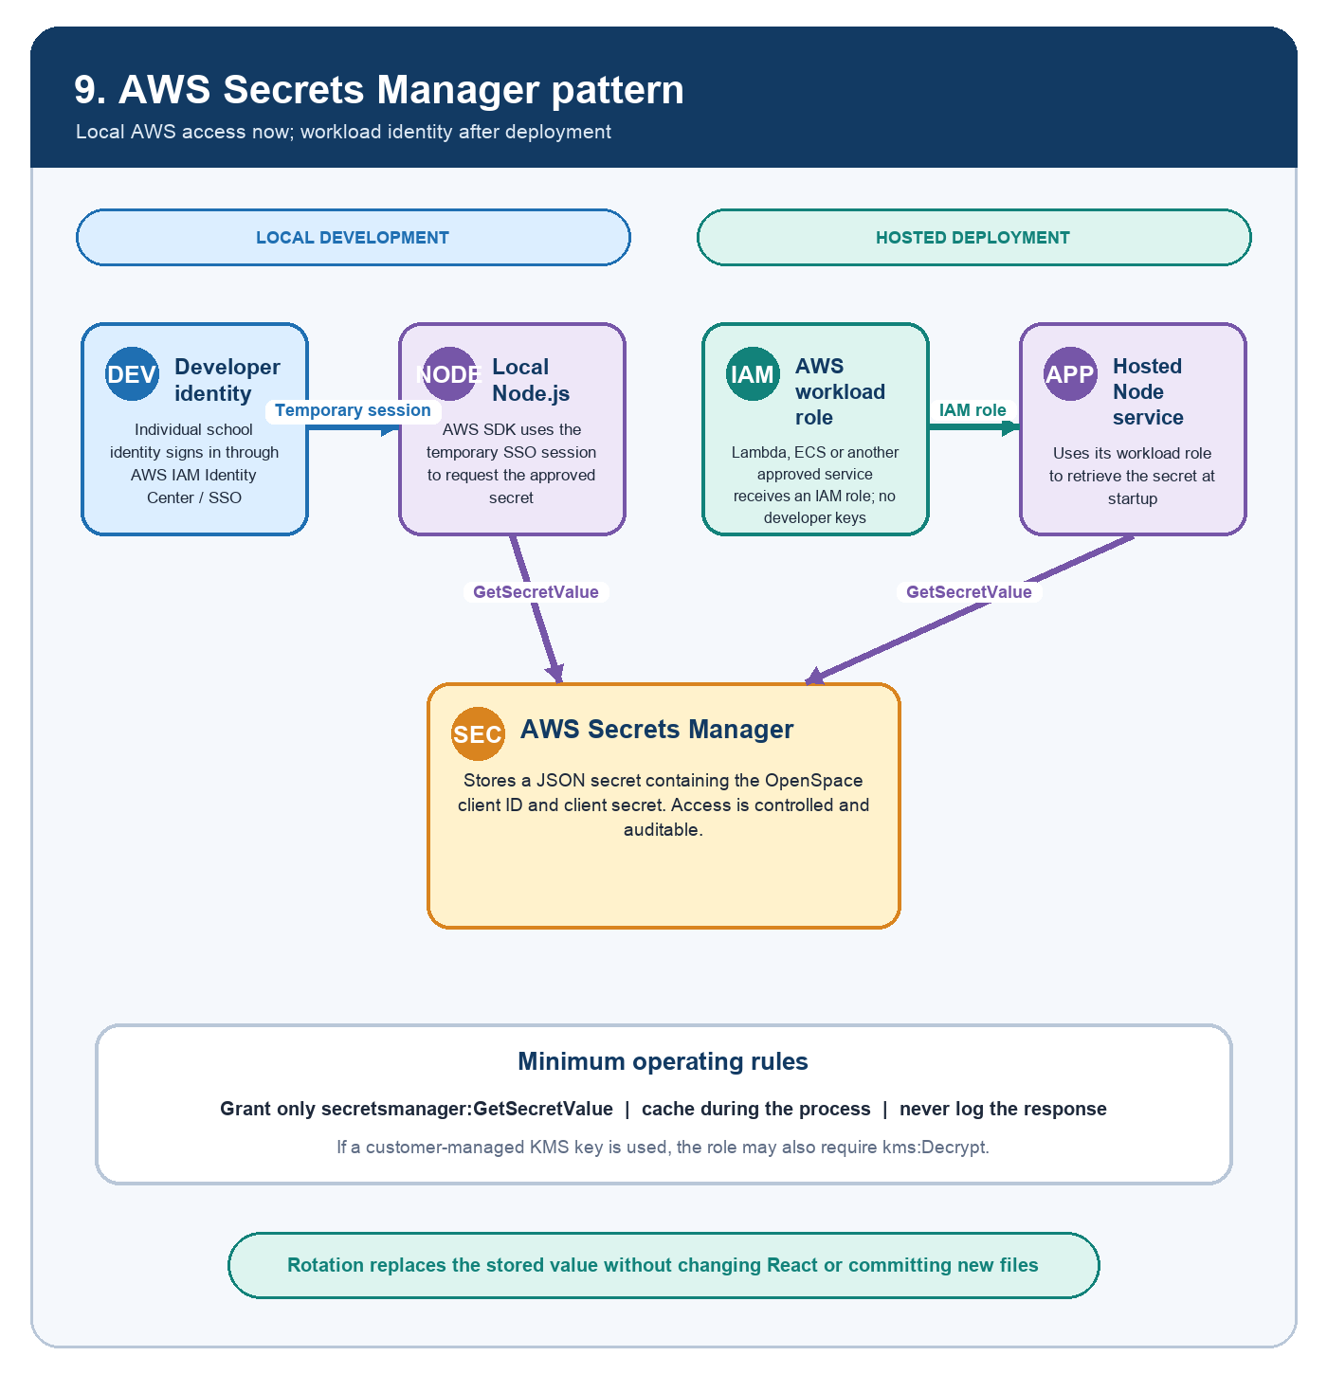
Explanation. During local AWS development, each authorised developer signs in through an individual AWS IAM Identity Center session. The Node.js SDK then retrieves the OpenSpace credential from AWS Secrets Manager. After deployment, the hosted workload uses its IAM role instead of a developer identity.
Implementation note. Grant least-privilege GetSecretValue access, cache the value within the running process, never log the secret response and rotate the stored secret when exposure is suspected. React must never call Secrets Manager directly.
References: AWS Secrets Manager GetSecretValue for JavaScript; AWS SDK for JavaScript local authentication guidance.

Meeting questions
Clarifications required before finalising the OpenSpace integration
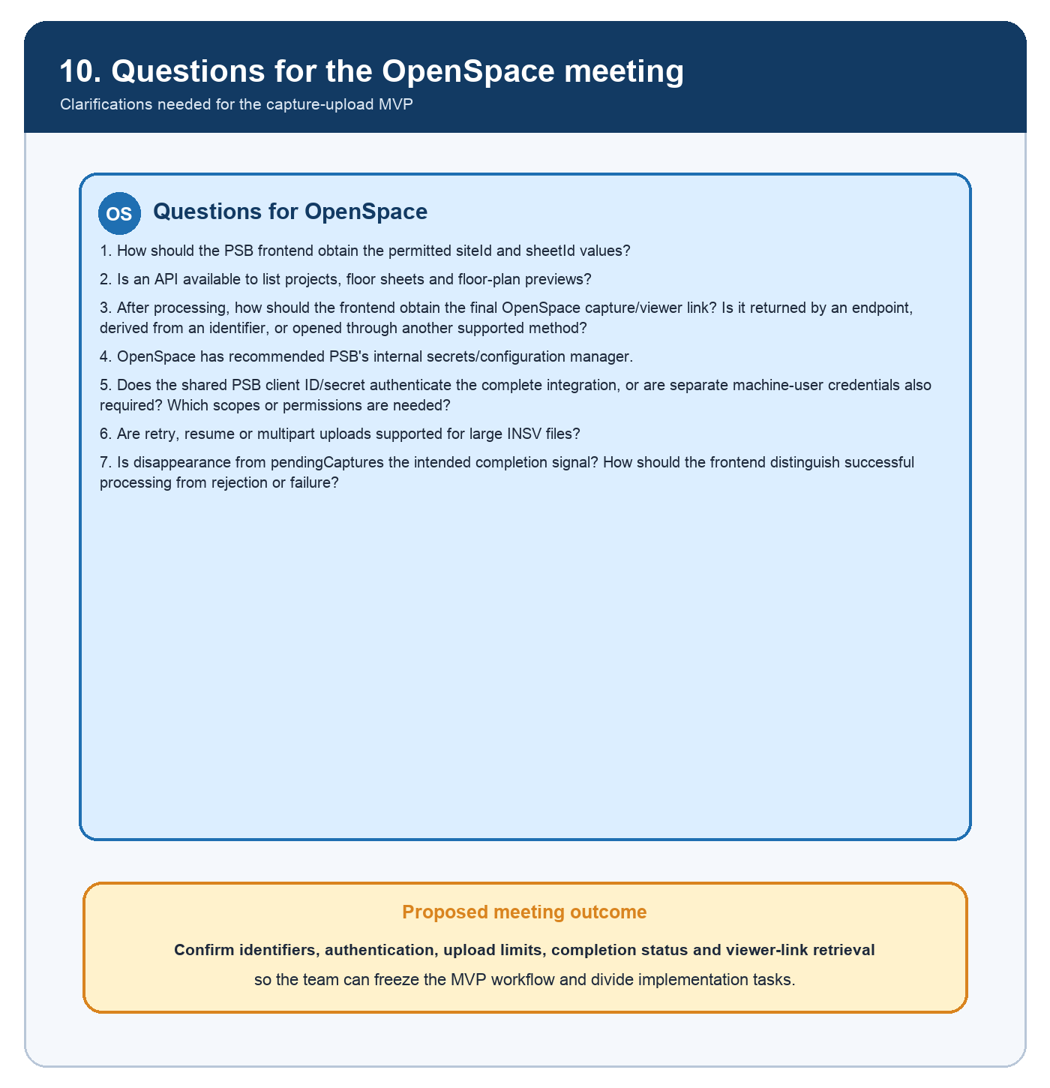
Explanation. The revised questions focus on OpenSpace identifiers, API authentication, credential protection, large-file upload behaviour, processing completion and final viewer-link retrieval.
Implementation note. Answers should be recorded as architecture decisions before the team freezes the MVP and assigns implementation ownership.
Discussion draft for the OpenSpace technical review.

