PSB ACADEMY • OPENSPACE PROJECT

Repository Structure
and Team Development Guide
A plain-language guide to the React frontend, Node.js API, SQLite data layer, shared package, and supporting folders.
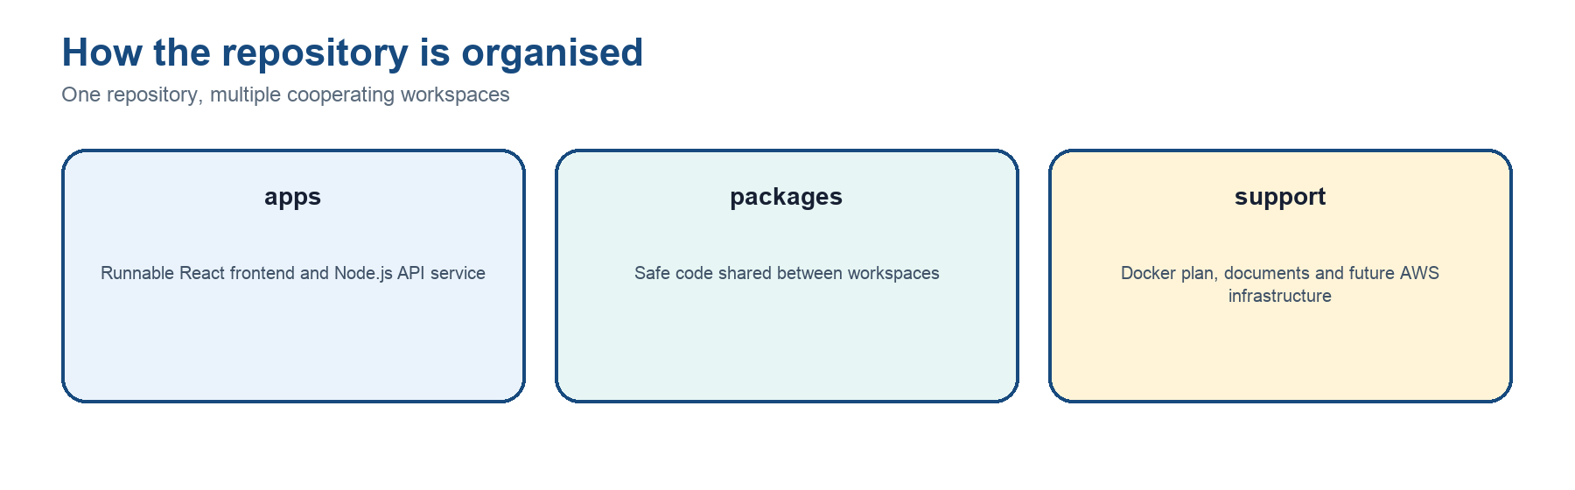
Figure 1. One repository containing cooperating application workspaces.
Audience: All OpenSpace project members, including teammates who are learning React and JavaScript for the first time.

Current scope: Repository state reviewed on 2 September 2026. The first MVP covers the capture upload dashboard; OpenSpace live integration, Docker runtime files and AWS infrastructure are still planned work.

Prepared for the PSB OpenSpace Project Team
Version 1.0 | 2 September 2026

How to use this guide
This guide is designed to answer three questions: Where does a file belong? Which layer should a teammate call? What happens after the call? It explains the current repository rather than an imagined final system.
Section | What teammates will learn
Section 1 | The overall repository: root folders, workspace files and generated items.
Section 2 | The runnable applications: the React web application and the Node.js/Express API service.
Section 3 | Supporting areas: Docker, documentation, future AWS infrastructure and the shared package.

Most important rule: A React page calls a function from apps/web/src/services. It does not call SQLite or OpenSpace directly, and it never contains private credentials.

Section 1 — Overall repository structure
The repository is an npm workspace (also called a monorepo): one GitHub repository contains several related JavaScript packages. Running npm install at the root installs the dependencies for the root, frontend, backend and shared package together.
OpenSpace/
├── apps/ runnable applications
│ ├── api/ Node.js + Express + SQLite service
│ └── web/ React + Vite + Bootstrap frontend
├── docker/ future container setup
├── docs/ project and technical documents
├── infra/aws/ future AWS infrastructure-as-code
├── packages/shared/ safe constants shared by applications
├── .gitignore files Git must not upload
├── .nvmrc required Node.js major version
├── package.json root workspace and commands
├── package-lock.json exact dependency versions
├── README.md project entry guide
└── SECURITY.md credential and data-handling rules

1.1 Root folders
Item | Purpose / how it connects
apps/ | Contains the software that runs: web for the browser interface and api for the local backend service.
docker/ | Reserved for Dockerfiles and Compose configuration. Docker will later standardise the runtime and Node.js environment across computers.
docs/ | Stores proposals, meeting records, architecture notes, setup instructions, wireframes and team guides.
infra/aws/ | Reserved for reviewed AWS infrastructure code after account, region, services, ownership and security decisions are confirmed.
packages/shared/ | Contains safe JavaScript values that more than one workspace may import. It must never contain secrets.
node_modules/ | Local installed dependency code created by npm install. It is generated, large and ignored by Git.

1.2 Root files
Item | Purpose / how it connects
package.json | Defines the workspaces, supported Node/npm versions and team commands such as npm run dev, test, lint, build and check.
package-lock.json | Locks every dependency and transitive dependency to an exact resolved version. Commit this file so teammates install the same dependency tree.
.nvmrc | Contains 22. Running nvm use selects Node.js 22, matching the repository requirement.
.gitignore | Prevents generated builds, node_modules, .env secrets, SQLite files, INSV files, logs and editor settings from entering GitHub.
README.md | The first document a teammate should read: technology, local start commands, main folders and security rules.
SECURITY.md | Defines what must never be committed and keeps OpenSpace credentials on the backend only.
Henrick’s log | A dated summary of project changes and current next steps.

1.3 What npm workspaces do
- A teammate clones the repository and runs npm install at the repository root.
- npm reads the root package.json and discovers apps/* and packages/* as workspaces.
- npm reads each workspace package.json and installs the required packages into the shared dependency tree.
- The root commands can start or check several workspaces in the correct order.
npm run dev # starts web and API together
npm run check # validates manifests, lint, tests and builds
npm run build # checks shared/API and builds the Vite frontend

1.4 Source files versus generated local files
Category | Meaning
Source | Files teammates write and review: src/, package.json, documentation and configuration examples. These normally belong in Git.
Generated | node_modules/, dist/, *.tsbuildinfo, SQLite databases and logs. Tools recreate these; Git ignores them.
Local/private | .env and captured INSV files. These stay on the developer’s computer and must never be committed.

About dist: A dist folder is normally a generated production build. The old packages/shared/dist found locally is a TypeScript-era leftover, is not tracked by GitHub, and is not used by the current JavaScript package.

Section 2 — Runnable applications in apps/
apps/api and apps/web are separate programs that cooperate. The browser runs the React application. The computer runs the Node.js API service. The browser never opens SQLite itself.
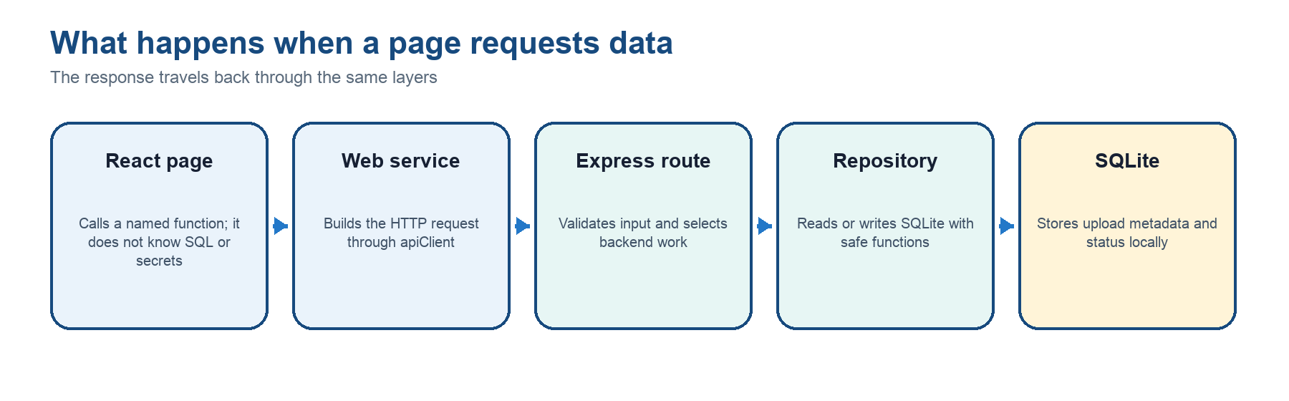
Figure 2. The standard path for dashboard, upload-history and upload-record data.

2.1 The API application: apps/api
The API is a local Node.js and Express service. It protects backend configuration, validates browser requests and provides controlled access to SQLite. Future OpenSpace Private API calls will also live here, never in React.
apps/api/
├── data/
│ ├── database/ local SQLite file (generated)
│ ├── diagnostics/ future safe diagnostic output
│ └── uploads/ temporary local upload workspace
├── src/ backend source code
├── .env local private configuration (not in Git)
├── .env.example safe setup template (in Git)
├── node_modules/ installed dependencies (generated)
└── package.json API dependencies and commands

API top-level items
Item | Purpose / how it connects
data/database | Holds openspace.sqlite when the local server runs. The code creates the folder and database automatically.
data/diagnostics | Reserved for local troubleshooting output. Real secrets should never be written here.
data/uploads | Reserved for temporary capture-upload files. Large INSV files are ignored by Git.
.env | A developer’s local values: ports, database path, mock/live mode and—only for authorised backend work—credentials. It is ignored by Git.
.env.example | A safe template showing required variable names. Teammates copy it to .env, but the template contains no secret values.
package.json | Defines Express, SQLite, validation, upload handling, linting and test dependencies, plus dev/build/start/test commands for this workspace.
node_modules | Installed third-party package code. Never edit or commit it.

2.2 Inside apps/api/src
Item | Purpose / how it connects
config/ | environment.js reads and validates environment values. environment.test.js verifies safe mock defaults and rejects incomplete live configuration.
database/ | connection.js opens SQLite and applies the schema. schema.js defines projects, sheets, uploads and indexes. seed.js optionally adds demonstration upload records.
repositories/ | The only layer that should contain normal SQLite queries. uploadRepository provides create, list, progress, complete, fail, retry and dashboard-summary methods.
routes/ | Express endpoints used by the frontend services. Routes validate request data, call repository methods and return JSON responses.
openspace/ | Reserved for the future authenticated OpenSpace adapter and the five-step private upload workflow.
services/ | Reserved for backend business workflows that coordinate multiple repositories or external services.
controllers/ | Currently empty. It can later hold request-handling logic if routes become too large.
middleware/ | Currently empty. It can later hold shared request checks, logging or authentication.
types/ | Currently empty and not required by the JavaScript implementation. It is a reserved organisational area only.
app.js | Creates Express, connects repositories to routes, enables CORS/JSON handling and defines health/error responses. It does not open a network port.
server.js | The runtime entry point. It loads .env, opens SQLite, optionally seeds demo data, creates the Express app and listens on localhost:8787.

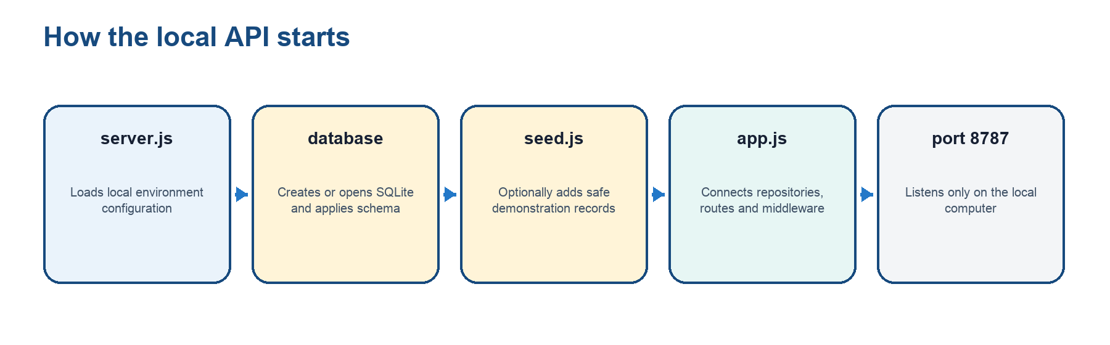
Figure 3. Backend startup sequence when npm run dev starts the API workspace.

2.3 API routes currently available
Endpoint | Current purpose
GET /api/health | Confirms that the local API service is running.
GET /api/dashboard/summary | Returns total uploads, in-progress/completed/failed counts and recent uploads.
GET /api/projects | Returns locally stored project records. Future live project synchronisation is not implemented yet.
GET /api/uploads | Returns searchable, filterable and paginated upload history.
POST /api/uploads | Creates an upload metadata record from validated form data.
PATCH /api/uploads/:id/progress | Stores byte-transfer progress between 0 and 100.
POST /api/uploads/:id/retry | Restarts a failed or cancelled record.
POST /api/uploads/:id/complete or /fail | Records the final local outcome and optional viewer information/error message.

2.4 Tests and the in-memory database
Files ending in .test.js are automated checks. The upload repository tests use SQLite’s :memory: mode: a temporary database exists only in memory during the test and disappears afterward. This means tests can create, update and retry records without changing the real local openspace.sqlite file.
Normal development: Use npm run dev to run the applications. Use npm run test to run automated tests. Use npm run check before committing; tests are not a replacement for the development server.

2.5 The Web application: apps/web
The Web application is the user interface displayed in the browser. Vite provides the local development server and production build. React creates the screens, React Router selects a screen from the URL, and Bootstrap plus base.css provide styling.
apps/web/
├── public/ static public files
├── src/
│ ├── assets/ images imported by React
│ ├── components/ reusable TopBar and Sidebar
│ ├── hooks/ reusable React behaviour
│ ├── layouts/ common application shell
│ ├── pages/ route-level screens
│ ├── routes/ URL-to-page mapping
│ ├── services/ safe frontend HTTP functions
│ ├── styles/ global styling after Bootstrap
│ ├── App.jsx application root component
│ └── main.jsx browser startup entry point
├── index.html browser HTML shell
├── vite.config.js Vite, React and local API proxy settings
└── package.json frontend dependencies and commands

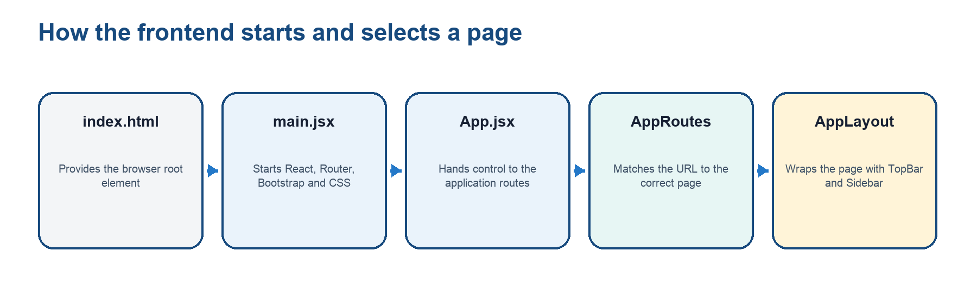
Figure 4. The frontend startup chain and shared layout.

Web top-level files
Item | Purpose / how it connects
index.html | Browser HTML shell; provides the root element and loads /src/main.jsx.
main.jsx | Starts React and Router, loads Bootstrap/base.css, and renders App.
App.jsx | Root React component; delegates navigation to AppRoutes.
vite.config.js | React plugin, port 5173 and the /api proxy to the local backend at port 8787.
package.json | Frontend dependencies and dev, build, lint, test and preview commands.
public/ | Static files served without React imports, such as a future favicon.
dist/ | Generated deployment output from npm run build; ignored by Git.

2.6 Inside apps/web/src
Item | Purpose / how it connects
components/ | Small reusable UI pieces. Sidebar owns navigation links and active highlighting. TopBar owns the application header.
layouts/ | AppLayout combines TopBar, Sidebar and an Outlet where the selected page appears.
pages/ | Route-level screens assigned to team members: Dashboard, New Capture, Upload Progress, Capture History and Not Found.
routes/ | AppRoutes maps URL paths to page components. It redirects the root URL to /dashboard.
services/ | The page-friendly HTTP layer. This is normally the only backend-facing folder a page developer needs to call.
hooks/ | Reusable React state/effect behaviour. useApi loads asynchronous data and reports data, loading and error state.
assets/ | Images or visual files imported by React components.
styles/ | base.css provides the application shell, navigation colors, spacing and mobile layout after Bootstrap loads.

2.7 Frontend services: the page developer’s API layer
Service | What pages receive
apiClient.js | Central fetch helper. It adds /api, sends JSON, parses responses and turns backend failures into JavaScript errors.
dashboardApi.js | getSummary() retrieves dashboard totals and recent uploads.
uploadApi.js | Creates, lists, reads, updates progress, retries, completes and fails upload records.
projectApi.js | list() retrieves the current locally stored project list.

// Example inside a page component
import { dashboardApi } from "../services/dashboardApi.js";
const summary = await dashboardApi.getSummary();
// The page renders summary; it does not write fetch(), SQL or secrets.

2.8 What a page developer should do
- Work mainly in the assigned file under apps/web/src/pages.
- Reuse AppLayout, TopBar and Sidebar; do not duplicate the navigation shell.
- Import a named function from dashboardApi, uploadApi or projectApi when backend data is needed.
- Show loading, success, empty and error states in the page.
- Ask the backend owner for a new service function if a needed operation does not exist. Do not call SQLite or OpenSpace directly.
- Run npm run check before submitting changes and never commit node_modules, dist, .env, SQLite or INSV files.
Automatic connection: The layers are connected by agreed URLs and functions, but not by magic: the page calls a frontend service; apiClient sends HTTP; Vite proxies /api locally; Express matches a route; the route calls a repository; the repository runs SQLite.

Section 3 — Supporting folders and shared code

3.1 docker/
The Docker folder is currently a documented placeholder. Docker is planned first for the Node.js integration and upload service. A future Docker image can standardise the operating environment and Node.js runtime. package-lock.json still controls the exact npm dependency tree.
- Current state: no runnable Dockerfile or Compose file is committed.
- Later role: package the API consistently and make setup more repeatable across development or deployment environments.
- Docker should be added when the upload workflow and runtime needs are stable enough to describe accurately.

3.2 docs/
The docs folder is the project knowledge base. It contains management files, research, proposals, architecture, wireframes, meeting records, presentation material and technical guides. Documents explain decisions; application source code remains under apps and packages.

3.3 infra/aws/
This folder is reserved for future infrastructure-as-code. It should not contain guessed cloud resources. AWS implementation begins only after the team confirms the account, Singapore region, approved services, environment ownership, security controls, cost controls and the hosting approach for large-file upload handling.

3.4 packages/shared
@openspace/shared is a small npm workspace containing safe values that multiple applications can import. Its public entry point is src/index.js. The API currently imports UPLOAD_STATUSES for request validation and DEFAULT_PAGE_SIZE for upload-history pagination.
packages/shared/
├── src/
│ └── index.js shared upload statuses and page-size default
└── package.json package name, export and syntax-check command

Item | Purpose / how it connects
src/index.js | Exports ordinary JavaScript constants. It is .js—not .jsx—because it contains no React markup.
package.json | Makes the folder importable as @openspace/shared and points imports directly to src/index.js.
UPLOAD_STATUSES | One approved list: pending, uploading, completed, failed and cancelled.
DEFAULT_PAGE_SIZE | The default number of upload-history records returned per page.
dist/ | Not required by the current package. A local dist with .d.ts or .map files is obsolete TypeScript-generated output and is not tracked in GitHub.

Shared does not mean public: Only safe constants and cross-application contracts belong here. Credentials, client secrets, tokens, environment-specific URLs and private data must never be placed in packages/shared.

3.5 Local start-to-screen workflow
- At the repository root, run nvm use and npm install.
- Copy apps/api/.env.example to apps/api/.env. Keep mock mode unless authorised for live backend integration.
- Run npm run dev. The root command starts both workspaces.
- Vite serves the React application at http://localhost:5173.
- Express serves the local API at http://localhost:8787.
- When React requests /api, Vite sends it to Express; Express reads or writes SQLite and returns JSON.

3.6 Common mistakes to avoid
Mistake | Correct approach
Calling OpenSpace from React | Do not do this. It exposes credentials and bypasses the controlled backend workflow.
Writing SQL inside a page | Do not do this. Pages call frontend services; repositories own SQL.
Putting secrets in VITE_ variables | Do not do this. Vite variables are included in browser-delivered code.
Editing node_modules or dist | Do not do this. They are generated and will be replaced.
Committing .env, SQLite or INSV | Do not do this. They are private/local and intentionally ignored.
Duplicating TopBar or Sidebar | Reuse AppLayout and shared components so navigation stays consistent.
Hardcoding a new API URL in a page | Add or extend a function under apps/web/src/services instead.

Quick reference for page owners
Screen / need | Approved connection
Dashboard | Call dashboardApi.getSummary(); render totals and recent uploads.
New Capture | Collect verified form values; call uploadApi.create(); backend/OpenSpace orchestration will remain server-side.
Upload Progress | Read uploadApi.get(); display byte-transfer progress; treat OpenSpace processing as a separate indeterminate stage.
Capture History | Call uploadApi.list(filters); display search, status/date filters and pagination results.
Retry action | Call uploadApi.retry(id); do not directly change SQLite.
Projects | Call projectApi.list(); remember current records are local until live OpenSpace synchronisation is implemented.

If you are unsure: Start in your assigned page, look for an existing function under apps/web/src/services, and ask the backend owner before creating a new backend route. This keeps responsibilities clear and prevents duplicated or insecure code.

Glossary
Term | Plain-language meaning
Frontend | The React interface that runs in the user’s browser.
Backend/API | The local Node.js/Express service that performs protected work and returns JSON.
Route | A URL plus HTTP method handled by the frontend router or backend API.
Service layer | Named frontend functions that hide HTTP details from page components.
Repository layer | Backend functions that hide SQL details from API routes.
SQLite | The local database storing upload metadata and status, not the large INSV content.
Workspace | A package managed as part of the root npm project.
Dependency | Third-party software declared in package.json and installed by npm.
Mock mode | Safe development mode that does not require real OpenSpace credentials.

End of guide. The source of truth remains the repository itself; update this guide when folder responsibilities or integration boundaries change.

