TEAM IMPLEMENTATION GUIDE
PSB Capture Dashboard MVP v0.4
Frontend screen assignments, data contracts and acceptance checks
SCOPE This guide covers Screen 01 Dashboard, Screen 05 Upload History, and the paired Screen 03 Uploading + Screen 04 Upload Complete experience. Screen 02 New Upload is intentionally excluded from the detailed assignments because Henrick is implementing it.

How teammates should use this guide
Start with the assigned screen | Use the matching Figma image as the visual target.
Reuse shared layout | TopBar, Sidebar and AppLayout already exist. Page owners must use them rather than recreating them.
Read data through services | React pages call functions in apps/web/src/services. They do not open SQLite or call OpenSpace directly.
Keep page ownership narrow | Build the page UI, loading/error/empty states and navigation described here. Henrick owns the backend, OpenSpace integration and New Upload workflow.

Repository paths used in this guide
Frontend pages: apps/web/src/pages • Shared layout: apps/web/src/components and apps/web/src/layouts • HTTP services: apps/web/src/services • Routes: apps/web/src/routes/AppRoutes.jsx

1. Shared implementation boundary
RULE A page component talks to the local Node.js API through the service layer. It must not contain SQL queries, database paths, OpenSpace credentials or direct OpenSpace API calls.

What is already provided
TopBar.jsx | Shared header for the PSB OpenSpace Capture Dashboard.
Sidebar.jsx | Shared navigation with active-link behaviour.
AppLayout.jsx | Places the top bar, sidebar and current page together.
AppRoutes.jsx | Maps /dashboard, /captures/new, /captures/:captureId/progress and /captures to the correct pages.
dashboardApi.js | Provides getSummary() for dashboard metrics and recent uploads.
uploadApi.js | Provides list(), get(), retry() and the upload status helpers.

Data flow
React page | Frontend service | Local Node.js API | SQLite upload records
The service layer keeps page code simple and prevents each teammate from inventing a different backend connection.

Shared states every page must handle
☐ | Loading: show a clear loading message or skeleton while the service request is running.
☐ | Success: render the values returned by the service; do not hardcode the example numbers shown in Figma.
☐ | Empty: explain that there are no upload records yet and provide a useful next action.
☐ | Error: show a readable message and a Retry action; do not expose stack traces or secret values.
☐ | Responsive behaviour: keep the content readable on a laptop and allow the table to scroll horizontally on narrow screens.

2. Dashboard page owner
Route: /dashboard • File: apps/web/src/pages/DashboardPage.jsx
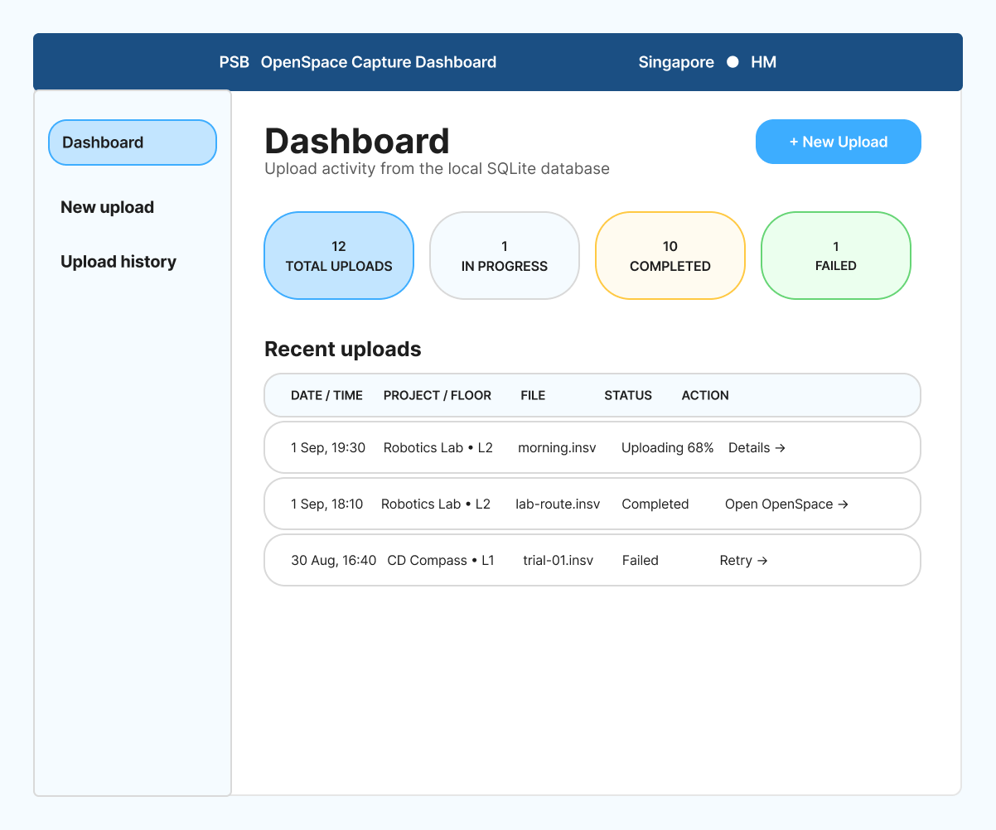
Figure 1. Final v0.4 dashboard wireframe — values shown are examples, not hardcoded production data.

Dashboard — what to build
OWNER BOUNDARY Build only the dashboard content area. Reuse AppLayout, TopBar and Sidebar. Do not recreate their HTML or CSS inside DashboardPage.jsx.

Required UI
☐ | Page heading and short description matching the wireframe.
☐ | A + New Upload button that navigates to /captures/new.
☐ | Four metric cards: Total Uploads, In Progress, Completed and Failed.
☐ | A Recent uploads table with Date/Time, Project/Floor, File, Status and Action columns.
☐ | Status badges that are visually distinct and readable without relying only on colour.
☐ | Row actions: Details, Open OpenSpace when a viewer URL exists, and Retry for failed records.

Where the data comes from
Service call | dashboardApi.getSummary() from apps/web/src/services/dashboardApi.js
Local endpoint | GET /api/dashboard/summary
Returned fields | totalUploads, inProgress, completed, failed and recentUploads
Source of truth | The local Node.js API reads upload records from SQLite.

Navigation and actions
Control | Expected action | Implementation note
+ New Upload | Go to /captures/new | Use React Router navigation; do not reload the entire browser page.
Details | Go to /captures/{id}/progress | Use the upload record ID returned by the API.
Open OpenSpace | Open viewerUrl in a new tab | Show only when viewerUrl is present; use rel="noreferrer".
Retry | Call uploadApi.retry(id) | After success, refresh the dashboard summary.

Dashboard acceptance checks
☐ | The four values and recent rows come from getSummary(), not constants in JSX.
☐ | The page still renders correctly when recentUploads is empty.
☐ | Failed records show Retry; completed records show Open OpenSpace only when a URL is available.
☐ | The active sidebar highlight appears only on Dashboard.

3. Upload History page owner
Route: /captures • File: apps/web/src/pages/CaptureHistoryPage.jsx
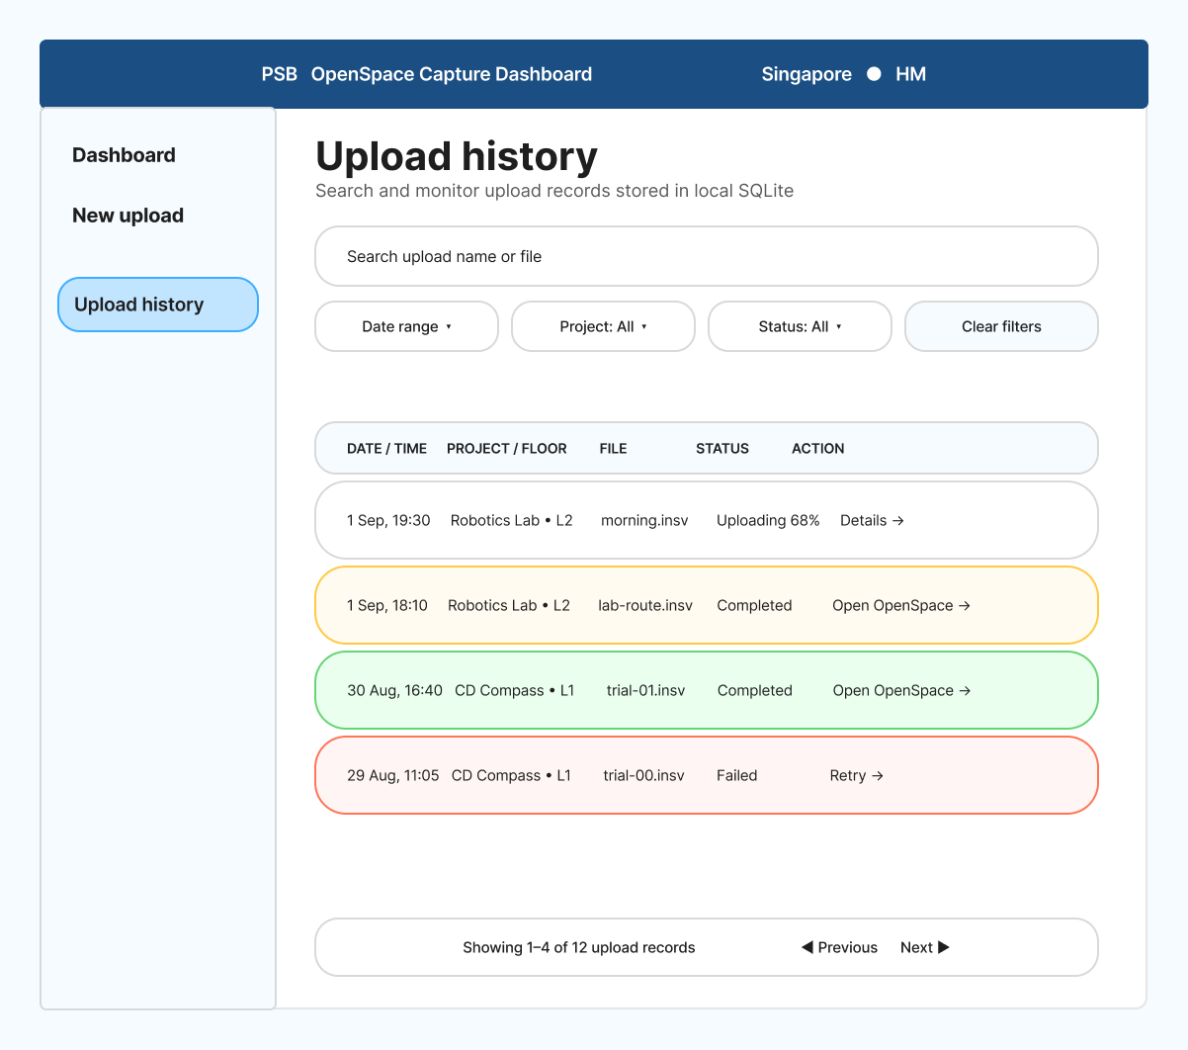
Figure 2. Final v0.4 Upload History wireframe — this page shows locally recorded upload activity.

Upload History — what to build
PURPOSE This page is an upload log, not an OpenSpace project-management screen. It displays records already saved in the local SQLite database.

Required UI
☐ | Search input for upload name, file name, project name or floor text supported by the backend.
☐ | Date-range filter, project filter and status filter.
☐ | Table columns: Date/Time, Project/Floor, File, Status and Action.
☐ | Pagination controls and a result-count message.
☐ | Details, Open OpenSpace and Retry actions following the same rules as the dashboard.

Where the data comes from
Service call | uploadApi.list(filters) from apps/web/src/services/uploadApi.js
Local endpoint | GET /api/uploads with query parameters
Supported filters | search, status, siteId, from, to, page and pageSize
Returned shape | items, page, pageSize and total
Source of truth | SQLite upload records written by the local Node.js API.

Filter behaviour
Wireframe control | Send to API | Expected behaviour
Search captures | search | Debounce typing briefly or submit explicitly; reset to page 1 when the value changes.
Date range | from, to | Send ISO date/time values accepted by the API; show a clear control to remove the range.
Project | siteId | Use the siteId saved with upload records. The page owner does not call OpenSpace directly.
Status | status | Use the shared upload status values; All means omit the parameter.
Previous / Next | page, pageSize | Disable Previous on page 1 and Next when the final page is reached.
PROJECT FILTER NOTE If the UI needs a clean list of distinct projects from existing upload records, coordinate with Henrick for a small local API helper. Do not query SQLite from React and do not continuously poll OpenSpace for this screen.

Upload History acceptance checks
☐ | Filters update the API request and reset pagination appropriately.
☐ | An empty result shows a friendly message without breaking the page layout.
☐ | Open OpenSpace is hidden or disabled when no viewer URL is stored.
☐ | Retry refreshes the current list after the backend accepts the request.

4. Upload Progress + Completion owner
Route: /captures/:captureId/progress • File: apps/web/src/pages/UploadProgressPage.jsx
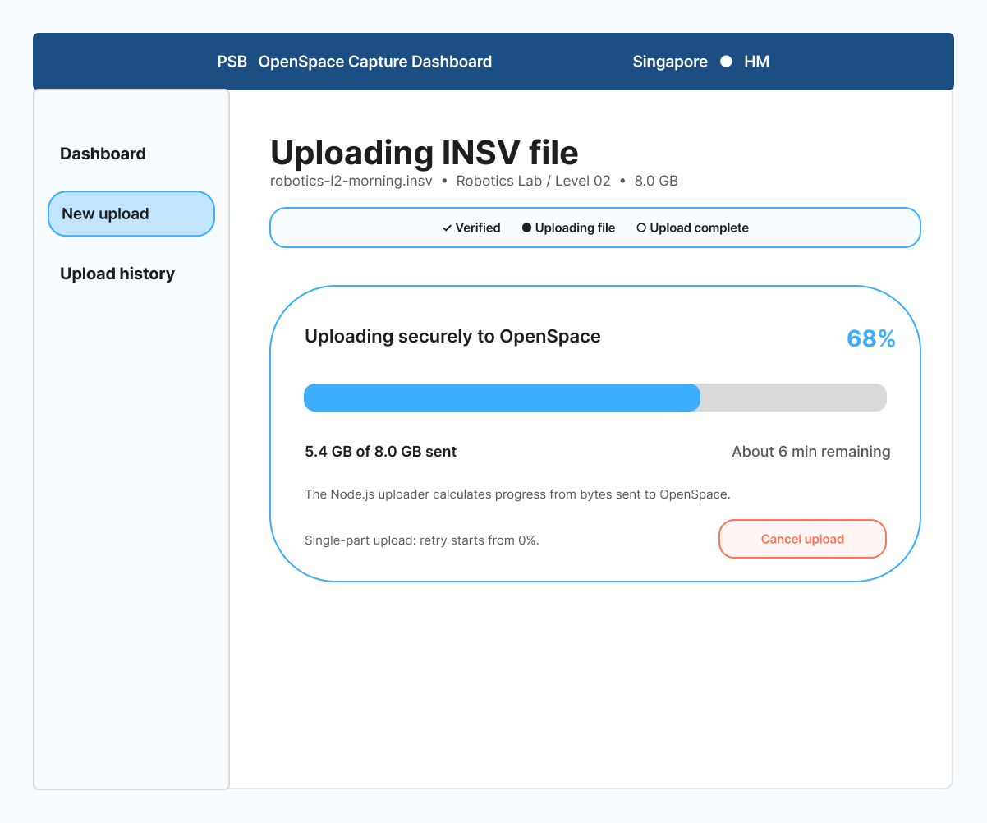
Figure 3. Final v0.4 uploading state — the percentage represents file-transfer progress, not OpenSpace processing progress.

Upload Complete state
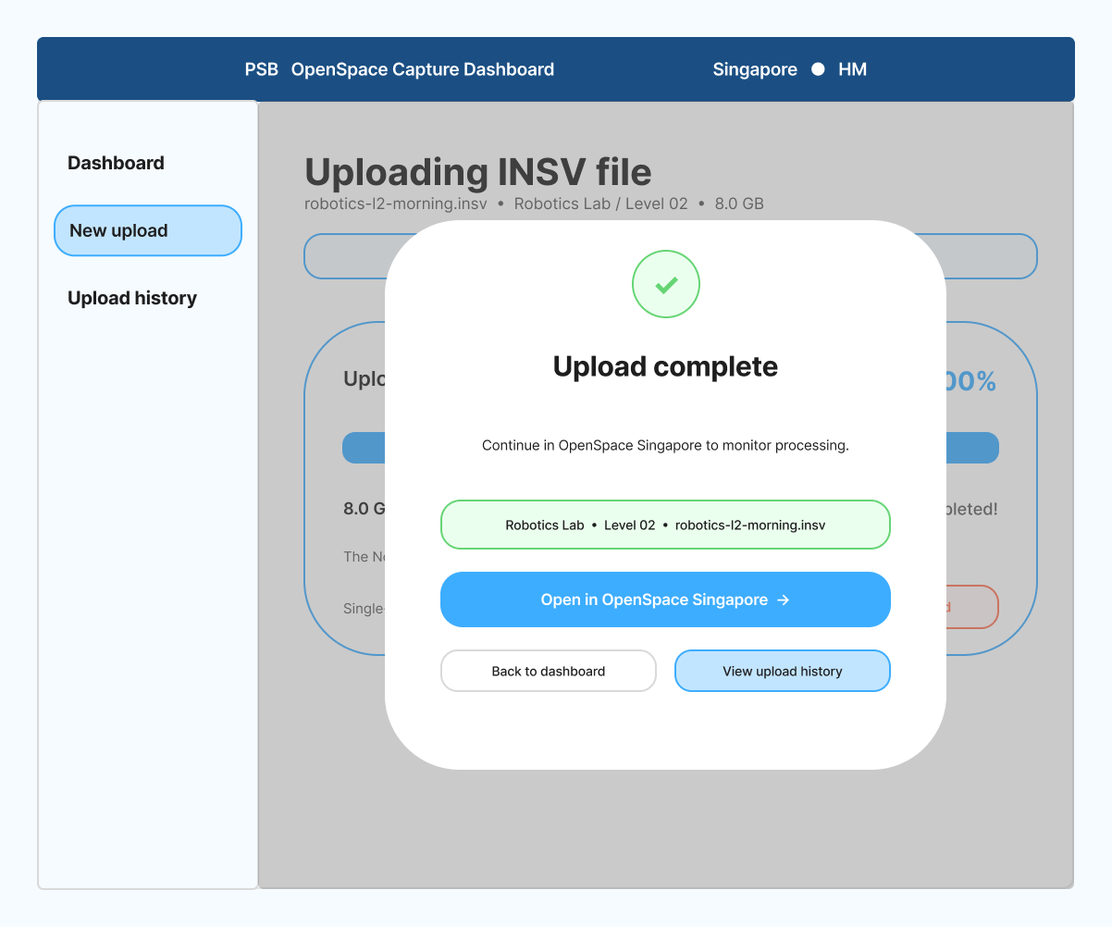
Figure 4. Final v0.4 completion state — implement this as a modal dialog over the progress page, not as another route.
IMPORTANT Upload complete means the INSV file transfer and handoff succeeded. It does not mean OpenSpace has finished processing the capture. The user continues in the OpenSpace Singapore application to monitor or view the result.

Progress experience — what to build

Uploading state
☐ | Show the selected filename, project, floor and file size from the upload record.
☐ | Show three clear stages: Verified, Uploading file and Upload complete.
☐ | Render a determinate progress bar only when the backend supplies bytes sent or a reliable percentage.
☐ | Show bytes sent versus total bytes. The percentage is (bytes sent ÷ total bytes) × 100.
☐ | Estimated time remaining is optional and should be based on measured transfer speed; label it as an estimate.
☐ | Provide Cancel only when the uploader integration can actually abort the transfer.
☐ | Do not add Pause or Resume: the documented workflow uses a single-part upload, so a retry starts again from zero.

Data and service responsibilities
Initial record | Call uploadApi.get(captureId) to load the saved upload record.
Progress source | Use actual uploader/backend progress events. Never animate a fake percentage with a timer.
SQLite updates | The backend/uploader records the current status and progress. The React page only displays it.
Completion condition | Open the modal only after the backend confirms the transfer/handoff succeeded.
Failure | Show the error safely and provide Retry through uploadApi.retry(captureId).

CURRENT IMPLEMENTATION NOTE The repository already has upload record and progress service functions, but the real OpenSpace file-transfer workflow still belongs to Henrick. The page owner may first build against the service contract and seeded/demo records, then connect to the real progress source when it is available.

Completion modal behaviour
☐ | Use a React modal dialog rendered conditionally inside UploadProgressPage; do not add a new route.
☐ | Display the completed filename, project, floor, file size and final upload status.
☐ | Open in OpenSpace Singapore uses viewerUrl when supplied; otherwise use only an approved generic Singapore destination.
☐ | Back to dashboard navigates to /dashboard.
☐ | View upload history navigates to /captures.
☐ | The modal must have a dialog label, visible focus, keyboard-close behaviour where appropriate and a backdrop.

React modal example
The project currently includes Bootstrap CSS but not the separate react-bootstrap component library. The following example uses conditional React JSX and Bootstrap modal classes without adding a dependency.
import { useNavigate } from "react-router-dom";
export function UploadCompleteModal({ show, upload, onClose }) {
const navigate = useNavigate();
if (!show) return null;
const destination = upload.viewerUrl || "https://sgp.openspace.ai/";
return (
<>
<div className="modal-backdrop fade show" />
<div className="modal fade show d-block" role="dialog"
aria-modal="true" aria-labelledby="uploadCompleteTitle">
<div className="modal-dialog modal-dialog-centered">
<div className="modal-content">
<div className="modal-header">
<h2 id="uploadCompleteTitle" className="modal-title fs-4">
Upload complete
</h2>
<button className="btn-close" onClick={onClose}
aria-label="Close" />
</div>
<div className="modal-body">
<p>Continue in OpenSpace Singapore to monitor processing.</p>
<strong>{upload.fileName}</strong>
</div>
<div className="modal-footer">
<button className="btn btn-outline-secondary"
onClick={() => navigate("/dashboard")}>
Back to dashboard
</button>
<button className="btn btn-outline-primary"
onClick={() => navigate("/captures")}>
View upload history
</button>
<a className="btn btn-primary" href={destination}
target="_blank" rel="noreferrer">
Open in OpenSpace Singapore
</a>
</div>
</div>
</div>
</div>
</>
);
}

WHEN TO SHOW IT Set show to true only after the backend confirms success. Do not treat a frontend timer reaching 100% as proof that OpenSpace accepted the upload.

Progress + Completion acceptance checks
☐ | The route reads captureId from React Router and loads the matching upload record.
☐ | The percentage and byte values come from real progress data or remain indeterminate; they are never fabricated.
☐ | The completion state is a modal over the same route.
☐ | Upload complete is clearly separated from OpenSpace processing complete.
☐ | Every modal action goes to the expected destination and keyboard users can identify the dialog.

5. Team handoff and ownership
Owner | Responsible for | Must not implement
Dashboard owner | DashboardPage UI, summary loading, recent rows, navigation and page states. | SQL queries, OpenSpace calls, shared top bar/sidebar.
History owner | CaptureHistoryPage UI, filters, pagination, row actions and page states. | SQL queries, direct project discovery from OpenSpace, backend routes.
Progress owner | UploadProgressPage UI, transfer display, error/retry state and completion modal. | The actual OpenSpace uploader, credentials or fake processing percentages.
Henrick | New Upload screen, Node.js/API layer, SQLite, OpenSpace integration and frontend-backend connection. | N/A

Before merging a page
☐ | The page uses AppLayout and the existing shared navigation components.
☐ | API calls exist only in apps/web/src/services; the page imports a service function.
☐ | Loading, empty, error and success states have been tested.
☐ | No credentials, local database paths or environment-secret values appear in React code.
☐ | Buttons and links use the routes documented in this guide.
☐ | The screen visually follows the final v0.4 Figma frame and remains usable on a normal laptop viewport.

FINAL REMINDER Screen 02 New Upload is visible in the complete wireframe appendix for context, but it is not assigned or specified in this guide.

Appendix A — Complete final v0.4 wireframe
This overview is included for shared context. Detailed teammate instructions intentionally exclude Screen 02 New Upload.
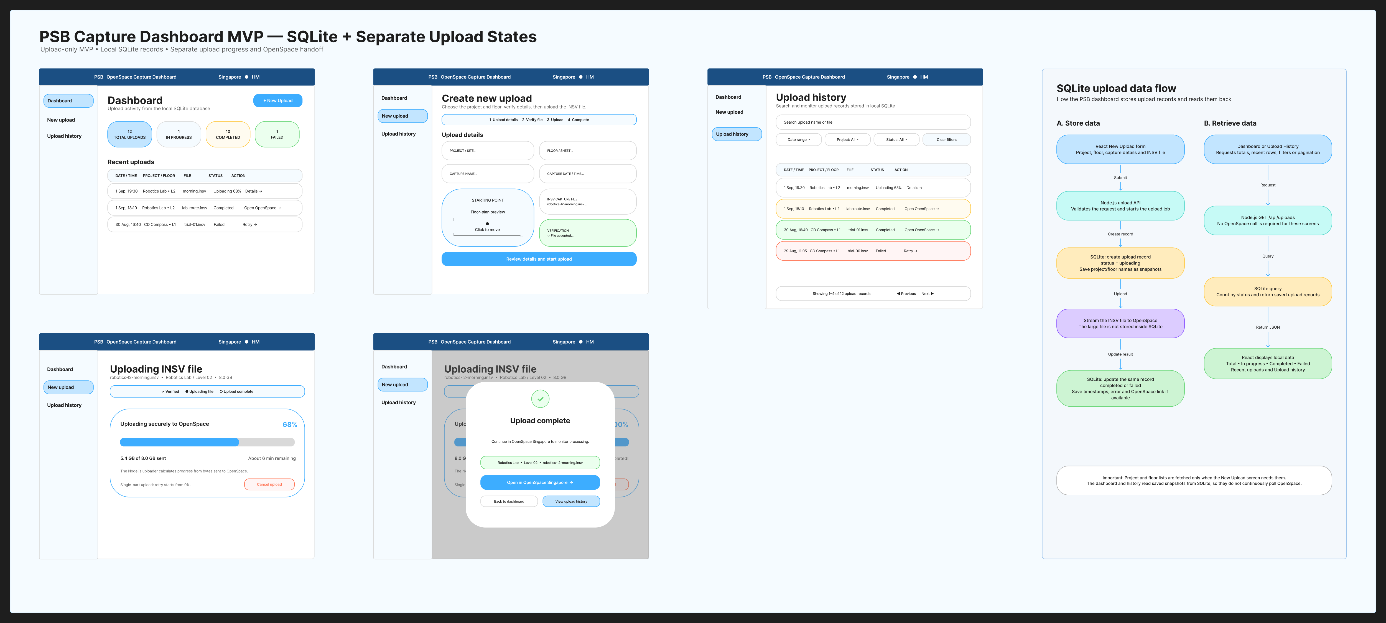
Figure 5. PSB Capture Dashboard MVP v0.4 — SQLite + Progress (complete Figma section).

