



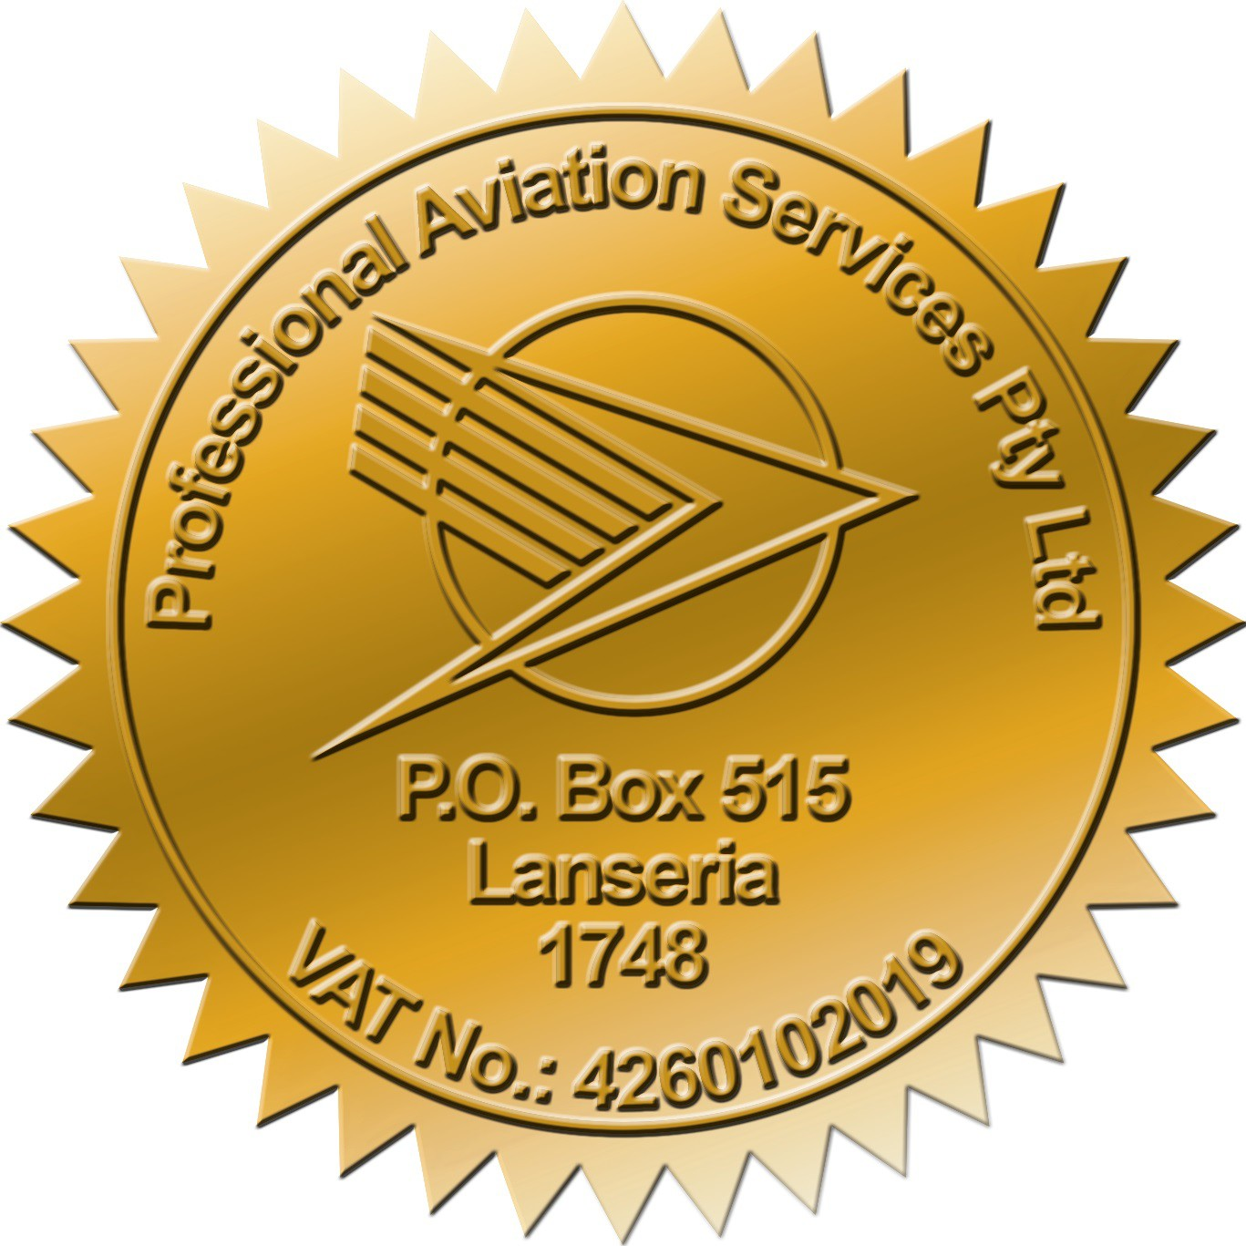
Certificate of Competence
This is to certify that
(Student Name Here)
ID No. (ID Number Here)
Has met the assessment requirements for
(E-Learning)
(Course Name Here)
and is hereby found competent.

Held on (Date of Completion Here) at
E-Learning

Course Contents:
Syllabus is per requirements of SACAA SACATS Part 109

This qualification is valid from (Date of Completion Here) to (1 Year Later Here)

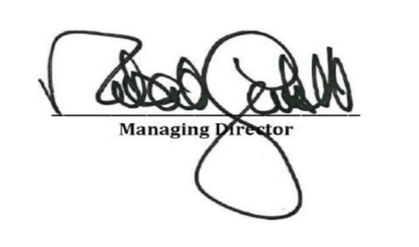



Instructor



Training Manager

ASTO: CAA/10908/ASTO ATO: SACAA/1515/ATO. Certificate No: 73979

