Logistic Regression Analysis: Philippine Mouse Deer Detectability
Henrik Navarroza
July 9, 2026
# 1. Load libraries and read data
library(terra)
## terra 1.9.34
library(tidyverse)
## ── Attaching core tidyverse packages ──────────────────────── tidyverse 2.0.0 ──
## ✔ dplyr 1.2.1 ✔ readr 2.2.0
## ✔ forcats 1.0.1 ✔ stringr 1.6.0
## ✔ ggplot2 4.0.3 ✔ tibble 3.3.1
## ✔ lubridate 1.9.5 ✔ tidyr 1.3.2
## ✔ purrr 1.2.2
## ── Conflicts ────────────────────────────────────────── tidyverse_conflicts() ──
## ✖ tidyr::extract() masks terra::extract()
## ✖ dplyr::filter() masks stats::filter()
## ✖ dplyr::lag() masks stats::lag()
## ℹ Use the conflicted package (<http://conflicted.r-lib.org/>) to force all conflicts to become errors
library(sf)
## Linking to GEOS 3.14.1, GDAL 3.12.1, PROJ 9.7.1; sf_use_s2() is TRUE
setwd("C:/Users/Admin/downloads")
species_data <- read.csv("ph_mouse_deer.csv")
species_clean <- species_data[complete.cases(species_data$Detected), ]
species_sf <- st_as_sf(species_clean, coords = c("Longitude", "Latitude"), crs = 4326)
species_ext <- ext(species_sf)
buffer <- 0.5
zoom_extent <- ext(
xmin(species_ext) - buffer, xmax(species_ext) + buffer,
ymin(species_ext) - buffer, ymax(species_ext) + buffer
)
if(file.exists("PHL_msk_alt.tif")) {
# Load the raster if it hasn't been loaded yet
map_raster <- rast("PHL_msk_alt.tif")
print("Raster successfully loaded.")
} else {
stop("Error: 'PHL_msk_alt.tif' not found in your working directory.")
}
## [1] "Raster successfully loaded."
map_crop <- crop(map_raster, zoom_extent)
plot(map_crop, main = "Philippine Mouse Deer Study Area")
plot(st_geometry(species_sf), add = TRUE, col = "red", pch = 19)
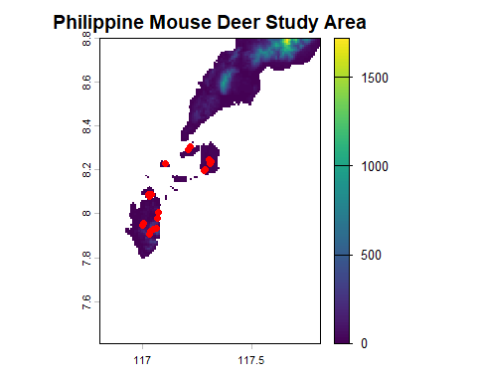
species_clean$HabitatCode <- as.factor(species_clean$HabitatCode)
model_log <- glm(Detected ~ AverageDistance + Effort + HabitatCode,
data = species_clean,
family = binomial)
summary(model_log)
##
## Call:
## glm(formula = Detected ~ AverageDistance + Effort + HabitatCode,
## family = binomial, data = species_clean)
##
## Coefficients:
## Estimate Std. Error z value Pr(>|z|)
## (Intercept) -19.57441 3525.85824 -0.006 0.996
## AverageDistance 0.16806 0.12985 1.294 0.196
## Effort 0.05477 1.10880 0.049 0.961
## HabitatCode2 19.79372 3525.85719 0.006 0.996
## HabitatCode3 16.51916 3525.85736 0.005 0.996
## HabitatCode4 36.08148 7414.61276 0.005 0.996
##
## (Dispersion parameter for binomial family taken to be 1)
##
## Null deviance: 26.287 on 18 degrees of freedom
## Residual deviance: 14.638 on 13 degrees of freedom
## AIC: 26.638
##
## Number of Fisher Scoring iterations: 17
par(mfrow=c(1,2))
dist_range <- seq(min(species_clean$AverageDistance),
max(species_clean$AverageDistance), length.out = 100)
pred_data_dist <- data.frame(AverageDistance = dist_range,
Effort = mean(species_clean$Effort),
HabitatCode = factor(rep(levels(species_clean$HabitatCode)[1], 100)))
probs_dist <- predict(model_log, newdata = pred_data_dist, type = "response")
plot(species_clean$AverageDistance, species_clean$Detected,
col = "red", pch = 19, xlab = "Average Distance", ylab = "Probability",
main = "Detection Probability vs Distance")
lines(dist_range, probs_dist, col = "blue", lwd = 2)
effort_range <- seq(min(species_clean$Effort),
max(species_clean$Effort), length.out = 100)
pred_data_eff <- data.frame(AverageDistance = mean(species_clean$AverageDistance),
Effort = effort_range,
HabitatCode = factor(rep(levels(species_clean$HabitatCode)[1], 100)))
probs_eff <- predict(model_log, newdata = pred_data_eff, type = "response")
plot(species_clean$Effort, species_clean$Detected,
col = "red", pch = 19, xlab = "Sampling Effort", ylab = "Probability",
main = "Detection Probability vs Effort")
lines(effort_range, probs_eff, col = "green", lwd = 2)
