1)

2)

Jeg kan finde Console og Source men ikke ”connection header”?

3)

Explain:

* The two HTTP-request you see

1. Jeg får en side hvor der står ” You got redirected to me”.
2. 404 Not Found

nginx/1.14.0 (Ubuntu)

* How the browser knew where to go in the second request

response.sendRedirect("r.html"); Der bliver refereret til r.html siden i vha. doGET metoden.

3a)

Jeg kan ikke finde ”the network-tab open”!

4a)

**HTTP Status 500** – Internal Server Error

Type Exception Report

Message / by zero

Description The server encountered an unexpected condition that prevented it from fulfilling the request.

Exception

java.lang.**ArithmeticException: / by zero**

servlets.Ups.processRequest(Ups.java:33)

servlets.Ups.doGet(Ups.java:60)

javax.servlet.http.HttpServlet.service(HttpServlet.java:634)

javax.servlet.http.HttpServlet.service(HttpServlet.java:741)

org.apache.tomcat.websocket.server.WsFilter.doFilter(WsFilter.java:53)

Note The full stack trace of the root cause is available in the server logs.

Apache Tomcat/9.0.24

Vi får en status 500 fejl og en forklaring som hedder ArithmeticException: / by zero.

4b)

**HTTP Status 404** – Not Found

Type Status Report

Message /i_dont_exist

**Description The origin server did not find a current representation for the target resource or is not willing to disclose that one exists.**

Apache Tomcat/9.0.24

Vi får en status 404 meddelelse og en forklaring ”Description …”.

4c)

200's Successful requests.

300's Redirections.

400's Problem with the request.

404 Not found.

500's Problem with the server.

5)

Vælg: Network -> Name “index1”-> Headers

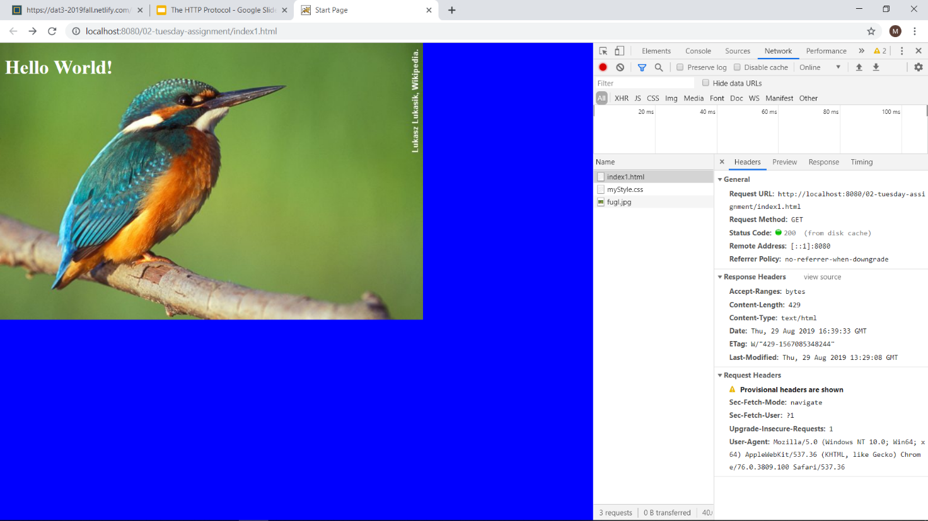

Jeg har fundet Header informationer men jeg har på fornemmelsen at opgaven er løst forkert!