Results

Descriptive Statistics

variable

mean

sd

min

max

height

138.26

27.60

53.98

179.07

weight

35.61

14.72

4.25

62.99

age

29.34

20.75

0.00

88.00

Note: Some table note

Table 1 shows descriptive statistics of the study variables. There were no missing values in the data and all participants were included for our final analysis. In the first analysis step, we regressed height on weight and age. The assumptions of normality of residuals and homogeneity of variance were violated (figure 1). The diagnostic plots suggest that a curvelinear model should be more suitable. Following the guidelines of de Weerth (2017) we fitted a quadratic model in the next step, which led to a more appropriate model (figure 2). The final model was as follows:

$$
y_i \sim N(\mu, \sigma)\\
\mu_i = \beta_0 + \beta_1 \times weight + \beta_2 \times weight^2 + \beta_3 \times weight^3 + \beta_4 \times gender
$$

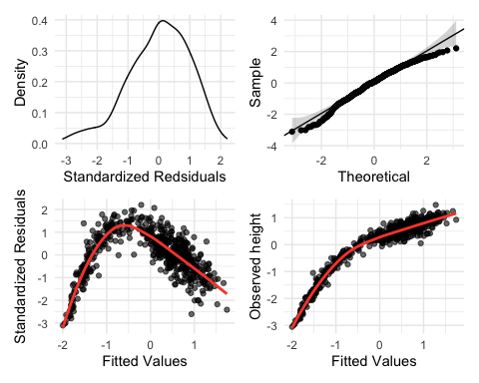

Diagnostic Plots Standard Regression Model

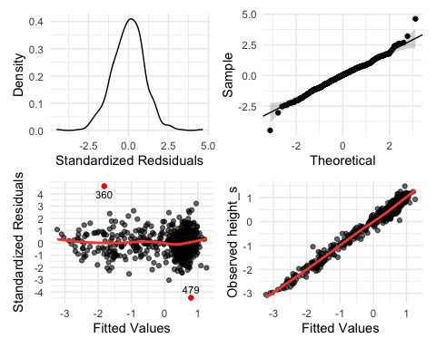

Diagnostic Plots Polynomial Regression

We found that weight is positively associated with height (table 2) and that the relation can best be described using a polynomial regression model. However, the assumptions of constant variance remains violated as the error variation increases with age indicating that we miss important predictors that explain height development in humans. Furthermore we found that males are 0.122 taller than females on average (*p* < .001). Figure 3 shows the regression lines for each gender that are most compatible with the real observations (black dots).

Regression Coefficients

Parameter

Estimate

Standard Error

t-value

p-value

intercept

0.269

0.012

22.812

< .001

weight_s

0.544

0.017

32.581

< .001

weight_s2

-0.262

0.010

-27.032

< .001

weight_s3

0.119

0.008

14.500

< .001

male

0.122

0.015

7.977

< .001

Note: Some table note

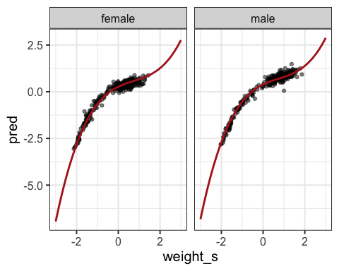

Regression lines of the final model

# References

de Weerth, Carolina. 2017. “Do Bacteria Shape Our Development? Crosstalk Between Intestinal Microbiota and HPA Axis.” *Neuroscience & Biobehavioral Reviews* 83 (December): 458–71. <https://doi.org/10.1016/j.neubiorev.2017.09.016>.