# Homework #2

Henrik Lucander, 724140

## Problem 1)

$$b=average friction coefficient$$

$$u=controller^{'}s action$$

### a)

Forces applied to the car:

$$∑F=ma$$

$$u-b\dot{x}=m\ddot{x}$$

$$\ddot{x}+\frac{b}{m}\dot{x}=\frac{u}{m}$$

and if $v\left(t\right)=\dot{x}\left(t\right)$ we can rewrite it as:

$$\dot{v}\left(t\right)+\frac{b}{m}v\left(t\right)=\frac{u\left(t\right)}{m}$$

### b)

$$m=1000kg$$

$$b=100$$

Design specification: 0 km/h to 100 km/h in 8 seconds with an overshoot less than 20%

#### i)

As stated in Problem 1 part a), the system can be represented by:

$m\dot{v}+bv=u$

We take the Laplace transform:

$$L\left\{m\dot{v}+bv\right\}=L\left\{u\right\}$$

$$msL\left\{v\right\}+bL\left\{v\right\}=L\left\{u\right\}$$

$$msV\left(s\right)+bV\left(s\right)=U\left(s\right)$$

$$\left(ms+b\right)V\left(s\right)=U\left(s\right)$$

We get:

$$G\left(s\right)=\frac{V\left(s\right)}{U(s)}=\frac{1}{ms+b}$$

The PI controller:

$$C_{PI}\left(s\right)=\frac{K_{p}s+K_{i}}{s}$$

Closed loop:

$$H\left(s\right)=\frac{Y\left(s\right)}{R\left(s\right)}=\frac{C_{PI}(s)G\left(s\right)}{1+C_{PI}\left(s\right)G\left(s\right)}=\frac{\frac{K_{p}s+K_{i}}{s}*\frac{1}{1000s+100}}{1+\frac{K_{p}s+K_{i}}{s}*\frac{1}{1000s+100}}=\frac{\frac{K_{p}s+K_{i}}{1000s^{2}+100s}}{1+\frac{K_{p}s+K_{i}}{1000s^{2}+100s}}=\frac{K_{p}s+K_{i}}{1000s^{2}+\left(100+K_{p}\right)s+K_{i}}=\frac{0.001K_{p}s+0.001K_{i}}{s^{2}+\left(0.1+0.001K_{p}\right)s+0.001K_{i}}$$

We need an overshoot less than 20%:

We can find $ω_{n}$ and $ζ$ from:

$$H\left(s\right)=\frac{ω_{n}^{2}}{s^{2}+2ζω_{n}s+ω_{n}^{2}}$$

I assume that the car "reaches 100km/h" when at the settling time $t_{s}$,and not at the time it raises above 100km/h for the first time:

$$ζ≥0.6\left(1-\frac{M_{p}in\%}{100}\right)=0.6\left(1-\frac{20}{100}\right)=0.48$$

$$t_{s}=\frac{4.6}{ζω_{n}}$$

$$ω_{n}=\frac{4.6}{ζt_{s}}=\frac{4.6}{0.48*8}≈1.198$$

Therefore, we want the following closed loop transfer function H(s):

$$H\left(s\right)=\frac{1.435}{s^{2}+1.15s+1.435}$$

We get the following gains:

$$K_{p}=\frac{1.05}{0.001}=1050$$

$$K_{i}=\frac{1.435}{0.001}=1435$$

When simulating with these gain values, the overshoot is around 28% which is not acceptable. We increase the damping factor $ζ$ by half:

$$ζ=0.72$$

$$ω_{n}=\frac{4.6}{ζt_{s}}=\frac{4.6}{0.72*8}≈0.799$$

$$H\left(s\right)=\frac{0.638}{s^{2}+1.15s+0.638}$$

$$K_{p}=\frac{1.05}{0.001}=1050$$

$$K_{i}=\frac{0.638}{0.001}=638$$

When simulating with these new gain values, the overshoot is 16,8% and a settling time of 7 seconds, which is acceptable.

Therefore, our PI controller is:

$$C_{PI}\left(s\right)=\frac{K_{p}s+K_{i}}{s}=\frac{1050s+638}{s}$$

#### ii)

Simulink:

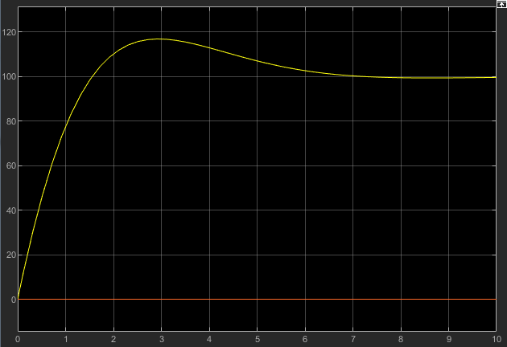

We get an overshoot of 16.8% and a settling time of 7 seconds.

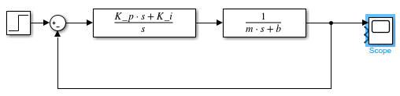

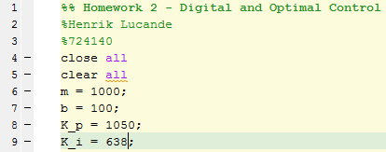

### c)

We get the bandwidth from the bode diagram. Bandwidth is the frequency where magnitude drops -3dB from peak value. Therefore, bandwidth = 1.5rad/s = 0.2387 Hz

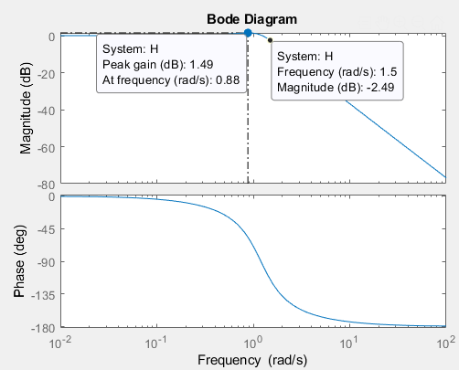

Discretization with Tustin method where $T_{s}=\frac{1}{30*0.2387}≈0.14$

$$C\left(z\right)=C\left(s\right){\left.​\right|}_{s=\frac{2}{T_{s}}*\frac{z-1}{z+1}}=\frac{1050s+638}{s}{\left.​\right|}_{s=\frac{2}{T_{s}}*\frac{z-1}{z+1}}=\frac{1050\frac{2}{T_{s}}*\left(\frac{z-1}{z+1}\right)+638}{\frac{2}{T_{s}}*\left(\frac{z-1}{z+1}\right)}=\frac{{(T}_{s}*(z+1))*(1050\frac{2}{T_{s}}*\frac{z-1}{z+1}+638)}{2(z-1)}=\frac{2100\left(z-1\right)+638T_{s}z+837T_{s}}{2(z-1)}=\frac{2100z-2100+89.32z+117.18}{2(z-1)}=\frac{1094.66z-991.41}{z-1}$$

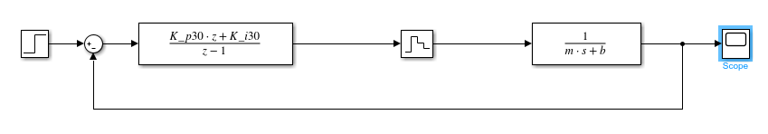With the discretized controller with a sampling rate 30 times the bandwidth, we got the following results:

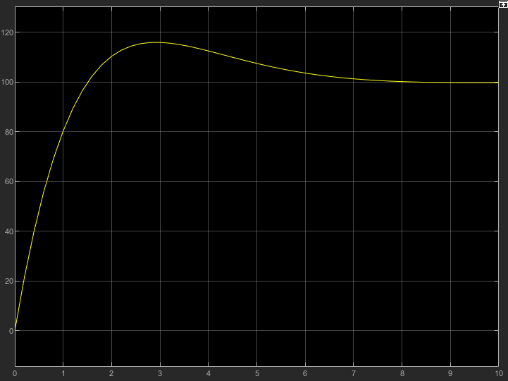

As we can see from the plot above, performance is almost the same as with the continuous controller. With an 16% which is slightly less than the continuous one, but with a slightly slower settling time.

### d)

#### i)

We discretize the controller with a sampling rate 6 times the bandwidth using the Tustin transformation.

$$T_{s}=\frac{1}{6*0.2387}≈0.7$$

$$C\left(z\right)=C\left(s\right){\left.​\right|}_{s=\frac{2}{T_{s}}*\frac{z-1}{z+1}}=\frac{1050s+638}{s}{\left.​\right|}_{s=\frac{2}{T_{s}}*\frac{z-1}{z+1}}=\frac{1050\frac{2}{T_{s}}*\left(\frac{z-1}{z+1}\right)+638}{\frac{2}{T_{s}}*\left(\frac{z-1}{z+1}\right)}=\frac{{(T}_{s}*(z+1))*(1050\frac{2}{T_{s}}*\frac{z-1}{z+1}+638)}{2(z-1)}=\frac{2100\left(z-1\right)+638T_{s}z+837T_{s}}{2(z-1)}=\frac{2100z-2100+446.6z+585.9}{2(z-1)}=\frac{2546.6z-1514.1}{z-1}$$

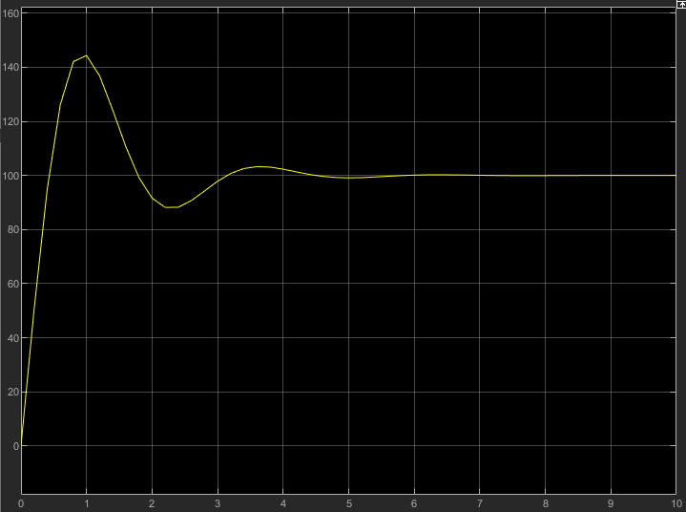With this controller we get the following response:

As we can see from the plot above, the controller doesn’t perform nearly as good as the continuous one. We get an overshoot of 44.3%, which is far from the system specifications.

#### ii)

We discretize the plant with $T_{s}=0.7$:

$$G\left(z\right)=\left(1-z^{-1}\right)Z\left\{\frac{G\left(s\right)}{s}\right\}=\frac{z-1}{z}Z\left\{\frac{0.001}{s(s+0.1)}\right\}=\frac{z-1}{z}Z\left\{\frac{0.01}{s}-\frac{0.01}{s+0.1}\right\}=0.01*\frac{z-1}{z}*\left(\frac{z}{z-1}-\frac{z}{z-e^{-0.1*T_{s}} }\right)=\frac{0.00058}{z-0.942}$$

Our digital controller:

$$C\left(z\right)=k_{p}+k_{i}*\frac{z}{z-1}=\frac{{(k}_{p}+k_{i})z-k_{p}}{z-1}$$

Our closed loop transfer function therefore is:

$$H\left(z\right)=\frac{G\left(z\right)C(z)}{1+G\left(z\right)C(z)}=\frac{\frac{0.00058}{z-0.942}*\frac{{(k}_{p}+k_{i})z-k_{p}}{z-1}}{1+\frac{0.00058}{z-0.942}*\frac{{(k}_{p}+k_{i})z-k_{p}}{z-1}}=\frac{0.00058{(k}_{p}+k_{i})z-0.00058k_{p}}{z^{2}-z-0.942z+0.942+0.00058{(k}_{p}+k_{i})z-0.00058k_{p}}=\frac{0.00058{(k}_{p}+k_{i})z-0.00058k_{p}}{z^{2}+\left(0.00058\left(k_{p}+k_{i}\right)-1.942\right)z+(0.942-0.00058k_{p})}$$

We need to find the desired H(z) by using the zeta and omega from the continuous case:

$$ζ=0.72$$

$$ω_{n}=0.799=\frac{0.15π}{T}$$

From the “s-plane to z-plane”-map we get:

$$z_{p}=0.7+j0.2$$

From which we get the desired H(z):

$$H\left(z\right)=\frac{(1-z_{p})(1-{\overline{z}}_{p})}{(z-z_{p})(z-{\overline{z}}_{p})}=\frac{0.13}{z^{2}-1.4z+0.53}$$

Now we can get the following gains:

$$0.53=0.942-0.00058k_{p}$$

$$k_{p}=\frac{0.53-0.942}{-0.00058}=710.3$$

$$-1.4=0.00058\left(k_{p}+k_{i}\right)-1.942$$

$$k_{i}=\frac{-1.4+1.942-0.00058*710}{0.00058}=224.5$$

We get our final controller:

$$C\left(z\right)=k_{p}+k_{i}*\frac{z}{z-1}=\frac{{(k}_{p}+k_{i})z-k_{p}}{z-1}=\frac{934z-710}{z-1}$$

Now we simulate:

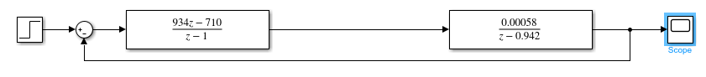

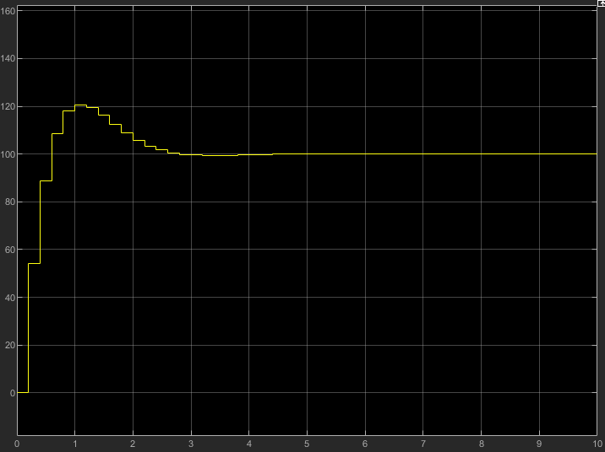

As we can see from the plot above, the discretized plant with a sampling rate of 6 times the bandwidth with a discrete PI controller, does not meet the design specifications.

We get an overshoot of 20.7%

The m-code used in this homework is short as most was calculated for hand in this document (in the last simulation I just added the gains straight to Simulink):

