# Homework 3

Henrik Lucander, 724140

## Problem 1)

$$1+\frac{0.2Kz+0.5K}{z^{2}-1.2z+0.2}=0$$

$$z^{2}+\left(0.2K-1.2\right)z+0.5K+0.2=0$$

For a 2nd order transfer function we can determine stability by using the triangle rule:

$$A\left(z\right)=z^{2}+a_{1}z+a_{2}$$

$$\left\{\begin{aligned}a_{2}<1 \\ a_{2}>-a_{1}-1 \\ a_{2}>a_{1}-1\end{aligned}\right.$$

$$\left\{\begin{aligned}0.5K+0.2<1 \\ 0.5K+0.2>-(0.2K-1.2)-1 \\ 0.5K+0.2>0.2K-1.2-1\end{aligned}\right.$$

We get:

$$\left\{\begin{aligned}K<1.6 \\ K>0 \\ K>-8\end{aligned}\right.$$

**Combined:**

$$0<K<1.6$$

## Problem 2)

$$X\left(z\right)=z^{3}-2z^{2}+1.4z-0.1=0$$

Using the characteristic polynomial:

$$A\left(z\right)=a_{o}z^{n}+a_{1}z^{n-1}+…+a_{n}$$

We can test if all poles are inside the unit circle with Jury’s test:

$\left\{\begin{aligned}\underline{\begin{matrix}a_{o} & a_{1} & … & a_{n-1} & a_{n} \\ a_{n} & a_{n-1} & … & a_{1} & a_{0}\end{matrix}} \\ \underline{\begin{matrix}a_{0}^{n-1} & a_{1}^{n-1} & … & a_{n-1}^{n-1} \\ a_{n-1}^{n-1} & a_{n-2}^{n-1} & … & a_{0}^{n-1}\end{matrix}} \\ \begin{matrix}… & & & \\ a_{o}^{0} & & & \end{matrix}\end{aligned} \right.$ $\begin{matrix}b_{n}=\frac{a_{n}}{a_{o}} \\ b_{n-1}=\frac{a_{n-1}^{n-1}}{a_{o}^{n-1}}\end{matrix}$

$\left\{\begin{aligned}\underline{\begin{matrix}1 & -2 & 1.4 & -0.1 \\ -0.1 & 1.4 & -2 & 1\end{matrix}} \\ \underline{\begin{matrix}0.99 & -1.86 & 1.2 & \\ 1.2 & -1.86 & 0.99 & \end{matrix}} \\ \begin{matrix}-0.464 & 0.394 & & \\ 0.394 & -0.464 & & \\ -0.798 & & & \end{matrix}\end{aligned}\right.$ $\begin{matrix}b_{3}=\frac{a_{n}}{a_{o}}=-\frac{0.1}{1}=-0.1 \\ b_{2}=\frac{a_{n-1}^{n-1}}{a_{o}^{n-1}}=\frac{1.2}{0.99}=1.212 \\ b_{3}=-\frac{0.394}{0.464}=0.849\end{matrix}$

**Where:**

$$\left\{\begin{matrix}a_{0}^{0}<0 \\ a_{0}^{2}<0 \\ a_{0}^{1}>0 \\ a_{0}^{}>0\end{matrix}\right.$$

**as the negative values corresponds to 2 poles outside the unit circle, the system is unstable.**

## Problem 3)

### a)

$$P\left(z\right)=-\frac{1}{z^{2}+z+2}$$

Open loop poles of a system can be obtained from the roots of the denominator:

$$x=\frac{-b±\sqrt{b^{2}-4ac }}{2a}=\frac{-1±\sqrt{1^{2}-4*1*2 }}{2*1}=\frac{-1±\sqrt{-7 }}{2}=-0.5±i\sqrt{7 }$$

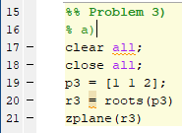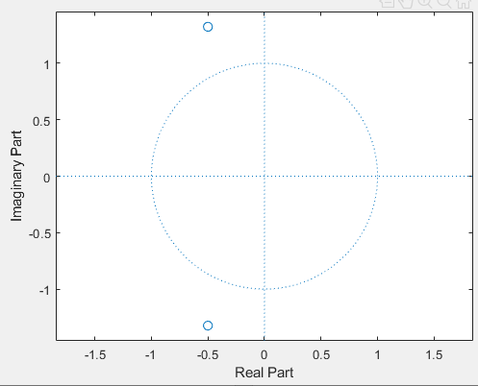

**From the plot above, we can see that poles are outside the unit circle. Therefore, the system is unstable.**

### b)

The closed loop transfer function is obtained from:

$$G\left(z\right)=\frac{Y\left(z\right)}{R(z)}=\frac{K*P\left(z\right)}{1+K*P\left(z\right)}=\frac{\left(-\frac{K}{z^{2}+z+2}\right)}{1+\left(-\frac{K}{z^{2}+z+2}\right)}=\frac{-K}{z^{2}+z+2-K}$$

### c)

The poles of a closed loop function can be obtained from the roots of the denominator.

$$z^{2}+z+2-K=0$$

For a 2nd order transfer function we can determine stability by using the triangle rule:

$$A\left(z\right)=z^{2}+a_{1}z+a_{2}$$

$$\left\{\begin{aligned}a_{2}<1 \\ a_{2}>-a_{1}-1 \\ a_{2}>a_{1}-1\end{aligned}\right.$$

We get:

$$\left\{\begin{aligned}2-K<1 \\ 2-K>-1-1 \\ 2-K>1-1\end{aligned}\right.$$

$$\left\{\begin{aligned}K>1 \\ K<4 \\ K<2\end{aligned}\right.$$

**We combine these 3 criteria and get:**

$$1<K<2$$

### d)

The final value theorem allows the time domain behavior to be directly calculated by taking the limit of a frequency domain expression, instead of converting first to time domain and then taking its limit (only when the poles are inside the unit circle).

We can obtain the steady state value of $y[k]$ by using the final value theorem:

$${y[k]}_{steadystate}=\lim_{k→∞ }{y[k]}=\lim_{z→1 }\left(z-1\right)Y\left(z\right)=\lim_{z→1 }\left(z-1\right)G\left(z\right)U\left(z\right)=\lim_{z→1 }\left(z-1\right)*\frac{-K}{z^{2}+z+2-K}*\frac{z}{z-1}=\frac{-K}{1^{2}+1+2-K}*\frac{1}{1-1}=\frac{-K}{4-K}$$

### e)

As the open loop transfer function has two poles outside the unit circle (see Problem3 part a) ), the Nyquist plot needs to encircle -1 two times.

**Therefore, Nyquist plot B is correct.**

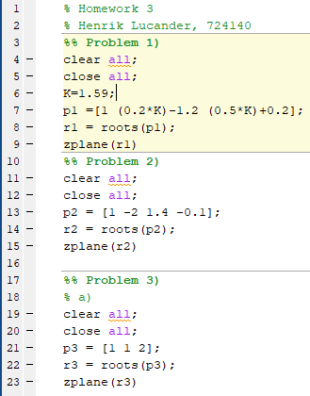Matlab code I used for this homework: