# Homework 4

Henrik Lucander, 724140

## Problem 1)

### a)

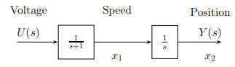

$$y\left(t\right)=x_{2}\left(t\right)$$

$$\dot{y}\left(t\right)={\dot{x}}_{2}\left(t\right)=x_{1}\left(t\right)$$

$$\ddot{y}\left(t\right)={\dot{x}}_{1}(t)$$

transfer function:

$$H\left(s\right)=\frac{Y\left(s\right)}{U(s)}=\frac{1}{s(s+1)}=\frac{1}{s^{2}+s}$$

we get:

$$s^{2}Y\left(s\right)+sY\left(s\right)=U\left(s\right)$$

as $\ddot{y}\left(t\right)={\dot{x}}_{1}(t)$ and $\dot{y}\left(t\right)={\dot{x}}_{2}\left(t\right)=x_{1}\left(t\right)$ we get:

$$sX_{1}\left(s\right)+X_{1}\left(s\right)=U\left(s\right)$$

which equals:

$${\dot{x}}_{1}\left(t\right)=-x_{1}\left(t\right)+u(t)$$

Therefore:

$$\left[\begin{matrix}\begin{matrix}{\dot{x}}_{1}(t) \\ {\dot{x}}_{2}(t)\end{matrix}\end{matrix}\right]=\left[\begin{matrix}-1 & 0 \\ 1 & 0\end{matrix}\right]\left[\begin{matrix}x_{1}(t) \\ x_{2}(t)\end{matrix}\right]+\left[\begin{matrix}1 \\ 0\end{matrix}\right]u(t)$$

$$y\left(t\right)=\left[\begin{matrix}0 & 1\end{matrix}\right]\left[\begin{matrix}x_{1}(t) \\ x_{2}(t)\end{matrix}\right]$$

### b)

$ϕ\left(h\right)=e^{Ah}=e^{Ah}{\left.​\right|}_{t=h}=L^{-1}\left\{{\left(sI-A\right)}^{-1}\right\}{\left.​\right|}_{t=h}=L^{-1}\left\{{\left(\left[\begin{matrix}s & 0 \\ 0 & s\end{matrix}\right]-\left[\begin{matrix}-1 & 0 \\ 1 & 0\end{matrix}\right]\right)}^{-1}\right\}{\left.​\right|}_{t=h}=L^{-1}\left\{\left[\begin{matrix}\frac{1}{s+1} & 0 \\ \frac{1}{s^{2}+s} & \frac{1}{s}\end{matrix}\right]\right\}{\left.​\right|}_{t=h}=\left[\begin{matrix}e^{-t} & 0 \\ {1-e}^{-t} & 1\end{matrix}\right]{\left.​\right|}_{t=h}=\left[\begin{matrix}e^{-h} & 0 \\ {1-e}^{-h} & 1\end{matrix}\right]$

$$Γ\left(h\right)=\int_{0}^{h}{e^{As}dsB}=\int_{0}^{h}{\left[\begin{matrix}e^{-s} & 0 \\ {1-e}^{-s} & 1\end{matrix}\right]ds\left[\begin{matrix}1 \\ 0\end{matrix}\right]}=\int_{0}^{h}{\left[\begin{matrix}e^{-s} \\ {1-e}^{-s}\end{matrix}\right]ds}=\left[\begin{matrix}1-e^{-h} \\ h+e^{-h}-1\end{matrix}\right]$$

$$x\left(kh+h\right)=\left[\begin{matrix}e^{-h} & 0 \\ {1-e}^{-h} & 1\end{matrix}\right]x\left(kh\right)+\left[\begin{matrix}1-e^{-h} \\ h+e^{-h}-1\end{matrix}\right]u(kh)$$

$$y\left(kh\right)=\left[\begin{matrix}0 & 1\end{matrix}\right]x\left(kh\right)$$

### c)

$$h=1$$

$$u\left[k\right]=my_{ref}-L\hat{x}[k]$$

$$ϕ=\left[\begin{matrix}e^{-h} & 0 \\ {1-e}^{-h} & 1\end{matrix}\right]=\left[\begin{matrix}e^{-1} & 0 \\ {1-e}^{-1} & 1\end{matrix}\right]=\left[\begin{matrix}0.368 & 0 \\ 0.632 & 1\end{matrix}\right]$$

$$Γ=\left[\begin{matrix}1-e^{-h} \\ h+e^{-h}-1\end{matrix}\right]=\left[\begin{matrix}1-e^{-1} \\ e^{-1}\end{matrix}\right]=\left[\begin{matrix}0.632 \\ 0.368\end{matrix}\right]$$

The system is reachable if the controllability matrix $W_{c}$ is full rank

$$W_{c}=\left[Γ ϕΓ\right]=\left[\left[\begin{matrix}1-e^{-1} \\ e^{-1}\end{matrix}\right] \left[\begin{matrix}e^{-1} & 0 \\ {1-e}^{-1} & 1\end{matrix}\right]\left[\begin{matrix}1-e^{-1} \\ e^{-1}\end{matrix}\right]\right]=\left[\left[\begin{matrix}0.632 \\ 0.368\end{matrix}\right] \left[\begin{matrix}0.368 & 0 \\ 0.632 & 1\end{matrix}\right]\left[\begin{matrix}0.632 \\ 0.368\end{matrix}\right]\right]=\left[\begin{matrix}0.632 & 0.233 \\ 0.368 & 0.767\end{matrix}\right]$$

If the determinant of the controllability matrix $W_{c}$ is non-zero, it is full rank

$$\det\left(W_{c}\right)=\left|\begin{matrix}0.632 & 0.233 \\ 0.368 & 0.767\end{matrix}\right|=0.632*0.767-0.368*0.233=0.399≠0$$

The rank is full; therefore, the system is reachable.

Thus, we can choose the feedback gain $L$ such that the poles are placed as desired $0.5 ±j0.5$ with Ackermann

$$L=\left[\begin{matrix}0 & 1\end{matrix}\right]W^{-1}P\left(ϕ\right)$$

we find $W^{-1}$ and $P(ϕ)$:

$$W^{-1}={\left[\begin{matrix}0.632 & 0.233 \\ 0.368 & 0.767\end{matrix}\right]}^{-1}=\left[\begin{matrix}1.9223 & -0.5840 \\ -0.9223 & 1.5840\end{matrix}\right]$$

$$P\left(z\right)=\left(z-\left(0.5-0.5j\right)\right)\left(z-\left(0.5+0.5j\right)\right)=z^{2}-0.5z-0.5zj-0.5z+0.25+0.25j+0.5zj-0.25j-0.25j^{2}=z^{2}-z+0.5$$

$$P\left(ϕ\right)=ϕ^{2}-ϕ+0.5I={\left[\begin{matrix}0.368 & 0 \\ 0.632 & 1\end{matrix}\right]}^{2}-\left[\begin{matrix}0.368 & 0 \\ 0.632 & 1\end{matrix}\right]+0.5\left[\begin{matrix}1 & 0 \\ 0 & 1\end{matrix}\right]=\left[\begin{matrix}0.135 & 0 \\ 0.865 & 1\end{matrix}\right]-\left[\begin{matrix}0.368 & 0 \\ 0.632 & 1\end{matrix}\right]+\left[\begin{matrix}0.5 & 0 \\ 0 & 0.5\end{matrix}\right]=\left[\begin{matrix}0.267 & 0 \\ 0.233 & 0.5\end{matrix}\right]$$

$$L=\left[\begin{matrix}0 & 1\end{matrix}\right]W^{-1}P\left(ϕ\right)=\left[\begin{matrix}0 & 1\end{matrix}\right]\left[\begin{matrix}1.9223 & -0.5840 \\ -0.9223 & 1.5840\end{matrix}\right]\left[\begin{matrix}0.267 & 0 \\ 0.233 & 0.5\end{matrix}\right]=\left[\begin{matrix}0.122 & 0.792\end{matrix}\right]$$

The gain m needs to be chosen such that the output follows the reference input $y_{ref}$

We can take use of the final value theorem to obtain the gain m:

$$\lim_{k→∞}{y\left[k\right]}=\lim_{z→1}\left(z-1\right)Y(z)$$

We find $Y\left(z\right)$:

$$x\left[k+1\right]=ϕx\left[k\right]+Γ\left(u\left[k\right]+my_{ref}\right)=\left(ϕ-ΓL\right)x\left[k\right]+Γmy_{ref}$$

z-transform:

$$zX\left(z\right)=\left(ϕ-ΓL\right)X\left(z\right)+Γm*\frac{Y_{ref}\left(z\right)}{z-1}$$

$$\left(zI-ϕ+ΓL\right)X\left(z\right)=Γm*\frac{Y_{ref}\left(z\right)}{z-1}$$

$$y\left[k\right]=Cx\left[k\right]$$

z-transform:

$$Y\left(z\right)=CX(z)$$

insert X(z):

$$Y\left(z\right)=C*\frac{Γm*\frac{Y_{ref}\left(z\right)}{z-1}}{\left(zI-ϕ+ΓL\right)}$$

We get:

$$\lim_{k→∞}{y\left[k\right]}=\lim_{z→1}\left(z-1\right)*C*\frac{Γm*\frac{Y_{ref}\left(z\right)}{z-1}}{\left(zI-ϕ+ΓL\right)}=\left(z-1\right)*C*\frac{Γm*Y_{ref}\left(z\right)}{\left(z-1\right)\left(zI-ϕ+ΓL\right)}=\lim_{z→1}{C{\left(zI-ϕ+ΓL\right)}^{-1}ΓmY_{ref}\left(z\right)}=1{\left(\left[\begin{matrix}1 & 0 \\ 0 & 1\end{matrix}\right]-\left[\begin{matrix}0.368 & 0 \\ 0.632 & 1\end{matrix}\right]+\left[\begin{matrix}0.632 \\ 0.368\end{matrix}\right]\left[\begin{matrix}0.122 & 0.792\end{matrix}\right]\right)}^{-1}\left[\begin{matrix}0.632 \\ 0.368\end{matrix}\right]mY_{ref}\left(z\right)=\left[\begin{matrix}0 \\ 1.263\end{matrix}\right]mY_{ref}\left(z\right)=1.263mY_{ref}(z)$$

Therefore:

$$m=\frac{1}{1.263}$$

### d)

Only u and y are measured. State observer can be designed separately.

For the observer, we need the gain K:

$$\det\left(zI-ϕ+KC\right)=\det\left(\left[\begin{matrix}z & 0 \\ 0 & z\end{matrix}\right]-\left[\begin{matrix}0.368 & 0 \\ 0.632 & 1\end{matrix}\right]+\left[\begin{matrix}k_{1} \\ k_{2}\end{matrix}\right]\left[\begin{matrix}0 & 1\end{matrix}\right]\right)=\det\left(\left[\begin{matrix}z-0.368 & k_{1} \\ -0.632 & z-1+k_{2}\end{matrix}\right]\right)=\left(z-0.368\right)\left(z-1+k_{2}\right)-\left(-0.632\right)k_{1}=z^{2}-z+k_{2}z-0.368z+0.368-0.368k_{2}+0.632k_{1}=z^{2}+\left(k_{2}-1.368\right)z+(0.632k_{1}-0.368k_{2}+0.368)$$

$$k_{2}=1.368$$

$$k_{1}=\frac{0.368k_{2}-0.368}{0.632}=0.2143$$

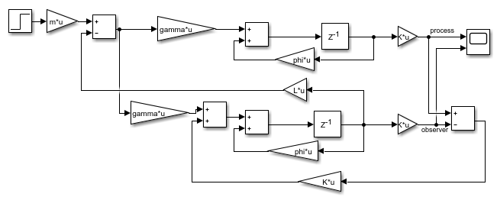

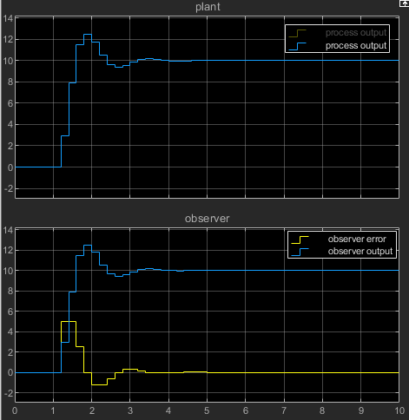

Figure 1. The final value is set to 10.

The process converges and the error goes to 0. Everything seems to work as intended.

### e)

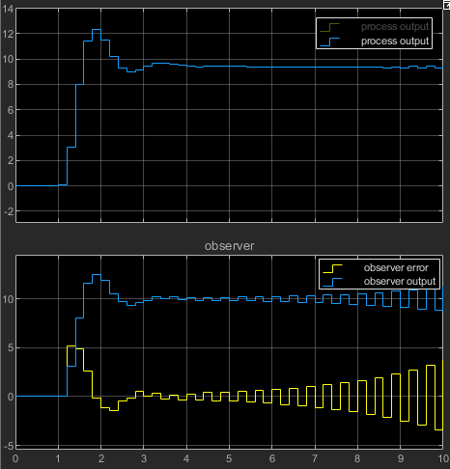

Figure 2.

My hypothesis was that the observation error would go higher and converge to 0 later. The system would remain stable.

However, it seems like the system can’t handle the disturbance. After double checking the math and going through the lecture slides, I couldn’t come up with any logical explanation why this happens….

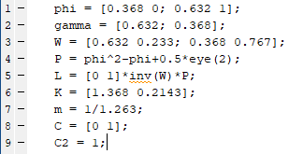

m-code used. Math was done by hand/calculator. Included in the document.