# Final Exercise

Henrik Lucander, 724140

## Problem 1)

## Problem 2)

## Problem 3)

### Dataset 1)

#### a)

**chosen model: amx1221**

#### b)

When determining the delay, all the arx models had the same delay. Therefore, delay of 1 was chosen.

$$n_{k}=1$$

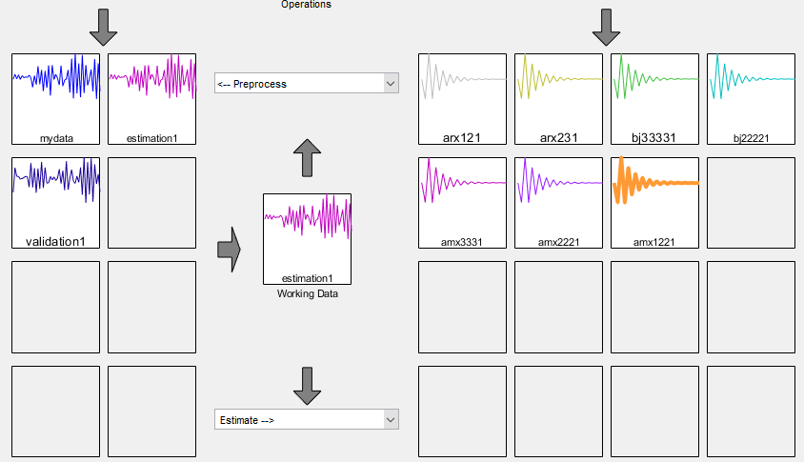

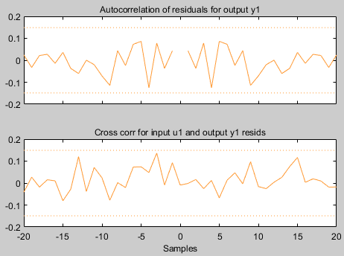

Inside confidence levels. Does not go over the bands.

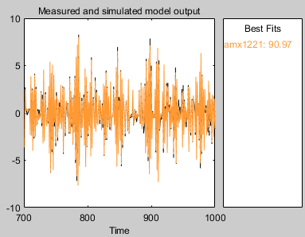

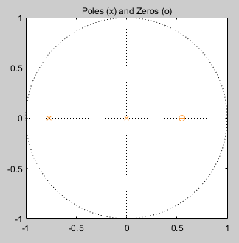The model is a good fit: 90.97

Poles and zeros are within the unit circle and they are not close together.

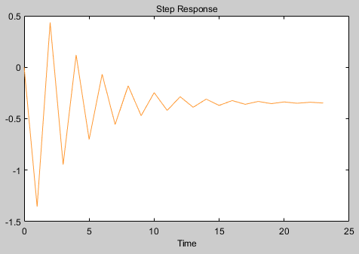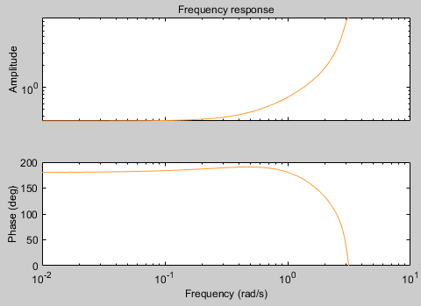

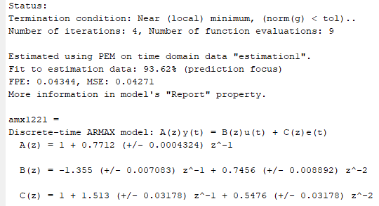

The standard deviation analysis is good.

#### c)

The best model was quite obvious and a very good fit, so no alternative models were considered.

### Dataset 2)

#### a)

**chosen model: bj11221**

#### b)

When determining the delay, all the arx models had the same delay. Therefore, delay of 1 was chosen.

$n_{k}=1$

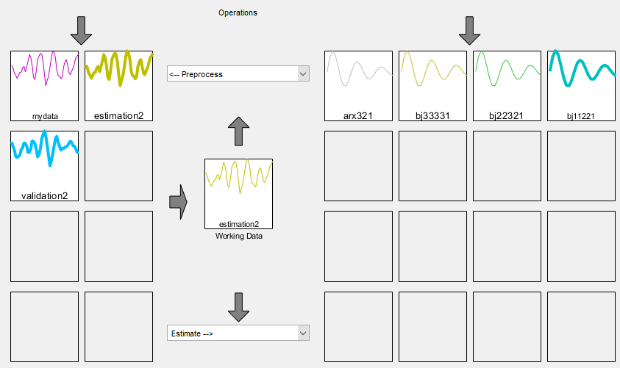

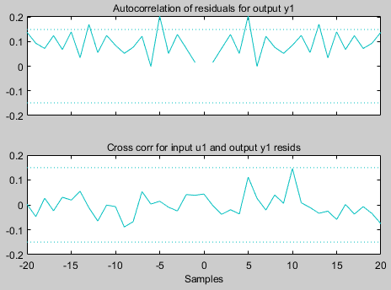

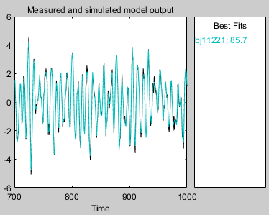Inside confidence levels. Does not go over the bands (autocorrelation is shifted but it is okay as the variance is smaller than the bands).

The model is a good fit: 85.7

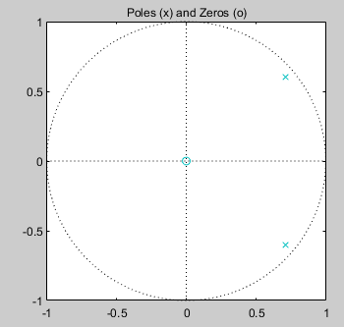

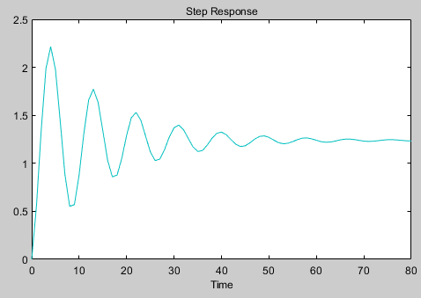Poles and zeros are within the unit circle and not too close together.

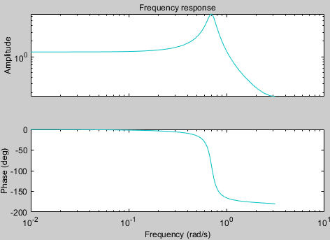

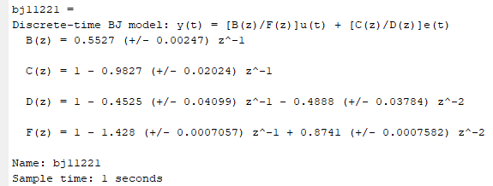

The standard deviation analysis is good.

#### c)

The best model was quite obvious and a very good fit, so no alternative models were considered.

### Dataset 3)

#### a)

**model chosen: oe322**

#### b)

When determining the delay from arx models, we can see that the autocorrelation of arx332 is sinusoidal and goes over the band.

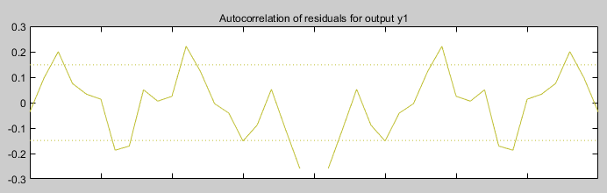

The autocorrelation is sinusoidal and goes over the band.

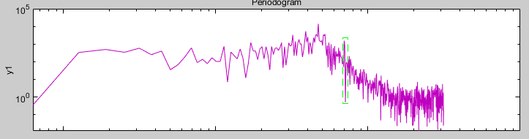

From filtering the data, we can see that the noise peaks around 0.7 Rad/s. Also, the bj33332 has a huge spike in its noise spectrum at 0.7 Rad/s. Therefore, we filter it out from the range: [0.68 0.72]

With the new filtered data, we determine the delay from arx models. All but the 2nd has a delay of 2. Also, the bj33331 and bj33333 both have a peak in cross correlation at 2. Therefore, delay of 2 is chosen.

$$n_{k}=2$$

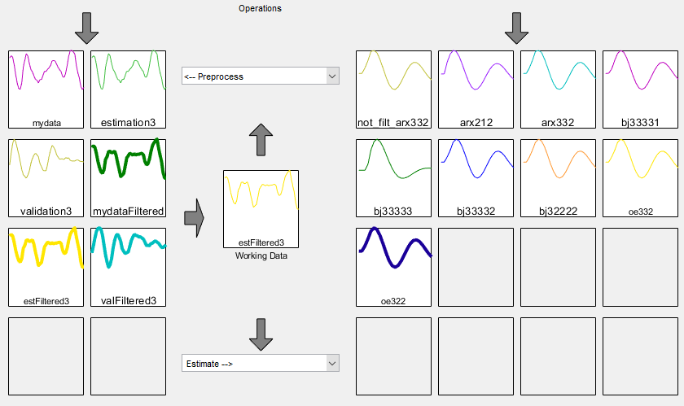

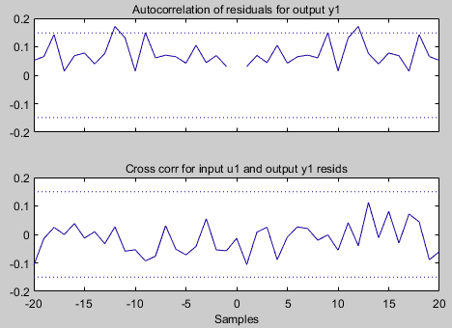

Inside confidence levels. Does not go over the bands (autocorrelation is shifted but it is okay as the variance is smaller than the bands).

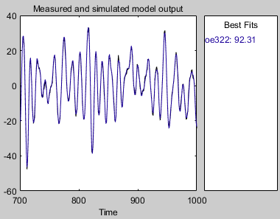

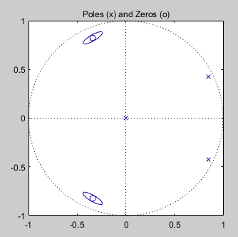The model is a good fit: 92.31

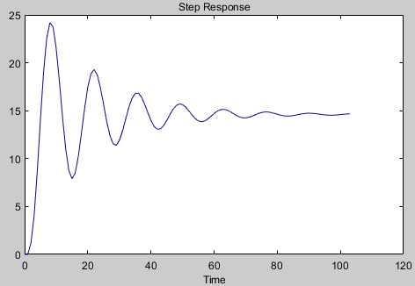Poles and zeros are within the unit circle and not too close together

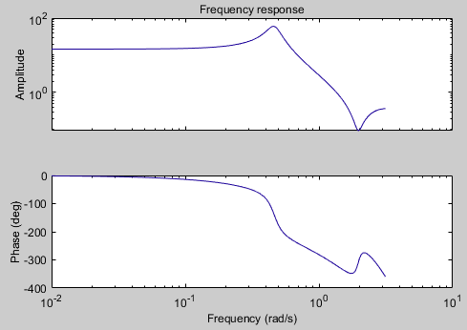

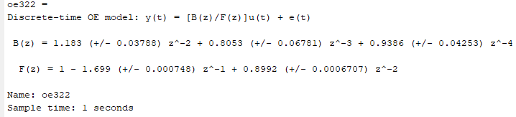

The standard deviation analysis is good.

#### c)

Basically, bj32222 was an okay model, but as C&D were similar, we were able move to Output Error (OE) models.

The oe322 was a very good model and therefore, other models were not very seriously considered.