**Lab 1:  
Philip Ngo – phing272  
Henrik Rosander – henro926**

**Part 1:  
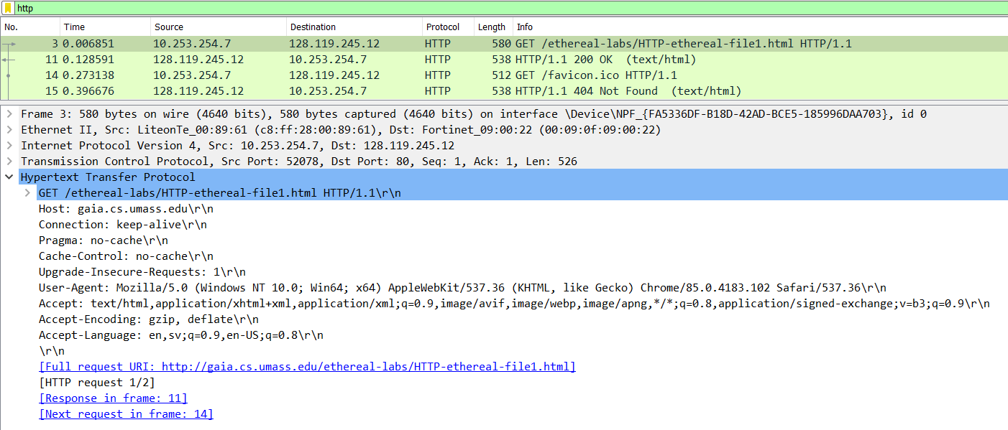**

1. It is running HTTP 1.1
2. It accepts en, sv; q=0.9, en-US; q=0.8
3. The computer IP-address is 10.253.254.7 and server address is 128.119.245.12
4. The status code returned was “200 OK”

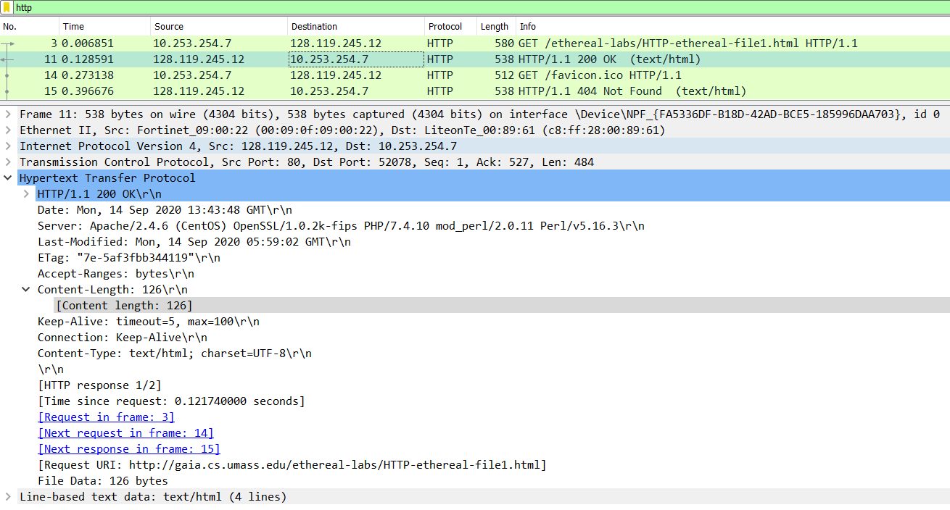

1. Last modified Mon, 14 September, 2020, 05:59:02 GMT
2. 126 bytes (from the length)

**Part 2:**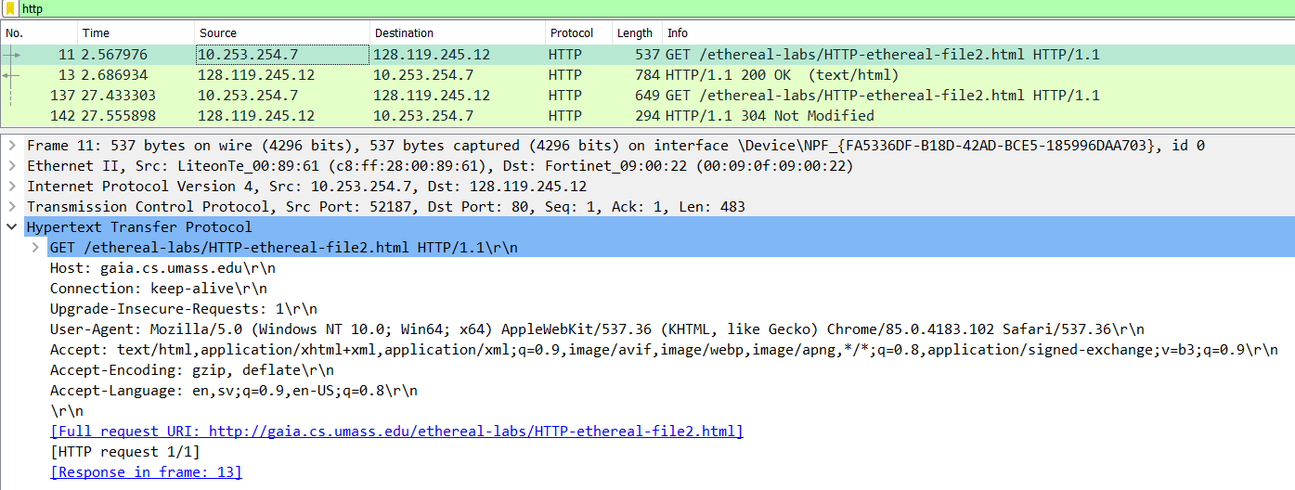

1. No, we do not. See image above

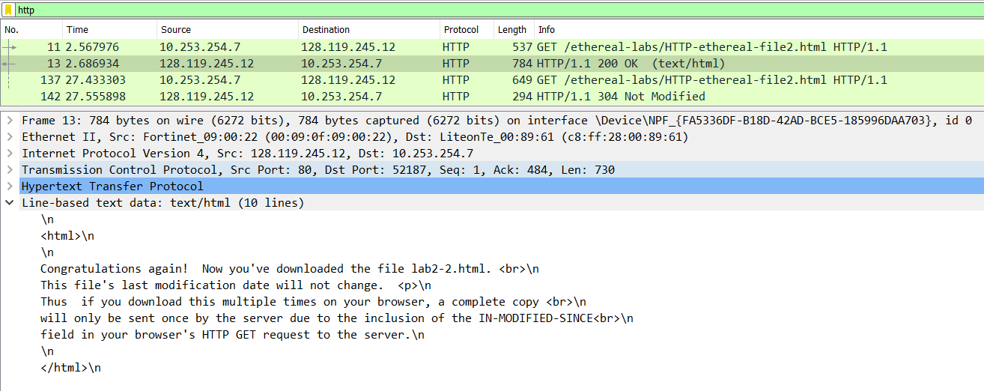

1. Yes, it did. See image above
2. IF-MODIFIED-SINCE: is Mon, 14 September, 2020, 05:59:02 GMT
3. HTTP Status Code “304 Not Modified”. The server did not return any content because the website the website was unmodified from its previous request. When we did our first HTTP GET request, the text was saved in chromes memory cache. So when we reload the page, we don’t need to get new data since the webpage is unmodified.

**Part 3:**

1. One HTTP GET request messages were sent by the browser  
     
   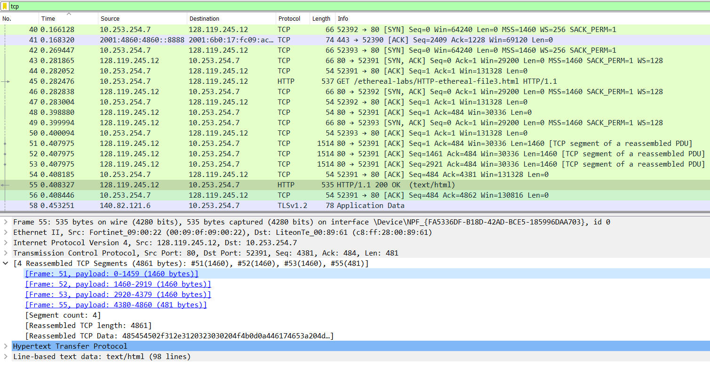
2. 4 TCP segments for the HTTP GET. See image above
3. The status code is “200 OK”

**Part 4:**

1. 3 total HTTP GET requests were sent, whereas two were sent to <https://liu.se/mall06/grafik/header/default_header/default_big_header.gif?fbclid=IwAR2ZkNhAtCaDOh-k7UnlLBy5O_mlwRFjfexFo5D1IBSKIDTVnWtNUx0VxzU> and <https://www.ox.ac.uk/sites/files/oxford/pi.jpg?fbclid=IwAR2ZkNhAtCaDOh-k7UnlLBy5O_mlwRFjfexFo5D1IBSKIDTVnWtNUx0VxzU>  
     
   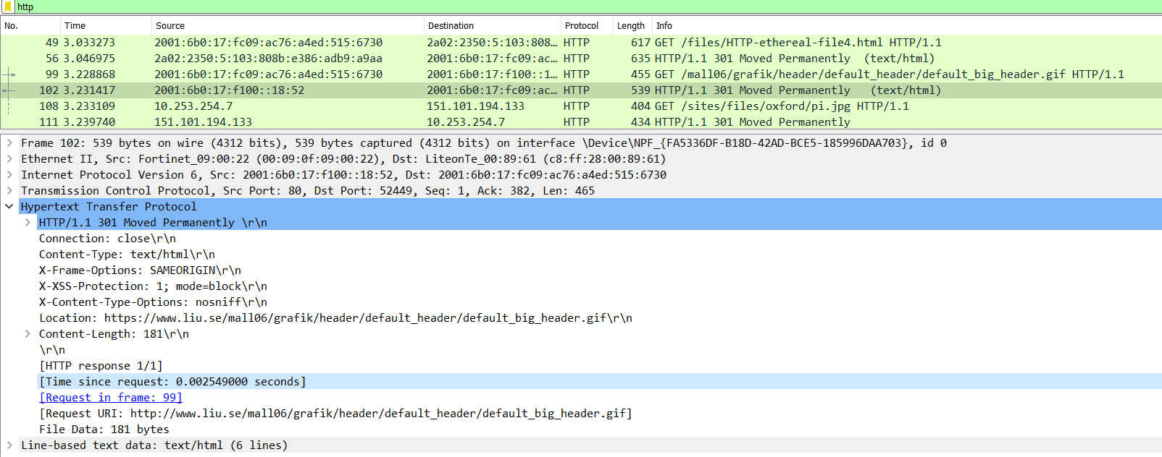
2. Serially, since the timestamps are different.

**Part 5:** 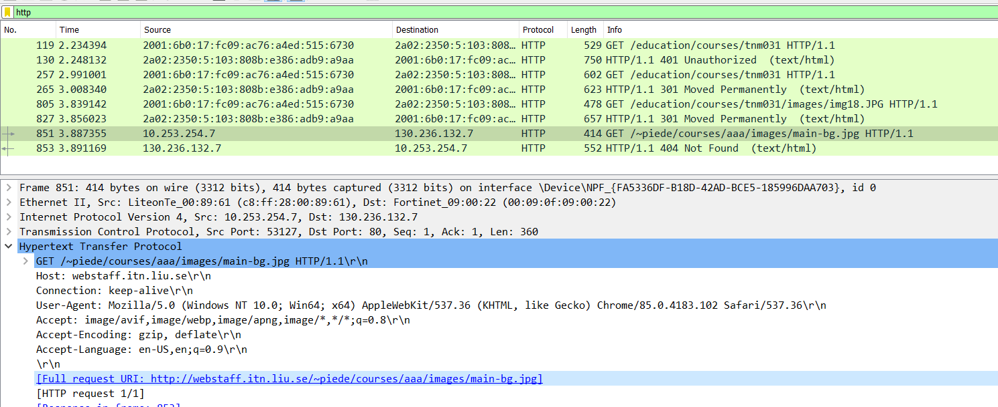

1. The servers response code is “401 Unauthorized”. See image above

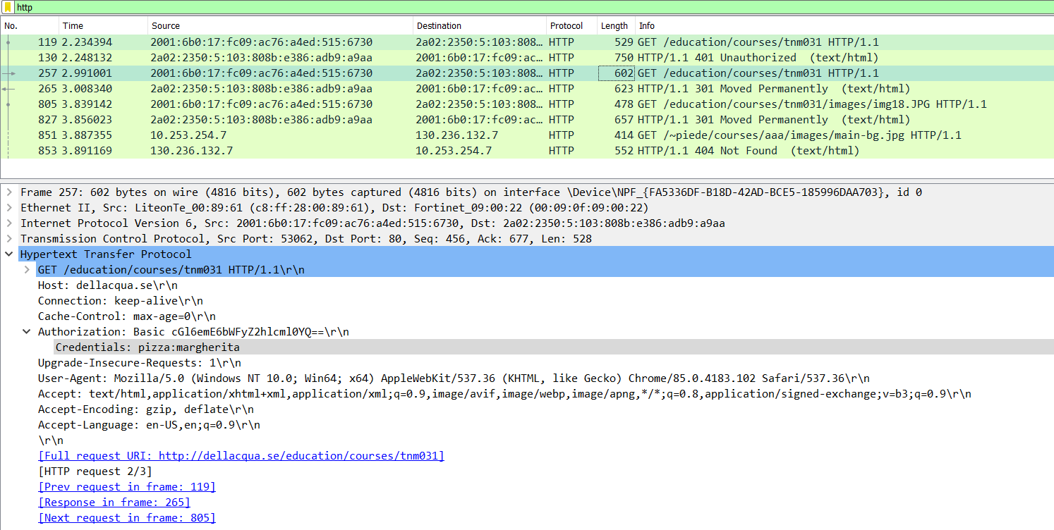

1. We can see Authorization: “Credentials: pizza : margherita”. See image above

**Part 6 (Optional):**

1. *ring ring*, “Test”(or Check), “One”, “Two”, “Three”