Development of Control Loops for the Fixed-Wing Mode of a Hybrid VTOL Drone
KAUE MARTINS DE SOUZA
Hybrid Vertical Take-Off and Landing (VTOL) drones combine the hovering capability of multi-rotor systems with the long-range cruise efficiency of fixed-wing aircraft, making them attractive for surveillance, mapping, and last-mile delivery missions. Although the literature is rich in transition and hover control strategies, the design of dedicated longitudinal and lateral-directional control loops for the fixed-wing flight phase of custom hybrid platforms is still under-addressed. This paper presents the context, motivation, and the methodology adopted in the development of a classical PID-based autopilot for the fixed-wing flight mode of a custom hybrid VTOL drone, leveraging the open-source PIPER-1-6 framework originally validated for the Piper J-3 Cub 1/6 model aircraft. The full pipeline — from the 6-DOF nonlinear plant assembled in MATLAB/Simulink, through the trim computation via fmincon and Jacobian-based linearization, to cascaded PID design with stability augmentation systems (SAS) and anti-windup — is described. A feed-forward compensation term is proposed to mitigate the altitude loss observed during banked turns. Closed-loop validation in Software-In-the-Loop (SIL) configuration, as well as the discussion of the obtained results, will be reported in a forthcoming version of this work.
Martins de Souza: Development of Control Loops for the Fixed-Wing Mode of a Hybrid VTOL Drone Martins de Souza: Development of Control Loops for the Fixed-Wing Mode of a Hybrid VTOL Drone
Autopilot, fixed-wing flight, flight control system, hybrid VTOL drone, linearization, MATLAB/Simulink, PID control, software-in-the-loop, stability augmentation system, unmanned aerial vehicle.

Introduction

Importance of the Topic
Aerial Vehicles (UAVs) were originally developed for military reconnaissance and strike missions, but their use has rapidly expanded to civil and academic applications, including search-and-rescue, environmental monitoring, precision agriculture, last-mile delivery, and aerial cinematography . The growing availability of low-cost embedded electronics, brushless motors, lithium-polymer batteries, and microelectromechanical (MEMS) inertial sensors has enabled the proliferation of small UAVs, while at the same time raising the demand for more robust and precise autonomous flight control systems that minimize human intervention and operational risk .
Among the various airframe configurations, hybrid Vertical Take-Off and Landing (VTOL) drones have emerged as a particularly attractive class of platforms. They combine the static-thrust capability of multi-rotor systems — which allows them to take off, hover, and land vertically without the need for runways — with the higher cruise efficiency and longer endurance of fixed-wing aircraft, which rely on aerodynamic lift instead of continuous rotor thrust . This dual nature, however, comes at the cost of a more complex flight envelope: hybrid VTOLs operate in three distinct modes — hover, transition, and cruise — each one with its own dynamics, actuator allocation, and control objectives .
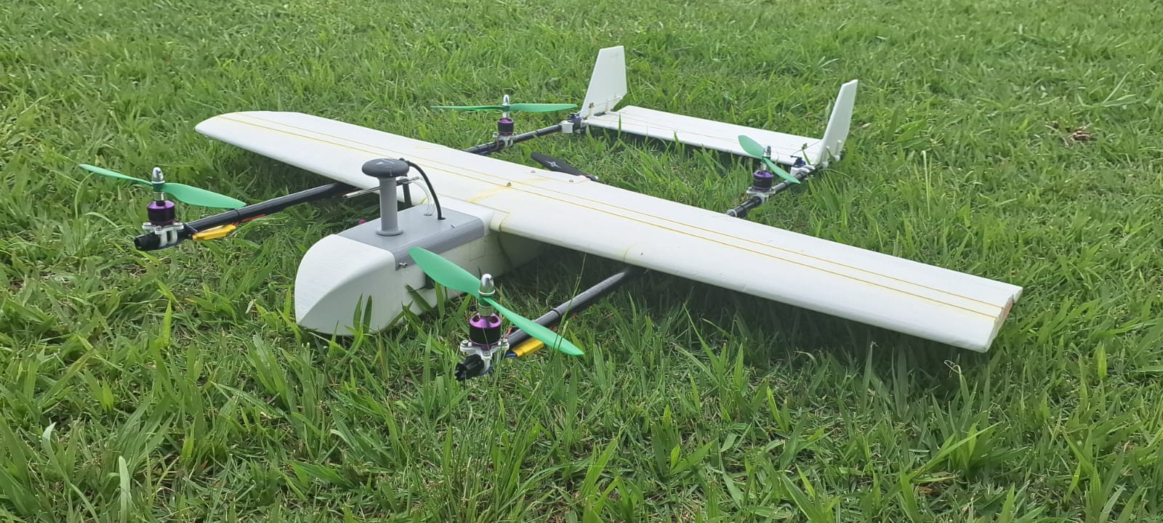
Custom hybrid VTOL drone developed by the Neusa research group at the Aeronautics Institute of Technology (ITA), used as the target platform for the fixed-wing autopilot designed in this work.
The development of reliable autopilots for hybrid platforms is therefore a non-trivial task. Although the hover and transition phases have received the larger part of the research effort, the fixed-wing cruise phase remains crucial for mission performance, since it is during cruise that the platform covers the bulk of the operational distance. In cruise, aerodynamic modeling and the careful tuning of the longitudinal and lateral-directional control loops are essential to guarantee stability, gust rejection, and tracking accuracy .

What is Known (State of the Art)
In the open-source ecosystem, the PX4 autopilot stack running on Pixhawk hardware has become a widely adopted reference for fixed-wing and hybrid UAV flight control, both in industry and in academic research . PX4’s fixed-wing module relies on two key subsystems. The first is the Total Energy Control System (TECS), which decouples altitude and airspeed by treating the aircraft as an energy reservoir: throttle controls the total energy (kinetic plus potential) while pitch controls how that energy is distributed between altitude and airspeed, avoiding the natural coupling in which a pitch-up command increases altitude but reduces speed. The second is a cascaded attitude/rate controller with an outer P loop generating a rate setpoint, an inner PI plus feed-forward loop driving the surface deflections, airspeed scaling for gain adaptation across the flight envelope, and coordinated-turn compensation. While TECS is elegant from a multivariable perspective, it requires accurate aerodynamic and propulsion models and a careful integration of feed-forward terms — assets that are often unavailable for custom academic platforms.
A more accessible alternative — and the one followed in this work — is the classical autopilot architecture introduced by Stevens and Lewis and Nelson , in which the longitudinal and lateral-directional dynamics are decoupled around a trim point and addressed by a hierarchy of cascaded loops: an inner stability augmentation system (SAS) that uses angular-rate feedback to damp the natural modes, and outer attitude/altitude/heading loops with PID compensators tuned via root-locus or interactive tuning tools. Although less elegant than energy-based formulations, this approach is well documented, fast to tune, and has been successfully applied to a number of small fixed-wing aircraft .
In particular, two prior projects developed at the Aeronautics Institute of Technology (ITA) form the technical foundation of the present work. The Pegasus AutoPilot, presented by Santos , proposed a complete classical autopilot for the Piper J-3 Cub 1/4 model aircraft, including a 6-DOF nonlinear plant and longitudinal and lateral-directional control loops. The architecture of the central processing unit of the Pegasus platform was further detailed by Bittar . Building on these works, the open-source PIPER-1-6 project re-implemented and extended the Pegasus framework for the Piper J-3 Cub 1/6, providing a fully reproducible MATLAB/Simulink toolchain that includes parameter loading, trim computation via fmincon, model linearization, PID tuning, and waypoint guidance.

What is Unknown (Research Gap)
Despite this consolidated body of work, several gaps remain when one tries to transfer those control loops to a hybrid VTOL platform operating in fixed-wing mode. First, regarding model transferability, control loops designed for conventional fixed-wing UAVs (e.g., the Piper J-3 Cub 1/6) have not been systematically adapted and validated for hybrid VTOL platforms operating in fixed-wing mode. Second, in terms of aerodynamic differences, hybrid drones present distinct aerodynamic characteristics due to motor placement, propeller interactions, and airframe geometry, requiring revalidation of the stability derivatives and the control gains . Third, considering integrated fixed-wing control, most hybrid VTOL research focuses on transition and hover; fewer studies address the design of dedicated longitudinal and lateral-directional control loops optimized for the cruise phase of custom hybrid platforms . Finally, on the methodological side, there is a need for accessible simulation-first pipelines that enable iterative control design before committing to costly and risky flight campaigns, especially for academic groups that lack dedicated wind-tunnel or telemetry facilities .

Research Objective
The main objective of this work is to design, implement, and validate the longitudinal and lateral-directional control loops for the fixed-wing flight mode of a custom hybrid VTOL drone, leveraging the control framework developed in the PIPER-1-6 project. The specific objectives are:
- to characterize the aerodynamic model of the hybrid drone in fixed-wing configuration using Vortex Lattice methods (XFLR5/AVL);
- to obtain the linearized state-space representation of the aircraft dynamics at the cruise trim condition;
- to design PID-based control loops for pitch, airspeed, and altitude (longitudinal channel) and for roll and yaw (lateral-directional channel) using classical control techniques;
- to validate the closed-loop system through Software-In-the-Loop (SIL) simulation in MATLAB/Simulink with the 6-DOF nonlinear model;
- to evaluate the controller performance and compare results against the Piper J-3 Cub 1/6 baseline.

Approach Overview
The proposed approach adapts the proven Piper J-3 Cub 1/6 control framework to the hybrid VTOL platform through a systematic five-step pipeline: (1) geometric and aerodynamic characterization of the hybrid drone; (2) assembly of the 6-DOF nonlinear mathematical model in MATLAB/Simulink; (3) trim computation and linearization around the cruise condition; (4) design of the longitudinal and lateral-directional control loops; and (5) closed-loop simulation and validation. The control strategy is a classical PID-based autopilot with cascaded loops — an inner rate-feedback SAS and an outer attitude/altitude/heading layer — tuned with the MATLAB PID Tuner on the linearized plant. Validation is performed in Software-In-the-Loop (SIL) configuration, exercising the closed-loop controller against the nonlinear 6-DOF model. The PIPER-1-6 open-source autopilot project is used as the starting point for this adaptation.

Main Contributions
The main contributions of this work, to be consolidated in its forthcoming versions, are the following:
- an adapted control framework that systematically transfers the Piper J-3 Cub 1/6 autopilot loops to a custom hybrid VTOL drone operating in fixed-wing mode, illustrating the portability of classical control techniques across different airframes;
- a hybrid-drone aerodynamic and dynamic model, including stability derivatives and a validated 6-DOF simulation environment in MATLAB/Simulink for the fixed-wing configuration;
- an open-source extension of the PIPER-1-6 project to support hybrid VTOL platforms, contributing a reusable simulation and control-design framework to the academic community.
The remainder of this paper is organized as follows. Section 2 describes the methodology adopted in the project, including the aerodynamic and 6-DOF mathematical models, the trim and linearization procedure, the control architecture for both flight axes, the proposed feed-forward compensation, and the simulation framework. Section 3 and Section 4 are reserved for the closed-loop validation results and final conclusions, which will be addressed in a forthcoming version of this work.

Materials and Methods

Target Aircraft and Aerodynamic Model
The platform considered in this work is a custom hybrid VTOL drone developed by the Neusa research group at ITA (see Fig. 1). The aircraft is composed of a fixed-wing fuselage carrying four lift rotors mounted on tail booms for the VTOL phase and a single tractor propeller for forward thrust. In fixed-wing mode, the lift rotors are switched off and the aircraft behaves as a conventional rear-elevator/aileron/rudder airplane.
The stability and control derivatives of the hybrid drone in cruise configuration were obtained by another member of the project group through Vortex Lattice methods (XFLR5/AVL). Because the present work focuses on control design, the aerodynamic model was treated as an external input. The model is composed of the dimensionless force and moment coefficients $C_{L}$, $C_{D}$, $C_{m}$, $C_{Y}$, $C_{l}$, $C_{n}$ and of their partial derivatives with respect to the angle of attack $α$, the sideslip angle $β$, the body-axis angular rates $p$, $q$, $r$, and the control-surface deflections $δ_{e}$, $δ_{a}$, $δ_{r}$. The base coefficients describe the equilibrium aerodynamic state of the airframe in cruise flight, while the derivatives quantify how each force or moment changes when the aircraft is perturbed away from that condition or when a control surface is deflected — they are, in essence, the linear sensitivities that close the rigid-body equations of motion. Together with the reference geometric quantities (wing area $S$, mean aerodynamic chord $\overset{‾}{c}$ and span $b$) and the air density $ρ$, they allow the dynamic pressure $q_{∞}=1/2ρV_{T}^{2}$ and the resulting aerodynamic forces and moments to be computed at every integration step of the simulation.
For comparison, the same control architecture was also instantiated for the Piper J-3 Cub 1/6, whose aerodynamic data come pre-validated from the PIPER-1-6 repository . The Piper J-3 Cub 1/6 is a 1/6-scale radio-controlled model of the original Piper J-3 Cub, with a cruise speed of $V_{T}=15$ m/s and a nominal cruise altitude of $h=100$ m, and serves as the reference airframe against which the hybrid drone was compared. Both aircraft were described by a 12-state vector,
$$x={\left[u,v,w,p,q,r,ϕ,θ,ψ,x_{N},x_{E},x_{D}\right]}^{⊤},$$
and by four control inputs,
$$u={\left[δ_{T},δ_{e},δ_{a},δ_{r}\right]}^{⊤},$$
representing throttle, elevator, aileron and rudder commands, respectively. A bootstrap script in MATLAB loads the full set of geometric and inertial parameters of both airframes (wing reference area, mean aerodynamic chord, span, mass, and moments of inertia) into the workspace, ensuring that every Simulink model in the toolchain is exercised against the same aircraft definition.

6-DOF Nonlinear Plant in MATLAB/Simulink
The aircraft dynamics were described by the standard six-degree-of-freedom rigid-body equations of motion :
$$m \dot{v}=F_{\text{aero}}+F_{\text{grav}}+F_{\text{prop}},$$
$$I \dot{ω}+ω×(I ω)=M_{\text{aero}}+M_{\text{prop}},$$
where $v=[u,v,w]^{⊤}$ is the body-axis linear velocity vector, $ω=[p,q,r]^{⊤}$ is the body-axis angular velocity, $m$ is the aircraft mass, and $I$ is the inertia tensor. The aerodynamic forces and moments $F_{\text{aero}}$, $M_{\text{aero}}$ were computed from the stability derivatives, the dynamic pressure, and the control deflections, while the propulsion forces and moments $F_{\text{prop}}$, $M_{\text{prop}}$ were obtained from a static propeller model fed by the throttle command. Euler angle kinematics and NED-frame position equations closed the model.
In MATLAB/Simulink, the entire 6-DOF nonlinear plant was implemented as a single compiled C-MEX S-function with twelve internal states, four control inputs, and twenty-one outputs (the twelve states plus airspeed $V_{T}$, angle of attack $α$, sideslip $β$, altitude $h$, body-axis accelerations, and additional monitoring channels). The same S-function was reused as the reference plant by the two Simulink models of the toolchain employed in this work — one dedicated to closed-loop control validation under step references and small disturbances, and another in which the autopilot is exercised by a Line-Of-Sight waypoint-guidance law — guaranteeing that every comparison was made against an identical aircraft model. The development environment was MATLAB/Simulink R2024a or later (tested up to R2025b), with the Optimization Toolbox required for the trim procedure described in Section 2.3. All Simulink models were exercised with the fixed-step fourth-order Runge–Kutta solver ode4 at a sampling time of $T_{s}=0.01$ s, with a default simulation horizon of $30$ s for step-response tests and $200$ s for waypoint-navigation tests.

Trim Condition and Linearization
The trim, or equilibrium, condition is the steady-state flight regime in which all body-axis accelerations vanish, i.e.,
$$\dot{x}=f(x_{0},u_{0})=0.$$
For straight-and-level cruise flight, this corresponds to constant airspeed $V_{T}$ (thrust equals drag), constant altitude $h$ (lift equals weight), wings level ($ϕ_{0}=0$), and zero angular rates ($p_{0}=q_{0}=r_{0}=0$).
Because the nonlinear equations of motion contain trigonometric and quadratic terms in the aerodynamic coefficients, the trim problem does not admit a closed-form solution and must be solved numerically. The PIPER-1-6 toolchain casts the problem as a constrained nonlinear optimization, solved by MATLAB’s fmincon from the Optimization Toolbox. A trim-candidate vector was used to set the initial states and control inputs of the Simulink model; the model was then evaluated for an instant; the resulting accelerations were extracted; and the cost function
$$J(x,u)={∥\dot{x}∥}^{2}$$
was minimized iteratively with physically plausible bounds on the decision variables (throttle within $[0,1]$ and the three control surfaces within $±{25}^{∘}$). Convergence was declared whenever $J$ fell below a tolerance of ${10}^{−6}$.
Once the trim point $(x_{0},u_{0})$ is known, a small-perturbation linearization yields the state-space model
$$Δ\dot{x}=A Δx+B Δu, Δy=C Δx+D Δu,$$
with $A$ and $B$ obtained by numerically evaluating the Jacobians of $f(x,u)$ around $(x_{0},u_{0})$. Three independent linearization methods were compared in the PIPER-1-6 project — a hand-coded script following Nelson’s book , an analytic implementation, and MATLAB’s built-in linearize command, which numerically perturbs the Simulink model around the operating point — and the smallest RMSE against the nonlinear plant was obtained, respectively, by linearize for the longitudinal channel and by the analytical script for the lateral-directional channel. The system naturally decoupled into two five-state subsystems:
$$x_{\text{long}}={\left[u,w,q,θ,h\right]}^{⊤}, u_{\text{long}}={\left[δ_{T},δ_{e}\right]}^{⊤},$$
$$x_{\text{lat}}={\left[v,p,r,ϕ,ψ\right]}^{⊤}, u_{\text{lat}}={\left[δ_{a},δ_{r}\right]}^{⊤}.$$
The corresponding eigenvalues revealed the four classical modes of the airframe — short-period and phugoid in the longitudinal channel, dutch-roll, spiral, and pure-roll in the lateral channel.

Longitudinal Control Loops
The longitudinal autopilot follows the cascaded structure proposed by Stevens and Lewis and refined by Santos . Three loops act in parallel to control airspeed, pitch attitude, and altitude.
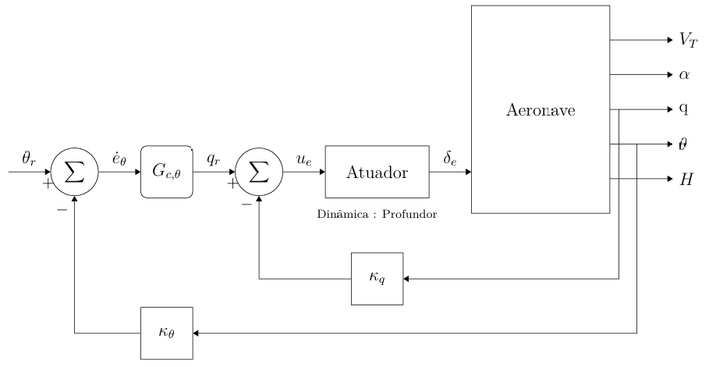
Pitch attitude autopilot with stability augmentation system (SAS), adapted from Santos .
1) Pitch attitude with SAS: the innermost loop tracks a pitch reference $θ_{\text{ref}}$. The pitch rate $q$ is fed back through a proportional gain $K_{q}=0.1$ (root-locus tuned to obtain a damping ratio of about $0.7$ on the short-period mode), forming a stability augmentation system that damps the natural short-period oscillation. Around this SAS, a PID compensator with $K_{p}=0.260$, $K_{i}=0.143$, $K_{d}=0$ and a derivative-filter coefficient $N=20$ closes the outer pitch loop. The elevator deflection $δ_{e}$ is saturated at $±{25}^{∘}$ ($±0.4363$ rad) and the integrator is protected with a clamping anti-windup scheme.
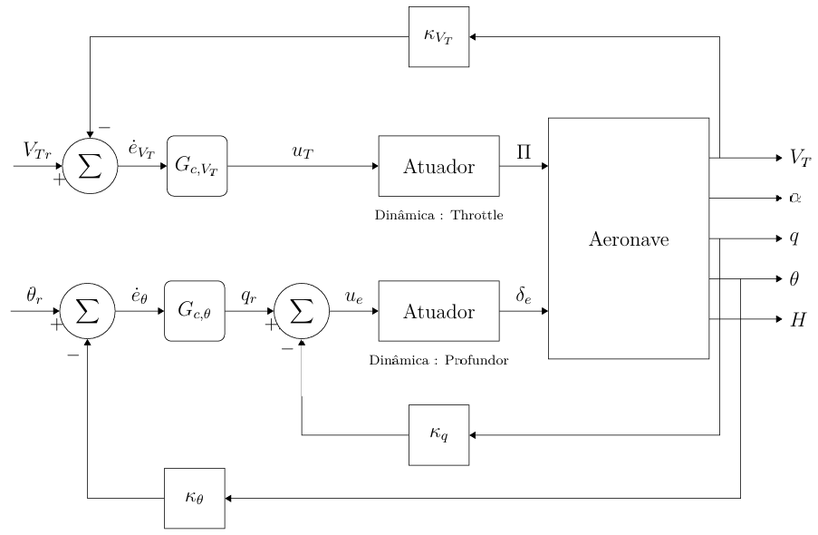
Velocity autopilot: a PID throttle loop runs in parallel with the pitch attitude loop, attenuating the speed loss caused by climb maneuvers.
2) Velocity autopilot: a parallel PID with $K_{p}=0.05$, $K_{i}=0.02$, $K_{d}=0.01$, $N=20$, acting on the airspeed error $e_{V}=V_{T,\text{ref}}−V_{T}$, drives the throttle command $δ_{T}$. The throttle is saturated to the unit interval $[0,1]$ and the integrator is again clamped. The simultaneous action of the pitch loop on the elevator and the velocity loop on the throttle attenuates the speed losses naturally caused by climbing maneuvers, when only the elevator is commanded.
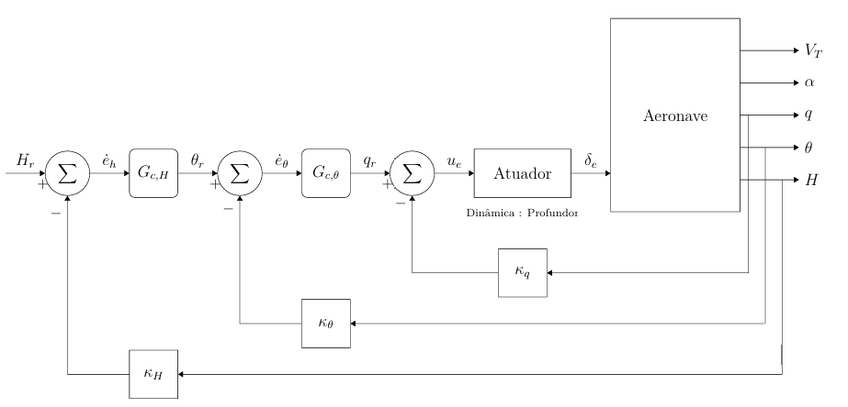
Altitude hold autopilot: an outer PID generates the pitch reference $θ_{\text{ref}}$ tracked by the inner pitch attitude loop.
3) Altitude hold: an outer PID with $K_{p}=0.08$, $K_{i}=0.02$, $K_{d}=0$, $N=20$ converts the altitude error $e_{h}=h_{\text{ref}}−h$ into a pitch reference $θ_{\text{ref}}$ that is then tracked by the pitch attitude loop. The output of the altitude PID is saturated within $[−0.17,+0.26]$ rad to prevent unrealistic pitch demands. According to Santos , the altitude hold mode is enabled only when the aircraft is within five meters of the target altitude; otherwise, climb or descent is performed at constant pitch.

Lateral-Directional Control Loops
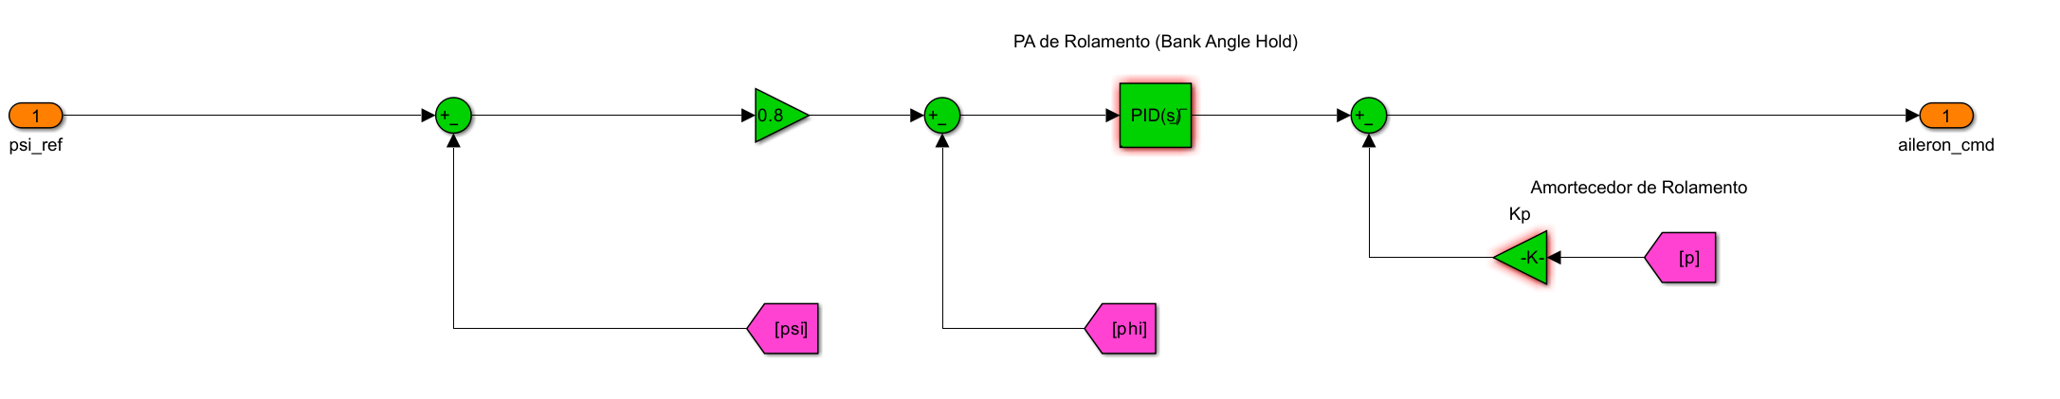
1) Bank angle hold: heading commands are converted into a bank-angle reference through a proportional gain $K_{ψ}=0.3$, exploiting the coordinated-turn approximation
$$ϕ≈\frac{\dot{ψ} u_{0}}{g}.$$
The roll attitude is then tracked by a PID compensator with $K_{p}=10$, $K_{i}=0$, $K_{d}=0$, $N=20$, whose output drives the aileron channel. A roll SAS with $K_{p,\text{sas}}=0.119$ closes an inner loop on the roll rate $p$, damping the pure-roll mode. The aileron is saturated at $±{25}^{∘}$, and back-calculation anti-windup is used.
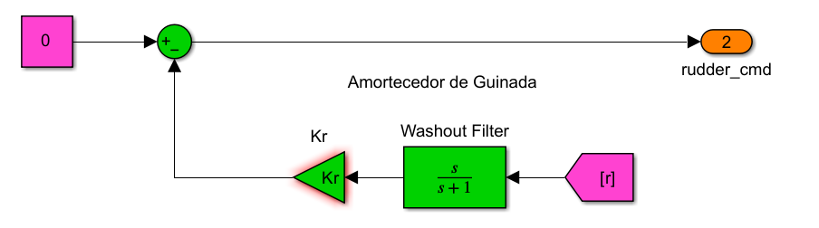
Yaw damper with washout filter on yaw rate $r$, used to damp dutch-roll oscillations without opposing steady-state coordinated turns.
2) Yaw damper: dutch-roll oscillations are damped by feeding the yaw rate $r$ through a first-order washout filter,
$$G_{w}(s)=\frac{τ_{w} s}{1+τ_{w} s},$$
with $τ_{w}=1$ s, multiplied by a static gain $K_{r}=0.15$, and applied to the rudder channel. The washout filter passes only the transient $r$ variations, preventing the rudder from biasing the steady-state coordinated turn. The rudder is saturated at $±{25}^{∘}$.

Proposed Feed-Forward Compensation
A well-known limitation of the cascaded altitude hold is the transient altitude loss observed during a banked turn: when the aircraft rolls to a bank angle $ϕ$, the vertical component of the lift drops according to
$$L_{\text{vert}}=L \text{cos}ϕ,$$
so that, for $ϕ={30}^{∘}$, this corresponds to about a $13\%$ loss. The integral term of the altitude PID eventually corrects the error, but only after a measurable transient. To anticipate this loss, a feed-forward term is proposed,
$$Δθ_{\text{ff}}=f(ϕ_{\text{cmd}}),$$
which is added to the pitch reference whenever a bank command is issued. The exact functional form will be derived analytically and then refined via simulation, following the approach proposed by Bittar . The expected effect is a reduction in peak altitude deviation and in settling time during turns, without compromising the small-signal response of the altitude hold.
It is worth emphasizing that this feed-forward compensation is currently in an early stage of development. The author is still working on its analytical derivation and simulation tuning, so this paper deliberately limits itself to stating the problem, the proposed structure, and the rationale, without yet presenting closed-form expressions, gain values or comparative simulation results. The detailed design and quantitative evaluation of the compensator will be addressed in a forthcoming version of this work, once enough additional progress on this specific topic has been consolidated.

Simulation and Validation Framework
The control design followed a structured Software-In-the-Loop (SIL) validation pipeline: (i) loop shaping on the linearized plant, where stability margins, bandwidth and disturbance-rejection requirements were imposed in the frequency domain; (ii) closed-loop SIL on the nonlinear Simulink plant under step references and small disturbances around the cruise trim, in order to assess the robustness of each loop to the residual nonlinearities of the model; and (iii) waypoint-navigation tests in which the same autopilot was driven by a Line-Of-Sight (LOS) guidance law, exposing the controller to mission-like scenarios involving heading transitions and altitude changes. Each level adds a layer of fidelity, so any inconsistency can be detected and isolated as soon as it appears.

Evaluation Criteria
The performance of each control loop was assessed through the following quantitative metrics, computed from the SIL time histories: (a) rise time $t_{r}$ and settling time $t_{s}$ (within a $±2\%$ band of the reference); (b) percent overshoot $M_{p}$; (c) steady-state error $e_{ss}$; (d) actuator activity, expressed as the maximum and root-mean-square (RMS) deflection of each control surface; and (e) the open-loop gain and phase margins read from the Bode plot of the linearized loop transfer function. The fidelity of the linearization step was quantified by the root-mean-square error (RMSE) between the nonlinear and linearized step responses around the trim point. Because the simulations are deterministic and noise-free, no statistical inference (e.g., Monte-Carlo dispersion analysis) was performed in this stage; each scenario was executed once, and only the deterministic time-series indicators above were used.

Results
Coming soon. The closed-loop validation of the proposed control loops — including step-response and disturbance-rejection tests on the linearized plant and Software-In-the-Loop (SIL) verification on the nonlinear 6-DOF model — will be reported in the next version of this work, together with a quantitative comparison against the Piper J-3 Cub 1/6 baseline and an evaluation of the proposed feed-forward compensation.

Conclusion and Future Work
Coming soon. The conclusions of the project, summarizing the lessons learned from the SIL simulation campaigns, the limitations of the classical PID-based architecture when transferred to the hybrid platform, and the planned roadmap towards an outdoor flight-test campaign with the physical airframe in coordination with the Neusa group at ITA, will be presented once the validation phase described in Section 3 is completed.

Acknowledgment
The author thanks the Neusa research group at the Aeronautics Institute of Technology (ITA) for sharing the hybrid VTOL airframe and aerodynamic data, and the PIPER-1-6 project authors for providing the open-source MATLAB/Simulink toolchain on which this work is built. The Aeronautics Institute of Technology (ITA) provided the academic framework for this study.

References
R. W. Beard, D. Kingston, M. Quigley, D. Snyder, R. Christiansen, W. Johnson, T. McLain, and M. A. Goodrich, “Autonomous vehicle technologies for small fixed-wing UAVs,” Journal of Aerospace Computing, Information, and Communication, vol. 2, no. 1, pp. 92–108, 2005.
D. M. Marshall, R. K. Barnhart, S. Hottman, E. Shappee, and M. T. Most, Introduction to Unmanned Aircraft Systems, 2nd ed. Boca Raton, FL, USA: CRC Press, 2016.
R. Garcia and L. Barnes, “Multi-UAV simulator utilizing X-Plane,” Journal of Intelligent and Robotic Systems, vol. 57, no. 1–4, pp. 393–406, 2010.
K. P. Valavanis and G. J. Vachtsevanos, “Future of unmanned aviation,” in Handbook of Unmanned Aerial Vehicles, K. P. Valavanis and G. J. Vachtsevanos, Eds. Dordrecht, Netherlands: Springer, 2015, pp. 2993–3009.
A. S. Saeed, A. B. Younes, C. Cai, and G. Cai, “A survey of hybrid unmanned aerial vehicles,” Progress in Aerospace Sciences, vol. 98, pp. 91–105, 2018.
G. J. J. Ducard and M.-D. Hua, “Review of designs and flight control techniques of hybrid and convertible VTOL UAVs,” Aerospace Science and Technology, vol. 118, p. 107035, 2021.
J. M. Levin, M. Nahon, and A. A. Paranjape, “Real-time motion planning with a fixed-wing UAV using an agile maneuver space,” Autonomous Robots, vol. 43, no. 8, pp. 2051–2069, 2019.
H. Chao, Y. Cao, and Y. Chen, “Autopilots for small unmanned aerial vehicles: A survey,” International Journal of Control, Automation and Systems, vol. 8, no. 1, pp. 36–44, 2010.
L. Meier, D. Honegger, and M. Pollefeys, “PX4: A node-based multithreaded open source robotics framework for deeply embedded platforms,” in Proc. IEEE Int. Conf. Robotics and Automation (ICRA), Seattle, WA, USA, May 2015, pp. 6235–6240.
, “PX4 autopilot user guide,” Online, 2025, available: https://docs.px4.io/main/en/.
B. L. Stevens, F. L. Lewis, and E. N. Johnson, Aircraft Control and Simulation: Dynamics, Controls Design, and Autonomous Systems, 3rd ed. Hoboken, NJ, USA: Wiley, 2016.
R. C. Nelson, Flight Stability and Automatic Control, 2nd ed. Boston, MA, USA: WCB/McGraw-Hill, 1998.
R. W. Beard and T. W. McLain, Small Unmanned Aircraft: Theory and Practice. Princeton, NJ, USA: Princeton University Press, 2012.
O. Cetin and I. Zagli, “Continuous airborne communication relay approach using unmanned aerial vehicles,” Journal of Intelligent and Robotic Systems, vol. 65, no. 1–4, pp. 549–562, 2012.
Y. Du, “Development of real-time flight control system for low-cost vehicle,” Master’s thesis, Cranfield University, Cranfield, UK, 2011.
M. H. Santos, “Projeto e teste em bancada de um piloto automático para veículos aéreos n ao tripulados,” Master’s thesis, Aeronautics Institute of Technology (ITA), S ao José dos Campos, SP, Brazil, 2018.
A. Bittar, “Arquitetura da UCP do Pegasus AutoPilot: da concepç ao à implementaç ao de um sistema de tempo real em HIL,” Master’s thesis, Aeronautics Institute of Technology (ITA), S ao José dos Campos, SP, Brazil, 2012.
K. Martins, “PIPER-1-6: Open-source modeling, simulation and control of the Piper J-3 Cub 1/6 model aircraft,” Source code repository, 2025, available: https://github.com/Kauemartins2233/PIPER-1-6.
B. Theys, G. Dimitriadis, P. Hendrick, and J. De Schutter, “Influence of propeller configuration on propulsion system efficiency of multi-rotor unmanned aerial vehicles,” in Proc. Int. Conf. Unmanned Aircraft Systems (ICUAS), Arlington, VA, USA, Jun. 2016, pp. 195–201.
V. F. Filho and J. Cooper, “Aerodynamic modeling of fixed-wing UAVs using XFLR5 and vortex lattice methods,” in Proc. ASME Int. Mechanical Engineering Congress and Exposition, Salt Lake City, UT, USA, Nov. 2019, pp. 1–8.
P.-J. Bristeau, P. Martin, E. Salaün, and N. Petit, “The role of propeller aerodynamics in the model of a quadrotor UAV,” in Proc. European Control Conference (ECC), Budapest, Hungary, Aug. 2009, pp. 683–688.

