Technical Document Lab1

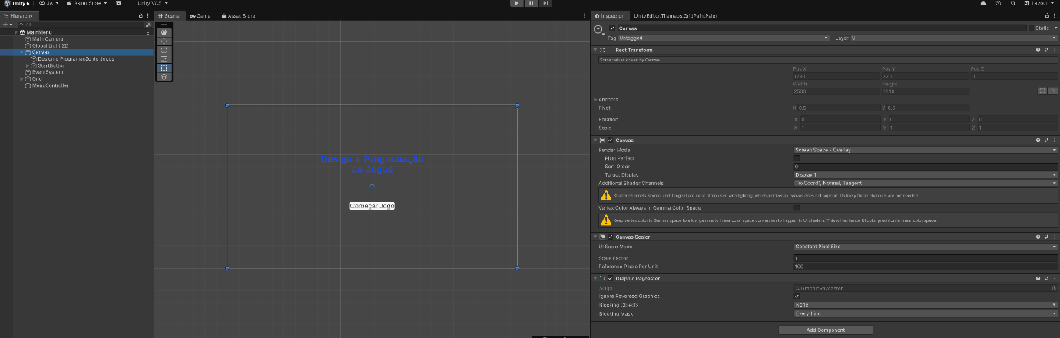
  - Canvas
Rect Transform: Defines the baseline spatial boundaries, anchoring, pivot point, and scale for the main UI area on screen.
Canvas: Controls how UI components are drawn to the screen. Its key attributes include:
Render Mode: Set to Screen Space - Overlay, drawing UI elements over the game view directly on top of the screen.
Target Display: Set to Display 1, ensuring UI output is rendered to the primary viewing monitor.
Additional Shader Channels: Configured to include essential mesh vertex data such as TexCoord1, Normal, and Tangent.
Canvas Scaler: Dynamically manages the overall scale and pixel density of UI elements relative to screen resolutions.
UI Scale Mode: Set to Constant Pixel Size, maintaining absolute UI element pixel dimensions regardless of screen resolution changes.
Scale Factor: Fixed at 1, rendering elements at their base pixel dimensions.
Reference Pixels Per Unit: Set to 100, specifying image unit conversion scaling.
Graphic Raycaster: Enables raycasting for UI elements inside the canvas, allowing mouse clicks, touch taps, and interactions to hit buttons and interactive UI widgets.
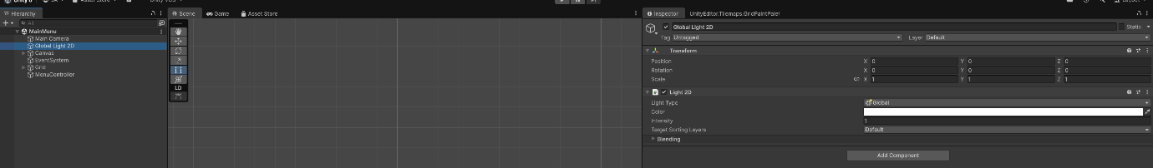
  - Global Light 2D
Transform: Defines the spatial properties—Position (X: 0, Y: 0, Z: 0), Rotation (X: 0, Y: 0, Z: 0), and Scale (X: 1, Y: 1, Z: 1)—of the light object in world space.
Light 2D: Manages the properties of the 2D lighting system. Key parameters include:
Light Type: Configured as Global, applying light evenly across the whole scene.
Color: Set to default solid white, illuminating sprites in their original colors.
Intensity: Set to 1, providing full baseline illumination level.
Target Sorting Layers: Set to Default, determining which visual layers are affected by this light source.

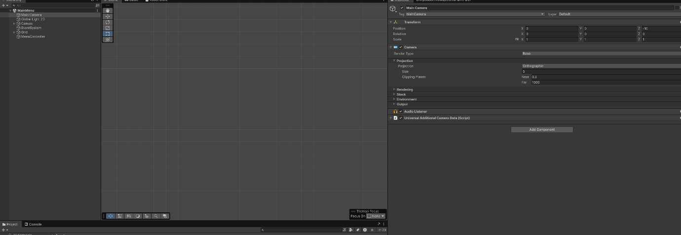
  - MainCamera
Transform: Defines the spatial coordinates of the camera, positioned at (X: 0, Y: 0, Z: -10) to view 2D scene elements from an offset distance.
Camera: Renders the view of the scene. Key properties include:
Render Type: Configured as Base camera rendering.
Projection: Set to Orthographic with a size of 5, eliminating perspective depth for 2D alignment.
Clipping Planes: Defines rendering distances between Near (0.3) and Far (1000).
Audio Listener: Acts as the central microphone in the scene, receiving audio emitted from Audio Sources and outputting sound to the player's speakers.
Universal Additional Camera Data (Script): An internal script component used by Unity's Universal Render Pipeline (URP) to manage camera stacking and advanced rendering settings.
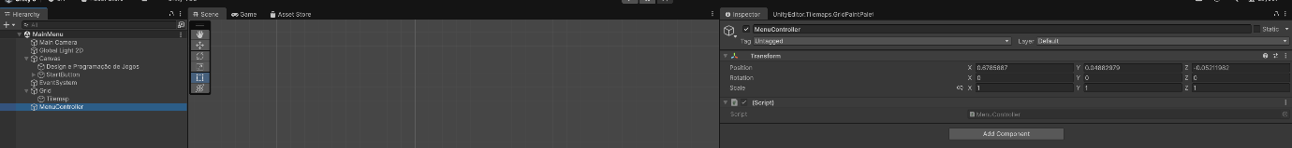
  - MenuController
Transform: Sets the basic position (X: 0.6785887, Y: 0.04882979, Z: -0.05211982), rotation, and scale of the controller object within the scene space.
MenuController (Script): A custom C# script component attached to the GameObject. It defines game logic, handles button click events, and coordinates menu state changes.
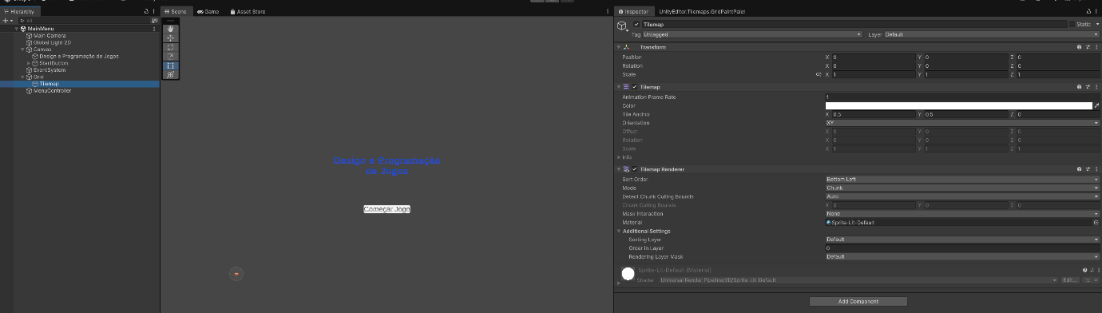
  - Tilemap
Transform: Defines the local position, rotation, and scale of the tilemap relative to its parent Grid GameObject.
Tilemap: Stores tile data and cell mapping settings, controlling attributes such as frame rate for animated tiles, overall tint color, and tile anchor offsets.
Tilemap Renderer: Controls how tiles on the tilemap are drawn on screen. It defines rendering properties such as sort order, rendering mode, assigned material (Sprites-Default), and sorting layers.

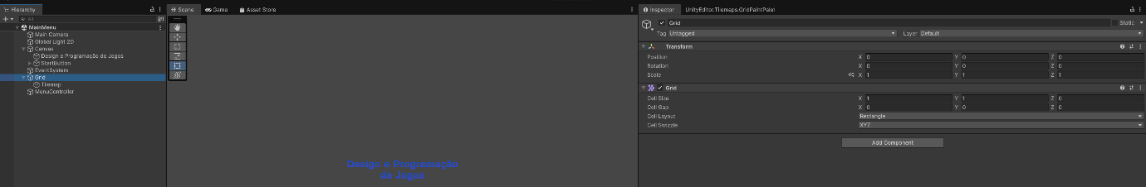
  - Grid
Transform: Defines the global 3D spatial properties—Position (X: 0, Y: 0, Z: 0), Rotation (X: 0, Y: 0, Z: 0), and Scale (X: 1, Y: 1, Z: 1)—of the grid in the scene.
Grid: Coordinates the layout and cell dimensions for child Tilemap layers. It specifies key properties such as:
Cell Size: Defines the base size of each individual grid cell (X: 1, Y: 1, Z: 0).
Cell Gap: Sets the spacing or distance between cells (X: 0, Y: 0, Z: 0).
Cell Layout: Determines the geometric shape of the grid cells (set to Rectangle).
Cell Swizzle: Controls how cell axes map to world coordinates (set to XYZ).
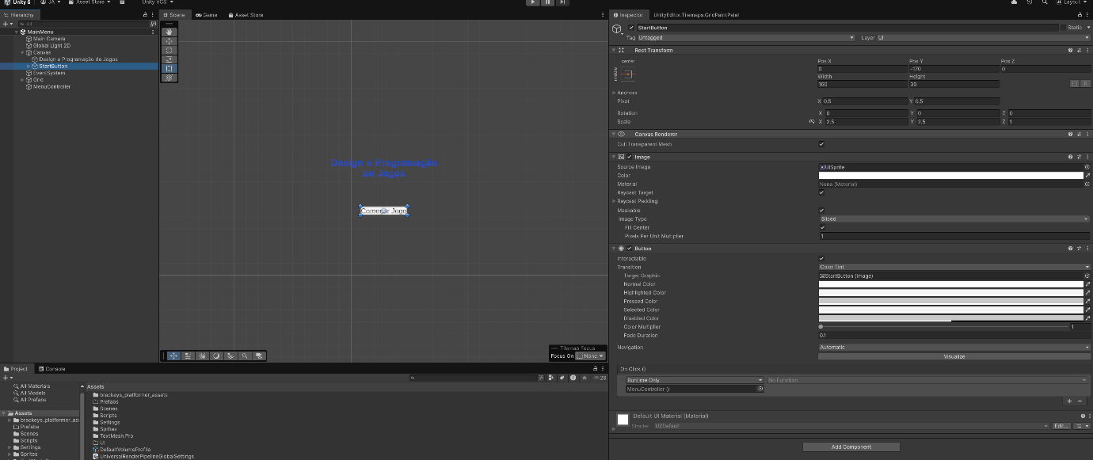
  - StartButton
Rect Transform – Defines the position, size, rotation, and scale of the button within the Canvas / UI layout.
Canvas Renderer – Renders the button as a UI graphic element on the screen.
Image – Defines the visual appearance of the button and the sprite assigned to it.
Button – Makes the element interactive and allows an action (event) to be executed when clicked.
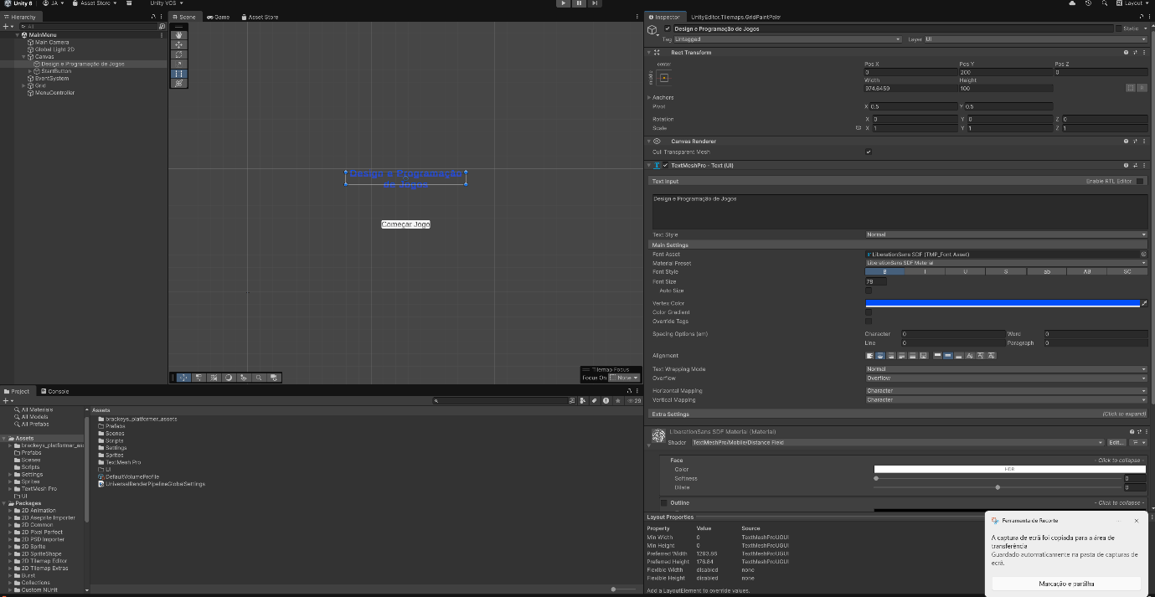
  - Design e Programação de Jogos
Rect Transform: Defines the position (X: 0, Y: 200, Z: 0), dimensions (Width: 1200, Height: 300), rotation, and alignment of the text element within the UI space.
Canvas Renderer: Prepares and renders the vector text mesh and materials onto the UI Canvas screen overlay.
TextMeshPro - Text (UGUI): Controls the text content, formatting, typography, and styling properties. Key attributes include:
Text Input: Displays the custom text string ("Design e Programação de Jogos").
Font Asset & Style: Uses LiberationSans SDF font with regular styling.
Font Size & Color: Configured with a font size of 78 and a custom blue color hue.
Alignment: Sets horizontal and vertical text alignment parameters inside the bounding box.

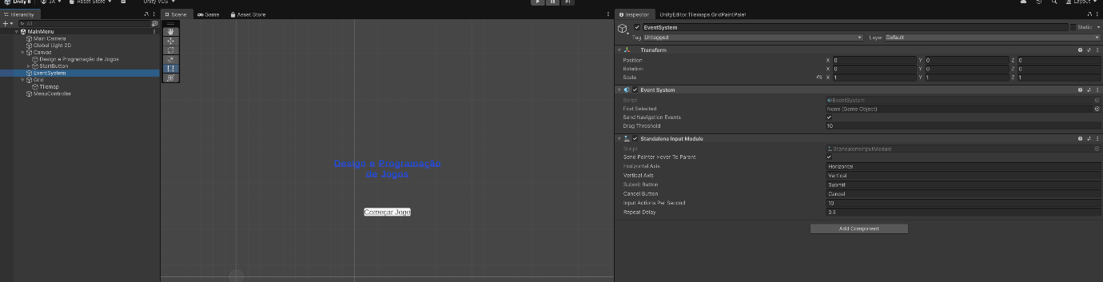
  - EventSystem
Transform - Sets the standard 3D spatial position (X: 0, Y: 0, Z: 0), rotation, and scale of the object in the scene.
Event System - Manages state tracking, selection, and event routing for user interactions across UI elements.
Standalone Input Module - Processes direct input signals from devices such as the keyboard, mouse, or controllers to trigger corresponding UI events.
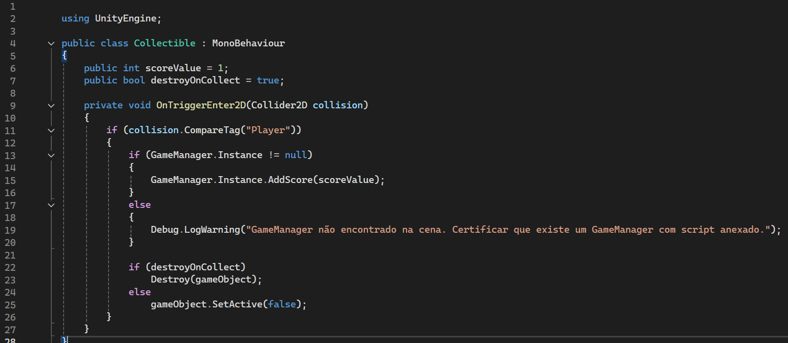
According to the code, every time the player touches this object, it is deleted and gives a +1 to the score board of the player.

  - Rigidbody Body Types
The Rigidbody 2D component allows a GameObject to interact with Unity's physics system. The Body Type determines how the object moves and how it interacts with other objects.
- Dynamic – The object is fully controlled by the physics system. It is affected by gravity, forces, and collisions and can move freely during the game. This is the most common option for characters and other objects that need realistic physics.
- Kinematic – The object is not affected by gravity or external forces. Its movement is controlled explicitly by the user or by scripts, making it useful for objects whose movement needs to be controlled directly.
- Static – The object does not move under physics simulation and behaves as an immovable object. It is suitable for objects such as walls, floors, and other parts of the environment that remain in the same position.

  - Steps that we made
We started by opening the project and loading the "MainMenu" scene, first we made a screenshot of the contents already present in the file and made this document, then we started working on the game itself, first by loading the "Level1" scene and made a small level, then we made the collectible coin object and made sure that it worked, after we made the player, by adding the respective components listed in the instructions, until we had a playable character that could move around, jump and collect the coins, next we made the "Score" function so that every coin collected increases its value by 1 and lastly made a challenge to the player by making it so if you fall into the water you have to start over the level.

