
Análise e Integração de Dados

Grupo 16

78375 – João Pirralha
84725 – Henrique Almeida
84773 – Tomás Oliveira

Contents
1) Schema matching between the AdventureWorks database and the mediated schema 2
2) SQL views that define the schema mapping between the two data sources and the mediated schema 2
3) PDI transformation to detect approximate duplicates between the job titles in both databases 3
4) SQL instructions to create the data warehouse tables 7
5) Extract-Transform-Load (ETL) process that populates the data warehouse 8
dim_territory 8
dim_product 9
dim_time 11
fact_order 13
job 15
6) SQL Queries 16
7) SQL/OLAP query 16
8) 16
9) 17
10) 17
11) 17

1) Schema matching between the AdventureWorks database and the mediated schema

all_employees(emp_no, birth_date, first_name, last_name, gender, hire_date, title, report_to)

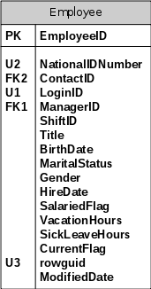
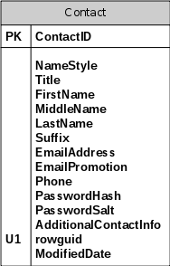
all_departments(dept_no, dept_name)  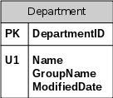 | all_dept_emp(emp_no, dept_no, from_date, to_date)  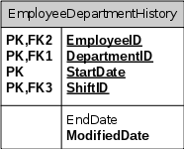

2) SQL views that define the schema mapping between the two data sources and the mediated schema

-- Auxiliar views
create or replace view employees.curr_dept_emp(emp_no, dept_no, from_date, to_date) as
select emp_no, dept_no, from_date, to_date
from employees.dept_emp
where from_date <= current_date and to_date >= current_date;

create or replace view employees.curr_dept_manager(emp_no, dept_no) as
select emp_no, dept_no
from employees.dept_manager
where from_date <= current_date and to_date >= current_date;

create or replace view adventureworks.curr_dept_emp(EmployeeID, DepartmentID, ShiftID, StartDate, EndDate, ModifiedDate) as
select EmployeeID, DepartmentID, ShiftID, StartDate, EndDate, ModifiedDate
from adventureworks.employeedepartmenthistory
where StartDate <= current_date and (EndDate is NULL or EndDate >= current_date);

-- Main views
-- The maximum emp_no from adventureworks is 290 and the minimum from employees is 10721, so there's no overlap
create or replace view all_employees(emp_no, birth_date, first_name, last_name, gender, hire_date, title, report_to) as
(select a.emp_no, a.birth_date, a.first_name, a.last_name, a.gender, a.hire_date, d.title, c.emp_no as report_to
from employees.employees as a,
employees.curr_dept_emp as b,
employees.curr_dept_manager as c,
employees.titles as d
where a.emp_no = b.emp_no and b.dept_no = c.dept_no
and a.emp_no = d.emp_no)
union
(select a.EmployeeID, a.BirthDate, b.FirstName, b.LastName, a.Gender, a.HireDate, a.Title, a.ManagerID
from adventureworks.employee as a,
adventureworks.contact as b
where a.ContactID = b.ContactID);

-- dept_no's from adventureworks are numeric and dept_no's from employees have a "d" prefix, so there's no overlap
create or replace view all_departments(dept_no, dept_name) as
(select dept_no, dept_name from employees.departments)
union
(select DepartmentID, Name from adventureworks.department);

create or replace view all_dept_emp(emp_no, dept_no, from_date, to_date) as
(select emp_no, dept_no, from_date, to_date from employees.curr_dept_emp)
union
(select EmployeeID, DepartmentID, StartDate, EndDate from adventureworks.curr_dept_emp);

3) PDI transformation to detect approximate duplicates between the job titles in both databases

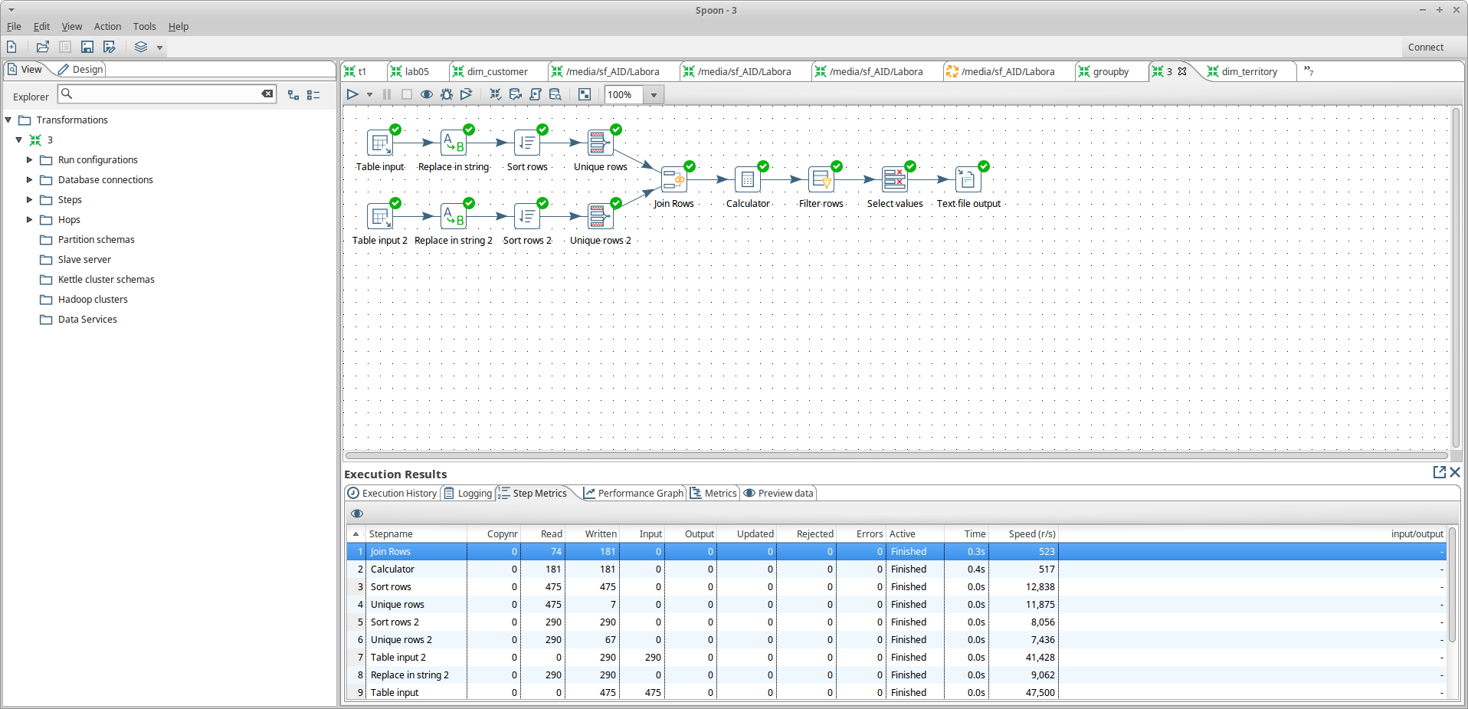
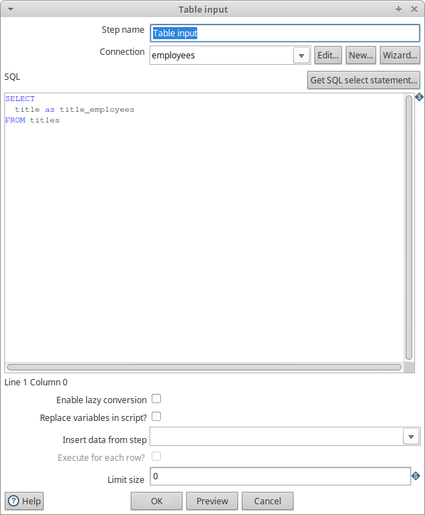 | 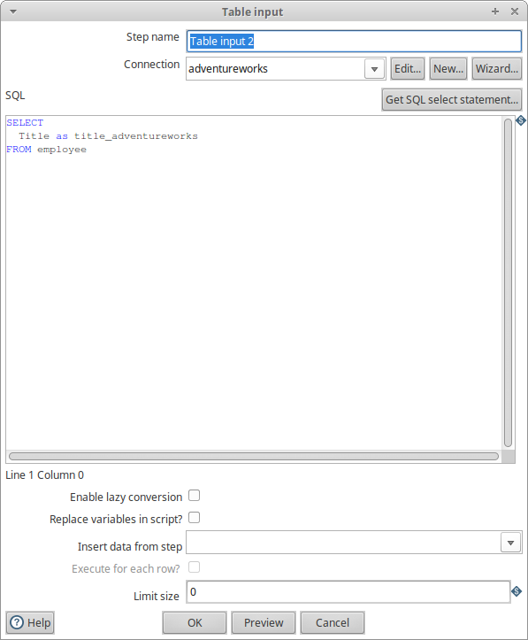
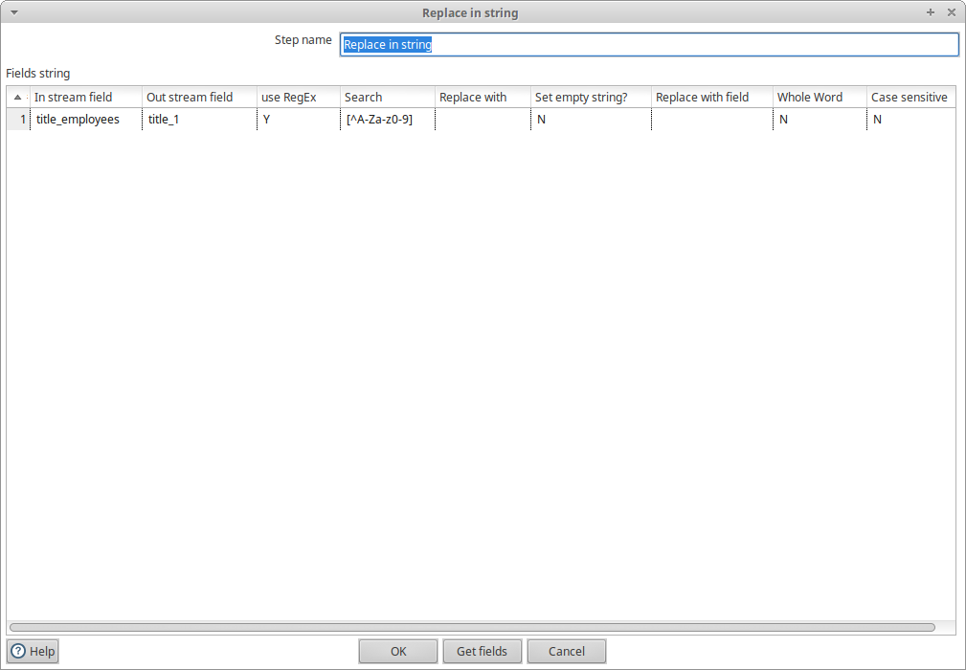 | 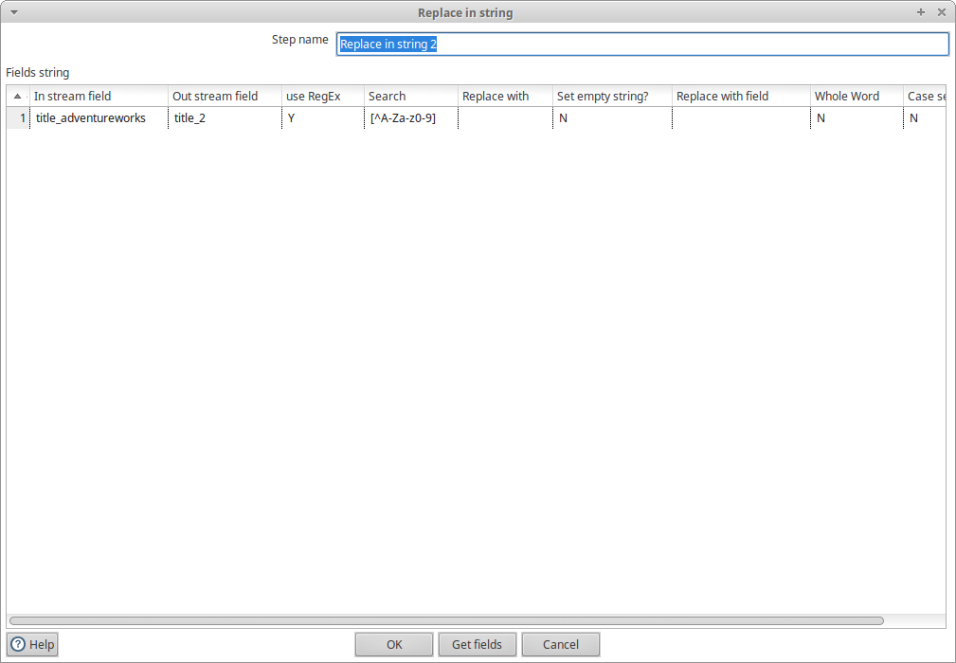
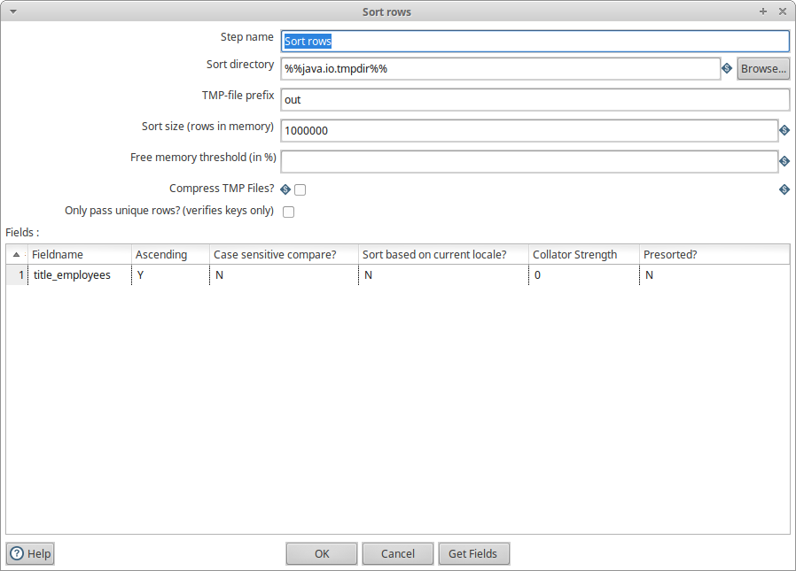 | 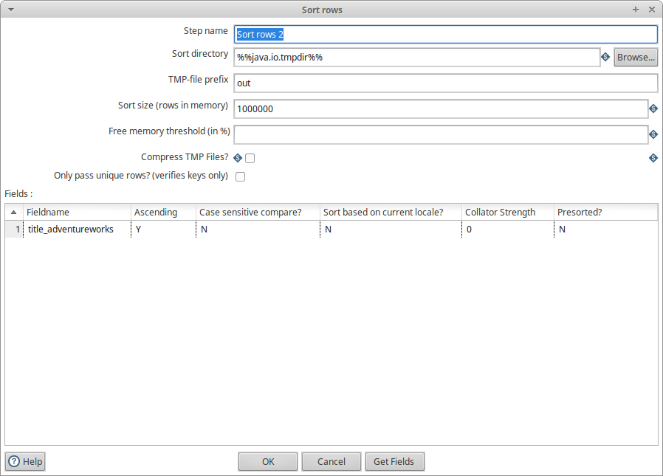
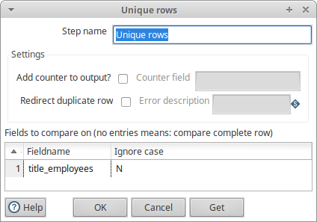 | 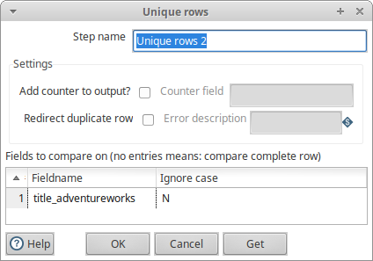

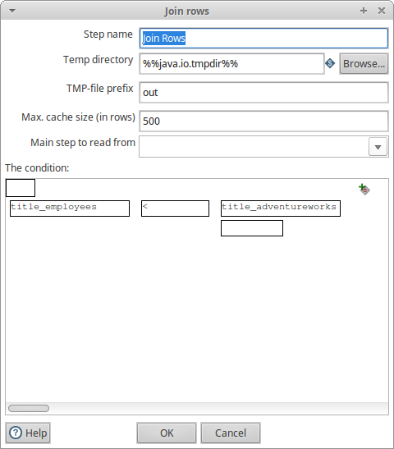
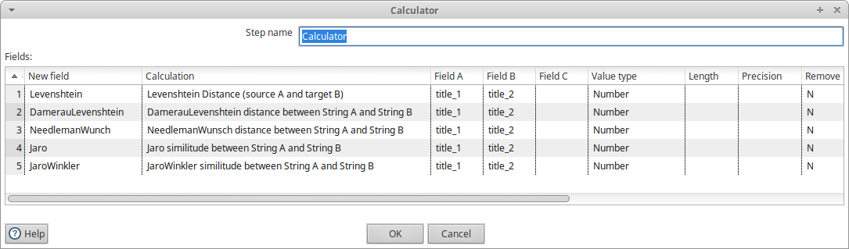

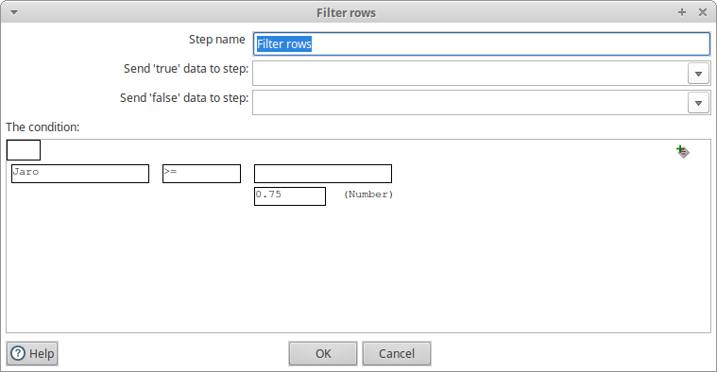
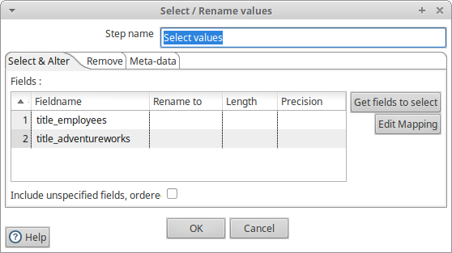
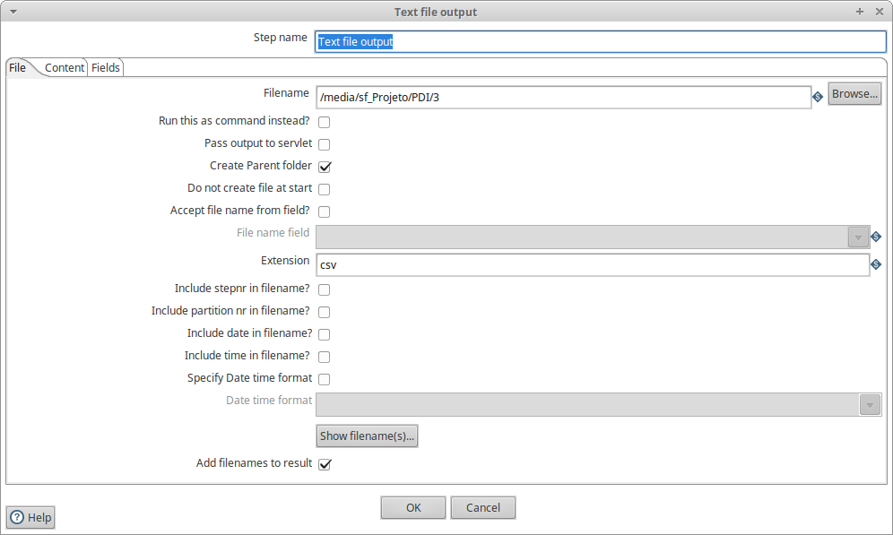
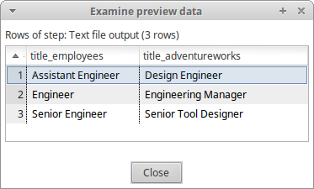

4) SQL instructions to create the data warehouse tables

DROP DATABASE IF EXISTS adventureworks_dw;
CREATE DATABASE adventureworks_dw;

USE adventureworks_dw;

-- salesterritory
CREATE TABLE dim_territory (
TerritoryID int(11) NOT NULL,
Name varchar(50) NOT NULL,
CountryRegionCode varchar(3) NOT NULL,
`Group` varchar(50) NOT NULL,
PRIMARY KEY (TerritoryID)
);

-- product, productsubcategory & productcategory
-- Slowly changing dimension!
CREATE TABLE dim_product (
ProductSK int(11),
ProductID int(11),
Name varchar(50),
ProductSubcategoryName varchar(50),
ProductCategoryName varchar(50),
Version int,
DateFrom DATETIME,
DateTo DATETIME,
PRIMARY KEY (ProductSK)
);

-- salesorderheader
CREATE TABLE dim_time (
OrderDate timestamp NOT NULL,
`Day` int,
MonthID int,
MonthName varchar(255),
`Year` int,
PRIMARY KEY (OrderDate)
);

-- salesorderdetail & salesorderheader
CREATE TABLE fact_order (
SalesOrderID int(11) NOT NULL,
SalesOrderDetailID int(11) NOT NULL,
TerritoryID int(11) NOT NULL,
ProductSK int(11) NOT NULL,
OrderDate timestamp NOT NULL,
LineTotal double NOT NULL,
OrderQty smallint(6) NOT NULL,
PRIMARY KEY (SalesOrderDetailID, SalesOrderID),
FOREIGN KEY (TerritoryID) REFERENCES dim_territory (TerritoryID),
FOREIGN KEY (ProductSK) REFERENCES dim_product (ProductSK),
FOREIGN KEY (OrderDate) REFERENCES dim_time (OrderDate)
);

5) Extract-Transform-Load (ETL) process that populates the data warehouse

dim_territory
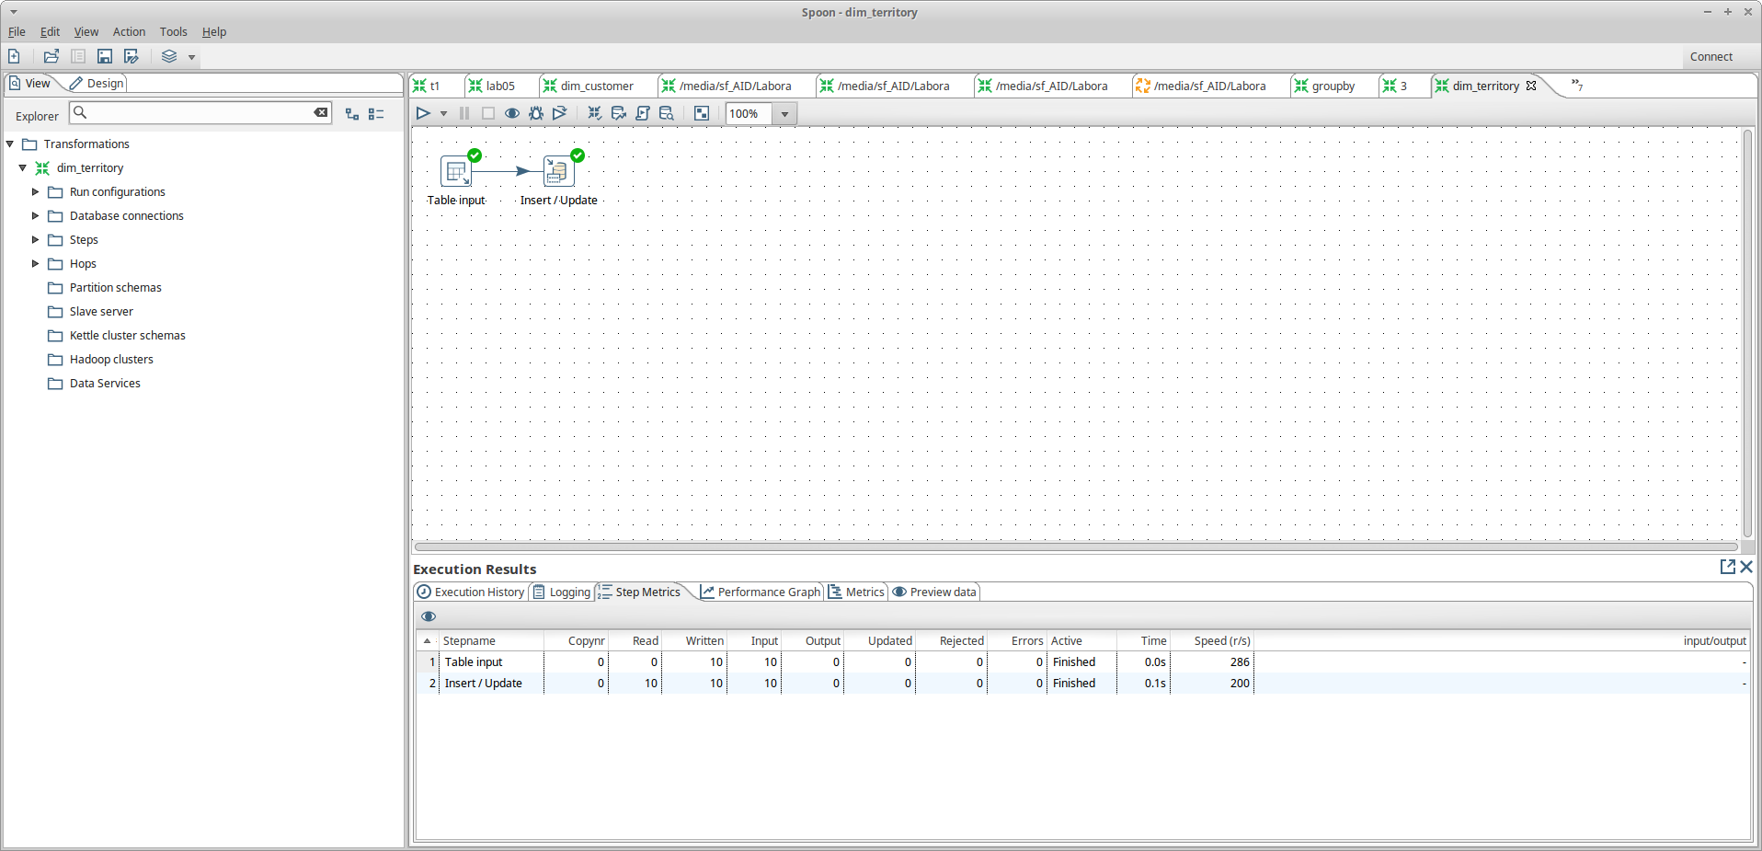
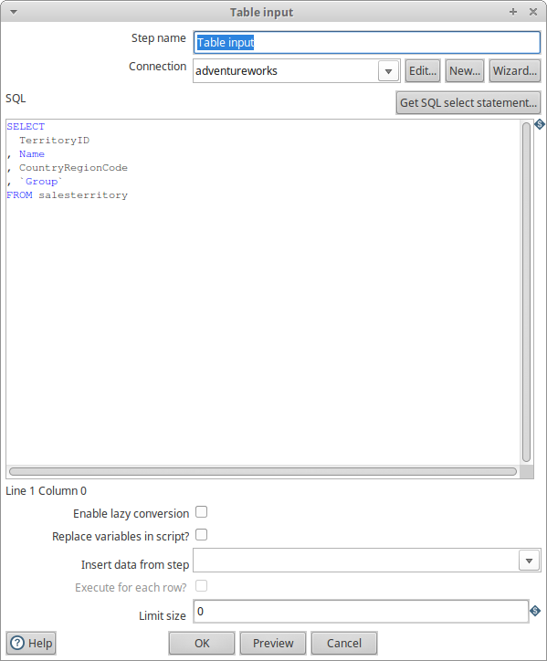
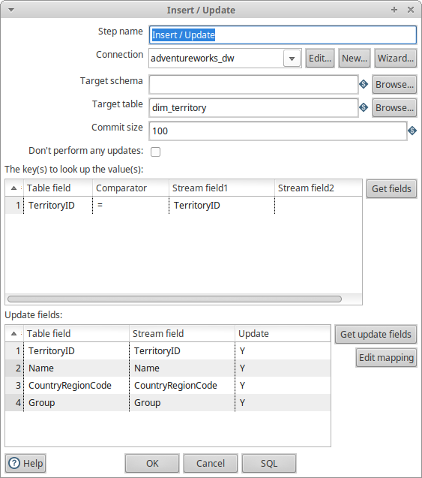

dim_product
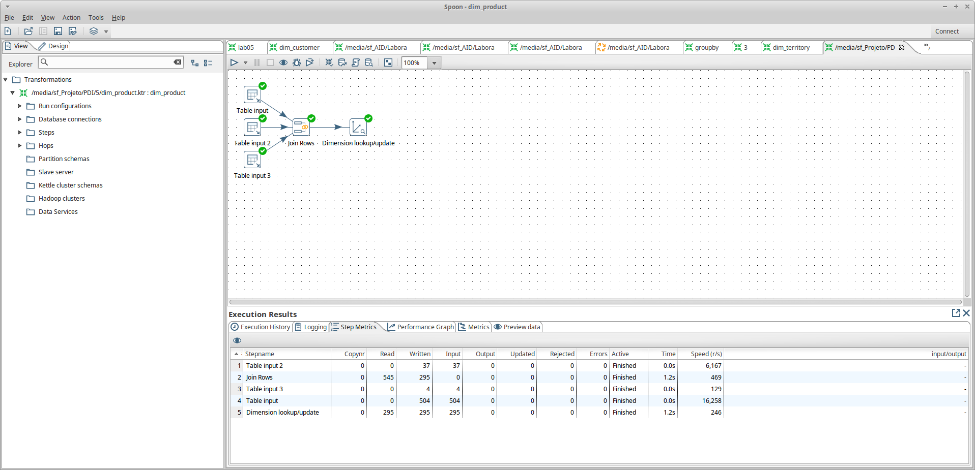

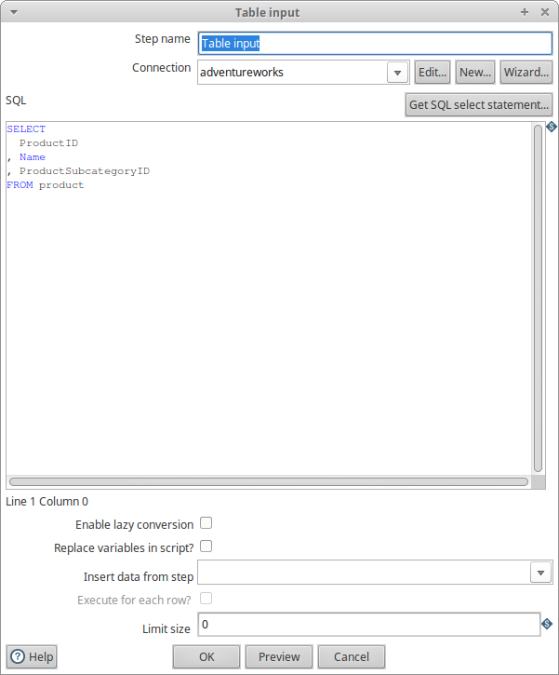 | 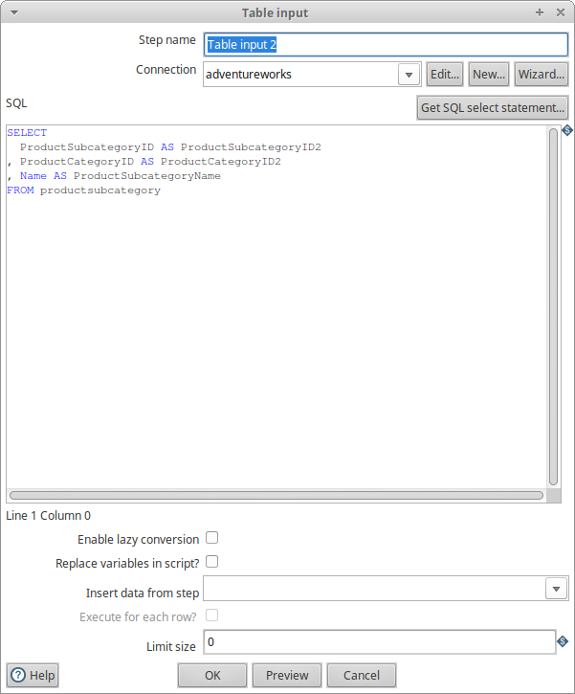
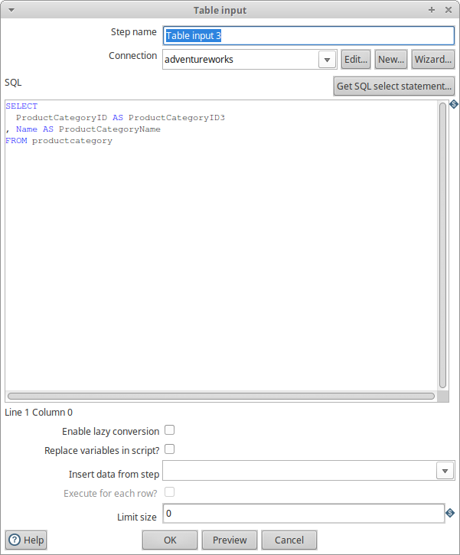 | 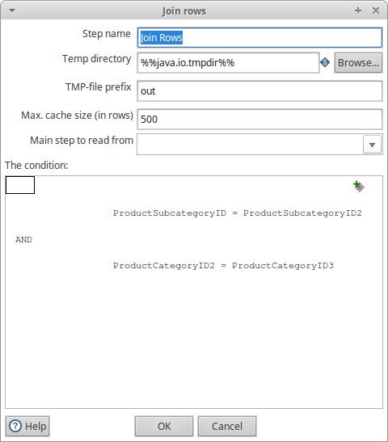

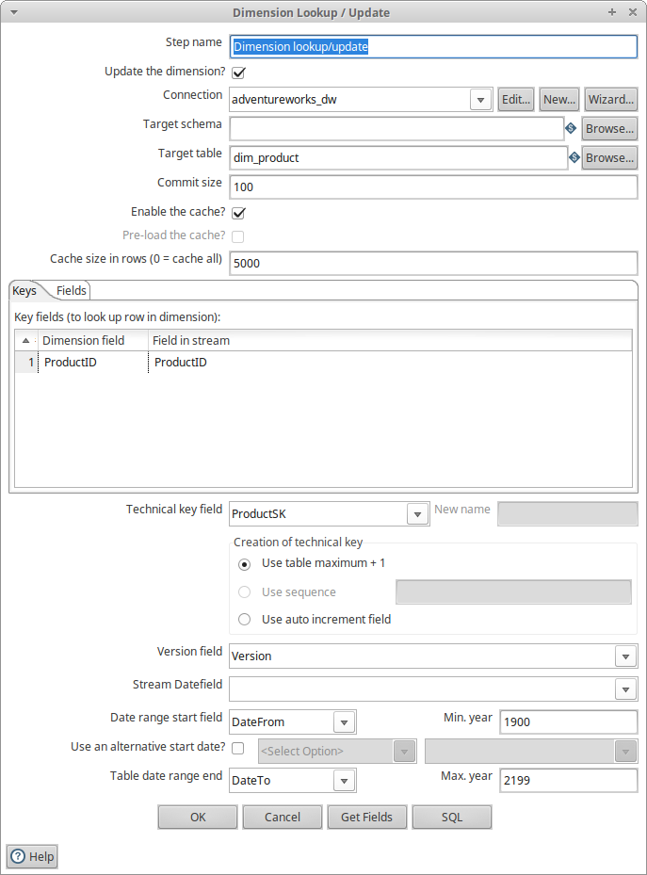

dim_time

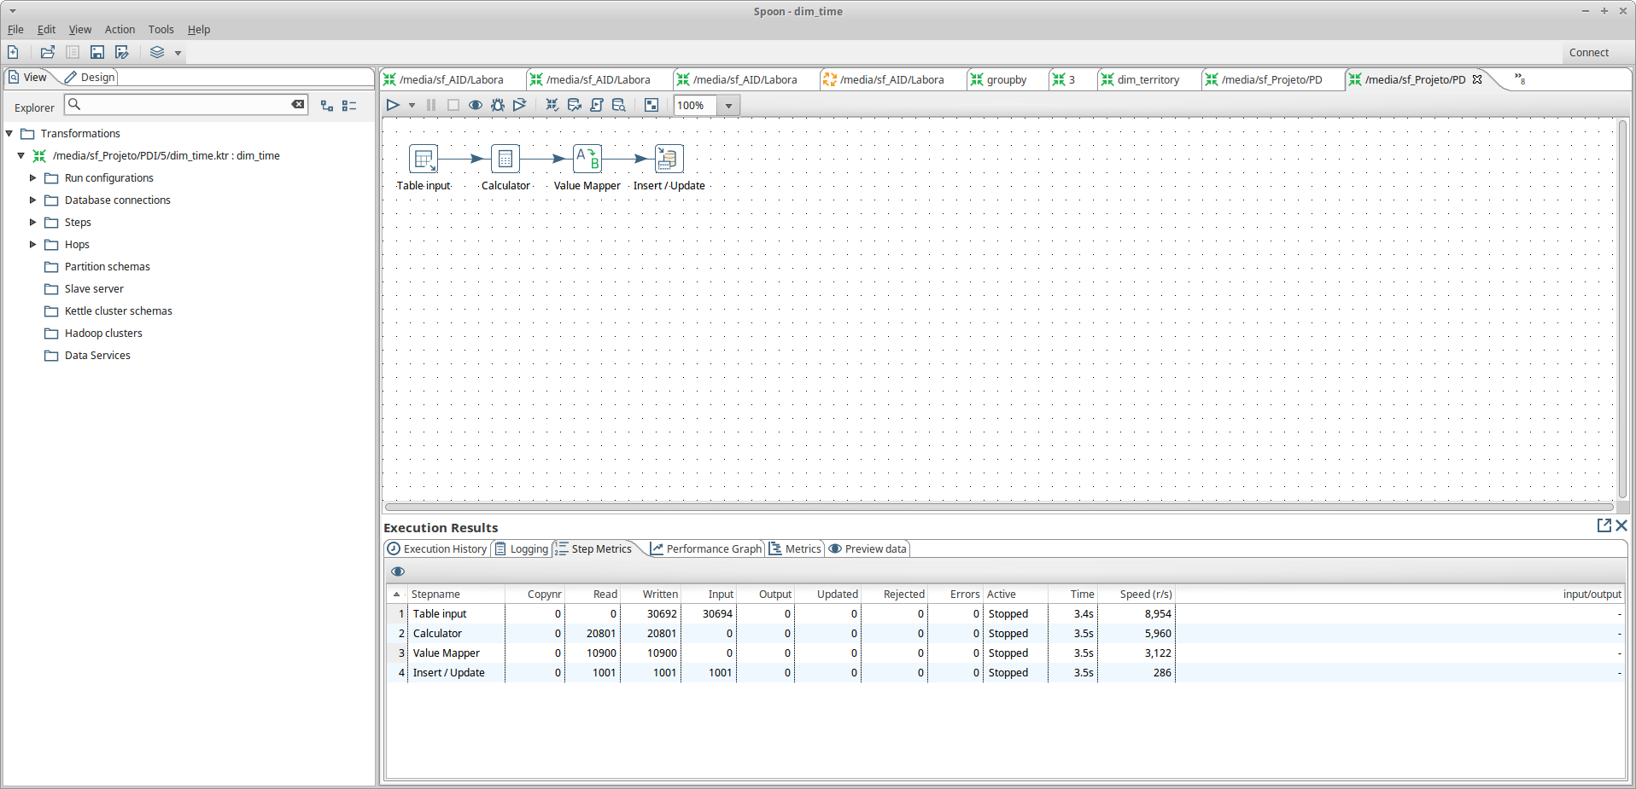
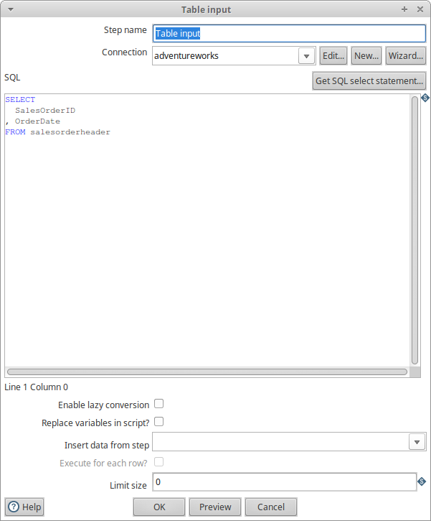
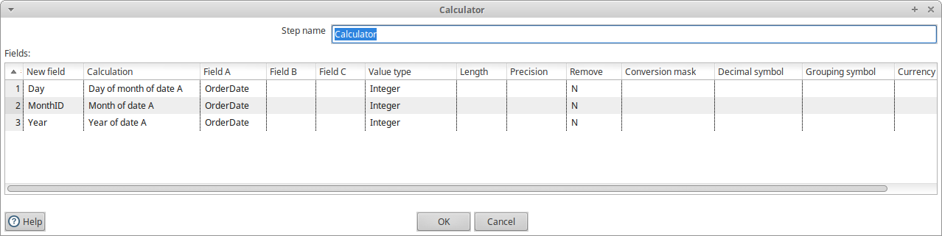
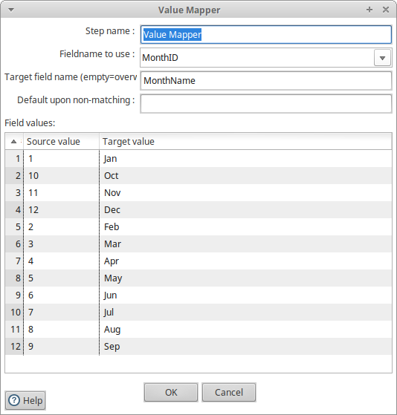 | 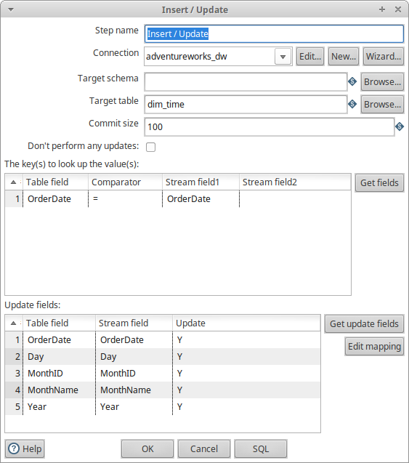

fact_order
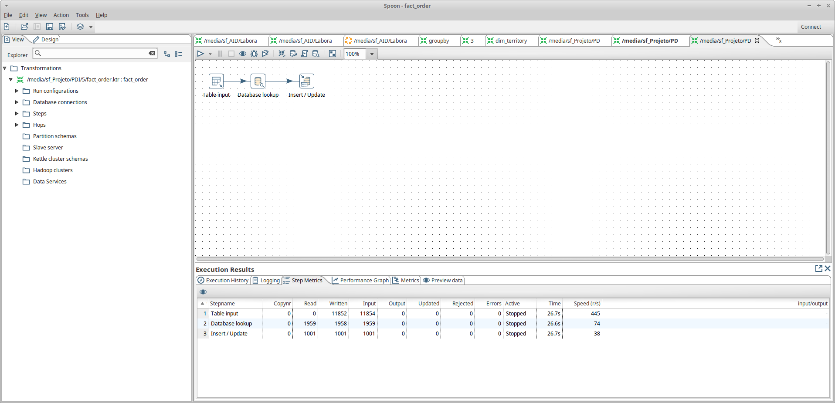
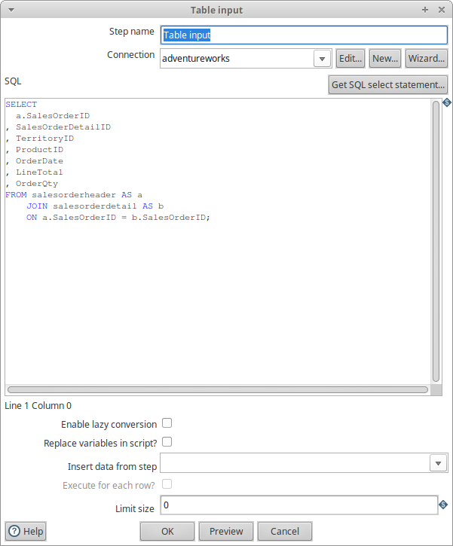 | 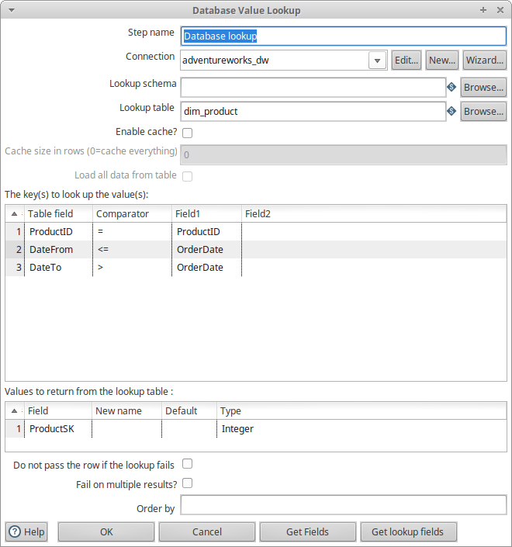

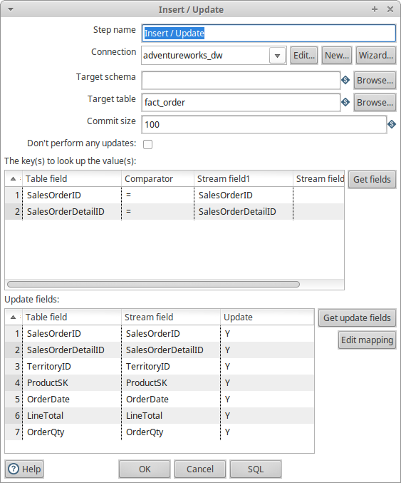

job
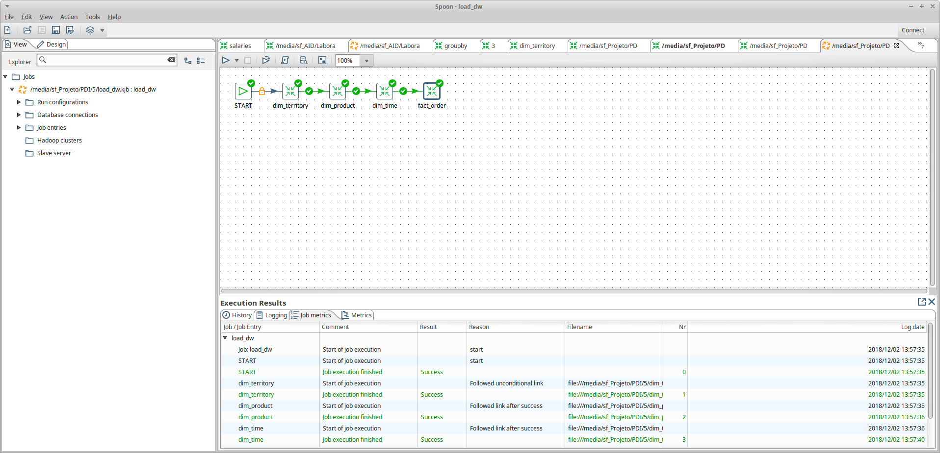
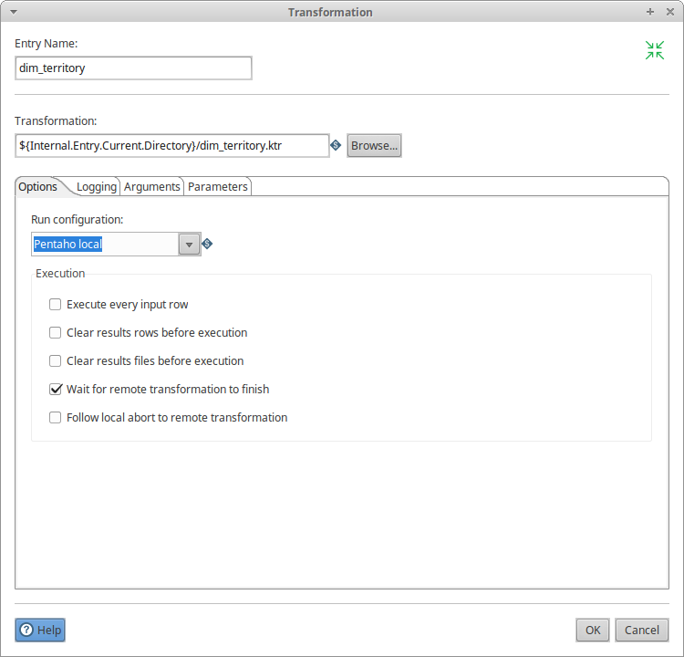 | 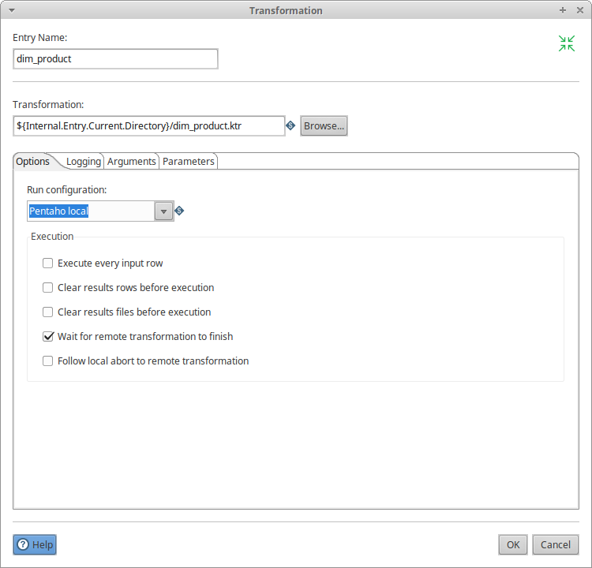
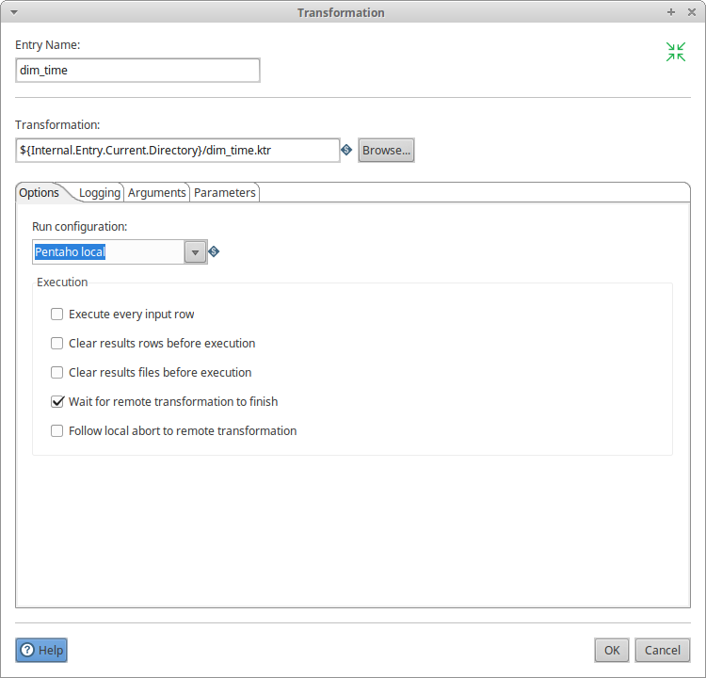 | 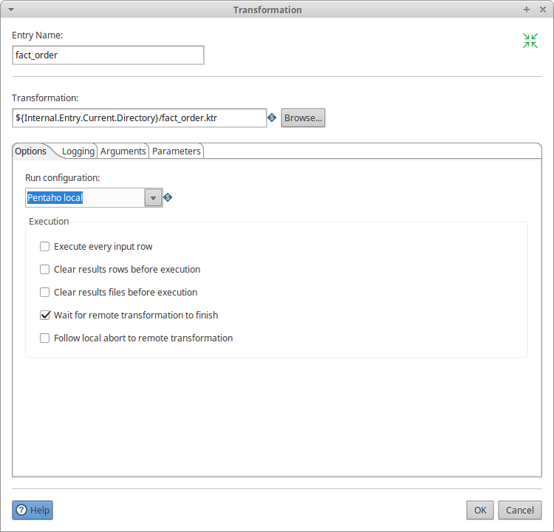

6) SQL Queries
Use adventureworks_dw;

#a)

Select sum(OrderQty) as TotalQ
From fact_order;

#b)

Select sum(OrderQty) as TotalQ, CountryRegionCode
From fact_order natural join dim_territory
Group by CountryRegionCode;

#c)

Select sum(OrderQty) as TotalQ, CountryRegionCode, ProductCategoryName
From fact_order natural join (Select TerritoryID, CountryRegionCode From dim_territory) as dim_Region natural join dim_product
Group by CountryRegionCode, ProductCategoryName

7) SQL/OLAP query
Use adventureworks_dw;

Select sum(OrderQty) as TotalQ, CountryRegionCode, ProductCategoryName
From fact_order natural join (Select TerritoryID, CountryRegionCode From dim_territory) as dim_Region natural join dim_product
Group by CountryRegionCode, ProductCategoryName with Rollup;

8)

9)

10)

11)
