Sorare Football Scoring Matrix
Reference Guide
Compiled from Sorare Help Center: “How does scoring work in Sorare Football?”
Accessed: 25 May 2026
https://sorare.com/pt/help/a/4402904001809/how-does-scoring-work-in-sorare-football
Important note: This document is a practical reference and paraphrased summary of the scoring information published by Sorare. Always check the official Sorare rules/help page for the latest applicable version before making lineup, trading, or model decisions.

1. Scoring overview
- Sorare Football scoring combines a player score and a card score for each of the five cards in a submitted lineup.
- The Player Score reflects the player’s real match performance on the pitch.
- The Card Score starts from the Player Score and adds any card bonuses that apply to that specific card, such as captain bonus, current-season bonus, XP/training bonus, and collection bonus.
- The Team Score is the sum of the five Card Scores and is used to rank lineups on competition leaderboards.

2. Player Score (PS)
Sorare Player Scores range from 0 to 100. On a player page, Sorare displays historical scores, the average score across the most recent five matches, and the average score across the most recent fifteen matches. DNP matches are excluded from these averages.
Core formula used by Sorare:
Player Score = Decisive Score + All-Around Score
Sorare notes that if the All-Around Score is negative, it may be treated as zero in the Player Score calculation, except where negative decisive-score levels allow the score to be impacted by negative all-around performance. The final Player Score remains capped between 0 and 100.
If a player has two matches in a game week, only one match is counted for the score, according to the help page.

3. Decisive Score (DS)
The Decisive Score captures match-changing events. Players start at level 0, which corresponds to 35 points for a starter and 35 points for a substitute who comes on during the match. Each positive decisive action increases the level; each negative decisive action decreases it.
Positive impact actions | Negative impact actions
Goal | Red card
Assist | Own goal
Penalty won | Penalty conceded
Clearance off the line | Error leading to a goal
Clean sheet (goalkeeper only)
Penalty save
Last-man tackle
Sorare examples: two goals, one assist, and one red card produce level 2, equal to 70 points. One penalty conceded plus one red card produces level -2, equal to 5 points.

3.1 Decisive Score levels
Level | Points | Guaranteed minimum?
-3 | 0 | No
-2 | 5 | No
-1 | 15 | No
0 | 35 | No
1 | 60 | Yes
2 | 70 | Yes
3 | 80 | Yes
4 | 90 | Yes
5 | 100 | Yes

4. All-Around Score (AAS) matrix
The All-Around Score captures secondary statistics that are not always obvious in live viewing but contribute to the evaluation of a player’s performance and match impact. Sorare’s matrix has “Current” and “New” values by position. Blank/non-applicable values are shown as “—”.
Category | Stat | GK Current | GK New | DEF Current | DEF New | MID Current | MID New | FWD Current | FWD New
GENERAL | YELLOW_CARD | -3 | -3 | -3 | -3 | -3 | -3 | -3 | -3
GENERAL | FOULS | 0 | -1 | -1 | -2 | -0.5 | -1 | 0 | -0.5
GENERAL | WAS_FOULED | 0 | 0 | 0 | 0 | 0.5 | 1 | 1 | 1
GENERAL | ERROR_LEAD_TO_SHOT | -5 | -5 | -1 | -5 | -1 | -3 | -1 | -3
GENERAL | CLEAN_SHEET_60 | 0 | 0 | 10 | 10 | 0 | 0 | 0 | 0
DEFENSIVE | GOALS_CONCEDED | 0 | -3 | -2 | -4 | -2 | -2 | 0 | 0
DEFENSIVE | EFFECTIVE_CLEARANCE | 0 | 0 | 0.5 | 0.5 | 0 | 0 | 0 | 0
DEFENSIVE | WON_TACKLE | 0 | 0 | 3 | 3 | 3 | 3 | 0 | 0
DEFENSIVE | BLOCKED_CROSS | 0 | 0 | 1 | 1 | 1 | 1 | 0 | 0
DEFENSIVE | OUTFIELDER_BLOCK | 0 | 0 | 2 | 2 | 1 | 1 | 0 | 0
DEFENSIVE | DOUBLE_DOUBLE | 0 | 0 | 4 | 4 | 4 | 4 | 4 | 4
DEFENSIVE | TRIPLE_DOUBLE | 0 | 0 | 6 | 6 | 6 | 6 | 6 | 6
DEFENSIVE | TRIPLE_TRIPLE | 0 | 0 | 12 | 12 | 12 | 12 | 12 | 12
POSSESSION | POSS_LOST_CTRL | -0.3 | -0.3 | -1 | -0.6 | -0.5 | -0.5 | -0.1 | -0.1
POSSESSION | POSS_WON | 0 | 0 | 0.5 | 0.5 | 0.5 | 0.5 | 0 | 0
POSSESSION | DUEL_LOST | 0 | 0 | -2 | -2 | -0.5 | -0.8 | -0.5 | -1
POSSESSION | DUEL_WON | 0 | 0 | 1.5 | 1.5 | 0.5 | 0.8 | 0.5 | 1
POSSESSION | INTERCEPTION_WON | 0 | 0 | 3 | 3 | 2 | 3 | 0 | 3
PASSING | BIG_CHANCE_CREATED | 3 | 3 | 3 | 3 | 3 | 3 | 3 | 3
PASSING | ADJUSTED_TOTAL_ATT_ASSIST | 2 | 2 | 2 | 3 | 2 | 2 | 2 | 2
PASSING | ACCURATE_PASS | 0 | 0.1 | 0.1 | 0.08 | 0.1 | 0.1 | 0.1 | 0.1
PASSING | SUCCESSFUL_FINAL_THIRD_PASSES | 0 | 0.5 | 0.5 | 0.4 | 0.3 | 0.3 | 0.1 | 0.1
PASSING | ACCURATE_LONG_BALLS | 0.2 | 0.2 | 0.5 | 0.5 | 0.5 | 0.5 | 0 | 0
PASSING | LONG_PASS_OWN_TO_OPP_SUCCESS | 0 | 0 | 0.5 | 0.5 | 0 | 0 | 0 | 0
PASSING | MISSED_PASS | -0.2 | -0.2 | -0.2 | -0.2 | -0.2 | -0.3 | 0 | 0
ATTACKING | ONTARGET_SCORING_ATT | 3 | 3 | 3 | 3 | 3 | 3 | 3 | 3
ATTACKING | WON_CONTEST | 0 | 0 | 0.5 | 0.5 | 0.5 | 0.5 | 0.5 | 0.5
ATTACKING | PEN_AREA_ENTRIES | 0 | 0 | 0.5 | 0.5 | 0.5 | 0.5 | 0.5 | 0.5
ATTACKING | PENALTY_KICK_MISSED | -5 | -5 | -5 | -5 | -5 | -5 | -5 | -5
ATTACKING | BIG_CHANCE_MISSED | -5 | -5 | -5 | -5 | -5 | -5 | -5 | -5
GOALKEEPING | SAVES | 2 | 2 | — | — | — | — | — | —
GOALKEEPING | SAVED_IBOX | 1 | 2 | — | — | — | — | — | —
GOALKEEPING | GOOD_HIGH_CLAIM | 1.2 | 1.5 | — | — | — | — | — | —
GOALKEEPING | PUNCHES | 1.2 | 1.5 | — | — | — | — | — | —
GOALKEEPING | DIVE_SAVE | 3 | 3 | — | — | — | — | — | —
GOALKEEPING | DIVE_CATCH | 3.5 | 3.5 | — | — | — | — | — | —
GOALKEEPING | CROSS_NOT_CLAIMED | -5 | -3 | — | — | — | — | — | —
GOALKEEPING | SIX_SECOND_VIOLATION | -5 | -5 | — | — | — | — | — | —
GOALKEEPING | GK_SMOOTHER | 5 | 5 | — | — | — | — | — | —
GOALKEEPING | ACCURATE_KEEPER_SWEEPER | 5 | 3 | — | — | — | — | — | —
Clean sheet note: Sorare states that clean sheet points apply if the player spends at least 60 minutes on the field, excluding extra time.

5. Card Score (CS)
Sorare Card Score is calculated by taking the Player Score and adding the score bonus attached to that card. Bonuses may include captain bonus, current-season card bonus, XP/training bonus, and collection bonus.
Card Score = Player Score + applicable card bonuses
Example from Sorare: if a card has a 10% bonus and the player obtains a Player Score of 70, the Card Score is 77, calculated as 70 + 10% of 70.

6. Double-Double, Triple-Double, and Triple-Triple bonuses
Defensive players can earn additional all-around scoring bonuses during a Game Week based on three categories: interceptions, won tackles, and net duels.
Bonus | Points | Requirement
Double-Double | 4 | At least two each from two of the three categories.
Triple-Double | 6 | At least two each from all three categories.
Triple-Triple | 12 | At least three each from all three categories.

7. Official source snapshots
The following images were downloaded from the Sorare help page to provide a visual cross-check against the transcribed matrix above.
Decisive impact actions
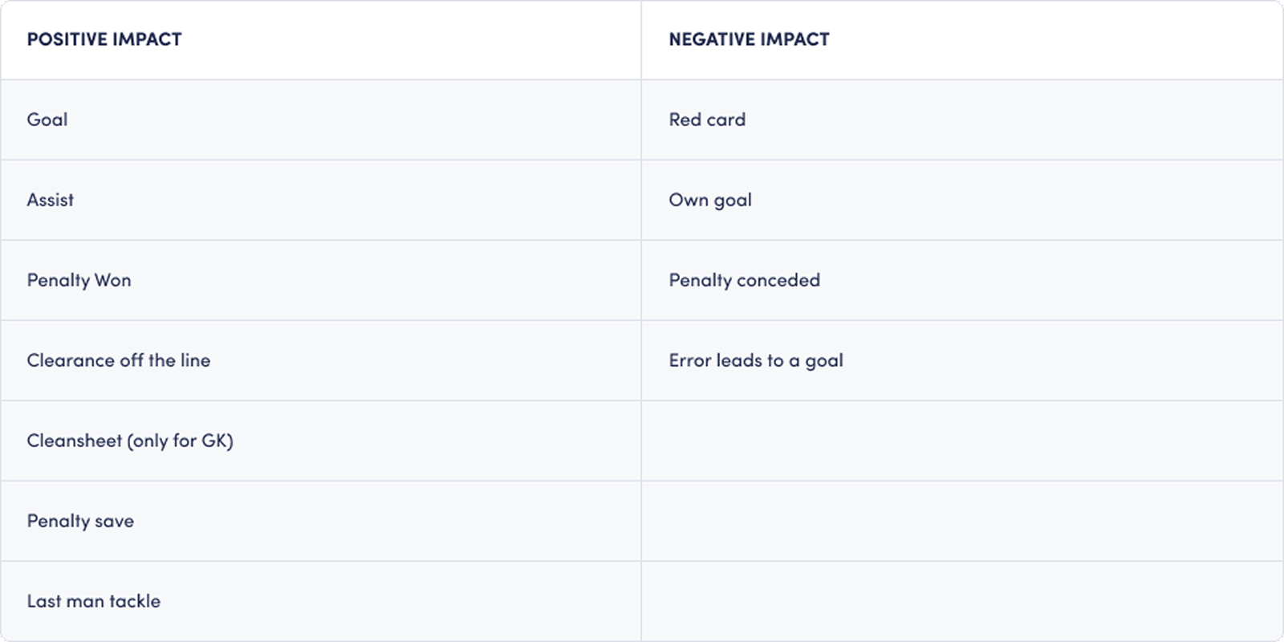
Decisive Score levels
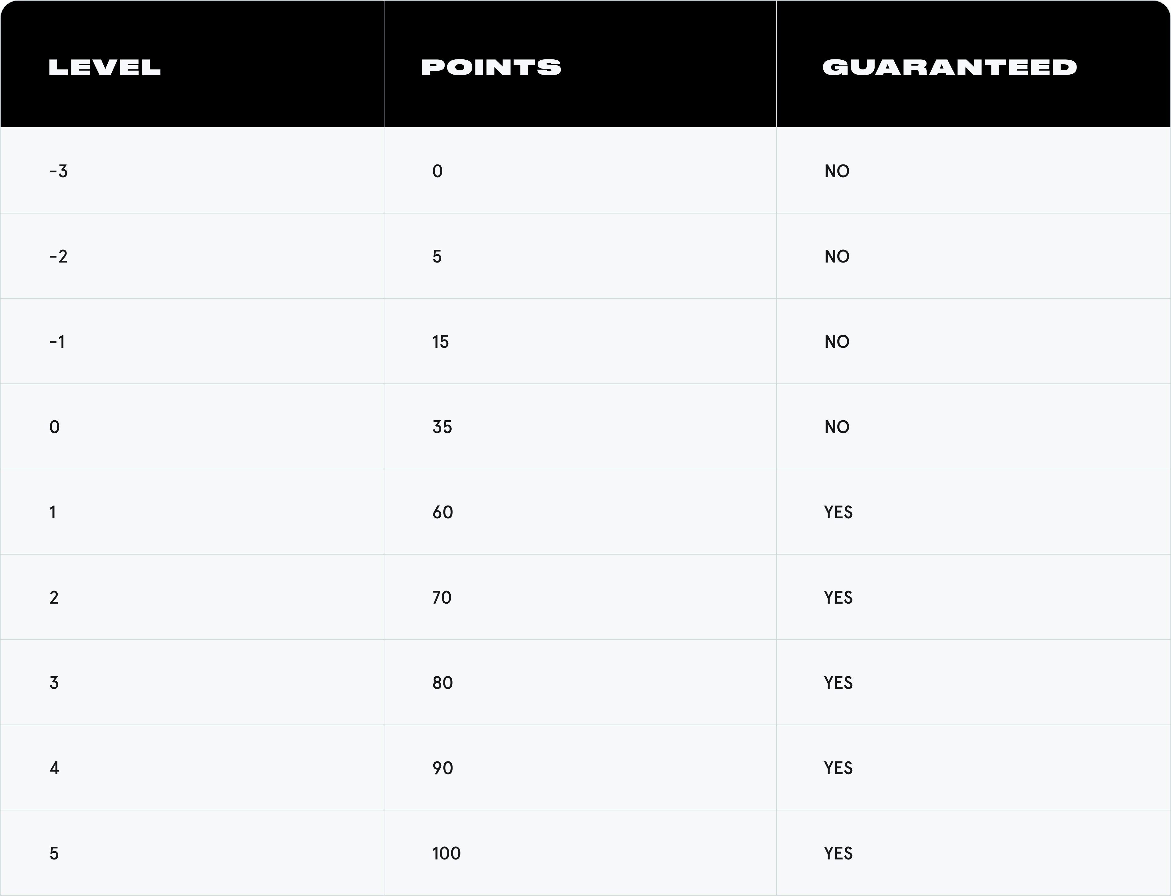



8. Reference
Sorare Help Center. “How does scoring work in Sorare Football?” https://sorare.com/pt/help/a/4402904001809/how-does-scoring-work-in-sorare-football Accessed 25 May 2026.

