Your Article Title Here
First Author¹, Second Author²
¹ First Institution Name, City, Country
² Second Institution Name, City, Country

Abstract
Your abstract goes here. This should be a concise summary of your research.

Introduction
Write your introduction here. Use bold and italic formatting as needed. Reference your figures using Fig. 1 and your tables as shown below for @table:example. You can include citations like [1].
You can include equations: $$E=mc2$${#eq:einstein}
And reference them using Eq. 1.
You can now also use executable code within the manuscript, for example we're getting this build date 2025-12-14 directly through a python, by through the 2025-12-14 call.

Results
Present your results here.
Include figures and tables:
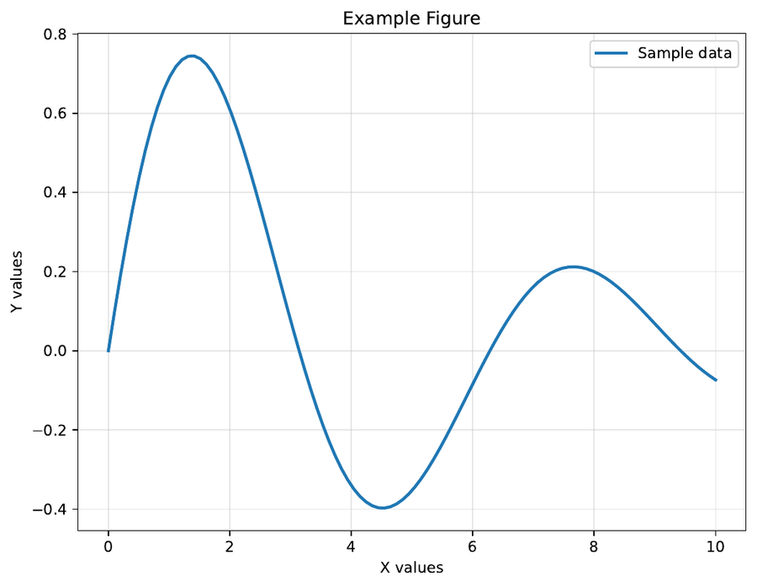
Example Figure Caption. Describe what your figure shows.
Column 1 | Column 2 | Column 3
Data 1 | Data 2 | Data 3
Data 4 | Data 5 | Data 6

Example Table Caption. Describe what your table contains.
Reference supplementary information, for example Supp. Note 1 or Supp. Fig. 1 or Supp. Table 1.

Discussion
Discuss your findings here.

Methods
Describe your methodology here. For additional methodological details, see Supp. Note 2. Include traditional code blocks when showing examples:
# Example code
import numpy as np
import matplotlib.pyplot as plt
# Your code here
data = np.random.randn(100)
plt.hist(data)
plt.savefig('histogram.png')

Conclusions
Summarize your main conclusions here.

Data availability
Describe where your data is available.

Code availability
Describe where your code is available.

Author contributions
Describe author contributions here.

Acknowledgements
Add your acknowledgements here.

Supplementary Information

Supplementary Information

Supplementary Tables
Parameter | Value | Description
Sample size | 100 | Number of samples analyzed
Temperature | 25°C | Experimental temperature
Duration | 2 hours | Experimental duration

Experimental Parameters. Key parameters used in the study.

Supplementary Notes
Example Supplementary Note.
This is an example of a supplementary note that can be referenced from the main text using Supp. Note 1. You can include detailed methodology, additional data analysis, or extended discussion here.
You can include mathematical expressions: $$∫0∞e−x2dx=π2$$
And code blocks:
# Example supplementary code for data analysis
import numpy as np
import pandas as pd
# Load experimental data
experimental_data = np.array([1.2, 1.5, 1.8, 2.1, 1.9, 1.7, 2.0, 1.6])
# Calculate summary statistics
mean_result = np.mean(experimental_data)
std_result = np.std(experimental_data)
sem_result = std_result / np.sqrt(len(experimental_data))
print(f"Mean: {mean_result:.2f} ± {sem_result:.2f}")
Extended Methods.
Provide detailed methodology that supplements the main text. Include step-by-step procedures, additional protocols, or technical specifications here.

Supplementary Figures
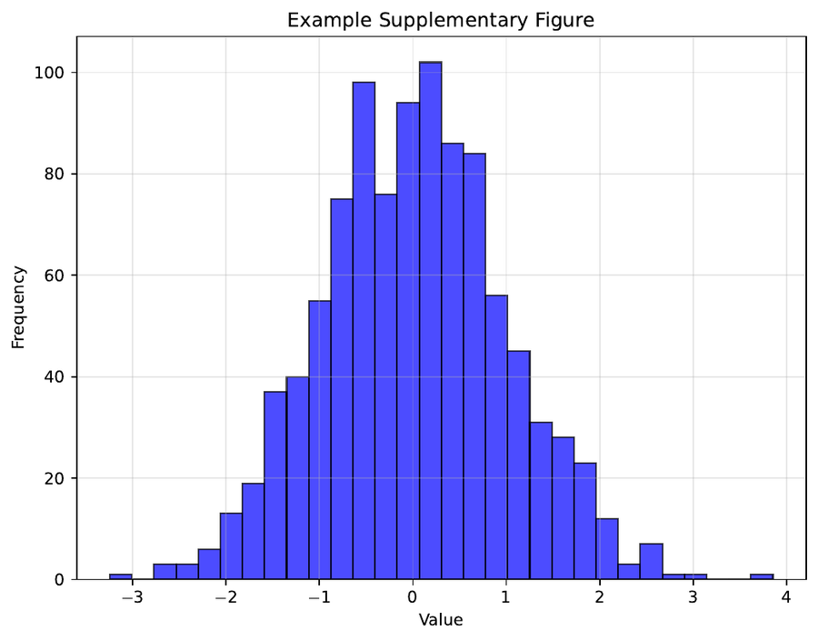
Example Supplementary Figure. Caption describing the supplementary figure content.

Bibliography
[1] Author, F. and Author, S. (2024). Example Article Title. Example Journal 1(1): 1–10.

