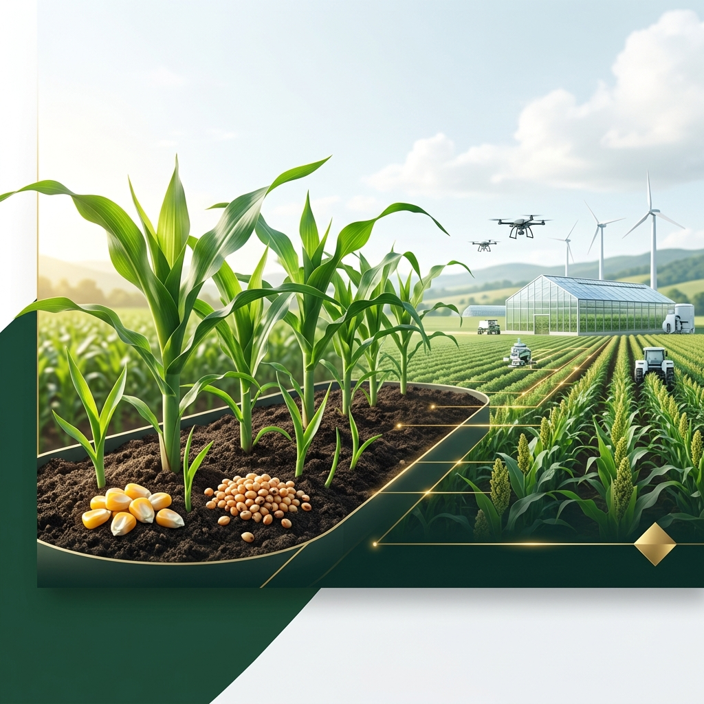

Basamukh Seed Integrated Services
Cultivating the Future of African Agriculture

Company Overview
Basamukh Seed Integrated Services is a premier agricultural enterprise based in Samaru Zaria, Kaduna. We specialize in the production, processing, and distribution of high-quality seeds that drive agricultural productivity across Africa.
Our Vision | Our Mission
To become a leading seed production and agricultural solutions company in Nigeria and across Africa, contributing to food security and sustainable farming systems. | To provide farmers with high-quality, affordable, and improved seeds that enhance productivity, profitability, and sustainability in agriculture.

Core Values
- Quality Assurance
- Integrity & Transparency
- Innovation in Agriculture
- Customer Satisfaction
- Sustainability

The Seed Quality Journey
Our process ensures that every seed delivered to a farmer is of the highest genetic and physical purity. From rigorous R&D to final distribution, we maintain global standards of excellence.
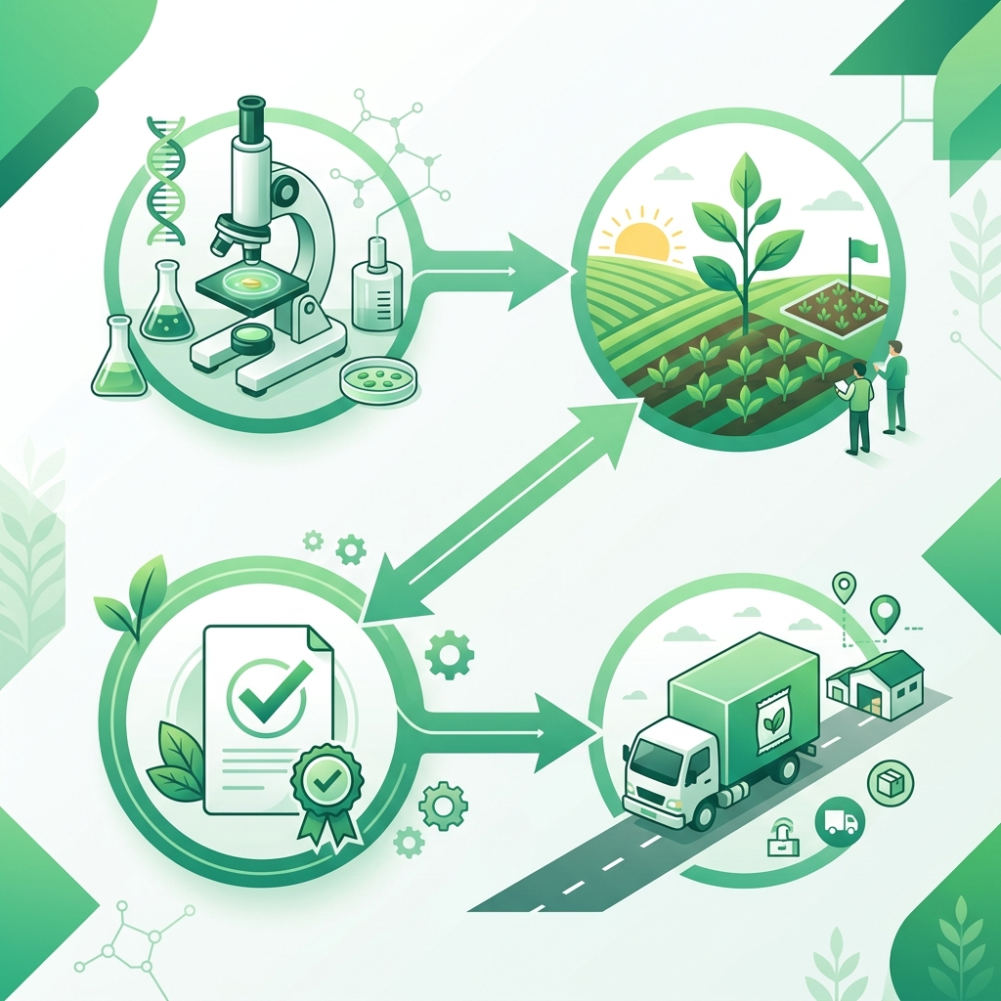

Our Seed Portfolio
Maize: High-yield hybrids and open-pollinated varieties developed for drought tolerance.
Sorghum: Climate-smart varieties with improved nutritional profiles.
Cowpea: Quick-maturing, insect-resistant varieties.
Groundnut: High-oil content seeds with excellent disease resistance.
Sesame: Export-quality seeds for international markets.
Soybean: Protein-rich seeds with superior germination rates.

Contact & Reach
Basamukh Seed Integrated Services is headquartered in the agricultural heart of Northern Nigeria.
📍 Address | No. 10 Tsamiya Road, Hayin Dogo Samaru - Zaria, Kaduna State, Nigeria
📞 Phone | 07019800030 | 08065307616
✉️ Email | basamukhseed@gmail.com

