**A Polyvinyl Alcohol Based Passive Wing Morphing Strategy**

Hanyue Shen1

1 Crimson Global Academy, Florida, USA.

E-mail: shenhanyueshanghai@163.com

Abstract

Cross-domain vehicles have been proposed as powerful tools for environment data collection. However, it is challenging to balance their efficiency in air and water, while using mechanical means of morphing will deplete energy and available space. This research proposes the usage of polyvinyl alcohol (PVA) material with biodegradable structure to fabricate an easily manufactured irreversably morphing wing profile, demonstrating an example of morphing from a MH-78 airfoil to a symmetric foil closely resemblying NACA-0009 upon entry to water. Existing data support that the proposed strategies are potentially useful for small air-water cross domain vehicles aiming for zero pollution and high efficiency due to its capability to boost the overal operation duration of the vehicle.

Keywords: Cross Domain Vehicle, Fluid Dynamics, PVA

1. Introduction

Ocean has become an increasingly crucial part in sustainable development since recent years. However, as industrial development progresses, pollution to ocean has been severe. Plastic is found to be present at remote coral reefs [1], and the Pacific trash vortex [2] is endangering the water quality and biodiversity in the world’s largest bluewater region. In light of these, the need to monitor, as well as collecting visual data becomes crucial to reparing the environment.

Buoys have been used to these purposes as a cheap data collection method [3]. However, just like underwater robots, these buoys face the problem of deployment deep into the ocean, as well as the possibility of creating more pollution due to the failure of reclaimation. Hence, this research proposes the utilization of cross domain vehicles.

Cross domain vehicles (CDVs) have been of interest in recent years due to their wide potentials in research contributed by their enhanced mobility. A research team from Imperial College London has formulated the AquaMAV project [4] to collect and return water samples from waters where conventional surface vehicles could not enter.

To maintain longer durations under water, however, it is more preferable that the vechicle could operate with buoyancy engines and glide with minimal consumption of energy in its crusing stage rather than folding aerodynamic wings as did by AquaMAV and other examples such as QiangXiang II [5]. Such measures not only take up the cabin space, but also consumes energy as well as reduces the reliability of the vehicle due to additional mechanical structure.

Nezha III [6] is an example of such type of vehicle that maintains its aerodynamic surfaces throughout its flight profile.

An additional issue would arise on the vehicle that due to the drastic density change between water and air, cross domain vehicles operate at Reynold’s numbers at two different orders of magnitudes. There are no mature means to design a vehicle competant for observation mission in both mediums [7] considering the need for both maneuverability and efficiency.

Given that there is no known existing foil competant in both water and air, but it is known that while aircrafts use mostly cambered foils, underwater gliders use symmetric [8] or low-cambered [9] foils, a logical proposal is not to morph the wing to change its sweep and span, but to change the airfoil.

Due to the comparative small scales of existing CDVs, the thin airfoil section on their wings, using mechanically controlled airfoil morphing strategies will be complex, energy-consuming, and unreliable. This research is hence proposing a passive chemical method to morph the airfoil from a cambered gliding foil into a symmetryc hydrofoil.

Polyvinyl Alcohol (PVA) is a water soluble polymeter [10], and it is also biodegradable [11]. It can be desinged to dissolve at different water temperatures, both room temperature, cold, or heated. Using attachment and detachment can be made upon takeoff and entry to water without further energy consumption and commands.

In this research, a thorough investigation of a passive irreversibly morphing wing adopting this strategy will be designed and evaluated.

2. Methodology and Process

To fabricate the morphing wing, a gliding airfoil is selected to be the basline, and then divided into the symmetric foil and the jettisoned section(s). The respective aerodynamic coefficients will be investigated through Xfoil. Upon reaching an acceptable design, the foil will be applied on a three-dimensional wing, including segmented design with PVA strings as fixation.

2.1 Vehicle Flight Profile

The flight of the vehicle consists of three major stages – aerial arrival of probing area, underwater gliding, and return to collection area or return via taking off from water depending on specific requirements. During the first stage, the vehicle maintains its aerial wing profile, while during the second stage, parts of the airfoil detach from the wing, leaving the symmetric wing profile.

The vehicle will operate in the following typical conditions. Underwater, the Reynold’s number will be 30,000, and in air, the Reynold’s number will be 400,000.

2.2 2-Dimensional Airfoil Design

Given that the glide ratio at 30m/s of Nezha III is slightly below 13 (wing only) [6], it is not challenging for the airfoil to reach similar or higher standards. Hence, the prime directive in the designing of airfoil is to increase the hydrofoil section area given an existing airfoil.

With this consideration, the MH-78 airfoil is selected for its different curvature on lower and upper surfaces, comparative thickness and efficiency in air.

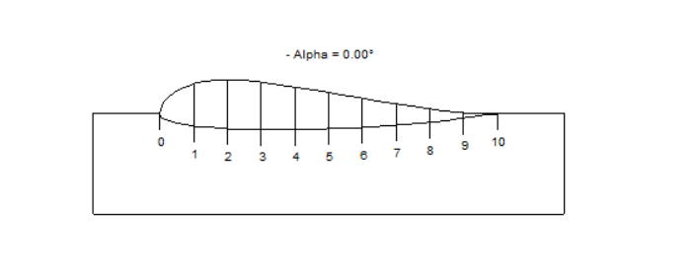

Figure 1. The original MH-78 Airfoil.

The airfoil is divided as shown in the following sketch.

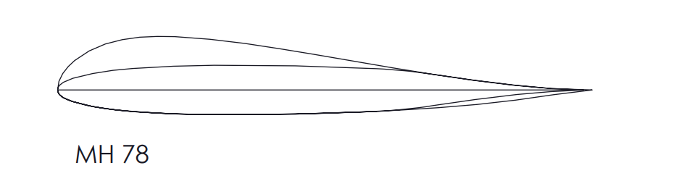

Figure 2. The split MH-78 Airfoil.

The middle section forms a new symmetric foil, while the uppermost section at the leading edge and the lowermost section at the trailing edge will be jettisoned upon entry. The foil is then filleted in the three-dimensional design for realistic purpose.

Both the larger MH-78 airfoil and the symmetric foil are calculated under their respective operating conditions for evaluation.

The symmetric foil is investigated under Reynolds number of 30,000 along with NACA-0009. The maximum lift-drag ratio of the symmetric foil is 19.5, which is slightly larger than NACA-0009’s 18.7. Comparatively, the maximum efficiency of MH-78, which is slightly more cambered, is 14.4 under this condition.

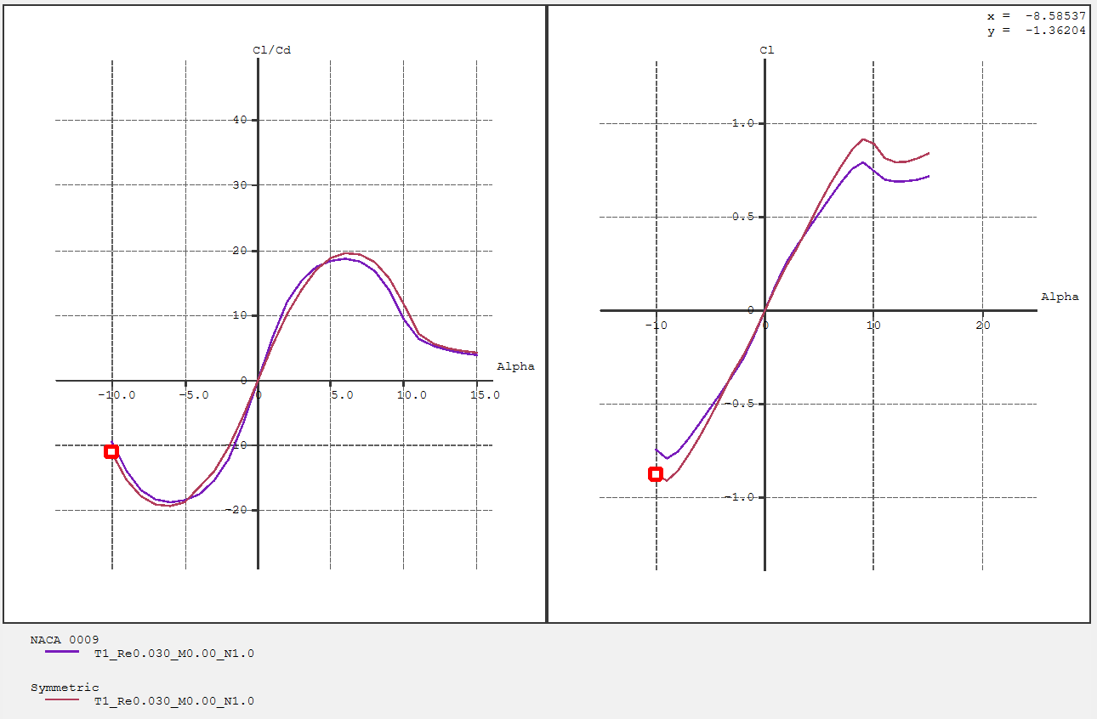

Figure 3. Polars of NACA-0009 (purple) and the symmetric foil (crimson) under Re=30,000.

From the plot, it can be shown that the symmetric foil designed and NACA-0009 show a consistency in performance due to their geometric similarity.

Meanwhile, in airborne conditions of 30m/s (if considering aerial return), the lift-drag ratio of the symmetric foil is 45.7, while that of NACA-0009 is 49.2. This could be a result of less smooth trailing edge on the symmetric foil.

Comparatively, MH-78 is a foil adapted to gliding, and its aerodynamic curves are given below.

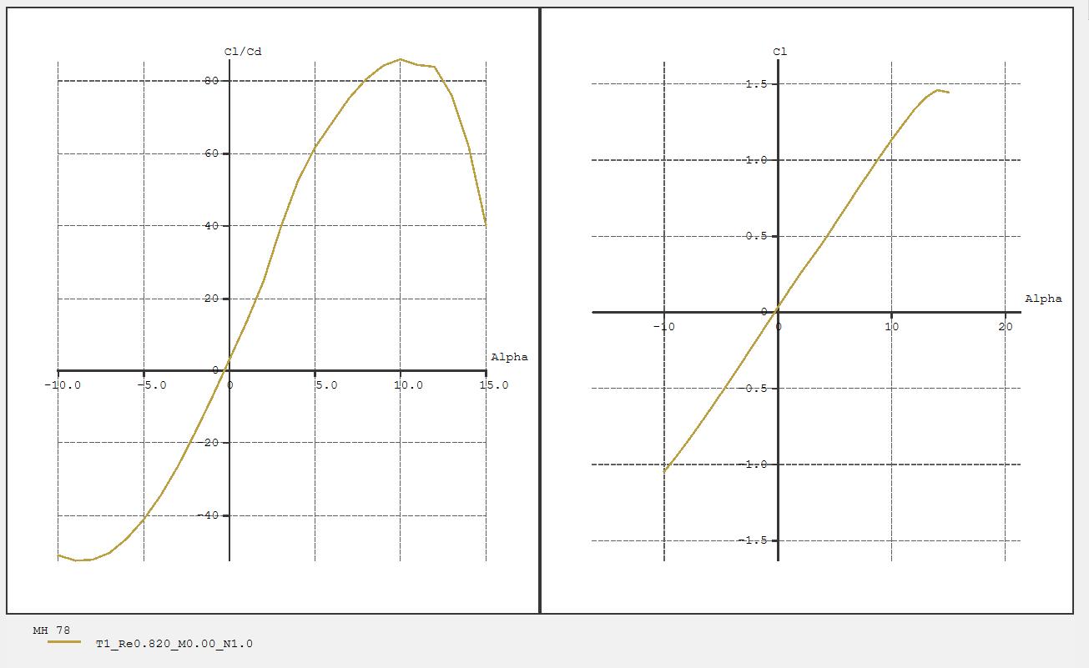

Figure 4. Polar of MH-78 under Re=400,000.

The maximum lift-drag ratio is 62.6 under a Reynold’s number of 400,000, the efficiency of which is significantly larger than that of the aforementioned symmetric foils, demonstrating its superiority in aerial gliding.

Through these investigations, it can be indicated that dividing an existing foil into jettisoned parts and a smaller symmetric foil can boost the working efficiency of the airfoils in both mediums. Hence, it can be asserted that this method is theoretically advantageous compared to fixed airfoils.

2.3 3-Dimensional Wing Design

The design of the three-dimensional wing form is segmented due to prevention of inability to fix detached parts onto the main structure. Using segments will hence increase the reliability and decrease fixation requirements. One single segment is shown below.

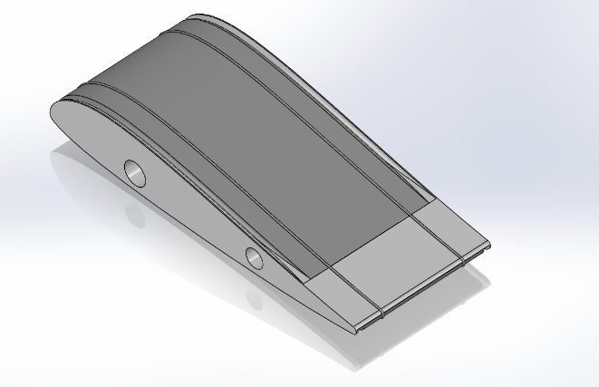

Figure 5. Segment of wing before dissolving.

The darker sections are constructed with PVA. While larger chunks of PVA dissolve slowly, they can also be made with other biodegradable materials for sustainability considerations. The lighter sections in this example are made with polyetheretherketone (PEEK), but can also be replaced with other rigid structural materials. The three main parts have two slots on them for the PVA cold water-soluble strings. The strings are responsible for keeping the detachable sections in place before entry to water. Such strings have been used in fishery and are sufficiently mature. After dissolving, the structure becomes the following.

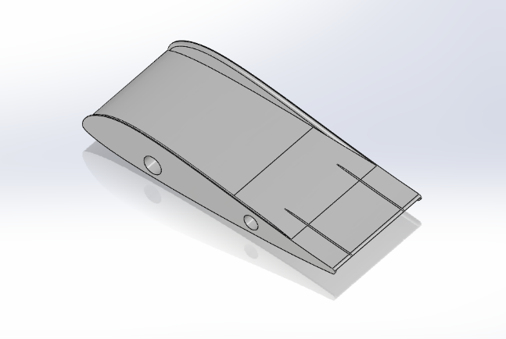

Figure 6. Segment of wing after dissolving.

The two cavities in the airfoil are left for supporting carbon fibre tubes. Hence, the entire wing can be pieced together.

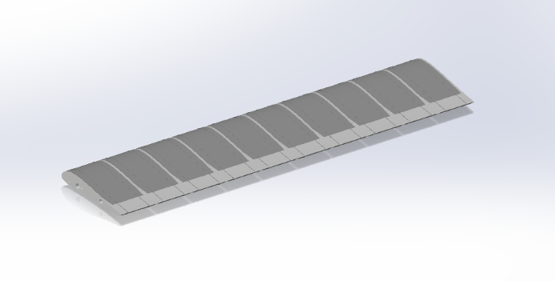

Figure 7. Model of full wing.

This indicates the final design for the chemically deforming wing. It will alter its profile after dark segments detach from the main structure.

3. Result and Discussions

In order to numerically evaluate the advantage of the chemically morphing airfoil, a comparison is made concerning their maximum efficiency (lift-drag ratios). The compared terms include airborne efficiency and underwater efficiency. Due to the change in airborne efficiency after the dissolving of PVA sections, for the designed airfoil, an average will be taken. The Reynold’s numbers of consideration are 30,000 and 400,000.

Table 1. Comparison of foil efficiency.

|  |  |  |
| --- | --- | --- |
| Foil Name | Underwater | Airborne |
| PVA Morph | 19.5 | 54.2 |
| NACA-0009 | 18.7 | 49.2 |
| MH-78 | 14.4 | 62.6 |
| NACA-4412 | 8.3 | 98.3 |

Through the table above, it can be indicated that dividing an existing material allows the aircraft to obtain a comparative advantage compared to some standard foils.

Admittedly, some standard foils, such as NACA-2412, operates better compared to the designed morphing foil at this range. But under a slower underwater gliding speed at Re=20,000 and below, the morphed symmetric wing regains its advantage. In fact, the chemically morphing wing is not in disadvantage compared to any given foil, as it is capable of combining all given cambered foils to satisfaction with a symmetric foil.

While differently cambered airfoils will result in different results, as long as the upper and lower surface of the original foil is curved differently, sufficient area can be allocated to the symmetric foil.

4. Conclusion and Evaluation

In conclusion, this research proposes a novel method of irreversible morphing wing based on chemical changes when PVA material contacts water. It combines any cambered airfoil of satisfaction suited for aerial flight with a symmetric foil more suited to underwater gliding. The three-dimensional structure features biodegradable jettisoned sections fixed onto the main structure with PVA water soluble strings. Through an example operated on the glider foil MH-78, the research indicates that the combined foil operates better than any of MH-78 and NACA-0009 alone. Meanwhile, it is capable of surpassing some standard foils. Higher efficiencies can be obtained via choosing any cambered foil of satisfaction. This proves the potential usage of this strategy on small cross-domain vehicles for environmental data collection with sustainability measures as it will significantly boost the vehicle’s range by increasing the efficiency.

More research can be conducted on several aspects of the research – more types of airfoils, including supercritical airfoils, can be attempted in order to optimize the use of this strategy. Meanwhile, the fixture method currently can still be optimized given that PVA tapes and PVA films can also be used for fixture and dissolving in cold water aside from PVA string. A combination of these can potentially result in more stable and reliable fixtures operating with longer and thinner wings.

Despite these aspects to be discussed in further research, this research has been able to point out this novel application of PVA for cross domain flight, and remains a valuable topic of discussion and research.

Acknowledgements

The author thanks Prof. Xingwei Kong for his advices in the conceptualization of the research.

References

1. Sanderson, K. (2023). Striking images show plastic litter in the world’s most remote coral reefs. *Nature*, ***619***(7970), 447. https://doi.org/10.1038/d41586-023-02271-8.
2. *Great Pacific Garbage patch*. (n.d.). https://education.nationalgeographic.org/resource/great-pacific-garbage-patch/
3. *HOME | default*. (n.d.). Default. https://mdbuoyproject.wixsite.com/default
4. *The AquaMAV project*. (n.d.). Imperial College London. https://www.imperial.ac.uk/aerial-robotics/research/aquamav/
5. Zou, Y., You, C., Tan, X., Wang, Y., Wang, J., Li, C., He, M., Lv, K., Zou, Y., Song, H., Lv, P., & Li, H. (2023). Design and implementation of a gliding cross-domain vehicle. *Ocean Engineering*, **280**, 114549. https://doi.org/10.1016/j.oceaneng.2023.114549
6. Lyu, C., Lu, D., Xiong, C., Hu, R., Jin, Y., Wang, J., Zeng, Z., & Lian, L. (2022). Toward a gliding hybrid aerial underwater vehicle: Design, fabrication, and experiments. *Journal of Field Robotics*, **39**(5), 543–556. https://doi.org/10.1002/rob.22063
7. Zeng, Z., Lyu, C., Bi, Y., Jin, Y., Lu, D., & Lian, L. (2022). Review of hybrid aerial underwater vehicle: Cross-domain mobility and transitions control. *Ocean Engineering*, **248**, 110840. https://doi.org/10.1016/j.oceaneng.2022.110840
8. Divsalar, K., Shafaghat, R., Farhadi, M., & Alamian, R. (2021). Experimental analysis on hydrodynamic coefficients of an underwater glider with spherical nose for dynamic modeling and motion simulation. *SN Applied Sciences*, **3**(2). https://doi.org/10.1007/s42452-021-04241-z
9. Lemaire, S., Lidtke, A. K., Turnock, S. R., & Vaz, G. (2016). Modelling natural transition on hydrofoils for application in underwater gliders.

[10] PubChem. (n.d.). *Polyvinyl alcohol*. PubChem.

https://pubchem.ncbi.nlm.nih.gov/compound/Polyvinyl-alcohol

[11] Chiellini, E., Corti, A., D’Antone, S., & Solaro, R. (2003). Biodegradation of poly (vinyl alcohol) based materials. *Progress in Polymer Science*, **28(6)**, 963–1014. https://doi.org/10.1016/s0079-6700(02)00149-1