ELEC 3300 – Introduction to Embedded Systems

Peer Discussion Worksheet

Project Group Number: 7

1. Please describe your Project in 120 to 150 words, which includes
   * Functional description of your project in laymen terms
   * Role of the microcontroller

Game controller with a touchscreen in the middle (like switch)

Can play simple games with the controller (e.g. tic tac toe, asteroids)

Sensors:

Buttons&joystick&limit switch on the sides for controlling

Buzzer/speaker for some simple sound effects

Touchscreen can also be used to control the game

Extra features:

Small vibration motors installed on the back for haptic feedback

SD card to save game progress and store audio files

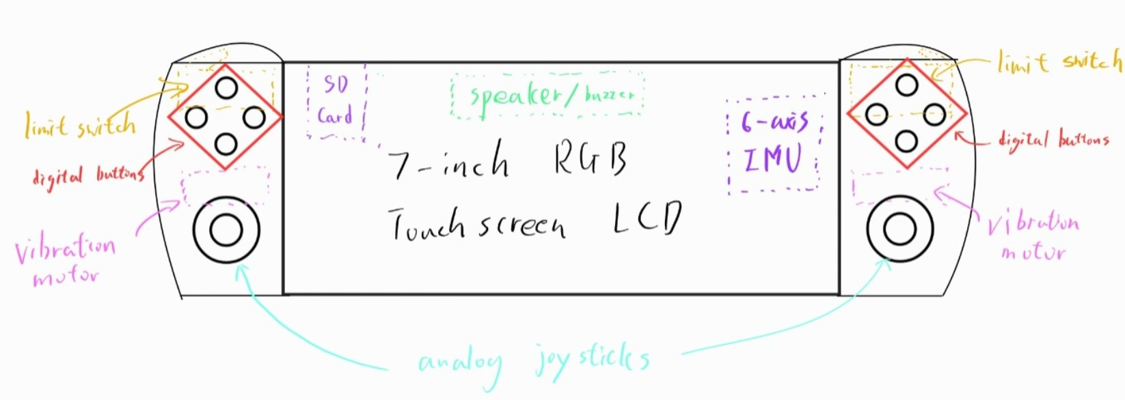

1. List of hardware (like sensors, device, motor that you might need for your project)

Sensor:

6-axis IMU - ICM20600 (SPI)

Digital Button (GPIO)

Analog Joystick x2 (ADC)

Limit Switch x2 (GPIO)

Output:

7-inch touchscreen TFT - TFTLCD电容触摸屏V3 1024\*600 (LTDC + I2C)

Buzzer(adjustable pitch) / Speaker (GPIO/PWM)

RGB LED (GPIO)

Phone vibration motor (GPIO/PWM)

SD Card (SDIO)

1. Can the STM32F103 Development Board satisfy your Project need?

If not, what development board you intend to use?

No

F103 does not have enough RAM to support our large touchscreen display

Also does not have LTDC for our display

Will design PCB with F429 MCU