This is the Final Milestone Submission Instruction Document and also should be used as a Template for Your Submission
Full Marks: 100 (15% to final grade)
Submission Deadline (FIRM): 11:55 PM, Sunday, December 1, 2013

Submitted by

Dr. Chanchal Roy

Assistant Professor
Department of Computer Science
University of Saskatchewan

Submitted to

The students of CMPT 370 (2013-14)
University of Saskatchewan

November 18, 2013, Saskatoon

Abstract: In the abstract you are supposed to provide an overall summary of your project in a similar way to your milestone 2. Just provide a paragraph of not more than 200 words about your project. You can mention what the project is about, what its business values are and how successful you have been in working in this project. Also write about your feelings of working in this project. Abstract should be of font size 10 Times New Roman. All other text will be 12 Times New Roman. Section headings should be 13 Times New Roman and sub-section headings should be 12 Times New Roman. You should use standard paper size of US letter. Before you write the abstract you must provide a “cover page” similar to the “cover page” of this milestone. You must include the project title, group name, group ID, submission date, NSIDs/Names of the group members in the cover page. Also provide a Table of Contents of your project similarly to the one in this document. This final submission has a different marking scheme as provided in Appendix A. It is also mandatory that you use the word version of this document for your submission. If you have been working with Latex or other editors pls. let e know first and I will try to help out. (2 marks)

***Read the abstract carefully before working on this milestone***

Note: If you need a latex version of this document, pls. feel free to send me an email.

Table of Contents |  |  | Page No.
 | Abstract (2 marks) |  | 2
1. | Introduction (2 marks) |  | 5
 | 1.1 | System description (0.25 mark) | 5
 | 1.2 | Business case (0.25 mark) | 5
 | 1.3 | User-level goals for the system (0.25 mark) | 5
 | 1.4 | User scenarios (0.25 mark) | 5
 | 1.5 | Scope document (0.25 mark) | 5
 | 1.6 | Project plan / rough estimates (0.25 mark) | 5
 | 1.7 | User involvement plan (0.25 mark) | 5
 | 1.8 | Low fidelity prototypes (0.25 mark) | 5
2. | Requirements and Early Design (17 marks) |  | 6
 | 2.1 | Summary Use Cases (2+ 1 marks) | 6
 | 2.2 | Fully-dressed Use Cases (1 marks) | 6
 | 2.3 | Use Case Diagram (1 mark) | 6
 | 2.4 | Domain Model (2 marks) | 6
 | 2.5 | Glossary (2 mark) | 7
 | 2.6 | Supplementary Specification (2 marks) | 7
 | 2.7 | System Sequence Diagrams (3 marks) | 7
 | 2.8 | Operation Contracts (2 marks) | 7
 | 2.9 | Obtaining User Feedback (1 marks) | 7
3. | Updated Design and Testing (14 mark) |  | 8
 | 3.1 | System Operations (1 marks) | 8
 | 3.2 | Sequence or Communication Diagrams with GRASP Patterns (2 marks) | 8
 | 3.3 | Class Diagram (3 marks) | 8
 | 3.4 | Unit Testing (8 marks) | 8
4. | Reengineering (22 marks + 2 bonus marks) |  | 9
 | 4.1 | Code Smells (7 + 6 marks) (Also 2 bonus marks for the second part) | 9
 | 4.2 | Refactoring (5 marks) | 11
 | 4.3 | Gang of Four Design Patterns (4 marks) | 11
5. | Complete Implementation and Product Delivery (33 marks) |  | 12
 | 5.1 | Naming Conventions (1 marks) | 12
 | 5.2 | Commenting (1 marks) | 12
 | 5.3 | Pretty-printing of the source (2 marks) | 12
 | 5.4 | Usability Engineering (7 marks) | 12
 | 5.5 | Excellency of the Complete Implementation (15 marks) | 13
 | 5.6 | User Manual (7 marks) | 13
6. | Project plan, Budget Justification and Performance Evaluation (7 marks) |  | 13
7. | Conclusion (1 marks) |  | 17
 | Acknowledgements (1 marks) |  | 17
 | How to Submit? (0 marks, penalty of 2 marks if not followed) |  | 17
 | References (1 marks) |  | 18

1. Introduction (2 marks)

1.1 System description

Our Warehouse Management System software allows employees within a retail warehouse to better manage their inventory and reduce errors in their business. The system does this by storing all stock information on an item, including details such as price, name, attributes, and physical location within the warehouse.
The software will provide; Receivers with a simple and easy interface for adding incoming products to their inventory, Shippers with the ability to remove products for outgoing shipments, and Stock Handlers with an interface to locate and manage inventory within the warehouse. The system will have the ability to print and format reports for management, detailing internal metrics and stock within the warehouse.
By meeting the needs of each type of employee in the warehouse, this software system will be central to the efficient and successful operation of a retail warehouse.

1.2 Business case

The modern warehouse of today is run essentially the same way that it was twenty years ago, predominantly on paper documents that are handled by a wide variety of actors. This results in lost product, missed shipments, confusion and low efficiency. Some workers are constantly working hard every day, while others take advantage of the current situation and partake in leisure activities on the job. As warehouses remain central to brick-and-mortar stores, the meteoric rise of online sales has only increased the stress and demand on the warehousing industry. It is time to develop a new and innovative way to run the world’s warehouses, and disrupt their current offerings with the power of technology.
The main purpose of our electronic Warehouse Management System is to help management and staff to monitor, track, and improve efficiency with the power of data. Tools to track worker speed, stock turnover speed, and interactive stock tracking features all will allow management to better improve the efficiency of their organization, allowing them to reduce manpower and cut expenses.
This software provides functionality to integrate and organize the tasks of all members of the warehouse organization by providing a graphical user interface to easily navigate and perform tasks. Along with the management features mentioned above, Stock Handlers will receive optimized routes for gathering products for shipment, Shippers will be able to simply track and manage all outgoing shipments, and Receivers will be able to autonomously record new stock and determine immediately if a the warehouse has the capacity for a new shipment.
Our Warehouse Management System provides an easy to use program to assist all members of a warehouse organization make once complicated tasks simple.

1.3 User-level goals for the system

We have set the following user-level goals for the system. The goals have been divided into four separate categories to match the four types of actors using the system.

Manager
The main expectations and requirements that a Manager has for the Management and Reporting System functionality of our program is to be able to:
- View information on the products in the warehouse, including name, description, item number, category, price, quantities, and location within warehouse.
- Display the shipping reports for outgoing products for a given time period (past, present or future), including date ordered, status (pending, gathered, shipped), tracking information, weight, destination, and product manifest.
- Display the purchase order report for incoming products for a given time period (past, present or future), including the date ordered, tracking information, order cost, and product manifest.
- Display statistics and metrics reports, listing the fastest selling products, slowest moving products, and the percentage of the warehouse space currently being used.
- Display employee status report, containing one or more employee’s information such as name, title, employee speed (i.e. orders gathered per hour, average time to ship a shipment, average time to receive a shipment)
- Create, modify and delete shipment orders made to the warehouse.
- Create, modify and delete purchase orders made by the warehouse.

Shipper
The main expectations and requirements that a Shipper has for the Shipping System functionality of our program is to be able to:
- View a listing of all upcoming shipments.
- Assign upcoming shipments to a Stock Handler.
- Record outgoing shipment information such as tracking number and date shipped.

Receiver
The main expectations and requirements that a Receiver has for the Receiving System functionality of our program is to be able to:
- Update stock information according to received purchase orders.
- Input information of new incoming products.
- Assess if there is capacity in the warehouse for a given purchase order.
- Analyze which shipments will need to be shipped before the warehouse has enough capacity for an incoming purchase order.

Stock Handler
The main expectations and requirements that a Stock Handler has for the Stock Handling System functionality of our system is to be able to:
- Print out a list of the items required to be gathered to fulfill upcoming orders.
- Record the time of that they finished gathering the product for each pallet.
- Record any inconsistencies in stock levels, product location or product information.

1.4 User scenarios

Use Case Name: Statistics Reporting
Level: Summary
Actors: Manager
Goal: Provide a high level view of warehouse operations, to drive efficiency gaining decision making
Activities: Analyze staff efficiency for promotion and layoffs, view turnover speed of specific products to guide purchase order and discount sales decisions, gauge warehouse stock level
Quality: high quality, fast, accurate, and reliable
Version: September 28, 2013

Use Case Name: Stock Reporting
Level: Summary
Actors: Manager
Goal: Provide in depth view of information about warehouse stock
Activities: Monitor stock levels, view stock information for all products currently or previously contained in the warehouse
Quality: high quality, fast, accurate, and reliable
Version: September 28, 2013

Use Case Name: Routing Stocking Tasks
Level: Summary
Actors: Stock Handler
Goal: Increase efficiency of navigating the warehouse for stocking tasks
Activities: Putting away stock that has been received, gathering stock for an upcoming shipment, building pallets correctly
Quality: high quality, accurate, reliable, and effective
Version: September 28, 2013

Use Case Name: Receive Purchase Order
Level: Summary
Actors: Receiver, Stock Handler
Goal: Add new stock items to the system
Activities: Recording information on newly received stock, increasing warehouse stock level to correspond to received shipments, assign Stock Handler to store the product
Quality: high quality, accurate, high ease of use, reliable, flexible
Version: September 28, 2013

Use Case Name: Send Shipments
Level: Summary
Actors: Shipper, Stock Handler
Goal: Send the items ordered for shipment from the warehouse
Activities: Remove stock from the warehouse, track pallet contents, record progress of Stock Handlers in gathering items required for shipment.
Quality: high quality, accurate, high ease of use, reliable, flexible
Version: September 28, 2013

Use Case Name: Locating Stock
Level: Summary
Actors: Manager, Stock Handler
Goal: Find the location of stock within the warehouse
Activities: Locate stock for shipment, locate old stock location to store recently received stock of the same item, view map of warehouse to find location of the stock
Quality: high quality, reliable, efficient

1.5 Scope document

The Warehouse Management System will provide all the tools necessary to run a basic, retail-scale warehouse. The following functionality will be available for each type of user:

Stock Handler
- Create printable day plans for stock to be gathering tasks
- Produce the most efficient routes that the Stock Handler should take to gather all products in a matter that will build a sturdy pallet
- Recording and monitoring of inconsistencies in stock levels
- Recording and moving items with inconsistencies in stock locations
- Track speed of each of the workers at performing tasks

Manager
- Display product information report for a set of items within the warehouse (showing one item or more) such as description, item number, category, price, quantities, location within warehouse
- Display statistics reports, listing the fastest selling products, slowest moving products, the percentage of the warehouse space currently being used
- Display shipping report for a given time period (past, present or future), including date ordered, status (pending, gathered, shipped), tracking information, weight, destination, and product manifest
- Display purchase order report for a given time period (past, present or future), including date ordered, tracking information, cost, and product manifest
- Display employee status report, containing one or more employee’s information such as name, title, employee speed (i.e. orders gathered per hour, average time to ship a shipment, average time to receive a shipment)
- Create, modify and delete orders made to the warehouse
- Create, modify and delete purchase orders made by the warehouse
- Configure the GUI warehouse map to mimic the warehouse floor plan

Shipper
- Check upcoming shipments
- Assign upcoming shipments to a Stock Handler
- Record outgoing shipment information
- Track pallet contents

Receiver
- Input information of incoming products
- Check if there is capacity in the warehouse for a given purchase order
- Check which shipments will need to be shipped before the warehouse has enough capacity for a new shipment

Only the above functionality will be able to be accomplished by our system unless some key functionality is determined by test users to be required.
The estimated work time required for this project is 60 hours of planning and programming for the work unit for each team member. An additional 30 hours for each team member will be required for meetings, testing, and user interviews.

1.6 Project plan / Rough estimates

The following are our current rough estimates for completing the required functionality for this project. Note that these are rough estimates for the initial creation of each piece of functionality, additional iterations will certainly be required to iterate and refine the product based on user feedback. Due to the unknown nature of user suggestions, we are unable to estimate their completion time, however, it is estimated that for the completion of the coding and planning for the project will take 60 hours per team member by the end of the term.

Task | Assigned To | Rough Estimate for Completion (hours)
Stock Handler | - | -
Create printable day plans for stock to be gathered for shipment | Spencer | 8
Figure out most efficient routes to take to gather all products for shipment | Matt | 3
Recording and monitoring of inconsistencies in stock levels | Spencer | 3
Recording and moving items with inconsistencies in stock locations | Spencer | 5
Track speed of each of the workers at performing tasks | Spencer | 2
Manager | - | -
Create and display product information report | Han | 2
Create and display statistics reports | Han/Matt | 2
Create and display shipping report | Han | 3
Create and display purchase order report | Han | 3
Create and display employee report | Han | 4
Create, modify and delete purchase orders | Han | 3
Create, modify and delete shipment orders | Han | 3
Shipper | - | -
Check upcoming shipments | Xingze | 4
Assign upcoming shipments to Stock Handler | Xingze | 4
Record outgoing shipment information | Xingze | 4
Track pallet contents | Xingze | 4
Receiver | - | -
Input information for incoming products | Xingze | 5
Check warehouse capacity for incoming purchase order | Xingze | 5
Check shipments to be shipped to create space for incoming shipments | Xingze | 5
Graphical User Interface | - | -
Create toy prototype | Sam | 5
Configure GUI warehouse map | Sam | 5
Move items from one section of the warehouse to another | Sam | 4
Display current usage levels for each section | Sam | 3
Refine user interface and menus | Sam | 5
Database/Backend | - | -
Set up MySQL database to record warehouse information | Matt | 1.5
Create dummy data to fill MySQL database | Matt | 1
Set up Neo4j Graph Database to record warehouse layout | Matt | 7
Create accessors objects to access data securely within the MySQL database | Matt | 8
Create mutator objects to manipulate data in a concurrent manner | Matt | 8
Set up and manage Ant build management system | Matt | 10
Set up JUnit testing suite | Matt | 2

1.7 User involvement plan

We will involve users throughout the project to ensure that our software is easy to use, error free, and most importantly, what the customer wants. This will give us the opportunity to receive feedback on which features users would like to see implemented and which features are unnecessary.
We have already involved users in the initial milestones for this project. Thanks to the prior experience of two of our team members (one of them with a vast range of experience in both retail and mining warehouses, the other with retail warehouse experience) we have been identifying their feedback as we outlined the project scope and initial requirements. We have used three hours of their time for this project so far, and we will continue to use their experience throughout the development cycle.
Beyond our internal users, we will start by only involving management and will require 30 minutes of their time. We will begin our user interaction with our toy prototype and a demonstration of the features we plan to implement. This will be a basic discussion of the features in the abstract. We will discuss with the user any problems they notice with the system at a high level and restructure our program accordingly. At this phase nothing is implemented, so changes can easily be made to the functionality of our system. Any change arising from these discussions will not consume very many resources.
After collecting initial input we will implement our functions with continual contact with the previously interviewed management to address if design decisions are acceptable. Each of these communications are expected to take under 10 minutes, and will allow us to further refine our system to ensure that our implementation does not deviate from the customer’s needs.
To make optimal use of the employee’s time we will enlist a single member of each type of employee (Shipper, Receiver, Stock Handler, and Manager) to maintain continual contact. Once the functionality for a phase is completed we will consult that group’s user. We will have the user navigate and use the completed functionality, while we observe their behavior. A short, informal, interview will take place after the usage of the functionality to determine what issues or confusion they encountered in using the product. We will use the spiral method for prototyping and iteration until all desired functionality has been addressed. The amount of time and resources required for this user involvement will range depending on the initial quality of each prototype, however, each session with the user should take approximately 30 minutes.
When all functionality is discussed and addressed to the satisfactory of our sample subjects, we will beta test our program with a new member of that group who is inexperienced with our software. This will ensure ease of use for many different operators and is likely to require two iterations (or spiral twice). This stage is likely to require user involvement for 45 minutes in total. At the final stage, management will be consulted for any remaining finishing touches, estimated to require 15 minutes of their time.
Each time a user is involved in a consultation it will require one of the developers on our team to be present with the latest release of our software. Testing will take place in an area similar to the environment the software would be used in, in order to observe and interview the user in a realistic use case scenario.

1.8 Low fidelity prototypes

Our low fidelity prototypes were primarily drawn on paper, and can be viewed in the images below:
Main Screen
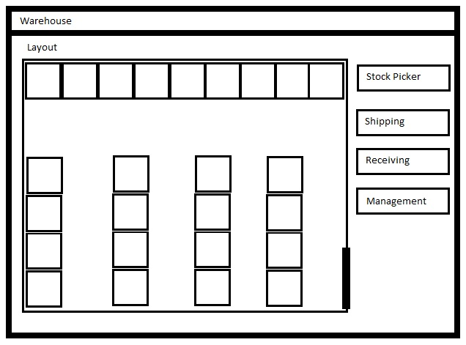
Provides an interactive map of the layout of the warehouse, navigation buttons on the right allow access to each of the individual users functionalities.

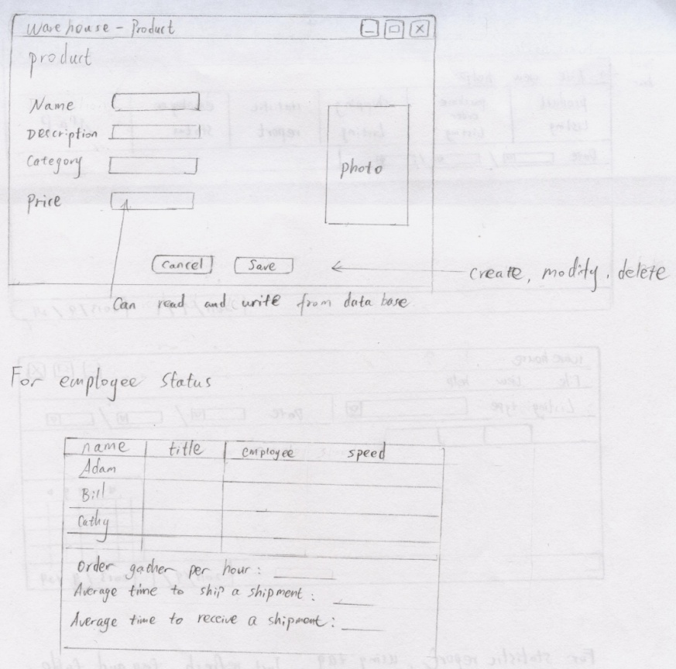
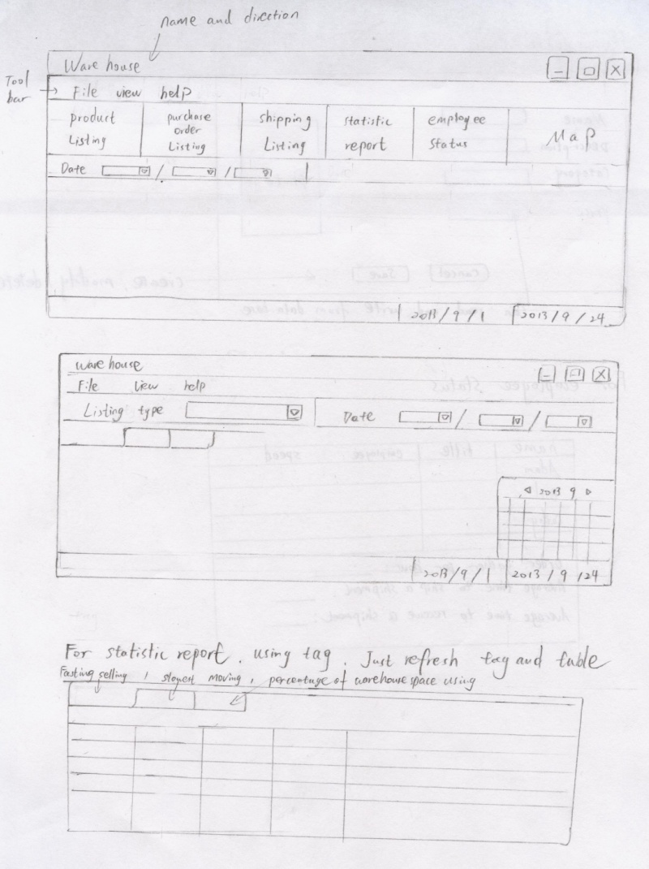
Management System

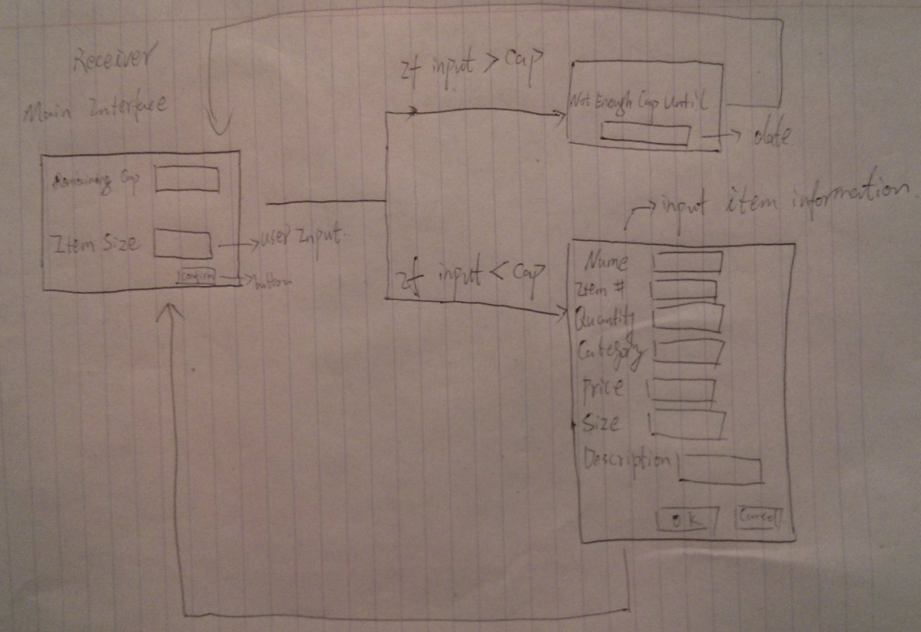
Receiving System
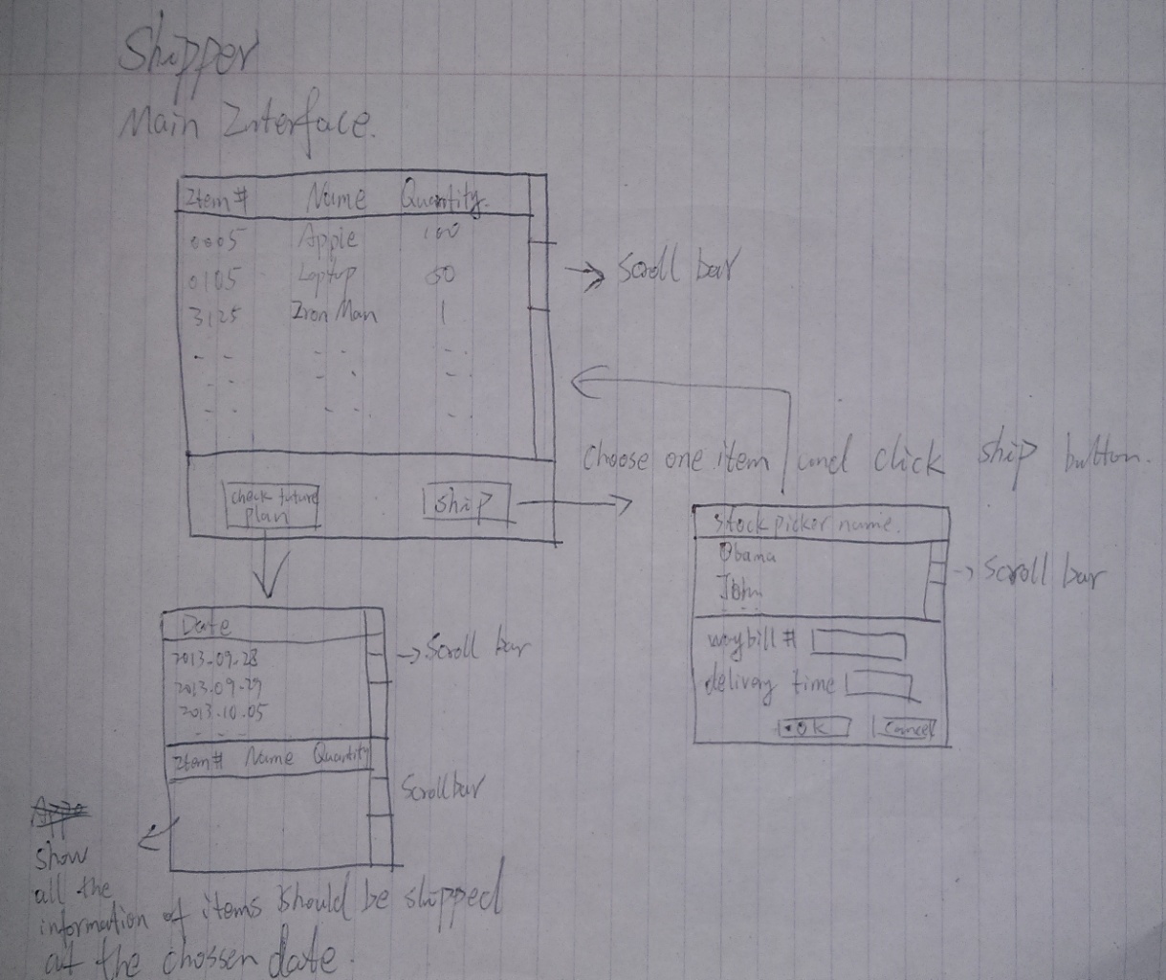
Shipping System

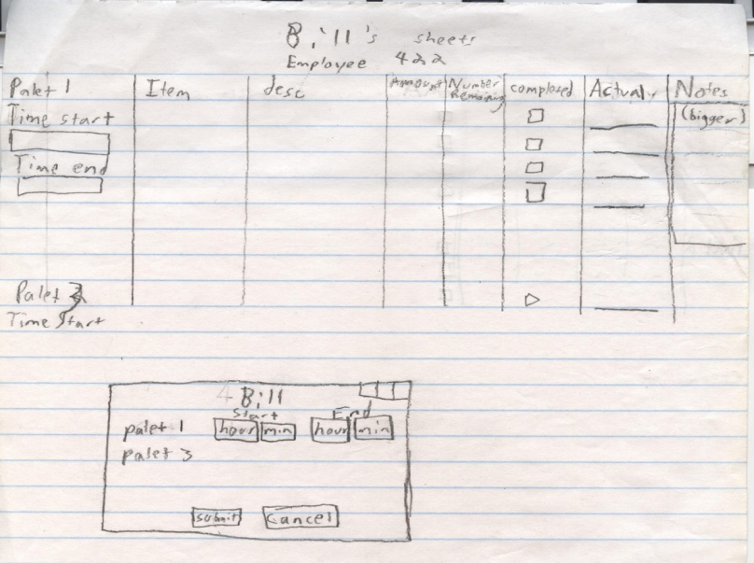
Stock Picker

2. Requirements and Early Design (17 marks)

We have been following RUP and many of the work we have done in the Introduction above is part of the Inception Phase of RUP. This is our time to further work on Inception Phase and in the same time we have to work on the Elaboration Phase. In particular, address the following issues and you are welcome to note any additional things that you have considered (in case). You must use UML drawing tools (of your choice) for the different UML diagrams. Whenever you are using or referring a third party thing, you must cite (see e.g. the References section below) that to your document.

2.1 Summary Use Cases (2 +1 marks)

(a) List the names of all the use cases of the system and provide a two line description for each of them.

(b)
Use Case Name: Statistics Reporting
Level: Summary
Actors: Manager
Goal: Provide a high level view of warehouse operations, to drive efficiency gaining decision making
Activities: Analyze staff efficiency for promotion and layoffs, view turnover speed of specific products to guide purchase order and discount sales decisions, gauge warehouse stock level
Quality: high quality, fast, accurate, and reliable
Version: September 28, 2013

Use Case Name: Stock Reporting
Level: Summary
Actors: Manager
Goal: Provide in depth view of information about warehouse stock
Activities: Monitor stock levels, view stock information for all products currently or previously contained in the warehouse
Quality: high quality, fast, accurate, and reliable
Version: September 28, 2013

Use Case Name: Routing Stocking Tasks
Level: Summary
Actors: Stock Handler
Goal: Increase efficiency of navigating the warehouse for stocking tasks
Activities: Putting away stock that has been received, gathering stock for an upcoming shipment, building pallets correctly
Quality: high quality, accurate, reliable, and effective
Version: September 28, 2013

Use Case Name: Receive Purchase Order
Level: Summary
Actors: Receiver, Stock Handler
Goal: Add new stock items to the system
Activities: Recording information on newly received stock, increasing warehouse stock level to correspond to received shipments, assign Stock Handler to store the product
Quality: high quality, accurate, high ease of use, reliable, flexible
Version: September 28, 2013

Use Case Name: Send Shipments
Level: Summary
Actors: Shipper, Stock Handler
Goal: Send the items ordered for shipment from the warehouse
Activities: Remove stock from the warehouse, track pallet contents, record progress of Stock Handlers in gathering items required for shipment.
Quality: high quality, accurate, high ease of use, reliable, flexible
Version: September 28, 2013

Use Case Name: Locate Stock
Level: Summary
Actors: Stock Handler, Manager, Shipper, Receiver
Goal: Find stock location within the warehouse
Activities: Find the location of the stock within the warehouse using the GUI to click on an overhead map to view the products in each bin, display location on stock reports, search using the main screen of the GUI by item number or name to highlight on the GUI the location of the stock. Display stock location when the shipper creates shipping tasks.
Quality: high quality, very accurate and reliable
Version: October 8, 2013

Use Case Name: Modify Inventory
Level: Summary
Actors: Receiver, Manager, Loss Prevention, Stock Handler
Goal: Add and correct stock information
Activities: Add new item information to the system, which would include name, description, item number, category, price, quantity, and location. Alter the quantity of a stock item, in the case of a lost, damaged, or stolen item. Change the location of the item in the warehouse when it has been moved. Remove an item from the system if it has been discontinued or will no longer be carried by the warehouse.
Quality: high quality, high ease of use, reliable
Version: October 8, 2013

Use Case Name: Order Stock
Level: Summary
Actor: Stock Handler, Manager, 3rd Party Product Suppliers
Goal: Manager orders additional products when stock levels are low
Activities: After viewing the Stock Level Report, the Manager will identify which products they will require more of for future shipments to customers. The Manager will create a new purchase order using the Management & Reporting System. They will then enter the item number and the quantity for the order, the system will then get the item name, size, and weight information and attach it to the purchase order, which will be sent to the 3rd Party Product Suppliers.
Quality: high quality, high ease of use, reliable
Version: October 20, 2013

Use Case Name: Login
Level: Summary
Actor: Stock Handler, Manager, Shipper, Receiver
Goal: Allow users the appropriate level of access to the system
Activities: The GUI will prompt any user wishing to access the system for their username and password. Each user will be assigned their own username and password for the system. The system will only allow users access to the sections for their position. If a user attempts to access a section they are unauthorized for, they will be denied.
Quality: high quality, high ease of use, reliable
Version: October 20, 2013

Use Case Name: Manage Employees
Level: Summary
Actor: Manager
Goal: Provide HR functions to the manager, allow the addition of new employees, removal of old employees, and changing the position of an employee when they are promoted or change roles
Activities: Allows a manager to look up an employee, by name or by ID number. Once the manager has selected the employee, they can remove them from the system, or change their title to a different position. New employees can also be added through a form inputting their name and title.
Quality: high quality, high ease of use, reliable
Version: October 10, 2013

2.2 Fully-dressed Use Cases (1 marks)

Name: Locate Stock
Scope: Stock Handler
Level: Subfunction
Primary Actor: Stock Handler
Stakeholders and Interests:
- Stock Handler, Manager, Shipper, Receiver: Find stock location within the warehouse
Preconditions:
- A Warehouse map has been coded into the GUI that is synonymous with the actual warehouse.
- Locations of stock are accurately recorded in the database.
- The warehouse’s floor plan changes have been recorded in the database.
- The person knows the item ID for the item they are searching for.
- User has been logged in and authenticated by the System
Main Success Scenario:
- From the main screen/map view of the warehouse, user selects the field “Locate Stock”.
- User enters in the item’s product ID and clicks “OK”.
- The bins containing that item within the warehouse are highlighted on the map.
- The user clicks on one of the highlighted bins, showing a detailed listing of the products in that bin, with the item being searched for highlighted.
Extensions:
- The item number they are looking for is incorrect. An error message is displayed to the user.
- Item does not currently have a location. The System sends an error message, notifying the user of this, and attaches all the information about the product currently in the database.
Special Requirements: None.
Technology and Data Variations List:
- User enters the numerical ID for the product
- User attempts to identify the product by name (close matches will be identified)
Frequency of Occurrence:
- New employees: Very often, due to new employees low level of familiarity with the warehouse
- Seasoned employees: Daily. Depending on the person and experience this system is likely to be used between a few times each day to a few times a week.
Miscellaneous:
- The user should also be able to browse item locations in a list format. They might vaguely remember an item and need a piece of information to jog their memory.

Name: Make Shipment
Scope: Shipper, Stock Handler
Level: User Goal
Primary Actor: Shipper
Stakeholders and Interests:
- Shipper: Needs to check the pending shipments, assign tasks to a Stock Handler and a shipping company
- Stock Handler: Requires a well organized list of items to be gathered
- Shipping Company: Wants to know the shipment specifications, such as name, weight, dimensions and destination
- Manager: Wants to know what shipments have been sent
Preconditions: Shipper is logged in and authenticated
Success Guarantee: The shipment task is assigned to a stock handler and a shipping company, the shipping record is saved.
Main Success Scenario:
- Shipper opens the Shipment menu.
- Shipper checks confirms destination, all required items are in the warehouse.
- Shipper selects the “Update Shipment”.
- Shipper inputs the tracking number and estimated delivery date.
- Shipper assigns the shipment to a shipping company for pick-up and delivery.
- Shipper assigns the shipment to a Stock Handler, to gather and transfer the products.
- System saves the shipping record to the database.
- System notifies the Shipper that the shipment was successfully updated and assigned
- Shipper exits the Shipment menu.
Extensions:
- At any time, the Shipper can view the shipment specifications, but does not need to assign the shipment to a shipping company or Stock Handler.
Special Requirements:
Because the database updates concurrently from many different users, the list of shipment specifications needs be refreshed automatically every minute.
Technology and Data Variations List:
- Shipper chooses the requirement, Stock Handler and a shipping company by using a mouse to select from a drop-down menu of valid choices.
- Shipper inputs the tracking number and estimated delivery date by keyboard.
- The form of tracking number is sixteen digits.
- The form of delivery time is YYYY/MM/DD (e.g. 2013/10/25).
- Stock handlers and shipping companies are identified by name.
Frequency of Occurrence: Many times per day, depending on the rate of shipment requests.
Miscellaneous:
- Open Issue: What if the shipment needs to be canceled or changed?
Name: System Login
Scope: Warehouse Management System
Level: User Goal
Primary Actor(s): All Users of the System (Manager, Shipper, Receiver, Stock Handler)
Stakeholders and Interests:
- Manager: Login to update shipment and purchase orders, and monitor the status of the warehouse.
- Shipper: Login to update shipment specifications, assign shipment tasks.
- Receiver: Login to update products, input received purchase orders to the System, assign purchase order tasks.
- Stock Handler: Login to look up product location, receive and print daily tasks.
Preconditions:
- User has the application for the System launched.
- User has their account registered in the System.
- User enters a valid username and password that match the account registration information.
- User has been granted permission to access the system.
Success Guarantee:
- Username and password entered are correct.
- User can now access sections of the System to complete their tasks.
Main Success Scenario:
- User enters a username that matches a record in the database.
- User enters a password that matches the same record in the database.
Extensions:
- Users enter a wrong user name
- Users enter a wrong password
- Users enter a wrong user name and a wrong password
- The database does not record the information of users
- Users do not have valid permission to login the system
Special Requirements: None.
Technology and Date Variations List:
- Touch screen digital keyboard
- Physical keyboard
Frequency of Occurrence:
- Individual terminals: Once per day.
- Shared terminals: Many times per day as users switch to access their own functionality.
Miscellaneous:
- Need to prompt users to enter a new login when they attempt to access unauthorized sections of the system to prevent a full reboot when new functionality is needed
Name: Routing Stocking Tasks
Scope: Stock Handler
Level: Subfunction
Primary Actor: Stock Handler
Stakeholders and Interests:
- Manager: Desires Stock Handlers to be as efficient as possible, that they not attempt any actions that are impossible to complete (not enough space, stock not available for an order).
- Receiver: Have products put away as quickly as possible, ensure that all items are able to be stored in the warehouse.
- Shipper: Have products gathered quickly and efficiently, on a well formed pallet, with all the items required for the order.
- Stock Handler: Handle tasks as quickly and easily as possible, without errors or backtracking on the warehouse floor
Preconditions:
- Stock has been received by the Receiver, is sitting at the warehouse entrance
  - Stock is ready to be placed into bins in the warehouse for storage
- Order has been received by the Shipper
  - All stock required for the order is within the warehouse
Success Guarantee:
- Most efficient route has been located
- Items are ordered by their destination within the warehouse
- Items are ordered by their location within the warehouse for pickup
Main Success Scenario(s):
- Receiver sends the purchase order manifest to this sub-function
- Items in the list are checked for a current location within the warehouse
- Items are assigned a bin to be placed in (with the old stock if it exists, otherwise a closest available location, where it will fit
- Order of the items is returned to another sub-function to create a printable plan for the Stock Handler

- Shipper sends the shipment manifest to this sub-function
- Items in the list are checked to confirm they are in the warehouse, and their current location(s) are recorded
- Route is planned that will take into account the weight of the items being gathered (heaviest first), and the location of the items throughout the warehouse.
- Order of the items is returned to another sub-function to create a printable plan for the Stock Handler
Extensions:
- Unable to store the items in the warehouse due to lack of space, return an error message to notify the user, do not return a list of items
- Unable to locate all the items required for the shipment, return an error message to notify the user, do not return a list of items
Special Requirements: Must not specify that the stock be stored in a bin that it does not fit.
Technology and Data Variations List:
- Input of a list of items to be stored
- Input of a list of items to be retrieved.
- Output is the sorted list of items that were entered, sorted in the order that they should be handled
Frequency of Occurrence:
- Multiple times per day, dependent on number of Stock Handler tasks.
Miscellaneous: None

Use case name: Manage Employees
Scope: Manager
Level: User Goal
Primary Actor: Manager
Stakeholders and Interests:
- Manager: Needs to add and removes employees from the system, record how fast they complete tasks, give employees a promotion or demotion
- Stock Handler, Shipper, Receiver: Report task completion speed.
Preconditions:
- Manager has been logged in and authenticated
Success guarantee:
- Staff information is recorded in the System
- Staff information accurately reflects the Manager’s input
Main Success Scenario:
- Manager accesses the Management menu.
- Manager chooses to view a list of all employees, or searches for a specific employee by ID, name, or title.
- Manager edits the employee’s name, title, or speed information.
- The updated information is stored in the database.
- The Manager is notified that the changes have been saved.
Special Requirement:
- Employee information should be refreshed every minute, in the case that multiple managers are using the system.
Technology and Data Variations List:
- Employee name and speed can be entered with physical keyboard.
- Employee name and speed can be entered with a touch screen.
- Employee title will be selected from a drop down menu.
Frequency of Occurrence:
- Daily to enter employee speed information.
- Every few weeks or months for editing, adding or removing employee information.
Issue: None.

2.3 Use Case Diagram (1 mark)

Draw a Use Case Diagram for your project. You must show the changes that you have made compared to Milestone 4 submission. Show all changes with a different colour or list the new use cases below the diagram. You must use a UML drawing tool of your choice.

2.4 Domain Model (2 marks)

Build a Domain Model for your project. This domain model should be an updated model from your Milestone 4 and you must clearly indicate (e.g., showing with a different colour) of what changes have been made in this domain model compared to the earlier one. For each of the changes note what were the reasons behind the change. Instead of thinking in terms of design objects (e.g., Java class), consider in terms of real-world objects at this stage. Again, you must use a UML drawing tool of your choice.

2.5 Glossary (2 marks)

Forklift – A machine with a “fork” on the front, can be used to lift heavy pallets high into the air

Pallet – A wooden platform for placing products on, commonly used in a warehouse to bundle products for shipment and moving the products using a forklift

Purchase Order – A pallet containing products that have been ordered by the warehouse

Shipment – A pallet that will be sent via truck to its destination

Shipper – An employee who plans and prepares shipments to be sent to the purchaser

Stock – A product or item that can be bought by customers

Stock Handler – An employee, who puts stock items inside the warehouse when they have arrived for storage, and gathers stock items for shipment when they have been purchased

Receiver – An employee who records and tracks all incoming shipments to the warehouse

2.6 Supplementary Specification (2 marks)

Reliability
- Concurrency
  - The data shown to the user must an up to date representation of the database.
- Performance
  - Users should be able to input and receive output data quickly.
  - The time cost of each operation should be less than 5 seconds.

Supportability
- Configurability
  - Any warehouse can utilize our system by only setting up their floor plan and warehouse location information.
  - Robust databases enable our system to support the world’s largest warehouse or a small scale warehouse in the back of a shop.
- Adaptability
  - Due to the modular nature of our classes and the flexibility of Java we are able to easily create new specifications for different clients.
  - The warehouse program is able to work in a multi-tiered environment.
  - Multiple users can update the database at the same time without needing to worry about locks due to a single database updated using atomic actions.

Usability
- Human factors: The user of the warehouse system will be able to use a touchscreen monitor or keyboard and mouse to operate, thus,
  - Font should be clear to view, and the size of the text need be 12 to 14.
  - High contrast between background colours and foreground elements.
  - Consider warehouse system response time, database update speed and handling of the system in the case of a crash.
  - The warehouse system will be compatible with any operating system that can run the Java Virtual Machine.
  - Interactive map and menus are clean, simple, and easy to use.

Interfaces:
- Noteworthy Hardware and Interfaces:
  - Touch screen monitor
  - Mouse
  - Keyboard

- Software Interfaces:
- Graphical user interface
- System-database interface
- Be able to update/modify database through the warehouse system

Legal Issues:
- Utilization of open source components such as the Neo4j database is allowed as it is a academic/non-commercial project
- Some products that may be stored in the warehouse have storage restrictions due to safety (i.e. flammable and explosive products should not be stored near to each other)

2.7 System Sequence Diagrams (3 marks)

Draw four System Sequence Diagrams (SSDs) if you are four in your group (and three if you are three) for the success scenarios of the major (those are fully-dressed above for example) use cases of your project. Follow all the instructions that were discussed in the lecture. Use a UML drawing tool of your choice. Are there any updates from your Milestone 4 submission? Note all the changes below the diagrams.

If your system does not have the scope of the required number of SSDs, you are welcome to break down the big ones into smaller ones. You might also want to clearly mention why you do not have sufficient SSDs in case you cannot break then out.

2.8 Operation Contracts (2 marks)

Operation: checkShipRequire()
Cross References: uses cases: NIL
Preconditions: NIL
Postconditions:
*All shipment requirements are listed in user interface.

Operation: assignTask()
Cross References: uses cases: check Shipment Requirements
Preconditions: At least one Stock Handler is available.
At least one shipping company is available.
Postconditions:
- All shipment requirements are listed in user interface.
- A shipment requirement S is chosen.
- Tracking number is assigned by user input.
- Delivery time is assigned by user input.
- S is distributed to a shipping company
- The gathering task is distributed to a Stock Handler.
- The shipping information is recorded.

Operation: onStartSystem()
Cross References: use cases: NIL
Precondition:
- System hardware works correctly
- User has launched the applications
Postconditions:
- System starts successfully
- System loads all data, loads GUI, and connects to databases.
- System is ready to login.

Operation: verifyUserInfo()
Cross References: use cases: Login
Precondition:
- Users already have been registered with the system
- Users already have the valid username entered
- Users already have the valid password entered
Postconditions:
- Users successfully login into the system if the username and password is correct. Else user is given feedback to ask them to double check their input.
Operation: checkEmployeeStatus()
Cross References: uses cases: NIL
Precondition:
- Employees have been registered in the System.
- Manager is logged onto the system.
Postconditions:
- Full report of all employees, title, ID, and task speed status.

Operation: assignPersonalAdjustment()
Cross Reference: use cases: Manage Employees
Precondition:
- Employees have been registered in the System.
- Manager is logged onto the system.
Postcondition:
- Employee title information has been modified and saved to the database.
- Employees that have quit or been fired are removed from the system.
- Employee task speed has been updated.

Operations: checkBinCapacity(itemBin: binID)
Cross References: use cases: Routing Stocking Tasks
Preconditions:
- itemBin instance b exists
- b exists within the set of bin ID's
Postconditions:
- ItemList instance iL was created
- Item instances i[] were created
- i associated with item instance j from database
- Float instance sum was created
- sum became i[].size

Operations: getItemLocation(item: productID)
Cross References: use cases: Routing Stocking Tasks
Preconditions:
- Item instance i exists
Postconditions:
- Integer instance n was created
- n was associated with Bin ID instance b from database

2.9 Obtaining User Feedback (1 mark)

In the inception and elaboration phases we talked with someone who worked within a warehousing environment. We showed them our materials and presented how we broke up the specific types of employees within a warehouse environment. The discussion sequentially went over functions that we thought would be important to implement. The expert commented on each of the ideas and modified some of them, there were things that the team didn’t think were important however the expert made clear the uses of the system. An instance of this is refining the stock picker to simply receive an order on paper opposed to doing it on a computer. The expert wanted this implemented because he didn’t want to provide a computer to everyone working on the floor. This changed our implementation from purely being on a computer to also utilizing a printer.

3. Updated Design and Unit Testing (14 marks)

At this stage, you were mostly done with the Inception phase and had been working on the Elaboration and Construction phases of RUP. It means that you had been heavily working on improving the design, implementing your system and testing. You should thus provide the following for this stage:

3.1 System Operations (1 mark)

Look at your system sequence diagrams (SSDs) from previous section and list all the system operations of your project. You should name at least four system operations per group member.

1. Check Future Plan
2. Receive Product
3. Order Stock
4. Check Shipment Requirement

3.2 Sequence or Communication Diagrams with GRASP Patterns (2 marks)

Choose two important system operations per group member from the list above and draw sequence diagrams (or communication diagrams) for them (two diagrams per group member). You must consider GRASP patterns when drawing the diagrams and clearly indicate which GRASP pattern has been used for what. You must show the application of at least one GRASP pattern per group member. Write down the rationale of their applications in a separate paragraph below each of the diagrams. Of course, use a UML drawing tool of your choice.

3.3 Class Diagram (3 marks)

Draw a class diagram of your project. This class diagram must reflect your current implementation, i.e., there should have a direct mapping between the design objects and the actual classes in your project. The objects must include the attributes and methods reflecting your implementation. The class diagram will reflect your knowledge of GRASP patterns and the gang of four design patterns. Furthermore, clearly indicate the changes you made from your Milestone 5 submission. Of course, use a UML drawing tool of your choice.

3.4 Unit Testing (8 marks)

Given that you were mostly done with your design and you had been heavily working on implementing the system, you were required to do unit testing for each of the new functionalities you added. Report your experience of applying JUnit [3] in your project. Provide at least a couple of situations of how JUnit was used and whether it was useful for your project. Provide the name of the subject method/class to test, the sample testing data, and the source code of applying JUnit in your project along with any comments you have. Those of you are not using Java, use a corresponding widely used unit testing tool for this part (or ask me if you do not find one). In addition, provide the locations (in terms of full file names and begin-end line numbers) of these testing details in your source code. Yes, provide everything in this document and also provide the location in the source.
4. Reengineering (22 marks + 2 bonus marks)

At this stage your implementation is done (almost at the end of the Construction phase of RUP) and you would like to deliver the product to the customer. However, before you deliver the product, you have to make sure about the professional quality of your product. You thus now plan to improve the design of the project by refactoring and in the same time you would like them to be aware of some of the bad smells (in particular software/code clones) which might not be possible to remove at this stage. You are also interested to apply the gang of four design patterns for improving the design further. You should thus focus on the following issues:

4.1 Code Smells (7 marks + 6 marks) (Also 2 bonus marks for the second part)

There might be many different types of clone smells in your system, and duplicated code fragments (also called software clones or code clones) are the number one bad code bad smell. We thus must be (at least) aware of them. We also have to know what are the root causes of such code clones (e.g., why did you make that particular clone? Was there any way of avoiding that clone?)? We then have to decide whether such clones should be refactored or kept in the system? If we decide to refactor what are the possible risks in refactoring? First, detect the code clones from your project (or your TA will be doing it for you). If you want to detect the clones by yourself, you can use my clone detection tool NiCad [1] or you may use other tools available in the clone detection literature [2]. For example, you might use CCFinder [4] or Simian [5].) Just send an email to me (with your group ID) and I will give you the clones from your project. Once the clones are detected, your job is to guess (yes, just “your intuition”) why you guys have created such clones? If you have a quick look on my technical report [6] (Section 2, pages 3-7), you will find the details of possible root causes of clones. In particular, for each of the clones you might consider the following taxonomy in deciding the possible reasons for their existence. If you believe there are some other reasons, you should also note that. Because you created that clones, you better know why you did so.

Taxonomy of Root Causes of Code Clones (derived from Roy and Cordy’s technical report [6] Section 2, pages 3-7):

- Development Strategy

  - Reuse Approach
    - Simple reuse by copy and paste
    - Forking
    - Design reuse
    - Functionalities /Logic reuse

  - Programming Approach
    - Generative programming
    - Merging similar systems
    - Delay in restructuring

- Maintenance Benefits

  - Avoiding
    - Risk
    - Unwanted design dependencies

  - Ensuring
    - Robustness
    - Better performance in real time programs

  - Reflecting
    - Design decisions (e.g. cross-cutting concerns)

- Overcoming Underlying Limitations

  - Language Limitations
    - Lack of reuse mechanisms
    - Abstraction creates complexity
    - Abstraction is error-prone
    - Significant efforts in making abstractions

  - Programmers' Limitations
    - Time Limitations
    - Performance by LOC
    - Lack of ownership
    - Lack of knowledge in the domain
    - Difficulty in understanding large systems

- Cloning by Accident

  - Language Paradigm
    - Protocols to interact with API and Libraries

  - Programmers' Working Style
    - Programmer’s mental model
    - Unknowingly implementing the same logic by different programmers
The TA or I will provide you the clones where each clone class/pair will have an ID number. For each of the clone pairs/classes, you just need to say what were the possible reasons for that clone pair/class from the taxonomy above. For example, for a clone pair with ID n1, you believe that reusing the logic/functionalities was the primary reason for its existence, and it matches with 1.a(iv) in the above taxonomy, your answer will be as follows:

Clone Pair/  Class ID | Root causes | Further comments (e.g., those causes not covered in the taxonomy above)
n1 | 1.a(iv) | …..

As a part of Section 4.2 below, you will then try to refactor the obvious and easy clones from the system.

However, not all clones are refactorable and thus they should be kept in the system. In such cases, provide the rationale of why these clones are not refactorable (and what are the risks of refactoring). You might also get an idea from the taxonomy above for finding the reasons. In addition to the 6 marks assigned for this part, you might get two more bonus marks here if you do a good job! In particular, you might use a table as follows:

Clone pair/ Class ID | Why Not Refactorable/Risks in refactoring
n2 | Not possible to refactor because c# does not allow procedural abstraction (just an example!)

4.2 Refactoring (5 marks)

We have talked about a significant number of refactorings in the lecture. You must consider all those with respect to your project. Indicate the applications of at least one such refactoring per group member in your code. You first have to say which refactoring, and then say where (full file names and begin-end line numbers of the location) in the source it was applied and then say why it was applied. How did this subject refactoring improve the design of your project? You should also make use of Eclipse [7] in doing these refactoring as discussed in the tutorial. You might get help from a tutorial of University of Manitoba [8]. You may use other IDE if you wish.

4.3 Gang of Four Design Patterns (4 marks)

You must make the best use of the Gang of Four Design patterns that have been discussed in the lecture and in the tutorial. In particular, you must at least use one of the design patterns in your implementation (one per group). If you have done so, write down the location of where the design pattern has been used. You might get help from a tutorial of University of Manitoba [9] (However, I am NOT expecting you to use CodePro as discussed in this document).

5. Complete Implementation and Product Delivery (33 marks)

Your implementation has now been completed, several re-engineering tasks (e.g., refactoring) have now been applied and that the system is now fully tested. You are basically in the Transition phase of RUP. At this stage you must focus on the following issues if not done already in the previous milestones:

5.1 Naming Conventions (1 mark)

5.2 Commenting (1 mark)

If not done already, provide appropriate and useful comments in your code. In particular, for each class, provide comments about it (e.g., who has implemented that class, what it is and what it does). Similarly for each of the methods provide appropriate comments. You should also go to the line level commenting. You might find Chapter 32: Self-Documenting Code of “Code Complete 2” useful or follow the tutorial slides posted in Moodle.

5.3 Pretty-printing of the source (2 marks)

Use Artistic Style [10] and apply pretty-printing to your project. You must show the evidence (e.g., the running command, any problems you have been encountered and so) that you did use this tool.

5.4 Usability Engineering (7 marks)

As we discussed in the lecture, good user interfaces are very important for the success of a project. You must thus consider the issues we talked about the properties of a good user interfaces and attempt to follow all those in your project. You must design your system by balancing the ease of learning and easy of use usability properties. In particular, you must follow the following user interface design guidelines from the lecture:

- Know the user
- Minimize memorization
- Optimize operations
- Engineer for errors
- Avoid modes
- Be consistent

You should have a look on the lecture slides for details about the above points. Provide some examples (at least one example per group member) for each of the points about. For example, you can indicate the names/locations of the Windows where you have considered what design guidelines.

5.5 Complete Implementation (15 marks)

Provide the complete implementation not only for the success scenarios of the major use cases but also for the alternative/failure scenarios. This is your final submission and thus you must have the implementation completed. The marker will closely look at your implementation and will evaluate with respect to several parameters such as the size of the project (not in terms of lines of code but in terms of the number of interesting functionalities addressed), technical challenges considered and tackled, correctness, and the applications of GRASP patterns, refactoring, gang of four design patterns (only those discussed in the lecture and tutorial) and user-interface design guidelines. You must thus try to make the best use of these factors if you want to get good marks for this section. If you want, you can write your experiences in working on some interesting and challenging things (in case you did) that deserve the marker’s attention here. This is the section where the marker and the instructor will try to determine the Excellency level of a project.

(Note that in other sections I have also assigned marks for many of these factors, but I just asked for a minimum requirement. Here, the marker will try to figure out whether you have made the best use of such factors in terms of the implementation).

5.6 User Manual (7 marks)

Your product is now ready for delivering to the customer and thus you must have to have a good user manual for your system. Provide a good (both ease of learning and ease of use) user manual for your system. It should include the details of installing and using your system. You also have to provide sample data (both input and output) for running your system on an overall level (e.g., for all major use cases).

6. Project plan, Budget Justification and Performance Evaluation (REQUIRED + 7 marks)

The project plan should list the tasks that have been completed. For each of the tasks list the names of the individual(s) who worked along with the time they worked on the task. List the tasks that have been mostly done in groups and say the % contributions for each group member (in number of hours). You must use tabular format for proving the details of this section as follows:

(Use NSID/LastName format when you are mentioning a group member)
List of Tasks |  |  | Completed by whom and % Contributions if done in group  (provide in number of hours) | Comments
 | Abstract
1. | Introduction |  | mdt879/Triff – 0.5
2. | Requirements and Early Design
 | 2.1 | Summary Use Cases | xig480/Guo – 20%, 0.5  roh919/Han – 20%, 0.5  xil430/Luo – 20%, 0.5  spo798/Ondrusek – 20%, 0.5  mdt879/Triff – 20%, 0.5 | Everyone split the task, each did 2 use cases
 | 2.2 | Fully-dressed Use Cases | xig480/Guo – 20%, 1  roh919/Han – 20%, 1  xil430/Luo – 20%, 1  spo798/Ondrusek – 20%, 1  mdt879/Triff – 20%, 1 | Everyone split the task, each did 1 use case
 | 2.3 | Use Case Diagram | xig480/Guo – 1
 | 2.4 | Domain Model | xil430/Luo – 2
 | 2.5 | Glossary | mdt879/Triff – 0.75
 | 2.6 | Supplementary Specification | xig480/Guo – 20%, 0.5  roh919/Han – 20%, 0.5  xil430/Luo – 20%, 0.5  spo798/Ondrusek – 20%, 0.5  mdt879/Triff – 20%, 0.5 | Everyone split the task, each did 1 supplementary specification
 | 2.7 | System Sequence Diagrams | xig480/Guo – 20%, 0.5  roh919/Han – 20%, 0.5  xil430/Luo – 20%, 0.5  spo798/Ondrusek – 20%, 0.5  mdt879/Triff – 20%, 0.5 | Everyone split the task, each did 1 SSD
 | 2.8 | Operation Contracts | xig480/Guo – 20%, 0.5  roh919/Han – 20%, 0.5  xil430/Luo – 20%, 0.5  spo798/Ondrusek – 20%, 0.5  mdt879/Triff – 20%, 0.5 | Everyone split the task, each did 2 Operation Contracts
 | 2.9 | Obtaining User Feedback
3. | Updated Design and Unit Testing
 | 3.1 | System Operations
 | 3.2 | Sequence or Communication Diagrams with GRASP Patterns
 | 3.3 | Class Diagram
 | 3.4 | Unit Testing
4. | Reengineering and Mutation Testing
 | 4.1 | Code Smells
 | 4.2 | Refactoring
 | 4.3 | Gang of Four Design Patterns
5. | Complete Implementation and Product Delivery
 | 5.1 | Naming Conventions
 | 5.2 | Commenting
 | 5.3 | Pretty-printing of the source | mdt879/Triff – 0.25
 | 5.4 | Usability Engineering
 | 5.5 | Complete Implementation
 | 5.6 | User Manual | xig480/Guo – 20%, 1  roh919/Han – 20%, 1  xil430/Luo – 20%, 1  spo798/Ondrusek – 20%, 1  mdt879/Triff – 20%, 1 | Everyone split the task, each did the user manual for 1 section
6. | Project plan, Budget Justification and Performance Evaluation |  | xig480/Guo – 20%, 0.5  roh919/Han – 20%, 0.5  xil430/Luo – 20%, 0.5  spo798/Ondrusek – 20%, 0.5  mdt879/Triff – 20%, 0.5
7. | Conclusion
 | Acknowledgements
 | References
Total % Contributions (in hours) of the group members |  |  | NSID1/LastName1:
 |  |  | NSID2/LastName2:
 |  |  | NSID3/LastName3:
 |  |  | NSID4/LastName4:
Total (in hours)

You must also provide another table by showing who has done what (i.e., who was responsible for which task) and how much help was taken from whom for the major tasks of your project as follows. Also list all the tasks (e.g., implementation related) for which your group or you spent a significant amount of time and the ones you would like to draw marker’s attention.

Group Member | Tasks Responsible For | % Contributions if not done alone, and then say who helped and how much | Comments
NSID1/LastName1 | Task1 | Spent 5 hours.  Received 1 hour of help from NSID2/LastName2 in connecting to the database (this is just an example)
NSID1/LastName1 | Task2
NSID1/LastName1 | Task3
NSID1/LastName1 | Task4
Total for LastName1 |  | X hours | Definitely one of the best among the group members
NSID2/LastName2 | Task7 | Spent 4 hours.  Received 0.5 hour of help from NSID1/LastName1 in connecting to the database (this is just an example)
NSID2/LastName2 | Task8
NSID2/LastName2 | Task9
NSID2/LastName2 | Task10
Total for LastName2 |  | Y hours
NSID3/LastName3 | Task11 | Spent 4 hours.  Received 0.5 hour of help from NSID1/LastName1 in connecting to the database (this is just an example)
NSID3/LastName3 | Task12
NSID3/LastName3 | Task13
NSID3/LastName3 | Task14
Total for LastName3 |  | Z hours
NSID4/LastName4 | Task15 | Spent 4 hours.  Received 0.5 hour of help from NSID3/LastName3 in connecting to the database (this is just an example)
NSID4/LastName4 | Task16
NSID4/LastName4 | Task17
NSID4/LastName4 | Task18
Total for LastName4 |  | Y2 hours
Total hours

Compare these actual data with the rough estimate provided in the Introduction and comment on the issues (e.g., whether the initial estimate was okay, over estimated and so on).

List the success or failure experiences that deserve (at least you feel so) the marker’s attention. Note that you might not be successful in all the cases given that you have had limited time and that the primary purpose of this course project is to develop a mid-size project by following all the software development/engineering principles. And thus, even if your implementation is bit weak this is okay. By telling us what you have tried but could not make it because of the challenges involved, you might increase the possibility of getting a higher grade even if you have failed to achieve that particular goal.

Note that there might be significant similarity between the above two tables, especially in terms of the tasks and number of hours spent. However, the purpose of the second table is to give you an opportunity to tell us in details about your contribution to the project, especially those that were challenging and that you did address those. The data provided here should be as accurate as possible and these data might have an effect in your final grade.

7. Conclusion (1 mark)

In this document, we have provided the details of what to submit for the final milestone of the CMPT 370 course project. We also suggested that the students must use the word version of this document as a Template for the submission. In this section, you must say again the executive summary of your project along with a short text for the future work.

Acknowledgements (1 mark)

In case you have taken any help from any third party (i.e., from outside of the group members), you must acknowledge them in this section for their contributions to your project. For example, my acknowledgement for this document is as follows:

The author would like to thank Khalid Billah not only for his hard efforts in conducting the tutorials for this course but also for helping the students in finding code clones from their projects and marking some of the projects. The author also thanks the other markers namely, Saidur Rahman and Farouq Al-Omari for their hard efforts in marking the projects. The author further thanks the guest speakers namely, Gord McCalla, Kevin Schneider, Tom Roberts, Lyle McRae and Nathan Heagy for their excellent talks in this course. Finally, the author greatly appreciates the efforts of the students of this course for their interests in this course and for working so hard for it.

How to submit? (REQUIRED + 0 marks)

  - Make a directory called FinalMilestone_groupName.

  - Make a pdf file for the documentation part, i.e., the completed version of this template in pdf format.

  - Also copy the project source including the databases and other associated materials inside the directory created in (a) above. Make necessary subfolders if you wish.

  - Make a tar/zip of the directory and submit to Moodle. Only one member is required to submit.

You must follow these guidelines for submission, otherwise, a penalty of up to 2 marks will be assigned to your group.

References (1 mark)

You must provide citations for the different things you use or refer to. For example, for this milestone, I have used the following things and I have also provided citations where I have used/referred them:

[1] | The NiCad website: http://www.txl.ca/forum/viewtopic.php?t=662
[2] | The Clone detection literature website: http://students.cis.uab.edu/tairasr/clones/literature/
[3] | The JUnit website: http://www.junit.org/
[4] | The CCFinder website: http://www.ccfinder.net/
[5] | The Simian Website: http://www.redhillconsulting.com.au/products/simian/
[6] | Chanchal Roy and Jim Cordy’s Technical Report: http://research.cs.queensu.ca/TechReports/Reports/2007-541.pdf
[7] | The Eclipse: http://www.eclipse.org/
[8] | Refactoring in Eclipse: http://www.cs.umanitoba.ca/~eclipse/13-Refactoring.pdf
[9] | The Design Patterns and CodePro:  http://www.cs.umanitoba.ca/~eclipse/14-DesignPatterns.pdf
[10] | The Artistic Style webpage: http://astyle.sourceforge.net/

