THE UNIVERSITY OF DODOMA

COLLEGE OF INFORMATICS AND VIRTUAL EDUCATION
DEPARTMENT OF COMPUTER SCIENCE AND ENGINEERING(CSE)
COURSE NAME: ROBOTICS AND AUTOMATION
COURSE CODE: CT 322

GROUP N0 11 MEMBERS
S/NO | STUDENT NAME | REG NUMBER
1 | HENRY DAVID | T23-03-01245
2 | FELECIAN JANUARY | T23-03-18348
3 | LEONARD KINYAMAE | T22-03-10611
4 | EMMANUEL MOSES | T22-03-15852

Table of Contents
- Introduction
- Selected Robot ZIP File
- CAD Assembly Inspection
- Robot Type and Degrees of Freedom
- Link and Joint Identification
- Robot Motion Reference Points
- Basic Robot Motion Description
- MATLAB/Simulink Preparation
- Robot Motion Demonstration
- Workspace Observation
- Practical Applications and Limitations
- Conclusion
- References
- Appendix

1. Introduction
Industrial robots have become an important part of modern manufacturing due to their speed, accuracy, and repeatability. Computer-Aided Design (CAD) models enable engineers to inspect robot structures before manufacturing and allow robot simulations using MATLAB Simulink and Simscape Multibody.
This project analyses an EPSON T3 SCARA robot exported from SolidWorks. The robot structure, links, joints, degrees of freedom, motion characteristics, and workspace are identified and explained.

2. Selected Robot ZIP File
Item | Description
ZIP File | assembly 2009010 epson t3
Assembly File | assembly 2009010 epson t3.SLDASM
Robot Type | SCARA Robot
CAD Software | SolidWorks
Simulation Software | MATLAB Simulink + Simscape Multibody
The uploaded Simscape XML identifies the root assembly as "assembly 2009010 epson t3" and references the SolidWorks assembly file.

Figure 1
Insert your uploaded robot image here.
Caption:
Figure 1: Complete EPSON T3 SCARA Robot Assembly

3. CAD Assembly Inspection
The SolidWorks model contains the major mechanical components required for robot operation.

Main Parts
Part | Function
Base | Supports the robot
Connecting Arm | Connects base to second arm
Arm | Carries end-effector
Shaft | Vertical movement
Stopper | Motion limitation
Cable | Electrical connection
The XML export lists these components as part of the assembly.

4. Robot Type and Degrees of Freedom
The robot is classified as a SCARA (Selective Compliance Assembly Robot Arm).

Characteristics
- Two rotational joints
- One vertical linear movement
- End-effector movement
Estimated Degrees of Freedom
4 DOF
Applications
- Pick and Place
- Packaging
- Assembly
- Electronics Manufacturing

5. Link and Joint Identification
Joint | Connected Parts | Joint Type | Motion
J1 | Base – Link 1 | Revolute | Rotation
J2 | Link 1 – Link 2 | Revolute | Rotation
J3 | Link 2 – Z Axis | Prismatic | Vertical
J4 | Z Axis – End Effector | Revolute | Tool Rotation

Figure 2
Insert labelled robot image showing
- Base
- Link 1
- Link 2
- Z-axis
- End-effector

6. Robot Motion Reference Points
Position | Description
Home | Initial position
Object | Object detected
Pick | Gripper lowered
Place | Destination
End | Robot returns home

7. Basic Robot Motion Description
Step 1
Robot begins at Home Position.
Step 2
Joint 1 rotates toward the object.
Step 3
Joint 2 extends the arm.
Step 4
Z-axis lowers.
Step 5
Gripper picks the object.
Step 6
Robot lifts the object.
Step 7
Robot rotates toward destination.
Step 8
Robot lowers the object.
Step 9
Gripper releases.
Step 10
Robot returns home.

Motion Sequence Table
Time(s) | J1 | J2 | J3 | J4
0.0 | 0° | 0° | Up | Open
0.5 | 20° | 15° | Up | Open
1.0 | 35° | 25° | Down | Close
1.5 | -20° | 30° | Up | Close
2.0 | 0° | 0° | Up | Open

8. MATLAB / Simulink Preparation
The robot was exported from SolidWorks using Simscape Multibody Link.
Simulation preparation included
- Import XML
- Detect robot bodies
- Detect joints
- Connect World Frame
- Test robot movement
The XML indicates it was created using Simscape Multibody Link from SolidWorks.

Figure 3
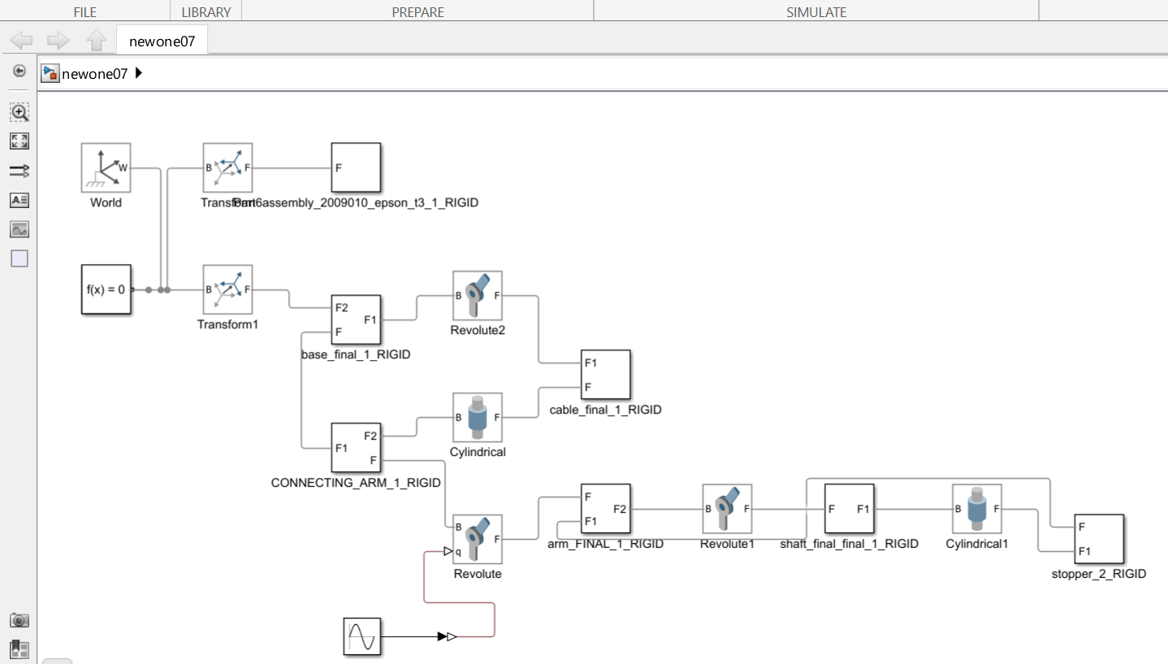

9. Robot Motion Demonstration
Motion Objective
Move object from Home Position to Pick Position and finally Place Position.
Motion Duration
2 Seconds

Figure 4
Insert Motion Sequence Screenshots

10. Workspace Observation
The robot has a semicircular working envelope.
Maximum reach is achieved when both arm links are fully extended.
Limitations include
- Limited vertical travel
- Limited payload
- Fixed installation position

Figure 5
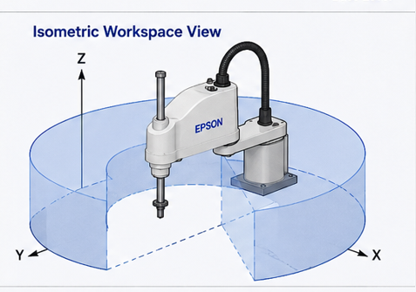

11. Practical Applications
- Electronics assembly
- PCB manufacturing
- Packaging
- Medical laboratories
- Pharmaceutical automation
- CNC loading
- Inspection

Limitations
- Limited payload
- Limited reach
- Fixed workspace
- High maintenance cost
- Requires calibration

12. Conclusion
The EPSON T3 SCARA robot demonstrates excellent performance for high-speed industrial automation tasks. Its SCARA configuration provides fast and accurate planar motion while maintaining good positional accuracy. The CAD model successfully illustrates the robot structure and can be prepared for simulation using MATLAB Simulink and Simscape Multibody.

References
- MATLAB Simscape Multibody Documentation.
- SolidWorks User Guide.
- Robotics: Modelling, Planning and Control.
- Peter Corke, Robotics Toolbox.

Appendix
Include
- XML Export
- SolidWorks Screenshots
- MATLAB Screenshots
- Joint Tables
- Additional Figures

