//////////////////////////////////////////////////////////////////

AFFDATA (modAFFTC.cpp)

Appellé par MAIN et PLSTD

Affecte des données liées aux Criteres

///////////////////////////////////////////
MODECADRE.CPP

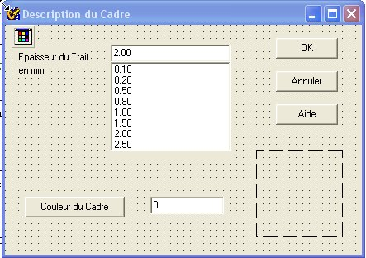

P_ELC[pc]=cbEpaiss->Text;
ff =AnsiToFloat(P_ELC[pc]); ff=ff*COEFMM;
P_ELCF[pc] = (int) ff;
P_CLC[pc]=Edit1->Text;

=========================
Form CHAMPS PROG MODCHAMPS

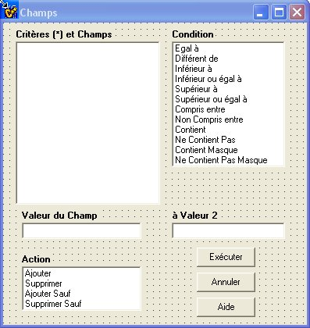
COLONNES / ModColonnes

cnt = asFD->RowCount;
if (cnt==2 && asFCC->Cells[1][2]=="") return;

// les 8 premieres reservées pour les Titre en Lignes
for (i=8;i<MAX_COL;i++) {P_ATTR[pc][i]='Z'; } // rien

P_COL[pc]=8;
for (i=2;i<cnt;i++) // 2 a cause de DEFAUT
{
j=i+7;
P_ATTR[pc][j]='C';
P_FIELD[pc][j]=asFCC->Cells[1][i];
P_FONT[pc][j]= asFCC->Cells[2][i]; // Nom de la fonte dans la colonne
strcpy(tmp,asFCC->Cells[6][i].c_str()); P_HAUT[pc][j]=atoi(tmp); // Hauteur du texte dans la colonne
strcpy(tmp,asFCC->Cells[10][i].c_str()); P_LARG[pc][j]=atoi(tmp); // Largeur du Texte
strcpy(tmp,asFCC->Cells[3][i].c_str()); P_CFCOLOR[pc][j]=atoi(tmp);
strcpy(tmp,asFCC->Cells[7][i].c_str()); P_CBCOLOR[pc][j]=atoi(tmp);
strcpy(tmp,asFCC->Cells[4][i].c_str()); P_ITAL[pc][j]=tmp[0]; if (tmp[0]==0x00) P_ITAL[pc][j]='N';
strcpy(tmp,asFCC->Cells[5][i].c_str()); P_BOLD[pc][j]=tmp[0]; if (tmp[0]==0x00) P_BOLD[pc][j]='N';
strcpy(tmp,asFCC->Cells[8][i].c_str()); P_JV[pc][j]=tmp[0]; if (tmp[0]==0x00) P_JV[pc][j]='H';
strcpy(tmp,asFCC->Cells[9][i].c_str()); P_JC[pc][j]=tmp[0]; if (tmp[0]==0x00) P_JC[pc][j]='C';

T_TITRE_COL[pc][j]=asFD->Cells[1][i];
T_FONT[pc][j]= asFD->Cells[2][i]; // Nom de la fonte dans la colonne
strcpy(tmp,asFD->Cells[6][i].c_str()); T_HAUT[pc][j]=atoi(tmp); // Hauteur du texte dans la colonne
strcpy(tmp,asFD->Cells[10][i].c_str()); T_LARG[pc][j]=atoi(tmp); // Largeur du Texte
strcpy(tmp,asFD->Cells[3][i].c_str()); T_CFCOLOR[pc][j]=atoi(tmp);
strcpy(tmp,asFD->Cells[7][i].c_str()); T_CBCOLOR[pc][j]=atoi(tmp);
strcpy(tmp,asFD->Cells[4][i].c_str()); T_ITAL[pc][j]=tmp[0]; if (tmp[0]==0x00) T_ITAL[pc][j]='N';
strcpy(tmp,asFD->Cells[5][i].c_str()); T_BOLD[pc][j]=tmp[0]; if (tmp[0]==0x00) T_BOLD[pc][j]='N';
strcpy(tmp,asFD->Cells[8][i].c_str()); T_JV[pc][j]=tmp[0]; if (tmp[0]==0x00) T_JV[pc][j]='H';
strcpy(tmp,asFD->Cells[9][i].c_str()); T_JC[pc][j]=tmp[0]; if (tmp[0]==0x00) T_JC[pc][j]='C';
P_COL[pc]++;
}
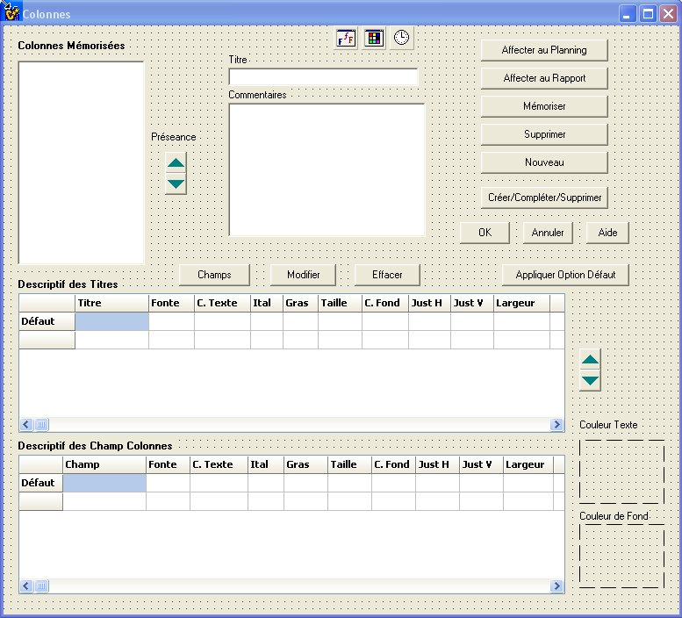

==========================================================

DescEnvelop / ModDescEnvelop

/////////// $$$$$$$$$$$$ a completer

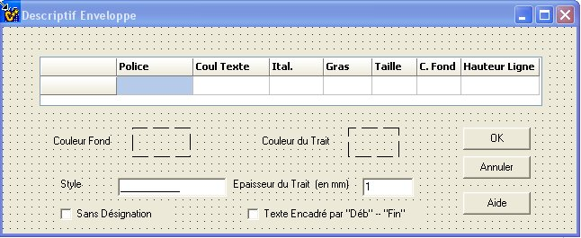

L_ENV_COUL = P_ENV_COUL[pc];
L_ENV_EPAIS = P_ENV_EPAIS[pc];
L_ENV_STYLE = P_ENV_STYLE[pc];

strcpy(tmp,L_ENV_COUL.c_str());
coul = atoi(tmp);
FillColor(coul,Image1);

Edit1->Text=L_ENV_EPAIS;
Edit2->Text = L_ENV_STYLE;

***********************************
Entete // modEntete

CREATE

int ind;
for (ind=0;ind<9;ind++) FillGrid(ind);
Edit1->Text=AnsiString(P_ET_BKG[pc]);
int c=StrToInt(Edit1->Text);
FillColor(c,imBColor);

void __fastcall TEntete::FillData(int ind)
{
TColor Color; int val; char tmp[250];

PACTIF[pc][ind]='O';
P_ORIENT[pc][ind]='L';
PTYPE[pc][ind]='L';

PB[pc][ind] = P_ET_BKG[pc];

PT[pc][ind]= avl->Cells[1][ind+1];
PF[pc][ind]= avl->Cells[2][ind+1];

strcpy(tmp,avl->Cells[3][ind+1].c_str());
if (strlen(tmp)==0) strcpy(tmp,"0");
val= atoi(tmp); PC[pc][ind]=TColor(val);

/*
strcpy(tmp,avl->Cells[7][ind+1].c_str());
if (strlen(tmp)==0) strcpy(tmp,"0");
val= atoi(tmp); PB[pc][ind]=TColor(val);
*/

strcpy(tmp,avl->Cells[4][ind+1].c_str());
if (strlen(tmp)==0) strcpy(tmp,"Standard");
if ((strcmp(tmp,"Standard")==0) || (strlen(tmp)==0)) PN[pc][ind]='N';
else PN[pc][ind]='I';

strcpy(tmp,avl->Cells[5][ind+1].c_str());
if (strlen(tmp)==0) strcpy(tmp,"Standard");
if ((strcmp(tmp,"Standard")==0) || (strlen(tmp)==0)) PX[pc][ind]='N';
else PX[pc][ind]='B';

strcpy(tmp,avl->Cells[7][ind+1].c_str());
if (strlen(tmp)==0) strcpy(tmp,"Centre");
if (strcmp(tmp,"Gauche")==0) PJH[pc][ind]='G';
else if (strcmp(tmp,"Centre")==0) PJH[pc][ind]='C';
else PJH[pc][ind]='D';

strcpy(tmp,avl->Cells[8][ind+1].c_str());
if (strlen(tmp)==0) strcpy(tmp,"Centre");
if (strcmp(tmp,"Haut")==0) PJV[pc][ind]='H';
else if (strcmp(tmp,"Centre")==0) PJV[pc][ind]='C';
else PJV[pc][ind]='B';

strcpy(tmp,avl->Cells[6][ind+1].c_str());
if (strlen(tmp)==0) strcpy(tmp,"24");
val= atoi(tmp); PH[pc][ind]=val;

strcpy(tmp,avl->Cells[9][ind+1].c_str());
if (strlen(tmp)==0) strcpy(tmp,"30");
val= atoi(tmp); PHH[pc][ind]=val;
}

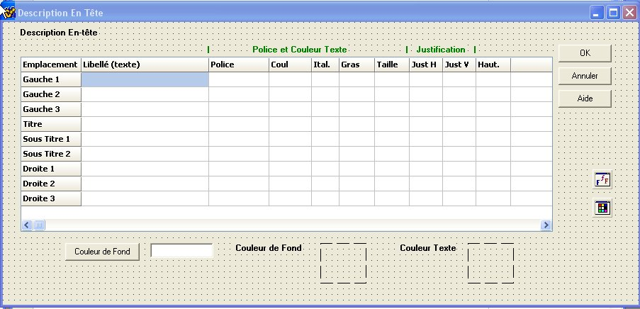

FDCAL // MODDCAL.CPP

void __fastcall TFDcal::Button1Click(TObject *Sender)
{
int val;char tmp[50]; AnsiString s;

// il faut just affecter les variables liees au calendrier
s=avh->Cells[1][1];
if (s=="O") P_ECHH[pc]="O"; else P_ECHH[pc]="N";
P_UNIT1[pc]=avh->Cells[2][1];
P_FORMATCAL1[pc]=avh->Cells[3][1];
P_FREQ1[pc]=avh->Cells[4][1];
PF[pc][9]=avh->Cells[5][1];
strcpy(tmp,avh->Cells[6][1].c_str()); val=atoi(tmp);
PC[pc][9]=TColor(val);
s=avh->Cells[7][1];
if (s=="Italique") PN[pc][9]='I'; else PN[pc][9]='N';
s=avh->Cells[8][1];
if (s=="Gras") PX[pc][9]='B'; else PX[pc][9]='N';
strcpy(tmp,avh->Cells[9][1].c_str()); val=atoi(tmp);
PH[pc][9]=val;
strcpy(tmp,avh->Cells[10][1].c_str()); val=atoi(tmp);
PB[pc][9]=TColor(val);
s=avh->Cells[11][1];
if (s=="Gauche") PJH[pc][9]='G';
if (s=="Centre") PJH[pc][9]='C';
else PJH[pc][9]='D';
s=avh->Cells[12][1];
if (s=="Haut") PJV[pc][9]='G';
if (s=="Centre") PJV[pc][9]='C';
else PJV[pc][9]='B';
strcpy(tmp,avh->Cells[13][1].c_str()); val=atoi(tmp);
PHH[pc][9]=val;
s=avh->Cells[14][1];
if (s=="O") PTYPE[pc][9]='O'; else PTYPE[pc][9]='N';

s=avh->Cells[1][2];
if (s=="O") P_ECHB[pc]="O"; else P_ECHB[pc]="N";
P_UNIT2[pc]=avh->Cells[2][2];
P_FORMATCAL2[pc]=avh->Cells[3][2];
P_FREQ2[pc]=avh->Cells[4][2];
PF[pc][10]=avh->Cells[5][2];
strcpy(tmp,avh->Cells[6][2].c_str()); val=atoi(tmp);
PC[pc][10]=TColor(val);
s=avh->Cells[7][2];
if (s=="Italique") PN[pc][10]='I'; else PN[pc][10]='N';
s=avh->Cells[8][2];
if (s=="Gras") PX[pc][10]='B'; else PX[pc][10]='N';
strcpy(tmp,avh->Cells[9][2].c_str()); val=atoi(tmp);
PH[pc][10]=val;
strcpy(tmp,avh->Cells[10][2].c_str()); val=atoi(tmp);
PB[pc][10]=TColor(val);
s=avh->Cells[11][2];
if (s=="Gauche") PJH[pc][10]='G';
if (s=="Centre") PJH[pc][10]='C';
else PJH[pc][10]='D';
s=avh->Cells[12][2];
if (s=="Haut") PJV[pc][10]='G';
if (s=="Centre") PJV[pc][10]='C';
else PJV[pc][10]='B';
strcpy(tmp,avh->Cells[13][2].c_str()); val=atoi(tmp);
PHH[pc][10]=val;
s=avh->Cells[14][2];
if (s=="O") PTYPE[pc][10]='O'; else PTYPE[pc][10]='N';

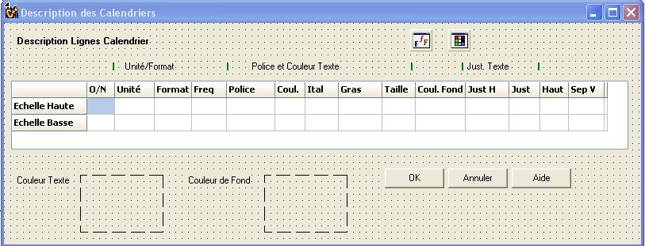

///////////////////////////////////////////
FDCORPS // MODCORPS.CPP

int i;
for (i=0;i<7;i++)
{
P_CYN[pc][i]=avl->Cells[1][i+1];
P_CCFG[pc][i]=avl->Cells[2][i+1];
P_CCST[pc][i]=avl->Cells[3][i+1];
P_CCEP[pc][i]=avl->Cells[4][i+1];
}

P_CJT[pc]=avv->Cells[2][1];
P_CJNT[pc]=avv->Cells[2][2];
P_CWENT[pc]=avv->Cells[2][3];
P_CDH[pc]=avv->Cells[2][4];
P_CDV[pc]=avv->Cells[2][5];

P_CCJT[pc]=avv->Cells[3][1];
P_CCJNT[pc]=avv->Cells[3][2];
P_CCWENT[pc]=avv->Cells[3][3];

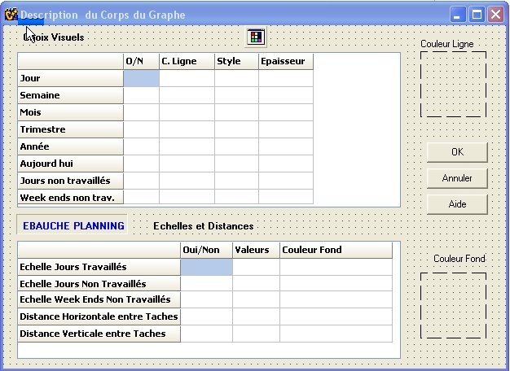

///////////////////////////////////////////////

FDEpaisseur // modEpaisseur

char tmp[200];
ExtractValue(tmp,m_exchange,"ep",0);
cbE->Text=AnsiString(tmp);
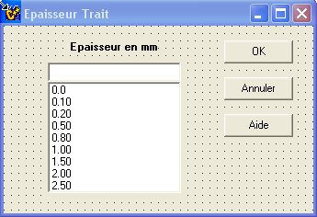

//////////////////////////////////////////////
FDMARGES // modMarges.cpp

P_MV1[pc]=Edit1->Text;
P_MV2[pc]=Edit2->Text;
P_MH1[pc]=Edit3->Text;
P_MH2[pc]=Edit4->Text;

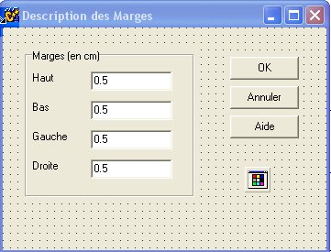

///////////////////////////////////////////////

FDPIED // ModPied

void __fastcall TFDpied::FillData(int ind)
{
TColor Color; int val; char tmp[250];

PACTIF[pc][ind]='O';
P_ORIENT[pc][ind]='L';
PTYPE[pc][ind]='L';

PT[pc][ind]= avl->Cells[1][ind-24];
PF[pc][ind]= avl->Cells[2][ind-24];

PB[pc][ind]= P_PD_BKG[pc];

strcpy(tmp,avl->Cells[3][ind-24].c_str());
if (strlen(tmp)==0) strcpy(tmp,"0");
val= atoi(tmp); PC[pc][ind]=TColor(val);

/*
strcpy(tmp,avl->Cells[7][ind+1].c_str());
if (strlen(tmp)==0) strcpy(tmp,"0");
val= atoi(tmp); PB[pc][ind]=TColor(val);
*/

strcpy(tmp,avl->Cells[4][ind-24].c_str());
if (strlen(tmp)==0) strcpy(tmp,"Standard");
if (strcmp(tmp,"Standard")==0) PN[pc][ind]='N';
else PN[pc][ind]='I';

strcpy(tmp,avl->Cells[5][ind-24].c_str());
if (strlen(tmp)==0) strcpy(tmp,"Standard");
if (strcmp(tmp,"Standard")==0) PX[pc][ind]='N';
else PX[pc][ind]='B';

strcpy(tmp,avl->Cells[7][ind-24].c_str());
if (strlen(tmp)==0) strcpy(tmp,"Centre");
if (strcmp(tmp,"Gauche")==0) PJH[pc][ind]='G';
else if (strcmp(tmp,"Centre")==0) PJH[pc][ind]='C';
else PJH[pc][ind]='D';

strcpy(tmp,avl->Cells[8][ind-24].c_str());
if (strlen(tmp)==0) strcpy(tmp,"Centre");
if (strcmp(tmp,"Haut")==0) PJV[pc][ind]='H';
else if (strcmp(tmp,"Centre")==0) PJV[pc][ind]='C';
else PJV[pc][ind]='B';

strcpy(tmp,avl->Cells[6][ind-24].c_str());
if (strlen(tmp)==0) strcpy(tmp,"12");
val= atoi(tmp); PH[pc][ind]=val;

strcpy(tmp,avl->Cells[9][ind-24].c_str());
if (strlen(tmp)==0) strcpy(tmp,"16");
val= atoi(tmp); PHH[pc][ind]=val;
}

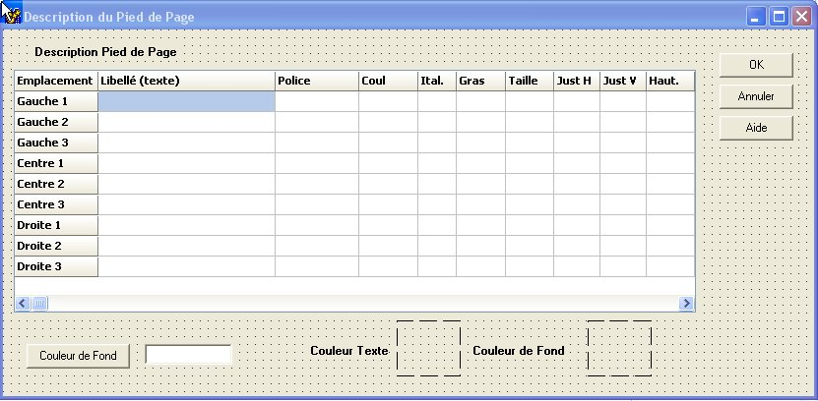

/////////////////////////////////////////////////

FDStyle // modStyle.cpp

strcpy(m_exchange,"<style>");
strcat(m_exchange,cbStyle->Text.c_str());
strcat(m_exchange,"</style>");

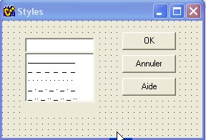

//////////////////////////////////////////////

FDTaches // Modtaches.cpp

void __fastcall TFDtaches::btOKClick(TObject *Sender)
{
int i; char tmp[250];

P_TRAIT[pc][indice]=avv->Cells[1][1];
P_EPTRAIT[pc][indice]=avv->Cells[1][2] ;
P_MARGE[pc][indice]=avv->Cells[1][3];
P_STYLEM[pc][indice]= avv->Cells[1][4];
P_COLMARGE[pc][indice]=avv->Cells[1][5];
P_LIENS[pc][indice] = avv->Cells[1][6];
P_STYLELIEN[pc][indice]= avv->Cells[1][7];
P_COL_LIEN[pc][indice]=avv->Cells[1][8];
P_EPAIS_LIEN[pc][indice]=avv->Cells[1][9];

for (i=0;i<4;i++)
{
P_INF[pc][indice][i]=avt->Cells[1][i+1];
P_INFO[pc][indice][i]=avt->Cells[2][i+1];
P_POLT[pc][indice][i]=avt->Cells[3][i+1];
P_COLTXTF[pc][indice][i]=avt->Cells[4][i+1];
P_ITALT[pc][indice][i]=avt->Cells[5][i+1];
P_BOLDT[pc][indice][i]=avt->Cells[6][i+1];
P_SIZET[pc][indice][i]=avt->Cells[7][i+1];
P_COLTXTB[pc][indice][i]=avt->Cells[8][i+1];
}

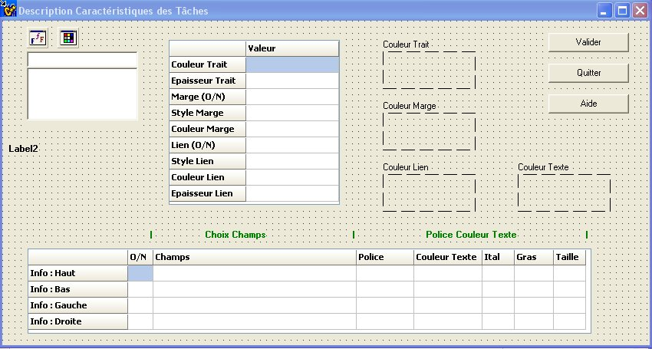
//////////////////////////////////////////////

FDTCOL // modTCol

else
{
avl->Cells[1][1]=PC_POL[pc];
avl->Cells[2][1]=PC_CTEXT[pc];
avl->Cells[3][1]=PC_ITAL[pc];
avl->Cells[4][1]=PC_BOLD[pc];
avl->Cells[5][1]=PC_HAUTEUR[pc];
avl->Cells[6][1]=PC_JSH[pc];
avl->Cells[7][1]=PC_JSV[pc];
avl->Cells[8][1]=PC_CBKG[pc];
avl->Cells[9][1]=PC_LARG[pc];
Edit1->Text=PC_LS1EP[pc];
Edit2->Text=PC_LS1CL[pc];
Edit3->Text=PC_LS2EP[pc];
Edit4->Text=PC_LS2CL[pc];

}
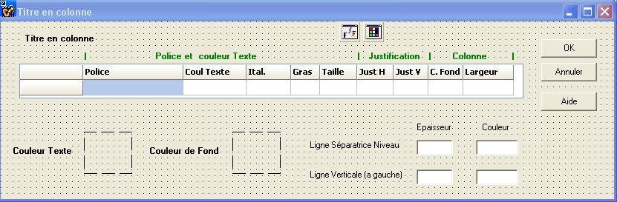

//////////////////////////////////////////////

FDTLigne // ModTLigne.cpp

PL_CTEXT[pc]=avl->Cells[2][1];
PL_ITAL[pc]= avl->Cells[3][1];
PL_BOLD[pc]=avl->Cells[4][1];
PL_HAUTEUR[pc]=avl->Cells[5][1];
PL_JSH[pc]=avl->Cells[6][1];
PL_JSV[pc]=avl->Cells[7][1];
PL_CBKG[pc]=avl->Cells[8][1];
PL_LARG[pc]=avl->Cells[9][1];
PL_LS1EP[pc]=Edit1->Text;
PL_LS1CL[pc]=Edit2->Text;
PL_LS2EP[pc]=Edit3->Text;
PL_LS2CL[pc]=Edit4->Text;

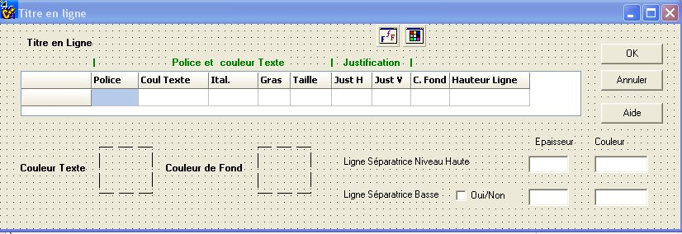

//////////////////////////////////////////////

FDUNITFORM // modUnitForm

int TFDUnitForm::Load_cb(AnsiString Unt)
{

cbForm->Clear();
cbUnit->Text=unite;
cbForm->Text=format;

if (Unt=="Jour")
{
cbForm->Items->Add("Vendredi");
cbForm->Items->Add("Ven");
cbForm->Items->Add("V");
cbForm->Items->Add("31/01/05");
cbForm->Items->Add("31/01");
cbForm->Items->Add("1,2...");
cbForm->Items->Add("Jour 1, Jour 2...");
cbForm->Items->Add("Aucun");
}

if (Unt=="Semaine")
{
cbForm->Items->Add("31 Janvier 05");
cbForm->Items->Add("31 Jan 05");
cbForm->Items->Add("31 Janvier");

cbForm->Items->Add("31 J");
cbForm->Items->Add("31/01/05");
cbForm->Items->Add("31/01");
cbForm->Items->Add("1,2,...52");
cbForm->Items->Add("Semaine 1,Semaine 2,..");
cbForm->Items->Add("Aucun");
}

if (Unt=="Mois")
{
cbForm->Items->Add("Janvier 05");
cbForm->Items->Add("Jan 05");
cbForm->Items->Add("Jan");
cbForm->Items->Add("J 05");
cbForm->Items->Add("J");
cbForm->Items->Add("1,2,3...");
cbForm->Items->Add("1-12,1-12..");
cbForm->Items->Add("1-12,13,...");
cbForm->Items->Add("Mois 1, Mois 2...");
cbForm->Items->Add("Aucun");
}

if (Unt=="Trimestre")
{
cbForm->Items->Add("Tri 1 05");
cbForm->Items->Add("Tri 1");
cbForm->Items->Add("T1 05");
cbForm->Items->Add("1T 05");
cbForm->Items->Add("1,2,3,4");
cbForm->Items->Add("1..4,1..4");
cbForm->Items->Add("Trimestre 1, Trimestre 2,...");
cbForm->Items->Add("Aucun");
}

if (Unt=="Année")
{
cbForm->Items->Add("2005");
cbForm->Items->Add("05");
cbForm->Items->Add("Année 1-Année 2...");
cbForm->Items->Add("Aucun");
}
return 0;
}

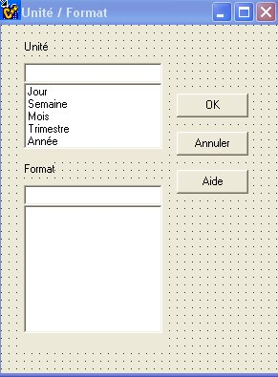

//////////////////////////////////////////////

HAUTEUR / modHauteur.cpp

strcpy(tmp,"<ht>");
strcat(tmp,Edit1->Text.c_str());
strcat(tmp,"</ht>");
strcpy(m_reports,tmp);

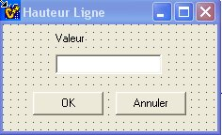

/////////////////////////////////////////////
JUST / modJust

char tmp[100];
strcpy (tmp,"<jh>");
if (RadioButton1->Checked == true) strcat(tmp,"Gauche");
if (RadioButton2->Checked == true) strcat(tmp,"Centre");
if (RadioButton3->Checked == true) strcat(tmp,"Droite");
strcat(tmp,"</jh>");

strcat (tmp,"<jv>");
if (RadioButton4->Checked == true) strcat(tmp,"Haut");
if (RadioButton5->Checked == true) strcat(tmp,"Centre");
if (RadioButton6->Checked == true) strcat(tmp,"Bas");
strcat(tmp,"</jv>");
strcpy(m_exchange,tmp);

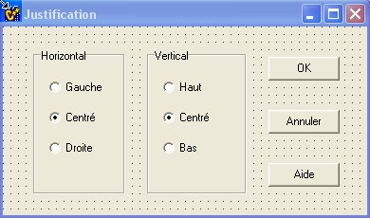

///////////////////////////////////////////////

PREPPLANNING

void __fastcall TPrepPlanning::BufMarges()
{
char tmp[50];

buf_marges[0]=0;
strcat(buf_marges,"<MRG>");
strcat(buf_marges,"<mrg>");
if (P_MARGES[pc]=='O') strcat(buf_marges,"O"); else strcat(buf_marges,"N");
strcat(buf_marges,"</mrg>");

strcat(buf_marges,"<mht>");
strcat(buf_marges,P_MV1[pc].c_str());
strcat(buf_marges,"</mht>");
strcat(buf_marges,"<mba>");
strcat(buf_marges,P_MV2[pc].c_str());
strcat(buf_marges,"</mba>");
strcat(buf_marges,"<mga>");
strcat(buf_marges,P_MH1[pc].c_str());
strcat(buf_marges,"</mga>");
strcat(buf_marges,"<mdr>");
strcat(buf_marges,P_MH2[pc].c_str());
strcat(buf_marges,"</mdr>");
strcat(buf_marges,"</MRG>");
}

void __fastcall TPrepPlanning::Bufferize(char *f,int indx)
{
char tmp[50]; int c;

strcat(f,"<txt>");
strcat(f,PT[pc][indx].c_str());
strcat(f,"</txt>");

strcat(f,"<act>");
strcat(f,PACTIF[pc][indx].c_str());
strcat(f,"</act>");

strcat(f,"<pol>");
strcat(f,PF[pc][indx].c_str());
strcat(f,"</pol>");

strcat(f,"<fgd>");
c=(int) PC[pc][indx]; sprintf(tmp,"%d",c); strcat(f,tmp);
strcat(f,"</fgd>");

strcat(f,"<ita>");
if (PN[pc][indx]=='N') strcat(f,"N"); else strcat(f,"I");
strcat(f,"</ita>");

strcat(f,"<bld>");
if (PX[pc][indx]=='N') strcat(f,"N"); else strcat(f,"B");
strcat(f,"</bld>");

strcat(f,"<siz>");
sprintf(tmp,"%d",PH[pc][indx]); strcat(f,tmp);
strcat(f,"</siz>");

strcat(f,"<bkg>");
c=(int) PB[pc][indx]; sprintf(tmp,"%d",c); strcat(f,tmp);
strcat(f,"</bkg>");

strcat(f,"<jsh>");
if (PJH[pc][indx]=='G') strcat(f,"G");
else if (PJH[pc][indx]=='C') strcat(f,"C");
else strcat(f,"D");
strcat(f,"</jsh>");

strcat(f,"<jsv>");
if (PJV[pc][indx]=='H') strcat(f,"H");
else if (PJV[pc][indx]=='C') strcat(f,"C");
else strcat(f,"B");
strcat(f,"</jsv>");

strcat(f,"<hgt>");
sprintf(tmp,"%d",PHH[pc][indx]); strcat(f,tmp);
strcat(f,"</hgt>");

strcat(f,"<lsp>"); // PTYPE L,C, O/N
tmp[0]=PTYPE[pc][indx];
tmp[1]=0; strcat(f,tmp);
strcat(f,"</lsp>");

}

void __fastcall TPrepPlanning::BufEntete()
{

buf_entete[0]=0;
strcat(buf_entete,"<ETT>");

strcat(buf_entete,"<ett>");
if (P_ENTETE[pc]=='O') strcat(buf_entete,"O</ett>");
else strcat(buf_entete,"N</ett>");

strcat(buf_entete,"<eg1>");
Bufferize(buf_entete,0);
strcat(buf_entete,"</eg1>");

strcat(buf_entete,"<eg2>");
Bufferize(buf_entete,1);
strcat(buf_entete,"</eg2>");

strcat(buf_entete,"<eg3>");
Bufferize(buf_entete,2);
strcat(buf_entete,"</eg3>");

strcat(buf_entete,"<ec1>");
Bufferize(buf_entete,3);
strcat(buf_entete,"</ec1>");

strcat(buf_entete,"<ec2>");
Bufferize(buf_entete,4);
strcat(buf_entete,"</ec2>");

strcat(buf_entete,"<ec3>");
Bufferize(buf_entete,5);
strcat(buf_entete,"</ec3>");

strcat(buf_entete,"<ed1>");
Bufferize(buf_entete,6);
strcat(buf_entete,"</ed1>");

strcat(buf_entete,"<ed2>");
Bufferize(buf_entete,7);
strcat(buf_entete,"</ed2>");

strcat(buf_entete,"<ed3>");
Bufferize(buf_entete,8);
strcat(buf_entete,"</ed3>");

strcat(buf_entete,"</ETT>");

}

void __fastcall TPrepPlanning::BufCal()
{
char tmp[50];

buf_cal[0]=0;
strcat(buf_cal,"<CAL>");

strcat(buf_cal,"<cah>");
if (P_CALHAUT[pc]=='O') strcat(buf_cal,"O"); else strcat(buf_cal,"N");
strcat(buf_cal,"</cah>");

strcat(buf_cal,"<cab>");
if (P_CALBAS[pc]=='O') strcat(buf_cal,"O"); else strcat(buf_cal,"N");
strcat(buf_cal,"</cab>");

strcat(buf_cal,"<cl1>"); // descriptif ligne 1 // unite, form ,freq, et INDEX = 9;
strcat(buf_cal,"<unt>"); // unite
strcat(buf_cal,P_UNIT1[pc].c_str());
strcat(buf_cal,"</unt>");
strcat(buf_cal,"<fmt>"); // format
strcat(buf_cal,P_FORMATCAL1[pc].c_str());
strcat(buf_cal,"</fmt>");
strcat(buf_cal,"<frq>"); // frequence
strcat(buf_cal,P_FREQ1[pc].c_str());
strcat(buf_cal,"</frq>");
// puis les attributs format d'edition classiques
Bufferize(buf_cal,9);

strcat(buf_cal,"</cl1>");

strcat(buf_cal,"<cl2>"); // descriptif ligne 2 // unite, form ,freq, et INDEX = 9;
strcat(buf_cal,"<unt>"); // unite
strcat(buf_cal,P_UNIT2[pc].c_str());
strcat(buf_cal,"</unt>");
strcat(buf_cal,"<fmt>"); // format
strcat(buf_cal,P_FORMATCAL2[pc].c_str());
strcat(buf_cal,"</fmt>");
strcat(buf_cal,"<frq>"); // frequence
strcat(buf_cal,P_FREQ2[pc].c_str());
strcat(buf_cal,"</frq>");
// puis les attributs format d'edition classiques
Bufferize(buf_cal,10);
strcat(buf_cal,"</cl2>");

strcat(buf_cal,"</CAL>");
}

void __fastcall TPrepPlanning::PrepTache(char *f,int indx)
{
int i; char tmp[200];

strcat(buf_taches,"<tt>"); strcat(buf_taches,P_TRAIT[pc][indx].c_str()); strcat(buf_taches,"</tt>");
strcat(buf_taches,"<tet>"); strcat(buf_taches,P_EPTRAIT[pc][indx].c_str()); strcat(buf_taches,"</tet>");
strcat(buf_taches,"<tm>"); strcat(buf_taches,P_MARGE[pc][indx].c_str()); strcat(buf_taches,"</tm>");
strcat(buf_taches,"<ts>"); strcat(buf_taches,P_STYLEM[pc][indx].c_str()); strcat(buf_taches,"</ts>");
strcat(buf_taches,"<tcm>"); strcat(buf_taches,P_COLMARGE[pc][indx].c_str()); strcat(buf_taches,"</tcm>");
strcat(buf_taches,"<tl>"); strcat(buf_taches,P_LIENS[pc][indx].c_str()); strcat(buf_taches,"</tl>");
strcat(buf_taches,"<tsl>"); strcat(buf_taches,P_STYLELIEN[pc][indx].c_str()); strcat(buf_taches,"</tsl>");
strcat(buf_taches,"<tcl>"); strcat(buf_taches,P_COL_LIEN[pc][indx].c_str()); strcat(buf_taches,"</tcl>");
strcat(buf_taches,"<tel>"); strcat(buf_taches,P_EPAIS_LIEN[pc][indx].c_str()); strcat(buf_taches,"</tel>");

for (i=0;i<4;i++)
{
sprintf(tmp,"<ti%d>",i); strcat(buf_taches,tmp);
strcat(buf_taches,"<inf>"); strcat(buf_taches,P_INF[pc][indx][i].c_str()); strcat(buf_taches,"</inf>");
strcat(buf_taches,"<info>"); strcat(buf_taches,P_INFO[pc][indx][i].c_str()); strcat(buf_taches,"</info>");
strcat(buf_taches,"<pol>"); strcat(buf_taches,P_POLT[pc][indx][i].c_str()); strcat(buf_taches,"</pol>");
strcat(buf_taches,"<ctxt>"); strcat(buf_taches,P_COLTXTF[pc][indx][i].c_str()); strcat(buf_taches,"</ctxt>");
strcat(buf_taches,"<ital>"); strcat(buf_taches,P_ITALT[pc][indx][i].c_str()); strcat(buf_taches,"</ital>");
strcat(buf_taches,"<bold>"); strcat(buf_taches,P_BOLDT[pc][indx][i].c_str()); strcat(buf_taches,"</bold>");
strcat(buf_taches,"<siz>"); strcat(buf_taches,P_SIZET[pc][indx][i].c_str()); strcat(buf_taches,"</siz>");
strcat(buf_taches,"<cbkg>"); strcat(buf_taches,P_COLTXTB[pc][indx][i].c_str()); strcat(buf_taches,"</cbkg>");
sprintf(tmp,"</ti%d>",i); strcat(buf_taches,tmp);
}

}

void __fastcall TPrepPlanning::BufTaches()
{

buf_taches[0]=0;
strcat(buf_taches,"<TCH>");
strcat(buf_taches,"<tc0>");
PrepTache(buf_taches,0); // Prev Critique
strcat(buf_taches,"</tc0>");
strcat(buf_taches,"<tc1>");
PrepTache(buf_taches,1); // Prev non crit
strcat(buf_taches,"</tc1>");

strcat(buf_taches,"<tc2>");
PrepTache(buf_taches,2); // reel critique
strcat(buf_taches,"</tc2>");

strcat(buf_taches,"<tc3>");
PrepTache(buf_taches,3); // reel non critique
strcat(buf_taches,"</tc3>");
strcat(buf_taches,"</TCH>");
}

void __fastcall TPrepPlanning::BufCorps()
{
char tmp[250]; int i;
char str[250];

strcpy(buf_corps,"");
strcat(buf_corps,"<COR>");

for (i=0;i<8;i++)
{
sprintf(str,"<c%d>",i);strcat(buf_corps,str);
strcat(buf_corps,"<cyn>"); strcat(buf_corps,P_CYN[pc][i].c_str()); strcat(buf_corps,"</cyn>");
strcat(buf_corps,"<ccfg>"); strcat(buf_corps,P_CCFG[pc][i].c_str()); strcat(buf_corps,"</ccfg>");
//strcat(buf_corps,"<ccbk>"); strcat(buf_corps,P_CCBK[pc][i].c_str()); strcat(buf_corps,"</ccbk>");
strcat(buf_corps,"<ccst>"); strcat(buf_corps,P_CCST[pc][i].c_str()); strcat(buf_corps,"</ccst>");
strcat(buf_corps,"<ccep>"); strcat(buf_corps,P_CCEP[pc][i].c_str()); strcat(buf_corps,"</ccep>");
sprintf(str,"</c%d>",i);strcat(buf_corps,str);
}

strcat(buf_corps,"<cjt>"); strcat(buf_corps,P_CJT[pc].c_str()); strcat(buf_corps,"</cjt>");
strcat(buf_corps,"<cjnt>"); strcat(buf_corps,P_CJNT[pc].c_str()); strcat(buf_corps,"</cjnt>");
strcat(buf_corps,"<cwent>"); strcat(buf_corps,P_CWENT[pc].c_str()); strcat(buf_corps,"</cwent>");
strcat(buf_corps,"<cdh>"); strcat(buf_corps,P_CDH[pc].c_str()); strcat(buf_corps,"</cdh>");
strcat(buf_corps,"<cdv>"); strcat(buf_corps,P_CDV[pc].c_str()); strcat(buf_corps,"</cdv>");

strcat(buf_corps,"<ccjt>"); strcat(buf_corps,P_CCJT[pc].c_str()); strcat(buf_corps,"</ccjt>");
strcat(buf_corps,"<ccjnt>"); strcat(buf_corps,P_CCJNT[pc].c_str()); strcat(buf_corps,"</ccjnt>");
strcat(buf_corps,"<ccwent>"); strcat(buf_corps,P_CCWENT[pc].c_str()); strcat(buf_corps,"</ccwent>");
strcat(buf_corps,"</COR>");

}

void __fastcall TPrepPlanning::BufPied()
{
strcpy(buf_pied,"");
strcat(buf_pied,"<PIE>");

strcat(buf_pied,"<pg1>");
Bufferize(buf_pied,25);
strcat(buf_pied,"</pg1>");

strcat(buf_pied,"<pg2>");
Bufferize(buf_pied,26);
strcat(buf_pied,"</pg2>");

strcat(buf_pied,"<pg3>");
Bufferize(buf_pied,27);
strcat(buf_pied,"</pg3>");

strcat(buf_pied,"<pc1>");
Bufferize(buf_pied,28);
strcat(buf_pied,"</pc1>");

strcat(buf_pied,"<pc2>");
Bufferize(buf_pied,29);
strcat(buf_pied,"</pc2>");

strcat(buf_pied,"<pc3>");
Bufferize(buf_pied,30);
strcat(buf_pied,"</pc3>");

strcat(buf_pied,"<pd1>");
Bufferize(buf_pied,31);
strcat(buf_pied,"</pd1>");

strcat(buf_pied,"<pd2>");
Bufferize(buf_pied,32);
strcat(buf_pied,"</pd2>");

strcat(buf_pied,"<pd3>");
Bufferize(buf_pied,33);
strcat(buf_pied,"</pd3>");

strcat(buf_pied,"</PIE>");

}

void __fastcall TPrepPlanning::BufTligne()
{

char tmp[3000];
strcpy(buf_tligne,"");
strcat(buf_tligne,"<TLIG>");
tmp[0]=0;
strcat(tmp,"<pol>"); strcat(tmp,PL_POL[pc].c_str()); strcat(tmp,"</pol>");
strcat(tmp,"<ct>"); strcat(tmp,PL_CTEXT[pc].c_str()); strcat(tmp,"</ct>");
strcat(tmp,"<it>"); strcat(tmp,PL_ITAL[pc].c_str()); strcat(tmp,"</it>");
strcat(tmp,"<bd>"); strcat(tmp,PL_BOLD[pc].c_str()); strcat(tmp,"</bd>");
strcat(tmp,"<ht>"); strcat(tmp,PL_HAUTEUR[pc].c_str()); strcat(tmp,"</ht>");
strcat(tmp,"<jh>"); strcat(tmp,PL_JSH[pc].c_str()); strcat(tmp,"</jh>");
strcat(tmp,"<jv>"); strcat(tmp,PL_JSV[pc].c_str()); strcat(tmp,"</jv>");
strcat(tmp,"<cb>"); strcat(tmp,PL_CBKG[pc].c_str()); strcat(tmp,"</cb>");
strcat(tmp,"<lg>"); strcat(tmp,PL_LARG[pc].c_str()); strcat(tmp,"</lg>");
strcat(tmp,"<ep1>"); strcat(tmp,PL_LS1EP[pc].c_str()); strcat(tmp,"</ep1>");
strcat(tmp,"<cl1>"); strcat(tmp,PL_LS1CL[pc].c_str()); strcat(tmp,"</cl1>");
strcat(tmp,"<ls2>"); strcat(tmp,PL_LS2[pc].c_str()); strcat(tmp,"</ls2>");
strcat(tmp,"<ep2>"); strcat(tmp,PL_LS2EP[pc].c_str()); strcat(tmp,"</ep2>");
strcat(tmp,"<cl2>"); strcat(tmp,PL_LS2CL[pc].c_str()); strcat(tmp,"</cl2>");

strcat(buf_tligne,tmp);
strcat(buf_tligne,"</TLIG>");

}

void __fastcall TPrepPlanning::BufTcol()
{
char tmp[3000];
strcpy(buf_tcol,"");
strcat(buf_tcol,"<TCOL>");

tmp[0]=0;
strcat(tmp,"<pol>"); strcat(tmp,PC_POL[pc].c_str()); strcat(tmp,"</pol>");
strcat(tmp,"<ct>"); strcat(tmp,PC_CTEXT[pc].c_str()); strcat(tmp,"</ct>");
strcat(tmp,"<it>"); strcat(tmp,PC_ITAL[pc].c_str()); strcat(tmp,"</it>");
strcat(tmp,"<bd>"); strcat(tmp,PC_BOLD[pc].c_str()); strcat(tmp,"</bd>");
strcat(tmp,"<ht>"); strcat(tmp,PC_HAUTEUR[pc].c_str()); strcat(tmp,"</ht>");
strcat(tmp,"<jh>"); strcat(tmp,PC_JSH[pc].c_str()); strcat(tmp,"</jh>");
strcat(tmp,"<jv>"); strcat(tmp,PC_JSV[pc].c_str()); strcat(tmp,"</jv>");
strcat(tmp,"<cb>"); strcat(tmp,PC_CBKG[pc].c_str()); strcat(tmp,"</cb>");
strcat(tmp,"<lg>"); strcat(tmp,PC_LARG[pc].c_str()); strcat(tmp,"</lg>");
strcat(tmp,"<ep1>"); strcat(tmp,PC_LS1EP[pc].c_str()); strcat(tmp,"</ep1>");
strcat(tmp,"<cl1>"); strcat(tmp,PC_LS1CL[pc].c_str()); strcat(tmp,"</cl1>");
strcat(tmp,"<ls2>"); strcat(tmp,PC_LS2[pc].c_str()); strcat(tmp,"</ls2>");
strcat(tmp,"<ep2>"); strcat(tmp,PC_LS2EP[pc].c_str()); strcat(tmp,"</ep2>");
strcat(tmp,"<cl2>"); strcat(tmp,PC_LS2CL[pc].c_str()); strcat(tmp,"</cl2>");

strcat(buf_tcol,tmp);
strcat(buf_tcol,"</TCOL>");

}

void __fastcall TPrepPlanning::BufCadre()
{
char tmp[50]; int c;
float ff;

strcpy(buf_cadre,"");
strcat(buf_cadre,"<CDR>");

strcat(buf_cadre,"<cad>");
if (P_CADRE[pc]=='O') strcat(buf_cadre,"O"); else strcat(buf_cadre,"N");
strcat(buf_cadre,"</cad>");
strcat(buf_cadre,"<cep>");

ff = AnsiToFloat(P_ELC[pc]);
sprintf(tmp,"%f",ff); strcat(buf_cadre,tmp);
strcat(buf_cadre,"</cep>");

// c= (int)P_CLC[pc];
strcat(buf_cadre,"<ccl>");
//sprintf(tmp,"%d",);
strcat(buf_cadre,P_CLC[pc].c_str());
strcat(buf_cadre,"</ccl>");
strcat(buf_cadre,"</CDR>");

}

void __fastcall TPrepPlanning::BufGen()
{
char tmp[250];

strcpy(buf_gen,"<GEN>");
strcpy(tmp,eMemoire->Text.c_str());

strcat(buf_gen,"<nom>"); strcat(buf_gen,tmp); strcat(buf_gen,"</nom>");
strcat(buf_gen,"<com>");
strcat(buf_gen,mPlanning->Lines->GetText());
strcat(buf_gen,"</com>");
strcat(buf_gen,"<fut>");
strcat(buf_gen,P_FILTRE[pc]);
strcat(buf_gen,"</fut>");
strcat(buf_gen,"<tut>");
strcat(buf_gen,P_TRI[pc]);
strcat(buf_gen,"</tut>");
strcat(buf_gen,"<cut>");
strcat(buf_gen,P_COLONNES[pc]);
strcat(buf_gen,"</cut>");
strcat(buf_gen,"<gen>");

strcat(buf_gen,"<envc>");
strcat(buf_gen,P_ENV_COUL[pc].c_str());
strcat(buf_gen,"</envc>");

strcat(buf_gen,"<enve>");
strcat(buf_gen,P_ENV_EPAIS[pc].c_str());
strcat(buf_gen,"</enve>");

strcat(buf_gen,"<envs>");
strcat(buf_gen,P_ENV_STYLE[pc].c_str());
strcat(buf_gen,"</envs>");

if (rb11->Checked==true)strcat(buf_gen,"C"); else strcat(buf_gen,"G");
// if (P_GENRE[pc]=='C') strcat(buf_gen,"C"); else strcat(buf_gen,"G");
strcat(buf_gen,"</gen>");
strcat(buf_gen,"<ggt>");
if(cb2->Checked==true) strcat(buf_gen,"O"); else strcat(buf_gen,"N");
// if (P_GRILLE[pc]=='O') strcat(buf_gen,"O"); else strcat(buf_gen,"N");
strcat(buf_gen,"</ggt>");
strcat(buf_gen,"<tpl>");
if (rb1->Checked==true) strcat(buf_gen,"P"); else strcat(buf_gen,"R");
// if (P_TYPE[pc]=='P') strcat(buf_gen,"P"); else strcat(buf_gen,"R");
strcat(buf_gen,"</tpl>");
strcat(buf_gen,"<lbr>");
if(cb1->Checked==true) strcat(buf_gen,"O"); else strcat(buf_gen,"N");
// if (P_LBRISE[pc]=='O') strcat(buf_gen,"O"); else strcat(buf_gen,"N");
strcat(buf_gen,"</lbr>");

strcat(buf_gen,"<mod>");
//if (rbPortrait->Checked==true)
strcat(buf_gen,"P");
//else strcat(buf_gen,"L");
strcat(buf_gen,"</mod>");

strcat(buf_gen,"<mrg>");
if (cb10->Checked==true) strcat(buf_gen,"O"); else strcat(buf_gen,"N");
strcat(buf_gen,"</mrg>");

strcat(buf_gen,"<cad>");
if (cb3->Checked==true) strcat(buf_gen,"O"); else strcat(buf_gen,"N");
strcat(buf_gen,"</cad>");

strcat(buf_gen,"<ett>");
if (cb4->Checked==true) strcat(buf_gen,"O"); else strcat(buf_gen,"N");
strcat(buf_gen,"</ett>");

strcat(buf_gen,"<cah>");
if (cb5->Checked==true) strcat(buf_gen,"O"); else strcat(buf_gen,"N");
strcat(buf_gen,"</cah>");

strcat(buf_gen,"<cab>");
if (cb6->Checked==true) strcat(buf_gen,"O"); else strcat(buf_gen,"N");
strcat(buf_gen,"</cab>");

strcat(buf_gen,"<pie>");
if (cb7->Checked==true) strcat(buf_gen,"O"); else strcat(buf_gen,"N");
strcat(buf_gen,"</pie>");

strcat(buf_gen,"<pdet>");
sprintf(tmp,"%d",P_DETAIL[pc]);
strcat(buf_gen,tmp);
strcat(buf_gen,"</pdet>");

strcat(buf_gen,"</GEN>");

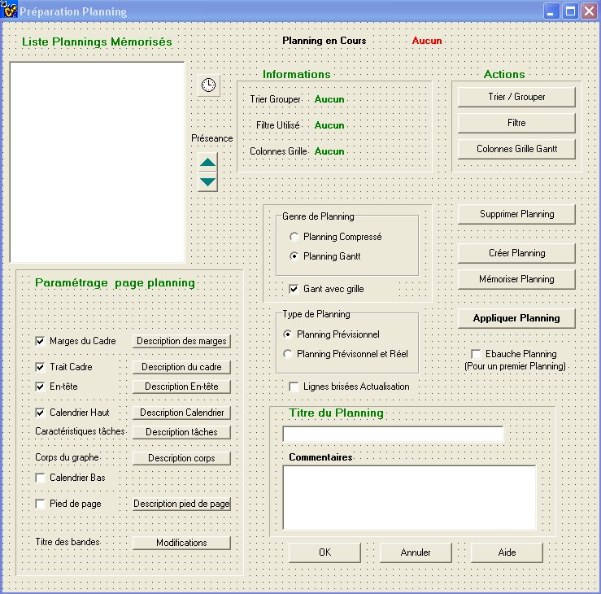
Ghost->ExtractValue(tmp,s,"champs",0);
count = Explode('|',s);
P_COL[pc]=count+1;
if (count)
{
for (i=8; i<=count+8; i++)
{
k=i;
P_TRICOL[pc][i]=0;
P_ATTR[pc][i]='C';

// Colonnes Detail
Ghost->ExtractValue(tmp,params[i-1],"ch",0);
P_FIELD[pc][k] = AnsiString(tmp);
Ghost->ExtractValue(tmp,params[i-1],"ft",0);
P_FONT[pc][k] = AnsiString(tmp);
Ghost->ExtractValue(tmp,params[i-1],"cl",0);
P_CFCOLOR[pc][k] = atoi(tmp);
Ghost->ExtractValue(tmp,params[i-1],"it",0);
P_ITAL[pc][k] = tmp[0];
Ghost->ExtractValue(tmp,params[i-1],"gr",0);
P_BOLD[pc][k] = tmp[0];
Ghost->ExtractValue(tmp,params[i-1],"ta",0);
P_HAUT[pc][k] = atoi(tmp);
Ghost->ExtractValue(tmp,params[i-1],"cf",0);
P_CBCOLOR[pc][k] = atoi(tmp);
Ghost->ExtractValue(tmp,params[i-1],"jh",0);
P_JC[pc][k] = tmp[0];
Ghost->ExtractValue(tmp,params[i-1],"jv",0);
P_JV[pc][k] = tmp[0];
Ghost->ExtractValue(tmp,params[i-1],"ht",0); // largeur
P_LARG[pc][k] = atoi(tmp);

Ghost->ExtractValue(tmp,params[i-1],"tch",0);
T_TITRE_COL[pc][k] = AnsiString(tmp);
Ghost->ExtractValue(tmp,params[i-1],"tft",0);
T_FONT[pc][k] = AnsiString(tmp);
Ghost->ExtractValue(tmp,params[i-1],"tcl",0);
T_CFCOLOR[pc][k] = atoi(tmp);
Ghost->ExtractValue(tmp,params[i-1],"tit",0);
T_ITAL[pc][k] = tmp[0];
Ghost->ExtractValue(tmp,params[i-1],"tgr",0);
T_BOLD[pc][k] = tmp[0];
Ghost->ExtractValue(tmp,params[i-1],"tta",0);
T_HAUT[pc][k] = atoi(tmp);
Ghost->ExtractValue(tmp,params[i-1],"tcf",0);
T_CBCOLOR[pc][k] = atoi(tmp);
Ghost->ExtractValue(tmp,params[i-1],"tjh",0);
T_JC[pc][k] = tmp[0];
Ghost->ExtractValue(tmp,params[i-1],"tjv",0);
T_JV[pc][k] = tmp[0];
Ghost->ExtractValue(tmp,params[i-1],"tht",0); // largeur
T_LARG[pc][k] = atoi(tmp);
}
}

}

void __fastcall TPrepPlanning::LoadMem(char *s,int indx)
{
char tmp[250];
int c;
Ghost->ExtractValue(tmp,s,"txt",0);
PT[pc][indx]=AnsiString(tmp);

Ghost->ExtractValue(tmp,s,"act",0); // Actif O/N
PACTIF[pc][indx]=AnsiString(tmp);

Ghost->ExtractValue(tmp,s,"pol",0);
PF[pc][indx]=AnsiString(tmp);
Ghost->ExtractValue(tmp,s,"fgd",0); c=atoi(tmp);
PC[pc][indx]=TColor(c);
Ghost->ExtractValue(tmp,s,"bkg",0); c=atoi(tmp);
PB[pc][indx]=TColor(c);
Ghost->ExtractValue(tmp,s,"siz",0); c=atoi(tmp);
PH[pc][indx]= c;;
Ghost->ExtractValue(tmp,s,"hgt",0); c=atoi(tmp);
PHH[pc][indx]=c;
Ghost->ExtractValue(tmp,s,"ita",0);
if (strcmp(tmp,"N")==0) PN[pc][indx]='N'; else PN[pc][indx]='I';
Ghost->ExtractValue(tmp,s,"bld",0);
if (strcmp(tmp,"N")==0) PX[pc][indx]='N'; else PX[pc][indx]='B';
Ghost->ExtractValue(tmp,s,"jsh",0);
if (strcmp(tmp,"G")==0) PJH[pc][indx]='G';
else if (strcmp(tmp,"C")==0) PJH[pc][indx]='C';
else PJH[pc][indx]='D';
Ghost->ExtractValue(tmp,s,"jsv",0);
if (strcmp(tmp,"H")==0) PJV[pc][indx]='G';
else if (strcmp(tmp,"C")==0) PJV[pc][indx]='C';
else PJV[pc][indx]='B';

PTYPE[pc][indx]='N';
// PACTIF[pc][indx]='O';
P_ORIENT[pc][indx]='L';

}

void __fastcall TPrepPlanning::LoadGen()
{
char tmp[2500];

Ghost->ExtractValue(tmp,str,"nom",0);
strcpy(P_NOM[pc],tmp);
eMemoire->Text=AnsiString(tmp);
Ghost->ExtractValue(tmp,str,"com",0);
mPlanning->SetTextBuf(tmp);
Ghost->ExtractValue(tmp,str,"fut",0);
strcpy(P_FILTRE[pc],tmp);
Affect_Filtre(P_FILTRE[pc]);
Ghost->ExtractValue(tmp,str,"tut",0);
strcpy(P_TRI[pc],tmp);
Affect_Tri(P_TRI[pc]);
Ghost->ExtractValue(tmp,str,"cut",0);
strcpy(P_COLONNES[pc],tmp);
Affect_Colonnes(P_COLONNES[pc]);

Ghost->ExtractValue(tmp,str,"pdet",0);
P_DETAIL[pc]=atoi(tmp);

Ghost->ExtractValue(tmp,str,"gen",0);
if (strcmp(tmp,"C")==0) { P_GENRE[pc]='C'; rb11->Checked=true;rb12->Checked=false; cb2->Checked=false;}
else { P_GENRE[pc]='G'; rb12->Checked=true; rb11->Checked=false;}
Ghost->ExtractValue(tmp,str,"ggt",0);
if (strcmp(tmp,"O")==0) { P_GRILLE[pc]='O'; cb2->Checked=true; }
else { P_GRILLE[pc]='N'; cb2->Checked=false; }
Ghost->ExtractValue(tmp,str,"tpl",0);
if (strcmp(tmp,"P")==0){ P_TYPE[pc]='P'; rb1->Checked=true; rb2->Checked=false;}
else { P_TYPE[pc]='R'; rb2->Checked = true; rb1->Checked=false; }
Ghost->ExtractValue(tmp,str,"lbr",0);
if (strcmp(tmp,"O")==0) { P_LBRISE[pc]='O'; cb1->Checked = true; }
else { P_LBRISE[pc]='N'; rb1->Checked = false; }
Ghost->ExtractValue(tmp,str,"mod",0);
//if (strcmp(tmp,"P")==0) {
P_MODE[pc]='P'; //rbPortrait->Checked=true; rbPaysage->Checked=false;}
// else { P_MODE[pc]='L'; rbPaysage->Checked=true; rbPortrait->Checked=false; }
Ghost->ExtractValue(tmp,str,"mrg",0);
if (strcmp(tmp,"O")==0) { P_MARGES[pc]='O'; cb10->Checked=true; }
else { P_MARGES[pc]='N'; cb10->Checked=false; }

Ghost->ExtractValue(tmp,str,"cad",0);
if (strcmp(tmp,"O")==0) { P_CADRE[pc]='O'; cb3->Checked=true; }
else { P_CADRE[pc]='N'; cb3->Checked=false; }

Ghost->ExtractValue(tmp,str,"ett",0);
if (strcmp(tmp,"O")==0) { P_ENTETE[pc]='O'; cb4->Checked=true; }
else { P_ENTETE[pc]='N'; cb4->Checked=false; }

Ghost->ExtractValue(tmp,str,"cah",0);
if (strcmp(tmp,"O")==0) { P_CALHAUT[pc]='O'; cb5->Checked=true; }
else { P_CALHAUT[pc]='N'; cb5->Checked=false; }

Ghost->ExtractValue(tmp,str,"cab",0);
if (strcmp(tmp,"O")==0) { P_CALBAS[pc]='O'; cb6->Checked=true; }
else { P_CALBAS[pc]='N'; cb6->Checked=false; }

Ghost->ExtractValue(tmp,str,"pie",0);
if (strcmp(tmp,"O")==0) { P_PIED[pc]='O'; cb7->Checked=true; }
else { P_PIED[pc]='N'; cb7->Checked=false; }
}

void __fastcall TPrepPlanning::LoadMarges()
{
char tmp[200];

Ghost->ExtractValue(tmp,str,"mrg",0);
if (strcmp(tmp,"O")==0) P_MARGES[pc]='O';
else P_MARGES[pc]='N';
Ghost->ExtractValue(tmp,str,"mht",0); P_MV1[pc]= AnsiString(tmp);
Ghost->ExtractValue(tmp,str,"mba",0); P_MV2[pc]= AnsiString(tmp);
Ghost->ExtractValue(tmp,str,"mga",0); P_MH1[pc]= AnsiString(tmp);
Ghost->ExtractValue(tmp,str,"mdr",0); P_MH2[pc]= AnsiString(tmp);
}

void __fastcall TPrepPlanning::LoadCadre()
{

char tmp[200];float ff;
int val;
Ghost->ExtractValue(tmp,str,"cad",0);
if (strcmp(tmp,"O")==0) P_CADRE[pc]='O';
else P_CADRE[pc]='N';

Ghost->ExtractValue(tmp,str,"cep",0);
P_ELC[pc]=AnsiString(tmp);
ff =AnsiToFloat(P_ELC[pc]); ff=ff*COEFMM;
P_ELCF[pc] = (int) ff;

Ghost->ExtractValue(tmp,str,"ccl",0); val=atoi(tmp);
P_CLC[pc]=(TColor)val;

}

float __fastcall TPrepPlanning::AnsiToFloat(AnsiString str)
{
char tmp[200]; char *p;
float f;
strcpy(tmp,str.c_str());

p=strchr(tmp,',');
if (p) *p='.';
f=atof(tmp);
return f;

}

void __fastcall TPrepPlanning::LoadEntete()
{
char tmp[2000];

Ghost->ExtractValue(tmp,str,"ett",0);
if (strcmp(tmp,"O")==0) P_ENTETE[pc]='O';
else P_ENTETE[pc]='N';
Ghost->ExtractValue(tmp,str,"eg1",0);
LoadMem(tmp,0);
Ghost->ExtractValue(tmp,str,"eg2",0);
LoadMem(tmp,1);
Ghost->ExtractValue(tmp,str,"eg3",0);
LoadMem(tmp,2);
Ghost->ExtractValue(tmp,str,"ec1",0);
LoadMem(tmp,3);
Ghost->ExtractValue(tmp,str,"ec2",0);
LoadMem(tmp,4);
Ghost->ExtractValue(tmp,str,"ec3",0);
LoadMem(tmp,5);
Ghost->ExtractValue(tmp,str,"ed1",0);
LoadMem(tmp,6);
Ghost->ExtractValue(tmp,str,"ed2",0);
LoadMem(tmp,7);
Ghost->ExtractValue(tmp,str,"ed3",0);
LoadMem(tmp,8);
}

void __fastcall TPrepPlanning::LoadCalendrier()
{
char s[2000],tmp[250]; int val;

Ghost->ExtractValue(tmp,str,"cah",0);
if (strcmp(tmp,"O")==0) P_CALHAUT[pc]='O'; else P_CALHAUT[pc]='N';
Ghost->ExtractValue(tmp,str,"cab",0);
if (strcmp(tmp,"O")==0) P_CALBAS[pc]='O'; else P_CALBAS[pc]='N';

Ghost->ExtractValue(s,str,"cl1",0);
Ghost->ExtractValue(tmp,s,"unt",0); P_UNIT1[pc]=AnsiString(tmp);
Ghost->ExtractValue(tmp,s,"fmt",0); P_FORMATCAL1[pc]=AnsiString(tmp);
Ghost->ExtractValue(tmp,s,"frq",0); P_FREQ1[pc]=AnsiString(tmp);
LoadMem(s,9);

Ghost->ExtractValue(s,str,"cl2",0);
Ghost->ExtractValue(tmp,s,"unt",0); P_UNIT2[pc]=AnsiString(tmp);
Ghost->ExtractValue(tmp,s,"fmt",0); P_FORMATCAL1[pc]=AnsiString(tmp);
Ghost->ExtractValue(tmp,s,"frq",0); P_FREQ1[pc]=AnsiString(tmp);
LoadMem(s,10);
}

void __fastcall TPrepPlanning::LoadTaches()
{
char tmp[3000];
int i;
Ghost->ExtractValue(tmp,str,"tc0",0);
Ftaches(tmp,0);
Ghost->ExtractValue(tmp,str,"tc1",0);
Ftaches(tmp,1);
Ghost->ExtractValue(tmp,str,"tc2",0);
Ftaches(tmp,2);
Ghost->ExtractValue(tmp,str,"tc3",0);
Ftaches(tmp,3);
}

void __fastcall TPrepPlanning::Ftaches(char *buf,int indice)
{
char tmp[5000]; int i; char tag[50];
char val[5000];

Ghost->ExtractValue(val,buf,"tt",0); P_TRAIT[pc][indice]=AnsiString(val);
Ghost->ExtractValue(val,buf,"tet",0); P_EPTRAIT[pc][indice]=AnsiString(val);
Ghost->ExtractValue(val,buf,"tm",0); P_MARGE[pc][indice]=AnsiString(val);
Ghost->ExtractValue(val,buf,"ts",0); P_STYLEM[pc][indice]=AnsiString(val);
Ghost->ExtractValue(val,buf,"tcm",0); P_COLMARGE[pc][indice]=AnsiString(val);
Ghost->ExtractValue(val,buf,"tl",0); P_LIENS[pc][indice] = AnsiString(val);
Ghost->ExtractValue(val,buf,"tsl",0); P_STYLELIEN[pc][indice]= AnsiString(val);
Ghost->ExtractValue(val,buf,"tcl",0); P_COL_LIEN[pc][indice]=AnsiString(val);
Ghost->ExtractValue(val,buf,"tel",0); P_EPAIS_LIEN[pc][indice]=AnsiString(val);

for (i=0;i<4;i++)
{
sprintf(tag,"ti%d",i);
Ghost->ExtractValue(tmp,buf,tag,0);
Ghost->ExtractValue(val,tmp,"inf",0);P_INF[pc][indice][i]=AnsiString(val);
Ghost->ExtractValue(val,tmp,"info",0);P_INFO[pc][indice][i]=AnsiString(val);
Ghost->ExtractValue(val,tmp,"pol",0);P_POLT[pc][indice][i]=AnsiString(val);
Ghost->ExtractValue(val,tmp,"ctxt",0);P_COLTXTF[pc][indice][i]=AnsiString(val);
Ghost->ExtractValue(val,tmp,"ital",0);P_ITALT[pc][indice][i]=AnsiString(val);
Ghost->ExtractValue(val,tmp,"bold",0);P_BOLDT[pc][indice][i]=AnsiString(val);
Ghost->ExtractValue(val,tmp,"siz",0);P_SIZET[pc][indice][i]=AnsiString(val);
Ghost->ExtractValue(val,tmp,"cbkg",0);P_COLTXTB[pc][indice][i]=AnsiString(val);
}

}

void __fastcall TPrepPlanning::LoadCorps()
{
char tmp[2000]; int i;
char elm[2000];
char tag[20];

for (i=0;i<8;i++)
{
sprintf(tag,"c%d",i);
Ghost->ExtractValue(tmp,str,tag,0);

Ghost->ExtractValue(elm,tmp,"cyn",0);P_CYN[pc][i]=AnsiString(elm);
Ghost->ExtractValue(elm,tmp,"ccfg",0);P_CCFG[pc][i]=AnsiString(elm);
//Ghost->ExtractValue(elm,tmp,"ccbk",0);P_CCBK[pc][i]=AnsiString(elm);
Ghost->ExtractValue(elm,tmp,"ccst",0);P_CCST[pc][i]=AnsiString(elm);
Ghost->ExtractValue(elm,tmp,"ccep",0);P_CCEP[pc][i]=AnsiString(elm);
}

Ghost->ExtractValue(elm,str,"cjt",0);P_CJT[pc]=AnsiString(elm);
Ghost->ExtractValue(elm,str,"cjnt",0);P_CJNT[pc]=AnsiString(elm);
Ghost->ExtractValue(elm,str,"cwent",0);P_CWENT[pc]=AnsiString(elm);
Ghost->ExtractValue(elm,str,"cdh",0);P_CDH[pc]=AnsiString(elm);
Ghost->ExtractValue(elm,str,"cdv",0);P_CDV[pc]=AnsiString(elm);

Ghost->ExtractValue(elm,str,"ccjt",0);P_CCJT[pc]=AnsiString(elm);
Ghost->ExtractValue(elm,str,"ccjnt",0);P_CCJNT[pc]=AnsiString(elm);
Ghost->ExtractValue(elm,str,"ccwent",0);P_CCWENT[pc]=AnsiString(elm);

}

void __fastcall TPrepPlanning::LoadPied()
{
char tmp[2000];

Ghost->ExtractValue(tmp,str,"pg1",0);
LoadMem(tmp,25);
Ghost->ExtractValue(tmp,str,"pg2",0);
LoadMem(tmp,26);
Ghost->ExtractValue(tmp,str,"pg3",0);
LoadMem(tmp,27);
Ghost->ExtractValue(tmp,str,"pc1",0);
LoadMem(tmp,28);
Ghost->ExtractValue(tmp,str,"pc2",0);
LoadMem(tmp,29);
Ghost->ExtractValue(tmp,str,"pc3",0);
LoadMem(tmp,30);
Ghost->ExtractValue(tmp,str,"pd1",0);
LoadMem(tmp,31);
Ghost->ExtractValue(tmp,str,"pd2",0);
LoadMem(tmp,32);
Ghost->ExtractValue(tmp,str,"pd3",0);
LoadMem(tmp,33);

}

void __fastcall TPrepPlanning::LoadTLigne()
{
char tmp[250];
Ghost->ExtractValue(tmp,str,"pol",0); PL_POL[pc]=AnsiString(tmp);
Ghost->ExtractValue(tmp,str,"ct",0); PL_CTEXT[pc]=AnsiString(tmp);
Ghost->ExtractValue(tmp,str,"it",0); PL_ITAL[pc]=AnsiString(tmp);
Ghost->ExtractValue(tmp,str,"bd",0); PL_BOLD[pc]=AnsiString(tmp);
Ghost->ExtractValue(tmp,str,"ht",0); PL_HAUTEUR[pc]=AnsiString(tmp);
Ghost->ExtractValue(tmp,str,"jh",0); PL_JSH[pc]=AnsiString(tmp);
Ghost->ExtractValue(tmp,str,"jv",0); PL_JSV[pc]=AnsiString(tmp);
Ghost->ExtractValue(tmp,str,"cb",0); PL_CBKG[pc]=AnsiString(tmp);
Ghost->ExtractValue(tmp,str,"lg",0); PL_LARG[pc]=AnsiString(tmp);
Ghost->ExtractValue(tmp,str,"ep1",0); PL_LS1EP[pc]=AnsiString(tmp);
Ghost->ExtractValue(tmp,str,"cl1",0); PL_LS1CL[pc]=AnsiString(tmp);
Ghost->ExtractValue(tmp,str,"ls2",0); PL_LS2[pc]=AnsiString(tmp);
Ghost->ExtractValue(tmp,str,"ep2",0); PL_LS2EP[pc]=AnsiString(tmp);
Ghost->ExtractValue(tmp,str,"cl2",0); PL_LS2CL[pc]=AnsiString(tmp);

}

void __fastcall TPrepPlanning::LoadTCol()
{
char tmp[250];
Ghost->ExtractValue(tmp,str,"pol",0); PC_POL[pc]=AnsiString(tmp);
Ghost->ExtractValue(tmp,str,"ct",0); PC_CTEXT[pc]=AnsiString(tmp);
Ghost->ExtractValue(tmp,str,"it",0); PC_ITAL[pc]=AnsiString(tmp);
Ghost->ExtractValue(tmp,str,"bd",0); PC_BOLD[pc]=AnsiString(tmp);
Ghost->ExtractValue(tmp,str,"ht",0); PC_HAUTEUR[pc]=AnsiString(tmp);
Ghost->ExtractValue(tmp,str,"jh",0); PC_JSH[pc]=AnsiString(tmp);
Ghost->ExtractValue(tmp,str,"jv",0); PC_JSV[pc]=AnsiString(tmp);
Ghost->ExtractValue(tmp,str,"cb",0); PC_CBKG[pc]=AnsiString(tmp);
Ghost->ExtractValue(tmp,str,"lg",0); PC_LARG[pc]=AnsiString(tmp);
Ghost->ExtractValue(tmp,str,"ep1",0); PC_LS1EP[pc]=AnsiString(tmp);
Ghost->ExtractValue(tmp,str,"cl1",0); PC_LS1CL[pc]=AnsiString(tmp);
Ghost->ExtractValue(tmp,str,"ls2",0); PC_LS2[pc]=AnsiString(tmp);
Ghost->ExtractValue(tmp,str,"ep2",0); PC_LS2EP[pc]=AnsiString(tmp);
Ghost->ExtractValue(tmp,str,"cl2",0); PC_LS2CL[pc]=AnsiString(tmp);

}

void __fastcall TPrepPlanning::Envoi_Params(int ligcol)
{
strcpy(m_exchange,"");
if (ligcol==0) // ligne
{
strcat(m_exchange,"<pol>");strcat(m_exchange,PL_POL[pc].c_str()); strcat(m_exchange,"</pol>");
strcat(m_exchange,"<ct>");strcat(m_exchange,PL_CTEXT[pc].c_str()); strcat(m_exchange,"</ct>");
strcat(m_exchange,"<it>");strcat(m_exchange,PL_ITAL[pc].c_str()); strcat(m_exchange,"</it>");
strcat(m_exchange,"<bd>");strcat(m_exchange,PL_BOLD[pc].c_str()); strcat(m_exchange,"</bd>");
strcat(m_exchange,"<ht>");strcat(m_exchange,PL_HAUTEUR[pc].c_str()); strcat(m_exchange,"</ht>");
strcat(m_exchange,"<jh>");strcat(m_exchange,PL_JSH[pc].c_str()); strcat(m_exchange,"</jh>");
strcat(m_exchange,"<jv>");strcat(m_exchange,PL_JSV[pc].c_str()); strcat(m_exchange,"</jv>");
strcat(m_exchange,"<cb>");strcat(m_exchange,PL_CBKG[pc].c_str()); strcat(m_exchange,"</cb>");
strcat(m_exchange,"<lg>");strcat(m_exchange,PL_LARG[pc].c_str()); strcat(m_exchange,"</lg>");
strcat(m_exchange,"<ep1>");strcat(m_exchange,PL_LS1EP[pc].c_str()); strcat(m_exchange,"</ep1>");
strcat(m_exchange,"<cl1>");strcat(m_exchange,PL_LS1CL[pc].c_str()); strcat(m_exchange,"</cl1>");
strcat(m_exchange,"<ls2>");strcat(m_exchange,PL_LS2[pc].c_str()); strcat(m_exchange,"</ls2>");
strcat(m_exchange,"<ep2>");strcat(m_exchange,PL_LS2EP[pc].c_str()); strcat(m_exchange,"</ep2>");
strcat(m_exchange,"<cl2>");strcat(m_exchange,PL_LS2CL[pc].c_str()); strcat(m_exchange,"</cl2>");
}
else // colonne
{
strcat(m_exchange,"<pol>");strcat(m_exchange,PC_POL[pc].c_str()); strcat(m_exchange,"</pol>");
strcat(m_exchange,"<ct>");strcat(m_exchange,PC_CTEXT[pc].c_str()); strcat(m_exchange,"</ct>");
strcat(m_exchange,"<it>");strcat(m_exchange,PC_ITAL[pc].c_str()); strcat(m_exchange,"</it>");
strcat(m_exchange,"<bd>");strcat(m_exchange,PC_BOLD[pc].c_str()); strcat(m_exchange,"</bd>");
strcat(m_exchange,"<ht>");strcat(m_exchange,PC_HAUTEUR[pc].c_str()); strcat(m_exchange,"</ht>");
strcat(m_exchange,"<jh>");strcat(m_exchange,PC_JSH[pc].c_str()); strcat(m_exchange,"</jh>");
strcat(m_exchange,"<jv>");strcat(m_exchange,PC_JSV[pc].c_str()); strcat(m_exchange,"</jv>");
strcat(m_exchange,"<cb>");strcat(m_exchange,PC_CBKG[pc].c_str()); strcat(m_exchange,"</cb>");
strcat(m_exchange,"<lg>");strcat(m_exchange,PC_LARG[pc].c_str()); strcat(m_exchange,"</lg>");
strcat(m_exchange,"<ep1>");strcat(m_exchange,PC_LS1EP[pc].c_str()); strcat(m_exchange,"</ep1>");
strcat(m_exchange,"<cl1>");strcat(m_exchange,PC_LS1CL[pc].c_str()); strcat(m_exchange,"</cl1>");
strcat(m_exchange,"<ls2>");strcat(m_exchange,PC_LS2[pc].c_str()); strcat(m_exchange,"</ls2>");
strcat(m_exchange,"<ep2>");strcat(m_exchange,PC_LS2EP[pc].c_str()); strcat(m_exchange,"</ep2>");
strcat(m_exchange,"<cl2>");strcat(m_exchange,PC_LS2CL[pc].c_str()); strcat(m_exchange,"</cl2>");

}
}

void __fastcall TPrepPlanning::Recupere_Params(int ligcol)
{
char tmp[250];
if (ligcol==0) // ligne
{
Ghost->ExtractValue(tmp,m_exchange,"pol",0); PL_POL[pc]=AnsiString(tmp);
Ghost->ExtractValue(tmp,m_exchange,"ct",0); PL_CTEXT[pc]=AnsiString(tmp);
Ghost->ExtractValue(tmp,m_exchange,"it",0); PL_ITAL[pc]=AnsiString(tmp);
Ghost->ExtractValue(tmp,m_exchange,"bd",0); PL_BOLD[pc]=AnsiString(tmp);
Ghost->ExtractValue(tmp,m_exchange,"ht",0); PL_HAUTEUR[pc]=AnsiString(tmp);
Ghost->ExtractValue(tmp,m_exchange,"jh",0); PL_JSH[pc]=AnsiString(tmp);
Ghost->ExtractValue(tmp,m_exchange,"jv",0); PL_JSV[pc]=AnsiString(tmp);
Ghost->ExtractValue(tmp,m_exchange,"cb",0); PL_CBKG[pc]=AnsiString(tmp);
Ghost->ExtractValue(tmp,m_exchange,"lg",0); PL_LARG[pc]=AnsiString(tmp);
Ghost->ExtractValue(tmp,m_exchange,"ep1",0); PL_LS1EP[pc]=AnsiString(tmp);
Ghost->ExtractValue(tmp,m_exchange,"cl1",0); PL_LS1CL[pc]=AnsiString(tmp);
Ghost->ExtractValue(tmp,m_exchange,"ls2",0); PL_LS2[pc]=AnsiString(tmp);
Ghost->ExtractValue(tmp,m_exchange,"ep2",0); PL_LS2EP[pc]=AnsiString(tmp);
Ghost->ExtractValue(tmp,m_exchange,"cl2",0); PL_LS2CL[pc]=AnsiString(tmp);
}
else // colonnes
{
Ghost->ExtractValue(tmp,m_exchange,"pol",0); PC_POL[pc]=AnsiString(tmp);
Ghost->ExtractValue(tmp,m_exchange,"ct",0); PC_CTEXT[pc]=AnsiString(tmp);
Ghost->ExtractValue(tmp,m_exchange,"it",0); PC_ITAL[pc]=AnsiString(tmp);
Ghost->ExtractValue(tmp,m_exchange,"bd",0); PC_BOLD[pc]=AnsiString(tmp);
Ghost->ExtractValue(tmp,m_exchange,"ht",0); PC_HAUTEUR[pc]=AnsiString(tmp);
Ghost->ExtractValue(tmp,m_exchange,"jh",0); PC_JSH[pc]=AnsiString(tmp);
Ghost->ExtractValue(tmp,m_exchange,"jv",0); PC_JSV[pc]=AnsiString(tmp);
Ghost->ExtractValue(tmp,m_exchange,"cb",0); PC_CBKG[pc]=AnsiString(tmp);
Ghost->ExtractValue(tmp,m_exchange,"lg",0); PC_LARG[pc]=AnsiString(tmp);
Ghost->ExtractValue(tmp,m_exchange,"ep1",0); PC_LS1EP[pc]=AnsiString(tmp);
Ghost->ExtractValue(tmp,m_exchange,"cl1",0); PC_LS1CL[pc]=AnsiString(tmp);
Ghost->ExtractValue(tmp,m_exchange,"ls2",0); PC_LS2[pc]=AnsiString(tmp);
Ghost->ExtractValue(tmp,m_exchange,"ep2",0); PC_LS2EP[pc]=AnsiString(tmp);
Ghost->ExtractValue(tmp,m_exchange,"cl2",0); PC_LS2CL[pc]=AnsiString(tmp);

}

}

void __fastcall TPrepPlanning::btAppliquerClick(TObject *Sender)
{

char tmp[250];
sprintf(tmp,"<pl>%d</pl><tri>%s</tri><col>%s</col><filt>%s</filt><exec>Y</exec>",pc,
P_TRI[pc],P_COLONNES[pc],P_FILTRE[pc]);
strcpy(m_planning,tmp);
strcpy(P_NOM[pc],eMemoire->Text.c_str()); // current_planning);
Save_Preseance();
Close();
}

void __fastcall TPrepPlanning::Maj_Decor()
{
Label5->Caption = AnsiString(P_FILTRE[pc]);
Label3->Caption = AnsiString(P_TRI[pc]);
Label7->Caption = AnsiString(P_COLONNES[pc]);

Label23->Caption = AnsiString(P_NOM[pc]); //current_planning);
eMemoire->Text = AnsiString(P_NOM[pc]); //current_planning);

//if ( P_MODE[pc]=='P') { rbPortrait->Checked=true; rbPaysage->Checked=false;}
// else { rbPaysage->Checked=true; rbPortrait->Checked=false; }
if (P_GENRE[pc]=='C') { rb11->Checked=true;rb12->Checked=false; cb2->Checked=false;}
if (P_GENRE[pc]=='G') { rb12->Checked=true; rb11->Checked=false; }

if (P_GRILLE[pc]=='O') cb2->Checked=true; else cb2->Checked=false;

if (P_TYPE[pc]=='P') { rb1->Checked=true;rb2->Checked=false; }
else { rb2->Checked=true; rb1->Checked=false; }

if (P_LBRISE[pc]=='O') cb1->Checked=true; else cb1->Checked=false;
if (P_MARGES[pc]=='O') cb10->Checked=true; else cb10->Checked=false;

if (P_CADRE[pc]=='O') cb3->Checked=true; else cb3->Checked=false;
if (P_ENTETE[pc]=='O') cb4->Checked=true; else cb4->Checked=false;
if (P_CALHAUT[pc]=='O') cb5->Checked=true; else cb5->Checked=false;
if (P_CALBAS[pc]=='O') cb6->Checked=true; else cb6->Checked=false;
if (P_PIED[pc]=='O') cb7->Checked=true; else cb7->Checked=false;
}

///////////////////////////////////////////////

PREPRAPPORT // ModPrepRapport

void __fastcall TPrepRapport::Bufferize(char *f,int indx)
{
char tmp[50]; int c;

strcat(f,"<txt>");
strcat(f,PT[pc][indx].c_str());
strcat(f,"</txt>");

strcat(f,"<act>");
strcat(f,PACTIF[pc][indx].c_str());
strcat(f,"</act>");

strcat(f,"<pol>");
strcat(f,PF[pc][indx].c_str());
strcat(f,"</pol>");

strcat(f,"<fgd>");
c=(int) PC[pc][indx]; sprintf(tmp,"%d",c); strcat(f,tmp);
strcat(f,"</fgd>");

strcat(f,"<ita>");
if (PN[pc][indx]=='N') strcat(f,"N"); else strcat(f,"I");
strcat(f,"</ita>");

strcat(f,"<bld>");
if (PX[pc][indx]=='N') strcat(f,"N"); else strcat(f,"B");
strcat(f,"</bld>");

strcat(f,"<siz>");
sprintf(tmp,"%d",PH[pc][indx]); strcat(f,tmp);
strcat(f,"</siz>");

strcat(f,"<bkg>");
c=(int) PB[pc][indx]; sprintf(tmp,"%d",c); strcat(f,tmp);
strcat(f,"</bkg>");

strcat(f,"<jsh>");
if (PJH[pc][indx]=='G') strcat(f,"G");
else if (PJH[pc][indx]=='C') strcat(f,"C");
else strcat(f,"D");
strcat(f,"</jsh>");

strcat(f,"<jsv>");
if (PJV[pc][indx]=='H') strcat(f,"H");
else if (PJV[pc][indx]=='C') strcat(f,"C");
else strcat(f,"B");
strcat(f,"</jsv>");

strcat(f,"<hgt>");
sprintf(tmp,"%d",PHH[pc][indx]); strcat(f,tmp);
strcat(f,"</hgt>");

strcat(f,"<lsp>"); // PTYPE L,C, O/N
tmp[0]=PTYPE[pc][indx];
tmp[1]=0; strcat(f,tmp);
strcat(f,"</lsp>");

}

void __fastcall TPrepRapport::BufMarges()
{
char tmp[50];

buf_marges[0]=0;
strcat(buf_marges,"<MRG>");
strcat(buf_marges,"<mrg>");
if (P_MARGES[pc]=='O') strcat(buf_marges,"O"); else strcat(buf_marges,"N");
strcat(buf_marges,"</mrg>");

strcat(buf_marges,"<mht>");
strcat(buf_marges,P_MV1[pc].c_str());
strcat(buf_marges,"</mht>");
strcat(buf_marges,"<mba>");
strcat(buf_marges,P_MV2[pc].c_str());
strcat(buf_marges,"</mba>");
strcat(buf_marges,"<mga>");
strcat(buf_marges,P_MH1[pc].c_str());
strcat(buf_marges,"</mga>");
strcat(buf_marges,"<mdr>");
strcat(buf_marges,P_MH2[pc].c_str());
strcat(buf_marges,"</mdr>");
strcat(buf_marges,"</MRG>");
}

void __fastcall TPrepRapport::BufTligne()
{

char tmp[3000];
strcpy(buf_tligne,"");
strcat(buf_tligne,"<TLIG>");
tmp[0]=0;
strcat(tmp,"<pol>"); strcat(tmp,PL_POL[pc].c_str()); strcat(tmp,"</pol>");
strcat(tmp,"<ct>"); strcat(tmp,PL_CTEXT[pc].c_str()); strcat(tmp,"</ct>");
strcat(tmp,"<it>"); strcat(tmp,PL_ITAL[pc].c_str()); strcat(tmp,"</it>");
strcat(tmp,"<bd>"); strcat(tmp,PL_BOLD[pc].c_str()); strcat(tmp,"</bd>");
strcat(tmp,"<ht>"); strcat(tmp,PL_HAUTEUR[pc].c_str()); strcat(tmp,"</ht>");
strcat(tmp,"<jh>"); strcat(tmp,PL_JSH[pc].c_str()); strcat(tmp,"</jh>");
strcat(tmp,"<jv>"); strcat(tmp,PL_JSV[pc].c_str()); strcat(tmp,"</jv>");
strcat(tmp,"<cb>"); strcat(tmp,PL_CBKG[pc].c_str()); strcat(tmp,"</cb>");
strcat(tmp,"<lg>"); strcat(tmp,PL_LARG[pc].c_str()); strcat(tmp,"</lg>");
strcat(tmp,"<ep1>"); strcat(tmp,PL_LS1EP[pc].c_str()); strcat(tmp,"</ep1>");
strcat(tmp,"<cl1>"); strcat(tmp,PL_LS1CL[pc].c_str()); strcat(tmp,"</cl1>");
strcat(tmp,"<ls2>"); strcat(tmp,PL_LS2[pc].c_str()); strcat(tmp,"</ls2>");
strcat(tmp,"<ep2>"); strcat(tmp,PL_LS2EP[pc].c_str()); strcat(tmp,"</ep2>");
strcat(tmp,"<cl2>"); strcat(tmp,PL_LS2CL[pc].c_str()); strcat(tmp,"</cl2>");

strcat(buf_tligne,tmp);
strcat(buf_tligne,"</TLIG>");

}

void __fastcall TPrepRapport::BufTcol()
{
char tmp[3000];
strcpy(buf_tcol,"");
strcat(buf_tcol,"<TCOL>");

tmp[0]=0;
strcat(tmp,"<pol>"); strcat(tmp,PC_POL[pc].c_str()); strcat(tmp,"</pol>");
strcat(tmp,"<ct>"); strcat(tmp,PC_CTEXT[pc].c_str()); strcat(tmp,"</ct>");
strcat(tmp,"<it>"); strcat(tmp,PC_ITAL[pc].c_str()); strcat(tmp,"</it>");
strcat(tmp,"<bd>"); strcat(tmp,PC_BOLD[pc].c_str()); strcat(tmp,"</bd>");
strcat(tmp,"<ht>"); strcat(tmp,PC_HAUTEUR[pc].c_str()); strcat(tmp,"</ht>");
strcat(tmp,"<jh>"); strcat(tmp,PC_JSH[pc].c_str()); strcat(tmp,"</jh>");
strcat(tmp,"<jv>"); strcat(tmp,PC_JSV[pc].c_str()); strcat(tmp,"</jv>");
strcat(tmp,"<cb>"); strcat(tmp,PC_CBKG[pc].c_str()); strcat(tmp,"</cb>");
strcat(tmp,"<lg>"); strcat(tmp,PC_LARG[pc].c_str()); strcat(tmp,"</lg>");
strcat(tmp,"<ep1>"); strcat(tmp,PC_LS1EP[pc].c_str()); strcat(tmp,"</ep1>");
strcat(tmp,"<cl1>"); strcat(tmp,PC_LS1CL[pc].c_str()); strcat(tmp,"</cl1>");
strcat(tmp,"<ls2>"); strcat(tmp,PC_LS2[pc].c_str()); strcat(tmp,"</ls2>");
strcat(tmp,"<ep2>"); strcat(tmp,PC_LS2EP[pc].c_str()); strcat(tmp,"</ep2>");
strcat(tmp,"<cl2>"); strcat(tmp,PC_LS2CL[pc].c_str()); strcat(tmp,"</cl2>");

strcat(buf_tcol,tmp);
strcat(buf_tcol,"</TCOL>");

}

void __fastcall TPrepRapport::BufGen()
{
char tmp[250];

strcpy(buf_gen,"<GEN>");
strcpy(tmp,eMemoire->Text.c_str());

strcat(buf_gen,"<nom>"); strcat(buf_gen,tmp); strcat(buf_gen,"</nom>");
strcat(buf_gen,"<com>");
strcat(buf_gen,mRapport->Lines->GetText());
strcat(buf_gen,"</com>");
strcat(buf_gen,"<fut>");
strcat(buf_gen,P_FILTRE[pc]);
strcat(buf_gen,"</fut>");
strcat(buf_gen,"<tut>");
strcat(buf_gen,P_TRI[pc]);
strcat(buf_gen,"</tut>");
strcat(buf_gen,"<cut>");
strcat(buf_gen,P_COLONNES[pc]);
strcat(buf_gen,"</cut>");
strcat(buf_gen,"<gen>");

// if (rb11->Checked==true)strcat(buf_gen,"C"); else strcat(buf_gen,"G");
// if (P_GENRE[pc]=='C') strcat(buf_gen,"C"); else strcat(buf_gen,"G");
strcat(buf_gen,"</gen>");

strcat(buf_gen,"<mrg>");
if (cbMarge->Checked==true) strcat(buf_gen,"O"); else strcat(buf_gen,"N");
strcat(buf_gen,"</mrg>");

/*
strcat(buf_gen,"<ggt>");
if(cb2->Checked==true) strcat(buf_gen,"O"); else strcat(buf_gen,"N");
// if (P_GRILLE[pc]=='O') strcat(buf_gen,"O"); else strcat(buf_gen,"N");
strcat(buf_gen,"</ggt>");
strcat(buf_gen,"<tpl>");
if (rb1->Checked==true) strcat(buf_gen,"P"); else strcat(buf_gen,"R");
// if (P_TYPE[pc]=='P') strcat(buf_gen,"P"); else strcat(buf_gen,"R");
strcat(buf_gen,"</tpl>");
strcat(buf_gen,"<lbr>");
if(cb1->Checked==true) strcat(buf_gen,"O"); else strcat(buf_gen,"N");
// if (P_LBRISE[pc]=='O') strcat(buf_gen,"O"); else strcat(buf_gen,"N");
strcat(buf_gen,"</lbr>");

strcat(buf_gen,"<mod>");
if (rbPortrait->Checked==true) strcat(buf_gen,"P"); else strcat(buf_gen,"L");
strcat(buf_gen,"</mod>");
*/
strcat(buf_gen,"<mrg>");
if (cbMarge->Checked==true) strcat(buf_gen,"O"); else strcat(buf_gen,"N");
strcat(buf_gen,"</mrg>");

strcat(buf_gen,"<cad>");
if (cb3->Checked==true) strcat(buf_gen,"O"); else strcat(buf_gen,"N");
strcat(buf_gen,"</cad>");

strcat(buf_gen,"<ett>");
if (cb4->Checked==true) strcat(buf_gen,"O"); else strcat(buf_gen,"N");
strcat(buf_gen,"</ett>");
/*
strcat(buf_gen,"<cah>");
if (cb5->Checked==true) strcat(buf_gen,"O"); else strcat(buf_gen,"N");
strcat(buf_gen,"</cah>");

strcat(buf_gen,"<cab>");
if (cb6->Checked==true) strcat(buf_gen,"O"); else strcat(buf_gen,"N");
strcat(buf_gen,"</cab>");
*/
strcat(buf_gen,"<pie>");
if (cb7->Checked==true) strcat(buf_gen,"O"); else strcat(buf_gen,"N");
strcat(buf_gen,"</pie>");

strcat(buf_gen,"</GEN>");

}

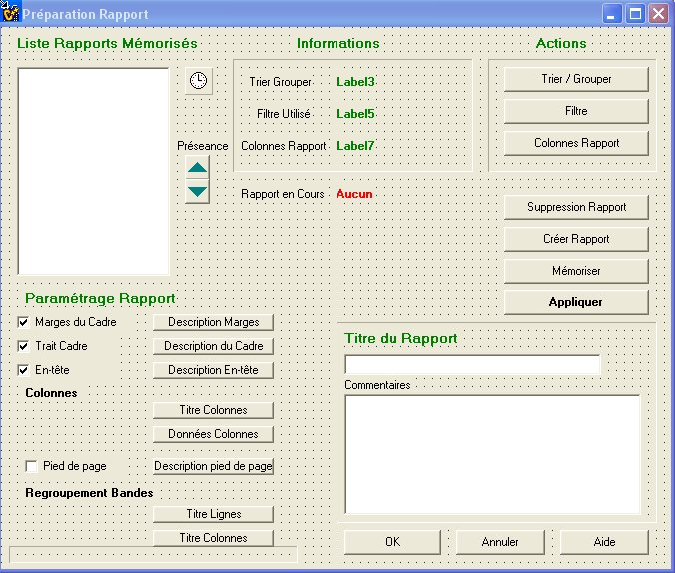

///////////////////////////////////////////////
TRI // MODTRI

int __fastcall TTri::SaveData()
{
//
char name[100];
char Key[100],RetKey[100];
int rc,recdata,i,nbitems;
char tmp[5000];
char filename[250];

strcpy(Key,eMemoire->Text.c_str());
if (strlen(Key) == 0)
{
Application->MessageBoxA("Pas de Nom de Tri",m_ecoplan,MB_OK);
return 0;
}

strcpy(filename,m_directory); strcat(filename,"\\eco_tri");
rc = tri->OpenEngine(filename,248,"ndx","dat"); //256 - 8
rc = tri->SetIndexMode(0,0);

// preparer buffer
strcpy(buffer,"<l>"); strcat(buffer,Key); strcat(buffer,"</l>");
strcat(buffer,"<des>");
strcat(buffer,mTri->Lines->GetText());
strcat(buffer,"</des>");
strcat(buffer,"<detail>");
if (cb1->Checked==true) strcat(buffer,"O"); else strcat(buffer,"N");
strcat(buffer,"</detail>");

strcat(buffer,"<champs>");
nbitems=asFC->RowCount-1; // lbDetail->Items->Count;
if (nbitems>8) nbitems=8;
for (i=1;i<=nbitems;i++)
{
strcpy(tmp,"<CH>"); strcat(tmp,asFC->Cells[1][i].c_str()); strcat(tmp,"</CH>");
strcat(tmp,"<N0>"); strcat(tmp,asFC->Cells[3][i].c_str()); strcat(tmp,"</N0>");
strcat(tmp,"<N1>"); strcat(tmp,asFC->Cells[4][i].c_str()); strcat(tmp,"</N1>");
strcat(tmp,"<N2>"); strcat(tmp,asFC->Cells[5][i].c_str()); strcat(tmp,"</N2>");
strcat(tmp,"<N3>"); strcat(tmp,asFC->Cells[6][i].c_str()); strcat(tmp,"</N3>");
strcat(tmp,"<DT>"); strcat(tmp,asFC->Cells[8][i].c_str()); strcat(tmp,"</DT>");
strcat(tmp,"<TR>"); strcat(tmp,asFC->Cells[12][i].c_str()); strcat(tmp,"</TR>");
strcat(tmp,"<BL>"); strcat(tmp,asFC->Cells[13][i].c_str()); strcat(tmp,"</BL>");
///////////////////////////////////
// les 3 descriptions Titre Ligne, Col et detail ??

if (asFC->Cells[10][i]=="X") T_LLCC[pc][i]="L";
if (asFC->Cells[11][i]=="X") T_LLCC[pc][i]="C";
if (asFC->Cells[12][i]=="X") T_LLCC[pc][i]="T";
if (asFC->Cells[13][i]=="X") T_LLCC[pc][i]="B";

strcat(tmp,"<lc>"); strcat(tmp,T_LLCC[pc][i].c_str()); strcat(tmp,"</lc>");
strcat(tmp,"<pol>"); strcat(tmp,T_POL[pc][i].c_str()); strcat(tmp,"</pol>");
strcat(tmp,"<ct>"); strcat(tmp,T_CTEXT[pc][i].c_str()); strcat(tmp,"</ct>");
strcat(tmp,"<it>"); strcat(tmp,T_TITAL[pc][i].c_str()); strcat(tmp,"</it>");
strcat(tmp,"<bd>"); strcat(tmp,T_TBOLD[pc][i].c_str()); strcat(tmp,"</bd>");
strcat(tmp,"<ht>"); strcat(tmp,T_HAUTEUR[pc][i].c_str()); strcat(tmp,"</ht>");
strcat(tmp,"<jh>"); strcat(tmp,T_JSH[pc][i].c_str()); strcat(tmp,"</jh>");
strcat(tmp,"<jv>"); strcat(tmp,T_JSV[pc][i].c_str()); strcat(tmp,"</jv>");
strcat(tmp,"<cb>"); strcat(tmp,T_CBKG[pc][i].c_str()); strcat(tmp,"</cb>");
strcat(tmp,"<lg>"); strcat(tmp,T_TLARG[pc][i].c_str()); strcat(tmp,"</lg>");
strcat(tmp,"<ep1>"); strcat(tmp,T_LS1EP[pc][i].c_str()); strcat(tmp,"</ep1>");
strcat(tmp,"<cl1>"); strcat(tmp,T_LS1CL[pc][i].c_str()); strcat(tmp,"</cl1>");
strcat(tmp,"<ls2>"); strcat(tmp,T_LS2[pc][i].c_str()); strcat(tmp,"</ls2>");
strcat(tmp,"<ep2>"); strcat(tmp,T_LS2EP[pc][i].c_str()); strcat(tmp,"</ep2>");
strcat(tmp,"<cl2>"); strcat(tmp,T_LS2EP[pc][i].c_str()); strcat(tmp,"</cl2>");

strcat(buffer,tmp); strcat(buffer,"|"); // | as separator
}
strcat(buffer,"</champs>");
rc = tri->ReadDirectKey(0,Key,RetKey,&recdata);
if (rc) rc = tri->RewriteRecord(buffer, strlen(buffer)+1,recdata);
else
{ recdata=tri->GetNewRecordNumber();
rc = tri->WriteKey(0,Key,recdata);
rc = tri->WriteRecord(buffer,strlen(buffer)+1);
lbTri->Items->Add(AnsiString(Key));
}
Save_Preseance();

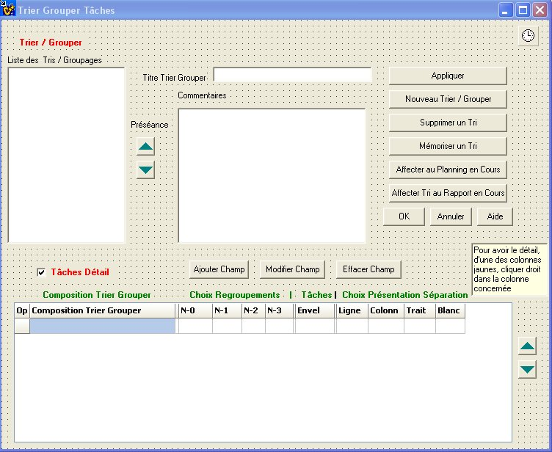
void __fastcall TTri::CleanMemory()
{
int i;
for (i=0;i<MAX_TCHP;i++)
{
T_LLCC[pc][i] = "L"; // valeur L ou C
T_POL[pc][i] = "Arial"; // police
T_CTEXT[pc][i] = "0"; // couleur Texte
T_TITAL[pc][i] = "Standard";
T_TBOLD[pc][i] = "";
T_HAUTEUR[pc][i] = "14";
T_JSH[pc][i] = "Centre";
T_JSV[pc][i] = "Haut";
T_CBKG[pc][i] = "";
T_TLARG[pc][i] = "200";
T_LS1EP[pc][i] = ""; // Epaisseur
T_LS1CL[pc][i] = ""; // Couleur
T_LS2[pc][i] = ""; // Oui/Non (pour titre en ligne)
T_LS2EP[pc][i] = "";
T_LS2CL[pc][i] = "";
}
}

void __fastcall TTri::Strip(char *s)
{
char tmp[5000];
int Row; int count;
Row = asFC->RowCount-1;
if ((Row>=1) && (asFC->Cells[0][Row] != "")) asFC->RowCount++;
Row=asFC->RowCount-1;

asFC->Cells[0][Row]=Row;

//ExtractValue(tmp,s,"CH",0);
ExtractValue(tmp,s,"champs",0);
Clean(asFC);
count = Explode('|',s);
if (count)
{
for (Row=1; Row<=count; Row++)
{

if (Row>1) asFC->RowCount++;
asFC->Cells[0][Row]=IntToStr(Row);
ExtractValue(tmp,params[Row-1],"CH",0);
asFC->Cells[1][Row]=AnsiString(tmp);
asFC->Colors[2][Row]=RGB(0,0,0);
ExtractValue(tmp,params[Row-1],"N0",0);
asFC->Cells[3][Row]=AnsiString(tmp);
ExtractValue(tmp,params[Row-1],"N1",0);
asFC->Cells[4][Row]=AnsiString(tmp);
ExtractValue(tmp,params[Row-1],"N2",0);
asFC->Cells[5][Row]=AnsiString(tmp);
ExtractValue(tmp,params[Row-1],"N3",0);
asFC->Cells[6][Row]=AnsiString(tmp);

asFC->Colors[8][Row] = RGB(255,255,153);
asFC->Colors[10][Row] = RGB(255,255,153);
asFC->Colors[11][Row] = RGB(255,255,153);
asFC->Colors[12][Row] = RGB(255,255,153);
asFC->Colors[13][Row] = RGB(255,255,153);

asFC->Colors[7][Row]=RGB(0,0,0);
ExtractValue(tmp,params[Row-1],"DT",0);
asFC->Cells[8][Row]=AnsiString(tmp);
asFC->Colors[9][Row]=RGB(0,0,0);
ExtractValue(tmp,params[Row-1],"TR",0);
asFC->Cells[12][Row]=AnsiString(tmp);
ExtractValue(tmp,params[Row-1],"BL",0);
asFC->Cells[13][Row]=AnsiString(tmp);

// Zone memoires a remplir
ExtractValue(tmp,params[Row-1],"lc",0);
T_LLCC[pc][Row]=AnsiString(tmp);

asFC->Cells[10][Row]=" ";
asFC->Cells[11][Row]=" ";
asFC->Cells[12][Row]=" ";
asFC->Cells[13][Row]=" ";

if (T_LLCC[pc][Row]=="L") asFC->Cells[10][Row]="X";
if (T_LLCC[pc][Row]=="C") asFC->Cells[11][Row]="X";
if (T_LLCC[pc][Row]=="T") asFC->Cells[12][Row]="X";
if (T_LLCC[pc][Row]=="B") asFC->Cells[13][Row]="X";
ExtractValue(tmp,params[Row-1],"pol",0);
T_POL[pc][Row]=AnsiString(tmp);
ExtractValue(tmp,params[Row-1],"ct",0);
T_CTEXT[pc][Row]=AnsiString(tmp);
ExtractValue(tmp,params[Row-1],"it",0);
T_TITAL[pc][Row]=AnsiString(tmp);
ExtractValue(tmp,params[Row-1],"bd",0);
T_TBOLD[pc][Row]=AnsiString(tmp);
ExtractValue(tmp,params[Row-1],"ht",0);
T_HAUTEUR[pc][Row]=AnsiString(tmp);
ExtractValue(tmp,params[Row-1],"jh",0);
T_JSH[pc][Row]=AnsiString(tmp);
ExtractValue(tmp,params[Row-1],"jv",0);
T_JSV[pc][Row]=AnsiString(tmp);
ExtractValue(tmp,params[Row-1],"cb",0);
T_CBKG[pc][Row]=AnsiString(tmp);
ExtractValue(tmp,params[Row-1],"lg",0);
T_TLARG[pc][Row]=AnsiString(tmp);
ExtractValue(tmp,params[Row-1],"ep1",0);
T_LS1EP[pc][Row]=AnsiString(tmp);
ExtractValue(tmp,params[Row-1],"cl1",0);
T_LS1CL[pc][Row]=AnsiString(tmp);
ExtractValue(tmp,params[Row-1],"ls2",0);
T_LS2[pc][Row]=AnsiString(tmp);
ExtractValue(tmp,params[Row-1],"ep2",0);
T_LS2EP[pc][Row]=AnsiString(tmp);
ExtractValue(tmp,params[Row-1],"cl2",0);
T_LS2CL[pc][Row]=AnsiString(tmp);
}
}
}

void __fastcall TTri::Envoi_Params(int row)
{
strcpy(m_exchange,"<lc>");strcat(m_exchange,T_LLCC[pc][row].c_str()); strcat(m_exchange,"</lc>");
strcat(m_exchange,"<pol>");strcat(m_exchange,T_POL[pc][row].c_str()); strcat(m_exchange,"</pol>");
strcat(m_exchange,"<ct>");strcat(m_exchange,T_CTEXT[pc][row].c_str()); strcat(m_exchange,"</ct>");
strcat(m_exchange,"<it>");strcat(m_exchange,T_TITAL[pc][row].c_str()); strcat(m_exchange,"</it>");
strcat(m_exchange,"<bd>");strcat(m_exchange,T_TBOLD[pc][row].c_str()); strcat(m_exchange,"</bd>");
strcat(m_exchange,"<ht>");strcat(m_exchange,T_HAUTEUR[pc][row].c_str()); strcat(m_exchange,"</ht>");
strcat(m_exchange,"<jh>");strcat(m_exchange,T_JSH[pc][row].c_str()); strcat(m_exchange,"</jh>");
strcat(m_exchange,"<jv>");strcat(m_exchange,T_JSV[pc][row].c_str()); strcat(m_exchange,"</jv>");
strcat(m_exchange,"<cb>");strcat(m_exchange,T_CBKG[pc][row].c_str()); strcat(m_exchange,"</cb>");
strcat(m_exchange,"<lg>");strcat(m_exchange,T_TLARG[pc][row].c_str()); strcat(m_exchange,"</lg>");
strcat(m_exchange,"<ep1>");strcat(m_exchange,T_LS1EP[pc][row].c_str()); strcat(m_exchange,"</ep1>");
strcat(m_exchange,"<cl1>");strcat(m_exchange,T_LS1CL[pc][row].c_str()); strcat(m_exchange,"</cl1>");
strcat(m_exchange,"<ls2>");strcat(m_exchange,T_LS2[pc][row].c_str()); strcat(m_exchange,"</ls2>");
strcat(m_exchange,"<ep2>");strcat(m_exchange,T_LS2EP[pc][row].c_str()); strcat(m_exchange,"</ep2>");
strcat(m_exchange,"<cl2>");strcat(m_exchange,T_LS2CL[pc][row].c_str()); strcat(m_exchange,"</cl2>");

}

void __fastcall TTri::Recupere_Params(int Row)
{
char tmp[250];

ExtractValue(tmp,m_exchange,"lc",0);
T_LLCC[pc][Row]=AnsiString(tmp);
ExtractValue(tmp,m_exchange,"pol",0);
T_POL[pc][Row]=AnsiString(tmp);
ExtractValue(tmp,m_exchange,"ct",0);
T_CTEXT[pc][Row]=AnsiString(tmp);
ExtractValue(tmp,m_exchange,"it",0);
T_TITAL[pc][Row]=AnsiString(tmp);
ExtractValue(tmp,m_exchange,"bd",0);
T_TBOLD[pc][Row]=AnsiString(tmp);
ExtractValue(tmp,m_exchange,"ht",0);
T_HAUTEUR[pc][Row]=AnsiString(tmp);
ExtractValue(tmp,m_exchange,"jh",0);
T_JSH[pc][Row]=AnsiString(tmp);
ExtractValue(tmp,m_exchange,"jv",0);
T_JSV[pc][Row]=AnsiString(tmp);
ExtractValue(tmp,m_exchange,"cb",0);
T_CBKG[pc][Row]=AnsiString(tmp);
ExtractValue(tmp,m_exchange,"lg",0);
T_TLARG[pc][Row]=AnsiString(tmp);
ExtractValue(tmp,m_exchange,"ep1",0);
T_LS1EP[pc][Row]=AnsiString(tmp);
ExtractValue(tmp,m_exchange,"cl1",0);
T_LS1CL[pc][Row]=AnsiString(tmp);
ExtractValue(tmp,m_exchange,"ls2",0);
T_LS2[pc][Row]=AnsiString(tmp);
ExtractValue(tmp,m_exchange,"ep2",0);
T_LS2EP[pc][Row]=AnsiString(tmp);
ExtractValue(tmp,m_exchange,"cl2",0);
T_LS2CL[pc][Row]=AnsiString(tmp);
}

//////////////////////////////////////////////

//////////////////////////////////////////////

GLOBALS

char *m_coche;
char *m_filtre;
char *m_project;
char *m_exchange;
char *m_exchange2;
char *m_ecoplan;
char *m_menu;
char *DatabaseName;
char *m_pasapas;
char *m_criteres;
char *m_sender;
char *m_params;
char *m_sort;
char *m_tridetail;
char *m_reports;
char *m_origin;
char *m_directory;
char *m_message;
char *m_planning;
char *m_rapport;
char *m_assign;
char *m_memoriser;

char *m_saveAV;
char *m_help;
char *m_dateprev;
char *m_simul;
char *m_savesimul;
char *m_renum;
char *m_status;
char *m_excel;
char *m_importtaches;
char *m_importliaisons;
char *m_save;

char LastAppli[250];
char LastPlanning[6][250];
AnsiString m_ghost_prep[6];

char AUTOMATE[6]; // memorise chargement plannings et rapport (origine)
//char LastRapport[250];
char LastTri[250];
char LastCol[250];
char LastFilter[250];
char HelpDirectory[250];

char LocalBase[250];
int Numt[3000];
AnsiString Design[3000];
int Duree[3000];
AnsiString Deb[3000];
AnsiString Fin[3000];
AnsiString Criter[3000][8];
int DistDeb [3000];
int DistFin[3000];

char m_automatic[10];

// CONSTANTES : COEF = correspondance cm -> Pixels

#define COEF 100
#define COEFMM 10

// Liste des Criteres

AnsiString CRITERES[8];
AnsiString LIB_CRITERES[8];
Word AnPrev,MoisPrev,JourPrev;
Word AnFin,MoisFin,JourFin;
int NB_TACHES;

#define MAX_T 3010
#define PS 100

#define NS 200
#define NN 300

int niveaux[NN][MAX_T];
int simul[MAX_T];
#define NB_CAL 5

int duree[MAX_T];
int duree_reelle[MAX_T];

//char libel[MAX_T][80];

int pr[MAX_T][PS]; int su[MAX_T][PS];
int pr_tl[MAX_T][PS]; int su_tl[MAX_T][PS];
int pr_decal[MAX_T][PS]; int su_decal[MAX_T][PS];
int deb_plus_tot[MAX_T];
int fin_plus_tot[MAX_T];
int deb_plus_tard[MAX_T];
int fin_plus_tard[MAX_T];

int vrai_deb_plus_tot[MAX_T];
int vrai_fin_plus_tot[MAX_T];

int retard[MAX_T];

char coche[MAX_T];
char coch[MAX_T];
char filtr[MAX_T];
char filtint[MAX_T]; // sert aux calculs intermediaires

char codetache[MAX_T][20];

char da[MAX_T][11]; // date avancement format YYYY-MM-DD
char dtr[MAX_T][11]; // date debut reel
char ftr[MAX_T][11]; // date fin reelle
int pca[MAX_T]; // Pourcentage (restant) en avancement
int nbj[MAX_T]; // nbjours restant
char tmom[MAX_T][11]; // code tache amont
int tcal[MAX_T+1]; // calendriers affectes aux taches;
int marg_tot[MAX_T]; // marge totale
int marg_lib[MAX_T]; // marge libre
char dds[MAX_T][11]; // date debut souhaite
char dfs[MAX_T][11]; // date fin souhaitée

int sommets[MAX_T+1];

int selection[MAX_T];

int t_select[MAX_T];
int t_selectf[MAX_T];
int t_pred[MAX_T][PS];

int renum[MAX_T];

#define MAX_PERIOD 100
AnsiString DebPer[MAX_PERIOD];
AnsiString FinPer[MAX_PERIOD];
int d1[MAX_PERIOD],d2[MAX_PERIOD];
int DurPer[MAX_PERIOD];
int PerPer[MAX_PERIOD];
int TDuree[MAX_PERIOD]; // pour chaque calcul de tache
int NbjtPer[MAX_PERIOD];
int NbPer;

#define MAX_JOURS 8000
char cal[NB_CAL+1][MAX_JOURS+1]; // 10 ans
char weeks[NB_CAL+1][30];

// Criteres et champs
#define MAX_CHAMPS 100
#define MAX_PLAN 7

int NUM_CHAMP[MAX_PLAN][MAX_CHAMPS];
char LIBEL_CHAMP[MAX_PLAN][MAX_CHAMPS][50];

int pc; // planning_en_cours de 1 à 5)
int rc; // rapport en cours

// Planning : 0-1-2
// Rapport : 3-4

bool P_PLANNING[MAX_PLAN]; // Plannings ou rapports initialisés

char P_NOM[MAX_PLAN][100]; // Nom du Planning en cours
char P_GENRE[MAX_PLAN]; // compresse ou gantt
char P_TYPE[MAX_PLAN]; // prev ou prev+reel

char *P_TRI[MAX_PLAN]; // tri associe
char *P_FILTRE[MAX_PLAN]; // filtre associé
char *P_COLONNES[MAX_PLAN]; // colonnes associees

int NB_DETAIL[MAX_PLAN]; // Nb lignes detail (nb taches)

char P_MODE[MAX_PLAN]; // Mode P ortrait ou L andscape
int P_H[MAX_PLAN],P_W[MAX_PLAN]; // Hauteur et Largeur Impression

// MARGES
int P_MARGH1[MAX_PLAN],P_MARGH2[MAX_PLAN],P_MARGV1[MAX_PLAN],P_MARGV2[MAX_PLAN]; // Marges en Pixels
AnsiString P_MH1[MAX_PLAN],P_MH2[MAX_PLAN],P_MV1[MAX_PLAN],P_MV2[MAX_PLAN]; // Marges en mm

char P_MARGES[MAX_PLAN]; // O/N
char P_CADRE[MAX_PLAN]; // O / N
char P_ENTETE[MAX_PLAN]; // O/N
char P_CALHAUT[MAX_PLAN]; // O/N calendrier Haut
char P_CALBAS[MAX_PLAN]; // O/N Calendrier bas
char P_PIED[MAX_PLAN]; // O/N

char P_GRILLE[MAX_PLAN];
char P_LBRISE[MAX_PLAN];

// ENVELOPPE

AnsiString P_ENV_COUL[MAX_PLAN];
AnsiString P_ENV_EPAIS[MAX_PLAN];
AnsiString P_ENV_STYLE[MAX_PLAN];

// CADRE
AnsiString P_ELC[MAX_PLAN]; // epaisseur du cadre
AnsiString P_CLC[MAX_PLAN]; // Couleur du cadre
int P_ELCF[MAX_PLAN];
int P_CLCC[MAX_PLAN];

// Ruptures sur criteres
int P_RUPT[MAX_PLAN][8];

#define MAX_RUPT 300
AnsiString RUPT[MAX_PLAN][MAX_RUPT];
int NB_TASK[MAX_PLAN][MAX_RUPT];
int NUM_CRIT[MAX_PLAN]; // dernier critere de rupture
int ENV_MIN[MAX_PLAN][MAX_RUPT];
int ENV_MAX[MAX_PLAN][MAX_RUPT];
int ENV_DUR[MAX_PLAN][MAX_RUPT];
int ENV_D1[MAX_PLAN][MAX_RUPT];
int ENV_D2[MAX_PLAN][MAX_RUPT];
char ENV_DEBUT[MAX_PLAN][MAX_RUPT][15];
char ENV_FIN[MAX_PLAN][MAX_RUPT][15];

// description des colonnes
int P_COL[MAX_PLAN]; // nb de colonnes (champs)
int P_DETAIL[MAX_PLAN]; // Detail dans TRI
#define MAX_COL 50

int P_TRICOL[MAX_PLAN][MAX_COL]; // numero de colonne dans ASTRI
char P_ATTR[MAX_PLAN][MAX_COL]; // attribut 'L' ou 'C'

AnsiString P_FIELD[MAX_PLAN][MAX_COL]; // Nom Variables ou criteres pour tri
int P_NIV0[MAX_PLAN][MAX_COL]; // Sous Niveau pour le tri
int P_NIV1[MAX_PLAN][MAX_COL];
int P_NIV2[MAX_PLAN][MAX_COL];
int P_NIV3[MAX_PLAN][MAX_COL];

int P_ENV[MAX_PLAN][MAX_COL];

AnsiString P_FONT[MAX_PLAN][MAX_COL]; // Nom de la fonte dans la colonne
int P_HAUT[MAX_PLAN][MAX_COL]; // Hauteur du texte dans la colonne
int P_LARG[MAX_PLAN][MAX_COL];
char P_ITAL[MAX_PLAN][MAX_COL]; // Italic / Normal
char P_BOLD[MAX_PLAN][MAX_COL]; // Bold / Normal
char P_JV[MAX_PLAN][MAX_COL]; // justification V 'H,C,ou B'
char P_JC[MAX_PLAN][MAX_COL]; // justification H 'G,C,D'
int P_CFCOLOR[MAX_PLAN][MAX_COL]; // couleur Texte des colonnes
int P_CBCOLOR[MAX_PLAN][MAX_COL]; // couleur Background

AnsiString T_TITRE_COL[MAX_PLAN][50]; // Titre des colonnes
AnsiString T_FONT[MAX_PLAN][MAX_COL]; // Nom de la fonte dans la colonne
int T_HAUT[MAX_PLAN][MAX_COL]; // Hauteur du texte dans la colonne
int T_LARG[MAX_PLAN][MAX_COL];
char T_ITAL[MAX_PLAN][MAX_COL]; // Italic / Normal
char T_BOLD[MAX_PLAN][MAX_COL]; // Bold / Normal
char T_JV[MAX_PLAN][MAX_COL]; // justification V 'H,C,ou B'
char T_JC[MAX_PLAN][MAX_COL]; // justification H 'G,C,D'
int T_CFCOLOR[MAX_PLAN][MAX_COL]; // couleur Texte des colonnes
int T_CBCOLOR[MAX_PLAN][MAX_COL]; // couleur Background

char LSH[MAX_PLAN][MAX_COL]; // LSep Haute Oui/Non
TColor LSH_COLOR[MAX_PLAN][MAX_COL]; // couleur ligne
int LSH_STYLE[MAX_PLAN][MAX_COL]; // style ligne
int LSH_EPAISSEUR[MAX_PLAN][MAX_COL]; // Epaisseur
char LSB[MAX_PLAN][MAX_COL]; // LSep Basse Oui/Non
TColor LSB_COLOR[MAX_PLAN][MAX_COL]; // couleur ligne
int LSB_STYLE[MAX_PLAN][MAX_COL]; // style ligne
int LSB_EPAISSEUR[MAX_PLAN][MAX_COL]; // Epaisseur

// Variable calculées
int P_LC[MAX_PLAN][MAX_COL]; // adresse x1;
int P_MAXSIZE[MAX_PLAN][MAX_COL]; // Taille du texte le plus long dans une colonne
int P_EPAISSV[MAX_PLAN][MAX_COL]; // Epaisseur du trait de la colonne "a gauche"
int P_LENGTH[MAX_PLAN][MAX_COL]; // calculée d'apres la long maximum du champ
int T_LC[MAX_PLAN][MAX_COL]; // adresse x1;
int T_LENGTH[MAX_PLAN][MAX_COL];

TColor P_ET_BKG[MAX_PLAN]; // Background pour entete
TColor P_PD_BKG[MAX_PLAN]; // background pour pied

int P_DEBUTGANTT[MAX_PLAN]; // debut du gantt et du calendrier

// Caracteristiques des Taches Prev Critique,non critiques, reelles crit et non critiques

#define MT 5
// 1 = Prev Crit 2=Prev Non Crit 3=Reel Crit 4 Reel Non Crit
AnsiString P_TRAIT[MAX_PLAN][MT]; // couleur du trait
AnsiString P_EPTRAIT[MAX_PLAN][MT]; // epaisseur
AnsiString P_LIENS[MAX_PLAN][MT]; // liens O/N
AnsiString P_MARGE[MAX_PLAN][MT]; // Marge O/N
AnsiString P_STYLEM[MAX_PLAN][MT]; // Style marge
AnsiString P_COLMARGE[MAX_PLAN][MT]; // Couleur Trait marge

// Texte Haut Bas Droite Gauche
AnsiString P_INF[MAX_PLAN][MT][4]; // O/N
AnsiString P_INFO[MAX_PLAN][MT][4]; // Champs a afficher
AnsiString P_POLT[MAX_PLAN][MT][4]; // Police
AnsiString P_COLTXTF[MAX_PLAN][MT][4]; // couleur texte
AnsiString P_COLTXTB[MAX_PLAN][MT][4]; // couleur de fond
AnsiString P_ITALT[MAX_PLAN][MT][4]; // Italique
AnsiString P_BOLDT[MAX_PLAN][MT][4]; // Gras
AnsiString P_SIZET[MAX_PLAN][MT][4]; // Taille texte

AnsiString P_STYLELIEN[MAX_PLAN][MT]; // Style Lien
AnsiString P_COL_LIEN[MAX_PLAN][MT]; // couleur Lien
AnsiString P_EPAIS_LIEN[MAX_PLAN][MT]; // Epaisseur lien

// CALENDRIER
int H_CAL1[MAX_PLAN],H_CAL2[MAX_PLAN];
AnsiString P_FORMATCAL1[MAX_PLAN], P_FORMATCAL2[MAX_PLAN]; // Format
AnsiString P_FREQ1[MAX_PLAN], P_FREQ2[MAX_PLAN]; // frequence
AnsiString P_UNIT1[MAX_PLAN],P_UNIT2[MAX_PLAN]; // Unite
AnsiString P_ECHH[MAX_PLAN]; // Echelle haute
AnsiString P_ECHB[MAX_PLAN]; // Echelle Basse

// PIED DE DOCUMENTS // Voir Plus Bas Indice 25 a 33

int H_COPYRIGHT[MAX_PLAN];

#define MAX_TEXTE 50
/*
Descriptif des Entete, Calendrier, Style ligne detail
Gauche 1 = 0 Gauche 2 = 1 Gauche 3 = 2;
Centre 1 = 3; Centre 2 = 4 Centre 3 = 5
Droite 1 = 6 Droite 2 = 7 Droite 3 = 8
Calendrier 1 = 9; Calendrier 2 = 10;
Crit 0 (en ligne) = 11; + Affect LS
Crit 1 (en colonne = 12; Crit 2 = 13 Crit 3 = 14 Crit 4 = 15
Crit 5 = 16 Crit 6 = 17 Crit 7 = 18
Descriptif texte des colonnes = 20
Libelle Taches = 21
Pied de Documents
25 Gauche 1 26 Gauche 2 27=Gauche 3
28 29 30
31 32 33
*/

AnsiString PACTIF[MAX_PLAN][MAX_TEXTE]; // actif ou non, surtout pour les criteres 3..4..5..6..
char P_ORIENT[MAX_PLAN][MAX_TEXTE]; // En Ligne = true, en colonne = false
AnsiString PT[MAX_PLAN][MAX_TEXTE]; // Texte
TColor PC[MAX_PLAN][MAX_TEXTE]; // Couleur Foreground
TColor PB[MAX_PLAN][MAX_TEXTE]; // backgroung
AnsiString PF[MAX_PLAN][MAX_TEXTE]; // Fonte Name
int PH[MAX_PLAN][MAX_TEXTE]; // size
int PHH[MAX_PLAN][MAX_TEXTE]; // hauteur totale
char PN[MAX_PLAN][MAX_TEXTE]; // italique I normal = N
char PX[MAX_PLAN][MAX_TEXTE]; // bold = B ou Regulier N
char PJH[MAX_PLAN][MAX_TEXTE]; // just H G,C,D
char PJV[MAX_PLAN][MAX_TEXTE]; // just V H,C,B
int PR[MAX_PLAN][MAX_TEXTE]; // Retrait;
char PTYPE[MAX_PLAN][MAX_TEXTE]; // type impression pour crit : Ligne ou Colonne

// Lignes separatrices utilisées pour les criteres et ruptures

// Description CORPS

#define CHOIX 8
AnsiString P_CYN[MAX_PLAN][CHOIX];
AnsiString P_CCFG[MAX_PLAN][CHOIX];
//AnsiString P_CCBK[MAX_PLAN][CHOIX];
AnsiString P_CCST[MAX_PLAN][CHOIX];
AnsiString P_CCEP[MAX_PLAN][CHOIX];

AnsiString P_CYNJT[MAX_PLAN];
AnsiString P_CYNJNT[MAX_PLAN];
AnsiString P_CYNWENT[MAX_PLAN];

AnsiString P_CJT[MAX_PLAN];
AnsiString P_CJNT[MAX_PLAN];
AnsiString P_CWENT[MAX_PLAN];
AnsiString P_CDH[MAX_PLAN];
AnsiString P_CDV[MAX_PLAN];

AnsiString P_CCJT[MAX_PLAN];
AnsiString P_CCJNT[MAX_PLAN];
AnsiString P_CCWENT[MAX_PLAN];

// Bandes Lignes Plannings
AnsiString PL_POL[MAX_PLAN]; // police
AnsiString PL_CTEXT[MAX_PLAN]; // couleur Texte
AnsiString PL_ITAL[MAX_PLAN];
AnsiString PL_BOLD[MAX_PLAN];
AnsiString PL_HAUTEUR[MAX_PLAN];
AnsiString PL_JSH[MAX_PLAN];
AnsiString PL_JSV[MAX_PLAN];
AnsiString PL_CBKG[MAX_PLAN];
AnsiString PL_LARG[MAX_PLAN];
AnsiString PL_LS1EP[MAX_PLAN]; // Epaisseur
AnsiString PL_LS1CL[MAX_PLAN]; // Couleur
AnsiString PL_LS2[MAX_PLAN]; // Oui/Non (pour titre en ligne)
AnsiString PL_LS2EP[MAX_PLAN];
AnsiString PL_LS2CL[MAX_PLAN];

// Bandes Colonnes Plannings
AnsiString PC_POL[MAX_PLAN]; // police
AnsiString PC_CTEXT[MAX_PLAN]; // couleur Texte
AnsiString PC_ITAL[MAX_PLAN];
AnsiString PC_BOLD[MAX_PLAN];
AnsiString PC_HAUTEUR[MAX_PLAN];
AnsiString PC_JSH[MAX_PLAN];
AnsiString PC_JSV[MAX_PLAN];
AnsiString PC_CBKG[MAX_PLAN];
AnsiString PC_LARG[MAX_PLAN];
AnsiString PC_LS1EP[MAX_PLAN]; // Epaisseur
AnsiString PC_LS1CL[MAX_PLAN]; // Couleur
AnsiString PC_LS2[MAX_PLAN]; // Oui/Non (pour titre en ligne)
AnsiString PC_LS2EP[MAX_PLAN];
AnsiString PC_LS2CL[MAX_PLAN];

// Variables intermediaires de calcul
int memy1[MAX_PLAN],memy2[MAX_PLAN];
int P_MAXDIST[MAX_PLAN];

int P_CDVV[MAX_PLAN];

int P_DECAL[MAX_PLAN];
int P_LASTTEXT[MAX_PLAN];
int P_LST[MAX_PLAN];

int LAST_RX1[MAX_PLAN];
int LAST_RX2[MAX_PLAN];
int LAST_RY1[MAX_PLAN];
int LAST_RY2[MAX_PLAN];
int LAST_ZOOM[MAX_PLAN];
char LAST_TYPE[MAX_PLAN];

int D_LEFT[MAX_PLAN];
int D_RIGHT[MAX_PLAN];
int D_TOP[MAX_PLAN];
int D_BOTTOM[MAX_PLAN];

// Variables pour TRIS

#define MAX_TRI 8
char S_CRIT[MAX_PLAN][MAX_TRI][100];

#define MAX_TCHP 8

AnsiString T_LLCC[MAX_PLAN][MAX_TCHP]; // valeur L ou C
AnsiString T_POL[MAX_PLAN][MAX_TCHP]; // police
AnsiString T_CTEXT[MAX_PLAN][MAX_TCHP]; // couleur Texte
AnsiString T_TITAL[MAX_PLAN][MAX_TCHP];
AnsiString T_TBOLD[MAX_PLAN][MAX_TCHP];
AnsiString T_HAUTEUR[MAX_PLAN][MAX_TCHP];
AnsiString T_JSH[MAX_PLAN][MAX_TCHP];
AnsiString T_JSV[MAX_PLAN][MAX_TCHP];
AnsiString T_CBKG[MAX_PLAN][MAX_TCHP];
AnsiString T_TLARG[MAX_PLAN][MAX_TCHP];
AnsiString T_LS1EP[MAX_PLAN][MAX_TCHP]; // Epaisseur
AnsiString T_LS1CL[MAX_PLAN][MAX_TCHP]; // Couleur
AnsiString T_LS2[MAX_PLAN][MAX_TCHP]; // Oui/Non (pour titre en ligne)
AnsiString T_LS2EP[MAX_PLAN][MAX_TCHP];
AnsiString T_LS2CL[MAX_PLAN][MAX_TCHP];

