**PIVOT TECH LAB LIMITED. (PTL)**



|  |
| --- |
| **PIVOT TECH LAB. (PTL)** |
| **CORPORATE OFFICE**  2nd Link Close, Teshie – Nungua, Estate. Accra.  Box 1574 T/N Teshie -Nungua, Accra – Ghana.  Telephone: (+233) 54.974.5699 / 54.974.5408. |
| E-mail: **pivottectlab@gmail.com** |

**PROPOSAL**

TO

**GHANA EDUCATION SERVICE. (GES)**

ON

**ONLINE LEARNING AND EXAMINATION PLATFORM**

All enquiries in connection with this document, or requests for further information should be addressed in the first instance to one of the following: The material contained within is exclusive and confidential. It is the sole property of Pivot Tech Lab Limited. The information shall only be disclosed to those individuals having a definite need to know. Such individuals shall be adequately notified of their obligations with respect to the enclosed information.

|  |  |  |
| --- | --- | --- |
| PRIMARY CONTACT DETAILS | | |
| Emmanuel Oduro **Head if IT**  Mobile: +233.54.974.5408  Mobile: +233.55.870.5462  [emmanuel.yaw@hotmail.com](mailto:emmanuel.yaw@hotmail.com) | Prince Joshua Pocco  **Business Administrator**  Mobile: +233.54.974.5699  Mobile: +233.54.379.3110  [prince.pocco@outlook.com](mailto:prince.pocco@outlook.com) | Mumuni Ali  **Executive System Administrator**  Mobile: +233.54.096.5372  Mobile: +233.24.523.1314  [info.pacifik@gmail.com](mailto:info.pacifik@gmail.com) |
|  | | |

Contents

INTRODUCTION 5

OVERVIEW OF THE APPLICATION 6

Extra Features 7

BENEFITS TO OUR CLIENTS 8

SPECIFICATIONS AND REQUIREMENT 10

MIND MAP 11

PIVOT TECH LAB OVERVIEW 14

# INTRODUCTION

Pivot Tech Lab (PTL) is a highly trained group professionals with years of industrial experience, providing exclusive services in software and hardware engineering. At Pivot, we provide you with IT solutions and most importantly the technical expertise you need to run your business and maximize your returns.

The modern world is undergoing a fundamental transformation as the industrial society of the

twentieth century rapidly gives way to the information society of the twenty-first century. This

dynamic process promises a fundamental change in all aspects of our lives, including knowledge

dissemination, social interaction, business practices, political engagement, media, entertainment,

health, leisure and education.

Education in its general sense is a form of learning in which the knowledge, skills, and habits of

a group of people are transferred from one generation to the next through teaching, training, or

research which frequently takes place under the guidance of others but may also be self-taught.

The concept of traditional education has changed radically within the last couple of years. Being physically present in a classroom isn’t the only learning option anymore, not with the rise of the internet and new technologies, at least. Nowadays, you have access to a quality education whenever and wherever you want, as long as you have access to a computer or a smart device. We are now entering a new era; the revolution of online education.

There is no need to discount the skepticism surrounding education through the internet. It’s hard to understand the notion of leaving behind the conventional classroom, especially if it's to face this vast space called The Internet.

However, that’s not reason enough to shy away from this alternative, which has proven to be valid and useful for many students. Online education is a sensible choice whether you’re a teenager or an adult. As a student, this can be a useful learning method for sharpening your skills in a difficult subject, or learning a new skill.

The flexibility of online education enables the teacher and the student to set their own learning pace, and there’s the added elasticity of setting a schedule that fits everyone’s agenda. As a result, using an online educational platform allows for a better balance of work and studies, so there’s no need to give anything up. Studying online teaches you vital of time management skills, which makes finding a good work-study balance easier. Having a common agenda between the student and teacher can also prompt both parties to accept new responsibilities and have more independence.

It offers a wide selection of programs. In a space as vast and wide as the internet, there are countless skills and subjects to teach and learn. A growing number of universities and higher education schools are offering online versions of their programs for various levels and disciplines. From music composition to quantum physics, there are options for every type of student. With the online (e-learning) platform, the student to introduces to a vast number of disciplines.

Its accessible, Online education enables you to study or teach from anywhere in the world. This means there’s no need to commute from one place to another, or follow a rigid schedule.

On top of that, not only do you save time, but you also save money, which can be spent on other priorities. The virtual classroom is also available anywhere there’s an internet connection.

It allows for a customized learning experience. We’ve mentioned before how flexibility can help you to set your own study pace. But online education is also flexible for each student’s individual requirements and level of ability. Also allows for greater interaction and more feedback between you and your tutor.

There’s often access to very diverse material such as videos, photos, and eBooks online as well, and tutors can also integrate other formats like forums or discussions to improve their lessons. And this extra content is available at any moment from anywhere, which will offer you a more dynamic and tailor-made education.

# OVERVIEW OF THE APPLICATION

At Pivot Tech Lab, we are well endowed with expertise’s in developing and operating sophisticated software’s required to render an online learning and examination platform meeting the GES curricula’s standard with security and reliability.

Features included:

High level and automated verification of tutors, registered students and system administrators as well as parents.

Integration of mailing, SMS, push notifications and WhatsApp messaging service as external means of notification

A well-structured dashboard for all members (administrator, tutors and students) of the system with real time analytics

Real time or live teaching and learning using video and voice conference

Uploading pre-recorded lessons for a course as well as learning material in the form of documents, photographs and infographics.

A group and private feedback module amongst students and tutor with a well advance alert/notification module

Personal note writing module for both students and tutors

Setting of exams by the course tutor to know how students are doing

Manual and automated marking of exams (e.g.: theory and objectives)

Generating reports for students

Allowing students to retake failed exams as and when they are ready

Monitoring the activities on the student’s device when taking the online exams to avoid cheating.

Recording the location of the students during exams for statistical purpose

A library module to give students and tutors access to materials and or books needed for a course or reading pleasure.

Tutors connecting to parents of students on the performance of their children and ways to help their wards

Generating of monthly reports on system health

Two factor authentication modules to enhance the level of security for all members of the system.

Review of tutors based on performance and interactivity by students

Administrator or facilitators being able to join any class for review purpose

Student and tutors will preview to the history of all course joined and taught respectively as well as exams and schedules.

Extra Features may be:

* Event management by tutors for the students
* Experience sharing by students
* Calendar services module
* Educational games module
* Educational blogging module
* Exposing of APIs endpoint for any future external integrations
* Customizable interface to suit the preference of the student or the tutor
* Storage space for students and tutors to keep their personal educational materials
* An educational community module for students to join and discuss their interest and learn more about the heading of the community for example, students can join a wildlife community to discuss and learn more about the wildlife and even share images and videos of their pest and or animals they have seen. The communities will be created with their own set of governing rules and may require approval by the community head to be able to join. The communities reward members with stars based on the number of inputs and over all likes on all inputs.

# BENEFITS TO OUR CLIENTS

Flexibility

Students have the freedom to juggle their potentials and school because they are not tied down to a fixed schedule. In a traditional classroom setting, class meeting times are set, and the student has no power over this, forcing them to work their schedules around these dates. Most people who choose online learning tend to have other commitments, and prefer this mode of learning as it gives them power over how they will delegate their time towards their different courses and projects.

Reduced Costs

Online education can cost less due to a variety of reasons. For example, there is no cost for commuting. Assorted costs that are related to transport, such as fuel, parking, car maintenance, and public transportation costs don't affect the online student.

Networking Opportunities

Online education also provides students with the chance to network with peers across the country, nations or even different continents, since there are Ghanaians all over the world. This often leads to other opportunities in terms of collaboration with other individuals in the implementation of a project. At the same time, it makes them culturally sensitive and able to fit into other environments easily given their exposure to other cultures.

Documentation

All the information that you will need will be safely stored in an online database. This includes things like live discussion documents, training materials, emails and InMail. This means that if there is ever anything that needs to be clarified, the student will be able to access these documents fast, saving valuable time. This is especially useful for individuals that need to carry out research for a project and submit their findings to a panel or individuals learning for an examination.

Increased Instructor - Student Time

Students in traditional classrooms may not get the personalized attention they need to have concepts clarified. Although class sizes vary from school to school. This is not a problem for this type of education because online guided discussions and personal talk time with their tutors and their assistants is a hallmark of online classes. This increases the chances of a student performing well due to the time their tutors give them. This also enhances their problem-solving and communication skills, as well as knowing how to defend their arguments to superiors if needed.

Access to Expertise

An online education might give students access to specialized knowledge based that may not be available in an easily accessible or local institution of learning. Online classes allow the sharing of expertise that helps more people have access to education that is not readily available in certain geographic locations.

This type of education has grown over the last few years and has experienced mainstream acceptance. With an online class, you get to control your learning environment, which ultimately helps you develop a deeper understanding of your course. New models of learning are always springing up in the market, providing students with varied opportunities to fashion their education into something that fits them, not the other way round. The future of online education looks promising, and opens up education to a larger section of the population than ever before.

SECURITY

For security purposes, information on the student’s national ID card or birth certificate will be required during registration. Voter ID, Passport, Driver’s License or SSNIT ID of parents will be required if the student is not able to provide any of the above documents.

Students will have a generated identification number (ID), which will be used to identify them.

There will be an audit log module for auditing purpose.

Content Encryption.

There will be access right module to control module access of the application

To ensure the systems security, the following penetration, vulnerability and system tests will be contacted by our inhouse security team.

* IP Spoofing
* Pressure testing
* UI/UX testing
* SQL Injection
* Buffer Overflows
* Account Spoofing
* D-Dos Attacks
* Caching of Web Pages

# SPECIFICATIONS AND REQUIREMENT

Recommended specification:

Server

* Linux based server (ubuntu, centos, redhat)
* Minimum storage 2tb
* 32g ram
* SSL
* Domain name

Scalability

* Upgradable server requirement

Others

* Google services (Map / location service)
* WhatsApp business API services (optional)
* Database Management System (Oracle, MSSQL Server, MySQL)

MIND MAP: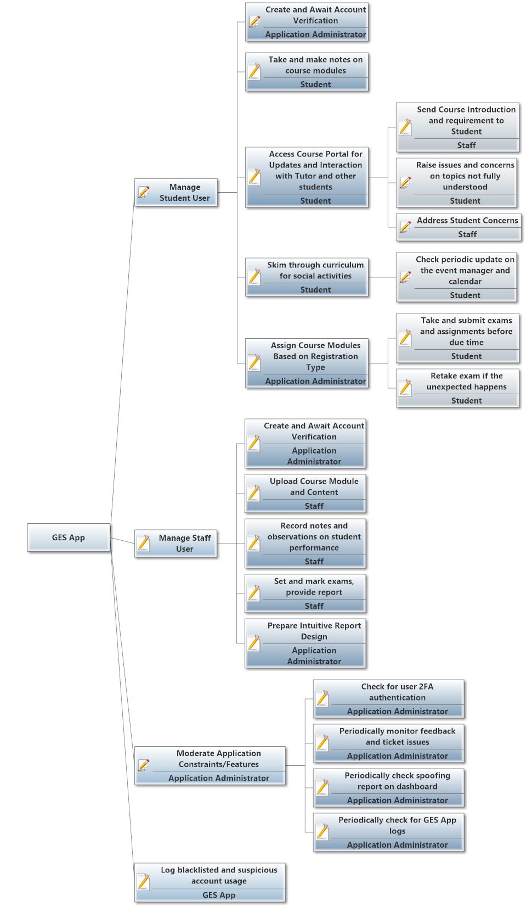

The above diagram illustrates the GES applications activity management from various users: the main Application Administrator user, the Staff user, and the Student user. The application would have sessions logged for each user; however, this can be an issue when detecting intrusions or hacks. As a result, security features would be put in place to manage authentication and access by the various users of the system as documented in the previous section.

The Application Administrator user would moderate application constraints and features by checking and ensuring that the 2FA works accurately as expected or designed. Regardless of this, the 2FA system setup in the application is expected to provide the maximum-security features to disallow security bypass. Periodic feedback and ticketing issues between staff and students would be displayed on the dashboard of the Application Administrator user as he is to ensure that all ticket issues are resolved and the necessary support is provided for and by the staff to students.

To further provide enhanced security features, an alarm system would be added to the application to create alerts or notifications on the dashboard of the Application Administrator alerting him/her of any possible attempts to login to the system either by some third-party application or by failed login attempts. The system shall also log basic information like the IP address of the intruder to easily identify and correct issues of intrusion. Users can be added to a blacklist so future attempts to login into the system by the same users would be automatically denied.

Application Administrator is allowed to design a custom report user activity to be delivered to staff, with this report, staff can verify student’s participation and contribution in class together with other issues and concerns which may be pending but have not been resolved by the tutor.

The Staff user upon successful registration and login, would upload course content and modules onto the system. These contents would include video recordings, articles and documents for further studies, assignment, exam schedules and other course-related activity schedules. Staff user is also expected to know and monitor students assigned or enrolled in his/her course so he/she can monitor students’ performance in class. In cases where there needs to be research and field work, staff would be required to provide the necessary materials, information and guidance as to how such research should be carried out. Staff would provide video illustrations and possibly pictures or audio files elaborating on how the research work is to be carried out. To moderate early and late submission of course work and assignments, staff would be compelled to set time lapses or deadlines for assignments, quizzes and exams.

Student users are expected to periodically check their dashboards for updates on events from staff or event planners. These updates are to help students get well informed about pending assignments, tasks, lessons, possible research or field work and discussions that need to be addressed. Students can create tickets or raise concerns of dissatisfaction where students do not fully comprehend a lecture or are unable to get the required files, software or documents needed to help them fully understand and pursue the course with utmost ease. Students would have a mail or chat feature enabled for each course so they can have personal interactions with staff taking the respective courses for which they are enrolled.

Below is a use case diagram that summarizes and introduces the main activities and transactions the system is expected to perform.

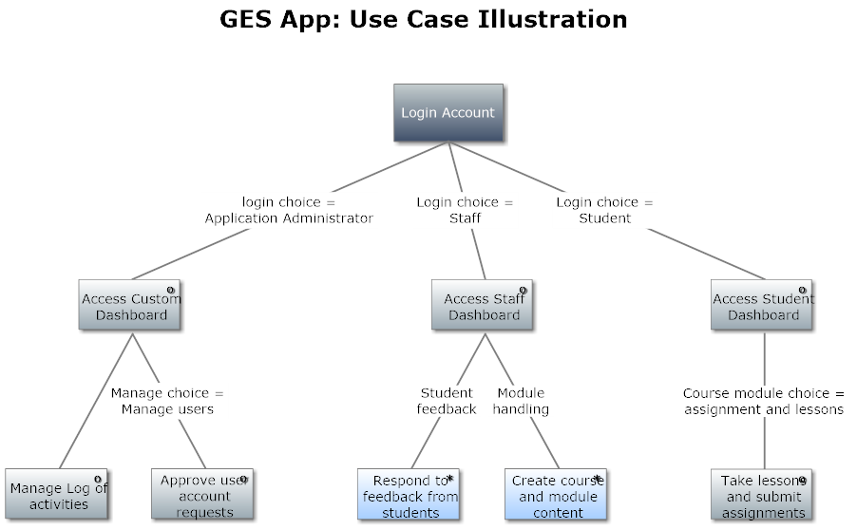

The diagram presents a login interface from which all users of the system get access to their respective dashboards. From the Application Administrator dashboard, user account activities and logs are managed. Whereas from the staff dashboard, staff is able to manage course modules and content and respond to feedback from students. These feedbacks can be in the form of tickets raised, assignments submitted, quizzes taken and the likes. Students on the other hand have access to course content and can make submissions and take lessons.

# PIVOT TECH LAB OVERVIEW

Pivot Tech Lab consists of highly qualified group of professionals with years of industrial experience, providing exclusive services in computer engineer’s, hardware technical consultants, graphic designers, developing and programing. This team has help companies over these few months of our business to carry on their work successfully and establish trust with our brand. The members that make Pivot Tech Lab, have years of experience working with some of the largest tech solution in Africa and are most consistent and professional.

As a solely native Ghanaian company, Pivot Tech Lab was incorporated under the Companies Code, 1963 (Act 179) as a limited liability company in January, 2020 and has magnificently impacted in our client’s line of business.

Pivot Tech Lab services and solution are diversified. Merging them all brings forward a unique and valuable offering in business enhancement. This cover aspect such as building from the right processes, programming them and launching them into the international marketplace whiles using the best practices and international standards as guidelines of quality and competences.

We deliver much more than just technology; Pivot’s objective is to fully understand its customers’ business processes and to deliver significant added value to its customer by developing solution that dramatically reduce their costs and enhance their ability to adapt to changes in their markets.

We are advancing on a tremendous pace and with involvement of skilled and experienced people working in the organization. APSIS is currently doing business with Large Corporate and medium Sector. It realizes the importance of functional knowledge and its impact in developing business solutions. We constantly strive to be a leading technology firm with profound business and functional knowledge. The key to the company's success is the maintenance of a close working relationship with the clients through ensuring the best possible solutions to their needs; to establish and maintain a thorough knowledge and understanding of client's objective.

Our Mission

To creatively transform our client’s ideas into an innovative software and hardware solutions while educating them and non-clients on the use and advancement of technologies based on research and inventions.

Vision

To be among the leading Tech giant providers of technological solutions, exploration and discovery.

Core Values

* Quality teamwork
* Innovation
* Customers satisfaction
* Integrity
* Employee evolution

Our client’s services are based on our values for:

* Exceeding expectations with quality service delivery
* Develop and maintain client concept into reality
* Understanding business function and International standards

The strive for excellence to:

* Excel in talent revolution to remain relevant
* Progress our employee’s development
* In working as a team to produce the best results possible

Services

We provide well complete and comprehensive service in software and hardware engineering, UI/UX modeling , data base administration, Linux administration, graphic designing, animation, videography, etc.