Getting Started Data Visualizations In R

Open Documentation by Henry Bernreuter

This documentation is under the assumption you have basic programming skills and have already downloaded Rstudio

library(lattice)

# lets use a built in data set called

mtcars

#if you would like to see the data set type, type mtcars can #then hit ctrl + enter

#you should see the following in the console window

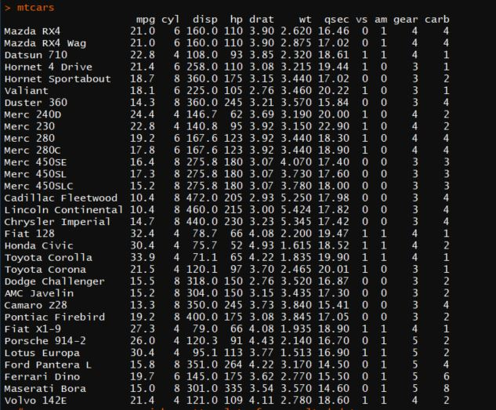

# now we can see a quick scatterplot of correalted data

plot(mtcars)

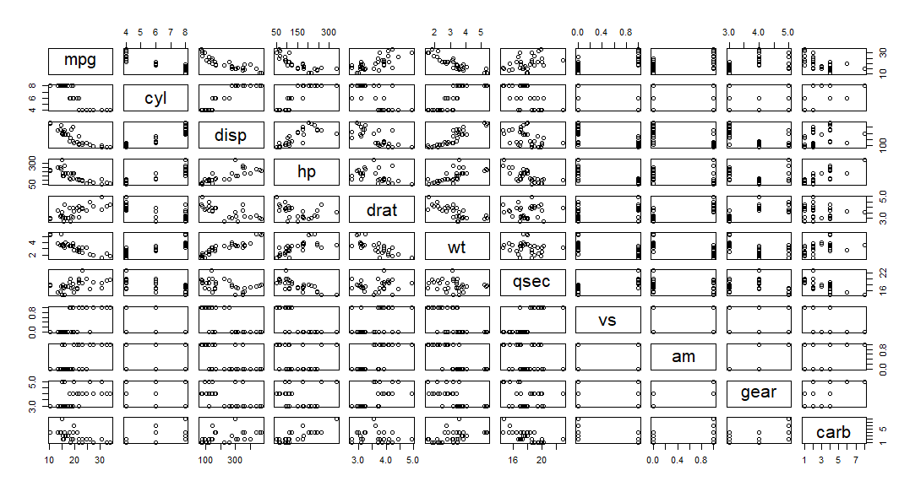

# thats not really going to do us any good. So lets compare # something....

# lets plot the dealer cost vs the manufactor suggested retail # price(MSRP)

plot(cars$MSRP,cars$Dealer_cost)

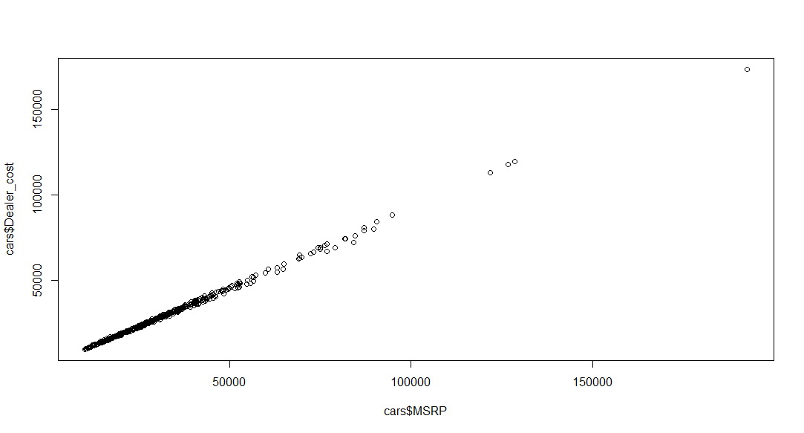

# ok now we are getting somewhere this chart shows the higher # the dealer cost the higher the MSRP

# but it is a boring lets make a chart showing miles per gallon # of all the cars in mtcars

dotchart(mtcars$mpg)

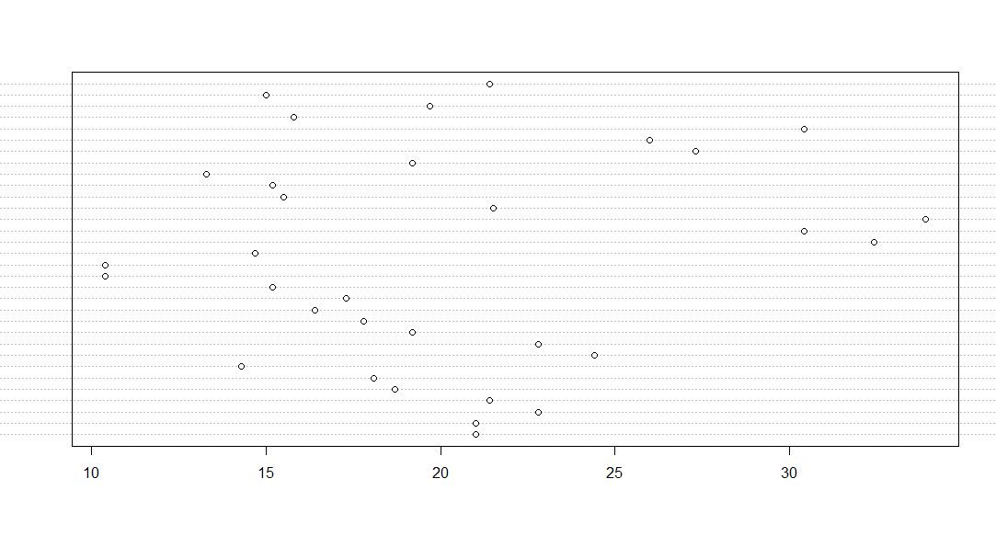

#that’s boring and does not explain much

#now we should add some labels

dotchart(mtcars$mpg,labels=row.names(mtcars), cex=0.9, xlab="Miles Per Gallon")

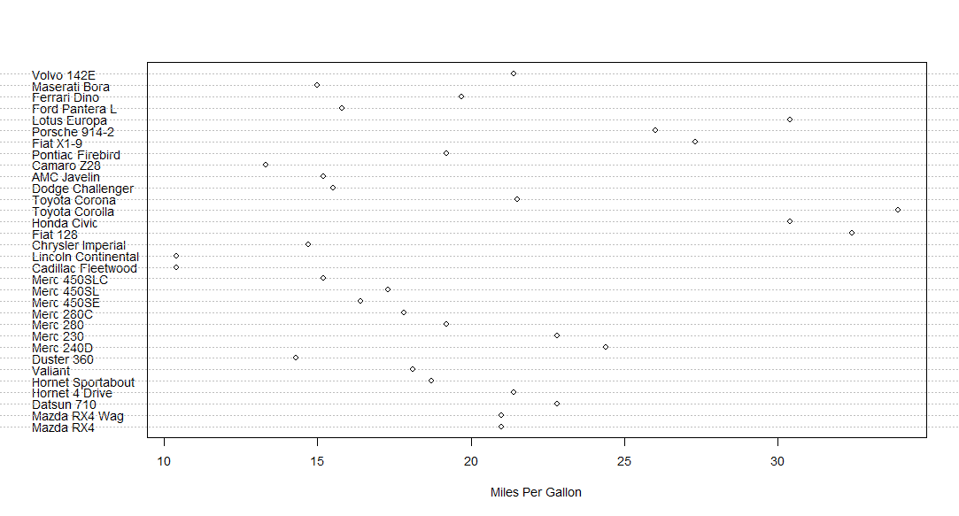

# Still boring so let's go all out

# Dotplot: Grouped Sorted and Colored

# Sort by mpg, group and color by cylinder

x <- mtcars[order(mtcars$mpg),] # sort by mpg

x$cyl <- factor(x$cyl) # it must be a factor

x$color[x$cyl==4] <- "red"

x$color[x$cyl==6] <- "blue"

x$color[x$cyl==8] <- "darkgreen"

dotchart(x$mpg,labels=row.names(x),cex=.9,groups= x$cyl,

main="Gas Milage for Car Models\ngrouped by cylinder",

xlab="Miles Per Gallon", gcolor="black", color=x$color)

